Participant Flow

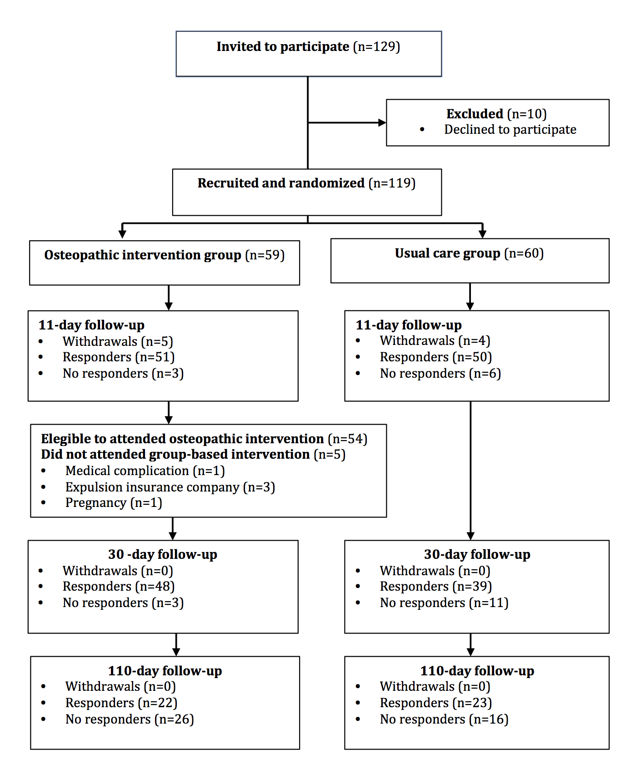

Baseline Characteristics

Table I. Baseline characteristics of participants recruited into the study.

 | All | Intervention group | Usual care group
Mean age (min-max) | 34,3 (18-59) | 30,6 (18-51) | 38,0 (19-59)
Gender (male/female) | 55/64 | 33/26 | 22/38
Type of injury (extension/flexion)(n) | 8/70 | 5/37 | 3/33
Employment situation (n):
Self-employed | 16 | 9 | 7
Employed | 40 | 19 | 21
Retired (n) | 1 | 0 | 1
Disabled (n) | 3 | 1 | 2
Student (n) | 9 | 7 | 2
Housewife (n) | 3 | 1 | 2
Unemployed (n) | 45 | 21 | 24
Mean days start treatment | 17,1 | 18,7 | 15,5
Mean (SD) pain (VAS) | 6,5 (2,0) | 6,7 (2,0) | 6,6 (1,9)
Mean (SD) disability (NPQ) | 46,5 (16,9) | 45,5 (16,1) | 47,6 (17,8)
Mean (SD) cervical mobility (CROM):
Flexion | 31,6 (13,9) | 31,7 (15,8) | 31,5 (11,9)
Extension | 41,6 (16,9) | 41,9 (17,9) | 41,3 (16,1)
Right rotation | 43,8 (16,4) | 44,6 (17,4) | 43,0 (15,5)
Left rotation | 42,5 (14,1) | 41,9 (15,1) | 43,2 (13,2)
Right side bending | 27,9 (10,5) | 28,2 (11,9) | 27,7 (9,0)
Left side bending | 30,8 (9,8) | 31,5 (10,2) | 30,1 (9,5)
Mean (SD) anxiety (HAD) | 10,3 (4,4) | 10,1 (4,1) | 10,5 (4,8)
Mean (SD) depression (HAD) | 7,2 (4,2) | 6,8 (3,6) | 7,6 (4,8)
Mean (SD) lordosis (COOB) | 20,0 (12,6) | 18,1 (11,9) | 22,0 (13,1)

n: number of participants; SD: standard deviation; VAS: pain Visual Analogue Scale; NPQ: Northwick Park Neck Pain Questionnaire; CROM: Cervical Range Of Motion Instrument; HAD: Hospital Anxiety and Depression Scale; COOB: Angular radiographic measurement using the Cobb method.

Outcome measures

Table 2. Primary measures.
Means observed at eleven days, thirty days, and one hundred and ten days after treatment in both the usual care and osteopathic intervention groups, and means difference between osteopathic intervention versus usual care.

 |  | Mean 10 days after treatment | Mean 30 days after treatment | Mean 110 days after treatment |  | Means Difference OI vs. UC
Disability (NPQ) | Usual care | 37,7 | 23,0 | 16,2 | 0,6
 | Osteopathic intervention | 37,4 | 24,4 | 13,1
Cervical mobility (CROM):
Flexion | Usual care | 32,9 | 39,5 | 44,0 | 3,4
 | Osteopathic intervention | 39,1 | 46,5 | 48,9
Extension | Usual care | 48,6 | 52,1 | 60,5 | 0,4
 | Osteopathic intervention | 45,9 | 55,9 | 63,2
Right rotation | Usual care | 48,3 | 53,4 | 59,5 | 2,7
 | Osteopathic intervention | 52,2 | 58,7 | 60,4
Left rotation | Usual care | 48,9 | 58,2 | 61,1 | -0,9
 | Osteopathic intervention | 50,9 | 59,4 | 59,9
Right side bending | Usual care | 31,9 | 34,0 | 37,2 | 2,0
 | Osteopathic intervention | 33,4 | 39,8 | 40,4
Left side bending | Usual care | 34,4 | 35,6 | 39,5 | 2,7
 | Osteopathic intervention | 37,2 | 43,3 | 44,6
Cervical lordosis (COOB) | Usual care | - | 25,2 | - | -3,0
 | Osteopathic intervention | - | 24,3 | -

OI: Osteopathic intervention; UC: Usual care; NPQ: Northwick Park Neck Pain Questionnaire; CROM: Cervical Range Of Motion Instrument; COOB: Angular radiographic measurement using the Cobb method.

Table 3. Additional measures.
Means observed at eleven days, thirty days, and one hundred and ten days after treatment in both the usual care and osteopathic intervention groups, and means difference between osteopathic intervention versus usual care.

 |  | Mean 10 days after treatment | Mean 30 days after treatment | Mean 110 days after treatment |  | Means Difference OI vs. UC
Pain (VAS) | Usual care | 5,5 | 3,8 | 2,4 | 0,6
 | Osteopathic intervention | 5,8 | 3,6 | 2,0
Anxiety (HAD) | Usual care | - | 7,4 | 7,0 | -0,2
 | Osteopathic intervention | - | 7,3 | 5,0
Depression (HAD) | Usual care | - | 4,0 | 3,7 | -0,2
 | Osteopathic intervention | - | 4,3 | 2,3

OI: Osteopathic intervention; UC: Usual care; VAS: pain Visual Analogue Scale; HAD: Hospital Anxiety and Depression Scale.

Adverse events
There were no adverse events associated with this trial.

