Participant Flow
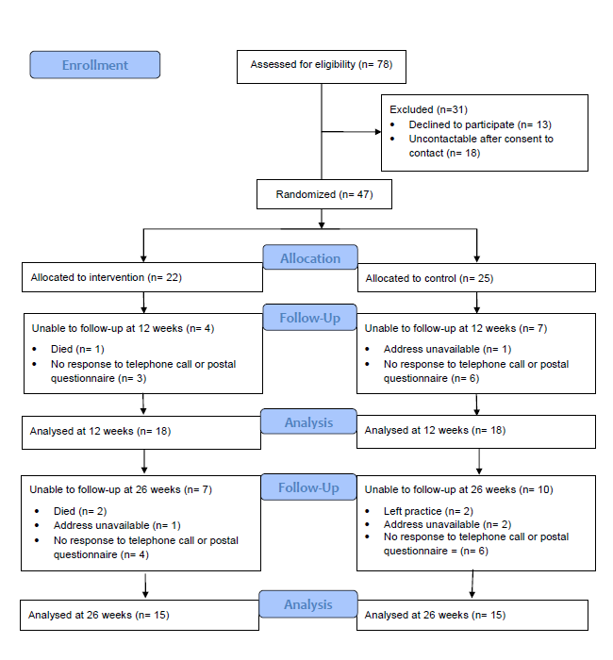

Baseline characteristics
Baseline Characteristics | Control patients  (n=25) | Intervention patients  (n=22)
Female | 16 (64.0%) | 13 (59.0%)
Age (Mean (SD)) | 43.1 (17.1) | 44.7 (18.5)
White ethnic group | 24 (96.0%) | 22 (100%)
Marital status
- Married/Cohabiting | 6 (24.0%) | 12 (54.5%)
- Widowed/separated/divorced | 8 (32.0%) | 6 (27.3%)
- Single | 11 (44.0%) | 4 (18.2%)
Any dependents at home | 9 (36.0%) | 7 (31.8%)
Age left education | 18.6 (5.3) | 18.8 (3.4)
Economic position
- Full/part time work | 17 (68.0%) | 14 (63.6%)
- Sick/disabled | 2 (8.0%) | 1 (4.6%)
- Unemployed | 1 (4.0%) | 1 (4.6%)
- Retired/student/homemaker | 5 (20.0%) | 5 (22.7%)
- Other | 0 | 1 (4.6%)
BDI-II total score Mean(SD) | 26.92 (7.93) | 23.90 (11.92)
WSAS total score Mean(SD) | 21.88 (9.37) | 18.13 (10.00)
GAD-7 total score Mean(SD) | 14.32 (5.27) | 11.64 (5.83)

Outcome measures
Outcome Measures |  | Control group |  |  | Intervention group
 |  | Baseline  (n=25) | 12 weeks  (n=18) | 26 weeks  (n=15) | Baseline  (n=22) | 12 weeks  (n=18) | 26 weeks  (n=15)
Depression  (BDI-II) | Mean (SD) | 26.92 (7.93) | 19.22 (11.62) | 15.53 (10.04) | 23.90 (11.92) | 12.00 (8.93) | 14.13 (12.54)
Social functioning  (WSAS) | Mean (SD) | 21.88 (9.37) | 14.89 (9.30) | 14.93 (10.79) | 18.13 (10.00) | 10.94 (8.12) | 12.07 (11.35)
Anxiety  (GAD-7) | Mean (SD) | 14.32 (5.27) | _ | _ | 11.64 (5.83) | _ | _
Quality of life  (EQ-5D-5L) | Mean (SD) | 0.624 (0.284) | 0.698 (0.246) | 0.674 (0.299) | 0.633  (0.242) | 0.759 (0.105) | 0.764 (0.158)
Satisfaction  (MISS) | Mean (SD) | _ | _ | 148.93 (34.19) | _ | _ | 137.93 (34.74)

Adverse Events
There were no adverse events associated with this trial.
Analysed at 26 weeks (n= 15)

