Information Sheet for Children
Faculty of Health and Human Sciences
School of Health Professions
Plymouth University
Peninsula Allied Health Centre
Derriford Road
PL6 8BH

Professor Jon Marsden
BSc (Hons) MSc PhD MCS

Version 2
Date 21/05/2018

Study Title: Elastic therapeutic taping of the thigh for children with Cerebral Palsy and spastic hemiplegia or diplegia.

This is some information for your parent (or carer with parental responsibility) to read through with you. If any of you have any questions you can contact and ask Samantha, the physiotherapist who will be doing most of the study. Hopefully this information can help you to decide if want to take part or not.

Why are we doing this study?
You may have seen the bright coloured tapes worn by sports people. We are looking at using tape like that on the legs of children with Cerebral Palsy. We think it will make it easier to stretch, stand up/sit down and walk. But we need to see what happens in a few people so that we can tell other physiotherapists if it works.

Do we have to take part?
It is up to you and your parent/carer to decide if you want to do the study or not. We have two parts (called phases) to this study, some people will only be in one of the phases, some people may be in both and some people will not want to be in either.
If you do want to take part you can put your name or mark on a form to say you have talked about the study and want to take part. Whatever you decide, nobody will mind and it will not change how you are looked after.
If you do not finish the study, or your parents/carers decided they do not want us to keep the results, that is ok, we will not be upset and it will not change what your usual physio does with you.

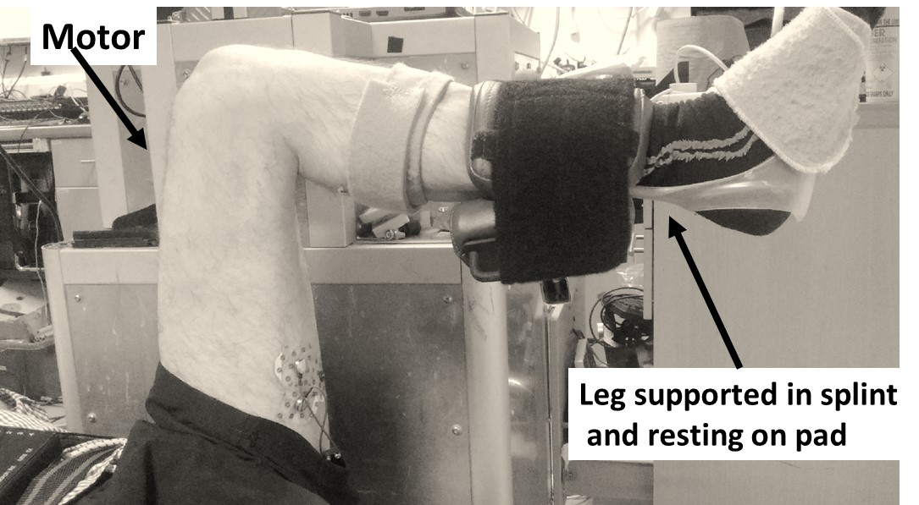
What will happen if we choose to take part?
Phase 1
If you do phase 1 of this study we will start by stretching your legs, like your physios or doctors usually do. Then you will lay on your back on a special bed with your leg in a machine, like in the picture.

We will put Small sticky pads that on the front and back of your leg so we can see what your muscles are doing. The machine will do slow and fast stretches, with your leg in two different positions. This should not hurt you but if it does we will stop the stretches.
We need to see what happens with no tape, with tape on the front of your leg and with tape on the back of your leg (we may not do it in this order). So we will have to do the leg movements a few times.
We will give you a rest between each test and the whole thing should take about an hour. Don’t worry we will take all the pads and tape off before you leave.

Phase 2
If you do phase 2 of this study we will stretch your legs, like your physios or doctors usually do and then put some things on your leg to look at how you move and we will draw on your leg with a special pencil. We will also put a piece of material to cover the part of your leg the tape will be put on, so that the person doing the activities with you will not know if you are wearing tape.
Together we will do a set of 5 activities that will take about 10 minutes each time We need to see what happens with no tape (twice), and with tape on the back of your leg (we may not do it in this order). So we will have to do the 5 activities a few times.
We will give you a rest between each set and the whole thing should take about an hour.

The activities in each set are:
1) With you lying on your tummy we will use a gadget to do small taps on the back of your leg. This tells us how tight your muscle is. We will do 3 taps as part of each set.
We will show you the gadget on your hand before we put it by your leg, to show it will not hurt.

2) Then, still lying on your tummy, but with your feet hanging off the end of the bed, we will do the next activity. With your test leg, we will bend your knee (you don’t have to do anything), we will count backwards from three and let your leg drop down to the bed. The things on your leg will tell us
how quickly the leg drops. We will do 3 drops in a row.
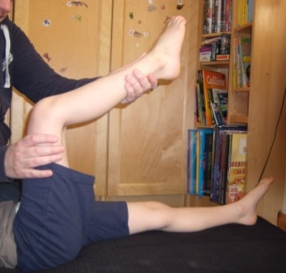
3) For the next activity you have to roll over on to your back. We will stretch your leg like the picture at the side shows and like the physio probably does with you. We then go back to this start position and do this 3 times.

4) With as much help as you need, you will move from the bed to a chair. We will time how quickly you can stand up from sitting 5 times in a row. You can use your arms or any walking aids if they help, and we will get you to do it the same way each time.

5) The last activity of the set will be you walking 5 meters, twice. This will be filmed on a camera. We will time how long it takes you to walk each 5 meters. You can use any walking aids that you usually use.

When we have finished doing all the sets, we will take off all the bandages, tape, gadgets and things, we will then get you and your parent/carer to do a short questionnaire about the activities and the study.

Things to remember on the day?
You will need to wear shorts, so please bring them with you. You should have any medication or do any activity as you would normally do. But, if your parents/carers think you are not well, you should not come to the study on the day.

Are there any side effects and benefits of taking part?
The activities we get you to do may make you tired or a little bit sore, this should not be more than when you have had physiotherapy. If it doesn’t go away, make sure you tell your parents or carers, they will let Samantha or one of the others know.
This study will not help you at the moment, but we want to do the study to help physios and doctors understand if taping helps.

What if something goes wrong?
If there is anything you are worried about you can tell Samantha, anyone else on the team or your parents/carers. There is nothing in the study that should hurt or harm you, but if it does please let us know so we can tell you and your parents/carer what to do.

Will anyone know it is me in the study?
When we write down information about you, we give you a number and we use that on everything, we do not tell anyone your name or anything like that, we also won't show anyone your video, only those of us you meet will see this. Of course, you can tell family and friends about it if you want.

What will happen to the information we get for the study?
When all of that is finished for all the people in the study any personal information we have about you will be destroyed. Then we will send your family a newsletter (if you want one) saying if the tape changed anything in the children that we saw. We will also tell physiotherapists and doctors about the results in a special newspaper/journal or by doing a teaching session for them.

Who do I Contact for further information:
Samantha Payne (research physiotherapist) or Prof Jon Marsden (research lead) on phone number: 01752 587590

Thank you for reading this and thinking about if you want to do the study.
Samantha Payne, Samantha.payne@postgrad.plymouth.ac.uk

