To be read and discussed with children aged 11-17 years

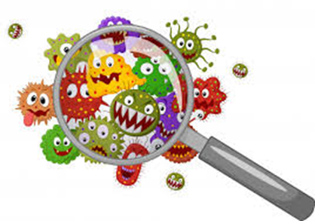
We would like to invite you and your family to take part in a research study called FAMILY MICRO. Before you decide, it is important to understand what the study is about and what will happen to you if you take part. Please read this leaflet carefully and ask us about anything that you do not understand.

What is this study for?
We want to examine the bacteria in the nose and mouth of you and your family to better understand why you may get respiratory infections during the winter. We will examine how bacteria are shared between you and your family members over time. This information could help us to learn more about how healthy people get respiratory infections and use this information to prevent and treat respiratory infections in children and adults in the future.

Why have I been chosen to take part?
You are in a family of four members and you are all generally well.

What will happen if I take part?
We will give you and your family sample pots and ask you to spit in your pot. Then to place a strip of paper in your nose for 2 minutes and swab your hands for less than a minute. This will be every 2 weeks for 6 months.
We will ask you and your parent or the person who looks after you to answer questions and keep a diary of what life is like for you. If you have been unwell or had any treatment, we will also ask your doctors to let us know. We will keep this information to help us learn more.

What happens to what the researchers find out?
Any information about you will not have your name in it. All samples will be labelled only with your study number. Your name will be stored separately and safely and only the research team will know. We will send a weblink after the end of the study to tell you what we have found.

Do I have to take part?
No. You do not have to take part if you do not want to. You can withdraw from the study at any time and without giving a reason by sending an email to 2volresearch@lstmed.ac.uk . The research may not help you, but we hope the information learned from the study will help us to understand more how healthy people are protected from respiratory infections to help us to prevent happening in the future.

Happy to take part?
If you have any questions you can contact us at any time
Research team: ****, EMAIL: ****, PHONE: ****
LSTM will use your name, NHS number and contact details to contact you about the research study, and make sure that relevant information about the study is recorded for your care, and to oversee the quality of the study. Individuals from LSTM and regulatory organisations may look at your medical and research records to check the accuracy of the research study. The only people in LSTM who will have access to information that identifies you will be people who need to contact you regarding your participation in the research or audit the data collection process. The people who analyse the information will not be able to identify you and will not be able to find out your name, NHS number or contact details.

