

**Incentives for alternatives to the CAr in Northstowe (ICAN-Northstowe) study protocol**

**V2.0 02 March 2020**

**Introduction**

This is the protocol for the feasibility study of financial incentives to promote alternatives to the car in Northstowe. The study is run by the MRC Epidemiology Unit, University of Cambridge, funded by and conducted under the auspices of the National Institute for Health Research School for Public Health Research (SPHR). The study is sponsored by the MRC Epidemiology Unit, University of Cambridge.

The purpose of the study is to assess the feasibility of a randomised controlled trial of a package of financial incentives to promote alternatives to the car implemented by policy makers, in a new housing development designed to be conducive to walking and cycling.

The project team comprises:

|  |  |
| --- | --- |
| **Principal Investigator:** | **Dr Jenna Panter** — Senior Research Associate, Population Health Interventions programme, MRC Epidemiology Unit, University of Cambridge |
| **Co-investigators:** | **Dr Jean Adams** — Senior University Lecturer, Population Health Interventions programme, MRC Epidemiology Unit, University of Cambridge  **Dr Louise Foley** — Senior Research Associate, Global Diet and Activity Research Group and Population Health Interventions programme, MRC Epidemiology Unit, University of Cambridge |
|  | **Prof Steve Cummins** — Professor of Population Health, London School of Hygiene and Tropical Medicine |
|  |  |
| **Research team:** | **Dr Kate Ellis** –Research Associate, Population Health Interventions programme, MRC Epidemiology Unit, University of Cambridge  **Dr Emma Lawlor –** Research Associate, Population Health Interventions programme, MRC Epidemiology Unit, University of Cambridge |
| **Study Co-ordination:** | **Dr Colin Farr** –Research Assistant, MRC Epidemiology Unit, University of Cambridge |
|  |  |

The short title Incentives for alternatives to the CAr in Northstowe (ICAN-Northstowe) will be used on all participant-facing study materials such as recruitment posters, questionnaires and consent forms. The long title *‘Feasibility of a randomised controlled trial of financial incentives to promote alternatives to the car in a new housing development’* more precisely reflects the primary underlying scientific aim of the study and will be used to refer to the study in the academic, public health and public policy environments.

**Scientific background**

Physical activity is important for the prevention of coronary heart disease, diabetes and other physical and mental health conditions, and the promotion and maintenance of active lifestyles is now a prominent goal of UK health policy.1 While interventions targeted at individuals can be effective in promoting physical activity in some circumstances, their use has not been associated with a discernible increase in population activity levels. Research has therefore increasingly focused on the influence of the wider social and physical environments.2 A substantial body of cross-sectional observational research suggests that certain features of these environments — such as social support, land use mix, the proximity of amenities and the directness and connectivity of routes for walking and cycling — are fairly consistently associated with overall physical activity or with specific types of activity such as walking.3 Embedding healthy principles in town and city planning is endorsed in WHO recommendations.4 However, the processes of creating healthy urban environments are less well understood and determining how characteristics of urban environments interact within the entire community system to affect health is unknown.

National Institute for Clinical Excellence (NICE) public health guidance has identified a number of promising environmental approaches to promoting physical activity and made specific recommendations relating to the planning of new developments, but has also drawn attention to some major limitations of the existing evidence base.2 In their recommendations for research, alongside public transport provision and ticketing, and reducing car ownership, NICE recommended further research on the integration between behavioural and environmental interventions. Behavioural interventions implemented without a supportive physical environment may not be enough to change behaviours and the same is true in the context of environmental interventions, they might be more effective with the addition of behavioural interventions.

**Rationale and justification for feasibility study of financial incentives**

Continuing pressure on housing stock means that new residential developments are required in many areas of the country, not just the South or South East,5 and local authorities charged with public health responsibilities require more evidence to support health-enhancing planning policy and practice. The case of the new town of Cambourne (near Cambridge) has also highlighted the importance of the social, as well as the physical environment of new residential developments, with concerns regarding the psychological well-being of some new residents who lack social support in their new surroundings. Both the mental and physical health of residents in these new developments is therefore key.

The Healthy New Town (HNT) programme was funded by the English NHS for three years from April 2016 to March 2019.6 HNTs involve 10 major housing and mixed use developments across England that aim to improve population health and reduce inequalities. Healthy design principles are applied covering movement and transport, green and social infrastructure, the local economy, food choices and place making. Three HNT programme priorities are:

* planning and designing a healthy built environment;
* creating innovative models of healthcare; and
* encouraging strong and connected communities.

The programme brings together partners in local government, planning and urban design, housebuilding, local communities and healthcare.

As part of the Healthy New Towns remit, many local authorities are spending money on promoting walking and cycling. Individually delivered interventions such as the provision of information about walking and cycling, personalised travel planning, the promotion of public transport and promotion of efficient car use are often implemented.7 Changing the cost of behaviours through reducing the financial barriers to behaviour may be one way to encourage use of alternatives to the car. For walking, cycling and public transport use this has included incentives such as free bus passes, free cycle training courses or vouchers for cycling equipment or safety clothing. However, there is little evidence that these incentives have been successful in changing travel behaviour. The majority of existing studies use an uncontrolled design and none provided evidence about how these interventions work.7 The theory of these interventions and specific mechanisms also vary depending on whether incentives are for one-off behaviours or maintenance of behaviours.8 Interventions require different levels of effort (‘agency’) or initial outlay to benefit and some evidence suggests that low agency interventions may be more effective than high agency ones.9 Randomised designs should be used where practicable, but are rarely conducted in this topic area because of the challenges involved in negotiating agreements to implement and randomise the allocation.

In the context of a physical environment that is conducive to walking, cycling and public transport use, this study provides an opportunity to explore the scientific feasibility of a package of incentives to encourage the use of alternatives to the car to affect behaviour change and the operational challenges of setting up a randomised controlled trial to study it. The current project is designed to prepare the ground for a grant application for a subsequent large-scale study by reducing the uncertainty concerning two critical aspects of study design: *the scientific value* and *operational feasibility* of running a randomised controlled trial of a package of incentives to promote alternatives to the car which will be delivered by the local authority. Therefore this research will assess a set of existing incentives that are being rolled out by policy makers and investigate their use, the mechanisms by which they might lead to behaviour change, including an investigation of any unintended consequences. It is therefore possible that one recommendation from this research might be that some incentives are not used as intended. One implication of this might be that redesign of the incentives or delivery may be required.

**The wider SPHR project**

The study is part of a wider project which explores the potential of combined behavioural and environmental approaches to promote alternatives to the car through feasibility, pilot and process evaluation studies in the North-East and the East of England. Specifically it includes (i) a study of the policy processes to implement environmental interventions in the NorthEast and the East of England (study 1), (ii) process evaluations to understand how parents, children and teachers experience environmental and financial interventions to promote alternatives to the car (study 2) and (iii) a feasibility and pilot RCT of a financial intervention to promote alternatives to the car implemented in an environment designed to be conducive to activity (study 3: *this study*).

**AIM**

The aim of the study is to answer the following research question:

1. Is a randomised controlled trial of a package of measures implemented by policy makers to incentivise the use of alternatives to the car and disincentivise car use feasible?

**Objectives**

1. To assess the operational and scientific feasibility of a package of financial (dis)incentives focussed on alternatives to car use with differing levels of agency and dose that can be randomly allocated to residents of a new town delivered by practitioners and policy makers

2. To assess the feasibility of recruiting a sample of residents of a new town into a study and estimate the response and retention rate that could be expected in future studies

3. To pilot data collection at baseline and three, six and twelve months after baseline, using individual survey data coupled with direct observations and information from providers

4. To estimate the key parameters for a full trial, including potential changes in weekly time spent using alternatives to the car

5. To describe the experiences of participants who move into new developments and the adaptations that they make to their daily routines and travel patterns and whether and how participants used the (dis)incentives

6. To quantify the feasibility of intervention to bring about change in travel behaviour, including the acceptability of (dis)incentives, considering the cost of delivery

**METHODS  
Study design**

The current study will be a 2 year mixed-methods study with longitudinal quantitative surveys and nested qualitative interviews.

**Setting**

We have identified Northstowe, a new town currently being built on a former Royal Air Force (RAF) base which will ultimately comprise 10,000 homes and contain some social or affordable housing. Northstowe is located 8 miles from Cambridge surrounded by farmland and neighbouring villages. It is close to existing public transport links: the Cambridgeshire Guided Busway provides access to Cambridge North station in 8 minutes and the city Centre in 25 minutes and the town’s design code is supportive of pedestrians and cyclists.10 The intention is for the development to provide 10,000 homes for around 28,000 people over 3 phases. Phase 1 received planning permission in 2014 and the first homes were occupied in May 2017. In 2015, planning permission for phase 2 was granted and homes are currently being constructed. The phase 2 homes cannot be occupied until upgrades to a major local arterial road (the A14) are completed (likely in 2020). Planning permission for phase 3 is expected to be submitted by the end of 2019. At the time of writing (November 2019) there are over 600 homes constructed and around 480 of the 1500 phase 1 homes are occupied (32%). There are plans for around 480 homes to be affordable in Phase 1 (300 affordable ownership and 180 affordable rented homes). Affordable housing is housing for sale or rent for those whose needs are not met by the market (including those with rents 20% below local market value or for sale at least 20% below market value). Full definition is given in National Planning Policy Framework (Ministry of Housing, Communities and Local Government, 2019).

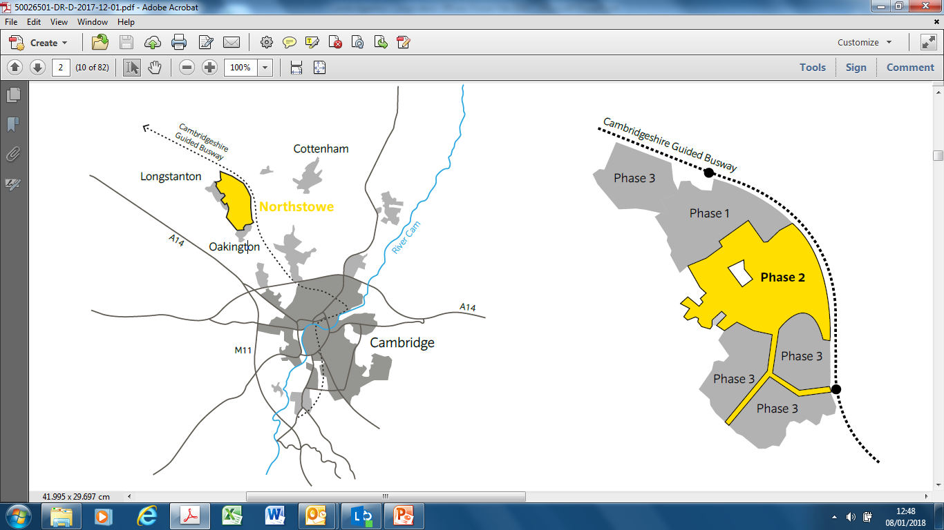



**Figure 1:** Layout of new town; inset in context of existing settlements of Oakington, Longstanton and Cambridge

**Participants**

The study is designed to assess the feasibility of a package of incentives to promote alternatives to the car which will be delivered by the local authority. To satisfy the obligations of a section 106 planning application (S/0388/12/OL), Smart Journeys are currently offering incentives to all residents of Northstowe to encourage walking, cycling and public transport use. The study population comprises all adults (aged 16 or over) from households in Northstowe. Those who are the first occupants of their home and who have not applied for or received any existing incentives will be eligible to take part in the study. Within this definition, participants are eligible for inclusion irrespective of their employment status, duration of residence or whether they have any disability that may limit their mobility.

All participants from the household are invited. If only one member of the household were to be invited we might not necessarily capture the person who requested or used the incentives. In addition, we want to maximise the number of people we can recruit, given the relatively small pool of potential participants. Alternatively, we could invite only one participant from each household to participate and ask them to complete questions about the travel made by all participants but this was deemed to be too burdensome. We will enter into a data sharing agreement with Smart Journeys and they will share information with us about those households that have not claimed any incentives, providing us with a list of eligible households. No personal information on those households will be shared by Smart Journeys.

**Recruitment**

Since the study is focussed around travel generally and only residents of Northstowe are eligible, participants will be recruited through flyers delivered directly to residents’ doors, distributed at local events, posts on the ‘Northstowe Pioneers’ (a closed group for residents with 609 members in November 2019) and ‘Northstowe Community’ (1086 members in November 2019) Facebook groups and through local forums. The same text will be used on the flyer and the Facebook posts. We will also attend Travel Plan Steering group Meetings (held every 6 months, next one April 2020) and Community Forum events (also held quarterly) to inform residents about the study and to recruit potential participants.

**Incentives**

Participants will be informed that every fourth household that signs up to the study and submits/returns a completed questionnaire will receive a gift token worth £10 and can choose between a Love2Shop gift token which can be redeemed in a wide range of retail outlets or a £10 voucher to spend in the local co-op food store. At the completion of the survey participants will leave a postal address or email address for the voucher to be sent. To decide which homes receive the incentive the time and date of paper and online questionnaires will be integrated. First all completed online surveys will be ordered by completion time and date. Participants completing a paper questionnaire will include the completion date at the end of the questionnaire, which will be integrated with online questionnaires. Using the integrated list, every fourth household by order of completion will be selected to receive a token or voucher.

**Data collection**

**Online survey**

Every year, Smart Journeys are required to complete a Travel Plan monitoring report to satisfy the obligations of a section 106 planning application (S/0388/12/OL). Northstowe residents are asked to complete an annual travel survey, usually in the first week of March. Initially, we thought that the existing Travel Plan Monitoring Report and the baseline ICAN-Northstowe survey would be combined into a single survey which would be hosted on the MRC EU site. Due to differences between Smart Journeys and MRC EU requirements for online survey platforms and a low completion rate in the Smart Journeys survey, we decided that this option was not feasible.

Here we describe the survey data collection method which provides a secure way for participants to complete the survey. Study advertising materials will be posted directly through the letterboxes of eligible households. These include a flyer advertising the study and a participant information sheet. Additionally, an envelope will be attached which will contain a unique set of four usernames and passwords. This will be used by participants so they can securely access the survey link. It ensures that a maximum of 4 household members can sign up to the study and complete the survey. This will ensure that only eligible participants can complete the survey and enable us to link completed questionnaires to residential location without collecting identifiable address/postcode information online. If participants lose these usernames and passwords, they can email the study team and these can be sent out again. We will conduct basic checks on demographic data provided by each household to ensure the information is not duplicated suggesting that the same person has completed the survey several times. If we suspect the same person has completed multiple surveys, we will record only the first survey completed from that household. On clicking the link and entering a username and password, participants will first see the participant information sheet followed by consent information. Once completed, this will lead to the start of the survey.

A copy of the information sheet providing information about the project will be sent to participants with the flyer. They can keep this information sheet and will be able to email/call a landline number and a member of the study team would be able to answer any queries they had, send usernames or passwords or make paper copies of the survey available. Upon entering the online survey, participants will be presented with a participant information sheet. Following this, participants are presented with a number of statements relating to consent to participate. Participants will click ‘I wish to proceed’ or ‘I do not consent’ and those who do not consent will be branched out of the survey and are unable to participate. They will be thanked for their interest in participating and time taken. A downloadable copy of the information sheet will be available to participants before survey completion. The final page of the survey will contain a ‘Submit’ button, prefaced by a statement reminding the participant that clicking the final ‘Submit’ button of the survey at the end will constitute the participant providing consent to participate, in full knowledge of the information in the participant information sheet.

The survey will be live for two weeks. Reports about survey completion will be downloaded from the survey server after one week. This information includes usernames that have entered the survey, completion date and time and whether the survey was fully or partly completed. This information will be used to issue one reminder letter after one week to households that have not completed the survey. The reminder letter will inform participants to contact the study team if they have not received the study pack so that this can be reissued. Reminders have been shown to be effective in postal surveys.11

**Measures**

At baseline participants will complete a brief online questionnaire assessing basic demographic and socioeconomic characteristics, individual travel patterns over the last week, neighbourhood perceptions and well-being. The questionnaire comprises sections adapted from validated surveys or existing surveys with minor alterations, for cultural reasons, where appropriate.

The first section will contain questions about **participants’ views on their neighbourhood**. This will be assessed by asking their perceptions of the physical conditions for walking and cycling using an adapted version of the Perceptions of the Environment in the Neighbourhood Scale (PENS) to also assess perceptions of the physical conditions for public transport use.12 This instrument is taken from the iConnect study, for which it was adapted from existing published instruments. The test-retest reliability of the individual items in the PENS scale ranged from an Intraclass correlation of 0.32 to 0.71. We will assess social cohesion and collective efficacy in the neighbourhood. The items used are taken from the Peterborough Adolescent and Young Adult Development Study.13 We will also ask the reasons for relocation which have previously been used in the RESIDE study which was set up to assess the impacts of relocating to a new development designed to be more supportive for walking and cycling.14 The items proposed specifically assess the reasons for relocation and will be used to assess any self-selection. In this case, residents might choose to move to a residential area that fits with their existing preferences for activity. In this section, we will also ask how long people have lived in the neighbourhood.

In the second section we will ask about **travel and travel options**, including the number of cars and bikes available in the household, driving licence provision and usual travel to work and all journeys made yesterday. We will also assess the costs of travel and the fuel type of cars in the household and car use habits. These are all taken from standard travel surveys (e.g. National Travel Survey).

In the third section we will ask about the **participant’s general health**, including disability, health in the last two weeks taken from WEMWBS which has shown good validity (Cronbach’s Alpha score, 0.91) and test-retest reliability (intra-class correlation, 0.83)15 and health overall used by ONS with a non-specified time period.

The fourth section asks five simple **demographic, household and socioeconomic questions** on sex, age, education, numbers of people in the household and housing tenure.

No personally identifiable information will be collected online but we will need to link participant data between surveys using the email address provided. In order for participants to receive the incentive we will ask for their name plus email address to send a link for their activated voucher as a thank you for survey completion, for them to receive the intervention incentives if assigned to those conditions and for us to use to re-contact at 3, 6 and 12 month follow-up.

**Randomisation**

Once the baseline survey has closed, the MRC Epidemiology Unit database will automatically match participants on car access and baseline travel patterns and randomly assign them individually to control or one of two intervention groups.The randomisation will occur at the household level on a 1:1:1 ratio. The study will be registered at the International Trial Registry database - ISRCTN. MRC Epidemiology Unit will send details of those participants who have been allocated to intervention, intervention plus or control arm to Cambridgeshire County Council. The interventions will be randomly delivered to study participants living in Northstowe in Spring 2020 by Smart Journeys and South Cambridgeshire District Council.

**Intervention**

|  |  |  |  |
| --- | --- | --- | --- |
|  | **Arm 1: Control** | **Arm 2: Intervention** | **Arm 3: Intervention Plus** |
| **Overall Description** | Incentives offered *but residents have to contact Travel Coordinator* | Incentives d*elivered directly to*  *to participants* | Incentives of *greater size*  *delivered directly to*  *participants* |
| **Components**  £50 Decathlon voucher | 1 offered per household | 1 sent directly to household | 2 sent directly to household |
| £50 Decathlon voucher | 1 offered per household | 1 sent directly to household | 2 sent directly to household |
| 7 day Megarider bus tickets (Stagecoach) | 4 offered per household | 4 sent directly to household | 4 vouchers per household member sent directly to household |
| Cycle maintenance (1 per household) | 1 free bike service per household. Pay for additional parts | 1 free bike service and parts at drop in session/ household | 1 free bike service and parts at drop in session and 1 free home maintenance kit/household |
| Voucher for discount to use bicycle hire service | Pay for electric bike hire | 1 voucher for 4 free days sent directly to household | 1 voucher for 14 free days sent directly to household |
| **Intervention target** | [Standard practice] | Reduce the effort required | Reduce the effort and increase the dose |

**Table 1:** Intervention descriptions

*Those in social housing will not pay this fee and at present the fee isn’t being charged, but this is likely to come into force in Jan 2020.

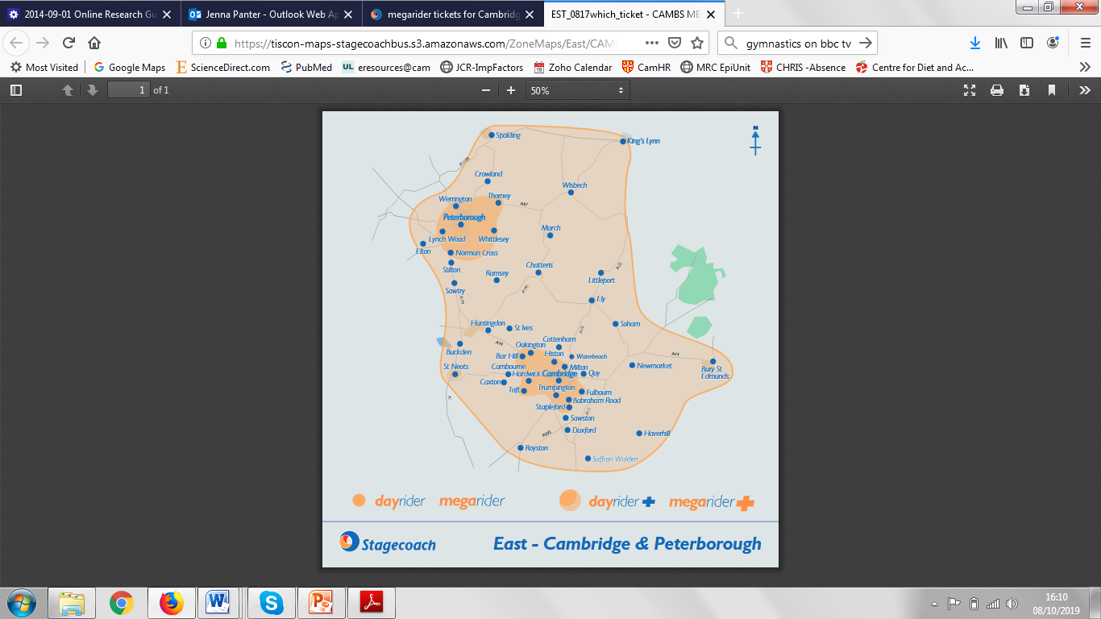

*Control (Current standard practice)* At present all residents who are the first occupants of new homes in Northstowe are eligible to take up travel incentives. These are funded from the developer contribution for sustainable transport (through a section 106 legal agreement) and the local authority. The package of incentives currently provided by the local authority include a £50 decathlon voucher, a voucher for one month’s travel on Stagecoach bus services and cycle training courses. Participants are notified of the incentives through the Welcome Pack issued to residents. These packs are usually distributed directly to the household within 3 weeks of residents moving in. Households are eligible for one of each of the incentives and can claim at any time after moving in, but can only claim each incentive once. Participants contact the travel coordinator to claim their vouchers.16

**Figure 2:** Map showing areas where the bus tickets can be used

The bus vouchers comprise of 4 Megarider plus tickets that are valid for 7 days. These can be used across the whole of the Cambridgeshire network (see Figure 2). For the decathlon voucher, this is a £50 voucher that can be used for any purchases made in Decathlon stores. According to Decathlon, these vouchers have been used for the purchase of sports clothing/equipment and cycle equipment.

The Dr Bike service, provided through Outspoken! Cycles is organised quarterly, usually on a Sunday. This service will continue in 2020 and is currently promoted through Facebook groups, the Travel Steering group and general advertising. Residents pre-book their preferred time slot with the Travel Plan Co-ordinator and can take one bike per household to the session and can attend sessions at each quarter. The sessions take place on the Green in Northstowe for five hours between 1pm-6pm. Dr Bike involves experienced mechanics who check bike wheels, brakes, gears and tyre pressures, lights, racks, pedals and saddles. In January and April 2019, 26 households used the Dr Bike service. Dr Bike sessions are offer free bike services to the residents as the funding is covered by Smart Journeys but residents have to pay for additional parts on the day.

An electric bike hire scheme will be available for all residents from March 2020 and residents pay to use the bikes. For the bike hire scheme, there will be a hub of 10 electric bikes provided by Cambridge Electric Transport available for residents to hire at a subsidised rate from March 2020. The hub will be located at the Longstanton Park and Ride (maximum 1km away). The bike hire will be bookable through an app by the time of the study. A second hub of 10 electric bikes located on the Greenway beside the Pathfinder Primary School has been granted a licence and preparations are in place for it to start running and it is hoped to be in place by the time the study starts.

Intervention & Intervention Plus:

For the participants allocated to the intervention or intervention plus arms, one Decathlon voucher will be sent directly to the household in arm 2 and two vouchers will be sent directly to the household in arm 3. Stagecoach vouchers (4 x 7 days tickets) will be send directly to participants (arms 2 & 3) and the number of vouchers will be increased according to the number of people in the household (arm 3). As part of the data sharing agreement, we will pass information on the number of residents in each home so that the correct number of vouchers can be allocated. For the offer of cycle maintenance sessions, participants allocated to the intervention arm will receive a flyer describing the dates of the drop-in sessions (between May and June) and a voucher for a free bike service (including service and parts) and participants allocated to the intervention plus arm will receive a voucher for a free bike service (including service and parts) plus a free home maintenance kit. For the electric bike hire scheme, participants allocated to the intervention arm will receive a voucher for free use of the bikes on four consecutive days and participants allocated to the intervention plus group will receive a voucher for free use of the bikes on fourteen consecutive days.

**Follow-up assessment**

Participants will be re-contacted again at 3, 6 and 12 months via email or post, depending on the nature of the contact details given. Participants will access the survey using the original username and new unique password to enable us to link participant responses between each survey. We will obtain online consent from participants at each follow up survey. At each time point, we will ask participants questions about gender and age to verify that the same individuals are completing the survey and that questionnaire responses can be correctly linked. This will not perfectly identify unique individuals but given what is known about the household and population composition of Northstowe this is likely to give sufficient certainty.

**Qualitative data collection**

**Semi-structured interviews**

Using data from the online surveys we will undertake up to 24 qualitative interviews with a sample of participants to explore any problematic aspects of study implementation identified elsewhere in the feasibility and pilot studies; to explore residents’ views and expectations regarding their new residential environments and how their lifestyle and well-being changed following relocation. This will contribute to our understanding of putative outcomes, mediators and moderators to be examined in the subsequent main study and how future participant recruitment and retention can be optimised.

Specifically, participants will be invited to register their interest in taking part in a qualitative interview when completing the online survey. Participants who register their interest will be given a separate participant information sheet and additional consent will be obtained prior to participating in the interview. A purposive sample of those who express an interest will later be drawn and invited for one-to-one interviews at a convenient date. The objective will be to gradually assemble an overall interview sample to include a mixture of different age groups, people with and without access to a car, and people allocated to intervention and control conditions. We aim to recruit 6-8 per study arm (total: 18-24). Written informed consent will be obtained prior to beginning the interview and participants will be given the opportunity to be interviewed at home, their place of work or the MRC Epidemiology Unit. Each interview will last for approximately 30 minutes and will be semi−structured using a flexibly applied topic guide. We will also consider how the (dis) incentives were distributed among the members of the household, how they used the incentives and the potential for contamination between study arms, focussing on whether participants gave their vouchers to others outside their household to use. The researcher will probe if and how these incentives might have instigated any changes in travel patterns.

Each interview will be recorded using a digital voice recorder and subsequently transcribed by a third party and transcripts checked against the audio recording. Field notes will also be written by the researcher during or immediately after each interview. They will document the context in which interview data is produced, record other informal interactions and gather data on the environmental and social surroundings of participants' homes and journeys. Those who participate in qualitative interviews will be given the option of being interviewed at home, work or at the MRC Epidemiology Unit. They will also receive travel expenses if required.

**Participant observation and informal interviews**

Participant observations will be undertaken in the community at locations where participants are able to use the financial incentives, including bus stops, electric bike hubs and Dr Bike. Additional observations of residents travel will be undertaken at community locations for example shops, community centres and eateries to understand how participants travel within the town. Observations will take place on both weekdays and weekend days and at different times throughout the day to understand differences in travel across work and leisure time.

While conducting participant observations, the researcher will undertake opportunistic informal interviews with residents using the travel services. The researcher will approach residents, explain the purpose of the study and obtain verbal consent to participate in a short interview and for the researcher to write retrospective field notes about the interview. The informal interview will use a flexibly applied topic guide exploring how and why participants are using the current travel mode and their uptake of travel incentives. This will provide additional exploration of residents travel patterns as they are engaging in the target behaviours and can provide additional data on the potential mechanisms involved. The interviews will last approximately five minutes. Participants will be given an observation information sheet including a brief overview of the purpose of the observations and interviews and study contact details.

**Figure 3. Flow of participants through the study**



**Sample size**

This is a feasibility and pilot study constrained by the need to collect data within a defined period and the phased nature of the development of Northstowe over the study period. During the period available for data collection we estimate that approximately 500 homes will be occupied and make the assumption that 50% of homes have already claimed the incentives, resulting in approximately 250 eligible households. A denominator population of potential participants of this size will be sufficient for us to estimate the initial response rate (the primary outcome for this feasibility and pilot study) with a confidence interval of ~+/-5%. We aim to recruit and 132 participants to the study resulting in 44 participants in each study arm.

**Analysis**

The analyses will be mixed method with quantitative and qualitative methods informing each other.

**Quantitative data analysis**

Data about study participation will be used in the analysis for (a) estimation of recruitment rates as a proportion of all who are eligible; (b) attrition reported as the % of participants who do not provide follow up data at each time point. Descriptive statistics will be calculated from the questionnaire data from all participants at all time points to analyse (c) estimation of the proportion of those who accessed the incentives in the control arm and use the incentives across all arms using data from questionnaires and incentive providers; (d) descriptive analysis of the demographic and socioeconomic profiles of the recruited samples in each arm of the study; (e) an estimate of the standard deviations for the key outcome measures for a future study.

**Qualitative data analysis**

The semi-structured interviews, participant observations and informal interviews will be analysed to understand the acceptability and potential to affect behaviour change. All qualitative data including interview transcripts and field notes from participant observations and informal interviews will be included in the analysis. An iterative process of content analysis will then be used to code segments of qualitative data extract related segments, identify and group themes, and identify patterns and negative cases using the method of constant comparison. Higher-order themes will mostly be derived from the topic guide (see Topic Guide), whereas the lower-order themes are likely to emerge from the data elicited in the interviews. After an initial batch of interviews, an interim descriptive account based on the content analysis described above will be discussed with the research team in order to validate emerging findings and review the recruitment strategy and topic guide before continuing with further recruitment, interviews and analysis. The identification of themes and patterns will be validated by one other member of the study group reading all the transcripts to verify and, if necessary, challenge and refine the coding and analytical decisions taken. Anonymised quotes and data summaries will be shared with project partners.

**Mixed methods analysis and integration**

Figure 4 displays how the qualitative and quantitative research strands will be combined. Quantitative and qualitative data will be analysed separately and integrated following a triangulation protocol which will be developed in order to combine the data sets to provide detail across all study aims. The final matrix will be used to provide a complete picture of the study data from both quantitative and qualitative methods. The matrix will be used to highlight findings relating to the feasibility outcomes.

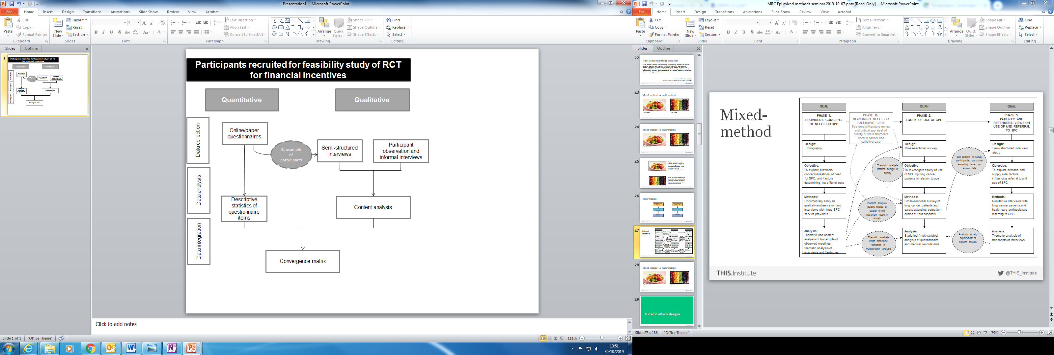

**Figure 4: Integration of survey and interview data**

**Successful study parameters**

To assess the feasibility of the study and assess the potential to progress to a fully powered trial, we will assess:

1. Recruitment, reported as a % of those interested in taking part (as identified from notes taken at recruitment events) who actually signed up to take part in the study
2. Attrition, reported as the % of participants who do not provide follow up data at each time point
3. Contamination, reported as the % of participants who access incentives outside of allocation
4. Use and uptake of incentives from surveys and data from incentive providers, reported as the average number of components used or taken up by participants in the intervention group
5. Intervention description, comparison of the final intervention to the proposed interventions in early protocols to determine the operational feasibility of delivering proposed incentives
6. Acceptability and potential to affect behaviour change, based on interviews and observations.

**Anticipated outputs**

1. A future application for substantial grant funding for a large-scale study with well-established methods for stakeholder and gatekeeper engagement, participant and control recruitment and data collection

2. Academic publications and conference presentations reporting methodological contributions regarding the scientific and operational feasibility of a randomised control trial

3. A workshop for invited participants from across the NIHR School for Public Health Research and other non-academic stakeholders to share emerging findings.

**Direct access to source data/documents**

The principal investigator (Dr Jenna Panter) and the host institution (MRC Epidemiology Unit) will permit study-related monitoring, audits, independent ethics committee review, and regulatory inspection, providing direct access to source data/documents.

**Ethics**

Ethical approval will be sought from the University of Cambridge Humanities and Social Sciences Ethics Committee prior to beginning the study.

**Data handling and record keeping**

Each participant will be assigned a unique identification number which will be used to identify their questionnaire and interview data. A master list linking each participant registration number to identifying details will be stored separately from the deidentified data. The study will be conducted in accordance with relevant current MRC Epidemiology Unit policy and standard operating procedures for data protection and security including the GDPR. In brief, there will be secure storage of both paper (locked filing cabinet) and electronic (password protected database) data, and participant contact details will be stored in a separate database on a secure private computer network. Data will not be copied, removed, or disclosed to anyone outside the collaborating investigators and approved study staff. All data shared will be covered by a relevant data sharing agreement or confidentiality agreement. All participants are entitled to request the details of any personal data relating to them. Study documents will be stored for 30 years after completion of the study and then destroyed.

**Publication and media policy**

As a condition of contract, the National Institute for Health Research requires notification of any study-related outputs (such as publications, conference presentations and press releases) at least 28 days prior to release. A separate publication and media policy will be agreed upon by the investigative team.

**Research governance**

The study is sponsored and insured by the University of Cambridge and will be managed by that institution (specifically, the MRC Epidemiology Unit, University of Cambridge) in collaboration with partners from the Smart Journeys under the terms of a formal collaboration agreement. The study will be conducted in accordance with relevant current MRC Epidemiology Unit policies and standard operating procedures including those pertaining to informed consent, indemnity, data protection and data storage.

**Indicative timetable**

Ethical approval will be sought from the University of Cambridge Humanities and Social Sciences Ethics Committee in November 2019. Data collection will begin in April 2020 and is expected to continue until June 2021.

**References**

1. Lee IM, Shiroma EJ, Lobelo F, et al. Effect of physical inactivity on major non-communicable diseases worldwide: an analysis of burden of disease and life expectancy. The Lancet 2012;380:219-29.

2. National Institute for Health and Care Excellence. Physical activity and the environment [NG90]. London, UK: National Institute for Health and Care Excellence; 2018.

3. Wendel-Vos W, Droomers M, Kremers S, Brug J, Van Lenthe F. Potential environmental determinants of physical activity in adults: a systematic review. Obesity Reviews 2007;8:425-40.

4. WHO. Global action plan on physical activity 2018–2030: more active people for a healthier world. Geneva: World Health Organization; 2018.

5. Homes England. Homes England strategic plan 2018 to 2023. London, UK: Homes England; 2018.

6. Healthy New Towns. 2018. (Accessed 5th September, 2018, at <https://www.england.nhs.uk/ourwork/innovation/healthy-new-towns>.)

7. Martin A, Suhrcke M, Ogilvie D. Financial incentives to promote active travel: an evidence review and economic framework. Am J Prev Med 2012;43:e45-e57.

8. Giles EL, Robalino S, McColl E, Sniehotta FF, Adams J. The Effectiveness of Financial Incentives for Health Behaviour Change: Systematic Review and Meta-Analysis. PLOS ONE 2014;9:e90347.

9. Adams J, Mytton O, White M, Monsivais P. Why Are Some Population Interventions for Diet and Obesity More Equitable and Effective Than Others? The Role of Individual Agency. PLOS Medicine 2016;13:e1001990.

10. Northstowe. 2018. (Accessed 6th September 2018, at <https://www.northstowe.com/>.)

11. Sahlqvist S, Song Y, Bull F, Adams E, Preston J, Ogilvie D. Effect of questionnaire length, personalisation and reminder type on response rate to a complex postal survey: randomised controlled trial. BMC Medical Research Methodology 2011;11:62.

12. Adams EJ, Goodman A, Sahlqvist S, Bull FC, Ogilvie D, iConnect c. Correlates of walking and cycling for transport and recreation: factor structure, reliability and behavioural associations of the perceptions of the environment in the neighbourhood scale (PENS). Int J Behav Nutr Phys Act 2013;10:87-.

13. Wikstrom P, Oberwittler D, Treiber K, Hardie B. Criminogenic Exposure. In: Wikstrom P, ed. Breaking Rules: The Social and Situational Dynamics of Young People's Urban Crime. Oxford: Oxford University Press; 2012:144-5.

14. Giles-Corti B, Knuiman M, Timperio A, et al. Evaluation of the implementation of a state government community design policy aimed at increasing local walking: Design issues and baseline results from RESIDE, Perth Western Australia. Preventive Medicine 2008;46:46-54.

15. Tennant R, Hiller L, Fishwick R, et al. The Warwick-Edinburgh Mental Well-being Scale (WEMWBS): development and UK validation. Health and Quality of Life Outcomes 2007;5:63.

16. Northstowe - Apply for benefits. 2018. at <https://www.northstowe.com/travel>.)

17. Farmer T, Robinson K, Elliott SJ, Eyles J. Developing and Implementing a Triangulation Protocol for Qualitative Health Research. Qualitative Health Research 2006;16:377-94.