Accuracy of a rapid intrapartum test for maternal group B streptococcal colonisation and its potential to reduce antibiotic usage in mothers with risk factors



PROTOCOL

|  |  |  |
| --- | --- | --- |
| TRIAL DETAILS AND MAIN CONTACTS | | |
| Full Title | Accuracy of a rapid intrapartum test for maternal group B streptococcal colonisation and its potential to reduce antibiotic usage in mothers with risk factors | |
| Acronym | GBS2 | |
| Sponsor | Queen Mary, University of London | |
| Sponsor representative | **Director of Research Services and Business Development**  **Queen Mary University of London** Joint Research Management Office (JRMO)  Queen Mary Innovation Centre Lower Ground Floor  5 Walden Street  London, E1 2EF | **Tel: 020 7882 7260**  Office fax: **020 7882 7276**  E-mail: sponsorsrep@bartshealth.nhs.uk |
| REC Reference | 16/WM/0036West Midlands – Edgbaston | |
| ISRTN | 7476075 | |
| Chief Investigator | Professor Khalid Khan  Women’s Health Research Unit  Blizard Institute  Barts and The London School of Medicine and Dentistry  Yvonne Carter Building  58 Turner Street  London, E1 2AB | Tel: 020 3594 2352  Email: k.s.khan@qmul.ac.uk |
| Funding | National Institute for Health Research, Health Technology Assessment Programme | Project number 13/82/04 |

|  |  |  |
| --- | --- | --- |
| TRIAL COORDINATING CENTRES | | |
| Trial Coordination Centre |  |  |
|  | Birmingham Clinical Trials Unit  University of Birmingham  Edgbaston  Birmingham B15 2TT |  |
| Trial Coordinator | Dr William McKinnon | w.mckinnon@bham.ac.uk |
|  |  | 0121 414 8335 |
|  |  | www.trials.bham.ac.uk/gbs2 |
| Microbiology Study Coordination Centre |  |  |
|  | Women’s Health Research Unit  Blizard Institute  Barts and the London School of Medicine and Dentistry  4 Newark Street  London E1 2AT |  |
| Research Assistant | Ms Maria D’Amico | mdamico@qmul.ac.uk |
|  |  | 020 7882 6695 |

|  |  |  |
| --- | --- | --- |
| TRIAL COMMITTEES  Trial Management Group | | |
| Dr Jane Daniels | Deputy Director, Birmingham Clinical Trials Unit, University of Birmingham | j.p.daniels@bham.ac.uk |
| Prof. Jonathon Deeks | Professor of Healthcare Statistics, Birmingham Clinical Trials Unit, University of Birmingham | j.j.deeks@bham.ac.uk |
| Dr Karla Hemming | Senior Statistician, Institute of Applied Health Research, University of Birmingham | k.hemming@bham.ac.uk |
| Prof Tracy Roberts | Health Economics Unit, University of Birmingham | t.e.roberts@bham.ac.uk |
| Dr Julie Dodds | Senior Research Manager, Barts and The London School of Medicine and Dentistry | j.dodds@qmul.ac.uk |
| Dr Jim Gray | Consultant Microbiologist, Birmingham Children’s Hospital | jim.gray@bch.nhs.net |
| Dr Michael Millar | Consultant Microbiologist, Pathology & Pharmacy Building, Barts Health NHS Trust | m.r.millar@qmul.ac.uk |
| Dr Mark Wilks | Vice-Chair (Microbiology) Pathology & Pharmacy Building, Barts Health NHS Trust | m.wilks@qmul.ac.uk |
| Dr Shahid Husain | Consultant Neonatologist, [Homerton University Hospital](http://www.specialistinfo.com/hosp_find.php?r=homh&param=h1&s=0&l=1) | s.m.hussain@qmul.ac.uk |
| Dr Steven Kempley | Consultant Neonatologist, [The Royal London Hospital](http://www.specialistinfo.com/hosp_find.php?r=roho&param=h3&s=0&l=1) | s.t.kempley@qmul.ac.uk |
| Prof Shakila Thangaratinam | Consultant in Obstetrics and Gynaecology, [The Royal London Hospital](http://www.specialistinfo.com/hosp_find.php?r=roho&param=h3&s=0&l=1) | s.thangaratinam@qmul.ac.uk |
| Mrs Jane Plumb | Chief Executive, Group B Strep Support, Group B Strep Support | jpulumb@gbss.org.uk |

|  |  |  |
| --- | --- | --- |
| Trial Steering Committee | | |
| Prof. Paul Heath (Chair) | Professor of Paediatric Infectious Diseases, St. George’s Hospital (London) | pheath@sgul.ac.uk |
| Prof. Kerry Hood | Director, Research Design & Conduct Service, School of Medicine, University of Cardiff | HoodK1@Cardiff.ac.uk |
| Prof Stavros Petrou | Professor of Health Economics, University of Warwick | S.Petrou@warwick.ac.uk |
| Prof Ben Stenson | Consultant Neonatologist,  Neonatal Unit, Royal Infirmary of Edinburgh | Ben.Stenson@nhslothian.scot.nhs.uk |
| Dr. Sarah McMullen | Head of Research, National Childbirth Trust (NCT) | Sarah.Mcmullen@nct.org.uk |
| Dr. Julia Sanders | Reader & Consultant Midwife, University of Cardiff | sandersj3@cardiff.ac.uk |
| Ms. Alison Stanley | PPI Representative,  Group B Strep Support | Alison.Stanley@yahoo.co.uk |

|  |  |  |
| --- | --- | --- |
| Data Monitoring Committee | | |
| Prof. Stephen Walters (Chair) | Director of Design, Trials and Statistics Section, School of Health and Related Research and NIHR Research Design Service Yorkshire and the Humber, University of Sheffield | s.j.walters@sheffield.ac.uk |
| Prof. Patrick Bossuyt | Department of Clinical Epidemiology, Biostatistics and Bioinformatics, Academic Medical Centre, Amsterdam | p.m.bossuyt@amc.uva.nl |
| Prof Ruth Gilbert | Professor of Clinical Epidemiology, UCL Institute of Child Health | r.gilbert@ucl.ac.uk |
| Dr Rhona Hughes | Consultant Obstetrician, Royal Infirmary of Edinburgh | Rhona.Hughes@nhslothian.scot.nhs.uk |

## Recruiting Sites

|  |
| --- |
| A minimum of sixteen maternity units within the NHS Trusts listed below will be selected to participate in GBS2. Selection is based on the feasibility assessment by the NHS Trust and ability to adhere to the randomised site allocation, so not all Trusts, or hospitals within a Trust, listed below will necessarily become a recruiting site.WEST AND EAST MIDLANDS |
| Royal Stoke University Hospital, University Hospitals of North Midlands NHS Trust Newcastle Road, Staffordshire, ST4 6QG |
| George Eliot Hospital NHS Trust, College Street, Nuneaton, Warwickshire, CV10 7DJ |
| Worcestershire Royal Hospital, Charles Hastings Way, Worcester, WR5 1DD |
| Sandwell and West Birmingham NHS Trust, City Hospital, Dudley Road, Winson Green, Birmingham, B18 7QH |
| University Hospitals Coventry & Warwickshire, Clifford Bridge Road, Walsgrave, Coventry, CV2 2DX |
| Nottingham University Hospitals NHS Trust, Derby Road, Nottingham, NG7 2UH |
| Heart of England NHS Foundation Trust, Bordesley Green East, Birmingham, B9 5SS |
| Burton Hospitals NHS Foundation Trust, Belvedere Road, Burton upon Trent, Staffordshire, DE13 0RB |
| Walsall Healthcare NHS Trust, Walsall Manor Hospital, Moat Road, Walsall, WS2 9PS |
| Hinchingbrooke NHS Trust, Hinchingbrooke Hospital, Peterborough PE29 6NE |
| LONDON AND SOUTHEAST |
| Barts Health NHS Trust, Newark Street, London. E1 2ES |
| Imperial College Healthcare NHS Trust, Du Cane Road, White City, London, W12 0HS |
| Frimley Health NHS Foundation Trust, Portsmouth Road, Camberley, Surrey, GU16 7UJ |
| Western Sussex Hospital NHS Foundation Trust, Spitalfield Lane, Chichester, West Sussex, PO19 6SE |
| Barking, Havering and Redbridge University Hospitals NHS Trust, Romford, Essex, RM5 0AG |
| Homerton University Hospital NHS Foundation Trust, Homerton Row, London, E9 6SR |
| Brighton and Sussex University Hospitals NHS Foundation Trust, Eastern Road, Brighton, BN2 5BE |
| Ashford and St Peter’s Hospitals NHS Foundation Trust, Guildford Road, Chertsey, Surrey. KT16 0PZ |
| Maidstone and Tunbridge Wells NHS Trust, Hermitage Lane, Maidstone, Kent, ME16 9QQ |

|  |  |
| --- | --- |
| MICROBIOLOGY SUB-STUDY LABORATORY | |
| Dr Michael Millar | Microbiology 3rd Floor [Pathology & Pharmacy Building](http://www.specialistinfo.com/hosp_find.php?r=roho&param=h8&s=0&l=1),  Barts Health NHS Trust,  80 Newark Street,  London, E1 2ES |

CONTENTS

TRIAL DETAILS AND MAIN CONTACTS 2

TRIAL COORDINATING CENTRES 3

TRIAL COMMITTEES 4

CONTENTS 8

GLOSSARY 9

Version Control 10

SIGNATURE PAGE 11

TRIAL SUMMARY 12

1. INTRODUCTION 13

2. TRIAL OBJECTIVES 21

3. STUDY DESIGN 22

4. METHODOLOGY 25

5. STUDY PROCEDURES 29

6. ANTIBIOTIC REGIMENS AND NEONATAL MANAGEMENT 33

7. STATISTICAL CONSIDERATIONS 35

8. ETHICS AND GOVERNANCE APPROVALS 40

9. DATA HANDLING AND RECORD KEEPING: 41

10. LABORATORY METHODS 42

11. TEST TECHNOLOGY 43

12. SAFETY REPORTING 43

13. MONITORING AND AUDITING 45

14. TRIAL COMMITTEES 46

15. FINANCE AND FUNDING 46

16. INDEMNITY 47

17. DISSEMINATION OF RESEARCH FINDINGS 47

18. REFERENCES 48

19. STUDY FLOWCHARTS 52

GLOSSARY

|  |  |
| --- | --- |
| BCTU | Birmingham Clinical Trials Unit at the University of Birmingham |
| CI | Chief Investigator |
| CRT | Cluster Randomised Controlled Trial |
| DMEC | Data Monitoring and Ethics Committee |
| EOGBS | Early onset Group B s*treptococcus* disease |
| GBS | Group B streptococcus |
| GCP | Good Clinical Practice |
| ICC | Intraclass Correlation Coefficient |
| IAP | Intrapartum Antibiotic Prophylaxis |
| IMP | Investigational Medicinal Product |
| ISRCTN | International Standard Randomised Controlled Trial Number |
| MREC | Multicentre Research Ethics Committee |
| NICE | National Institute for Health and Clinical Excellence |
| NICU | Neonatal Intensive Care Unit |
| NSC | National Screening Committee |
| PCR | Polymerase chain reaction |
| PI | Principal Investigator – the local lead investigator for the GBS2 Trial |
| POC | Point of care |
| PROM | Prolonged rupture of membranes |
| RCOG | Royal College of Obstetricians and Gynaecologists |
| RR | Relative Risk |
| RRR | Relative Risk Ratio |
| SAE | Serious Adverse Event |
| SAR | Serious Adverse Reaction |
| SCBU | Special Care Baby Unit |
| TMG | Trial Management Group |
| TSC | Trial Steering Committee |

Version Control

The following amendments and / or administrative changes have been made to this study since the activation of the contract with the HTA.

|  |  |  |  |  |
| --- | --- | --- | --- | --- |
| **Change Number** | **Summary of Change** | **Date** | **Implemented in Protocol Number** | **Date of REC Approval** |
| 1 | This qualitative sub-study was more clearly defined | 23/10/15 | 1.0 | 09/03/16 |
| 2 | A trial number was introduced to link the data rather than the NHS number | 07/01/16 | 1.0 | 09/03/16 |
| 3 | A four week familiarisation period was introduced for staff at sites assigned a rapid test so that and the operational procedures had become embedded in local practice and the local team had confidence to act upon the results of the rapid test | 03/03/16 | 2.0 |  |
| 4 | Clarification of the project timeline, and the approval of activity based funding from the CRN for a cluster randomised trial | 11/03/16 | 2.0 |  |
| 5 | To minimise bias and maximise delivery suite engagement the responsibility of data collection was shifted from the delivery suite staff to a dedicated, local member of the research team | 06/04/16 | 2.0 |  |
| 6 | The number of test systems available was increased from two to six. This increased the number of participating sites in each arm from eight to ten. The introduction of per patient payments to reimburse the site for the time the local midwife spends on data collection. Areas of the text edited to improve readability | 17/06/16 | 2.0 |  |
| 7 | To reflect the pending publication of the new RCOG Guidelines the eligibility criteria were expanded to include women in pre-term labour | 16/03/17 | 2.0 | 18/04/17 |
| 8 | Confirmation of the final sites participating in GBS2. Replacement of Shrewsbury and Telford Hospitals NHS Trust, with Nottingham University Hospitals NHS Trust, | 26/04/17 | 2.1 | 04/05/17 |
| 9 | Addition of Tunbridge Wells as a participating site in the protocol | 08/06/17 | 2.2 |  |

SIGNATURE PAGE

## Chief Investigator Agreement

The clinical study as detailed within this research protocol **(Version 2.0, dated 28th February 2017)**,or any subsequent amendments will be conducted in accordance with the Research Governance Framework for Health & Social Care (2005), the World Medical Association Declaration of Helsinki (1996) and the current applicable regulatory requirements and any subsequent amendments of the appropriate regulations.

**Chief Investigator Name**: *Prof. Khalid Khan*

**Chief Investigator Site:** QMUL, Blizard Institute, Barts and The London School of Medicine and Dentistry, Yvonne Carter Building, 58 Turner Street, London, E1 2AB

**Signature and Date**:

## Principal Investigator Agreement (for each site)

The clinical study as detailed within this research protocol **(Version 2.0, dated 28th February 2017)**,or any subsequent amendments will be conducted in accordance with the Research Governance Framework for Health & Social Care (2005), the World Medical Association Declaration of Helsinki (1996) and the current applicable regulatory requirements and any subsequent amendments of the appropriate regulations.

**Principal Investigator Name**:

**Principal Investigator Site:**

**Signature and Date**:



TRIAL SUMMARY

|  |  |
| --- | --- |
| Short Title | GBS2 |
| Methodology | Prospective test accuracy study embedded within a cluster randomised controlled trial (CRT), and economic evaluation |
| Research Sites | A minimum of sixteen, consultant-led NHS Hospital maternity units |
| Objectives | To establish the real time accuracy of the GeneXpert rapid test for GBS colonisation among women presenting to a labour ward with risk factors associated with GBS transmission, comparing against the reference standard of selective enrichment culture, in a prospective cohort study.  To evaluate if rapid GBS testing reduces maternal and neonatal antibiotic usage, compared with usual care where administration of Intrapartum Antibiotic Prophylaxis (IAP) is directed based on maternal risk factors alone, in a cluster randomised trial |
| Number of Participants | A minimum of 1340 women in either preterm labour, or term labour with at least one risk factor associated with GBS colonisation |
| Main Inclusion Criteria | Women with defined GBS risk factors presenting to a labour ward in either preterm labour, or term labour with at least one risk factor associated with GBS colonisation, will be eligible and included. |
| Statistical Methodology and Analysis | The accuracy of the rapid test for detection of GBS will be expressed as sensitivity, specificity, positive and negative predictive values, positive and negative likelihood ratios, and their 95% confidence intervals.  The mother’s baseline characteristics will be summarised as means and standard deviations, or medians and inter-quartile ranges, and grouped by unit allocation (risk factor based screening or rapid test screening).  Analyses of outcomes will be by intention to treat. As randomisation will be at the maternity unit level, appropriate statistical methods to account for the clustering within units will be used in the analysis |
| Award Start Date | 1st May 2016 |
| Award End Date | 31st October2018 |
| Study Duration | 30 months |

# INTRODUCTION

## Background

### Group B streptococcus

Group B *streptococcus* (GBS) is a ubiquitous bacterium and forms part of the normal bacterial flora of the gut and genital tract. In adults, GBS is an occasional cause of serious systemic infections in immunocompromised patients, but is more commonly seen as an opportunistic pathogen of the female urogenital tract. However if a neonate, whose immune system is immature, is exposed to GBS it can lead to sepsis and death. Most systemic GBS infections usually present within 24 hours of delivery as rapidly progressing septicaemia, although early onset disease is defined by NICE(1) as occurring within the first 72 hours of life. The RCOG define early onset disease as that which occurs within the first seven days of life(2). Exposure to GBS present in the gut and genital tract of the mother during birth is thought to be the most common route for early onset colonisation in the neonate.

Any infection with GBS in children between eight days and 3 months of age is deemed late-onset and is more often associated with localised infections (especially meningitis and pneumonia). Colonisation from environmental sources is thought to be the most common cause of late-onset GBS and is beyond the remit of GBS2.

### Incidence

GBS is the leading cause of serious early-onset neonatal sepsis in developed countries. The incidence of early-onset GBS sepsis in the newborn in England, Wales, and Northern Ireland has changed little between 2003 and 2010 at 0.37-0.41 per 1,000 livebirths.(3)

### Maternal GBS colonisation

The gastrointestinal tract is the natural reservoir of GBS in humans, and is the likely source of vaginal colonization. Asymptomatic colonisation of the genital and lower gastrointestinal tracts with GBS has been reported at 10-30% in pregnant women,(4) although this figure can vary with age, sexual activity, race and the method of laboratory culture used for its detection.(5) A single vaginal or rectal swab during pregnancy has been shown to have a poorer predictive value for neonatal sepsis than either multiple site swabbing or repeated culture from a single site.(6) Boyer *et al* noted that whilst 35% of their sample of pregnant women were colonised with GBS at some point in pregnancy, only 17% were persistent carriers and some lost or gained GBS strains during the pregnancy.(7) Nine UK studies of untreated women in labour have suggested rates of maternal colonisation of between 5-15% (8-10) based only on vaginal culture and 15-21% if both vaginal and rectal swabs are cultured.(11-14) The mean colonisation rate for all studies is 13.6% (95%CI: 9.6 - 18.3%).(15)

There is ample evidence to suggest that the lower gastrointestinal tract often acts as the primary site for genesis of new GBS strains. Gastrointestinal colonisation is thought to be more persistent than vaginal colonisation.(16-18) Urinary tract infections due to GBS are associated with perinatal infection and late spontaneous abortion.(19)

### Transmission

Neonates with early onset infection show initial colonisation mainly in the mucous membranes of their respiratory tract, and the major route of vertical transmission at the time of delivery is thought to be through aspiration of vaginal, rectal, and amniotic aerosols during birth. Vertical transmission *in utero* is thought to occur as a consequence of prolonged rupture of membrane and is regarded as one of the causes of stillbirth.(20) Colonisation of the mother is less predictive for late onset GBS infection, with prematurity being the major risk factor.(21)

The association between the rates of maternal colonisation, transmission, and infection has been established. Figure 1. A meta-analysis of six studies of the maternal and baby colonisation rates in an untreated general population showed a transmission rate between the colonised mother and her baby of 36.4% (95% CI 27-41%). A further analysis in the same report gave an average incidence of 3.0% (95% CI 1.6-4.7%) of babies born to colonised mothers who went on to develop early onset GBS disease.(15)

Maternal population

Maternal carriage

Transmission to baby

Early onset GBS disease

13.6%

(95%CI % 9.6 – 18.3)

36.4%

(95%CI 28.1 – 45.0)

3.0%

(95%CI 1.6 – 4.7)

Figure : Model of colonisation, transmission and early onset GBS disease

## Epidemiology of Early onset Group B s*treptococcus* disease (EOGBS)

The incidence of Early onset Group B s*treptococcus* disease (EOGBS) can be decreased if women with risk factors associated with GBS colonisation are given Intrapartum Antibiotic Prophylaxis (IAP) during labour. In countries where use of IAP is widespread, the incidence of EOGBS has decreased, but GBS remains one of the most important causes of severe early onset infection in newborn infants in most industrialised countries. In the USA, the incidence of neonatal EOGBS disease has fallen from 1.7/1000 in the early 1990s to 0.34-0.37/1000 between 2003 and 2008.(22) Likewise in Australasia the incidence fell from 1.43/1000 in 1993 to 0.25/1000 in 2001. Enhanced surveillance in the UK and Ireland between 2000 and 2001 showed an incidence of culture-proven neonatal EOGBS disease of 0.48 per 1000 live births. It is highly likely that some cases of serious neonatal sepsis caused by GBS are unrecognised because cultures of blood and CSF are negative. By taking into account superficial swab culture results from all neonates who underwent a septic screen in the first 72 hours of life, Luck *et al* concluded that the true incidence of neonatal EOGBS disease in the UK may be as high as 3.6/1000 live births, over seven times higher than previously estimated. (23)

In the 1970s, mortality rates from EOGBS as high as 50% were reported, but with advances in intrapartum and neonatal care these have fallen. In 2001 a national UK surveillance study identified 376 cases of whom 39 (10.4%) died.(24) Mortality is much higher in pre-term babies. Oddie and Embleton found that preterm infants comprised 38% of all cases and 83% of the deaths from EOGBS.(25) Information on morbidity amongst survivors is less clear, but significant long-term morbidity, including impaired psychomotor development, has been reported in up to 30% of survivors. (26)

## Risk factors

Epidemiological studies have suggested that various factors present at the time of birth are associated with the neonate having an increased risk of developing GBS disease, presenting as either an early or late onset infection. A systematic review estimated that 71% of deliveries had no recognised maternal risk factors for GBS disease.(15)

These risk factors have been suggested to include:

#### Prematurity

Colonised premature babies are at a high risk of developing early onset GBS disease as their immune system is immature and they are less likely to have received passive immunity transplacentally. The pooled incidence of early onset GBS from 5 UK studies (27-30), showed 40% were preterm deliveries; a 5.5 fold higher risk than for term births. Birth weight is highly correlated with prematurity and inversely related to developing EOGBS disease. The surveillance study by Heath *et al* indicated an incidence of 4.0 early onset cases per 1000 deliveries in babies under 1500g, compared with 0.49 per 1000 overall.(31)

#### Prelabour rupture of membranes (PROM)

Prelabour rupture of membranes (PROM) with a delay in progress to establised labour would be expected to lead to an increased likelihood of ascending infection and baby colonisation *in utero*, although there is debate as to what, if any, role the presence of GBS plays in the induction of PROM. Rupture of the membranes more than 18 hours before delivery is significantly associated with early onset GBS disease with an odds ratio 25.8 (95% CI 10.2 - 64.8) compared with non-infected infants. (25) Thus, babies born to mothers who experience preterm labour with prelabour rupture of membranes of any duration, or preterm labour if there is suspected or confirmed intrapartum rupture of membranes lasting more than 18 hours, are especially thought to be at risk of developing EOGBS. The risk for preterm labour whilst membranes are intact is comparable to other risk factors (personal communication P Brocklehurst).

#### Maternal fever

Pyrexia is a symptom of chorioamnionitis or endometritis and may be associated with a more vigerous maternal and baby colonisation.(32) Intrapartum fever is also highly associated with the development of EOGBS (odds ratio 10.0, 95% CI 2.4 - 40.8). (25)

#### Previous baby with GBS disease

Whilst suggested by some as being a significant risk factor for newborns devleoping EOGBS disease in subsequent pregnancies, given the low incidence of GBS it is difficult to reliably estimate the size, if any, of the increased risk played by the mother having given birth to a previous baby with GBS disease.

#### GBS detected in current pregnancy

Data from four studies of women with GBS bacteriuria in labour produced a pooled prevalence of maternal GBS colonisation of 78% (95% CI 63- 90%).(33-36) The association with GBS colonisation in labour given a previous positive urine or vaginal swab depends on the time interval between the two tests. Therefore the above prevalence is likely to be an over-estimate as screening for GBS was undertaken concurrently in urine and vaginal samples.

## Detection of maternal GBS colonisation

There are several methods of detecting the presence of GBS from vaginal-rectal swabs, with bacterial culture regarded as the definitive approach. Several non-culture-based diagnostic systems are available commercially for GBS screening. The optimal test would accurately detect the presence of GBS within a timeframe that allows sufficient IAP to be adminstered to women in labour colonised with GBS.

As well as being rapid and accurate, the ideal test would require minimal preparatory steps and be easily interpretable to enable routine use in a busy clinical environment. Several of the diagnostic systems and technologies e.g. loop-mediated isothermal amplification and optical immunoassay require several preparative steps before the sample can be analysed. We therefore only considered polymerase chain reaction (PCR) tests as potentially suitable for point of care testing.

### Bacteriological Culture

GBS grows on blood agar plates, forming characteristic glossy white colonies surrounded by areas of β-haemolysis after 24-48 hours. The use of a selective enrichment broth prior to plating increases the recovery of GBS from genital and anorectal samples by over 50%. (37) Lim broth, comprising of a Todd-Hewitt base with nalidixic acid and colistin to suppress gram-negative bacteria, is the most widely used enrichment media prior to plating on to chromogenic GBS agar plates, although the necessity of *selective* enrichment has been questioned.(22, 38) Obtaining swab specimens from both the vagina and rectum increases the incidence of detection of maternal GBS colonisation by 40% over swabs taken fron the vagina alone. (39, 40) A meta-analysis demonstrated a pooled sensitivity of 76% and pooled specificity of 95% for culture based tests.(41)

### PCR based tests

PCR involves the repeated logarithmic amplification of specific areas of the bacterial chromosome using an iterative process of hybridisation of replication primers, amplification from these primers of the target DNA and separation of the nascent DNA. Real-time detection of the amplified DNA is by the incorporation of a fluorescent marker which is quantitatively measured within the PCR thermocycler.

In GBS1, we found the highest levels of accuracy were obtained from combing the results from vaginal and rectal swabs, with this showing an 84% sensitivity and 87% specificity. However, this was considerably lower than the pooled estimates from a meta-analysis of all previous studies,(42) which reported a pooled sensitivity and specificity of 97% for PCR. This discrepancy may have arisen since, with more robust methodology, GBS1 avoided overestimation of accuracy associated with review bias.(43) Updating the meta-analysis to include results from GBS1 reduced the pooled estimates for PCR, with a new pooled sensitivity of 90% (95% CI 88-93%) and pooled specificity of 92% (95% CI 91-94%). The accuracy of the PCR, when considering samples from both the vagina and the rectum, compares favourably with that of screening by culture of swabs taken at 35-37 weeks gestation.

In GBS1, it was possible to train midwifery staff to undertake the complex testing required by the Cepheid IDI-GBS and SmartCycler system, but it was not feasible to establish testing on demand. As the study progressed, fewer tests were done in real-time but were processed in batches instead. This was possible as prophylaxis was not directed by the results of the rapid test. Even when processing started immediately, there were considerable difficulties in ensuring the availability of results within the timescale that would have been required clinically. These mainly related to problems in ensuring the ongoing availability of sufficient staff who were competent to undertake testing, the fact that it was impossible when undertaking tests that require significant hands-on test time for staff to begin processing another sample when one was already in progress, as well as the conflicting demands on the midwifery staff.

## Current NHS Policy and Practice

The current approach to minimise the development of EOGBS disease is that of prevention of mother to child transmission during labour by administering intrapartum antibiotic prophylaxis (IAP). In many countries around the world, culture based screening at 34-37 weeks is used to identify women in labour who are colonised with GBS and informs intrapartum antibiotic prophylaxis. The UK adopts a risk based approach.

Introducing culture based screening into the UK healthcare system has been considered alongside other testing and vaccination strategies, and was cost-effective if all women in premature labour were also provided with IAP. (44) In another analysis, extension of the current practice to offer IAP to all women in preterm labour and at high risk was the most cost-effective option.(15) The National Screening Committee reviewed the evidence for universal and risk factor based screening in 2012 and concluded there was insufficient evidence against their standardised criteria to justify a change from the current risk factor based screening approach to guide administration of IAP.

The Royal College of Obstetricians and Gynaecologists have produced two Greentop guidelines (one in 2003, the other in 2012) recommending a screening strategy based on maternal risk factors for EOGBS disease. (45, 46) A revision to these guideline has been produced, with publication anticipated mid-2017 (personal communication P Brocklehurst).

The risk factors to consider in this approach, and the management options available, in the original and 2012 revised guidance are summarised below:

* Women with a previous baby with neonatal GBS disease

2003 guidelines: offer IAP; 2012 guidelines: offer IAP

* Women with GBS bacteriuria in the current pregnancy

2003 guidelines: consider IAP; 2012 guidelines: offer IAP

* Women with an incidental finding of vaginal GBS colonisation in the current pregnancy

2003 guidelines: consider IAP; 2012 guidelines: offer IAP

* Prematurity < 37 weeks

2003 guidelines: discuss IAP; 2012 guidelines: do not offer IAP in women presenting in established preterm labour with intact membranes with no other risk factors for GBS, unless they are known to be colonised with GBS

* Prolonged rupture of membranes > 18 hours

2003 guidelines: consider IAP; 2012 guidelines: states that for women at term with prelabour rupture of membranes the evidence for IAP is unclear

* Fever in labour > 38°C

2003 guidelines: discuss IAP; 2012 guidelines: offer IAP

The pending revision will extend the risk factors to recommend IAP for all confirmed premature labours, regardless of whether the membranes have ruptured.

A further recommendation is that for women who were diagnosed as GBS carriers in a previous pregnancy, the opportunity for culture-based screening in the late third trimester should be offered in subsequent pregnancies.

NICE issued guidance in 2012 on antibiotics for the prevention and treatment of early-onset neonatal infection.(1) It recommends that IAP should be offered to women who have had:

* A previous baby with an invasive GBS infection
* GBS colonisation, bacteriuria or infection in the current pregnancy

It suggests that IAP is considered for women:

* In preterm labour if there is prelabour rupture of membranes of any duration
* In preterm labour if there is suspected or confirmed intrapartum rupture of membranes lasting more than 18 hours

For women with prelabour rupture of membranes at term, including prolonged (>24 hours) rupture, the use of prophylactic antibiotics is not recommended.(47)

### Current management protocols

Where IAP is indicated for prophylaxis against GBS transmission, the standard treatment is the intravenous administration of three grams of benzylpenicillin as soon as possible after the onset of labour, and half that dose at four hourly intervals until delivery. Should the woman be allergic to penicillin then they should be offered 900mg of Clindamycin every eight hours. If chorioamionitis is suspected then a broad spectrum antibiotic including an agent active against GBS should be used. The RCOG suggests that to optimise the efficacy of IAP, the first dose should be given at least two hours before delivery, although a minimum of four hours is considered ideal. (48) Benzylpenicillin levels in cord blood appear to exceed the minimum inhibitory concentration for GBS as early as 1 hour after maternal administration, (49) but it is not known how this relates to prevention of transmission.

### Management of neonates

Around 94% of neonates who develop EOGBS do so within 12 hours of delivery. Two thirds of these had mothers with one or more risk factors during labour, with a significant number exhibiting foetal distress and low Apgar scores at delivery.(31, 50) Where clinical signs and symptoms of sepsis are observed, the baby should be evaluated and antibiotics prescribed. Other infants without clinical signs but whose mother had risk factors should be observed closely in their first 24 hours after birth. Routine administration of antibiotics to babies deemed low risk is not recommended.

## Rationale for GBS2

### Better targeting of IAP

Existing UK guidelines (RCOG, NICE) and the National Screening Committee advocate a risk based approach to the prevention of neonatal early-onset GBS sepsis. This approach results in 20-30% of women receiving antibiotics. GBS1 showed that only two thirds of women with risk factors are colonised with GBS and compliance with national guidelines varies in practice.(51) Thus antibiotic exposure could be considerably reduced if targeted only at those women in labour who are shown to be colonised with GBS.

### The need to reduce the use of antibiotics and spread of resistance

Currently, at least 10% of all babies born in the UK are treated with intravenous antibiotics, despite the fact that the incidence of early-onset neonatal sepsis is very low at 0.48 per 1000 births.(32) As a result, tens of thousands of babies are kept in hospital at considerable cost to the NHS and receive intravenous antibiotics that may be unnecessary. As well as encouraging the emergence of an increasing number of antibiotic resistant superbugs, recent research has highlighted a number of not insignificant risks arising from exposure of the foetus and new-born infant to antibiotics. These may include a heightened risk of developing necrotising enterocolitis, (52, 53), inflammatory bowel disease,(54) fungal infection,(55) and cerebral palsy.(56)

Antibiotic resistance is regarded by many as an imminent threat to human health. The international importance of this issue is reflected by the call for action from the World Health Organisation,(53), The Centre for Disease Control in the USA,(54) and Public Health England in the UK(55).

Antibiotic (treatment) resistant bacteria have been increasingly shown to cause early and late onset neonatal sepsis(57, 58), and neonatal intensive care unit (NICU) sepsis outbreaks.(59, 60) Strategies for control have focused to antibiotic stewardship to reduce selection pressure and control the spread of the resistant strains. Carriers of antibiotic resistant microbes can be identified by screening and actions taken to prevent spread to others including the implementation of contact precautions and decontamination of the colonised individual. By contrast with methicillin-resistant *Staphylococcus aureus* (MRSA), there is currently no reliable method of decontamination of individuals colonised with antibiotic resistant *Enterobacteriaceae* including those with extended spectrum β-lactamases (ESβLs). ESβLshave recently emerged in community acquired *Escherichia coli* and *Klebsiella pneumonia*,and their identification as causal agents of infections in neonatal units and the lack of effective therapeutic options is a worrying development.

Transmission of bacteria from mothers to their infants has been well documented. Studies have predominantly focused on the causative agents of early neonatal sepsis – *Streptococcus agalactiae*, (GBS), and *E. coli*.(61, 62) Risk factors for neonatal colonisation with ESΒLs have been described but the relative contribution of perinatal vertical transmission as opposed to horizontal acquisition is uncertain.(63) The reported prevalence of *E. coli* vaginal colonization in pregnant women has been reported to range between 7% to 20%.(64, 65) One study from Argentina reported peri-anal colonization with ESβL-producing *E.coli* in 5.4% of pregnant women.(66)

As part of an Olympics surveillance project (in collaboration with Public Health England) ESβL-producing *Enterobacteriaceae* were isolated from 20% of women of child bearing age (15-45 years) in North-East London who submitted a faecal sample for laboratory examinations.(67) At the same time colonisation with ESβL-producing *Enterobacteriaceae* has been demonstrated in 7% of NICU infants of less than 31 weeks gestational age recruited into a multi-centre, double blind, placebo-controlled randomised probiotic feeding study in South-East England (K Costeloe *PIPS* study, personal correspondence). The extent to which NICU infant colonisation reflects perinatal vertical transmission is currently unclear.

Studies are required to investigate the vertical transmission of these bacteria from mother to neonate and the prevalence of resistant strains within the pregnant population.

### Choice of Screening Approaches

Development of molecular methods that allow rapid bedside detection of microorganisms offers the potential to target antibiotic use more specifically than was previously possible. GBS1 showed that implementation of complex point of care (POC) tests is technically feasible. However the practical value of any POC test depends on accurate results being reliably available within a clinically relevant timeframe. To this end, careful consideration is required of a number of factors including the expected frequency of testing, achievable result turnaround times, the amount of hands-on test time, strategies to deal with test failure, and assurance of the ongoing availability of sufficient staff able to undertake testing when required.

The majority of the commercially available test systems require multiple preparation and incubation steps comparable to the previous generation Cepheid Smart-Cycler system. In light of the limitations found with this system in GBS1, the technology that we propose to investigate is the Cepheid GeneXpert system. The GBS Xpert test for this platform allows accurate detection of GBS within 35 minutes, and can confirm the absence of GBS DNA in a sample within 55 minutes of placing an appropriate sample in the machine, with a hands-on preparation time of less than 2 minutes.

### Existing research related to Cepheid GeneXpert GBS system

The Cepheid GeneXpert GBS system has been available since 2008 and several groups have assessed its accuracy in studies, although with different swabbing strategies and reference standard comparators. A systematic search of test evaluation studies and randomised comparisons of screening strategies using the Cepheid GeneXpert GBS system has been undertaken. Searches were made of Medline, Embase, Cochrane Clinical Trial Register, Cochrane Database of Systematic Reviews and the International Clinical Trial Registry Portal (ICTRP), from 2008 to the present (the GeneXpert GBS system received a CE mark in 2009) using search terms(*group B streptococcus* or *streptococcus agalactiae*) and *(GeneXpert* or *pcr*) and (*identif$* or *screen$* or *diagnos$* or *test$*).

The search identified 15 test evaluation studies, from which data for meta-analysis could be extracted from eleven. There is one ongoing single centre study registered on ICTRP, at a UK private hospital, of which we were already aware. There were no randomised comparisons of strategies.

The majority of studies excluded pre-term and precipitate deliveries. Double or triple swabs were invariably used to minimise sampling differences and 8 took recto-vaginal swabs. From a meta-analysis of 9 studies that used an enriched culture method for the reference standard we obtained estimates for the average sensitivity of 96.4% (90.8-98.6) and specificity of 98.9% (97.5-99.5) for the GeneXpert test. Figure 2.

Overall, the quality of the studies was adequate, but the potential for bias remained, mainly from a lack of blinding, use of only vaginal swabs or an inappropriate reference standard that could underestimate colonisation rates.



Figure : Receiver-operative curve for 8 GeneXpert accuracy studies

### Economic Assessment of Screening Strategies

If a rapid point of care test improves the detection of GBS then it is likely that important cost implications will be seen for the health care sector. For example, inappropriate IAP will be avoided for many women who test negative for GBS colonisation. Furthermore, the rapid administration of appropriate antibiotic treatment for those who test positive should lead to a reduction in admissions to neonatal intensive care. The accuracy of the test must be carefully examined and established for its impact on both false positive and false negative results, and the costs and outcomes that follow decisions based on the result of the test must be evaluated. For example, if extended to the labouring population as a whole, and not limited to those women in labour with a risk factor associated with GBS colonisation, the rapid test may detect additional cases of GBS compared to standard risk factor based screening alone. This will increase the use of antibiotics prescribed in the intra-partum period, although it could ultimately reduce the incidence of EOGBS disease and so reduce costly admissions to higher cost specialist care units. Alternatively, the replacement of risk factor screening with the rapid test may lead to an increased number of false positives resulting in the administration of unnecessary IAP, or it could lead to an increased number of false negative test results and consequential increase in adverse outcomes.

# TRIAL OBJECTIVES

## Primary Objective

1. To evaluate if rapid GBS testing reduces maternal and neonatal antibiotic usage compared with usual care where intrapartum antibiotic prophylaxis is directed based on maternal risk factors alone, in a cluster randomised trial
2. To establish the real time accuracy of the Cepheid GeneXpert system rapid point of care test for GBS colonisation among women presenting to a labour ward with risk factors associated with GBS transmission. The results of the Cepheid test will be compared against the reference standard of selective enrichment culture in a prospective cohort study

## Secondary Objectives

1. To establish a standard operating procedure for use of a rapid, point-of-care test for GBS colonisation (GeneXpert) on a labour ward
2. To determine if the turnaround time (from taking the sample from the patient to obtaining a result) is compatible with the provision of a suitable duration of antibiotic administration to test positive mothers
3. To explore the impact of testing strategies on the timely administration of antibiotic prophylaxis to women with risk factors associated with GBS colonisation
4. To determine the cost and cost-effectiveness of rapid GBS testing for preventing EOGBS disease in babies born to women with risk factors associated with GBS transmission
5. To determine the GBS2 colonisation rate of neonates born to mothers who have risk factors associated with GBS colonisation, and to explore the rates of neonatal infection

## Sub-study Objectives

1. To determine the antibiotic resistance profile of any GBS isolated from the rectal vaginal swab taken from the mother around or during her time of labour, and to compare this with the antibiotic resistance profile from any GBS isolated from a faecal sample taken from the woman’s baby at six weeks of age
2. To estimate the carriage rate of three groups of antibiotic resistant bacteria of current public health concern in rectal samples from women recruited to the GBS2 study from centres in London and the South-East who are assigned a rapid test system. The groups are meticillin-resistant Staphylococcus aureus (MRSA), vancomycin-resistant enterococci (VRE), and extended-spectrum β-lactamase producing (ESβL) *Enterobacteriaceae* and other multi-resistant bacteria.
3. To confirm that there is vertical transmission of MRSA, VRE or ESβL-producing *Enterobacteriaceae* and other multi-resistant bacteria from mothers to their infants
4. To gather some information on peri-partum risk factors for transmission (mode of delivery, maternal co-morbidities, colonising species). We will explore appropriate ways to use this evidence, if deemed relevant, in the economic model.

# STUDY DESIGN

## Choice of Study Design

Given the uncertainty remaining around the accuracy of the PCR test for GBS colonisation in real-life situations, i.e. when performed by labour ward staff, and the feasibility of using the test result to direct IAP, a classical test accuracy study is required. The rapid test performed on vaginal-rectal swabs using the GeneXpert system is the index test. The results of this test will be compared against microbiological enrichment culture of duplicate swabs, which will act as the reference standard.

To compare screening strategies, a randomised comparison provides the most reliable data. We have considered and rejected individual randomisation due to the risk of contamination which we believe will come from two sources. Firstly once the GeneXpert system becomes available on a maternity unit, given its presumed high accuracy, it would be difficult not to offer this test to all women in labour. Secondly, previous experience from GBS1 suggests that not all women in labour are not approached to take part in GBS diagnostic studies, as explaining the trial and taking consent significantly delays the onset of IAP administration, a situation which is clinically unacceptable.

To reduce these factors as far as possible GBS2 will randomise at the level of the maternity unit. Each unit will be randomised to follow either a standardised risk factor based strategy (referred to as usual practice), or a strategy of administering IAP to women with risk factors associated with GBS colonisation based on the result of the rapid, point of care, PCR test.

A model based economic evaluation is required to assess the cost-effectiveness of alternative screening strategies, as it is necessary to extend the time frame of the analysis beyond the pathway of the GBS2 test accuracy study and CRT. This model based analysis should adopt the perspective of the NHS.

### No consent model

Within cluster trials, it is important that all eligible participants are identified prior to the unit being randomised. As intrapartum risk factors can only be identified at the time when the screening strategy needs to be applied we need to include all women in this group. If consent was sought there would be selection by midwife (overtly or unintentionally, due to time pressures), and as a result of women declining to provide swabs or data for research. The selection bias caused by the need to approach and individually consent participants within a cluster leads to unreliable estimates of screening effectiveness.(68) However, if the screening strategy is adopted as standard practice by the maternity unit, and anonymous routinely collected data is retrieved, consent for research is unnecessary (although clinical consent for vaginal / rectal and neonatal swabs would prevail).

The principal difference to an individually randomised trial is that individual written consent for participation in the main GBS2 cluster trial and test accuracy study will not be sought. The rationale for this is that in the maternity units allocated to risk based screening, usual practice is being followed and all women would be screened and treated in the same manner had the study not existed. In the maternity units allocated to rapid test based screening, rapid tests will be considered to be standard practice for the duration of that unit’s study participation and offered to all women identified as having risk factors for GBS colonisation, using the same criteria as for risk based screening i.e. the women attending these centres will have a second level of test. In this situation, participation in the cluster trial is not something that they can chose.

## Randomisation of maternity units

With a relatively small number of clusters, we will use a restricted method of randomisation.

The restricted randomisation method will balance allocations by three strata:

* Region (Consultant led maternity units in The Midlands, or London and the South-East)
* A measure of baseline IAP rate, grouped into above and below the median value. Information will be sought from all participating units regarding their current rate of administration of IAP for GBS transmission. This can be derived from audit, interrogation of hospital records or pharmacy prescribing databases
* The number of vaginal deliveries, or trials of labour with Caesarean section, grouped into those above and below the median

Maternity units will be randomised to follow either the usual practice of risk factor based screening or the rapid test strategy to direct the decision to offer IAP.

## Economic Evaluation

The overall approach to the economic analysis will take the form of a model based economic evaluation and will build on that used in GBS1,(44, 69) whilst maintaining all the alternative screening and treatment pathways. We will refine and develop the previous decision tree model using the data from GBS2 and from up-to-date secondary sources. The test accuracy study will provide data on sensitivity and specificity of the GeneXpert rapid test and allow the treatment pathways followed by women on the basis of the tests results to be modelled. The CRT will provide clear data on the feasibility of the woman receiving antibiotics before the baby is delivered, and provide clarity for the treatment pathways being compared in the study.

A decision based analytic model will be used to allow the extrapolation of cost and effectiveness parameters beyond the data observed in the clinical study (and to allow extrapolation to other settings, for example, an unselected population of women in labour).

A limitation in the economic model on which the GBS1 evaluation was based is that this was an accuracy only study. This meant that treatment pathways had to be modelled and could only suggest what the comparator pathway should look like on the basis of the test result. There was concern that, in reality, clinical practice was likely to be very heterogeneous compared to what our model assumed. The advantage of the GBS2 CRT is that it will provide absolute clarity on the comparators upon which the economic evaluation is based. Thus, the previous economic evaluation will be refined using GBS2 data and compared with many of the previously modeled alternatives and combinations.

## GBS2 Sub-study

A sub-study embedded in GBS2 will estimate the relatedness of certain bacterial strains of public health concern which may be colonising the mother during the birth of her baby, and in her child when it reaches six weeks of age. This sub-study will only run in participating centres in London and the South-East who are randomised to receive a rapid test system. Written consent will also be sought for the long term follow-up of the child born to study participants in these centres.

In these centres the vaginal-rectal swab will be taken from women who have risk factors associated with GBS colonisation using a triple headed swab. The first swab and second swab heads will follow the same pathway as in other centres assigned a rapid test. The third swab will be sent to the microbiology laboratory at Barts Health NHS Trust and will only be processed further if notification of written consent has been obtained from the woman is given to the sub-study trial co-ordinator who will pass this on to the Microbiology laboratory.

## Risks and Benefits

The women taking part in GBS2 in the control arm (units where usual practice is followed) will face no additional risks above that associated with standard practice. Women taking part in GBS2 in units where the rapid test is placed should quickly and confidentially know their GBS colonisation status. This has a number of potential benefits including:

* Reducing antibiotic use

By better identifying and only targeting those women colonised with GBS, Intrapartum antibiotics will only be given where they are needed

* Reducing time spent in hospital

By knowing the GBS colonisation status of the mother with considerable certainty, babies born to mothers with risk factors for, but who are not colonised with GBS can be discharged home sooner and with less medical intervention

* Reducing readmissions

Should a baby be born to a mother who has tested positive for GBS colonisation then this will aid clinical staff in judging if the mother has received sufficient Intrapartum antibiotics to prevent vertical transmission of GBS to her baby. By taking any necessary action earlier, the need to readmit at a later date will be reduced

# METHODOLOGY

## Centre eligibility

Maternity units will be eligible to participate in GBS2 if they are prepared to accept a policy of rapid test directed IAP administration as their standard practice of treating GBS colonisation for the duration of the study period. Maternity units must also be prepared to include all preterm labours as high risk, irrespective of the implementation date of the RCOG guidelines and their current local policy. The Trusts hosting the maternity units will need to have microbiology facilities which are able to perform an enriched bacteriological culture to detect GBS.

## Participant Eligibility Criteria

## Inclusion

Presence of one or more of the following risk factors will define inclusion of the mother and baby into the study:

* Previous baby with early or later onset neonatal GBS disease as reported by the mother and documented in the maternal notes
* GBS bacteriuria during current pregnancy, as documented in the maternal notes, irrelevant of whether the GBS bacteriuria was treated at the time of diagnosis with antibiotics
* GBS colonisation of the vagina and / or rectum (determined from a vaginal / rectal swab) in current pregnancy, as documented in the maternal notes
* Preterm labour (<37 weeks’ gestation), with intact membranes or rupture of membranes of any duration, whether suspected, diagnosed or established
* Maternal pyrexia (>38°C) observed at any point in labour, or clinically suspected / confirmed chorioamnionitis

Where sites have defined the risk factors slightly differently to the above definition in their local GBS screening strategy, sites will be required to adopt the above definition of risk factors for the duration of the study. Sites will be required to provide their local policies for review against the protocol criteria prior to randomisation.

The first four risk factors are apparent from the women’s history and will be evident before the start of labour or at presentation at the maternity unit, enabling women to be immediately approached for a vaginal and rectal swab if delivering in a rapid test strategy hospital.

Pyrexia and chorioamnionitis are emerging risk factors associated with maternal GBS colonisation and labouring women should be monitored for these signs.

### Exclusion Criteria

Women who will automatically be excluded from screening will be:

* Those under 16 years of age
* Women in labour at a gestation age of <24 weeks
* Women who, on arrival at the maternity unit, are already in second stage of labour or who are considered likely to deliver their baby imminently
* Women whose baby is known to have died in utero or who has a congenital anomaly incompatible with survival at birth
* Women having an elective Caesarean delivery

All these exclusion criteria should be apparent when the woman arrives at the maternity unit labour ward or delivery suite.

## Identification of eligible women

Women will be screened for eligibility to participate in GBS2 if they present to the labour ward in either preterm labour (suspected, diagnosed, established) regardless of rupture of membranes, or in term labour (latent or established) and are not perceived to be likely to deliver imminently, by the clinical team.

### Definitions

GBS2 will use the NICE definitions for term and preterm labour. (70, 71),

#### Preterm Labour

All women presenting with pre-term labour of any type are eligible to participate in GBS2 if they meet the entry criteria and their child is viable. It is down to the judgement of the clinical team to determine if the best care pathway is to proceed with consideration of IAP in anticipation of a preterm delivery or if instigating a rescue treatment, such as tocolysis, is more appropriate.

#### Suspected preterm labour

A woman can be considered to be in suspected preterm labour if they present with symptoms that might be indicative of preterm labour (such as abdominal pain) before 37+0weeks of pregnancy, and where a clinical assessment confirms the possibility of preterm labour but rules out established labour.

#### Diagnosed and Established preterm labour

A woman is diagnosed as being in preterm labour following a positive test, for example fetal fibronectin, which becomes established if she has progressive cervical dilatation from 4cm with regular contractions.

#### Preterm prelabour rupture of membranes (P‑PROM)

A woman is described as having P‑PROM if she has ruptured membranes before 37+0 weeks of pregnancy but is not in established labour.

#### Term Labour

Women in term labour should only be included in GBS2 if they also present with at least one risk factor associated with GBS colonisation.

Latent (first stage) labour is defined as painful contractions with some cervical changes for whom the triage team are reasonably confident that labour will be established within 48 hours.

Established labour is characterised by regular painful contractions and / or cervical dilation of ≥ 4cm.

A paper checklist will be used by delivery suite midwives to screen all women presenting to the labour ward to record the presence or absence of maternal risk factors that determine eligibility. This eligibility checklist anticipates the 2017 revision of the RCOG guidelines. The standard policy for GBS screening in most participating hospitals reflects the 2012 revision of the guidelines, so GBS2 will use slightly broader definitions of maternal risk factors than is usual practice. See Figure 3.

If the woman does have risk factors associated with GBS colonisation then the midwife will take a GBS2 Grab Bag. This is a Ziploc back which contains all the forms and consumables relevant to the site. All the items in this bag will be labelled where practicable with the same unique trial number and extra labels will be provided.

In order to ensure that the already heavy workload of labour ward staff is disrupted as little as possible we plan to minimise the data collected by the clinical midwifery staff. The delivery suite midwife will record the labouring woman’s NHS number (or use a hospital sticker) and the unique trial number (obtained from the grab bag) on the eligibility form which will then be stored securely on the labour ward. The research midwife will collate all eligibility forms and transcribe the trial number alongside a number of identifiers such as the woman’s name, NHS / Hospital number and Date of Birth on a central form held at the local site.

At intervals, the research midwife will retrieve the notes of those women presenting with risk factors during the period of the trial and transcribe clinical information and outcome dataonto either paper data collection forms or, if facilities exist, directly onto a secure web based database system. The collected data will only be identified by the unique trial number. By using this method we can ensure that no identifiable data leaves the Trust but local research staff have a method from which they can identify women to retrieve their data should any queries arise.

Should risk factors not be present when the woman first presents in labour then the woman will be monitored during her labour for any emerging risk factors.

## Consent

### Consent model for cluster trial and test accuracy study

Women delivering in the rapid test strategy units will be supplied with a REC approved information sheet informing them of why the swab is being taken and how to raise any concerns they may have, before verbal clinical assent to have a vaginal-rectal swab taken is obtained. This consent will be obtained in the same way that the woman would be asked for verbal consent for a vaginal examination or cardiotocograph, and the woman can decline.

### Consent in the Substudy

In centres in London and the South-East assigned a rapid test, following the swabs being taken, the woman will be provided with an information sheet and asked to consider participating in the sub-study.. The woman should have sufficient time to consider participation in this sub-study and, if they agree, their consent will be taken. As it may not be appropriate to seek consent during labour, consent to participate in the sub-study can be requested at any time between the woman being admitted to the labour ward and her discharge home.

The Research Assistant at Barts Health NHS Trust who is overseeing the sub-study will be informed by the local midwifery team once written consent has been obtained. The sub-study Research Assistant will simply be informed of the unique trial number associated with each participant and that they have consented for their third swab to be processed as part of the sub-study. No other information will be passed to the sub-study trial office. The date this information is received by the sub-study trial office will be noted.

## Outcome measures

### Primary outcome measure for the CRT

The primary outcome of GBS2 is the proportion of women receiving IAP for GBS prophylaxis, of all those identified with one or more risk factors for GBS transmission.

This is defined as those women receiving IAP which has been indicated as being for GBS prophylaxis (regardless of whether there is another reason for antibiotic administration) and have been prescribed either benzylpenicillin or clindamycin, as a proportion of those identified by the delivery suite midwives as having one or more risk factors for GBS transmission. In the rapid test sites, the indication that IAP has been prescribed for GBS prophylaxis will be a positive rapid test, or if the test has failed, documentation that IAP was given due to the presence of one or more risk factors. In the usual practice sites, documentation that IAP was given because of presence of one or more risk factors will be required.

### Secondary outcome measures for the CRT

1. Intrapartum maternal antibiotic use for any indication

This is defined as those women receiving any intrapartum antibiotic which has been indicated as being for GBS prophylaxis, for a maternal clinical indication such as pyrexia, on maternal request, or for any other reason, as a proportion of those identified by the delivery suite midwives as having one or more risk factors for GBS transmission.

1. Intrapartum maternal antibiotic use for any indication other than Caesarean section

This is defined as those women receiving any intrapartum antibiotic which has been indicated as being for GBS prophylaxis, for a maternal clinical indication such as pyrexia, on maternal request, or for any other reason other than for Caesarean section, as a proportion of those identified by the delivery suite midwives as having one or more risk factors for GBS transmission.

1. Neonatal antibiotic use for prophylaxis or treatment

This is defined as those babies receiving antibiotic prophylaxis due to maternal GBS status or antibiotic treatment for suspected or confirmed neonatal infection, and who have been prescribed benzylpenicillin and gentamycin, as a proportion of babies born to women identified by the delivery suite midwives as having risk factors for GBS transmission.

1. Post-partum maternal antibiotic use for any indication

This is defined as those women receiving any post-partum antibiotic which has been indicated as being a maternal clinical indication such as pyrexia, on maternal request, or for any other reason, as a proportion of those identified by the delivery suite midwives as having one or more risk factors for GBS transmission. The period in which these data will be collected is from delivery until the mother’s discharge from either her delivery hospital or from any hospital to which she was immediately transferred. We will not collect antibiotic use data following any re-admittance or prescribed by her general practitioner.

1. Time of IAP exposure

This is defined as the duration between the start time of the first dose of IAP and the delivery of the baby. Sufficient exposure will be considered as an interval of either >2 hours or >4 hours before delivery.

1. Time taken to act on rapid test results

As an exploratory assessment of the practical challenges of implementing a rapid test policy, we will also determine the duration between a positive test becoming available on the GeneXpert machine and the time the result is collected by a midwife, and the duration between that point and the start of IAP. Reasons for any variation between sites will be explored.

1. Neonatal GBS colonisation rates

This will be the rate of GBS positive enriched cultures from the neonatal ear swabs as a proportion of all neonatal ear swabs cultured.

1. Neonatal infection

Neonatal infection rates will be derived from the number of babies prescribed antibiotics for presumed neonatal infection, as a proportion of all live born babies.

1. Neonatal mortality

Mortality rates will include stillbirth rate, early neonatal death (before 7 days) rate and these combined as the perinatal mortality rate, for both confirmed early onset GBS disease and for all causes.

### Outcomes for the Test Accuracy Study

1. Measures of test accuracy

The sensitivity, specificity, positive and negative predictive values of the GeneXpert GBS rapid test, using the enriched culture as the reference standard.

1. Failure of test

The proportion of the cartridges on which the tests were not commenced within fifteen minutes of inoculation within 15 minutes, the proportion of tests initiated on the Cepheid GeneXpert machine which failed to produce a result within 55 minutes, or be flagged up as ‘failed’ by the system will indicate the utility of the test as a rapid, point of care test on a labour ward.

# STUDY PROCEDURES

The procedures followed after determination of eligibility are dictated by the allocation of the maternity unit to either the usual risk factor based strategy (usual practice), or the rapid test strategy.

## Risk based screening units (usual practice)

All women considered eligible for the study according to the presence of any risk factors for GBS transmission described should be offered IAP. See Figure 4.

If a woman is pyrexic, or suspected or confirmed to have chorioamniotis, broad spectrum antibiotics (e.g. fourth generation cephalosporins) should be given immediately. See *Antibiotics for maternal infection.*

The use of IAP will be collected from the hospital records, including information of whether IAP was declined or deemed too late given the progression of the labour, along with the date and time the IAP was initiated.

## Rapid test screening units

### Supply of trial consumables

Units randomised to receive the rapid point of care test will be supplied with a Cepheid GeneXpert GBS rapid testing system, which will be installed and commissioned by Cepheid. The GBS2 Trial Offices will supply a sufficient number of test consumables in Grab Bags to cover the number of women projected to have GBS risk factors presenting to their unit during the study period. This Grab Bag will contain a multi-headed swab, the test cassette for use in the GeneXpert system, numbered stickers, and stickers to alert the microbiology lab that the swabs are part of the GBS2 trial. In sites in the West Midlands assigned a rapid test this test kit will contain a double headed swab and REC approved information sheet. In centres in London and the South – East this test kit will contain triple headed swabs, a REC approved information sheet for both the main and sub-studies, and a sub-study consent form. All the items in each individual Grab Bag will be labelled with the same trial number (except the GeneXpert cassette) to allow linking of all the results. Unnumbered spare swabs and test cassettes will be available as spares in case of contamination or damage. Should stocks of consumables or test cartridges start to run low (to a level of around 25% of that initially supplied) then the centre should contact the GBS Trial Office in Birmingham who will arrange re-supply.

### Obtaining a vaginal-rectal swab

The use of the rapid test for screening will be restricted to women who present to the labour ward at a site assigned a rapid test system and who exhibit at least one of the risk factors associated with GBS colonisation. At all sites assigned a rapid test, a testing kit will be taken from the pre-packed Grab Bags kept on the labour ward. See Figure 5 for the pathway in The Midlands and Figure 6 for the process in centres in London and The South-East.

Depending on the stage of labour the swabs will be obtained by either the woman herself, or a suitably qualified, trained, and locally approved member of the woman’s care team. This could be on admission to the labour ward, before a vaginal examination is performed, or after a risk factor is detected - for example, maternal fever is observed.

Swabs will be taken from lower vagina first and then from rectum, using the same multi-headed swab for each orifice. Vaginal specimens for testing will be obtained by gently rotating the swabs across the mucosa of the lower vagina. Rectal swabs will be obtained by inserting the swabs through the anal sphincter and then gently rotating. After withdrawal, the shafts of the swabs will be separated carefully. Should lubrication be required to minimise participant discomfort whilst the swabs are taken we ask that the use of lubricating gels such as KY are avoided. These gels contain antimicrobial preservatives , and which some believe may also interfere with the rapid test. If lubrication is required then we ask that the swab is moistened with sterile nonbacteriostatic fluid (e.g. sterile water or saline) only.

A vaginal examination is usually undertaken to establish labour, which may require the use of a lubricant gel. Furthermore, women who are being induced may have had a pessary inserted distally to the cervix, and placement of this pessary may be assisted by the application of a lubricant gel. As we wish to establish the accuracy of the rapid test in a real clinical setting, this will include testing women who have had multiple vaginal examinations beforehand. Thus we ask that women who have experienced recent internal examinations which has required the use of lubricant gels are included in GBS2 and swabbed as described above.

Additional swabs will be available on the ward in case of inadvertent contamination.

### Delayed Labour

If more than 48 hours have elapsed since the test result has become available and the woman has still to deliver then the test result shall be regarded as invalid. In this situation the woman should be re-swabbed and the presence of GBS tested for again using both the rapid test and microbiological techniques. This pathway is shown in the flow chart in Figure 7.

### Obtaining a neonatal ear canal swab

If the mother has risk factors associated with colonisation by GBS, as soon as convenient after birth a single swab should be gently rotated in the baby’s ear canal. This swab should be put into a transport tube, labelled with a numbered sticker and sent to microbiology for culture using the hospital’s usual request system.

This neonatal ear canal swab will only be sent to microbiology to determine the presence of GBS. The swab taken from the neonate’s ear canal will not be applied to the rapid test machine.

### Starting the rapid test

After vaginal-rectal sampling one swab will be used to immediately inoculate the test cartridge. The second swab will be placed into a transport tube to avoid any risk of inadvertent contamination. See Figure 7.

The test cartridge will be applied to the Cepheid GeneXpert rapid test to determine the colonisation status of the woman and thus guide the clinician if prophylactic antibiotics should be administered. Should the inoculated cartridge not be loaded into the rapid test system and the test commenced within 15 minutes of the swab being introduced into the cartridge then the test will be deemed to have failed and the woman should be offered antibiotics. Should more than 48 hours have elapsed since the test result has become available and the woman has still to deliver then the test result shall be regarded as invalid. In this situation the woman should be re-swabbed and the presence of GBS tested for again using both the rapid test and microbiological techniques.

### Requesting enrichment culture of the reference vaginal-rectal swab

The second vaginal-rectal swab will be sent to the local microbiology department where it will be used to inoculate a selective enrichment media prior to plating to detect the presence of any GBS. This process will be the same in both regions.

Good laboratory practice demands that any swabs sent for clinical microbiology are accompanied by at least two unique identifiers to ensure that the results are recorded in the correct set of notes. Any swab not accompanied by these identifiers are simply disposed of without processing. To ensure that the GBS2 swabs are processed, all clinical microbiology requested on the mother’s vaginal / rectal swab and the neonatal ear swab will follow the established local procedure for requesting and reporting microbiological tests. The request form or bag will be flagged with a GBS2 sticker to alert the microbiology department to follow the culture protocol and reporting arrangements. Results from the microbiological cultures will be returned to the care team using the usual reporting pathways who will record these results in the patient’s notes.

Swabs designated for bacteriological culture to determine the presence of GBS will be placed in a suitable transport tube and sent to a designated microbiology lab according to local practice. See *Enrichment Culture Method*

**Additional microbiological assessment of the third vaginal-rectal swab – London/ South East sites only**

In centres in London and the South-East assigned a rapid test kit a triple headed swab will be used to perform the vaginal – rectal swab. The third swab will be sent to the main GBS2 microbiology laboratory at Barts Health NHS Trust where it will be held pending the notification of receipt of informed, written consent. See Figure 6. In order to ensure that these women are not denied the opportunity to participate in research the third swab will be held for a period of 96 hours in the Microbiology Department of Barts Health NHS Trust to allow the woman to receive an invitation to participate in research and give informed consent. Should a woman decline to provide consent, or if 96 hours have passed since the receipt of the third swab in Bart’s and the London’s Microbiology Department, then this third swab will not be processed but disposed of in a suitable manner compliant with local policies.

### Obtaining a faecal sample from the infant – London/ South sites only

This will only occur in centres in London and the South-East who have been assigned a rapid test system, and to the children born to women who have consented to be part of the sub-study. See Figure 6 and Figure 9.

Once a period of five weeks has elapsed from when the Trial Office was notified that consent had been given the sub-study Research Assistant will supply the maternity unit with a faecal sample pot labelled with a unique number. The sub-study trial co-ordinator will record the number on the pot alongside the mother’s trial number.

After checking with the Community Midwifery team that nothing untoward has happened to the child, then maternity unit staff will send out a follow-up sample collection pack. This pack will consist of a faecal sample pot accompanied by a covering letter and a suitable prepaid, addressed transport container to the woman’s home address requesting a sample of her child’s faecal material be collected from its nappy.

Should this sample of the baby’s faecal material not be forthcoming after the first request then one repeat and final request will be sent to the mother at around nine weeks after her baby is born. Should this fail to be returned by twelve weeks after notification of the receipt of consent then the sample will be marked as ‘not received’ and no further attempts to obtain a faecal sample will be made.

## GeneXpert rapid test platform

Each unit allocated to the rapid test screening policy will be required to locate the GeneXpert machine and computer centrally within the unit and have it plugged in and operational at all times. Immediately after the vaginal – rectal swab has been taken, one exposed swab head should be inserted into the GeneXpert GBS test cartridge. Should more than 15 minutes have elapsed from when the swab was inserted into the test cartridge to the test cartridge being loaded onto the machine and the analysis commenced then the test will be deemed to have failed and the woman should be administered prophylaxic antibiotics in compliance with RCOG guidelines. To commence the diagnostic test the ‘start test’ icon is selected on the computer and the NHS or hospital number entered alongside the patient’s unique trial number. This trial number will be identical on each item of study material associated with this woman and her child. Once the start button has been clicked a blinking light on the machine will indicate which bay the cartridge should be loaded into. Once the door on the bay is shut, the test starts automatically. When the test is finished, the door opens the result is displayed on the computer screen and a paper copy produced for the woman’s notes .. To comply with medical records requirements this printout will contain identifiers to ensure that the results are associated with the correct woman in labour. The delivery suite midwife should write on the printout the time the results were collected from the computer.

It takes on average 35 minutes to give a result if GBS is present, 55 minutes to confirm if no GBS present, and an error message is presented if the test has failed.

Used test cartridges and swabs should be disposed of according to local policies for clinical waste.

Periodic downloads of the data held on the computer will supply data on the start time, duration and outcome of each test performed. When made available to the trial team these data will only be associated with the participant’s unique trial number.

## After the study period

The rapid test screening units will have the GeneXpert system and any remaining test kits retrieved by the study team, and will revert to their previous clinical policy for screening for GBS. The results from the rapid test will be exported from the GeneXpert system and stripped of identifiers other than the woman’s unique trial number. These stripped data will be securely forwarded to Birmingham Clinical Trials Unit.

Before the rapid test system leaves the site the patient information recorded on the GeneXpert system will be securely deleted by a representative of the machine manufacturers.

### End of Study Definition

The main study will be deemed complete once all babies born to mothers in the study have reached six weeks of age.

The sub-study will be deemed complete when the last woman in the last maternity unit has delivered and 12 weeks have elapsed since the birth. This will ensure that sufficient time has passed for any follow-up faecal samples to be received and processed in the central microbiology laboratories at Bart’s Health NHS Trust.

# ANTIBIOTIC REGIMENS AND NEONATAL MANAGEMENT

Subsequent clinical management of mother and baby is the responsibility of the local health care team and is not directed by the GBS2 trial. This section provides advice derived from the RCOG Guidelines(45), the NICE Guidelines(47) and from expert opinion. It also details routine data to be collected for the GBS2 study.

## Intrapartum GBS Prophylaxis

### Risk based screening units (usual practice)

All women considered eligible for the study according to the risk factors for GBS transmission described should be offered IAP.

### Rapid Test Screening Sites

Units supplied with a rapid test will be asked only to offer IAP based on the results of the rapid GBS test or if the woman specifically requests them, not on the presence of maternal risk factors alone. If the rapid test is positive, the mother will be presumed to be colonised with GBS (given the anticipated high sensitivity) and offered IAP.

If the rapid test is negative, no IAP should be offered for prevention of GBS transmission, unless the women is pyrexic, suspected or confirmed to have chorioamnionitis, or directly requests antibiotic prophylaxis.

If more than 15 minutes have elapsed from when the swab was inserted into the test cartridge and the test cartridge being loaded onto the machine and analysis commenced, or the rapid test fails to deliver a result within 55 minutes of loading the sample on the machine the test will be designated as ‘failed’. As the women has risk factors associated with GBS colonisation they will be given intrapartum antibiotic prophylaxis as per the RCOG guideline. We do not anticipate that more than 10% of tests will fail to deliver a timely result.

## Maternal antibiotic regimen

### Antibiotic regimen for prevention of vertical GBS transmission

In maternity units using either risk factor or rapid test based screening, the IAP regimen will be identical. IAP should be administered as soon as possible after the decision is made and the woman has given assent. Intravenous benzylpenicillin (3 grams) should be infused and an additional 1.5 grams of intravenous penicillin given every four hours until delivery. In those women who are allergic to penicillin, 900mg of Clindamycin should be administered intravenously every eight hours, until delivery.

The use of any IAP will be collected, including information of whether IAP was declined or given the progression of the labour deemed too late to be administered. The date and time the administration of IAP was initiated will be recorded.

### Antibiotics for maternal infection

If a woman is pyretic or is suspected or confirmed to have chorioamnionitis, broad spectrum antibiotics (e.g. fourth generation cephalosporins) should be given immediately.

### Collection of maternal antibiotic data

The offer and prescription of IAP or any other antibiotics for maternal infection will be recorded in the woman’s notes, alongside details of date and time of first dose, dosage and number of subsequent doses.

## Neonatal Management

### Management of well infants at risk of early onset sepsis

Well infants born to women who had at least one risk factor for GBS transmission during labour should be monitored hourly for the first two hours after birth, then at two hourly intervals until 12 hours after birth, with assessment made of their general wellbeing, heart rate, respiratory rate and temperature. Clinical judgement should be used to determine whether the appearance of one clinical indicator of potential sepsis necessitates further investigations and administration of antibiotics.

Regardless of the status of the infant, if intravenous antibiotics were administered to the mother for confirmed or suspected invasive bacterial infection e.g. sepsis at any time during labour or in the 24 hours before or after birth, the baby should be evaluated and antibiotic treatment started immediately, before the test results are available if necessary.

### Collection of neonatal antibiotic data

The prescription of antibiotics for neonatal infection will be recorded in the woman’s notes with details of date and time of first dose, dosage and number of subsequent doses.

## Management of infants with clinical signs of EOGBS disease

Many infants with EOGBS disease will have signs at or soon after birth. Whilst initially subtle these can progress quickly.(31) Respiratory distress, seizures and signs of shock are particularly important indicators for initiation of treatment. Whether the mother received IAP or not, clinical acumen should be used to determine if investigations should be undertaken in any baby with clinical signs and symptoms of sepsis before being administered antibiotics . If investigations are undertaken then these should include a blood culture and measurement of the level of C-reactive protein. A lumbar puncture to obtain cerebrospinal fluid should be undertaken if thought safe and timely, and there is a strong clinical suspicion of infection with or without symptoms or signs of meningitis.

Clinicians should manage the situation according to the NICE Guidelines on early onset neonatal infection and their local policies, with the engagement of clinical microbiologists or infectious disease doctors with specific experience in neonatal infection.

In multiple births where one sibling has suspected or confirmed EOGBS disease, the other siblings should be considered at high risk, evaluated and treated with antibiotics.

### Collection of neonatal treatment and outcome information

Information on the immediate destination of the baby, the date of discharge, any signs and symptoms of infection, and any antibiotic used will be collected from the neonatal notes using dedicated data collection forms and transcribed to a trial specific database by the local research midwife. The unique trial number will be used to link the information from the baby with that obtained from its mother.

# STATISTICAL CONSIDERATIONS

## Sample sizes

### Test accuracy study

The sample size of the test accuracy study is dependent on the sensitivity of the rapid test. For the test to be proven useful we need to show that it will detect a higher proportion of GBS infections than other tests, but not at the cost of low specificity and/or unnecessary administration of IAP.

Results from GBS1 suggested that the most cost-effective test (if untargeted universal IAP was excluded) was antenatal culture for GBS at 35-37 weeks’ gestation. In GBS1 the sensitivity of this test was 75.8% (95% CI 47.2% to 91.5%). Thus if we could prove that the sensitivity of rapid test was higher than 90% the results of the GBS2 study would be convincing. This is a stringent test – a lower threshold might also be adequate. We will not be comparing the rapid test with antenatal GBS culture testing within the study, but comparing with this result from external literature. Thus we will be undertaking a “one sample, sample size” computation comparing against a fixed value.

We have data from a systematic review on the performance of the new GBS test. From the meta-analysis of 9 studies, the pooled accuracy of the test was estimated, giving a sensitivity of 96.4% (90.8-98.6) and specificity of 98.9% (97.5-99.5). Sample size calculations are thus based on showing a test with sensitivity of 96.4% is greater than a fixed value of 90%. With a power of 90% to demonstrate this sensitivity, 167 cases of maternal GBS colonisation are required (or 136 at 80% power).

A sample size of 676 would provide a 90% chance of us accruing enough GBS colonised women to have 90% power to show the sensitivity of the GBS test to be statistically significantly (with p<0.05) greater than 90% should the meta-analytical estimate of its performance (96.4%) be correct whilst allowing for 10% loss from failed tests, based on the GBS prevalence observed in GBS1, which was 29.8% (89/299, 95% CI: 24.6%-35.2%). Of the 606 participants with data we would expect 167 to be GBS carriers and 439 to be negative for GBS colonisation. If the prevalence of GBS colonisation is actually at the lower 95% confidence interval from GBS1, namely 24.6%, then 673 total women will give 90% chance of observing 136 cases of GBS colonisation, including 10% lost tests.

The 95% CIs we would observe on sensitivities and specificities of 85%, 90%, 95% and 98% with a sample size of 676 (606 with data) are shown in Table 1 and have adequate precision (sensitivity within 10%, specificity within 6%) for modelling.

|  |  |  |
| --- | --- | --- |
| Point estimate | CI for sensitivity (*n* = 167) | CI for specificity (*n* = 439) |
| 85 | 78.7 – 90.1 | 81.3 – 88.2 |
| 90 | 84.2 – 94.0 | 86.8 – 92.7 |
| 95 | 90.9 – 97.9 | 92.5 – 96.8 |
| 98 | 94.8 – 99.6 | 96.2 – 99.1 |

Table : Confidence Intervals for sensitivity and specificity at various point estimates

## Cluster randomised trial

The focus of this sample size calculation is on the effectiveness of the rapid GBS test within a cluster randomised trial (CRT) in which the number of clusters, in this case maternity units, is limited by the by the willingness of NHS Trusts to participate, but the number of potential participants is only limited by the duration of study period.

The CRT requires a minimum of 8 maternity units per screening strategy; however the ability to detect meaningful differences is improved with increased number of clusters and hence participants. We estimate that the sample size per cluster will be approximately 83. This equates to a total sample size of approximately 664 participants per arm from 16 clusters, which will allows sufficient numbers of women to be recruited for the test accuracy study too. We have increased the number of clusters from 16 to 20 to allow for drop-out at the level of the cluster.

As there are two arms (Standard Practice / Rapid Test), each of at least 664 participants this gives a projected sample size of 1,328 women. This has been rounded up to a target sample size of 1,340 women.

For the sub-study looking at antibiotic resistance, of the 1,340 study sample size, we estimate that around 740 will be recruited from centres in London and the South-East. Of these, 370 will be assigned to the rapid test arm. Assuming that one out of three women decline their invitation to participate in the sub study, we estimate that the total sample size will be around 260 participants.

The proportion of women receiving IAP for prevention of GBS transmission under a risk factor based strategy is expected to be in the region of 50% to 75%. In GBS1, only 47% of women with risk factors received IAP. We expect that greater understanding and implementation of the RCOG and NICE guidelines will have improved this figure in contemporary practice, but it is unlikely that there will be perfect compliance with RCOG/ NICE guidelines. We thus estimate an IAP rate of 75% to be reasonable. This primary outcome is a process outcome and so the within-cluster correlation of this outcome (the ICC) is expected to be higher than it would be for a clinical outcome. We have therefore considered the sensitivity of our calculations to a range of proportions in the risk factor-based screening strategy group and a range of ICC values which we believe to be quite conservative. All of our calculations allow for 90% power and 5% significance.

Guided by the need to have at least 676 women to fulfil the needs of the test accuracy study, and under a range of values for the risk-factor based strategy IAP rates and values of ICC, we have worked out the difference detectable and equivalent relative risk reduction (RRR), shown in Table 2.

|  |  |  |  |  |
| --- | --- | --- | --- | --- |
| IAP rate in risk-factor screening strategy | ICC=0.2 | ICC = 0.1 | ICC = 0.05 | ICC = 0.01 |
| 75 | 38% (RR = 0.51) | 48% (RR = 0.64) | 55% (RR = 0.73) | 63% (RR = 0.84) |
| 60 | 22% (RR = 0.37) | 32% (RR = 0.53) | 39% (RR = 0.65) | 47% (RR = 0.78) |

Table : Range of relative risk reductions achieved with a range of important parameters

The CRT would have around 90% power to detect a reduction in the proportion of women prescribed antibiotics from 75% to 63% (RRR of about 20%) for a low value of the ICC; to a reduction from 75% to 38% for a very conservative value of the ICC (0.2), equating to a relative risk reduction of 50%.

We have not acknowledged varying cluster sizes in our calculations, as we consider the coefficient of variation of unit delivery sizes to be small (approximately 0.21 based on annual delivery rates for 2013) and can be altered by varying the study duration at maternity units. Given our conservative assumptions, and that the impact of the rapid test on the rate of IAP provided is expected to be large, it is expected that the impact of any varying cluster sizes will be minimal.

## Analysis methods

### Test accuracy study

The accuracy of the rapid test for detection of GBS colonisation will be expressed as sensitivity, specificity, positive and negative predictive values, and positive and negative likelihood ratios, along with their associated 95% confidence intervals.

### Cluster randomised trial

The baseline characteristics, for example parity, risk factors and gestational age at onset of labour will be summarised as means and standard deviations, or medians and inter-quartile ranges, grouped by unit allocation (risk factor based screening or rapid test based screening).

Analyses of outcomes will be by intention to treat. As randomisation will be at the maternity unit level, appropriate statistical methods to account for the clustering within units will be used in the analysis.

The primary aim of the study is to evaluate whether the proportion of women prescribed IAP for prevention of GBS transmission differs between the screening strategy groups. In statistical terms the null-hypothesis, that of no difference can be tested using a mixed logistic regression model with prescription of IAP as the dependent variable, study screening strategy group as the independent variable, and maternity unit as a grouping (random effect) variable. Similar models will be fitted for secondary outcomes and appropriate link functions used for outcomes which are not binary.

Primary analysis will be unadjusted, except for factors used in the restricted randomisation method, but secondary analyses will adjust for pre-specified and clinically important baseline covariates. These will include gestational age, and presence of individual risk factors, and all variables used in the restricted randomisation method. We will allow for clustering at the maternity unit level. The primary analysis will be a complete case analysis. However, missing data will be reported and associations between outcomes explored. Depending on the nature of these associations and the extent of the missing data, sensitivity will be explored by means of multiple-imputation.

The primary outcome will be considered significant at the 5% level (and so the 95% CIs reported); whereas other secondary outcomes will be interpreted cautiously as the CRT is not necessarily powered to detect a difference in these. Reports of interim analysis will be supplied in confidence to the DMEC during the recruitment period. Final analysis will be performed once six weeks have elapsed since the birth of the last baby to a GBS2 participant.

### Relatedness sub-study

The proportions of mothers and infants carrying antibiotic resistant bacteria will be documented alongside the degree to which the strains are indistinguishable . These data will allow an estimate of the extent to which mothers and infants at around six weeks of post-natal life carry indistinguishable strains of resistant bacteria and will be used to inform the design of more detailed studies aimed at better understanding transmission pathways with the objective of defining potential interventions.

## Accrual and study initiation roll-out

We will not attempt to start the study in all sites simultaneously but instead plan on opening equal numbers of control and experimental sites in rolling waves; the first wave opening not before March 2017. Lessons learnt in the first wave will be carried forward to the management of later units.

Using information from the 2014 maternity dataset we believe that that vast majority of sites will collect data from the minimum number of women (86 per site), within a two month period. However, we are aware that a small number of sites will require a longer data collection period to meet this minimum recruitment target and we have made allowances for this.

In order that using the rapid test becomes routine, sites assigned the rapid test system will have the test for a one month ‘familiarisation’ period. During this time the staff will be asked to take vaginal -rectal swabs from the woman in labour, then use one of these swabs to inoculate the rapid test cartridge, load this onto the rapid test system and be guided by the result. During this familiarisation period the data will not be collected, and the second swab will not be passed to Microbiology. Neonatal ear canal swabs will not be requested during this familiarisation period.

Staff working at sites who are not randomised to receive a rapid test system will continue with their usual practice although the eligibility checklist will be introduced.

Following the one month familiarisation period, the data collection period will commence. This will be of a sufficient length of time for the site to accrue a minimum of 86 datasets. We believe that most sites will accrue 86 eligible women within the two month recruitment period stated but are aware that there are a small number of sites who may need longer than this to obtain this minimum number of 86 datasets. As GBS2 has been funded to reflect practice across the whole of the NHS it is important that we collect data from all types of site. Sites will continue to recruit until a minimum number of 86 datasets have been collected, unless there is evidence of a systematic failure to detect women with risk factors, and in the rapid test sites, to initiate swabbing of these women. In this case, we will either require immediate improvement or terminate the site’s participation.

## Economic analysis

Resource use data will be collected within GBS2 to estimate the costs associated with the diagnosis of women using the rapid test compared to risk factor alone based screening. The main resources to be monitored include:

* The resources required to perform the GeneXpert rapid test and act on its results
* Any resource use associated with identifying risk factors, and establishing they exist before acting on the result
* The administration of IAP and associated resource use (midwife time, monitoring patients)
* Monitoring, investigation and management of infants born to women exhibiting risk factors for GBS transmission
* Any extended stays on the post-natal ward for neonatal monitoring and any admissions to neonatal unit, special, high or intensive care

Estimates of the incidence of EOGBS disease, treatment effects of maternal antibiotics on EOGBS disease, and mortality rates will be based on secondary sources.(72)

Information on unit costs or prices will be obtained and assigned to each resource item in order that an overall cost per patient can be calculated. Cost data will be collected from two principle sources.

Firstly, the test accuracy study will provide resource use data to estimate costs incurred in administering the rapid test. Where possible cost data, such as cost of midwife time etc will be collected from routine sources, including those obtained from Curtis and Netten(73) and hospital finance departments. Many cost sources are already identified and available in recently published sources including a systematic review and the GBS1 study.(69) These cost data will be appropriately updated by revisiting the relevant sources.

The two main strategies compared in GBS2 will be:

1. screening based on the presence of risk factors, and
2. screening based on the results of the rapid test during labour. These strategies will be compared against each other and with a ‘do nothing’ strategy using many of the ‘modelled’ pathways utilized in the GBS1 study. Comparing the interventions to ‘do nothing’ will again require a calibration process, but as this is not a strategy used in clinical practice it is not included as an arm in the trial.

The data available from the GBS2 study will be patient-specific resource use and costs adjusted for clustering. Given the skewness inherent in most cost data and the concern of economic analyses with mean costs, we shall use a bootstrapping approach in order to calculate confidence intervals around the difference in mean costs.(74, 75).

Using data from GBS2 it will be possible to estimate the additional cost per case of IAP avoided. An incremental economic analysis will be conducted. The base-case analysis will be framed initially in terms of cost-consequences, reporting data in a disaggregated manner, adjusted for cluster, and report on the incremental cost, the important consequences including use of IAP, alongside data on the number of true positive cases of GBS detected, etc.

The model based analysis will consider treatment over the total disease duration for an infected infant and will include appropriate consideration of medical and/or surgical treatments provided in the longer term, depending on availability of appropriate data. Dependent on data reported in published sources, the model-based analysis will adopt either a cost-effectiveness (i.e. cost per life year gained) or a cost-utility (i.e. cost per quality-adjusted life year [QALY]) approach. In GBS1, results were presented in terms of cost per episode of EOGBS disease avoided, and EOGBS associated infant death avoided, because there were insufficient data available to estimate a QALY based on infection with GBS. If QALY data are now available the results will be presented in terms of cost per QALY.

The model based analysis will allow projection of costs and benefits beyond the endpoint of the study which will be when the infant reaches six weeks age of age, to consider a lifetime impact. Given the relatively long time horizons being considered in these analyses, many of the costs (and benefits) will be incurred (and experienced) in future years. Using discounting, adjustments will be made to reflect this differential timing. The base-case analysis will follow recommendations of NICE and discount costs and benefits at 3.5%.

The results of these economic analyses will be presented using cost-effectiveness acceptability curves to reflect sampling variation and uncertainties in the appropriate threshold cost-effectiveness value. Both simple and probabilistic sensitivity analyses will be used to explore the robustness of these results to investigate plausible variations in key assumptions and variations in the analytical methods used, and to consider the broader issue of the generalisability of the results.

# ETHICS AND GOVERNANCE APPROVALS

## Good Clinical Practice

GBS2 will be conducted according to the principles of the International Conference on Harmonisation of Technical Requirements for Registration of Pharmaceuticals for Human Use, Good Clinical Practice Guidelines and Research Governance Framework for Health & Social Care (2005.

The GBS2 Trial Office will ensure researchers not employed by an NHS organisation hold an NHS research passport that includes the maternity units in their region.

## Research Ethics Committee

The GBS2 study has a favourable ethical opinion from the West Midlands – Edgbaston Multi-centre Research Ethics Committee (MREC), Ref: 16/WM/0036 confirming that the study design respects the rights, safety and wellbeing of the participants.

## Health Research Agency

The Comprehensive Research Network and NHS Trust R&D managers will conduct governance checks and assess the facilities and resources needed to run the GBS2 study in order to grant host site permission to start collecting data. The GBS Trial Office in Birmingham is able to help the local Principal Investigator in the process of the site specific assessment by completing as much of the standard HRA approval form as possible. The local Principal Investigator will be responsible for liaison with the Trust management with respect to locality issues and obtaining the necessary signatures at their Trust.

All centres will be required to sign a Site Agreement, detailing their commitment to strategy implementation, accrual, compliance, Good Clinical Practice, confidentiality and publication. Deviations from the agreement will be monitored and the Trial Steering Committee (TSC) will decide whether any action needs to be taken, e.g. withdrawal of funding, or suspension of the centre.

Before Trust approval has been obtained, the Trial Office will arrange for the maternity unit to be randomised to either a standard risk factor, or rapid test based screening strategy and this will be conveyed to the local Principal Investigator. A start date and duration for the study period will then be agreed.

## Funding and Cost implications

The research costs of the trial are funded by a grant from the National Institute of Health Research Health Technology Assessment Programme awarded to Queen Mary College, University of London.

Following discussions with the CRN, GBS2 is eligible for activity based funding. As GBS2 is an interventional trial, this activity based funding will be available at the highest rate. Excess treatment costs associated with the rapid tests have been estimated from the quotations received from Cepheid and the ability of the Trust’s to underwrite these costs will be discussed prior to randomisation, on the understanding that there will be a 50% chance of the Trust being called upon to fund such costs.

GBS2 has adopted an offset per patient model. For convenience the contracting parties for the training in the use of the rapid test system will be the Sponsor (QMUL), and Cepheid (The Manufacturer). QMUL will request Cepheid place a machine at those sites assigned a rapid test system.

Sites will be reimbursed for each eligible, complete dataset they return to the trials office up to a maximum of 100 datasets. To reimburse the sites for staff time spent in collecting these data we will make a per patient payment of £160 for each complete dataset received from sites in the rapid test arm, and a per patient payment of £65 in sites continuing with their normal practice.

Classed as Research Costs, the Sponsors will reimburse the Sites assigned a rapid test at the rate of £15.50 for each enriched culture undertaken to detect the presence of GBS undertaken on each of the maternal vaginal / rectal swabs (known as Swab 2), and each of the neonatal ear canal swabs (known as Swab 4).

At the end of the data collection period the Sponsors will calculate the potential funds due to the each site and deduct any treatment costs from these. The Sponsors will then send the site the balance of funds due to them. These payments are in addition to activity based funding the site will accrue by participating in GBS2.

# DATA HANDLING AND RECORD KEEPING:

## Electronic data transfer and paper data collection forms

Personal identifiers will be recorded on the eligibility checklist, however these will not be made available to the central GBS2 study team. Periodically, the research midwife will transpose the information from the forms and maternity and neonatal notes onto the secure trial database, or if this is not available, dedicated data collection forms. Only the local trial number will be used to link the data together – no other patient identifiers will be entered on to the trial database. Paper copies of the data collection forms will be stored securely at the local site. If a research midwife is not available to complete data entry, then copies of the data collection sheets will be forwarded to the GBS2 study office stripped of all identifiers other than the woman’s unique trial number. See Figure 7.

In order to ensure accuracy of the data the trials team will monitor the information. Should they have a query then they will approach the local research midwife with the woman’s trial number. By checking the woman’s trial number against their local records, the research midwife will be able to retrieve the NHS number and other identifiers and check any query against the source data and, if necessary, make any changes on the main trial database. Using this method, no identifiable information will leave the local site and participant confidentiality will be ensured.

Antibiotic prescription data will be extracted from either maternal prescription charts or pharmacy records for the labour ward, which will be cross-referenced with data already collected using the unique trial number. The GBS2 Trial Office will work with local trust staff in obtaining these data. The availability of, and access to, electronic data will be negotiated with each unit’s information systems manager and agreed during the local research governance approval process.

## Confidentiality of personal data

Once transferred to the GBS2 Study Office, data will be stored in a master database and linked using the unique trial number. This system, when linked with the completed eligibility forms retained by the local site also provides an effective archive which will allow results to be traced by the participating Trust should any queries arrive, or if they are required in the future e.g. to answer the threat of any legal action.

Information on the rapid tests will be downloaded from the computer attached to the GeneXpert machine at intervals throughout the study period. This data will be stripped of any identifiers other than the woman’s unique trial number and securely transferred to the GBS2 Trials Office. Depending on the local site this transfer will either take place via a secure electronic transfer using secure socket layer (SSL) encryption technology, or placed onto a suitably encrypted and locked USB device which will be securely transported to the trials office.

Data will be entered onto a secure computer database. Where possible, paper derived records will be entered directly by the research midwife at the local site *via* the internet using secure socket layer (SSL) encryption technology. Built in access controls will ensure that local microbiology staff and research midwives will only be able to view anonymised patient information derived from their site, and will prevent disclosure of rapid test results to the person entering microbiological data on to the database.

Results derived from participants in the sub-study examining the relatedness of any bacterial transmission between the mother and her infant after its birth will be stored against their trial number on a secure, independent database system at a site separate to that where the information on the main (cluster) trial is held. Patient identifiable information will not be available to any members of the trial team.

## Data transfer quality control

A bespoke computer database will be constructed for the GBS2 trial data and will include range and logic checks to prevent erroneous data entry. Independent checking of data entry will be periodically undertaken on small sub-samples. All data merging programs and macros will be tested prior to acceptance of the system.

## Record Retention

Archiving will be undertaken by the Sponsor following submission of the end of trial report to the funding body. GBS2 is not a clinical trial of an investigational medicinal product so no minimum retention periods are specified. The trial dataset (which is anonymised) will be put into a form allowing the computer database to be legacy archived indefinitely.

Since GBS2 is sponsored by Queen Mary (University of London), the approved repository for long-term storage of local records is the Barts Trust Modern Records Centre where paper records will be kept for a minimum of twenty years.

Principal Investigators are responsible for the secure archiving of essential trial documents for their site according to the local policy.

# LABORATORY METHODS

In centres randomised to receive a rapid test system, the participating trust’s microbiology laboratory will be requested to culture the mother’s vaginal / rectal swab, and that taken from the neonate’s ear canal on a selective media, and to report on the presence or absence of GBS.

## Laboratory Procedures

### Enrichment Culture Method

Swabs sent to microbiology lab for the determination of the GBS colonisation status will be introduced into Todd Hewitt broth for overnight enrichment at 37°C. This enriched broth will be subcultured onto chromogenic GBS agar plates where it will undergo a second overnight aerobic incubation at 37°C. GBS will be identified by the presence of pink-red colonies on this chromogenic media.

Results of the microbiological culture will need to be recorded in the patients’ notes according to local practice, mindful that these results will not likely be available until after delivery of the baby. Microbiological data will need to be transferred to the trial database by either a member of the microbiology department, a local research nurse or if possible, by direct data transfer from the sites’ information management system. Where manual data entry is required, the data entry screen will not allow review of the rapid test results for that woman by those outside of the study office, thus reducing the risk of review bias. All data transfers, no matter how they are performed will use only the unique trial number as a linker. No identifiable data will be available to the trial team.

## Microbiological testing of third vaginal-rectal swab

The sub-study coordinator who receives notification that consent has been obtained will inform the microbiology laboratory, who will then test the third swab for the presence of GBS, MRSA, VRE, ESβL-producing Enterobacteriaceae and other multi-resistant bacteria by a variety of techniques (including, but not necessarily limited to; antibiotic resistance, molecular / genetic characterisation, and [matrix-assisted laser desorption ionization–time of flight mass spectrometry](http://jcm.asm.org/content/49/9/3441.short)). Any bacteria of interest will be stored for later work. No personal information will be available to either the sub-study Research Assistant or microbiology staff

Comparing the isolate types from the mothers and their infants will allow an estimate to be made of the extent of vertical transmission of antibiotic-resistant isolates between a colonised mother and her child.

## Microbiological testing of infant faecal samples

Following receipt of this faecal sample the Microbiology Laboratory at Barts Health NHS trust will inform the sub-study Research Assistant who will record this against the woman’s unique trial number. The pot will have been placed in a suitable transport container and returned to the central microbiology lab at Barts Health NHS Trust. The post room at Pathology and Pharmacy Building will sort through all deliveries and any samples labelled for the GBS2 sub study will be directed to the appropriate lab for analysis. The bacterial flora present in the gut bacteria colonising the infant’s faeces will be compared with that obtained from the vaginal – rectal swab taken from the mother in labour.

# TEST TECHNOLOGY

The trial sites allocated to the rapid test strategy will be provided with a GeneXpert™ DX System, which is classed as an in vitro diagnostic medical device (reference 301–0045, Rev. C, June 2012). The assay is called Xpert™ GBS is also classed as an in vitro diagnostic medical device. Both the system and the assay has attained the European Union CE mark, indication conformity assessment, and so GBS2 is not regulated by the Medicines and Healthcare Products Regulatory Authority.

The machines and assay cartridges will be supplied by Cepheid. A contract between Cepheid and the sponsor details the division of responsibilities for supply and installation, training, data extraction and retrieval.

# SAFETY REPORTING

## Safety Considerations

GBS2 is a study comparing two screening policies and is not a clinical trial assessing the efficacy of an investigational medicinal product. This is reflected by the degree of study specific adverse event reporting in GBS2.

## Overview of Safety Reporting Responsibilities

The CI has the overall oversight responsibility for GBS2. The CI has a duty to ensure that safety monitoring and reporting is conducted in accordance with the sponsor’s requirements.

## Direct risks of screening policies

The risk based screening approach involves the noting of historical risk factors and the monitoring of women for emerging risk factors such as chorioamnionitis. This presents no risk to the women other than a failure to identify and act upon these risk factors.

The rapid test screening requires a vaginal / rectal swab to be collected during labour, which is benign and presents no foreseeable risk of harm. As with almost any diagnostic test, there is a risk that testers may suffer an inoculation injury (most likely mucous membrane exposure) with clinical material. Every effort will be made to minimise this risk through training and provision of appropriate personal protective equipment and a safe working environment. In the event of such an incident, the local Trust policy for the management of inoculation injuries will be followed.

## Risks arising from antibiotic regimens

There may be adverse events as a result of administering antibiotics, either to the mother or baby. The most significant of these is an anaphylactic reaction which requires immediate treatment with adrenaline. Lesser degrees of hypersensitivity are common and a rash (all forms), fever or serum sickness observed in 1-10% of recipients. Depending on their underlying cause, these adverse reactions may be treated with antihistamines.

There may be significant consequences of the failure to offer IAP to a woman with GBS risk factors, or who the rapid test identifies as being colonised with GBS, in terms of the potential vertical transmission of GBS to their baby and its increased risk of developing EOGBS disease. Conversely, there is a risk of overtreatment if women without risk factors, or with a negative rapid test, have IAP administered. These instances are considered outcomes of interest within the study, and not adverse events.

Despite either screening approach, there may be babies who develop a superficial or systemic infection, including EOGBS disease. Again, these are defined as outcomes, rather than adverse events, within the study.

## Reporting adverse events of testing or antibiotic administration

The following need to be reported as adverse events:

* Inoculation injury to the clinical staff either whilst taking the swab or using the GeneXpert system
* Anaphylaxis in the mother following IAP or other antibiotic treatment

## Notification and reporting of Serious Adverse Events

Should either event occur, then local hospital and Yellow Card reports should be submitted as per trust policy, and the event should be reported to the trials office using an SAE form within 24 hours of learning of the event. The sponsor will coordinate submission of the SAE to the main REC within 15 days in line with the required timeframe.

GBS2 is not assessing the efficacy of antibiotics *per se*, so the clinical trial concept of a suspected, unexpected serious adverse reaction is not applicable here. Serious adverse intrapartum and neonatal outcomes, including but not limited to birth asphyxia, post-partum haemorrhage, neonatal consequences of prematurity and neonatal death are not considered adverse events.

## Annual Safety Reporting

The CI will send the Annual Progress Report to the main REC using the NRES template (the anniversary date is the date on the MREC “favourable opinion” letter from the MREC) and to the sponsor.

## Urgent Safety Measures

There are no safety concerns above those associated with standard care for any participants in the GBS2 trial. It goes without saying that the clinical staff must take any measures they see fit at any time to ensure the safety and protection of the clinical trial participants from any immediate hazard to their health or safety. In this instance, the approval of the REC prior to implementing these safety measures is not required.

Should such an intervention be necessary it is the responsibility of the local PI to inform the co-ordinating unit in writing within 3 days of any such intervention taking place. The sponsor (care of the Joint Research Management Office) must be sent a copy of the correspondence with regards to this matter by the co-ordinating unit.

# MONITORING AND AUDITING

The CI will ensure that GBS2 is conducted in compliance with the principles of the Declaration of Helsinki (1996), and in accordance with all applicable regulatory requirements including but not limited to the Research Governance Framework, Good Clinical Practice, Trust and Research Office policies, procedures, and any subsequent amendments.

Non-Compliance is defined as a noted systematic lack of both the CI and the study staff adhering to the principles mentioned above, which leads to prolonged collection of deviations, breaches or suspected fraud.

These non-compliances may be captured from a variety of different sources including monitoring visits, collected data, communications and updates. The sponsor will maintain a log of any non-compliance to ascertain if there are any trends developing or escalating. The sponsor will assess the non-compliance and action a timeframe in which they need to be dealt with. Each action will be given a different timeframe dependent on the severity. If the actions are not dealt with accordingly, the sponsor will agree an appropriate action. This may include an on-site audit.

Due to the nature of the source data, the use of transferred electronic data, and the low risk of harm to the women delivering in the maternity units, a central monitoring approach will be adopted.

Notwithstanding this principle, investigators and their host Trusts will be required to permit any study-related monitoring and audits to take place by the sponsor or their nominated monitor, providing direct access to source data and site file documents as requested. Trusts may also be subject to inspection by the Research and Development Manager of their own Governance Team and should do everything requested by the Chief Investigator in order to prepare and contribute to any inspection or audit.

# TRIAL COMMITTEES

## Independent Trial Steering Committee (TSC)

The TSC provides independent supervision for the trial, providing advice to the funder, Sponsor, Chief and Co-Investigators on all aspects of the trial as well as affording protection for patients by ensuring the trial is conducted according to the MRC Guidelines for Good Clinical Practice in Clinical Trials.

If the Chief and Co-Investigators are unable to resolve any concern satisfactorily, Principal Investigators, and all others associated with the study, may write *via* the Trial Office to the Chair of the TSC drawing attention to any concerns they may have about the implementation of the study or about any other matters thought relevant.

## Data Monitoring and Ethics Committee (DMC)

If the use of a rapid test screening strategy for GBS really is substantially better or worse than risk factor alone based screening with respect to the rate of IAP administration then this may become apparent before the target number of participants has been reached or the total number of maternity units have been deployed. Alternatively, new evidence might emerge from other sources or NHS policy may change. To protect against this, during the rapid test implementation period of the study, interim analyses of the primary outcome will be supplied, in strict confidence, to an independent Data Monitoring and Ethics Committee (DMEC) along with updates on results of other related studies, and any other analyses that the DMEC may request. The DMEC will advise the Chair of the Trial Steering Committee if, in their view, the randomised comparisons has provided both (a) “proof beyond reasonable doubt”**[1]**that for all, or for some, types of labouring women, a particular strategy is definitely indicated or definitely contraindicated, in terms of a net difference in the primary outcome, or that the rapid test was demonstrating unanticipated poor accuracy and (b) evidence that might reasonably be expected to influence the National Screening Committee. The TSC can then decide whether to close or modify any part of the trial. Unless this happens, however, the TMG, TSC, the investigators and all of the central study staff (except the statisticians who supply the confidential analyses) will remain unaware of the interim results.

# FINANCE AND FUNDING

The research costs of the trial are funded by a grant from the National Institute of Health Research Health Technology Assessment Programme awarded to Queen Mary, University of London.

Following discussions, the CRN have agreed that GBS2 will qualify for activity based funding, with the tariff applied that relevant to an interventional trial (currently 3.5 points). In addition to these funds, participating sites will receive a per patient payment. Sites following their normal practice this will be reimbursed at the rate of £65 per complete, eligible dataset received in the trials office. Sites assigned the rapid test system will be reimbursed at the rate of £165 per complete dataset received in the trials office. Payments in both arms will be capped at 100 patients.

As they are used to direct patient care, AcoRD defines the cartridges and machine hire as Excess Treatment costs. Sites assigned the rapid test system will have the cost of these items offset from their total per patient payments. Upon receipt of the complete datasets, the balance of funds will be transferred to the participating site from the sponsor.

Excess treatment costs associated with the rapid tests have been estimated from quotations received from Cepheid and the ability of the Trust’s to underwrite these costs will be discussed prior to randomisation on the understanding that there will be a 50% chance of the Trust being called upon to fund such costs. Trusts will be made aware of the potential savings in being assigned a rapid test system. The swabs, transport tubes and the microbiology culture for GBS are research costs and will be met from the research grant.

Classed as Research Costs, the Sponsors will reimburse each of the Sites assigned a rapid test at the rate of £15.50 for each enriched culture to detect the presence of GBS undertaken on each of the maternal vaginal / rectal swabs (known as Swab 2), and each of the neonatal ear canal swabs (known as Swab 4).

# INDEMNITY

Queen Mary, University of London will act as a Sponsor, as defined by the Research Governance Framework for Health and Social Care (April 2005) for the project. The project will also be covered by the sponsor’s insurance brokers on a “No Faults Compensation for Clinical Trials and/or Human Volunteer Studies”. This policy will indemnify/cover the insured in respect of their legal liabilities arising out of the insured’s activities.

# DISSEMINATION OF RESEARCH FINDINGS

A meeting will be held after the end of the study to allow discussion of the main results among the collaborators prior to publication. The success of the study depends entirely on the wholehearted collaboration of a large number of doctors, nurses and others. For this reason, chief credit for the main results will be given not to the committees or central organisers but to all those who have collaborated in the study. Any publications shall acknowledge the role played by the NIHR (as the funders), Birmingham Clinical Trials Unit (as the co-ordinating centre), and QMUL (as the Sponsor).

Centres wishing to publish local data obtained from participants in the GBS2 Trial should submit a request outlining their audit or research project to the TSC.

# REFERENCES

1. National Institute of Health and Clinical Excellence. Antibiotics for the prevention and treatment of early-onset neonatal infection. London: National Institute of Health and Clinical Excellence; 2012.

2. Gynaecologists RCoOa. The Prevention of Early-onset Neonatal Group B Streptococcal Disease. Green Top Guideline. 2012;36.

3. PHE. Voluntary surveillance of pyogenic and non-pyogenic streptococcal bacteraemia in England, Wales and Northern Ireland. In: online) PHEs, editor.: Public Health England; 2014. p. 9-25.

4. Regan JA, Klebanoff MA, Nugent RP. The epidemiology of group B streptococcal colonization in pregnancy. Vaginal Infections and Prematurity Study Group. Obstet Gynecol. 1991;77(4):604-10.

5. Edwards MS, Baker CJ. Group B streptococcal infections. In: Remington JS, Klein JO, editors. Infectious diseases of the fetus and newborn infant. Philadelphia: WB Saunders; 2001. p. 1091-156.

6. Regan JA, Klebanoff MA, Nugent RP, Eschenbach DA, Blackwelder WC, Lou Y, et al. Colonization with group B streptococci in pregnancy and adverse outcome. VIP Study Group. Am J Obstet Gynecol. 1996;174(4):1354-60.

7. Boyer KM, Gadzala CA, Kelly PD, Burd LI, Gotoff SP. Selective intrapartum chemoprophylaxis of neonatal group B streptococcal early-onset disease. II. Predictive value of prenatal cultures. J Infect Dis. 1983;148(5):802-9.

8. Reid TM. Emergence of group B streptococci in obstetric and perinatal infections. BMJ. 1975;2(5970):533-5.

9. Simpson AJ, Mawn JA, Heard SR. Assessment of two methods for rapid intrapartum detection of vaginal group B streptococcal colonisation. J Clin Pathol. 1994;47(8):752-5.

10. Needham JR. Neonatal group B streptococcus infections: laboratory and animal studies. Med Lab Sci. 1982;39(3):261-70.

11. Mhalu FS. Reservoir of group B streptococci in women in labour. BMJ. 1977;1(6064):812.

12. Easmon CS, Hastings MJ, Neill J. Is group B streptococcal screening during pregnancy justified? BJOG. 1985;92(3):197-201.

13. Murphy JF, Sykes G, Gardiner M, al e. Group B streptococcal carrier rate in pregnant women and their newborn infants. J Infection. 1982;5(2):165-9.

14. Easmon CS, Hastings MJ, Clare AJ, Bloxham B, Marwood R, Rivers RP, et al. Nosocomial transmission of group B streptococci. BMJ. 1981;283(6289):459-61.

15. Colbourn T, Gilbert R. An overview of the natural history of early onset group B streptococcal disease in the UK. Early Hum Dev. 2007;83(3):149-56.

16. Boyer KM, Gadzala CA, Kelly PD, Gotoff SP. Selective intrapartum chemoprophylaxis of neonatal group B streptococcal early-onset disease. III. Interruption of mother-to-infant transmission. J Infect Dis. 1983;148(5):810-6.

17. Dillon HC, Jr., Gray E, Pass MA, Gray BM. Anorectal and vaginal carriage of group B streptococci during pregnancy. J Infect Dis. 1982;145(6):794-9.

18. Hoogkamp-Korstanje JA, Gerards LJ, Cats BP. Maternal carriage and neonatal acquisition of group B streptococci. J Infect Dis. 1982;145(6):800-3.

19. Daugaard HO, Thomsen AC, Henriques U, Ostergaard A. Group B streptococci in the lower urogenital tract and late abortions. Am J Obstet Gynecol. 1988;158(1):28-31.

20. Baker CJ, Barrett FF. Transmission of group B streptococci among parturient women and their neonates. J Pediatr. 1973;83(6):919-25.

21. Lin FY, Weisman LE, Troendle J, Adams K. Prematurity is the major risk factor for late-onset Group B Streptococcus disease. J Infect Dis. 2003;188(2):267-71.

22. Verani JR, McGee L, Schrag SJ. Prevention of perinatal group B streptococcal disease--revised guidelines from CDC, 2010. MMWR Recomm Rep. 2010;59(RR-10):1-36.

23. Luck S, Torny M, d'Agapeyeff K, Pitt A, Heath P, Breathnach A, et al. Estimated early-onset group B streptococcal neonatal disease. Lancet. 2003;361(9373):1953-4.

24. Phares CR, Lynfield R, Farley MM, Mohle-Boetani J, Harrison LH, Petit S, et al. Epidemiology of invasive group B streptococcal disease in the United States, 1999-2005. JAMA. 2008;299(17):2056-65.

25. Oddie S, Embleton ND. Risk factors for early onset neonatal group B streptococcal sepsis: case-control study. BMJ. 2002;325(7359):308.

26. Adriaanse AH, Lagendijk I, Muytjens HL, Nijhuis JG, Kollee LA. Neonatal early onset group B streptococcal infection. A nine-year retrospective study in a tertiary care hospital. J Perinat Med. 1996;24(5):531-8.

27. Beardsall K, Thompson MH, Mulla RJ. Neonatal group B streptococcal infection in South Bedfordshire, 1993-1998. Arch Dis Child Fetal Neonatal Ed. 2000;82(3):F205-F7.

28. Halliday E, Foote K, Dryden M, Heard M, Down R, Ward J. Universal maternal screening for neonatal group B streptococcal disease. Lancet. 2000;356(9239):1407-8.

29. Mifsud AJ, Efstratiou A, Charlett A, Christine M. Early-onset neonatal group B streptococcal infection in London: 1990-1999. BJOG. 2004;111(9):1006-11.

30. Moses LM, Heath PT, Wilkinson AR, Jeffery HE, Isaacs D. Early onset group B streptococcal neonatal infection in Oxford 1985-96. Arch Dis Child Fetal Neonatal Ed. 1998;79(2):F148-F9.

31. Heath PT, Balfour GF, Tighe H, Verlander NQ, Lamagni TL, Efstratiou A. Group B streptococcal disease in infants: a case control study. Arch Dis Child. 2009;94(9):674-80.

32. Heath PT, Balfour G, Weisner AM, Efstratiou A, Lamagni TL, Tighe H, et al. Group B streptococcal disease in UK and Irish infants younger than 90 days. Lancet. 2004;363(9405):292-4.

33. Boyer KM, Gotoff SP. Antimicrobial prophylaxis of neonatal group B streptococcal sepsis. Clin Perinatol. 1998;15(4):831-50.

34. Persson K, Bjerre B, Elfstrom L, Polberger S, Forsgren A. Group B streptococci at delivery: high count in urine increases risk for neonatal colonization. Scand J Infect Dis. 1986;18(6):525-31.

35. Wood EG, Dillon HC, Jr. A prospective study of group B streptococcal bacteriuria in pregnancy. Am J Obstet Gynecol. 1981;140(5):515-20.

36. Hammoud MS, Al-Shemmari M, Thalib L, Al-Sweih N, Rashwan N, Devarajan LV, et al. Comparison between different types of surveillance samples for the detection of GBS colonization in both parturient mothers and their infants. Gynecol Obstet Invest. 2003;56(4):225-30.

37. Al-Sweih N, Hammoud M, Al-Shimmiri M, Jamal M, Neil L, Rotimi V. Serotype distribution and mother-to-baby transmission rate of Streptococcus agalactiae among expectant mothers in Kuwait. Arch Gynecol Obstet. 2005;272(2):131-5.

38. El Aila NA, Tency I, Claeys G, Saerens B, Cools P, Verstraelen H, et al. Comparison of different sampling techniques and of different culture methods for detection of group B streptococcus carriage in pregnant women. BMC Infect Dis. 2010;10:285.

39. Badri MS, Zawaneh S, Cruz AC, Mantilla G, Baer H, Spellacy WN, et al. Rectal colonization with group B streptococcus: relation to vaginal colonization of pregnant women. J Infect Dis. 1977;135(2):308-12.

40. Philipson EH, Palermino DA, Robinson A. Enhanced antenatal detection of group B streptococcus colonization. Obstet Gynecol. 1995;85(3):437-9.

41. Schrag SJ, Zell ER, Lynfield R, Roome A, Arnold KE, Craig AS, et al. A population-based comparison of strategies to prevent early-onset group B streptococcal disease in neonates. N Engl J Med. 2002;347(4):233-9.

42. Honest H, Sharma S, Khan KS. Rapid tests for group B Streptococcus colonization in laboring women: a systematic review. Pediatrics. 2006;117(4):1055-66.

43. Green J, Statham H. Testing for fetal abnormality in routine antenatal care. Midwifery. 1993;9:124-35.

44. Kaambwa B, Bryan S, Gray J, Milner P, Daniels J, Khan KS, et al. Cost-effectiveness of rapid tests and other existing strategies for screening and management of early-onset group B streptococcus during labour. BJOG. 2010;117(13):1616-27.

45. Royal College of Obstetricians and Gynaecologists. The Prevention of Early-onset Group B Streptococcal Disease. London: Royal College of Obstetricians and Gynaecologists; 2012.

46. Royal College of Obstetricians and Gynaecologists. The Prevention of Early-onset Group B Streptococcal Disease. London: Royal College of Obstetricians and Gynaecologists; 2003.

47. Excellence NIoHaC. Intrapartum care: care of healthy women and their babies during childbirth. NICE Guidelines. 2014;CG190.

48. Illuzzi JL, Bracken MB. Duration of intrapartum prophylaxis for neonatal group B streptococcal disease: a systematic review. Obstet Gynecol. 2006;108(5):1254-65.

49. Barber EL, Zhao G, Buhimschi IA, Illuzzi JL. Duration of Intrapartum Prophylaxis and Concentration of Penicillin G in Fetal Serum at Delivery. Obstetrics and gynecology. 2008;112(2 Pt 1):265-70.

50. Vergnano S, Embleton N, Collinson A, Menson E, Russell AB, Heath P. Missed opportunities for preventing group B streptococcus infection. Arch Dis Child Fetal Neonatal Ed. 2010;95(1):F72-3.

51. Cromwell D, Joffe T, van der Meulen J, Dhillon C, Hughes R, Murphy D. The prevention of early-onset neonatal Group B Streptococcal disease in UK obstetric units: a audit of reported practice in England, Scotland, Wales and Northern Ireland. London; 2007 2007.

52. Poncelet-Jasserand E, Forges F, Varlet MN, Chauleur C, Seffert P, Siani C, et al. Reduction of the use of antimicrobial drugs following the rapid detection of Streptococcus agalactiae in the vagina at delivery by real-time PCR assay. Bjog. 2013;120(9):1098-108.

53. The evolving threat of antimicrobial resistance - Options for action. Switzerland: World Health Organisation; 2012.

54. Antibiotic resistance threats in the United States. Georgia: U.S. Center for Disease Control and Prevention; 2013.

55. Davies SC. Annual Report of the Chief Medical Officer: Infections and the rise of antimicrobial resistance. London: Department of Health; 2013.

56. Kuppala VS, Meinzen-Derr J, Morrow AL, Schibler KR. Prolonged initial empirical antibiotic treatment is associated with adverse outcomes in premature infants. J Pediatr. 2011;159(5):720-5.

57. Didier C, Streicher MP, Chognot D, Campagni R, Schnebelen A, Messer J, et al. Late-onset neonatal infections: incidences and pathogens in the era of antenatal antibiotics. European journal of pediatrics. 2012;171(4):681-7.

58. Sehgal R, Gaind R, Chellani H, Agarwal P. Extended-spectrum beta lactamase-producing gram-negative bacteria: clinical profile and outcome in a neonatal intensive care unit. Annals of tropical paediatrics. 2007;27(1):45-54.

59. Cantey JB, Sreeramoju P, Jaleel M, Trevino S, Gander R, Hynan LS, et al. Prompt control of an outbreak caused by extended-spectrum beta-lactamase-producing Klebsiella pneumoniae in a neonatal intensive care unit. J Pediatr. 2013;163(3):672-9 e1-3.

60. Oteo J, Cercenado E, Vindel A, Bautista V, Fernandez-Romero S, Saez D, et al. Outbreak of multidrug-resistant CTX-M-15-producing Enterobacter cloacae in a neonatal intensive care unit. J Med Microbiol. 2013;62(Pt 4):571-5.

61. Gibbs RS, Schrag S, Schuchat A. Perinatal infections due to group B streptococci. Obstet Gynecol. 2004;104(5 Pt 1):1062-76.

62. Friedman S, Shah V, Ohlsson A, Matlow AG. Neonatal escherichia coli infections: concerns regarding resistance to current therapy. Acta Paediatr. 2000;89(6):686-9.

63. Parm U, Metsvaht T, Sepp E, Ilmoja ML, Pisarev H, Pauskar M, et al. Risk factors associated with gut and nasopharyngeal colonization by common Gram-negative species and yeasts in neonatal intensive care units patients. Early Hum Dev. 2011;87(6):391-9.

64. Amstey MS, Lewin E, Colaice J. Vaginal colonization with invasive Escherichia coli during pregnancy. Am J Obstet Gynecol. 1980;137(5):534-5.

65. Krohn MA, Thwin SS, Rabe LK, Brown Z, Hillier SL. Vaginal colonization by Escherichia coli as a risk factor for very low birth weight delivery and other perinatal complications. J Infect Dis. 1997;175(3):606-10.

66. Villar HE, Aubert V, Baserni MN, Jugo MB. Maternal carriage of extended-spectrum beta-lactamase-producing Escherichia coli isolates in Argentina. Journal of chemotherapy. 2013;25(6):324-7.

67. Dave J, Millar M, Haigh j, Mead R, McEwan R, Phee LM, et al. Enhanced surveillance for multi-drug resistant bacteria during the Olympic period. Public Health England Annual Conference; Warwick, UK: Public Health England; 2013.

68. Eldridge S, Kerry S, Torgerson DJ. Bias in identifying and recruiting participants in cluster randomised trials: what can be done? BMJ. 2009;339:b4006.

69. Daniels J, Gray J, Pattison H, Roberts T, Edwards E, Milner P, et al. Rapid testing for group B streptococcus during labour: a test accuracy study with evaluation of acceptability and cost-effectiveness. Health TechnolAssess. 2009;13(42):1-iv.

70. Excellence NIoHaC. Intrapartum care for healthy women and babies. 2017.

71. Excellence NIoHaC. Preterm labour and birth. 2015.

72. Ohlsson A, Shah VS. Intrapartum antibiotics for known maternal Group B streptococcal colonization. OhlssonArne, ShahVibhutiSIntrapartumantibioticsfor knownmaternalGroup B streptococcalcolonizationCochrane Database of Systematic Reviews: Reviews 2009Issue3 JohnWiley& Sons, LtdChichester, UK DOI: 101002/14651858CD007467pub2. 2009.

73. Curtis L, Netten A. Unit Costs of Health and Social Care 2006. Personal Social Services Research Unit.

74. Barber JA, Thompson SG. Analysis of cost data in randomized trials: an application of the non-parametric bootstrap. Stat Med. 2000;19(23):3219-36.

75. Briggs A, Gray A. The distribution of health care costs and their statistical analysis for economic evaluation. J Health Serv Res Policy. 1998;3(4):233-45.

# STUDY FLOWCHARTS

Figure Eligibility Criteria Flow Chart

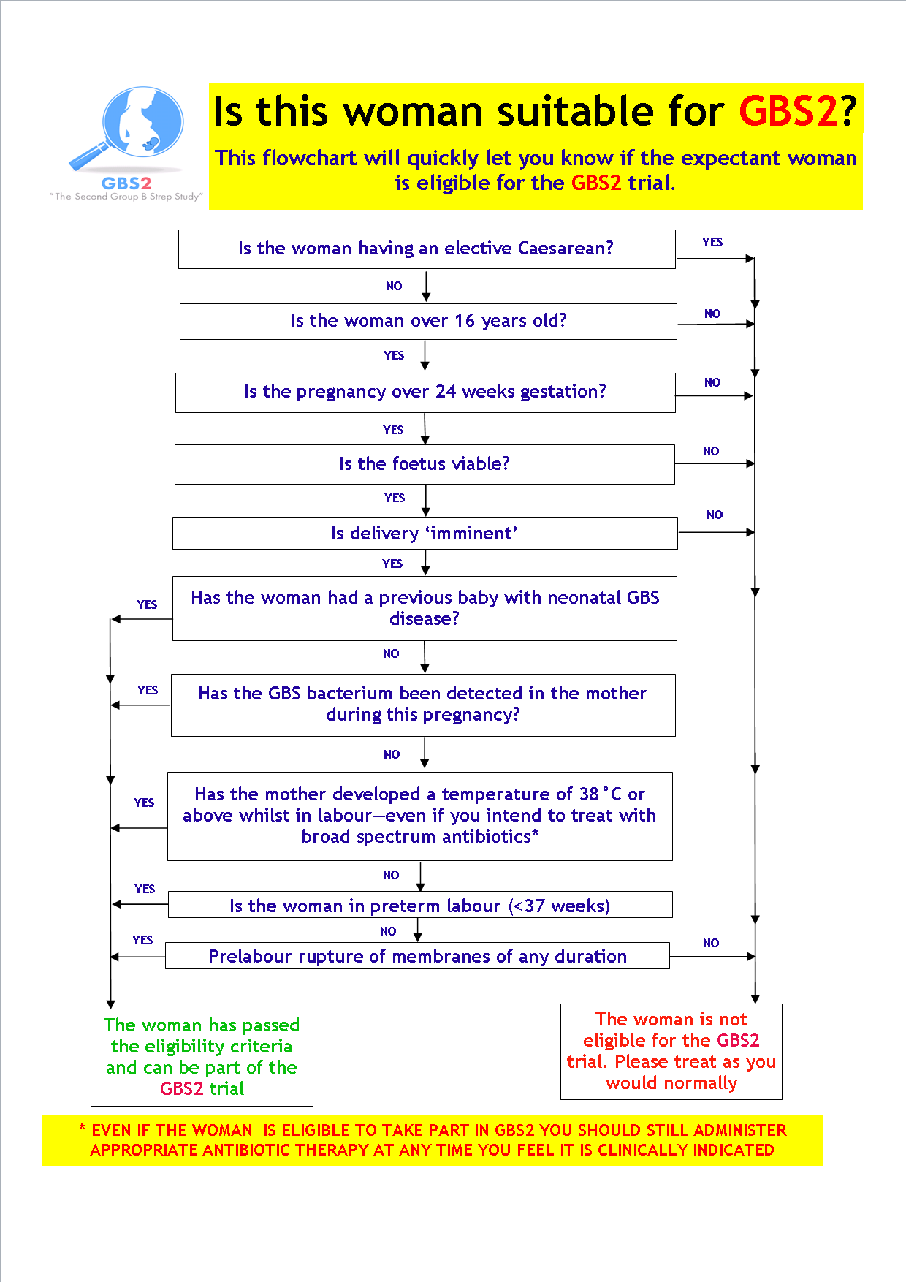

Figure : Study Schema – Centres allocated to usual practice

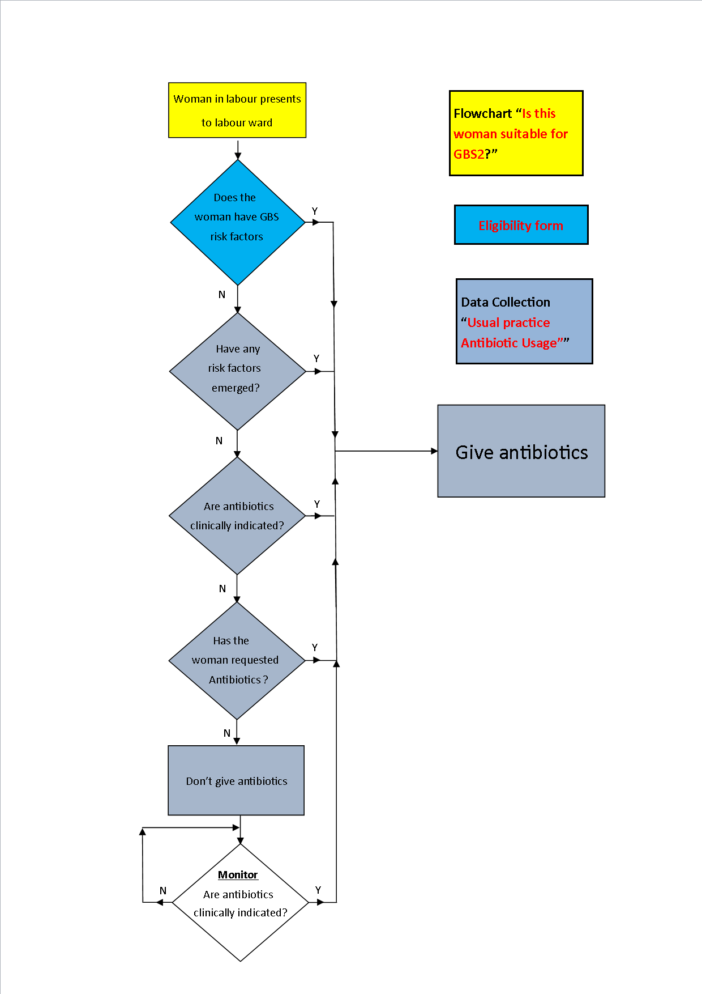

Figure : Study Schema – Centres in the Midlands assigned a rapid test system

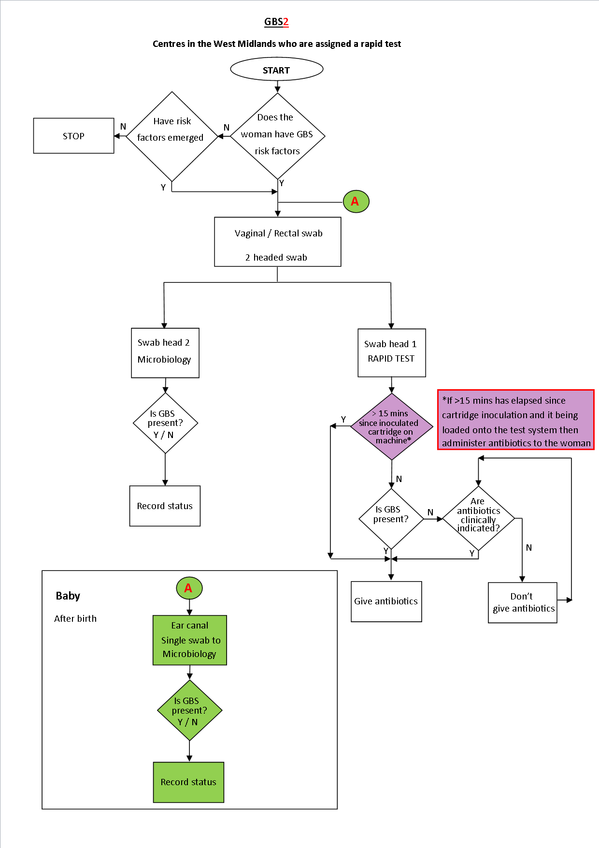

Figure : Study Schema – Centres in the South East assigned a rapid test system

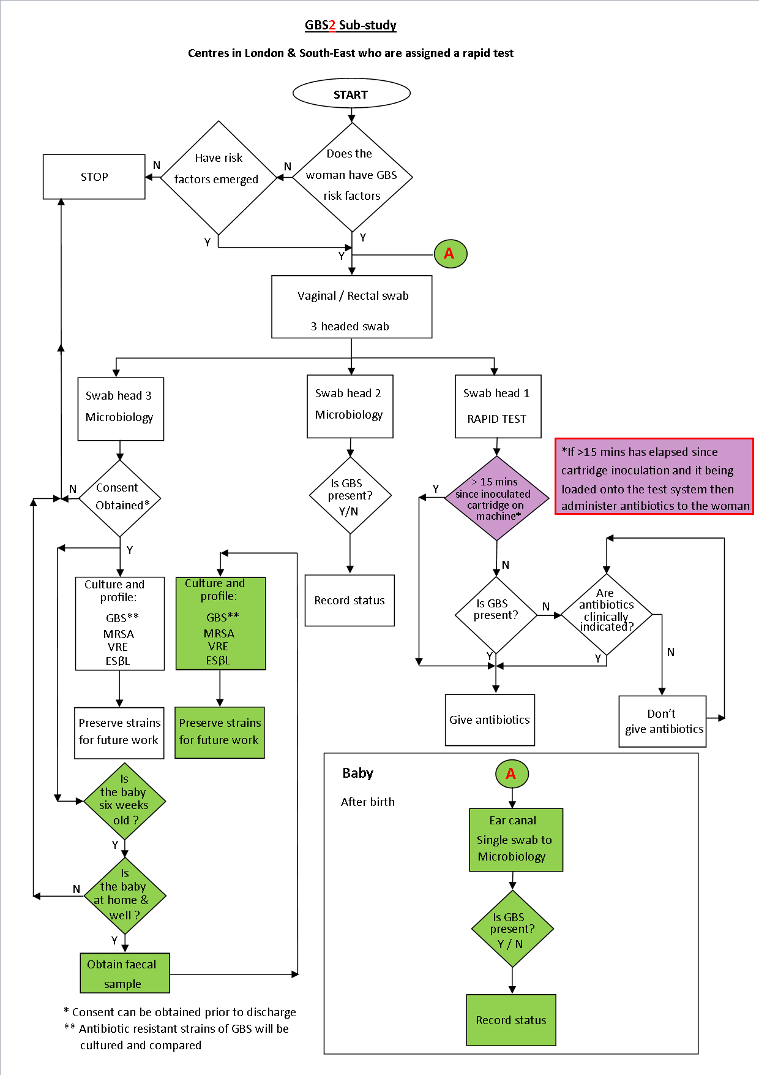

Figure : Example Patient Pathway (Centres assigned a rapid test)

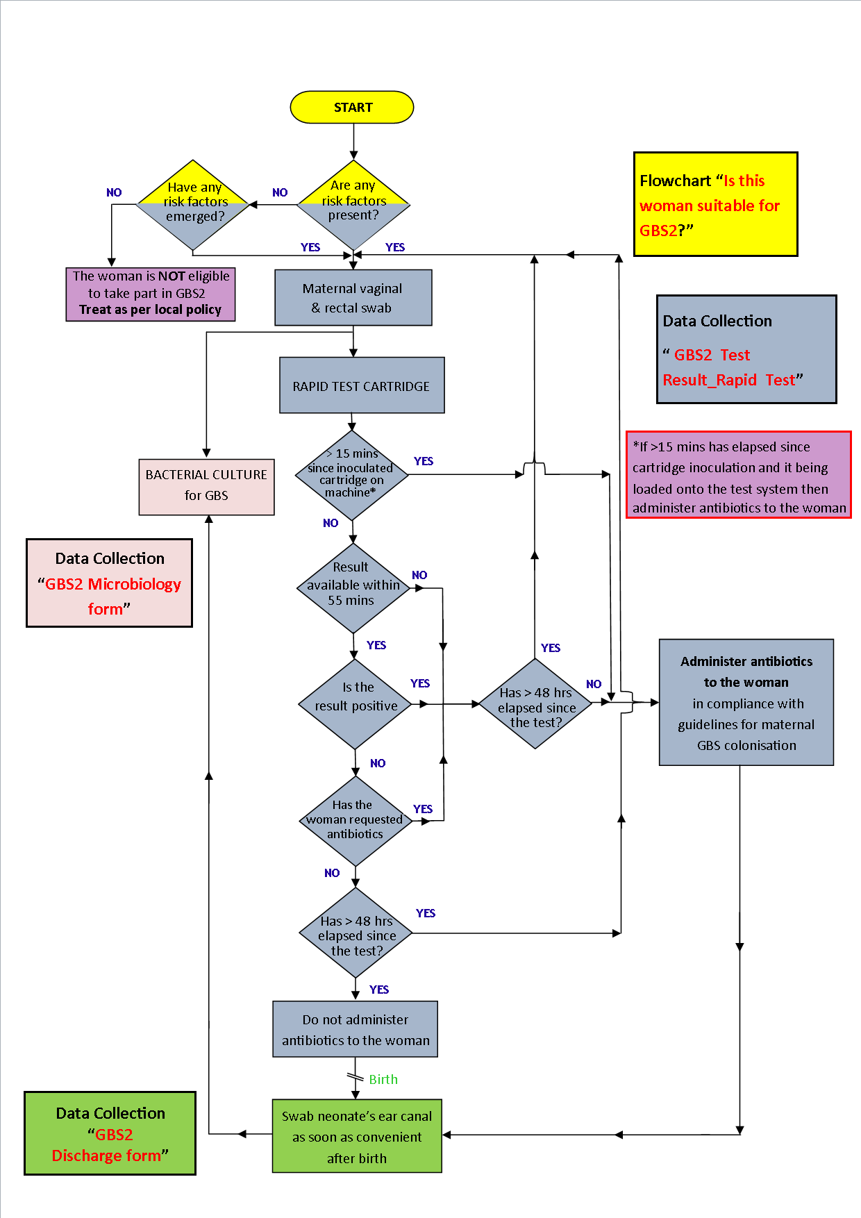

Figure : Data flow pathway – Main study

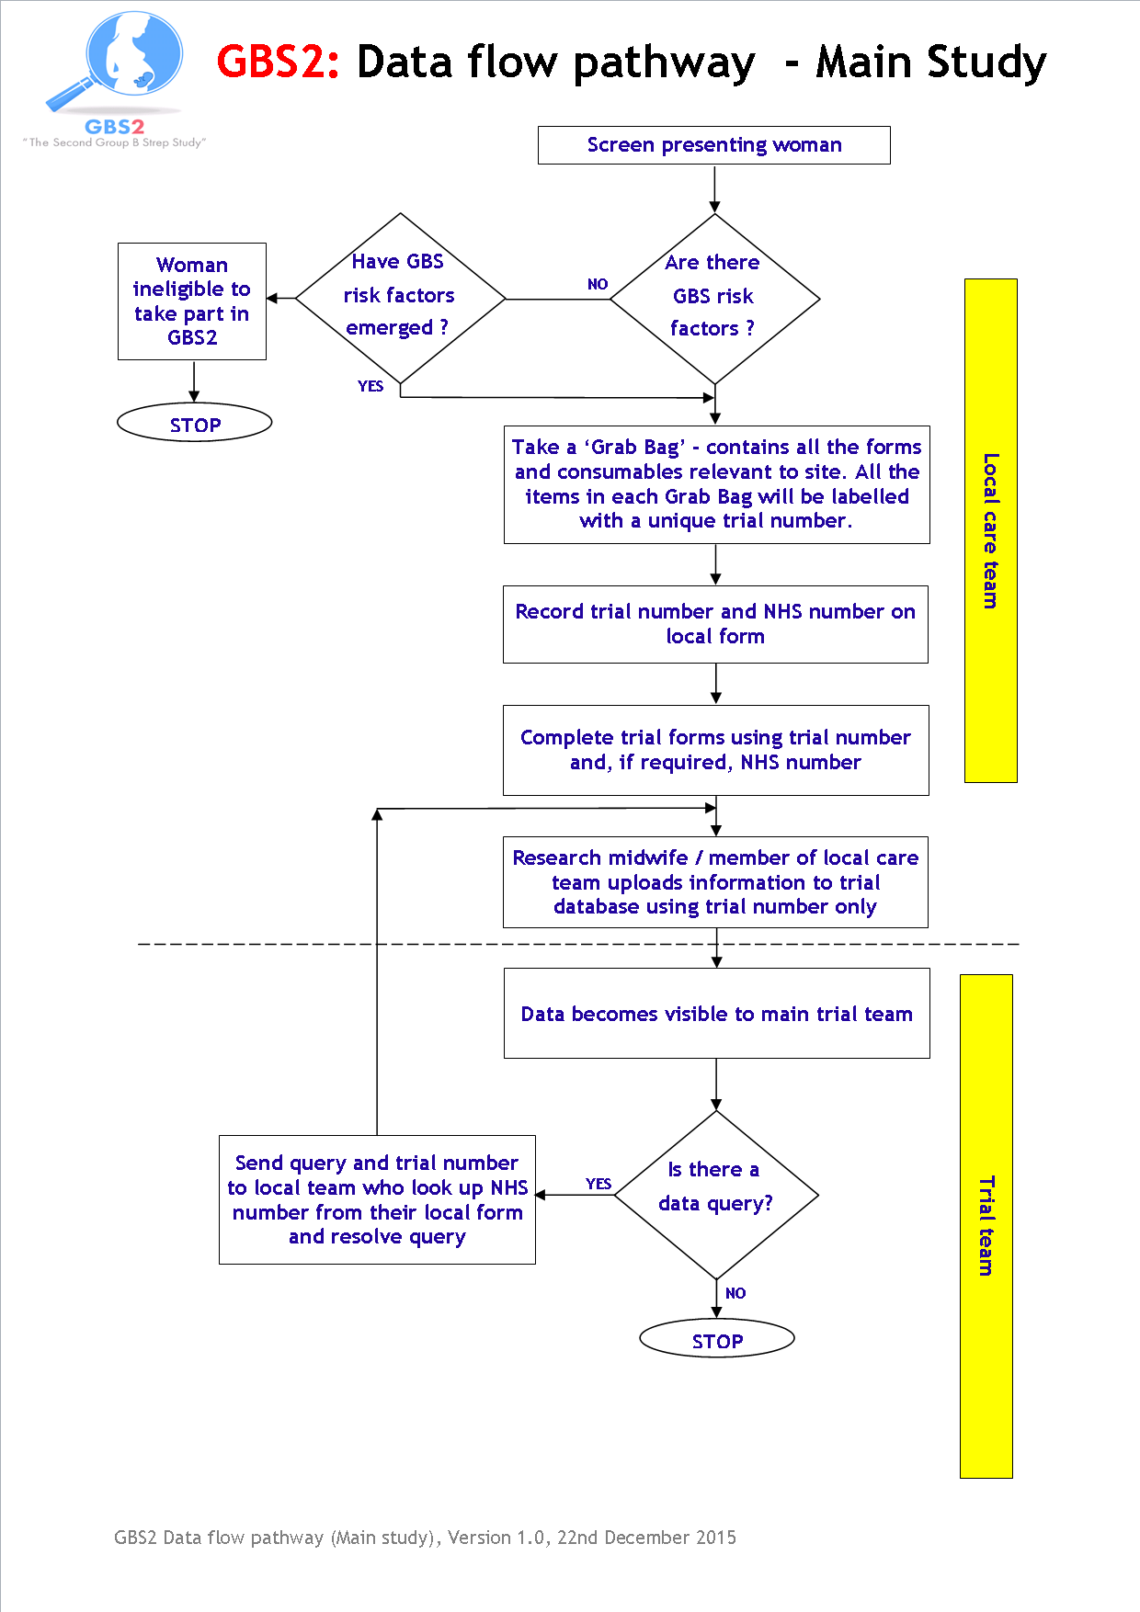

Figure : Data flow pathway for sub-study

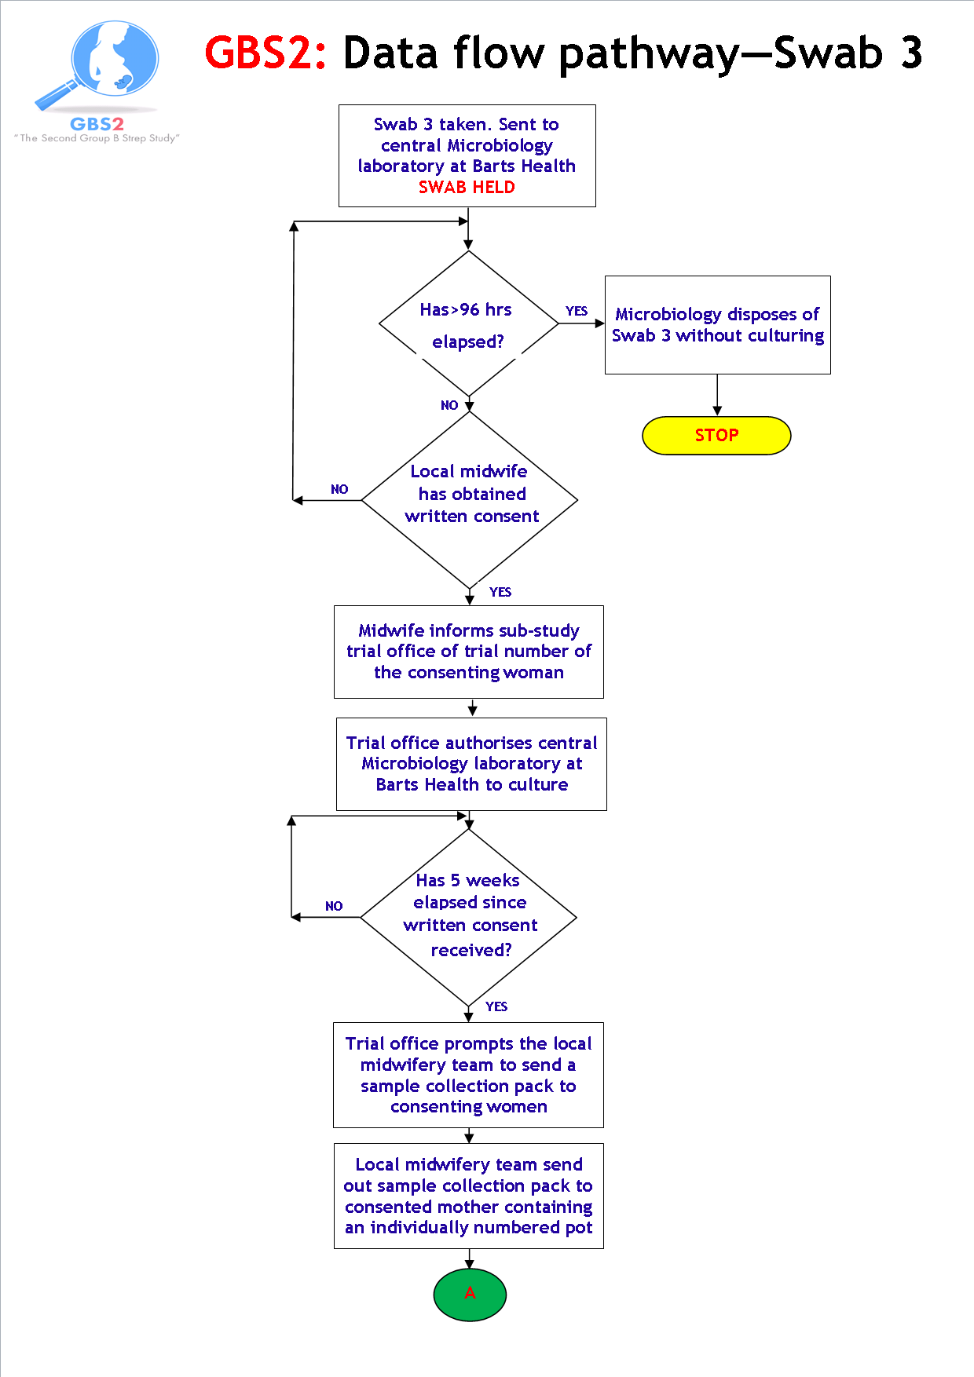

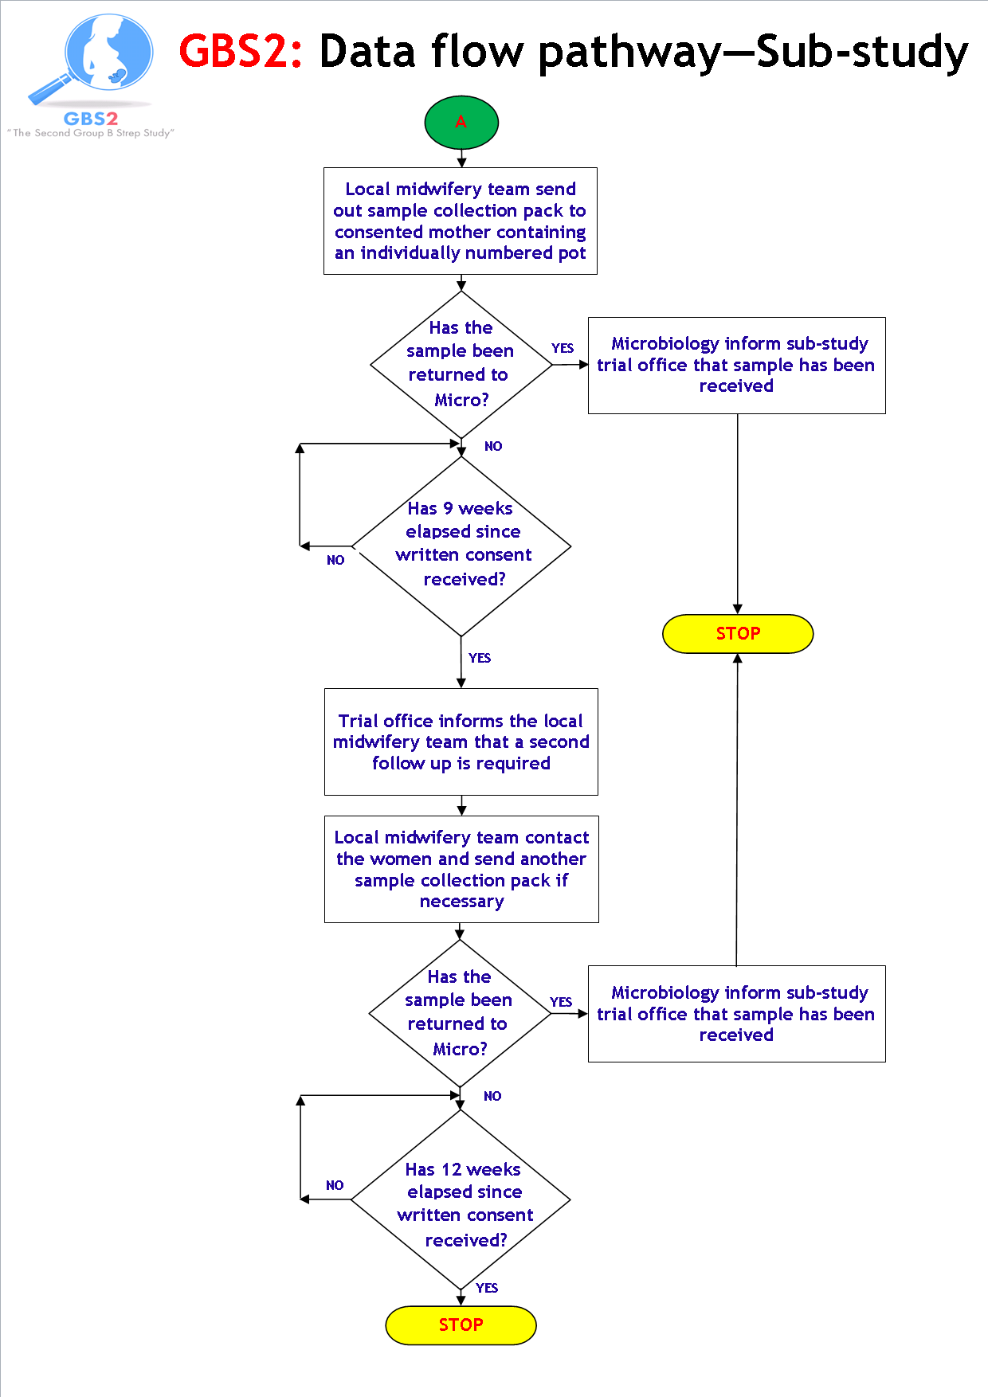

1. Appropriate criteria of proof beyond reasonable doubt cannot be specified precisely, but a difference of at least three standard deviations in an interim analysis of the primary outcome may be needed to justify halting, or modifying, the study prematurely. If this criterion were to be adopted, it would have the practical advantage that the exact number of interim analyses would be of little importance, so no fixed schedule is proposed.