Participant flow

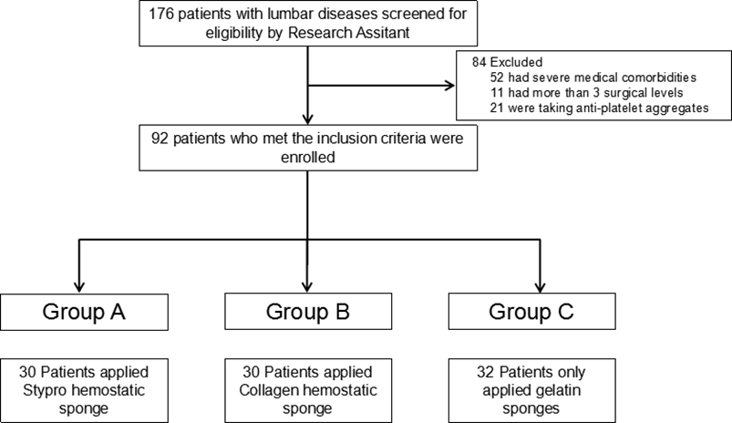
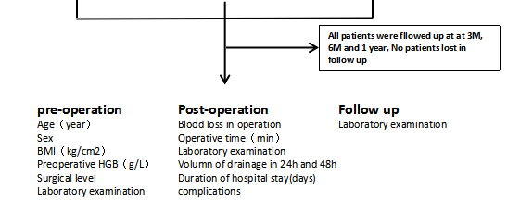

Baseline characteristics
variable | Group A | Group B | Group C
N | 30 | 30 | 32
Age（year） | 56.1±12.9 | 55.6±12.3 | 56.7±13.4
Sex
Males | 12 | 13 | 13
Females | 18 | 17 | 19
BMI（kg/cm2） | 24.83±3.6 | 24.93±3.3 | 24.81±3.4
Preoperative Hemoglobin (g/L） | 123.2±10.5 | 125.1±9 | 126.4±8.4
Surgical level | 2.31±0.09 | 2.76±0.12 | 2.40±0.10
Operative time（min） | 118.0±24 | 150.6±47 | 135.6±39
Blood loss（ml） | 202.5±25 | 292.7±39 | 259.8±37
Mean duration of hospital stay (days) | 6.82±1.2 | 6.89±1.3 | 7.3±1.3

Outcome measures
variable | Group A | Group B | Group C
Volume of Drainage in 24h (ml)* | 187.9±82 | 185.2±68 | 230.8±75
Volume of Drainage in the second 24h（ml） | 53.7±3.8 | 63.3±8.9 | 63.5±14.2
total volume of drainage（ml)* | 231.5±18.1 | 248.5±18.8 | 318.5±26.7

variable | Group A | Group B | Group C
HCT of Drainage in 24h（%） | 18.04±1.22 | 20.85±1.16 | 21.06±1.17
HCT of Drainage in the second 24h（%） | 11.72±1.17 | 13.22±1.23 | 12.53±1.24
Drainage blood in 24h(ml）* | 34.95±5.05 | 39.37±3.79 | 54.06±5.56
Drainage blood in the second 24h(ml） | 4.85±0.66 | 7.39±1.07 | 7.79±3.58
total volume of drainage blood（ml）* | 39.62±5.13 | 47.53±6.08 | 61.84±6.60

Adverse Events

Complications | Number of patients
postoperative infections | 0
deep venous thrombosis (DVT) | 0
pulmonary embolism (PE) | 0
postoperative hematomas | 0

