SEM Glove Study for spinal cord injury – v1
Clinical trial of the Soft Extra Muscle Glove to assess orthotic and long-term functional gain following chronic incomplete tetraplegia: a longitudinal mixed methods study

Participant Information Sheet

IRAS Number : 201786
Study Number :
Centre Number :

Short Project Title: | SEM Glove study for spinal cord injury – v1
Full Project Title: | Clinical trial of the Soft Extra Muscle Glove to assess orthotic and long-term functional gain following chronic incomplete tetraplegia: a longitudinal mixed methods study.
Name of Researcher:
Doc. Version Number:
Date:

Introduction
We would like to invite you to take part in a research study which will test the assistive hand device called the Soft Extra Muscle (SEM) Glove. The SEM Glove is shown here in Figure 1. This will involve participants wearing this SEM Glove at their own home during 12 weeks and visiting Stoke Mandeville Hospital four times to attend testing sessions with the clinical research team.
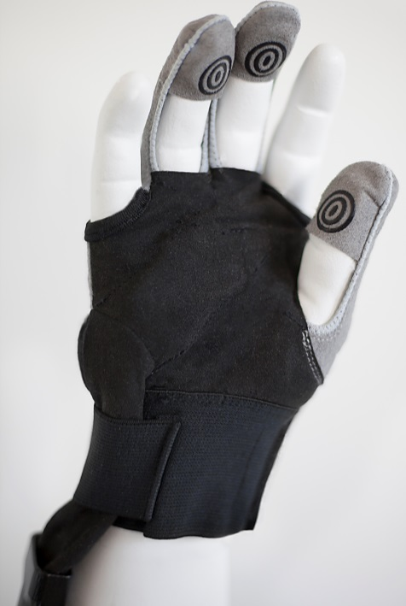
Figure. 1: The SEM Glove.
Please take time to read the following information about the study carefully and to discuss it with your partner, family and caregiver if you wish. Please contact us if there is anything that is not clear or if you need more information. Take your time to decide whether you wish to take part.

Thank you for reading this participant information sheet.

Why have I been invited?
You have been invited because you have a Spinal Cord Injury (SCI) that has affected your hand function for at least one year. We will contact 15 participants with chronic tetraplegia to take part in this study.

Do I have to take part?
No you do not have to take part if you do not want to. Taking part in this study is entirely voluntary and it is up to you to decide whether or not to take part. You do not have to give a reason not to take part. If you decide to take part but later change your mind, you can withdraw at any time without giving a reason.

What is the purpose of the study?
The loss of hand function is one of the devastating consequences of tetraplegia. It has the potential to make individuals dependent on caregivers and reduces the quality of life.

Despite the therapy offered to rehabilitate hand function after SCI, impairments will often persist into the chronic stage of the injury. As individuals with chronic SCI are not usually hospitalised and therefore have no regular hand therapy, their poor hand function places additional strain on the individual, relatives and clinical caregivers.

The SEM Glove is a unique assistive device which may help in two ways. First, the SEM Glove is designed to ‘strengthen’ grasping ability and therefore should help in the activities of daily living. Second, the design of the SEM Glove incorporates the latest techniques used in rehabilitation allowing the glove to serve as a rehabilitation tool which may help to improve hand function.

We intend to test the usefulness of the SEM Glove as an assistive hand device and as a rehabilitation tool.

What will happen to me if I take part?
If you decide to take part we will ask you to visit the National Spinal Injury Centre (NSIC) for initial assessments. The assessments will take about 4 hours and includes rest periods and the time to help you fit and set the glove. During the assessments you will fill out questionnaires on your ability to use your hand to perform activities of daily living. You will also complete questionnaires on your general wellbeing. We will ask you to grasp and release some of the everyday objects to enable us to determine how much hand function you have. None of the procedures will be painful.

You will then be given a SEM Glove device to take home with you and wear it for a minimum of 4 hours a day while doing functional tasks with the hand. You will be asked to perform the following minimum tasks with the glove.
- Grasp and release a softball 30 times using the glove.
- Simulate drinking from a can of coke starting from picking the can from a table and lifting it to your mouth 30 times using the glove.
- Eat a meal with a fork or spoon using the glove
- Write your own name and address using the glove.

After 6 weeks of wearing the SEM Glove, you will be invited back to the NSIC for a two hour re-assessment session. After the re-assessment, you will go back home and continue to use the SEM Glove for another 6 weeks. After the 6 weeks, you will be invited back to the NSIC to hand back the SEM Glove and take part in a re-assessment session. This re-assessment will be similar to the initial assessment which was done at the beginning of the study.

Finally, 6 weeks after handing back the devices to us, we will invite you for a two hour follow-up assessment for us to see if you have any long-term benefit of using the SEM Glove.

Some of the assessments require us to take video and or photo of your hand during object manipulation. Your face and your voice will not be captured and the video and photo will be made anonymous after being used for analysis by the research team.

What are the risks and benefits for me if I take part?
There is no known risk associated with using the SEM Glove. A potential benefit is that you will be able to use the SEM Glove which could contribute to good performance in your activities of daily living. Long-term use of the SEM Glove may also induce a long-term rehabilitative effect that would also help to improve independence. However this is a research study and we cannot promise that you will benefit directly from the glove.

At the end of the study, you can buy the SEM Glove system from the supplier if you are interested and want to continue using it.

What if there is a problem?
As a sponsor, the Buckinghamshire Healthcare NHS Trust has approved the design of the current study and remains liable for negligent harm caused during the conduct of the current study and claims arising from it. For more information regarding insurance coverage please ask either your doctor or a research team member named on the last page of this document.

Will the information I give be kept confidential?
All information which is collected about you during the course of the study will be kept strictly confidential. Also your name will not be written on any of the questionnaires making it impossible to connect you with the collected data. Your data will be kept secure using password-protection and will be stored with an anonymous identity number to maintain confidentiality. Data will be stored at the Buckinghamshire Healthcare NHS Trust only, and any information you provide will be seen by the research team only.

Any information about you that leaves the Buckinghamshire Healthcare NHS Trust will have your name and address removed so that you cannot be recognised. Following the Buckinghamshire Healthcare NHS Trust’s policy, all research records are kept for 15 years on the Trust’s promises in secured archives although the research team will access the personal and research data for up to one and five years respectively. After this period the documents will be destroyed using the confidential clinical record disposal service.

What will happen to the results of this study?
Once the results of the study have been gathered and analysed, we hope to publish the results in medical journals so that others can read and learn from them. The investigators will also publish a brief summary of the study results on the research webpage of the Buckinghamshire Healthcare NHS Trust and Stoke Mandeville Spinal Research website.

Who is organising and funding the research?
The research is organised by a team of researchers based at Stoke Mandeville Spinal Research at the National Spinal Injuries Centre in Aylesbury. This study is funded by Bioservo Technologies AB, Anatomical Concepts UK LTD, Regain Sports Charity and Rothschild Foundation. The researchers in this study conduct research on a full-time basis and are paid a fixed salary which is independent of whether you participate in the study or not.

How have patients and the public been involved in this study?
The SEM glove has been piloted by the OT Department at Stoke Mandeville Hospital with patients. This has helped to guide the design of the training tasks and hand function tests to be performed in the trial.

Who has reviewed and approved the study?
This study has been reviewed and approved by (1) Health Research Authority, (2) Buckinghamshire Healthcare NHS Trust R&D in conjunction with the National Spinal Injuries Centre Research Board and Stoke Mandeville Spinal Research.

What do I have to do if I decide to take part?
If you are happy to take part we will ask you to sign a consent form and for you to send this to Bethel Osuagwu, Stoke Mandeville Spinal Research, National Spinal Injuries Centre, Stoke Mandeville Hospital, Aylesbury, Buckinghamshire, HP21 8AL (contact number 07944142407). A copy of this information sheet and the signed consent form will be retained in our trial records. Please contact Bethel at any time to learn more about the project.

Who should I contact if I wish to make a complaint?
Any complaint about the way you have been dealt with during the study or any possible harm you might have suffered will be addressed. Please address your complaint to the independent person:
Patient Advice and Liaison Service (PALS)
Tel: 01296 316042
E-mail: pals@buckshealthcare.nhs.uk

How do I get in touch with the research team if I want any further information about the study?
If you have any questions, concerns or complaints about the study, please contact the research team at the following contact number and address.

Dr. Bethel Osuagwu
Stoke Mandeville Spinal Research, National Spinal Injuries Centre, Stoke Mandeville Hospital, Aylesbury, Buckinghamshire, HP21 8AL.
Tel: +44 (0) 7944142407
Email: Bethel.Osuagwu@buckshealthcare.nhs.uk

Ruth Peachment
National Spinal Injuries Centre, Stoke Mandeville Hospital, Aylesbury, Buckinghamshire, HP21 8AL
Email: ruth.peachment@buckshealthcare.nhs.uk

Helen Thrussell
National Spinal Injuries Centre, Stoke Mandeville Hospital, Aylesbury, Buckinghamshire, HP21 8AL
Email: helen.thrussell@buckshealthcare.nhs.uk

Thank you very much for reading this.
Please discuss this information with your friends or family if you wish.

Collaborators and Contact Details:
Dr Julian Taylor
Research Director
Stoke Mandeville Spinal Research
National Spinal Injuries Centre
Stoke Mandeville Hospital
Buckinghamshire Healthcare NHS Trust
HP21 8AL, Aylesbury, Buckinghamshire
United Kingdom
E-mail: julian.taylor@smsr.org.uk

Chief Investigator
Mr Tony Heywood
Stoke Mandeville Spinal Research
Stoke Mandeville Hospital
National Spinal Injuries Centre
Buckinghamshire Healthcare NHS Trust
HP21 8AL, Aylesbury, Buckinghamshire
E-mail: Tony.Heywood@buckshealthcare.nhs.uk

