Study Title: Digitising paper-based tools in common use for the treatment of mild to moderate depression and anxiety disorders: an investigation of efficacy and acceptability
Short title: Digital therapeutic tools in the treatment of mild to moderate depression and anxiety
IRAS Project ID: 275982
Date and Version No: Version 1 – 14th April 2020

Chief Investigator: | Dr Valentin Tablan, Ieso Digital Health, The Jeffreys Building, Cowley Road, Cambridge CB4 0DS.  T: 0800 074 5560  E: v.tablan@iesohealth.com
Investigators: | Mrs Sarah Bateup, Ieso Digital Health  Dr Andy Blackwell, Ieso Digital Health  Dr Sabine Buchholz, Ieso Digital Health  Dr Ana Catarino, Ieso Digital Health  Dr Ronan Cummins, Ieso Digital Health  Dr Michael Ewbank, Ieso Digital Health  Dr Jennifer Gentile, Ieso Digital Health  Dr Ann Hayes, The Ann Hayes Consultancy  Dr Valentin Tablan, Ieso Digital Health  Dr Justin Washtell-Blaise, Ieso Digital Health
Sponsor: | Ieso Digital Health  Contact: Annie Owen  Ieso Digital Health  The Jeffreys Building  Cowley Road  Cambridge  CB4 0DS  T: 0800 074 5560  E: a.owen@iesohealth.com
Funder: | Ieso Digital Health
Chief Investigator Signature:

Table of Contents
Summary 3
Synopsis 5
Background and rationale 6
Objectives 7
Study design 8
Digital tools 9
Clinical outcomes 11
Patient identification 12
Inclusion criteria 12
Exclusion criteria 12
Statistics and data analysis 13
Sample size 13
Analysis 13
Data management 14
References 15

Summary
Mental health disorders constitute an enormous healthcare concern, with one in four people estimated to be affected. Mental health problems are one of the main causes of the overall disease burden worldwide, causing 40 million years of disability in 20 to 29 year olds (Lozano et al., 2012; Vos et al., 2016). However, despite the high prevalence of these disorders and the huge human, societal and economic cost, global median government mental health expenditure per capita represents less than 2% of total health expenditure. Not surprisingly, access to care remains poor across the globe, with a median of 9 mental healthcare workers available per 100,000 population. Even in high income countries such as the UK, where the number of mental healthcare workers per 100,000 population can be as high as 70, still approximately only 1 in 5 adults with a mental health disorder has access to psychological therapy (World Health Organisation, 2014; World Health Organization, 2011).
The current study aims to explore the use of digital therapeutic tools to augment the therapeutic benefits of cognitive behavioural therapy (CBT), delivered by a qualified clinician, for the treatment of mild to moderate depression and anxiety disorders. The development of these digital tools will be informed by paper-based tools which are currently used by CBT therapists in accordance with standard CBT competencies (Roth & Pilling, 2008). The central vision for this project is to enable the creation of effective digital therapeutic tools, to assist the therapists in delivering the appropriate dose of therapy to patients, while optimising therapists’ time and resources. The aim of the project is to use digital tools to augment the working capacity of the existing mental healthcare workforce, thus providing a step change in access to evidence-based therapy for the relief of symptoms of depression and anxiety.
The enclosed project is defined by the following objectives:
- Digitise existing paper-based therapeutic tools commonly used for the treatment of mild to moderate depression and anxiety disorders, such that they can be delivered autonomously by a computer as support tools to CBT delivered by a qualified clinician;
- Evaluate the effectiveness of CBT enhanced by digital therapeutic tools in reducing symptoms of depression and anxiety in a safe environment, under the supervision of a qualified clinician;
- Evaluate the effectiveness of digital therapeutic tools in reducing the number of treatment sessions needed to reduce symptoms of depression and anxiety
- Assess the acceptability of autonomous digital therapeutic tools and the degree to which patients are willing to engage with these tools as part of therapy.

The innovation in this project is defined by:
- Evidence-based development of automated digital therapeutic tools, informed by existing paper tools in current use by clinicians when delivering CBT protocols for the treatment of depression and anxiety disorders;
- The evaluation of efficacy of digital therapeutic tools in a safe environment for patients, under the supervision of a clinician;
- The assessment of acceptability of digital therapeutic tools under real-world conditions, with the aim of maximising patient engagement.

Synopsis
Study Title | Digitising paper-based tools in common use for the treatment of mild to moderate depression and anxiety disorders: an investigation of efficacy and acceptability
IRAS ref no. / Short title | Digital therapeutic tools in the treatment of mild to moderate depression and anxiety
Joint Sponsors | Ieso Digital Heath  The Jeffreys Building  Cowley Road  Cambridge CB4 0DS  T: 0800 074 5560  E: thelab@iesohealth.com
Funder | Ieso Digital Health
Study Design | Randomised controlled trial of patients receiving Internet-enabled CBT (IECBT) for the treatment of mild to moderate depression or anxiety disorders. Consenting patients will be randomised at start of treatment to one of two groups:  - Digitally enhanced therapy: patients in this group will receive standard care, delivered by a qualified Psychological Wellbeing Practitioner (PWP) or a high intensity CBT therapist. Standard care will be enhanced by one of 6 possible digital therapeutic tools, consisting of digitised versions of paper tools commonly used by therapists in the treatment of the disorder.  - Control group: patients in this group will receive standard care only, using paper-based tools (e.g. pdf files) delivered by a qualified Psychological Wellbeing Practitioner (PWP) or CBT therapist.
Study Participants | Patients referred to Ieso Digital Health, receiving Internet-enabled CBT for the treatment of mild to moderate depression or an anxiety disorder.
Sample Size | 700 patients in total. 100 patients allocated to the control group, 600 patients allocated to digitally enhanced therapy group, within which 100 patients allocated to each one of six different digital therapeutic tools.
Planned Study Period | Total project length = 18 months.
Planned Recruitment period | July 2020 – July 2021
Primary objectives | The primary research objective is to explore the efficacy of digital therapeutic tools in reducing symptoms of depression and anxiety, when introduced as supporting tools to standard care delivered by a qualified practitioner.
Secondary objectives | The secondary research objective is to assess the acceptability of these digital tools, when used in support of standard care for mild to moderate depression and anxiety disorders, from both therapist and patient’s perspectives.

Background and rationale
Mental health disorders, such as depression and anxiety, are common, costly, and in need of timely treatment interventions. Despite the high prevalence of these disorders, and the economic, human and societal costs, access to care remains poor across the globe. Even in high income countries such as the UK, still only 1 in 5 adults with a mental health disorder have access to psychological therapy (World Health Organisation, 2014; World Health Organization, 2011).

Ieso Digital Health is a provider of Internet-enabled CBT (IECBT), where patients communicate with an accredited CBT trained clinician using a real-time text-based system. The clinical effectiveness of IECBT has been demonstrated in depression and other mental health conditions (Catarino et al., 2018; Kessler et al., 2009). However, many patients do not experience adequate symptom relief from existing first-line treatments – our own data indicate that approximately 50% of patients with mental health disorders experience treatment resistance to a standard course of IECBT, with similar rates reported elsewhere (Holtzheimer & Nemeroff, 2006; Tyrer & Baldwin, 2006). Understanding and overcoming barriers to improving treatment for common mental health conditions thus constitutes a vital goal, in order to provide the maximal therapeutic benefit to the largest possible numbers of people.

It is widely recognised by CBT therapists that patient engagement outside of formal therapy sessions is essential in driving good clinical outcomes. For example, studies have shown that patients who receive psychotherapy with homework do better than those receiving psychotherapy without homework (Kazantzis, Whittington, & Dattilio, 2010). Furthermore, it seems that both the quantity and the quality of the homework play an important role in helping patients to recovery (Kazantzis et al., 2016). In essence, extending therapy outside of formal weekly sessions seems to play a crucial role in driving clinical outcomes for patients. This idea is particularly relevant for conditions such as mild to moderate depression or anxiety, where self-help computerised approaches are already a recommended treatment option (National Institute for Health and Clinical Excellence, 2011). However, it is widely recognised that patient engagement with current self-help tools is poor (Gilbody et al., 2015).

The key aim of this project is thus to develop evidence-based digital therapeutic tools, based on existing paper-based tools currently used by CBT therapists in the treatment of mild to moderate depression and anxiety disorders. The design of these tools will be based on data which have been collected from thousands of patients treated using Ieso’s routine service provision; these data include therapy transcripts from therapy sessions, demographics, and outcomes data which are collected according to IAPT mandates. The design will thus be user-centred and user-informed. The role of these tools will be to support the therapy delivered by the clinician, thus augmenting the therapeutic dose received by the patient. This study aims to evaluate the efficacy of such tools in enhancing clinical benefits to patients and maintaining patient engagement with the therapeutic process throughout a course of treatment. In addition to improving outcomes, by reducing the amount of therapist time needed to provide treatment to a patient, it will be possible to use existing resources more effectively, increase access, and reduce waiting times for accessing care.

The development of evidence-based digital tools, informed by paper tools currently used by therapists and with patient acceptability at its core, has the potential to lead to automated self-guided therapeutic interventions that are not only more engaging than existing ones, but also more effective in reducing patients’ symptoms. In the future, fully automated effective interventions could prove crucial in the delivery of high-quality evidence-based care to communities around the world where care provision is non-existent.

Objectives
The primary objective of this research is to develop digital therapeutic tools (e.g. automated worry classification exercise on a computer), informed by existing paper-based tools currently used by clinicians in the treatment of mild to moderate depression and anxiety disorders. The research question this study aims to answer is: are digital tools more efficacious in reducing the severity of patients’ depression and anxiety symptoms than traditional paper-based tools? We aim to answer this question by comparing the use of human delivered therapy, delivered by text via the internet and enhanced by digital tools, to human delivered therapy without digital enhancement.

The secondary objective of this research is to evaluate patient acceptability of digital therapeutic tools, when used complementary to human delivered therapy. Current acceptability of self-help digital tools for the treatment of mental health disorders is poor, and patient engagement with such self-guided therapy protocols is low. We aim to test the hypothesis that user-centred and user-informed design, paired with knowledge from expert clinicians, and rigorous scientific evaluation under clinical trial conditions, will lead to evidence-based digital therapeutic tools that are more engaging than currently existing ones.

Study design
Patients entering into the Ieso IECBT service in the normal course of treatment, who receive a diagnosis of depression or an anxiety disorder, and fulfill eligibility criteria will be invited to participate in the research study, after being given time (at least 48h) to read the Information Sheets and ask any questions they wish of the research team. The same high quality of clinical care will be provided whether or not a given individual consents to participate in the study. Consenting patients will be randomized to one of two groups (Figure 1):
- Digitally enhanced therapy. Patients allocated to this group will receive a course of human-delivered IECBT for mild to moderate depression or an anxiety disorder, enhanced by one of six possible digital therapeutic tools, delivered under supervision of a clinician and used by the patient alone during the period in between therapy sessions.
- Standard therapy. Patients allocated to this group will receive a standard course of human-delivered IECBT for mild to moderate depression or an anxiety disorder, using paper-based tools but without the support of digital tools.

Patients’ clinical outcomes and response to therapy will be monitored. Therefore, patients will be involved in the study for the duration of a course of therapy, which is typically between 8 and 12 weeks.

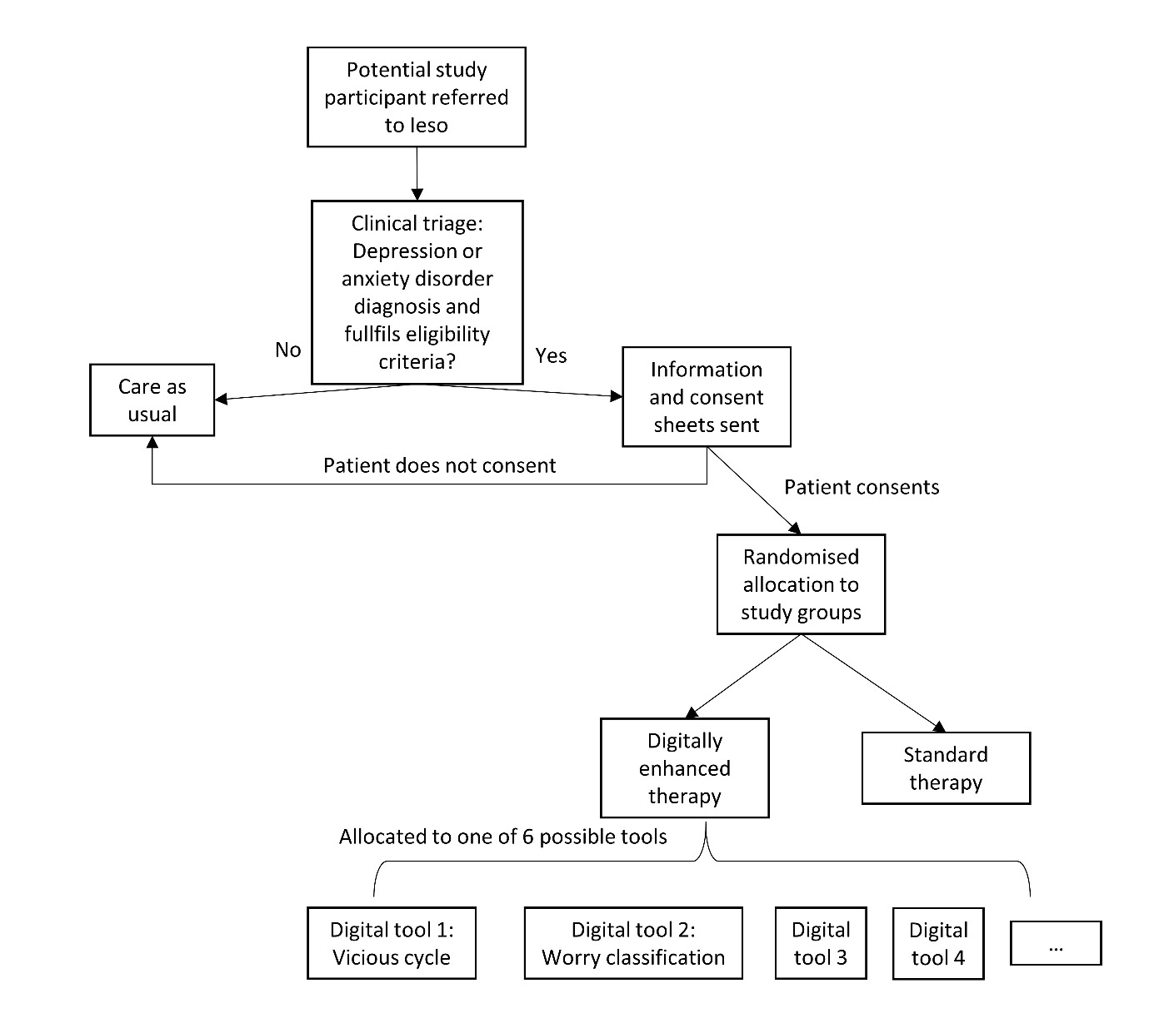

Figure 1. Summary of flow for participant involvement in the study.

Digital tools

Digital Tool 1: Vicious cycle
A conversational agent (i.e. chatbot) that will ask patients to provide examples of their thoughts, feelings, behaviours and sensations related to their problem. Using the patient’s responses, the tool will display a four-areas formulation (i.e. a diagram showing how these four areas influence each other) and will provide psychoeducation to the patient as to how their thoughts, feelings, behaviours and sensations help to maintain their problem in a vicious cycle of worry.

Digital Tool 2: Worry classification
A conversational agent that will teach patients to distinguish between worries that are “hypothetical” (i.e. a worry that has not actually happened/may never happen) or “practical” (i.e. the problem has happened, is real, and there is something we can do about it). Worry classification helps the patient adopt more of a reflective observer position in relation to worry rather than simply being caught up in it.

Digital Tool 3: Worry Time
A conversational agent that will teach patients how to contain their worry to designated periods. Patients will be helped to schedule worry time each day for one week to a length of their choice, e.g. 10 minutes. During this ‘worry period’ the patient is free to worry if they want. Postponing worries in this way helps undermine beliefs regarding the uncontrollability of worry.

Digital Tool 4: Worry diary
A digital tool that combines a conversational agent with an electronic diary to enable patients to record a selection of their worries over a period of at least a week. Patients will also record how anxious the worry makes them feel and what type of worry it is (after Digital Tool 2 has been completed). The aim is to collect a representative sample of the worries. A ‘worry diary’ helps patients to observe their worries as a process rather than focusing on the content.

Digital Tool 5: Problem solving
A conversational agent that will teach the patient to use structured problem solving to help them deal with stressors that may contribute to worry. This will involve a series of steps to help patients to identify the problem, propose possible solutions, evaluate the solutions, decide on the most appropriate solution, and plan how to implement the solution.

Digital Tool 6: Progressive Muscle Relaxation
Progressive muscle relaxation is a deep relaxation technique used to control stress and anxiety. This tool will guide the patient through a series of spoken exercises involving tensing or tightening one muscle group at a time followed by a relaxation phase with release of the tension.

Clinical outcomes
The clinical outcomes used in this study are collected as part of existing ‘standard of care’. In the context of this study treatment non-response will be defined as non-engagement or failure to achieve defined symptom change for recovery and/or improvement. The service provider, Ieso Digital Health, operates within the Improving Access to Psychological Therapies (IAPT) programme. As such, as mandated by IAPT, all patients receiving treatment, whether or not they have opted to participate in the study, will complete two symptom severity measures at initial assessment and before every therapy session: PHQ-9 (Kroenke, Spitzer, & Williams, 2001) and GAD-7 (Spitzer, Kroenke, Williams, & Löwe, 2006), corresponding to depressive and anxiety symptoms respectively. These metrics will be used to calculate clinical outcomes.

Within this framework, clinical outcomes including engagement, recovery and improvement will be defined following IAPT guidelines (Clark, 2011; Gyani, Shafran, Layard, & Clark, 2013). Non-engagement will be defined as failure to attend at least two treatment sessions. This is the minimum dose of therapy a patient must receive such that pre- and post-treatment scores are collected and clinical change can be estimated (Gyani et al., 2013).

Within the IAPT framework, clinical recovery and reliable improvement are calculated based on PHQ-9 and GAD-7 scores. Patients with two or more therapy sessions who show a significant reduction in at least one of the outcome measures from assessment to the last treatment session (i.e. decrease of six points or more in the PHQ-9 and/or four points or more in the GAD-7), while not showing a significant increase in the other outcome measure, will be classed as showing reliable improvement.

If a patient scores eight points or above for GAD-7, and/or ten points or above for the PHQ-9, they will be classed as meeting the clinical threshold for caseness, which means they are considered to be suffering from clinically significant anxiety and/or depression symptoms. Patients with two or more therapy sessions who move from above caseness at assessment to below caseness at the last treatment session will be classed as recovered.

Patient identification
Patients referred to the IECBT service for the treatment of mild to moderate depression or anxiety, who meet the eligibility criteria, will be invited to participate in the study.

Inclusion criteria
- Over 18 years old and registered with a general practitioner in the geographical region where the service is commissioned (over 50 CCGs in the UK);

- Patients must have a diagnosis of depression or an anxiety-disorder in the mild to moderate range, i.e. GAD-7 score at assessment between 8 and 14 points, PHQ-9 scores at assessment between 10 and 14 points, inclusive.

Exclusion criteria
- Patients who are not suitable for CBT, this includes patients with a comorbid diagnosis (a diagnosis of multiple disorders) of psychotic or personality disorder, autism spectrum condition or intellectual disability.

- Patients who have started a course of psychotropic medication or changed medication within the last 3 months (currently being prescribed medication is not an exclusion criteria).

- Patients at a significant risk of self-harm, as assessed by item 9 of the PHQ-9 questionnaire and ongoing assessment by their assigned clinician.

- Patients undergoing any other psychological therapy.

- People who do not have access to an internet-enabled device or have access to internet connection.
- People who have a low level of literacy; those who cannot write or read emails or texts will be excluded from this study because they will be unable to utilise the intervention.
- People who are visually impaired and are unable to write on or read from a computer and do not have access to appropriate assistive technology for the visually impaired.
- People who are not suitable for CBT, e.g. patients with cognitive deficits from brain damage or dementia, and patients who do not wish to engage with the process e.g. by completing homework.

- Patients who do not speak English.

Statistics and data analysis

Sample size
This study aims to recruit a total of 700 patients completing a course of treatment, of whom 100 will be randomly allocated to standard psychotherapy, and 600 to digitally enhanced standard therapy. Of these, groups of 100 patients will be allocated to one of six possible digital therapy tools. No patients will be allocated to more than one digital therapy tool simultaneously. This sample size is also consistent with those of previous research on the efficacy of IECBT (Kessler et al., 2009).

Analysis
Summary statistics will be produced separately for all patients enrolled in the study and patients completing a course of treatment per protocol. Summary statistics for continuous variables will include N, mean, standard deviation and median. Tests for normality of the distribution will also be conducted. Summary statistics for categorical variables will include number and percent. Efficacy analyses will be conducted for engaged patients only.

Where appropriate continuous predictor variables will be scaled and centred to the mean. Multicollinearity analyses will be performed to investigate potential correlations between independent variables. Statistical significance will be defined as p<.05 two-tailed, uncorrected. All analyses will be performed in R (R Core Team (2019). Primary analysis will be conducted on PHQ-9 and GAD-7 scores. These analyses will also be conducted on variables derived from PHQ-9 and GAD-7 metrics (i.e. recovery and improvement).

For categorical variables derived from PHQ-9 and GAD-7 scores (i.e. recovery and improvement), as well as secondary outcome measures of drop-outs and engagement, logistic mixed model regression analyses will be performed, with treatment group (digital; vs. standard) as a fixed effect and therapist as a random effect. Starting GAD-7 score, starting PHQ-9 score, and patient demographics (e.g. Age) will also be included as fixed effects.

For continuous variables, linear mixed model regression analyses will be performed to determine final GAD-7 and PHQ-9 scores, with treatment group (digital; vs. standard) as a fixed effect and therapist as a random effect. Starting GAD-7 score, starting PHQ-9 score, and patient demographics (e.g. Age) will also be included as fixed effects.

Growth curve modelling will be used to assess rate of change in primary and secondary outcome measures over time, and calculate the mean number of treatment sessions needed to reach the thresholds for the derived clinical outcomes variables for each group (i.e. mean number of sessions needed to reach recovery or improvement). Descriptive statistics for the mean recovery rate and improvement rate for each group will also be presented.

Data management
Ieso Digital Health follows nationally and internationally recognised standards for information security (Cyber Essentials Plus, ISO 27001 and the 10 National Data Guardian standards self-certified via the NHS Data Security and Protection Toolkit, https://www.iesohealth.com/en-gb/legal/iso-certificates). All patient data are stored confidentially and securely within the Microsoft Azure cloud environment geolocated within the UK, configured and maintained by Ieso. In all study-specific data and documents, other than the signed consent, the patients will be identified by a unique study-specific number and/or code, not by name. Patients’ names and any other directly identifying details will not be included in any study data electronic files.
Direct access to the data will be granted to authorised researchers and representatives from the sponsor for monitoring and/or audit of the study to ensure compliance with regulations; or if required by law, following at all times appropriate legislation and good governance procedures.
All research data including personal data held separately from your patient file will be held for a minimum of 20 years in accordance with Medical Research Council guidance. Personally identifiable data collected as part of routine practice (standard of care) shall be retained per standard clinical practice.

References
Catarino, A., Bateup, S., Tablan, V., Innes, K., Freer, S., Richards, A., … Blackwell, A. D. (2018). Demographic and clinical predictors of response to internet-enabled Cognitive Behavioural Therapy for depression and anxiety. BJPsych Open, 4(5), 411–418.
Clark, D. M. (2011). Implementing NICE guidelines for the psychological treatment of depression and anxiety disorders: The IAPT experience. International Review of Psychiatry, 23(4), 318–327. https://doi.org/10.3109/09540261.2011.606803
Gilbody, S., Littlewood, E., Hewitt, C., Brierley, G., Tharmanathan, P., Araya, R., … White, D. (2015). Computerised cognitive behaviour therapy (cCBT) as treatment for depression in primary care (REEACT trial): large scale pragmatic randomised controlled trial. BMJ, 351, h5627. https://doi.org/10.1136/bmj.h5627
Gyani, A., Shafran, R., Layard, R., & Clark, D. M. (2013). Enhancing recovery rates: Lessons from year one of IAPT. Behaviour Research and Therapy, 51(9), 597–606. https://doi.org/10.1016/j.brat.2013.06.004
Holtzheimer, P. E., & Nemeroff, C. B. (2006). Emerging treatments for depression. Expert Opinion on Pharmacotherapy, 7(17), 2323–2339. https://doi.org/10.1517/14656566.7.17.2323
Kazantzis, N., Whittington, C., & Dattilio, F. (2010). Meta-analysis of homework effects in cognitive and behavioral therapy: A replication and extension. Clinical Psychology: Science and Practice. https://doi.org/10.1111/j.1468-2850.2010.01204.x
Kazantzis, N., Whittington, C., Zelencich, L., Kyrios, M., Norton, P. J., & Hofmann, S. G. (2016). Quantity and Quality of Homework Compliance: A Meta-Analysis of Relations With Outcome in Cognitive Behavior Therapy. Behavior Therapy, 47(5), 755–772. https://doi.org/https://doi.org/10.1016/j.beth.2016.05.002
Kessler, D., Lewis, G., Kaur, S., Wiles, N., King, M., Weich, S., … Peters, T. J. (2009). Therapist-delivered internet psychotherapy for depression in primary care: a randomised controlled trial. The Lancet, 374(9690), 628–634. https://doi.org/10.1016/S0140-6736(09)61257-5
Kroenke, K., Spitzer, R. L., & Williams, J. B. (2001). The PHQ-9: validity of a brief depression severity measure. Journal of General Internal Medicine, 16(9), 606–613. https://doi.org/10.1046/j.1525-1497.2001.016009606.x
Lozano, R., Naghavi, M., Foreman, K., Lim, S., Shibuya, K., Aboyans, V., … Murray, C. J. L. (2012). Global and regional mortality from 235 causes of death for 20 age groups in 1990 and 2010: A systematic analysis for the Global Burden of Disease Study 2010. The Lancet. https://doi.org/10.1016/S0140-6736(12)61728-0
National Institute for Health and Clinical Excellence. (2011). Generalised anxiety disorder and panic disorder in adults: Management. National Institute for Health and Clinical Excellence.
Roth, A. D., & Pilling, S. (2008). Using an Evidence-Based Methodology to Identify the Competences Required to Deliver Effective Cognitive and Behavioural Therapy for Depression and Anxiety Disorders. Behavioural and Cognitive Psychotherapy, 36(February), 129–147. https://doi.org/10.1017/S1352465808004141
Spitzer, R. L., Kroenke, K., Williams, J. B. W., & Löwe, B. (2006). A brief measure for assessing generalized anxiety disorder: the GAD-7. Archives of Internal Medicine, 166(10), 1092–1097. https://doi.org/10.1001/archinte.166.10.1092
Tyrer, P., & Baldwin, D. (2006). Generalised anxiety disorder. Lancet. https://doi.org/10.1016/S0140-6736(06)69865-6
Vos, T., Allen, C., Arora, M., Barber, R. M., Bhutta, Z. A., Brown, A., … Murray, C. J. L. (2016). Global, regional, and national incidence, prevalence, and years lived with disability for 310 diseases and injuries, 1990–2015: a systematic analysis for the Global Burden of Disease Study 2015. The Lancet, 388(10053), 1545–1602. https://doi.org/10.1016/S0140-6736(16)31678-6
World Health Organisation. (2014). Mental health : strengthening our response. Fact Sheet N.220. https://doi.org/10.1037/e360882004-001
World Health Organization. (2011). Mental Health Atlas 2011. World Health Organization. https://doi.org/10.1093/bja/aes067

