Research Project

You have been invited to take part in some research.

Some of it will happen in the clinic and some will happen at home.
You won’t need to come to the clinic any more than usual.

What is it about?

Trying a new app
There is a new healthy eating app, called “FoodT”.

FoodT may help people to eat less of foods like crisps and chocolate.

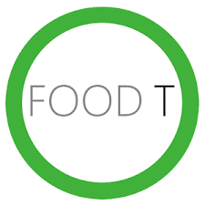
We would like to know if:
- Food T is helpful?
- You have time to play it?
- If you like playing it?

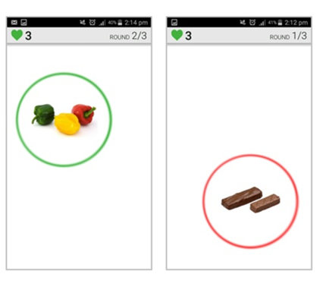
How do you play the app?

The app is a simple game.

It will show you pictures, one by one.

When there is a green circle around the picture, you should tap it as quickly as possible.

When there is a red circle around the picture, try not to tap it.

If you want to take part, we will help you to set it up when you come to clinic. Then you can play at home.

What will happen?

Your information
- Your information will be kept safe. It will not have your name on, so no one outside the research team will know what you have told us
- What you tell us will help us make the app better
Do I have to take part?
No, you do not need to take part. It is your choice. You can stop taking part at any time and you do not have to tell us why.

If you have questions or worries about the study, please tell your parents / guardians and you can speak to the researchers when you are next at clinic.

Contact: Jennifer.cox@bristol.ac.uk

