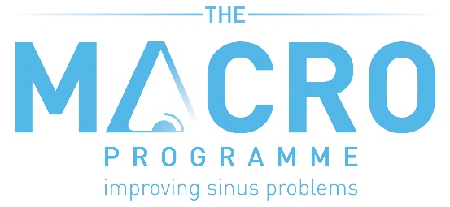

TRUST LOGO

Patient Information Sheet

Study title: Defining Best Management in Adult Chronic RhinOsinusitis (MACRO) Trial

We would like to invite you to take part in our research study. Before you decide we would like you to understand why the research is being done and what it would involve for you. One of our team will go through this information sheet with you and answer any questions you may have.

Part 1 tells you the purpose of this study and what will happen to you if you take part.
Part 2 gives you more detailed information about the conduct of the study.

Please ask us if there is anything that is not clear. Take time to decide whether or not you wish to take part.

PART 1

What is the purpose of the study?
The MACRO Trial, which is part of a large programme of work funded by the government, aims to establish which treatments work best for adults with CRS with and without nasal polyps.

Chronic Rhinosinusitis (CRS) is a long-term sinus disease affecting 1 in 10 adults in the UK. Symptoms of CRS include a blocked and runny nose, loss of smell, facial pain, tiredness and worsening of breathing problems, such as asthma. Studies have shown that sinus disease can have a greater impact on quality of life than heart disease and back pain.

The type of treatments given by GPs and Ear, Nose and Throat specialists in the NHS varies greatly. This is because doctors currently have limited information on how to effectively treat patients with CRS due to a lack of evidence from clinical trials in this area. Intranasal medications like nasal steroid sprays/drops and saline rinses (irrigations) play an important role in helping to improve CRS symptoms, and have been shown to be effective in trials. Saline rinses help wash away any excess mucus or irritants inside your nose, which can reduce swelling and relieve your symptoms. Nasal steroid sprays/drops help to reduce inflammation. Nasal steroids and saline rinses are considered “standard care”. Other treatments given may include further medications to reduce swelling, such as antibiotics, or operations such as endoscopic sinus surgery (ESS), but there are few trials comparing these with standard care.
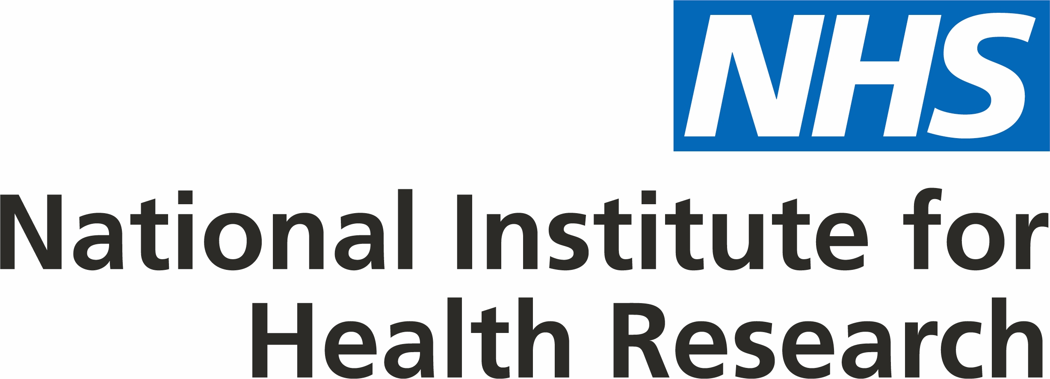

The MACRO Trial will investigate three different treatment options for patients with CRS. All participants who join the MACRO Trial will be asked to use standard care (intranasal medications), which are considered the current best practice for management of CRS. This intranasal medication includes nasal steroid drops/sprays and saline rinses. The trial duration is 6 months. All participants who have given their consent will be followed-up annually for up to 5 years (completion of annual follow-up is subject to additional funding).

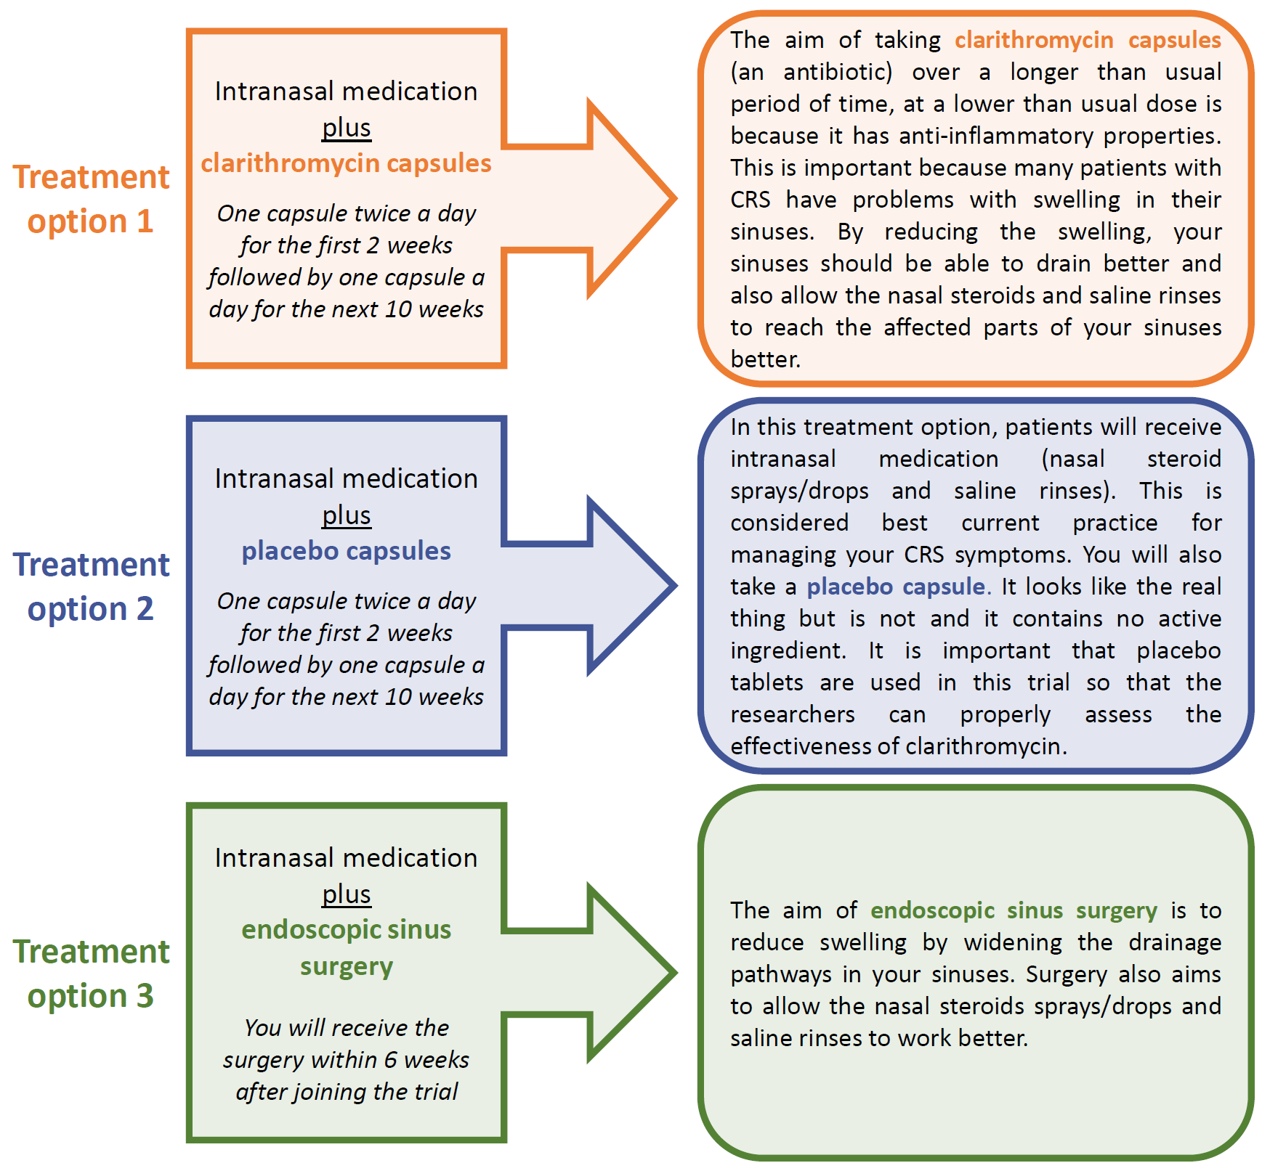
The three treatment options are shown below:

Why have I been invited?
You have been invited to consider joining the MACRO trial because your symptoms and examination / scan findings show that you have CRS. We will be recruiting 600 adults across the UK to join the trial.

Do I have to take part?
It is up to you to decide if you would like to join the study. You can decide not to take part. If you join the trial, you are free to withdraw at any time without giving a reason. This would not affect the standard of care you receive.

What will happen to me if I take part?
During your clinic appointment, your ENT doctor will discuss the MACRO Trial with you. They will assess whether you are eligible to take part by looking at the results of your routine tests which include endoscopy, SNOT-22 questionnaire (a questionnaire that you will be asked to complete) and non-contrast CT scan. They will also explain that in order to receive treatment in the MACRO Trial, you will first need to have a trial-specific electrical heart tracing (ECG). This is a painless procedure where electrodes are attached to your skin with sticky patches, and is to make sure that you can take clarithromycin safely. The ECG will take approximately 15 minutes. If you are a woman of childbearing potential, you will also be asked to take a urine pregnancy test, as you cannot join the trial if you are pregnant.

If you agree to take part, you will be given this information sheet to keep and be asked to sign a consent form. The original consent form will be stored by your hospital and you will be given a copy to take home. Part of the consent form includes consenting to receive the ECG and the pregnancy test.

Once your ECG and pregnancy test result (for those women of childbearing potential) has been reviewed and your ENT doctor has confirmed you are eligible to enter the trial, you will then be allocated your study treatment by a process called randomisation, which is described below:

Randomised Trial: Sometimes we don‘t know which way of treating patients is best. To find out, we need to compare different treatments. We put people into groups and give each group a different treatment. The results are compared to see if one is better. To try to make sure the groups are the same to start with, each patient is put into a group by chance (randomly).
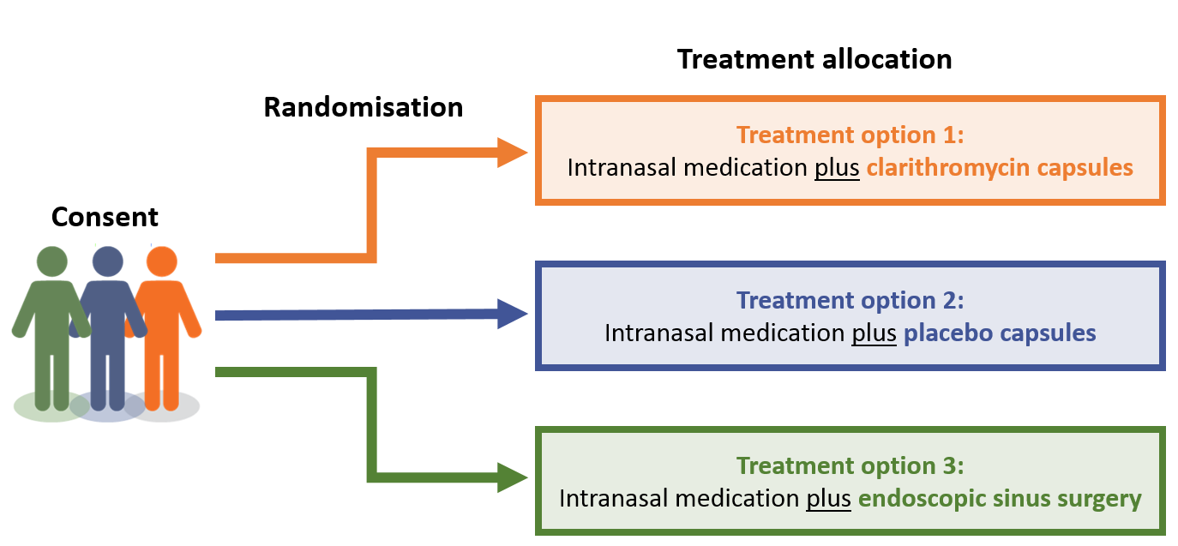
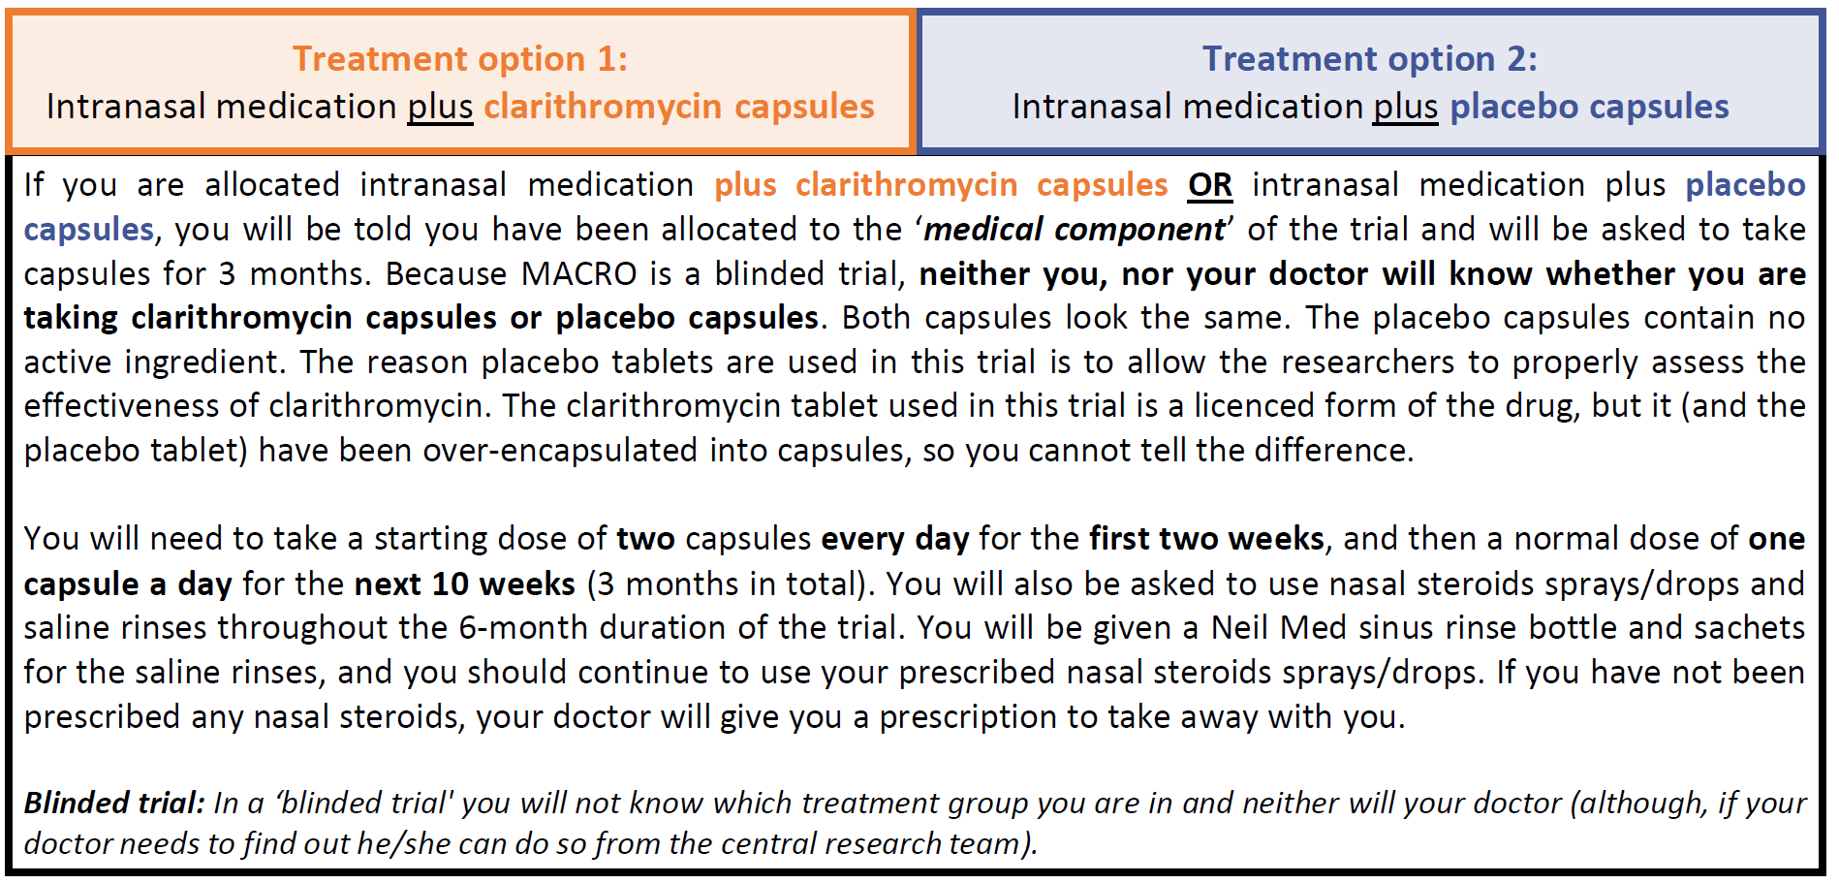
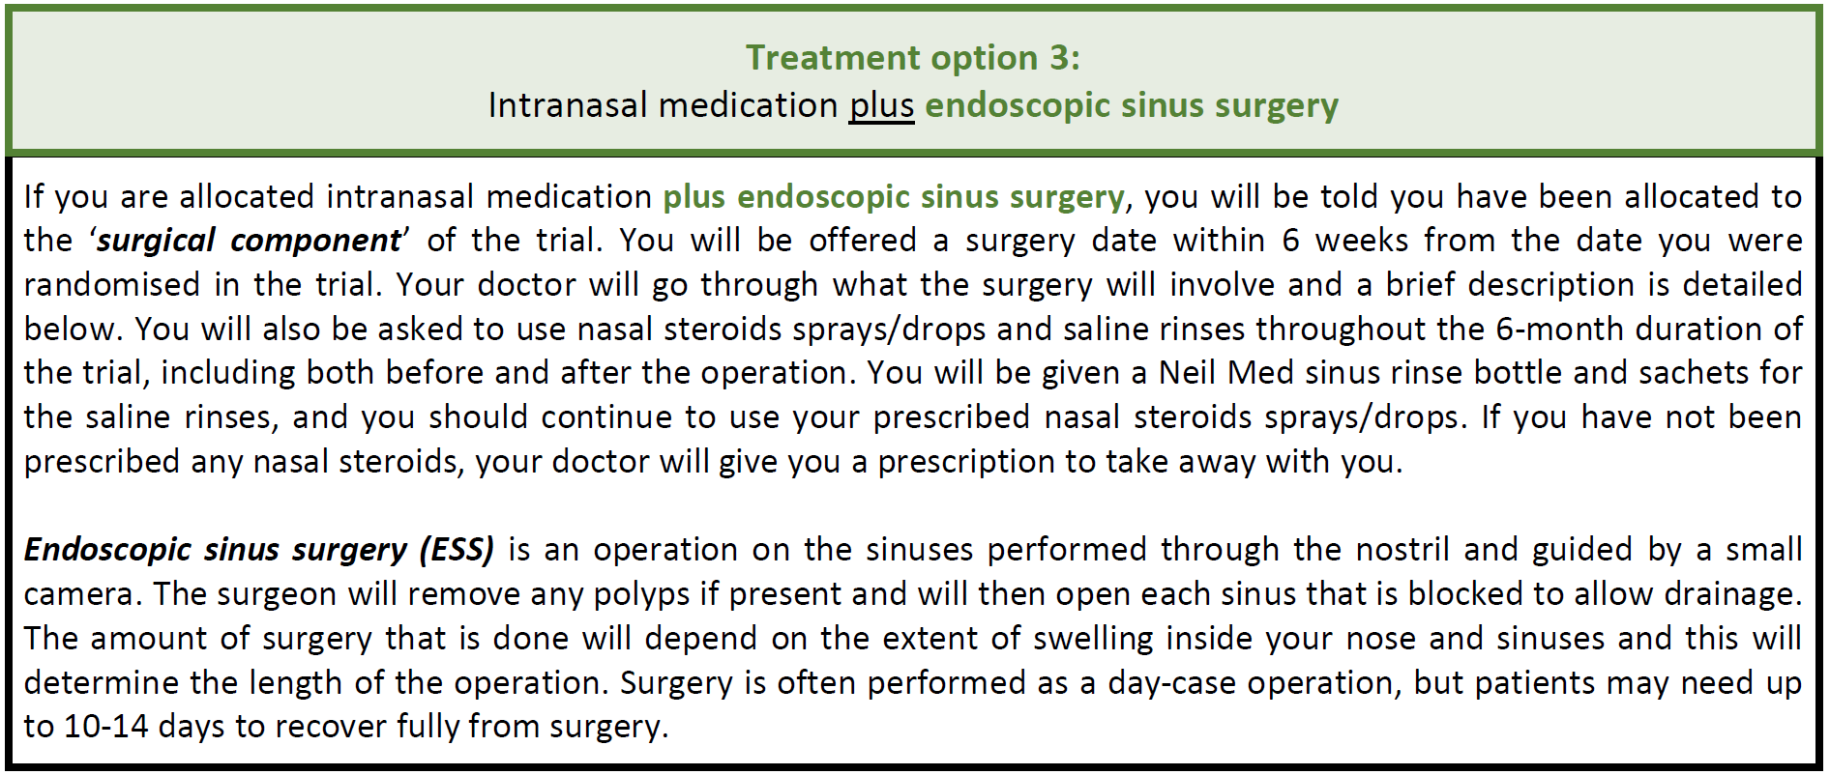
You will be randomly allocated to receive one of the three treatment options: intranasal medication plus clarithromycin capsules, intranasal medication plus placebo capsules or intranasal medication plus endoscopic sinus surgery. You will have an equal chance of getting one of receiving these three treatment options.

Please note that the nasal steroid sprays/drops are not provided as part of this study. You will need to pay for these as usual, in line with the NHS prescription charge. The saline rinses will be given to you free of charge.

Study Duration
The total study duration is 6 months. After 3 and 6 months you will return to the outpatient clinic to see your ENT doctor and/or research nurse or research practitioner and undergo some assessments. You will separately be asked to complete a number of questionnaires. These are vital aspects of the trial, as they record how you are feeling, if your symptoms are getting better, how much medication you are using and how many times you’ve been to see a doctor. Your ENT doctor or research nurse / research practitioner will go through these with you, and you will be asked to complete them on-line (a paper version is also available). You will be sent e-mails and text reminders to complete these, or reminders in the post if you have chosen to complete paper versions. A member of the central MACRO Trial Office which is part of the Oxford Clinical Trials Research Unit (OCTRU) based at the University of Oxford may contact you by telephone (up to a maximum of 5 times over the 6 months that you are in the trial) if you have not completed these documents and to see if you require any assistance. A sub-set of participants who have given their consent will be followed-up for up to five years, and asked to complete some short questionnaires on-line (a paper version will also be available).

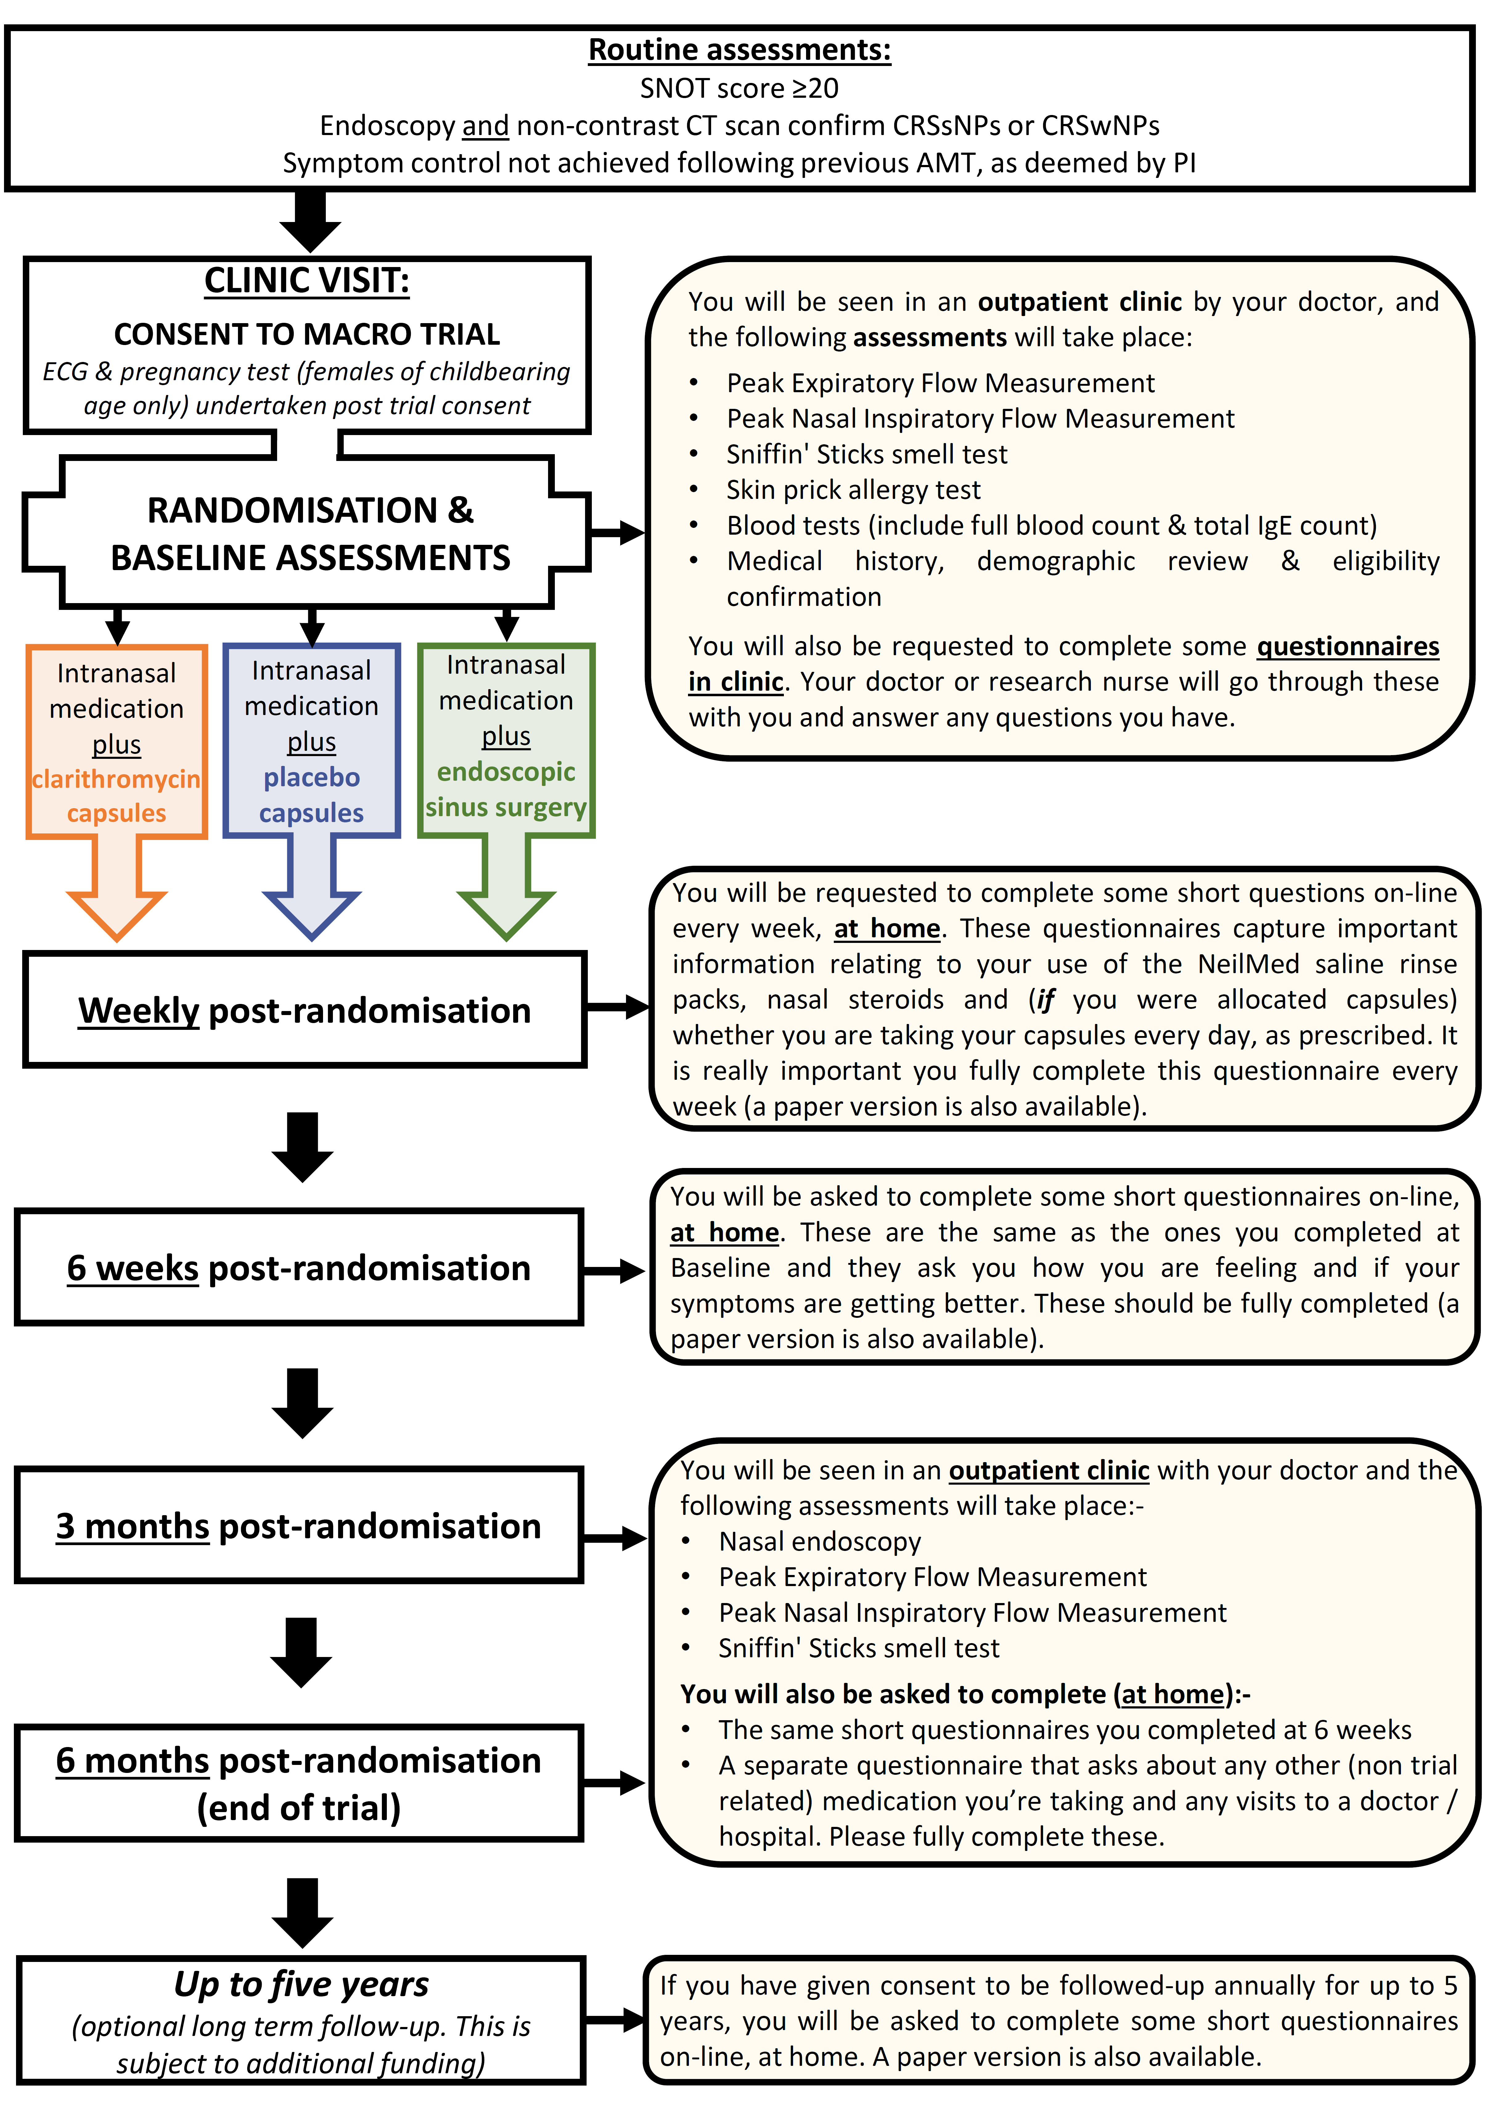
Below is a flow diagram which outlines the number of visits and assessments you will be asked to undertake in the MACRO Trial. Information can also be found on our website: https://workstream2.themacroprogramme.org.uk/

Expenses and payments
There are no payments for taking part in the MACRO Trial. We would normally expect all trial visits to coincide with routine standard care.

What will I have to do?
If you are allocated to the ‘medical component’ of the trial, where you will not know if you are taking clarithromycin or placebo capsules, it is important that you take the study medication as outlined in this information sheet and as directed by your ENT doctor. For the first two weeks, you need to take one capsule twice a day. For the next 10 weeks, you need to take one capsule a day. Clarithromycin 250mg is a marketed antibiotic which belongs to a group of medicines known as macrolides. This is a very commonly used antibiotic and its safety is well established. You may have to stop taking some of your regular medication for the 3 months that you are taking the study capsules in case they react – the ENT doctor/research nurse will clarify this with you as needed. After you have finished taking the study medication, you can resume taking any medication that you were advised to stop. If you are a woman of childbearing potential, it is important that you use additional barrier contraception measures while taking the trial capsules. If you become pregnant at any point during the trial, you must inform your ENT doctor or research nurse/research practitioner as soon as possible. You will be asked to stop taking the capsules if you fall pregnant. It is not clear that clarithromycin will cause any harm, but we will ask you to stop taking it as a precaution.

You will also be requested to carry a medical alert card with you at all times (see below). The card outlines that you’re taking part in a clinical trial and taking study medication. If you experience any unwanted side effects while taking the study medication, please let your ENT doctor or research nurse/research practitioner know as soon as possible. If you are seen by your GP or, in the very unlikely event, have to go to hospital because of the trial medication, please show the doctor this card. You may be requested to stop taking your medication. If this happens, please contact your ENT doctor or research nurse/research practitioner as soon as possible to let them know (please see section 14 of this information sheet for their details). If required, your doctor may be told what medication you’ve been taking in the trial (clarithromycin or placebo).

Example medical alert card:-
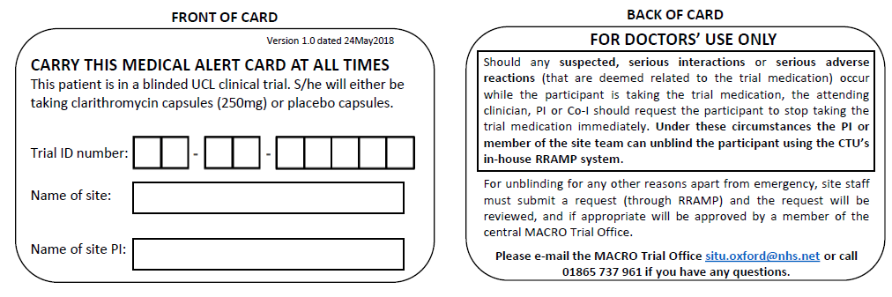

If you are allocated to the ‘surgical component’ of the trial, the ENT doctor will explain what is involved, and how you need to prepare on the day of surgery. You may have to stop taking some regular medication if the surgeon/anaesthetist recommend you do so. If you are a woman of childbearing potential and become pregnant before the operation, you must inform your ENT doctor/research nurse/research practitioner as soon as possible as you will be not be able to receive surgery within the MACRO Trial. We would however like you to remain in the trial, and continue completing all the trial questionnaires. If you become pregnant after the operation, you must also inform your ENT doctor/research nurse/research practitioner as soon as possible. You will be asked to remain in the trial, and continue completing all the trial questionnaires.
It is important that you fully complete all the questionnaires in the MACRO Trial. You will be given 7 days to complete each weekly questionnaire, and one month to complete the 3 & 6 month questionnaire

What are the alternatives for diagnosis or treatment?
The diagnosis of CRS will be made in accordance with established guidelines. Rarely, CRS may be caused by other conditions that affect your body more widely and if the ENT doctor suspects these conditions he/she may organise additional tests. If these tests are positive, then you might not be eligible for the trial.

The intranasal medications included in all treatment options are the only treatments which are currently supported by good evidence for use. The other commonly used medical and surgical treatment options are being explored in this trial.

There may be some additional medications that your ENT doctor may suggest that are available either as standard prescriptions or as part of other research trials. Your ENT doctor will let you know if anything else is suitable for you or if there are other trials to consider.

What are the possible disadvantages of taking part?
The possible disadvantages of taking part are listed in Table 1 at the end of this document. Please read this carefully, and ask as many questions as you wish at your next appointment.

What are the side effects and risks of any treatment received when taking part?
The side effects and risks for each treatment option are listed in Table 2 at the end of this document. Please read this carefully, and ask as many questions as you wish at your next appointment.

What are the possible benefits of taking part?
We cannot guarantee that participating in this study will be of direct benefit to you. We hope to be able to improve your CRS symptoms, but the main benefit of you taking part will be the information that we can gather. This information will help us improve treatment options for adults with CRS like you in the future. You will be closely followed up by your ENT doctor and the MACRO Research Team whilst participating in the trial.

What happens when the research study stops?
Once you have completed the trial, you will return to normal NHS care. If at the end of the trial you have not had any improvement in your CRS, you can discuss with your ENT doctor what course of treatment is best for you next. Depending on what treatment you received in the trial, you may want to consider receiving a treatment that you weren’t allocated to (this might include medical treatment or surgery); we won’t however be able to tell you if you had clarithromycin or placebo capsules (if you were allocated treatment options 1 or 2), except in an emergency.

What if there is a problem?
Any complaint about the way you have been dealt with during the clinical trial or any possible harm you might suffer will be addressed. The detailed information concerning this is given in Part 2 of this information sheet. If you have any concerns or complaints you should contact your ENT doctor or a member of the research team in the first instance.

Will my taking part in the study be kept confidential?
Yes. We will follow ethical and legal practice and all information about you will be handled in confidence. The details are included in Part 2.

Contact Details

Your ENT Doctor

Name add name Tel. Number: add Tel. number

Your Research/Specialist Nurse/Research Practitioner/Research Fellow delete as appropriate

Name add name Tel. Number: add Tel. number

This completes Part 1 of the Information Sheet.

If the information in Part 1 has interested you and you are considering participation, please read the additional information in Part 2 before making any decision.

PART 2

What if relevant new information becomes available?
Sometimes we get new information about the treatment being studied. If this happens, we will tell you about it and discuss whether you want to or should continue in the study. If you decide not to carry on, we will make arrangements for your care to continue. If you decide to continue in the study we will ask you to sign an updated consent form.

What will happen if I don’t want to carry on with the study?
If you don’t wish to continue with the treatment, you can stop taking the treatment but keep in contact with us to let us know your progress. If you are happy to, we would like you to continue completing the questionnaires. Information collected may still be used. If you wish to leave the study altogether, you can let the research team know at any time and you have no obligation to provide any reason for doing so. If you leave the study, you will be returned to normal care provided by the ENT team to whom you were originally referred, and the doctor will see you in clinic to discuss any further treatment you wish to consider.

What if there is a problem?
If you have a concern about any aspect of this study, you should contact the central MACRO Trial Office who will do their best to answer your questions [macrotrial@nds.ox.ac.uk]. If you remain unhappy and wish to complain formally, you can do this by contacting [insert details of PALS at each site].

Every care will be taken in the course of this clinical trial. However in the unlikely event that you are injured by taking part, compensation may be available.

If you suspect that the injury is the result of the Sponsor’s (University College London) or the hospital's negligence then you may be able to claim compensation. After discussing with your ENT doctor, please make the claim in writing to Professor Carl Philpott, Chief Investigator for the MACRO Trial, care of UCL, 1st Floor of Maple House, 149 Tottenham Court Road, London, W1T 7DN. The Chief Investigator will then pass the claim to the Sponsor’s Insurers, via the Sponsor’s office. You may have to bear the costs of the legal action initially, and you should consult a lawyer about this.

Participants may also be able to claim compensation for injury caused by participation in this clinical trial without the need to prove negligence on the part of University College London or another party. You should discuss this possibility with your ENT doctor in the same way as above.

Regardless of this, if you wish to complain, or have any concerns about any aspect of the way you have been approached or treated by members of staff or about any side effects (adverse events) you may have experienced due to your participation in the clinical trial, the normal National Health Service complaints mechanisms are available to you. Please ask your ENT doctor if you would like more information on this. Details can also be obtained from the Department of Health website: http://www.dh.gov.uk.

The privacy notice (confidentiality and data protection)
If you consent to take part in this study, the records obtained while you are in this study as well as related health records will remain strictly confidential at all times. UCL is the sponsor based in the United Kingdom but has delegated the responsibility of running and managing this study to the central MACRO Team at the Oxford Clinical Trials Research Unit (OCTRU) which is part of the University of Oxford. UCL will carry out this research under the provisions of the General Data Protection Regulation (EU) 2016/679 and will be using information from you and your medical records in order to undertake this study. UCL will act as the data controller for this study. This means that UCL, are responsible for looking after your information and using it properly.
[NHS site] will use your name, telephone number, email address and contact details to contact you about the research study, and make sure that relevant information about the study is recorded, and to oversee the quality of the study. [NHS site] will enter these details onto a secure randomisation system when you enter the trial, and these details, along with the information collected from you and your medical records will be sent to and accessed by the central MACRO Team at OCTRU. Your identifiable information will be held on an encrypted, password protected database at the University of Oxford, which is separate to the database where your pseudo-anonymised trial data is kept. This will ensure that all information about you to be kept confidential. OCTRU will use your name, e-mail address and telephone numbers to contact you (if you are completing the trial questionnaires on-line) or your name, home address and telephone numbers (if you are completing the trial questionnaires by post). If you give your additional consent for the MACRO Researcher undertaking telephone interviews (who is based at Southampton University) to contact you, OCTRU will send them your name, e-mail address and telephone number via a secure e-mail address. The only people in UCL, OCTRU, the University of Southampton or those delegated by the sponsor, who will have access to

information that identifies you will be people who need to contact you to as outlined above, or to monitor and audit the data collection process. The people who analyse the information will not be able to identify you and will not be able to find out your name or contact details.
The information will be held securely on paper and electronically at your treating hospital, OCTRU and the University of Southampton (if applicable). Your name will not be passed to anyone else outside the research team or the Sponsor (UCL), who is not involved in the trial. You will be allocated a trial number, which will be used as a code to identify you on all trial forms. Your initials and year of birth will also be written on trial forms.

Your records will be available to people authorised to work on the trial but may also need to be made available to people authorised by the Sponsor, which is the organisation responsible for ensuring that the study is carried out correctly.

The information collected about you may also be shown to people authorised by the Medicines and Healthcare Products Regulatory Authority (MHRA); this is to ensure that the study is carried out to the highest possible scientific standards. All will have a duty of confidentiality to you as a research participant.

OCTRU (on behalf of UCL) will keep identifiable information about you for 6-12 months after the study has finished. UCL will keep your personal data in accordance with legal requirements and this data will be stored securely in the trial database and in paper files for at least 25 years after the study ends. Arrangements for confidential destruction will then be made. NHS site will keep your identifiable data for at least 25 years after the trial has ended.

Data collected during the study may be transferred to associated researchers within/outside the European Economic Area. Some countries outside Europe may not have laws which protect your privacy to the same extent as the EU General Data Protection Regulation. The Sponsor of the trial will take all reasonable steps to protect your privacy.

Your rights to access, change or move your information are limited, as we need to manage your information in specific ways in order for the research to be reliable and accurate. If you withdraw from the study, we will keep the information about you that we have already obtained. To safeguard your rights, we will use the minimum personally-identifiable information possible.
You can find out more about how UCL use your information at http://www.ucl.ac.uk/jro/who-are-we/data-protection or by contacting the sponsor’s office at CTIMPS@UCL.ac.uk.
The UCL data protection officer can be contacted at data-protection@ucl.ac.uk.

Will my GP be informed of my involvement?
With your permission, your GP, and other doctors who may be treating you, will be notified that you are taking part in this study. We may also contact your GP to check your status, if we cannot reach you directly.

Further optional research
You have the option to consent to further optional related research, which includes:
- Being contacted in the future about the MACRO Trial or participating in other research studies (e.g. a research project which could involve the collection of tissue/blood/mucus samples)
- Taking part in a research interview (further explained below)
- Consenting to being contacted once a year, for a total of 5 years, as part of the larger MACRO Programme of work. If you consent to this, the MACRO Research Team will contact you once a year, and ask you to complete some short questionnaires on-line (paper versions also available).

Taking part in a research interview
Following your participation in the MACRO Trial you may be invited to take part in an optional telephone interview with a researcher about your views on the treatment you have received for your CRS and about your experience of taking part in the MACRO Trial. With your permission the interview will be audio-recorded. Data will be kept securely and in confidence, and all audio-recordings will be named with a reference number (not your name) to hide your identity. In line with the regulations, at the end of the study audio recordings will be securely archived for a minimum of 25 years. Arrangements for confidential destruction will then be made. Anonymous quotes may be used in reports and publications, but it won’t be possible to recognise you from any of the information we present. The information from the interviews will help us to interpret the results of the MACRO Trial and understand how they can be more widely used in the NHS.

What will happen to any samples I give?
You may be advised to have some samples taken as part of your normal clinical care, but you will not be required to give any additional samples as part of the MACRO Trial. You will be given the option to consent to being contacted regarding other research studies.

Will any genetic tests be done?
No, not as part of the MACRO trial.

What will happen to the results of the research study?
The results of the study will be available after it finishes and will usually be published in a medical journal or be presented at a scientific conference. Details will also be available on our website https://workstream2.themacroprogramme.org.uk/. The data will be anonymous and none of the patients involved in the trial will be identified in any report or publication.

Who is organising and funding the research?
The MACRO trial is funded by the National Institute of Health Research (NIHR): Programme Grant for Applied Research (PGfAR) funding stream. University College London are sponsoring this trial. The ENT doctor at your hospital who has recruited you is not being paid for his/her part in the MACRO Trial above beyond his/her normal salary and does not benefit personally from taking part in this trial.

Who has reviewed the study?
All research in the NHS is looked at by independent group of people, called a Research Ethics Committee, to protect your interests. This study has been reviewed and given favourable opinion by North East - Newcastle & North Tyneside 2 Research Ethics Committee (REC ref: 18/NE/0210).

Further information and contact details
You are encouraged to ask any questions you wish, before, during or after your treatment. If you have any questions about the study, please speak to your study nurse or ENT doctor, who will be able to provide you with up to date information about the drug(s)/procedure(s) involved. If you wish to read the research on which this study is based, please ask your study nurse or ENT doctor. If you require any further information or have any concerns while taking part in the study please contact one of the following people:

Your ENT Doctor

Name add name Tel. Number: add Tel. number

Your Research/Specialist Nurse/Research Practitioner/Research Fellow delete as appropriate

Name add name Tel. Number: add Tel. number

If you decide you would like to take part then please read and sign the consent form. You will be given a copy of this information sheet and the consent form to keep. A copy of the consent form will be filed in your patient notes, one will be filed with the study records and one may be sent to the Research Sponsor.
You can have more time to think this over if you are at all unsure. Thank you for taking the time to read this information sheet and to consider this study.

Table 1. Summary of possible disadvantages of taking part
Trial treatment | Possible disadvantage / risk
Clarithromycin capsules | - Side effects – see below
Placebo therapy | - Not the active drug – no effect
Endoscopic sinus surgery | - Complications of surgery and anaesthesia – see below  - Not effective at controlling swelling in sinuses

Table 2. Summary of current evidence about side effects and risks of taking part
Trial treatment | Side effect or risks
Intranasal medication | Steroid nasal sprays or drops  These do not usually cause any significant side effects if used correctly and at normal doses. Side effects can include:  - A stinging or burning sensation in the nose  - Dryness and crustiness in the nose  - A dry, irritated throat  - An unpleasant taste in the mouth  - Itchiness, redness and swelling in the nose  - Nosebleeds  Nasal rinses  Mild side effects, like a slight stinging or burning may occur, depending on individual reaction with the saline solution, strength of the mix, and sensitivity of the membrane in your nose.
Clarithromycin capsules | You will not know if you’re taking clarithromycin capsules or placebo capsules. The most common side effects of clarithromycin are:  - Abdominal pain - Insomnia  - Diarrhoea - Dyspepsia  - Nausea - Rash  - Vomiting - Hyperhidrosis  - Change in sense of taste - Liver function test abnormal  - Headache  These side effects are usually mild in intensity and are consistent with the known safety profile.
Placebo capsules | You will not know if you’re taking clarithromycin capsules or placebo capsules. In very rare cases, a reaction to the placebo capsule can take place.
Endoscopic sinus surgery | Specific complications of sinus surgery:  - Bleeding (affects 1 in 200), varies from mild to severe  - Infection (affects 1 in 15), usually mild to moderate  - Minor bleeding can occur into the eye socket which is seen as bruising around eye (affects 1 in 500), usually mild  - More serious bleeding into the eye socket can very rarely occur. Direct trauma to the orbital contents may cause double vision or in extremely rare cases loss of sight (affects <1 in 10,000), severe  - Leak of brain fluid and possible risk of meningitis if leak is not sealed (affects 1 in 1500), moderate  General complications:  - Deep vein thrombosis (DVT) less than 1% chance, mild  - Clot on lung (pulmonary embolism) 0.3% chance, moderate - severe  - Anaesthetic complications:  - Damage to teeth (1 in 5000)  - Reaction to anaesthetic drugs e.g. rash, high temperature (1 in 10,000, mild, 1 in 200,000 severe)

