The Liver Unit Main switchboard: 020 7377 7000
Secretary only: 020 7882 7241
The Royal London Hospital www.bartsandthelondon.nhs.uk
Whitechapel
London E1 1BB

Professor G R Foster
Professor of Hepatology

PATIENT INFORMATION SHEET (Version 1.4)

IRAS number 200503

Response guided therapy with sofosbuvir/velpatasvir for 12 or 24 weeks in patients with genotype 3 chronic hepatitis C virus: is longer therapy worthwhile? (EXTEND-3 study)

Invitation

You are invited to take part in a clinical research study involving the drugs sofosbuvir/velpatasvir for the treatment of chronic hepatitis C infection. Before you decide it is important for you to understand why the research is being done and what it will involve. Please take time to read the following information carefully. Please ask us if there is anything that is not clear or if you would like more information, and feel free to discuss with your doctor, family and friends before making a decision. You will be given as much time as you need to make a decision. Your participation in this study is voluntary. If you decide not to participate this will not affect the way you are treated and you will continue to be cared for in exactly the same way.

What is the purpose of the study?

Treatment for patients with chronic hepatitis C virus (HCV) infection is rapidly developing. Until recently, treatment required a weekly injection of pegylated interferon for 6 months for your subtype of HCV (genotype 3) infection. Interferon injections cause many side effects and are poorly tolerated by patients.

For genotype 3 HCV infection, one of the treatment options offered by NHS England which is tablet only, without interferon injections, is sofosbuvir/velpatasvir (Epclusa®)– containing two antivirus drugs in one tablet. This is prescribed for specific patients who usually have significant liver scarring (cirrhosis) due to HCV infection.

Sofosbuvir/velpatasvir treatment can be used for a duration of 12 or 24 weeks (i.e. 3 or 6 months). The drug license recommends for patients who are ‘difficult to cure’, they should receive 12 weeks of sofosbuvir/ velpatasvir with addition of the drug ribavirin. Ribavirin tablets are frequently used in part of HCV treatments, but can be associated with side effects which some patients find unable or unwilling to tolerate. International guidelines suggest that for such patients who cannot take ribavirin, extension of sofosbuvir/velpatasvir to 24 weeks is a suitable alternative.

There is not enough evidence yet to show extension of treatment is much better at curing HCV infection than the standard 12 weeks. Extended treatment may be more inconvenient as it is longer with potentially more side effects (although most are mild), and is more costly. Most patients on the NHS will be prescribed the standard 12 week course, with or without ribavirin.

This trial aims to improve treatment options for patients who are difficult to cure without using ribavirin. Many studies have shown that patients who respond slowly to sofosbuvir/velpatasvir treatment, that is the virus has not disappeared after the first 2 weeks of treatment, are difficult to cure, and may require more than 12 weeks of standard treatment. We want to test if extending treatment to 24 weeks helps to improve cure rate or not, and to see if the longer duration of therapy is worthwhile to be offered to NHS patients. The results will help doctors to offer better treatments for future patients, and may influence wider NHS treatment policies and guidelines.

Why have I been invited to take part?

You have been diagnosed with genotype 3 HCV and have advanced liver scarring (cirrhosis), and have been offered NHS treatment with sofosbuvir/velpatasvir. Your blood tests show that after the first 2 weeks of treatment, your virus levels have reduced but the virus is still present in your blood.

Based on earlier research, we believe that the presence of HCV in the blood after the first 2 weeks of treatment suggests that you may not respond as well as other patients. This study will compare the effectiveness of the treatment for 12 and 24 weeks, in patients like you who show this ‘slower’ early response to treatment. At present it is not known if patients like yourself are better treated with 12 or 24 weeks of therapy.

Do I have to take part?

No – you do not have to take part and it is up to you to decide whether you want to take part or not. If you choose to take part, you will be given this leaflet to keep and you will be asked to sign a consent form. You are still free to change your mind about participation at any time without giving a reason. A decision to withdraw at any time, or a decision not to take part, will not affect the standard of care you receive. If you do not take part, you will continue your usual NHS care and complete the course of sofosbuvir/velpatasvir at the standard duration which was originally decided by your doctor.

If you started the study but later withdraw, or if for any reason are withdrawn by the study investigators, but your treatment is not complete, it is up to your usual doctor to decide if you should continue treatment as part of routine NHS care. Your doctor will advice you should that happen.

If you withdraw or are withdrawn from the study, we would like to follow up on your treatment outcome, but only with your permission. We will only collect your virus blood test result at 3 months after you discontinued treatment, to see if the virus has been permanently cleared from your body. Your usual doctor will normally perform this test for you to see if you responded successfully to treatment, even though you have left the study, as it is still an important result for your ongoing medical care. If your usual doctor has not performed this test, we will request that they check it for you, but we will not directly contact you after you have left the study. We will not collect any data other than the virus test result.

If you prefer, you can choose for us not to collect any further data on you once you have left the study.

What will happen to me if I take part?

If you decide to take part, a study doctor/ nurse will meet you to discuss the trial in detail with you, and ensure that you fit the criteria for patients required for the trial. You may be asked to perform extra blood tests or scans, to check the status of your liver and general health, but for most patients these would have been performed as part of their routine clinical care, and we will record these results for the study. If you are a female of childbearing potential, you will be asked for a urine test to confirm you are not pregnant. The urine sample will then be discarded.

You will be randomly allocated by a computer to receiving 12 or 24 weeks of treatment with sofosbuvir/velpatasvir. You will be notified which duration you are allocated to before the end of treatment week 12.

Once you are enrolled into the study, you will see the study team instead of your usual doctor or nurse, until the end of the study. You will be reviewed in clinic every 4 weeks. The assessments during these clinic visits will be similar to your usual NHS treatment – you will have blood tests performed (to check your virus response and safety on treatment). Your doctor/ nurse will document any missed drug doses, and any problems related to treatment. They may perform additional examination or tests, arrange clinic visits at other time points, as deemed necessary according to your clinical condition. If you are allocated to extended treatment, you will receive extra sofosbuvir/velpatasvir tablets for 3 months. For all participants, you will be asked to answer a short survey on your quality of life twice (at the end of treatment, and at 3 months after end of treatment). You will be notified the outcome of treatment (whether or not HCV is permanently cleared and you have achieved SVR) after your final study visit at 3 months following end of treatment.

You will be enrolled into the study from week 8 of your NHS treatment with sofosbuvir/velpatasvir. The total duration of the trial is maximum 16 weeks if you are allocated to standard (12 weeks) treatment, or 28 weeks if you are allocated to extended (24 weeks) treatment. At the end of the study, or if you withdraw early, you will return to your usual doctor for ongoing liver care.

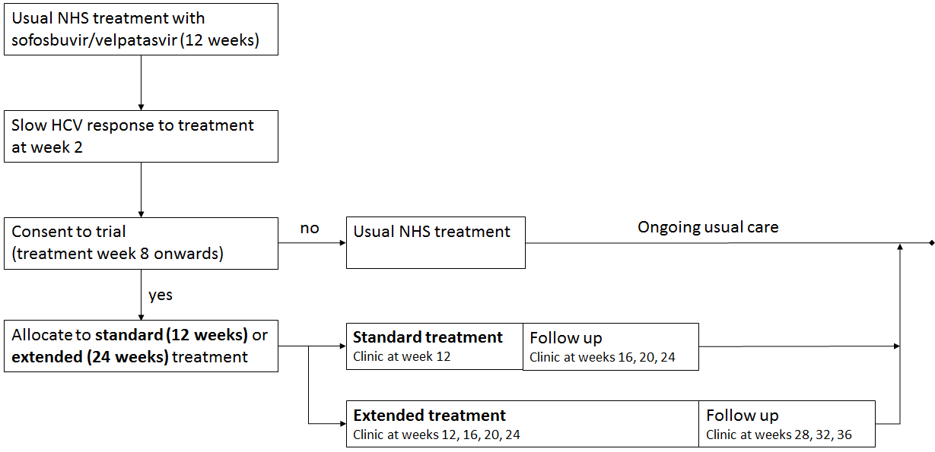

What is the drug or procedure that is being tested?

Sofosbuvir/velpatasvir is a licensed drug used to treat HCV and is amongst the most effective treatments for genotype 3 infection to date. Standard NHS treatment is a 12 week course, with or without ribavirin. Ribavirin is added when a patient is thought to be more difficult to cure, but it has unpleasant side effects which may be poorly tolerated. Ribavirin is the drug previously combined with interferon injection to treat HCV.

In this study, instead of adding ribavirin to improve treatment cure for patients who are difficult to cure, we will test if extending treatment, from standard 12 weeks of sofosbuvir/velpatasvir to 24 weeks, is effective. The longer course is not licensed standard treatment, but is recommended by international guidelines as an option if ribavirin is not used.

Earlier studies showed that for genotype 3 infected patients with cirrhosis, cure rates after 12 weeks of sofosbuvir/velpatasvir varied between 50-91% depending on severity of cirrhosis. Extending to 24 weeks did not improve cure but the number of patients tested were small and inconclusive. Adding ribavirin did improve cure but its use was also associated with increased side effects, which was not seen when extending treatment without adding ribavirin.

At present there is no established way to decide if patients are difficult to cure and require additional treatment. We believe that patients like yourself, whose virus is slow to respond on treatment, may be more difficult to cure, and are more likely to benefit from extended treatment, if extension is indeed more effective. There has not been previous studies comparing directly 12 and 24 weeks treatment in patients like yourself, so it is not known which duration is better. This study aims to investigate this, and to see if virus response during treatment is a useful guide to doctors when choosing the best duration of treatment.

Whether you are allocated to 12 or 24 weeks of treatment, you will receive the same drugs as those provided in usual NHS treatment and no additional drug will be used, but the 24 week course is only available within this trial.

What are possible disadvantages and risks of taking part?

During this study, you will be randomly allocated to receiving either 12 or 24 weeks of treatment in total (the study will have equal numbers in both treatment durations, so you will have a 50:50 chance of being in either treatment group). It is not known which will be more effective for you – it is the purpose of the trial to test this.

Previous studies showed that side effects with sofosbuvir/velpatasvir are mild. The most frequently reported symptoms (affecting more than 10% of treated patients) were headache, tiredness and nausea (sickness), but these were similar in patients who received placebo (sugar pill without active drug) when compared in a trial. The side effects of treatment are expected to be similar whether you are taking the drugs as your routine NHS care, or within the trial, since the drugs are the same. If you are taking the extended treatment course, you may experience side effects for a longer period of time, but the safety of the drug when tested in clinical trial is the same whether taken for 12 or 24 weeks.

Due to potential interaction with other drugs, you may be advised to temporarily stop or change certain medications during your treatment. This is according to the advice given by the drug manufacturers. The study advice may slightly vary to what you have been told by your usual doctor when you first started sofosbuvir/velpatasvir. This is because different hospitals may have different practices and for this study we require all participants to follow the same advice.

It is unknown if sofosbuvir/velpatasvir may affect an unborn baby, or if it may be passed into breast milk. The drug manufacturer recommends avoidance during pregnancy or breast feeding. The trial requires that male and female participants avoid trying for a baby until 30 days after treatment end. If you or your partner becomes pregnant during the trial, you should notify the research team for advice.

If following treatment your HCV is not cleared, or returns after being initially cleared, your doctor may offer alternative drugs, including clinical trial drugs, or to wait for future therapies. This is the case whether you participate in the study, or whether you are treated on routine NHS care.

What are the benefits of taking part?

NHS England offers sofosbuvir/velpatasvir for 12 weeks and according to licensed recommendation, patients who are difficult to cure may receive additional ribavirin to improve chance of successful treatment.

Since you have started taking sofosbuvir/velpatasvir, your HCV levels have shown a ‘slow’ response to treatment. We believe this represents a reduced likelihood of treatment cure, therefore compared to other patients you may benefit more from extending treatment to 24 weeks, although it is uncertain if longer therapy is more effective. Extending treatment is likely to be much easier to tolerate compared to the alternative option of adding ribavirin which has known unpleasant side effects.

If you are successfully cleared of HCV after treatment with sofosbuvir/velpatasvir, your liver disease is likely to improve over time.

This study aims to answer the uncertainty of whether viral response during treatment can help select the best duration of treatment required. Your participation will contribute to an important research area, to improve future treatment for patients.

To ensure participation in this study is voluntary, there is no financial reward for patients. If this study involves excess travel compared to your usual NHS care, please speak to your study nurse/doctor regarding hospital transport or compensation for travel.

What happens if new information becomes available?

If new information becomes available which may change the scientific value or safety of the research, or your willingness to take part, this will be provided to you in timely manner.

What happens if there is a problem?

During this study, your clinical management will be in line with usual NHS care. If there are medical problems, please report to your study doctor/ nurse. In case of emergencies, please see contact details below, or contact your local emergency services.

The drugs offered in this study are approved for routine NHS use. If you feel you have come to harm because of participation in the study, you can report this via the contact details below, or through the usual NHS complaints procedure using PALS. Queen Mary University of London (the study sponsor) has agreed that if you are harmed as a result of your participation in the study, you will be compensated, provided that, on the balance of probabilities, an injury was caused as a direct result of the intervention or procedures you received during the course of the study. These special compensation arrangements apply where an injury is caused to you that would not have occurred if you were not in the trial. These special arrangements do not affect your right to pursue a claim through legal action.

Contact details for further information:

For questions or problems relating to this research study please contact:

Chief Investigator: Prof Graham Foster
Daytime: 020 7377 7457/ 020 7882 7241
Address:
Blizard Institute, Barts & The London School of Medicine & Dentistry, Queen Mary University of London, 4 Newark Street, London E1 2AT

or the study team at your site:

Principle Investigator:
Study site:
Daytime:
Out of hours:
Address

For any complaints regarding your care as a study participant, please contact the Patient Advisory Liaison Service (PALS) at your hospital site:

Hospital:
Telephone:
Email:

Will my information be kept confidential?

All information which is collected about you during this study will be kept confidential. With your permission we will inform your GP and/or any other medical practitioners who currently treat you about your participation in this study.

Outside of your clinical team who are directly looking after your care, certain authorised personnel may require access to your medical records, for management of the study, or for monitoring that the study is carried out correctly.

Data which is recorded for the study will be processed in accordance with the Data Protection Act 1998. In accordance to the Sponsor (Queen Mary University of London) it will be stored in anonymised form for 20 years then disposed of securely. In addition, the study may be inspected by the Trial Oversight Committee, regulatory bodies and for audit purposes, but you will not be identifiable.

What will happen to the results of the research study?

At the end of the study the results will be published but patients who took part will not be identifiable.

The study results will also form part of a PhD (doctorate degree) which will be assessed by Queen Mary University of London.

Who is organising and funding the research?

This study is being led by the Chief Investigator Professor Graham Foster, and is sponsored by Queen Mary University of London. The study is funded by a Doctoral Research Fellowship awarded by the National Institute for Health Research (NIHR) which supports research within the NHS through the Department of Health.

Who has reviewed the study?

This study has been reviewed and was given a favourable opinion by an independent Ethics Committee (London - West London & GTAC Research Ethics Committee, reference 16/LO/0879). The scientific value of this study has been reviewed by independent experts in the field of hepatitis C.

Thank you for considering participating in this study

