Participant flow diagram
Excluded patients
84
3. Patient unable to wait on results 23
4. Antimicrobial treatment planned before surgery 1
5. Current or planned antibiotic treatment before
surgery 13
6. Surgery due to infection 7
7. Lives too far away for follow-up 12
10. Enrolled on other study 28
Inclusion Criteria not met
146

Total Screened
830

Eligible patients
600
Consent not obtained
326
A. Patient refusal 81
B. Patient incapacitated 13
C. Clinician refusal 39
D. No research staff 20
E. Lab unable to test samples 32
G. No clinical room 2
H. Too late in the day to screen 85
I. Not approached 38
J. Other 16

Consented patients
274

Results Unknown
10
Assay Failure 9
Withdrawn, not tested 1
SA negative
164
SA positive
100

Continued on Study
86
MSSA 81
MRSA 5

Follow-up
86
Lost to follow-up 0
Withdrawn 14

Analysis
86
Analysed 86
Excluded from analysis 0

Baseline characteristics

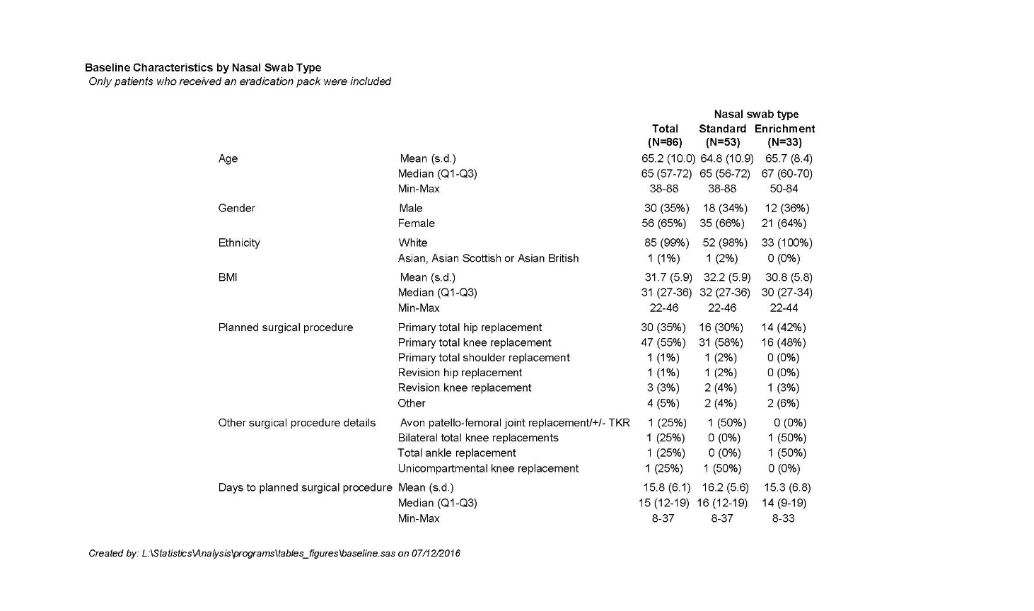

Outcome measures
Primary Outcome
Proportion of participants cleared of nasal SA at 48-96 hours after completing current eradication regimens for S. aureus.
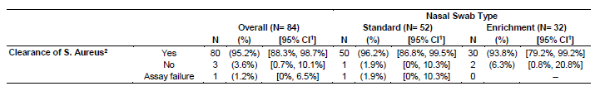

Secondary Outcomes

Feasibility Outcomes:
1. Consent rates as proportion of eligible patients
2. Recruitment rates
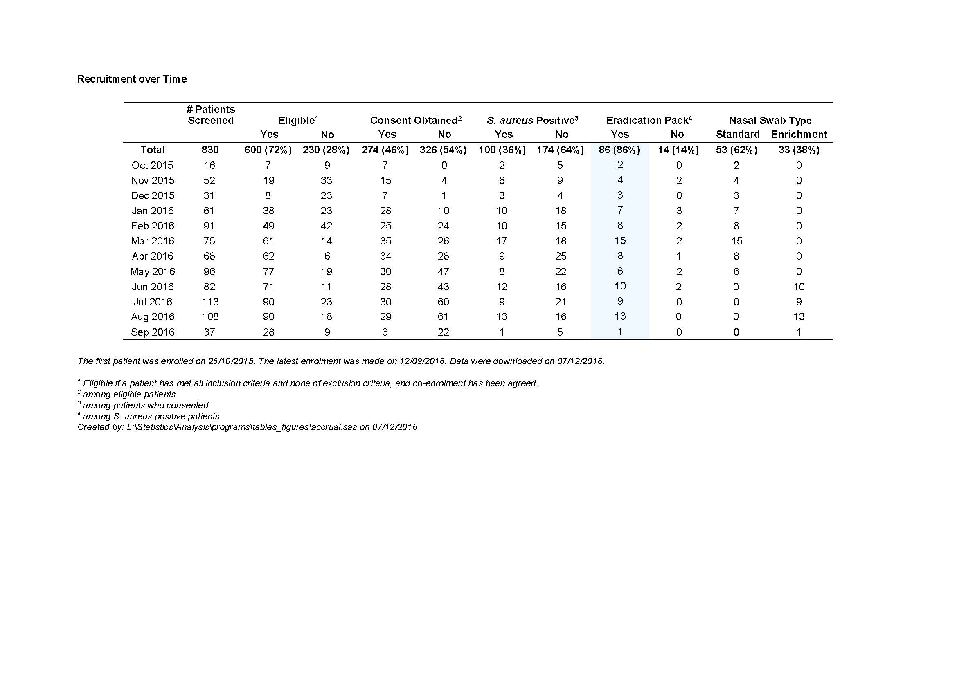

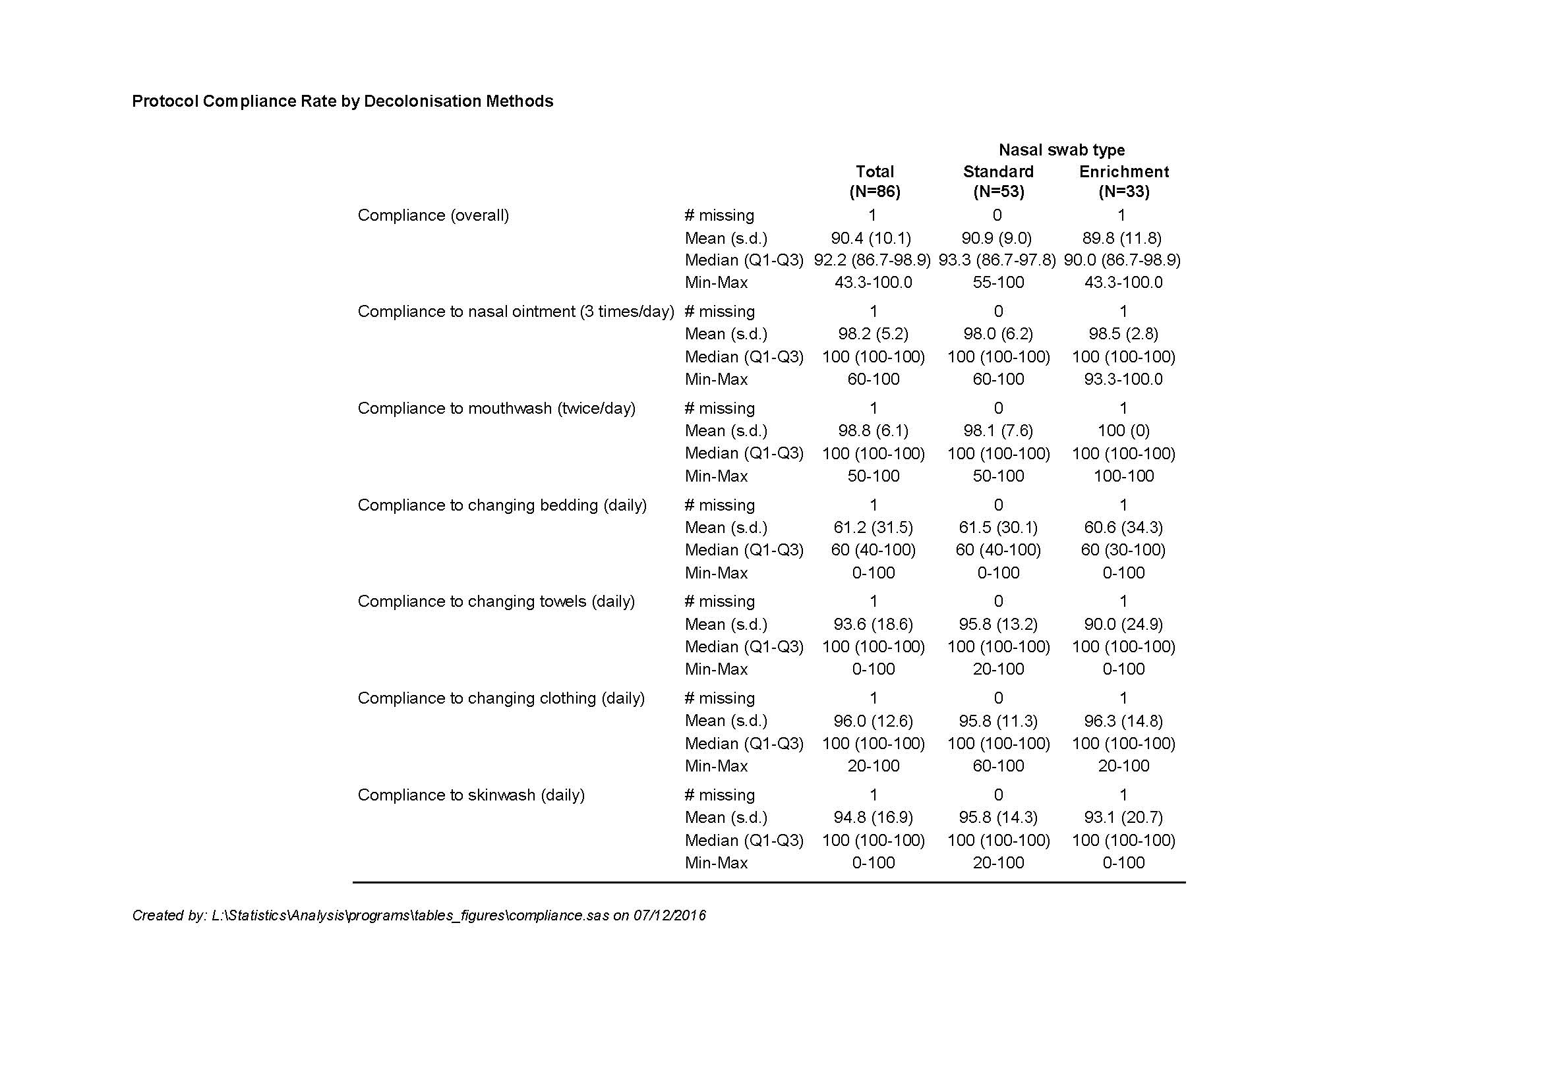
3. Protocol Compliance rates
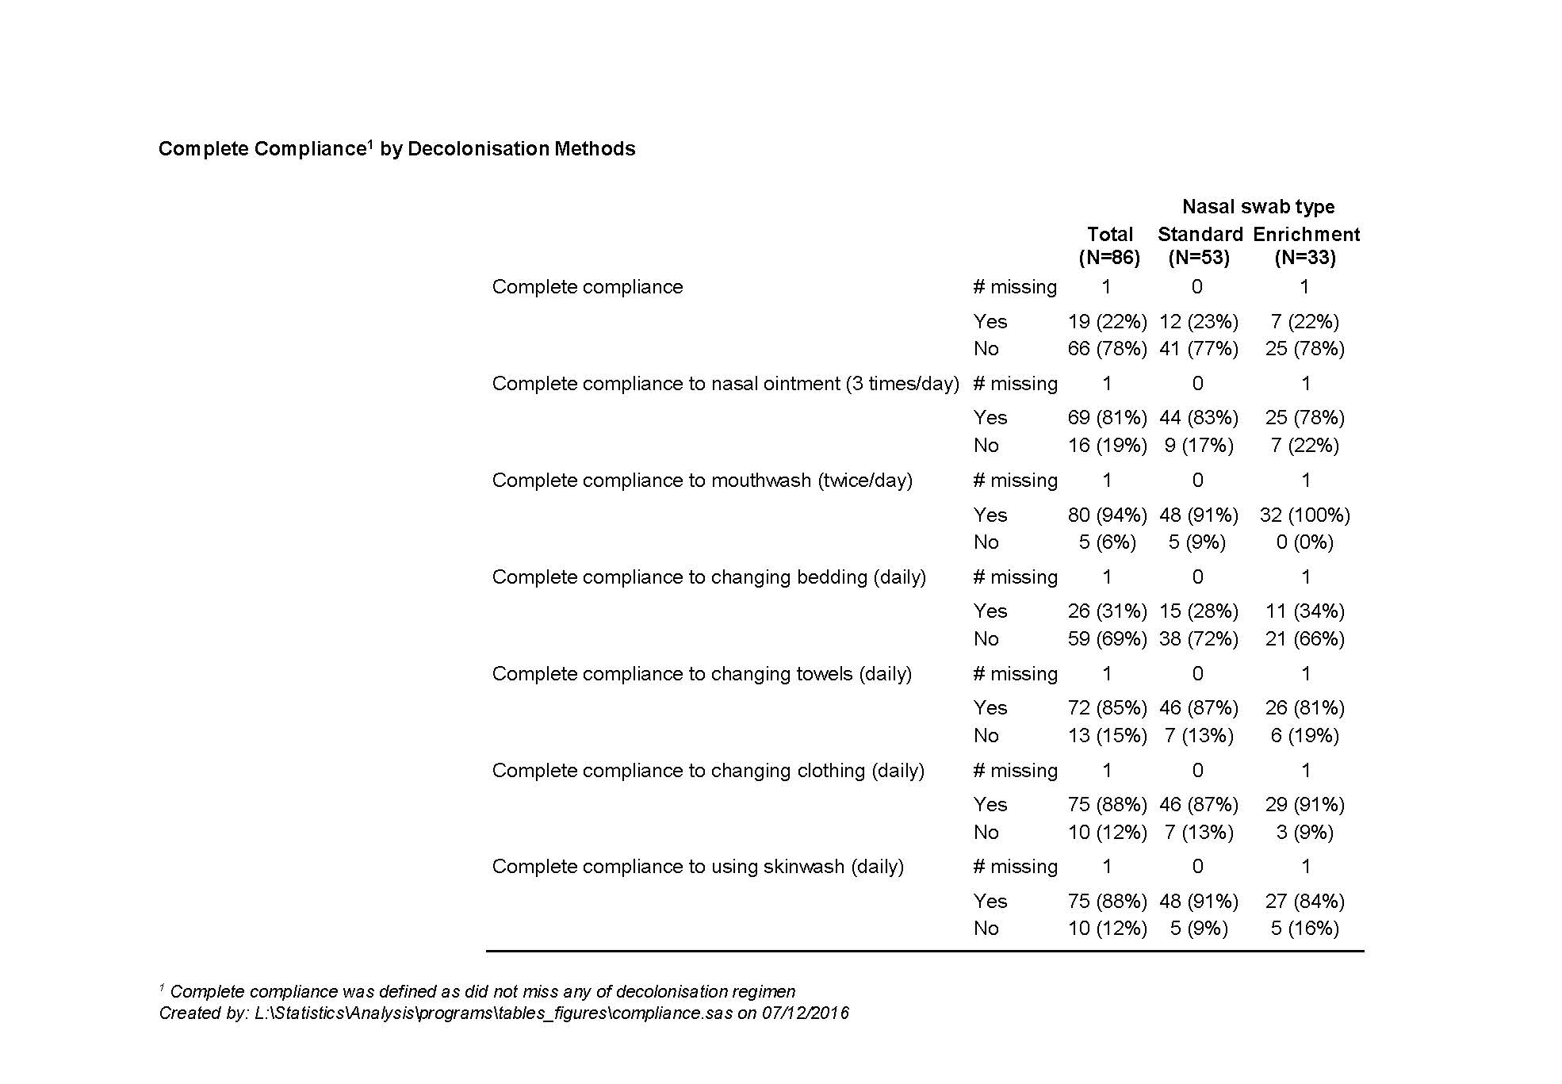

Clinical outcomes:

1. Clearance rates of SA from all 3 sampled sites at 48-96 hours after completing current eradication regimens for MRSA
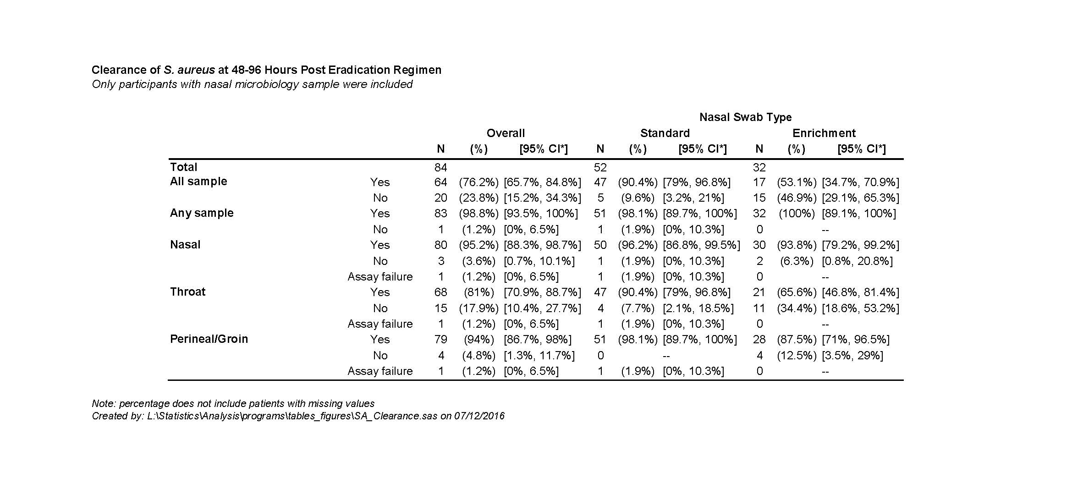

2. Clearance rates of SA from all 3 sampled sites at hospital admission (pre-surgery) after completing current eradication regimens for MRSA

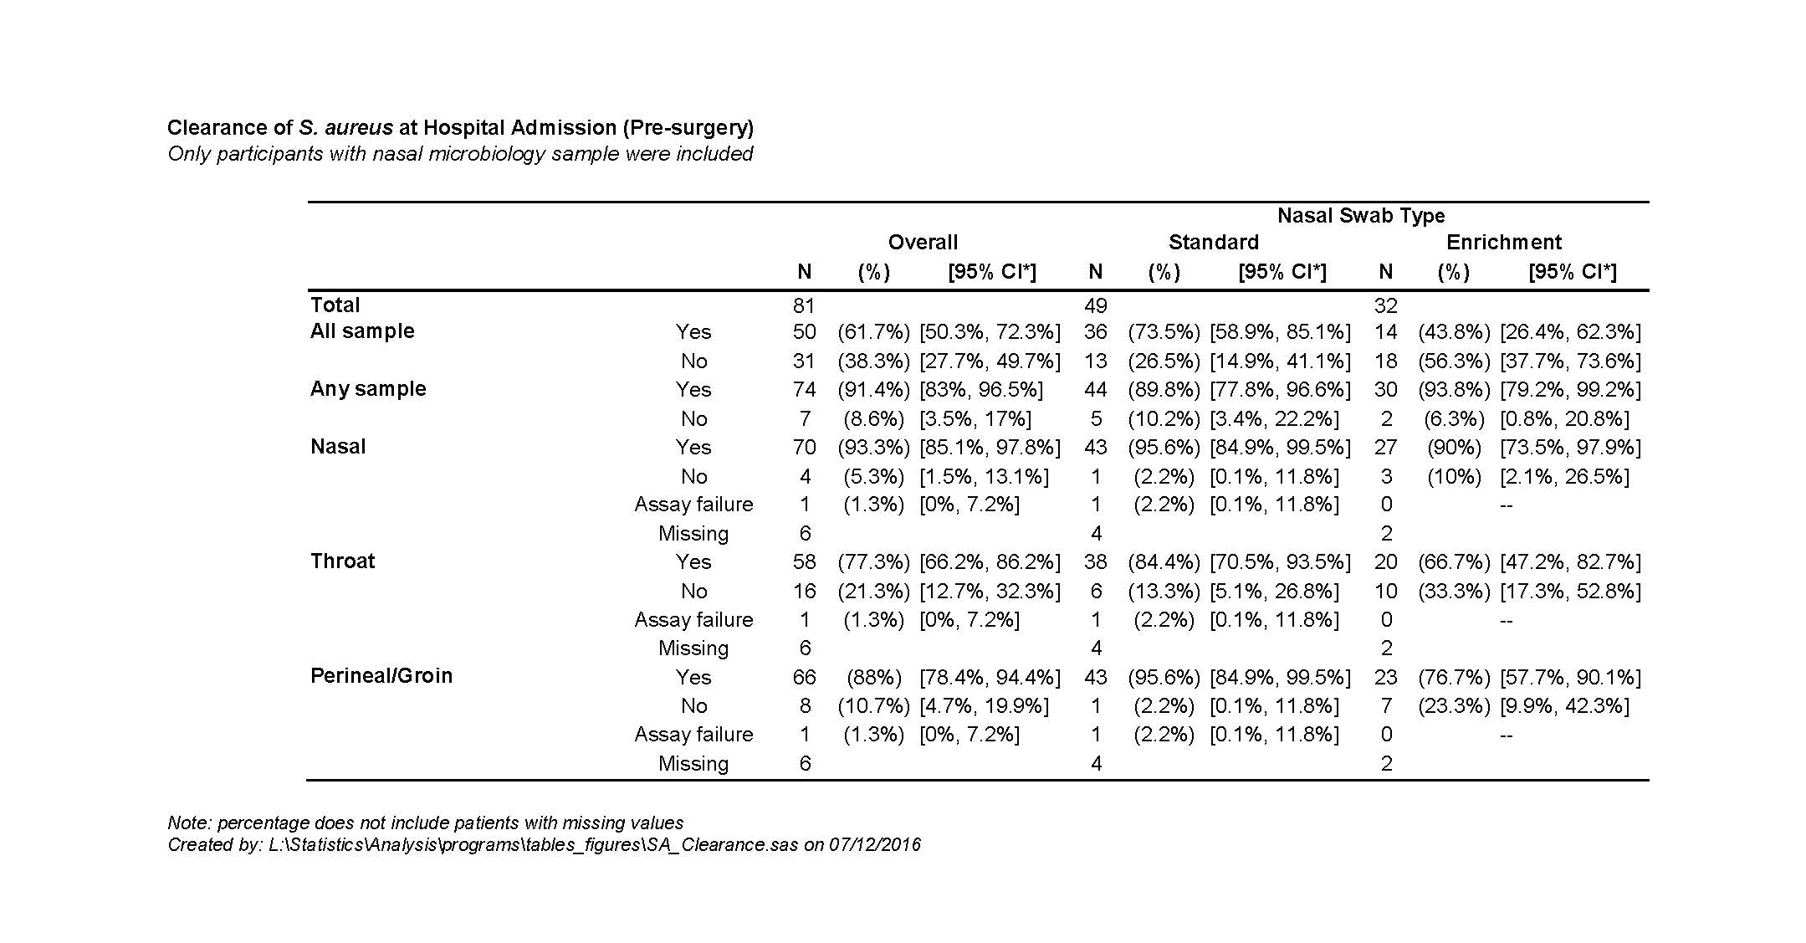

3. Clearance rates of SA from all 3 sampled sites at hospital discharge (post-surgery) after completing current eradication regimens for MRSA

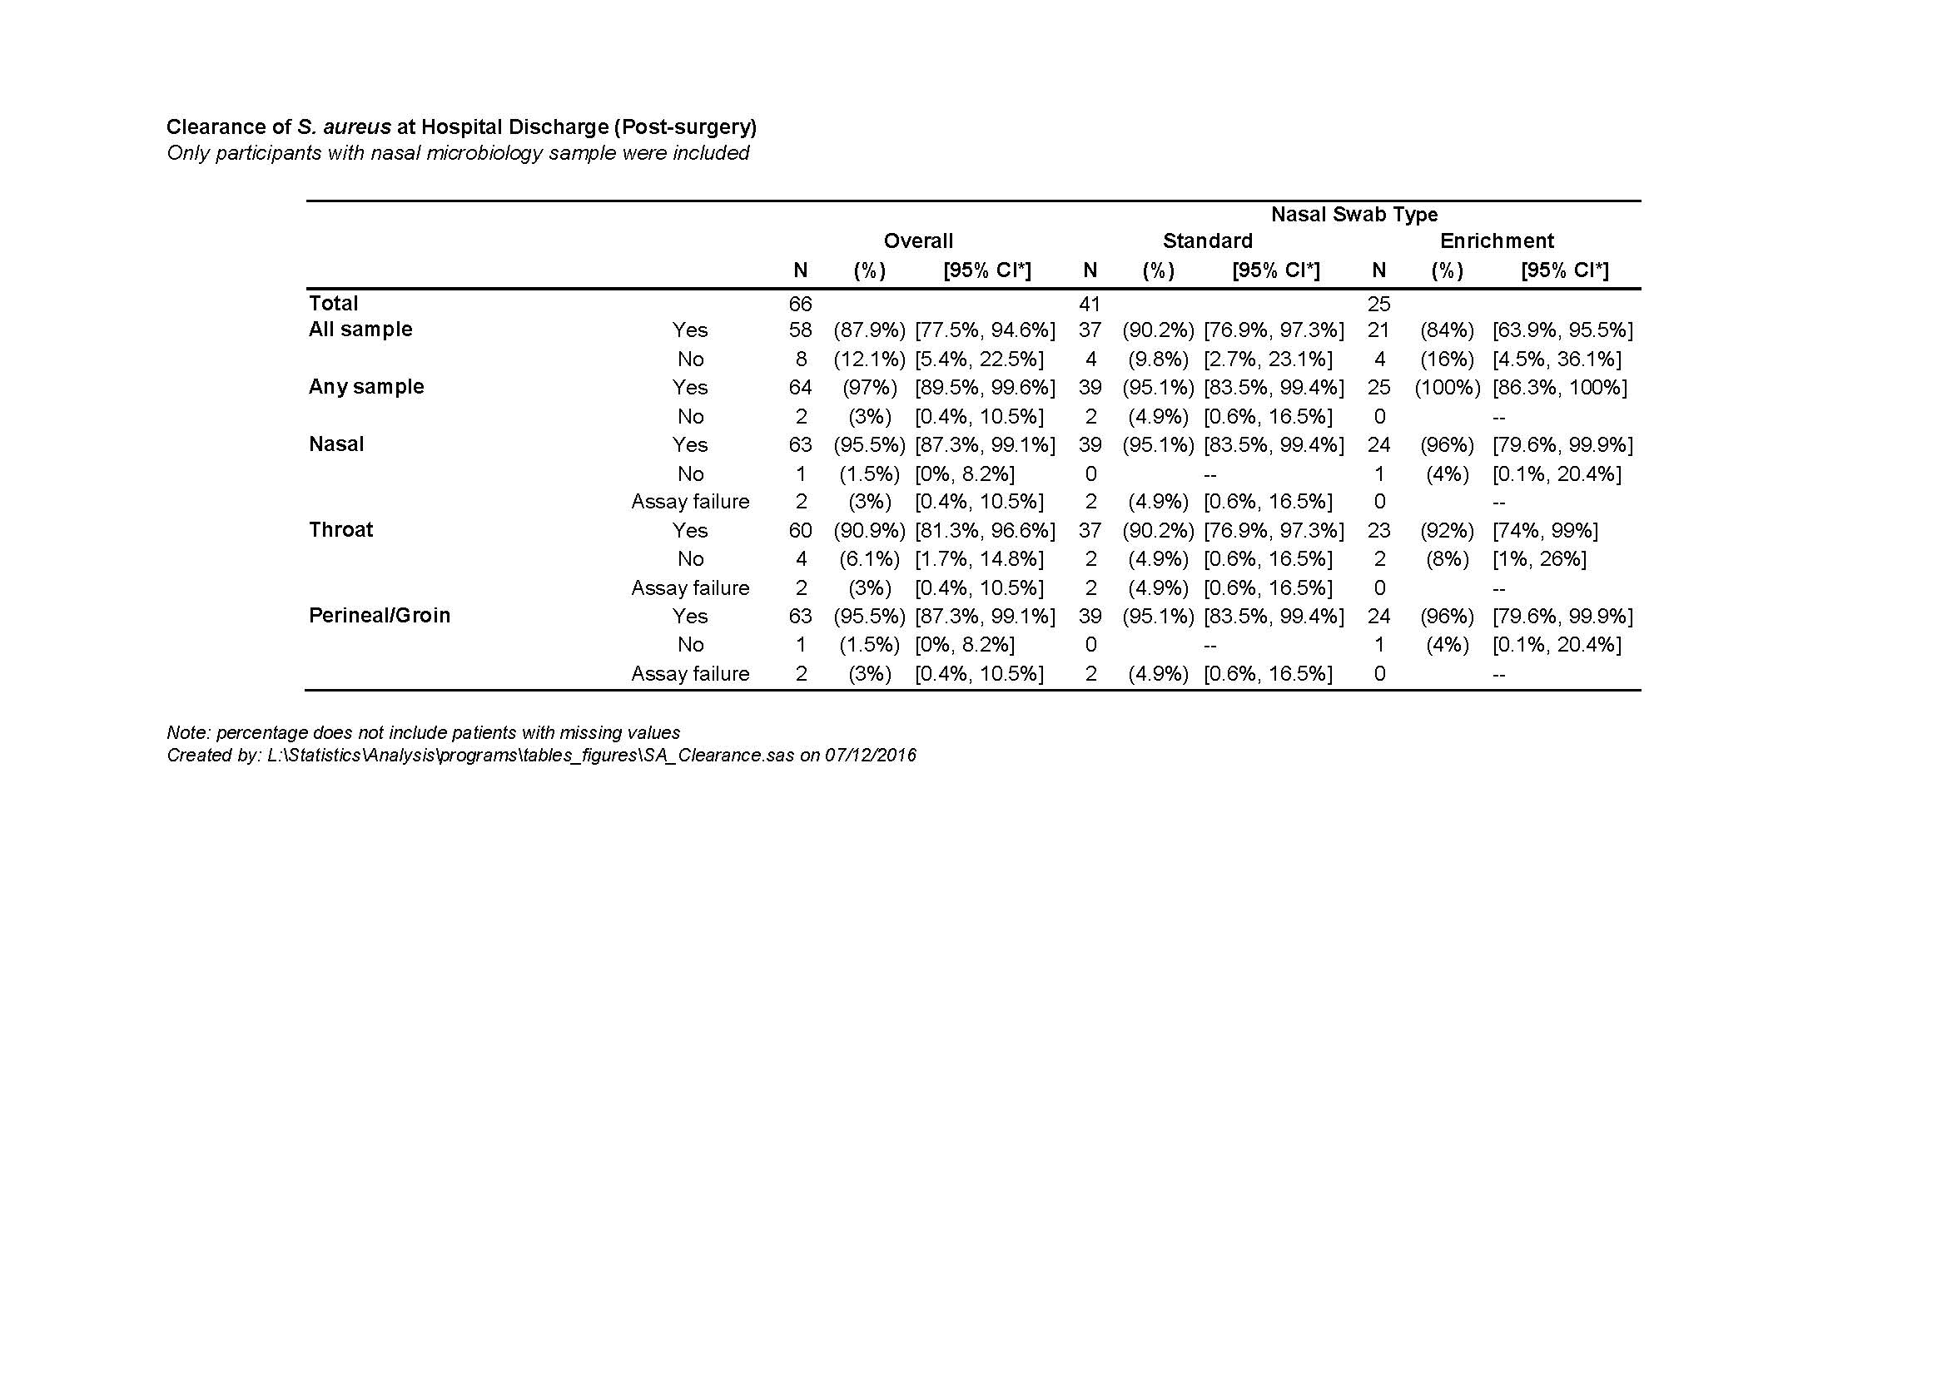

4. Clearance rates of SA from all 3 sampled sites at 6 weeks follow-up after surgery after completing current eradication regimens for MRSA

5. Adverse event and serious adverse event rates – refer to next section

Adverse Events

There were no serious adverse events associated with this trial.

Adverse events – 5 in total described below

