



**Patient Information Leaflet, Version 3.0; 21/06/2016**

**TEAM GB: The exercise and Gut Bacteria Study**

**Chief Investigator:** Professor Melanie J Davies (Diabetes Research Centre, The University of Leicester)

**Lead-Investigator**: Dr Patrice Carter

**Co-Investigators:** Professor Michael Barer, Dr Danielle Bodicoat, Dr Gary O’Donovan, Dr Clett Erridge, Dr Tom Yates, Dr David Webb.

We are inviting you to take part in a research study about the microbes in your gut, and how these may change after exercise. Before you decide if you want to take part it is important that you understand why the research is being done. Please take the time to carefully read this patient information leaflet. It may help to talk about it with your friends and family. If there is anything you do not understand, or if you want more information please contact one of the research team members and we will be happy to speak to you. Our contact details are on the back page of this leaflet.

# What is the purpose of this study?

Throughout the world, more people are becoming very overweight (obese). Being very overweight is linked to many health problems including type 2 diabetes, heart disease, non-alcoholic fatty liver disease, problems with sleep and some cancers. There are many different reasons that some people are more overweight than others. New research suggests that the bacteria in peoples gut may affect their body weight. There are different types of bacteria, and the amounts of these may be important. The study will offer an eight week supervised gym programme for overweight men. We aim to measure these bacteria and try to find out if exercise can change the types of bacteria.

# Why have I been invited to take part?

You have been asked to take part in this study because the information held either on our research database, University Hospitals of Leicester database or on your GPs database shows that you are aged between 25 to 50 years of age; this means you may be eligible to take part in this study.

Please note, **we are looking for men who do NOT exercise regularly,** if you take part in exercise two or more times per week for 20 minutes or longer you are not eligible to take part in this study.

# Do I have to take part in the study?

No, it is entirely your own decision to take part in the study. If you do decide to take part now, but change your mind later, you can stop taking part whenever you want. You don’t have to give any reason if you do not want to take part and it will not affect your usual care.

# If I choose to take part, what will I have to do?

If you do decide to take part in the study you will need to come to the Leicester Diabetes Centre at the Leicester General Hospital. You will have time to ask any questions you may want to ask. If you decide to take part in the study you need to visit the Leicester Diabetes Centre for three study visits, and attend the gym within the centre three times a week, for eight weeks. If you also agree to have a the standard meal test carried out, you will attend the Leicester Diabetes Centre an additional two more times (a total of five study visits) in addition to the gym sessions. If you decide to take part in the study you will be asked to sign a consent form.

## Pre intervention visit

We expect the first study visit to last around two and a half to three hours. At this visit we will check that you are safe to exercise, this will be carried out by a qualified member of the research team. We will also take the following measures:

* A full medical history
* A physical examination
* Weight, waist circumference and height
* Blood pressure
* Blood samples to measure blood sugars, blood fats and other markers of health.
* A urine sample
* A physical activity questionnaire
* A resting ECG, this is to test the rhythm and electrical activity of your heart. You will have several sticky patches attached to your chest and these will connect to the ECG monitor.
* An exercise ECG, this will include a VO2 max test. This is an assessment of your fitness. You will be required to breathe into a mouthpiece while a nurse checks your ECG. You will walk on a treadmill and the gradient will gradually increase and get harder, you will be encouraged to keep going for as long as possible. The average man can complete this in around 15-17minutes. After the test your ECG, blood pressure and pulse will be monitored until they return to normal.
* We will provide you with a wrist worn activity monitor, we hope you will wear this for the entire time that you are in the study. The watch is waterproof so does not need to be taken off in the shower or bath and can be worn 24 hours a day.
* We will ask you to take away a dietary record to complete; this will be a three day diet record; we will provide full instructions on how to complete this accurately.
* We will also provide you with a commode specimen collection kit, this is for you to collect a faecal sample and bring to your first exercise session. We provide this kit so that you can collect your sample without having to handle it. We ask that you collect the sample, and store in the provided box no more than 24hours before your next visit.
* We will also ask you to complete a seven day Bristol Stool diary; we will provide full instructions for this.

## Intervention

You will take part in an eight week supervised exercise programme. You will need to attend three 60 minute sessions a week at Leicester Diabetes Centre gym (This gym is not open to the public). Exercises will start in their most simple form (very basic techniques) and progress depending on your personal ability. All gym sessions will be supervised. You will be given an exercise programme card which will tell you what exercises to do, for how long and how hard you need to work. The exercise you undertake will be based on walking and/or jogging activities and will be set according to your abilities.

After the first four weeks you will undertake a further VO2 max test, the same as at your first visit, the results of this will help the researcher to re-calculate your exercise programme for the remaining four weeks that you are in the intervention.

## Post intervention visit

Between two and seven days after your final gym visit you will be asked to return to the Leicester Diabetes Centre to have the same measures taken that were carried out at the pre intervention visit. We will ask you to provide another faecal sample, and again you will be provided with a collection kit beforehand. You will NOT need to have another physical examination or ECG taken. We expect this visit to last between two to two and a half hours.

## Maintenance visit

You will be asked to return to the Leicester Diabetes Centre for a final visit, this is to see if any changes in your gut microbes have remained even though you have stopped the exercise intervention. We will collect all the same measures that were carried out at the pre intervention visit. We will also ask you to provide a final faecal sample, and again you will be provided with a collection kit beforehand. You will NOT need to have another physical examination, ECG taken or the VO2 max test. We expect this visit to last around one hour.

## Optional Standard Meal Test

At your first visit you will be invited to come into the Centre two additional times to take part in a meal test. If you agree, these visits will occur before and after the intervention period. We expect each of these visits to last around three hours.

We will ask you to arrive in a fasted state (not to have eaten since 10pm the night before). When you arrive you will be made comfortable and have a cannula fitted by a trained nurse. An initial blood test will then be taken to measure blood sugar, blood fats, insulin (a chemical which controls blood sugar levels) and hunger hormones (chemicals which tell you when you are hungry or full up). You will then be given a standard meal test, this has a set number of calories, carbohydrate, fat and protein in it. We will take bloods from you every 30 minutes for 2 hours. This is to see how your body responds to this food.

We will provide you with a food diary before the visit and request that you record all the foods that you eat, and drinks that you have, from 5pm till 10pm on the day before the meal test. You should not eat anything after 10pm. On your day before your second meal test, we will ask you to have exactly the same foods as recorded in this diary, and ask you to record this information in another diary that you will be given.

You also need to refrain from drinking alcohol or caffeine for 48 hours beforehand.

# Will I benefit from taking part?

You will benefit by receiving a personalised exercise programme from a trained specialist, and will have free gym access three times a week for eight weeks. You will gain knowledge about your current fitness levels and receive information about the levels of sugar and fat in your blood. You will also add to evidence-based exercise research that may improve the treatment for people in the future.

# Will there be any side effects?

During any physical activity there is always an increased risk of a heart event or injury. For those without any underlying heart disease, the risks to health are very low. Before you start the exercise programme you will be assessed by a qualified clinical team member. There will be a member of the exercise research team developing and supervising the programmes. A fully qualified member of the research team will carry out all the blood tests so any pain should be kept to a minimum. However some people experience minor discomfort and slight bruising from blood tests.

# What if I am harmed by the study?

We do not expect any harm will come to you as a result of taking part in the study. If you are harmed due to negligence, you may have grounds for legal action but you may have to pay for it as there are no special compensation arrangements for this study. If you wish to make a complaint or have any concerns about any aspect of the way you have been approached or treated during the course of the study, the normal National Health Services Complaints procedures are available to you. If you want to make a complaint please contact the Patient Advice and Liaison Service:

The Firs, C/O Glenfield Hospital, Groby Road, Leicester, LE3 9QP.

Tel: 08081788337

# Email: [pils@uhl-tr.nhs.uk](mailto:pils@uhl-tr.nhs.uk)

# Will my taking part in the study be kept confidential?

Yes. We will follow ethical and legal practice in accordance with the Data Protection Act (1998). All information about you will be handled in confidence unless you disclose that you, or someone else, are in immediate danger of serious harm. Access to identifiable data such as your name and address will be limited to selected members of the research team and to auditors for the purpose of monitoring the quality of the research study. No personal details will be included in the analysis, publications or reports. All information collected during the study will be identified by a unique code so that you cannot be identified from it. All data will be kept on secure computer servers and in locked filing cabinets at the University Hospitals of Leicester.

# What will be done with data and samples that you collect?

If you agree, we will keep your personal details so that we can contact you about future research, if you do not want us to do this, we will destroy your personal information 12 months after the study has ended.

We will immediately store your samples in freezers which are locked. We will conduct analysis on these samples once the last study sample from the last participant has been collected. Any remaining samples will be stored for future research, if you have given us permission for this. If not any samples will be destroyed.

# What will be done with the results of the study?

We will present our results at conferences and write articles for scientific journals. Study updates will be put on the Leicester Diabetes Website; <http://www.leicesterdiabetescentre.org.uk/> you can access this to find out how the study is going. At the end of the study will send you a summary of the results. Personal data will not be included in any of these reports.

# Who has reviewed this study?

All research which takes part with NHS patients, NHS staff, uses NHS medical records or takes place on NHS premises must be approved by an NHS Research Ethics Committee before it can start. This study has been approved by National Research Ethics Service Committee West Midlands.

Ethical approval does not guarantee you will not come to any harm if you take part in the study. Approval means that the committee believe your rights will be respected and any risks are kept to a minimum. Approval from the committee means that they think we have given you enough information to let you make an informed decision to take part in the study or not.

# Who has funded this study?

The study has been funded by The Novo Nordisk UK Research Foundation and is supported by The NIHR Leicester-Loughborough Diet, Lifestyle and Physical Activity Biomedical Research Unit which is a partnership between University Hospitals of Leicester NHS Trust, Loughborough University and the University of Leicester.

# Will it cost me anything to take part?

It will not cost you anything to be part of this study. All exercise sessions are free. You can claim up to £10 for travel expenses for the study visits (pre-intervention and post-intervention appointments, and for the standard meal test appointments). We are unable to refund the travel expenses for your visits to the gym. The cost of parking at the Leicester General Hospital is £2.50 for two hours.

# Is there anything else I need to know?

You should know that any study may need to be checked for monitoring purposes. This is to check we are carrying out the study properly. This does not happen to every study, but if it does relevant sections of your medical notes and/or study notes may be looked at by responsible individuals from the study team, the sponsor, or the NHS Trust.

# Do I have to take part?

No, it is completely your own decision to take part in this study or not. If you decide to take part in the study you can withdraw at any time without giving a reason and it will not affect the care you receive in any way. If you withdraw part way through the study any data we have already collected will be retained and included in the study analysis, but no further data will be collected.

If you decide to take part in the study you will be asked to sign a consent form. You will keep one copy of this and we will keep another. We will also inform your GP that you are taking part in the study.

# Study flow

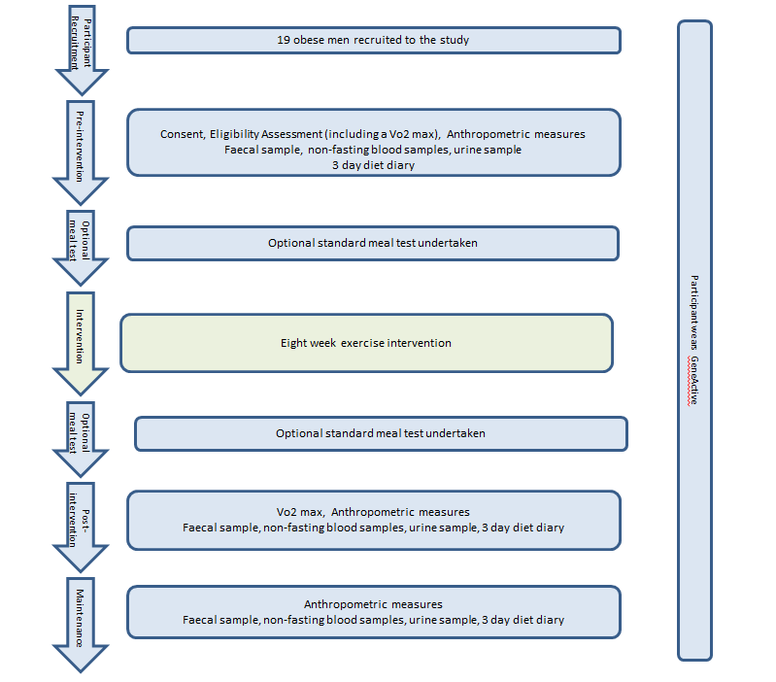

# How can I find out more?

The study team members will be happy to answer any questions you might have and give you any more information. The person to contact is:

[insert contact name]

The University of Leicester

Leicester Diabetes Centre

Leicester General Hospital

Leicester

UK

[insert phone number]

[insert email address]

**Thank you for taking the time to read this leaflet**