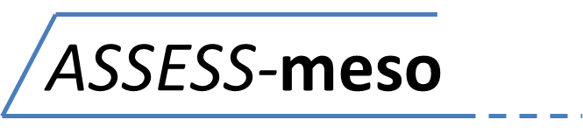

[INSERT TRUST LOGO]
A prospective obServational cohort Study collecting data on dEmographics, Symptoms and biomarkerS in people with mesothelioma that will provide a resource for future trials

Chief Investigator – Dr Anna Bibby
IRAS project ID - 220360

PARTICIPANT INFORMATION SHEET
Helping you decide whether you want to join this study

We would like to invite you to take part in this research study. Before you make a decision, it is important that you understand why the research is being done, and what it will involve. Please take some time to read this information sheet carefully before deciding whether or not you would like to take part. You may wish to discuss your decision with family, friends or your GP.

- What is the purpose of this study?
- The main aim of this study is to gather information about people with mesothelioma. We want to find out whether there are any specific factors that can affect outcomes. This study will help us understand more about mesothelioma and how we can improve care for people diagnosed with it.
- The second aim of this research is to use the information collected during the study to identify people with mesothelioma who may be eligible to join clinical trials, and to invite selected people to participate in those trials.

- Why have I been chosen?
- You have been chosen because you have been diagnosed with mesothelioma, and you are being looked after at a hospital that is contributing to the study.

- Do I have to take part?
- No, it is up to you to decide whether you want to participate in this study. If you choose not to take part, you do not have to give a reason, and your decision will not affect your medical care or legal rights in any way.

- What will I have to do if I decide to take part?
- If you decide you would like to participate in the study, you will be asked to sign a consent form. The consent form will ask if you are happy to have your information stored for use in this study and in future research studies, and whether you agree to having samples of blood, pleural fluid and biopsy tissue stored and used in the same way.

- Once you have joined the study, you will be asked to complete the following assessments:
  - A questionnaire relating to quality of life
  - A severity score for your current symptoms
  - Blood tests
  - A chest x-ray (unless you have already had one today)
  - An ultrasound scan of your chest
  - A CT scan of your chest (if one has not been done in the previous month)
  - Sampling of pleural fluid (only if fluid is being taken off any way, or if you have an indwelling pleural catheter in place)

- You will be asked to complete these assessments every time you come to the pleural clinic for a routine appointment. We will try not to ask you to come up for any extra appointments outside of your routine follow up, unless it is really necessary.

- Because some people live far away from the study centre, and because some people may find it tiring to come up to the hospital for routine appointments, we might offer you the opportunity to take part in telephone or postal assessments instead of face-to-face appointments.

- What will happen to my samples of blood, fluid and tissue?
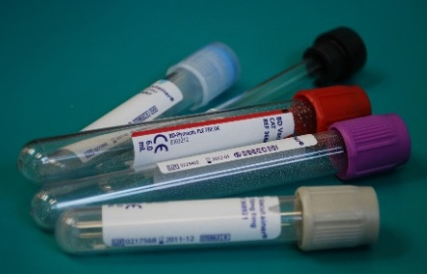
- Providing a sample of your blood, pleural fluid and biopsy tissue will allow the researchers to look at biological and medical measures and understand their influence on outcome in mesothelioma.
- Some of your samples will be processed and analysed on the same day. Other samples will be frozen and stored for use in future research. These samples will be anonymous, with no personal identifying information attached, just your study number. We may share these samples with other scientists who are doing ethically approved research.

- Will my information be kept confidential?
- All information and biological samples you provide for this study will be stored securely and confidentially, in locked storage at NHS hospital sites or on password-protected, encrypted NHS computer servers.

- All research-related information and biological samples will be labelled with your study number rather than your name or other identifying details.

- Any personal or identifiable information e.g. your name, NHS number or contact details will be stored separately to your research data, on a password protected, secure NHS server. All personal information will be destroyed 1 year after the study finishes.
- In order for us to run the study smoothly, certain members of the research team may need access to your information. These people may be members of the research team, doctors, nurses, administrators involved in the running of the study, or representatives of North Bristol NHS trust.

- With your permission, we may access some of your medical records held by the Health & Social Care Information Centre and other central UK NHS bodies.

- With your permission, we may share some of your non-identifiable study-related information with other researchers for use in other research projects.

- At the end of the study, we will archive your non-identifiable research data and store it, securely and confidentially, indefinitely.

- What are the potential disadvantages of taking part?
- One disadvantage is that it will take a bit more time to complete the assessments at each appointment.

- Another disadvantage is that you will need to have a blood test every time you come to clinic, which you may not have needed if you weren’t taking part in the study.

- As part of the trial, you will undergo approximately 2 extra CT scans and 3 extra chest x-rays. CT scans and chest x-rays are associated with ionising radiation that can damage the cells of the body and cause them to turn cancerous. This usually takes many years or decades to occur. The amount of extra radiation that you will be exposed to during this study is approximately 27 milliSieverts, which is equivalent to 6 years’ worth of natural radiation exposure.

- We will try to do all the assessments when you are at the hospital for a routine appointment, but sometimes we might need to invite you to an extra appointment just for research purposes. At most, this will be once every 3 months.

- What are the potential benefits of taking part?
- By taking part you would be helping us increase our understanding of mesothelioma, and improving care for future people with mesothelioma.

- You will also be regularly assessed to see if you are eligible for clinical trials.

- What if I am chosen to join a trial?
- If you are chosen to join a trial, the research team will inform you and give you information about the trial. You will be given time to consider whether you want to take part. You are under no obligation to take part and if you decide not to, it will not affect your medical care or legal rights in any way.

- You are welcome to take part in ASSESS-meso even if you have already decided that you do not want to take part in any trials in the future. If you let us know, we will keep this on record and will not discuss other trials with you.

- What if I am not chosen to join a trial
- Not everyone who is suitable for a trial will be chosen to participate. This is because trial numbers may be limited or because the trial treatment can’t be offered to everyone.

- If you are not chosen to join the trial, we will not tell you about the trial. This is because we don’t want you to feel disappointed.
- The process of choosing people to join the trial is done by a computer programme, based on random chance.

- If you are not chosen to join a trial, you might still provide important information to help the trial. The information you provide as part of ASSESS-meso may be used to compare your treatment with the treatment that is being tested in the trial.

- While you are taking part in ASSESS-meso you could be considered for multiple trials. Therefore, if you are not chosen for one trial, there may be another one in the future that you are chosen for.

- Can I change my mind and withdraw from the study once I have joined?
- Yes. Your participation in the study is voluntary, and you are welcome to change your mind and withdraw from the study at any point. If you chose to withdraw you do not have to provide a reason, and your medical care and legal rights will not be affected.

- We will ask whether you are happy to continue taking part at every study visit. You are also welcome to contact us between visits if you wish to withdraw at any stage.

- Who is organising and funding the study?
- The study is being conducted by researchers from the University of Bristol’s Academic Respiratory Unit, with support from North Bristol NHS Trust Research & Innovation department. The study has been funded by the Avon Mesothelioma Foundation.

- Who has reviewed this study?
- The study has been reviewed by the Health Research Authority Research Ethics Committee (South West – Central Bristol Research Ethics Committee, REC reference 17/SW/0019) who have approved the research. This is an independent panel that includes scientists, clinicians, and lay people. The committee is satisfied that your rights are being respected and you have been given enough appropriate information to make an informed decision to participate or not.

- Will I find out the results of this research?
- If you wish, we will send you a summary of the research findings as and when they become available.

- We will publish the results of this research in scientific journals, present them at conferences and patient groups and publicise them on mesothelioma charity websites.

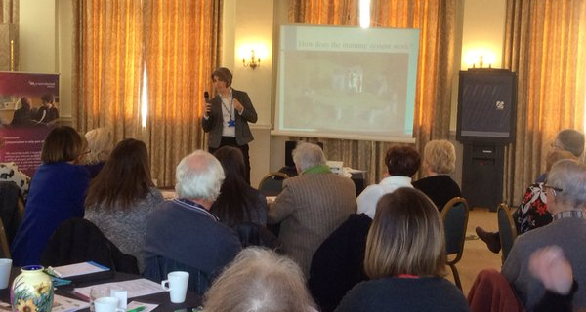
- Who should I contact about the study?
- If you have any questions or concerns about any aspect of this study, please speak to a member of the research team who will do their best to answer your questions. They can be contacted at [insert local research team contact details]

- If you remain unhappy and wish to complain formally, you can do this to NHS Complaints Procedure [Local contact details to be inserted]

