Participant Flow
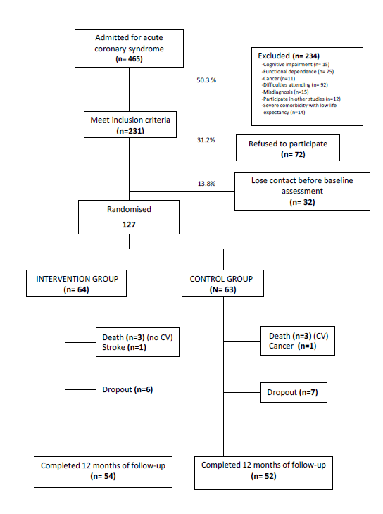

Baseline Characteristics:
 | Intervention  (n=54) | Control  (n=52) | P
Age | 76.5±3.4 | 76.2±3.8 | 0.717
Sex  -Male  -Female | 37 (68.5%)  17 (31.5%) | 27 (51.9%)  25 (48.1%) | 0.081
Barthel Index | 98.7 ± 2.8 | 97.1 ± 5.3 | 0.063
Pfeiffer’s SPMSQ | 0.7 ± 1.0 | 0.9 ± 1.0 | 0.405
Charlson Index | 2.2 ± 1.2 | 2.1 ± 1.4 | 0.724
Hypertension | 37 (68.5%) | 37 (71.2%) | 0.768
Dyslipidaemia | 33 (61.1%) | 37 (71.2%) | 0.275
Diabetes Mellitus II | 23 (42.6%) | 23 (44.2%) | 0.865
Smoking  -Current smoker  -Non- smoker | 9 (16.7%)  45 (83.3%) | 3 (5.8%)  49 (94.2%) | 0.077
History of ishaemic heart disease | 29 (53.7%) | 33 (63.5%) | 0.308
History of cerebrovascular disease | 7 (13%) | 6 (11.5%) | 0.823
Type of ACS:  -AMI-STEMI  -NSTE-ACS | 13 (24.1%)  41 (75.9%) | 13 (25%)  39 (75%) | 0.979
Length of hospital stay (days) | 14.9 ± 9.0 | 15.9 ± 12.4 | 0.630
Tests and invasive therapy during hospitalisation:  -Coronary angiography  -Echocardiography  -Myocardial perfusion gammagraphy  -Exercise stress test  -Coronary bypass surgery  -Angioplasty / Stent | 43 (79.6%)  41 (75.9%)  12 (22.2%)  14 (25.9%)  4 (7.4%)  30 (55.6%) | 36 (69.2%)  38 (73.1%)  17 (32.7%)  20 (38.5%)  6 (11.5%)  23 (44.2%) | 0.219  0.736  0.227  0.278  0.467  0.244
Systolic blood pressure (mmHg)  Diastolic blood pressure (mmHg)  LDL-c (mmol/L)  MET’s (h/wk)  BMI (kg/m²)  HbA1c* (%) | 142.8 ± 28.1  69.2 ± 10.8  2.2 ± 0.6  19.2 ± 19.6  27.7 ± 4.2  6.2 ± 1.2 | 139.1 ± 22.7  71.1 ± 11.2  2.1 ± 0.7  21.2 ± 28.7  29.0 ± 4.0  6.2 ± 1.3 | 0.456  0.379  0.583  0.680  0.117  0.809
Antiplatelet and/or anticoagulant  ACE inhibitors and/or ARB  Beta-blockers  Statins | 54 (100%)  29 (53.7%)  36 (66.7%)  47 (87.0%) | 52 (100%)  28 (53.8%)  35 (67.3%)  44 (84.6%) | 1.000  0.988  0.944  0.721
Mean ± SD or N(%).
*Only for the 46 diabetic patients (23 in each group).
ACS: acute coronary syndrome, ACE: angiotensin converting enzyme, AMI-STEMI: acute myocardial infarction with persistent ST-segment elevation, , ARB: angiotensin receptor blocker, BMI: body mass index, HbA1c: glycosylated haemoglobin, LDL-c: low-density lipoprotein-cholesterol, MET’s: metabolic equivalent of task, NSTE-ACS: acute coronary syndrome without persistent ST-segment elevation, SPMSQ: Short Portable Mental State Questionnaire.

Outcome Measures:

 |  | 12th month follow-up | p
No smoking | Usual care (control group)  Interventnion group | 96.2 %  96.3 % | 0.969
Blood pressure  < 140/90mmHg | Usual care (control group)  Interventnion group | 42.3 %  68.5 % | 0.007
LDL < 2.6 mmol/l | Usual care (control group)  Interventnion group | 78.8 %  96.3 % | 0.006
MET’s ≥ 6 h/wk | Usual care (control group)  Interventnion group | 67.3 %  85.2 % | 0.030
BMI < 25 kg/m² | Usual care (control group)  Interventnion group | 17.3 %  25.9 % | 0.282
HbA1c < 7%  (in diabetic patients) | Usual care (control group)  Interventnion group | 60.9 %  87 % | 0.044

Adverse Events:

There were no adverse events associated with this trial.

