Partnership in Prostate Cancer Care: the feasibility of an integrated system to improve patient outcomes and experience.

Participant Information Leaflet (ICARE-P)

IRAS project ID: 206153

You have been asked to take part in a research study. Before you decide what to do, it is important for you to understand why the research is being done and what it will involve. This information sheet tells you the purpose of this study, and how you might take part. Please take time to read it carefully and ask us if there is anything that is not clear, or if you would like more information.

What is the study about?
The study is about improving the well-being of men who have or have had prostate cancer. We aim to do this by enabling easier communication between men and their health care teams and through extra training for practice nurses working in GP surgeries.

Men may have a range of concerns following diagnosis, during active treatment or monitoring or for many years following treatment. For many reasons it can be difficult for men to get the information or support they need. In the study we will try out a secure, easy to use electronic system to help men identify a wide range of needs and concerns to their health care teams including the Primary Care team (GP and practice nurse) and specialist teams (Clinical nurse specialists, urologists and oncologists) where applicable, and to find relevant information. This system is known as a Holistic Needs Assessment (HNA). The assessment covers a broad range of topics including physical symptoms, emotional issues, problems with independence or access to services, as well as issues relating to work, money or care, amongst others.

The images below show the opening screens of the HNA which is called CHAT-P.
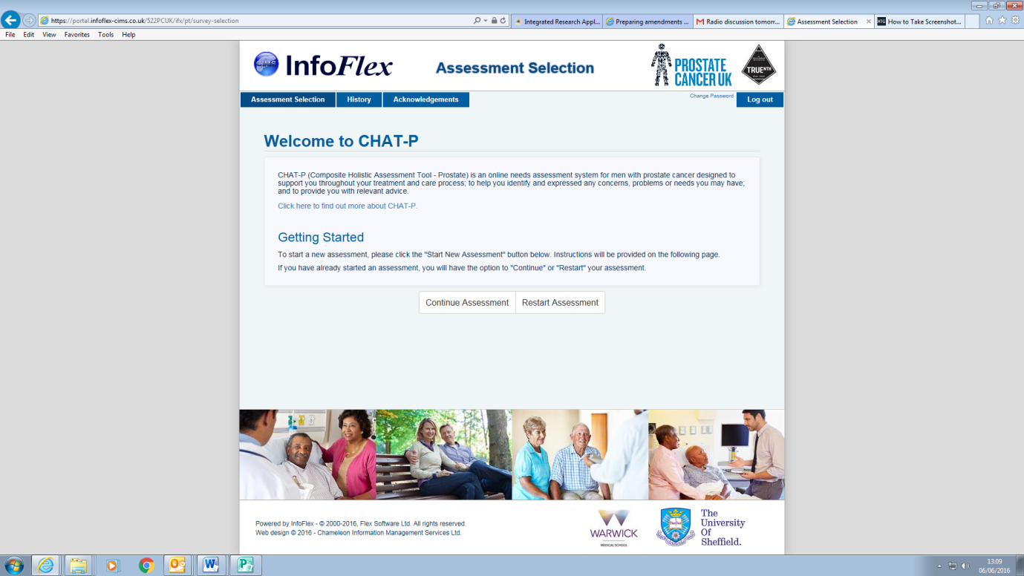
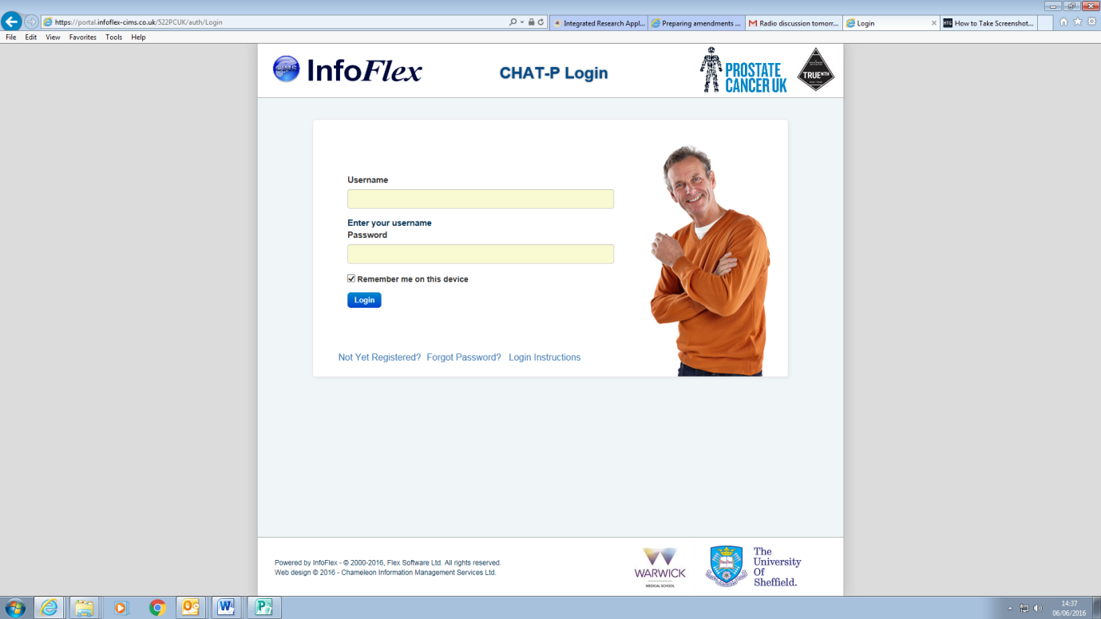

For men who are not confident with computers, ipads or the internet we will provide help in using the HNA.The practice nurses taking part in our study have undergone extra training to help them address any problems identified through the assessments. The digital technology will allow the patient, the Primary Care team and specialist teams to communicate easily and rapidly. In this way specialist teams will be able to provide advice and guidance to the practice nurses on clinical when this is needed . Similarly, specialist teams can inform the Primary Care team should the HNA identify any broader issues concerning the patient such as social, family or financial concerns.

During the 12 months of the study we will test how well the use of the HNA works in practice and whether it is useful to patients and their health care providers.

We will also compare men’s scores on a range of measures designed to assess quality of life and health in both men who are using the assement system (the intervention group) and men who are having usual care (the control group) to investigate the overall impact of this assessment tool.

Why is this study being done?
This study is the latest stage in a series of research and feasibility studies undertaken by researchers at Warwick Medical School. It stems from the recognised need for men with prostate cancer to understand more about their condition and access health information and advice to support them throughout their care.

Why have I been chosen?
Your GP surgery is taking part in this study and we are looking for a wide range of men from different backgrounds that have been diagnosed with prostate cancer, at varying stages of the condition to help us with this study.

What will happen if I agree to take part?
If you are willing to take part then we will send you six short questionnaires for you to complete online (or on paper copies if you prefer). We expect them to take about 20 minutes to fill out, and you can complete these in your own time. These assessments would then be repeated twice more at 6-monthly intervals, as well as 2 short additional questionnaires at 3 and 9 months. You will also be asked to complete the online HNA , either on your own or with the help of a family member, volunteer, or a member of the research team, four times at 3-monthly intervals. The assessment has been designed to be personalised to each patient’s concerns, therefore the time it takes to complete will vary between individuals. The first time you complete the assessment will take the longest as you will find it helpful to read through the guidance that is provided. Although the assessment does not have to be completed in one go, we suggest that you leave yourself between 45 minutes and one hour for your first session.

If needed, you will have a consultation with a specially trained nurse in your GP practice to discuss the results within two weeks of completing the assessment. The aim of this consultation is to provide you with information you need to help with any concerns identified in the HNA, as well as having an opportunity to talk to a specially trained nurse about any problems. With your permission, the results of this HNA would then be shared with your GP and any other clinicians involved in your care. At the end of the study you may also be asked to complete a short online usability questionnaire on your views of the online HNA. You may also be asked whether you would like to take part in a short interview about your experience of using the HNA. You can take part in the main part of the study without having to complete the usability questionnaire or take part in the interviews.

Do I have to take part? Will my decision affect the services that I receive?

No, we do hope that you will be willing to take part but your decision about whether to take part in the study will in no way affect the services you receive. It is entirely up to you whether or not you decide to participate. You may also withdraw from the study at any time, without giving any reason.

What are the possible benefits and disadvantages?
If you agree to take part in the study you may benefit from completing the HNA , as this provides links to information as well as the opportunity to talk about any concerns or unmet needs with your practice nurse. The system has also been set up to alert you to any concerning symptoms with a prompt to visit your GP. We do not think there are any disadvantages to taking part.
You will be entered into a voucher prize draw for a prize of 4 x £50 after the questionnaires at the start of the study, six, and 12 months to thank you for giving up your time to take part.

Will the information I provide be kept confidential?
Yes. No identifiable personal information will be used in writing up this research. Any data collected may be retained by the research team if any participant should lose capacity to continue with the study for any reason. Audio recordings will be stored securely on password protected computers, and any documents will be kept in locked filing cabinets only accessible to members of the study team. All data collected during the study will be stored for five years once the study ends.

Who is organising/funding and reviewing the study?
The study is being run by the University of Warwick and is sponsored by NHS Birmingham South & Central Clinical Commissioning Group. It is funded by the National Institute for Health Research, Research for Patient benefit Programme (www.nihr.ac.uk/funding/research-for-patient-benefit.htm). It is supported by Macmillan Cancer Support and Prostate Cancer UK. The study has been reviewed by a Research Ethics Committee, and by the Institutes team of scientific experts and West Midlands Primary Care Research and Development committee.

What will happen to the results from the study?
The results will be used to help develop ways for professionals to work together more closely and to continue to respond to the needs of their patients. The findings of the study will be published in medical journals, in order to be useful to as many people as possible. Findings included in the publication will be completely anonymous (no names will be used). If you would like to receive a copy of the findings we will arrange this.

What do I do next if I am interested in taking part?
If you are interested in taking part and/or learning more about this study, please complete the reply slip on the bottom of the enclosed letter and return in the pre-paid envelope. Alternatively please contact the study team by telephone or email as detailed below.

Who should I contact for further information about the study?
Dr Ronni Nanton – Principal Investigator | Becky Appleton – Researcher
The University of Warwick, Warwick Medical School, Gibbet Hill, Coventry, CV4 7AL
Contact Ronni by phone on 02476-574025 or by email: V.Nanton@warwick.ac.uk
Becky by email: R.Appleton@warwick.ac.uk

What if there is a problem?
If you have a concern about any aspect of this study, please contact the researchers in the first instance, (see details and telephone numbers above) who will do their best to answer your questions. If you have a complaint about the research, please contact the Director of Delivery Assurance, Registrar’s Office, University House,
University of Warwick, Coventry, CV4 8UW.

Thank you for taking the time to read this information leaflet.

