Glenfield Hospital
Groby Road
Leicester
LE3 9QP
Tel: 0116xxxxxx
Fax: 0116 258 3950

Information Sheet for Research Participants
You will be given a copy of this information sheet to keep
The effects of combining electrical stimulation of the calf and thigh muscles in patients with osteoarthritis of the knee

You are being invited to take part in a research study. Before you make your decision, it is important for you to understand why the research is being carried out and what it will involve. Please take time to read the following information carefully.
Please ask if there is anything that is not clear, or if you would like more information. Take time to decide whether or not you wish to take part. Thank you for your time.
What is the purpose of the study?
Patients with osteoarthritis of the knee tend to suffer from joint pain and stiffness. They may also experience swelling and a reduction in the range of movement of the knee joint. Pain can prevent or reduce the level of physical activity, which can lead to weakening of the muscles that support the knee joint. Ultimately, this can result in a worsening of symptoms. A new therapy option has recently become available which may help reduce pain and swelling, as and to increase muscle strength in the legs. The aim of this study is to look at its effect on people suffering from pain associated with osteoarthritis of the knee. The study has been ethically reviewed by the North West- Preston Research Ethics Committee.
Why have I been chosen?
You have been chosen because you are a patient with osteoarthritis of the knee and are currently suffering from symptoms such as pain, stiffness and swelling. Please note that if you are pregnant, have metallic implants, are fitted with a cardiac pacemaker, or are currently being treated for a DVT you will unfortunately not be able to take part in this study.

Do I have to take part?
Participation in this trial is voluntary. Even if you start the trial and then change your mind, you are free to withdraw at any point, without giving a reason and without your medical care or statutory rights being affected. By taking part in this study you are helping us to research a potential treatment for people with osteoarthritis of the knee.
Tell me some more about the device
The device is called RevitiveTM Arthritis Knee and is made by ActegyTM Ltd. Revitive activates your leg muscles by applying Electrical Muscle Stimulation (EMS) through two large foot pads and two self-adhesive thigh pads, while you are seated. EMS makes the muscles of the foot, calf and thigh contract. The ‘IsoRocker’ feature allows Revitive to gently tilt back and forth as your muscles contract, creating involuntary ankle movement, which replicates heel-toe raises. Consequently, blood circulation immediately increases, which can help reduce swelling, improve stiffness and alleviate pain. Furthermore, by contracting the thigh muscles, gains in strength can be achieved, providing better support for the knee joint and thereby alleviating pain.
Revitive has been on the market for several years and is generally found to be comfortable and easy to use.
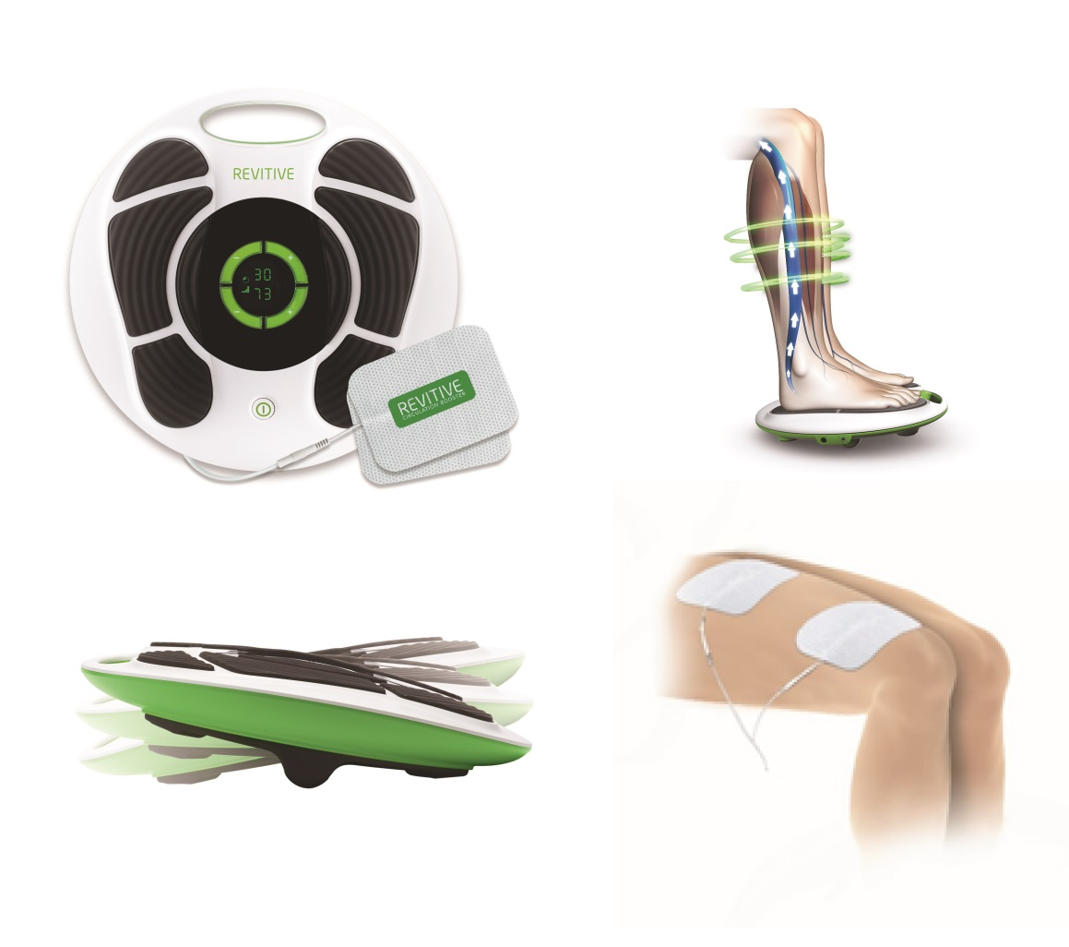

Top left: Revitive Arthritis Knee device; Top right: electrical muscle stimulation (EMS) causes foot and calf muscles to contract, increasing circulation; Bottom left: IsoRocker feature allows for natural ankle movement; Bottom right: EMS applied to the thigh muscles.

What will happen to me if I take part?
The study lasts 8 weeks. You will first be required to attend Glenfield Hospital to complete a 1 hour session with one of the research team, which will provide you with more information about the study and assess if you are eligible. If you are suitable for the study you will be provided with an activity monitor to wear for 1 week prior to using the device. The following week you will return to the Glenfield Hospital for approximately 2 hours. This will involve measuring muscle strength, exercise tolerance and completing some questionnaires. You will then be randomised into either a group that receives a working device, or a control group that receives a ‘sham’ device. You will use the device once per day for 8 weeks at home, with each session lasting between 30 and 50 minutes. During this time you will be contacted by a member of the clinical team to find out how you are getting on using the device. After 7 weeks you will be sent an activity monitor to track your activity levels over the final week of the study. After 8 weeks you will be invited to come back to Glenfield Hospital for a third visit where muscle strength and exercise tolerance will again be measured, and the same questionnaires will be completed. If subsequent visits are required, after the third visit, the costs of these will be reimbursed.
In more detail, at the first visit you will have your medical history taken and an examination by a physiotherapist. Other measurements that will be recorded include height and weight. You will then be shown the device while supervised and will be provided with instructions for using the device at home.
You will be asked to keep a diary over the 8 weeks, recording how long you use the device each day at home, the setting you use it on and how comfortable you find the device.
At the end of the study period, you will be offered a working device for free if you would like one, regardless of which group you allocated to.
What are the possible risks of taking part?
We do not anticipate any serious risks. The device has been through rigorous testing processes, including previous clinical trials, and has a CE mark for use in patients with osteoarthritis.
Activation of the muscles might result in an odd sensation at first but it should not hurt. There are several levels of intensity meaning that the device can be adjusted for your comfort.
We understand that travelling may be difficult or expensive therefore we are happy to offer a taxi or travel reimbursements.
What are the possible benefits of taking part?
We know from previous studies that the Revitive device increases blood flow and alleviates swelling in patients and healthy individuals. We expect it to be of direct benefit to you if you suffer from pain, stiffness and swelling or weakened leg muscles. You will not get paid for participating in this study.
What if something goes wrong?
You should not join the study if you have an implantable pacemaker or defibrillator device, or if you have a metallic implant in the hip or leg. You may be withdrawn from the study if the doctors feel it is best for you not to participate or if you do not comply with the requirements of the study. If during the screening session abnormal results are found, you will be immediately referred for clinical review as appropriate.
If you feel any discomfort or distress during the study you must say so immediately and contact the researchers. If for any reason during the study and you do not wish to continue, then we will stop the tests immediately.
If you are harmed due to someone’s negligence, then you may have grounds for a legal action. Regardless of this, if you wish to complain, or have any concerns about any aspect of the way you have been treated during the course of this study then you should immediately inform the research team (see below). There are no special compensation arrangements in the unlikely event that you are harmed through taking part in the research project. If you are harmed due to someone’s negligence you may have grounds for legal action but may also have to pay costs for such action. Regardless of this, if you wish to complain, or have any concerns about any aspect of the way you have been treated during the course of this study the normal National Health Service complaints mechanisms would be available to you. Advice can be sought from the Patient Information and Liaison Service (PILS). Their contact number is 08081788337 and email address pils.complaints@uhl-tr.nhs.
Will my taking part in this study be kept confidential?
All information that is collected about you during the course of the study will be kept strictly confidential. If you join the study, some parts of your medical records and the data collected for the study will be looked at by the clinical team. They may also be looked at by representatives of regulatory authorities to check that the study is being carried out to the highest professional and ethical standards.
If an abnormality is found, which does not relate to your osteoarthritis, a referral to an appropriate specialist will be made, with your permission, and your General Practitioner will be informed.
The company that make the device (Actegy Ltd.) will have access to your anonymised study data.
Actegy is the sponsor for this study based in the United Kingdom. We will be using information from you and your medical records in order to undertake this study and will act as the data controller for this study. This means that we are responsible for looking after your information and using it properly. Actegy will keep identifiable information about you for 5 years after the study has finished.
Your rights to access, change or move your information are limited, as we need to manage your information in specific ways in order for the research to be reliable and accurate. If you withdraw from the study, we will keep the information about you that we have already obtained. To safeguard your rights, we will use the minimum personally-identifiable information possible.
University Hospitals of Leicester will keep your name, NHS number and contact details confidential and will not pass this information to Actegy Ltd. University Hospitals of Leicester will use this information as needed, to contact you about the research study, and make sure that relevant information about the study is recorded for your care, and to oversee the quality of the study. Certain individuals from Actegy Ltd and regulatory organisations may look at your medical and research records to check the accuracy of the research study. Actegy will only receive information without any identifying information. The people who analyse the information will not be able to identify you and will not be able to find out your name, NHS number or contact details.
University Hospitals of Leicester will keep identifiable information about you from this study 5 years after the study has finished.
You can find out more about how we use your information by contacting the study team on 0116250 2758.
What will happen to the results of the study?
We will publish the overall results of the study, whatever the findings, to allow doctors to learn from our findings. As a participant, you will not be personally identifiable in any publication.
Who is organising and funding the research?
The project is organised by the University Hospitals of Leicester and devices are provided by Actegy Ltd
Further information
We are happy to provide you with any other information, now or later on. You can think about the study and come back to us at any time.

Please contact:

Centre of Exercise and Rehabilitation Sciences,
Glenfield Hospital
Groby Road,
Leicester
LE3 9QP
Tel: 0116 250 2758 Email: Samuel.briggs-price@uhl-tr.nhs.uk

