Participant Flow:
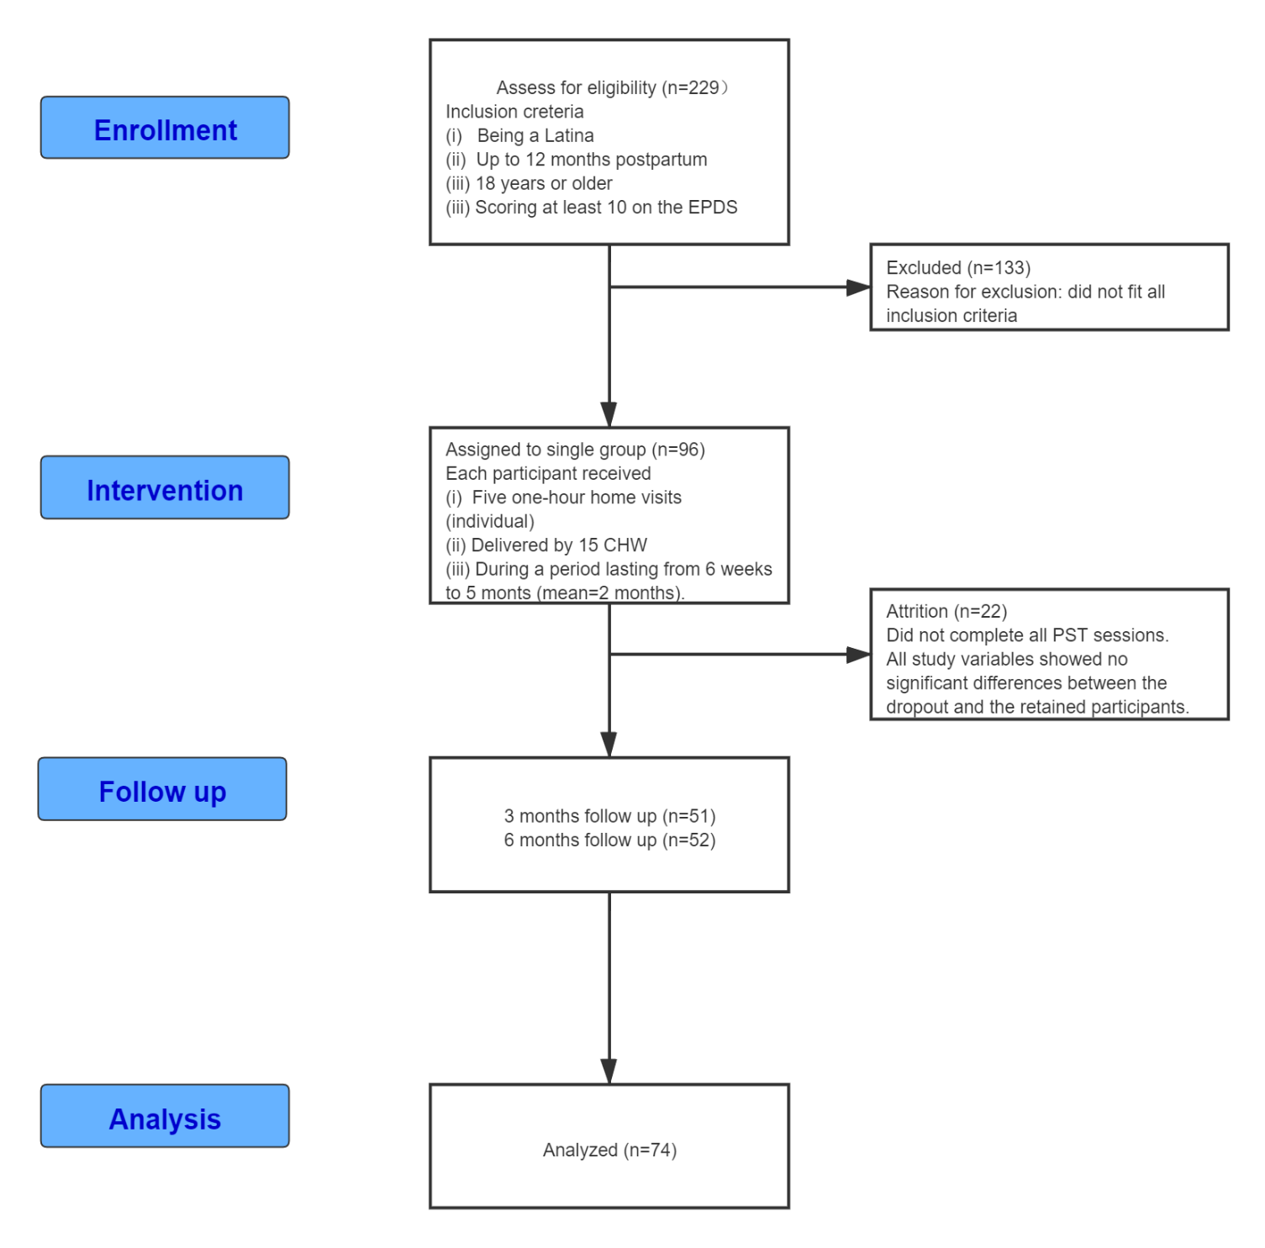

Baseline Characteristics
Table 1. Demographic information of participants who completed the study (n=74)
Categorical variables | N | %
Primary language
Spanish | 60 | 81.1
English | 13 | 17.6
Other | 1 | 1.4
Country of birth
USA | 20 | 27
Otherª | 53 | 71.6
Declined to answer | 1 | 1.4
Relationship Status
Married | 37 | 50
Single/Never Married | 29 | 39.1
Divorced/widowed/separated | 7 | 9.5
Decline to answer | 1 | 1.4
Employment Status
Employed | 24 | 32.4
Unemployed by choice | 28 | 37.8
Unemployed but desire to be employed | 22 | 29.7
Education
8th grade or less | 14 | 18.9
More than 8th grade to GED | 35 | 47.3
Continuous variables | M | SD | Min | Max
Age | 28.9 | 6.7 | 18 | 44
Length in US (if foreign born) | 12 | 7.1 | 1 | 29
Household income (last 30 days) | 1658.0 | 931.9 | 0 | 4000
EPDS* | 15.7 | 3.6 | 10 | 25
* One inclusion criterion is scoring 10 and above in EPDS.

Outcome Measures
Table 2 Descriptive statistics and paired-t test results for study variables
Outcome | Pretest |  | Posttest |  | t | df | p | Cohen’s d (effect size)
 | M | SD | M | SD
EPDS | 15.7 | 3.6 | 7.70 | 5.33 | 13.622 | 73 | .001 | 1.584 (large)
PHQ-9 | 10.9 | 5.7 | 5.00 | 3.96 | 9.49 | 73 | <.001 | 1.103 (large)
NGSE | 29.1 | 7.7 | 32.18 | 6.90 | -3.41 | 73 | .001 | 0.398 (small)
MEQ | 28.4 | 4.4 | 31.28 | 4.08 | -4.94 | 73 | <.001 | 0.575 (medium)
PPD Knowledge | 4.59 | 1.71 | 5.64 | 2.08 | -3.618 | 73 | <.001 | 0.424 (small)

Adverse Events
The Puerto Rico site was dropped due to hurricane Maria that struck the island in 2017.
To our best knowledge, there have not been any adverse events happened to the participants during the period of the intervention.

