

**CLINICAL STUDY PROTOCOL**

**PHOENIX-Feasibility: Picking up Hidden Osteoporosis**

**Effectively during Normal CT Imaging**

**Without additional X-rays**

PHOENIX-f

PHOENIX-f is a multi-centred, non-blinded, randomized controlled feasibility study. Opportunistic review of CT scans combined with calculation of fracture risk will be compared to normal clinical care with the aim of reducing osteoporosis and fragility fractures.

**Version 1.2**

**Date: 01/07/2019**

|  |  |
| --- | --- |
| **IRAS Number:** | 259482 |
| **SPONSORS Number:** | A095016 |
| **FUNDERS Number:** | **NIHR RfPB Grant:** PB-PG-0816-2007 |

**This protocol has regard for the HRA guidance and order of content**



KEY TRIAL CONTACTS

|  |  |
| --- | --- |
| Chief Investigator | Dr Ken Poole, 01223 217580, [kp254@medschl.cam.ac.uk](mailto:kp254@medschl.cam.ac.uk), [kenneth.poole@nhs.net](mailto:kenneth.poole@nhs.net) |
| Trial Co-ordinator | Karen Willoughby, 01223 217580, kw369@medschl.cam.ac.uk |
| Sponsor |  |
| Joint-sponsor(s)/co-sponsor(s) | Cambridge University Hospitals NHS Foundation Trust and the University of Cambridge |
| Funder(s) | NIHR RfPB stream |
| Key Protocol Contributors |  |
| Statistician | Dr Stephen Kaptoge, 01223 748668  [skk22@medshl.cam.ac.uk](mailto:skk22@medshl.cam.ac.uk) |
| Committees | **Trial Management Group:**  Dr Ken Poole  Consultant Rheumatologist  University of Cambridge  [kp254@medschl.cam.ac.uk](mailto:kp254@medschl.cam.ac.uk)  Dr Emma Clark,  Reader in Rheumatology, University of Bristol  [Emma.clark@bristol.ac.uk](mailto:Emma.clark@bristol.ac.uk)  Dr Stephen Kaptoge,  Senior Statistician, University of Cambridge  [skk22@medshl.cam.ac.uk](mailto:skk22@medshl.cam.ac.uk)  01223 748668  Professor Lee Shepstone  Professor of Medical Statistics,  University of East Anglia  L.Shepstone@uea.ac.uk    Dr Tom Turmezei  Consultant Radiologist  CUHNFT  Tom@turmezei.com    Dr Ann Frost  PPI representative  raf27@cam.ac.uk    Dr Peter Scholten  General Practitioner CUH  Dr Thomas Hiemstra  Clinical Trialist & Honorary Consultant Nephrologist  University of Cambridge  tfh24@cam.ac.uk  Dr Adam Wagner  Research Fellow in Health Economics,  University of East Anglia  [Adam.Wagner@uea.ac.uk](mailto:Adam.Wagner@uea.ac.uk)  Ms Karen Willoughby,  Trial Manager, University of Cambridge  [kw369@medschl.cam.ac.uk](mailto:kw369@medschl.cam.ac.uk), 01223217580 |

**i. LIST of CONTENTS**

|  |  |
| --- | --- |
| **GENERAL INFORMATION** | **Page No.** |
| TITLE PAGE | 1 |
| RESEARCH REFERENCE NUMBERS | 2 |
| SIGNATURE PAGE | 3 |
| KEY TRIAL CONTACTS | 4 |
| i. LIST of CONTENTS | 6 |
| ii. LIST OF ABBREVIATIONS | 7 |
| iii. TRIAL SUMMARY | 8 |
| iv. FUNDING | 9 |
| v. ROLE OF SPONSOR AND FUNDER | 9 |
| vi. ROLES & RESPONSIBILITIES OF TRIAL MANAGEMENT COMMITTEES, GROUPS AND INDIVIDUALS | 9 |
| vii, PROTOCOL CONTRIBUTERS | 9 |
| viii. KEYWORDS | 10 |
| ix. STUDY FLOW CHART | 11 |
| **SECTION** | |
| 1. BACKGROUND | 12 |
| 2. RATIONALE | 12 |
| 3. OBJECTIVES AND OUTCOME MEASURES/ENDPOINTS | 14 |
| 4. TRIAL DESIGN | 18 |
| 5. TRIAL SETTING | 18 |
| 6. PARTICIPANT ELIGIBILITY CRITERIA | 19 |
| 7. TRIAL PROCEDURES | 20 |
| 8. STATISTICS AND DATA ANALYSIS | 28 |
| 9. DATA MANAGEMENT | 36 |
| 10. MONITORING, AUDIT & INSPECTION | 37 |
| 11 ETHICAL AND REGULATORY CONSIDERATIONS | 37 |
| 12. DISSEMINATION POLICY | 38 |
| 13. REFERENCES | 39 |
| 14. APPENDICIES | 41 |

**ii. LIST OF ABBREVIATIONS**

Define all unusual or ‘technical’ terms related to the trial. Add or delete as appropriate to your trial. Maintain alphabetical order for ease of reference.

BMD Bone Mineral Density

CI Chief Investigator

CRF Case Report Form

DMC Data Monitoring Committee

EC European Commission

EU European Union

GCP Good Clinical Practice

ICF Informed Consent Form

ICH International Conference on Harmonisation of technical requirements for registration of pharmaceuticals for human use.

ISF Investigator Site File (This forms part of the TMF)

ISRCTN International Standard Randomised Controlled Trials Number

NHS R&D National Health Service Research & Development

PI Principal Investigator

PIC Participant Identification Centre

PIS Participant Information Sheet

QA Quality Assurance

QC Quality Control

QCT Quantitative Computed Tomography

QP Qualified Person

RCT Randomised Control Trial

REC Research Ethics Committee

RIS Radiology Information System

SDV Source Data Verification

SOP Standard Operating Procedure

TMF Trial Master File

TMG Trial Management Group

# iii. TRIAL SUMMARY

|  |  |  |
| --- | --- | --- |
| Trial Title | PHOENIX-Feasibility: Picking up Hidden Osteoporosis  Effectively during Normal CT Imaging without additional X-rays | |
| Internal ref. no. (or short title) | PHOENIX-f | |
| Trial Design | Pragmatic multi-centre, non-blinded, randomized controlled feasibility study with 3 parallel groups. | |
| Trial Participants | Women 65 < 91  Men 75 <91 | |
| Planned Sample Size | 375 | |
| Treatment duration | N/a | |
| Follow up duration | 1 year | |
| Planned Trial Period | 01.09.2019 (open to recruitment) – 31.08.2021 | |
|  | Objectives | Outcome Measures |
| Primary | To determine recruitment rate | Number of patients randomised in 10 months |
| Primary | a) Study retention rate. | The study will be considered feasible if we determine the outcome (treated / not on treatment) in ≥75% of the sample at 12 months from randomisation. |

# iv. FUNDING AND SUPPORT IN KIND

|  |  |
| --- | --- |
| **FUNDER(S)** | **FINANCIAL AND NON FINANCIALSUPPORT GIVEN** |
| NIHR  Kathryn Rumney, Program manager, [kathryn.rumney@nihr.ac.uk](mailto:kathryn.rumney@nihr.ac.uk) | Funding of feasibility study  dissemination of results |

**v. ROLE OF TRIAL SPONSOR AND FUNDER**

NIHR RfPB – funders.

Cambridge University Hospitals NHS Foundation Trust and the University of Cambridge: Sponsor

Responsible for trial design, protocol development, conduct, monitoring, data entry, database design, data analysis, interpretation, manuscript writing, dissemination of results.

Regular reports to be submitted to the NIHR.

**vi. ROLE AND RESPONSIBILITIES OF TRIAL MANAGEMENT COMMITEES/GROUPS & INDIVIDUALS**

**Trial Management Committees**

Trial Management Group (TMG)

The Trial Management Group will be responsible for the day to day running of the study to discuss practical aspects and ensure it is progressing well, with particular regard to accrual in a pragmatic trial. The group represents various specialist aspects of the study. Apart from the Chief Investigator there are no other principle investigators in the group.

The TMG aim to meet by teleconference every 2/3 months and will oversee the day to day management of the trial

**vii. PROTOCOL CONTRIBUTORS**

This protocol has been developed by a number of individuals

Dr Ken Poole and Dr Emma Clark have provided clinical expertise in the area of bone health which forms the basis for the study.

Dr Stephen Kaptoge has developed the statistical analysis plan including calculation of sample size and definition of primary and secondary outcomes and power calculations.

Dr Adam Wagner will be analysing results from a health economics perspective. He has developed suitable outcomes for the trial

Ms Karen Blesic has provided a nursing and patient orientated viewpoint for the protocol

Mr Daniel Chappell has been working with the software we will be using for the study and has provided information on the background and rationale for using it. He has helped clarify pathways for scan analysis in the study

Ms Karen Willoughby clarified pathways and study flow and liaised with the team to finalise the protocol.

Patients and service users have been involved in the patient documentation design and have contributed to suggestions for increasing patient recruitment and follow up

|  |  |
| --- | --- |
| **viii. KEY WORDS:** | Osteoporosis and osteoporotic fracture reduction  Opportunistic screening  Repurposing CT scans  Improving diagnosis of osteoporosis  osteoporosis  screening  vertebral fracture  secondary care |

# Study Flow Chart

Authorised clinical staff identify those attending for pelvic CT scans & within age range.

Patient attends for CT scan. Documentation given to patient by member of usual care team

Patient does not consent

Patient reviews pack; PIL, ICF and FRAX

Patient not eligible

Green FRAX group, patients at low risk of fracture: no further action

Site staff scan FRAX, ICF and contact details to secure account at Addenbrooke’s. ICF original retained at site.

Delegated member of research team takes informed consent; completes ICF and FRAX questionnaire in the CT Dept.

Research team calculates FRAX risk scores; removes low risk group

Month 0: RANDOMISATION n = 375

**Red / Amber** FRAX groups: patients at **High/Medium** risk of fracture

**Month 2:** Purposive sample, approx. n=20 MORTALITY STATUS CHECK Patient experience interview by phone or face-to-face

**Month 1 (as soon as FRAX scores entered +/- CT scan bone health reported):**

1 x baseline questionnaire posted to pt. / telephone call follow-up if needed

1 x copy ICF sent to patient. No ICF copy retained at coordinating centre

**Month 13: All** baseline FRAX scores sent to GPs. All baseline CT scans reviewed and reports to GPs with treatment advice. RIS data report retrieved for all CT scans

**Month 12: MORTALITY STATUS CHECK BEFORE CONTACT**

Follow-up postal questionnaire – service use, quality of life, patient experience

Telephone call if nor returned <3 weeks

**GROUP 2, n = 125**

**FRAX only**

* FRAX risk score calculated and data entered onto database
* CT scan reviewed by technician
* Bone Density calculated & any vertebral fractures identified
* Report sent to GP with treatment recommendations taking into account FRAX risk score
* FRAX risk score calculated and data entered onto database
* Completed FRAX questionnaire (but not FRAX score) sent toGP who can calculate score and decide if any investigation or treatment is necessary
* No review of scans by researchers until Month **13**, then sent to GP
* FRAX risk score calculated and data entered onto database for all patients.
* No correspondence with GP until month **13**
* No review of scans by researchers until Month **13**, then sent to GP

**GROUP 1, n = 125**

**FRAX & CT Review**

**,**

**GROUP** **3, n** = **125**

**USUAL CARE**

**USUAL CARE**

# 1 BACKGROUND

In osteoporosis, bones become porous and break more easily, especially in the spine and hips. While treatment of osteoporosis is now quite straightforward, detection is difficult. In the UK, osteoporosis causes 200,000 vertebral fractures yearly in women and men. Since vertebral fracture pain can mimic ordinary backache, patients are frequently left undiagnosed, so multiple fractures are common.

Two million computed tomography (CT) scans are performed each year in the UK 1, often for abdominal and pelvic problems. Up to a third of those scanned have osteoporosis or vertebral fractures without knowing it 2. Older patients attending hospital for CT scans stand to benefit from osteoporosis screening since many have undiagnosed spine fractures or low bone density. In fact, 42.3% of over 60-year-olds undergoing CT scans (for abdominal and pelvic problems unrelated to their bones) were found to have osteoporosis or vertebral fractures when the scan images were examined using computer- analysis methods3. However, radiologists reporting CT scans picked up only 16% of vertebral fractures in routine practice4, and the density of the bones is usually ignored. Systematic reviews indicate that missing these life-changing bone conditions can lead to serious, preventable pain, disability and health costs (>£2 billion per year from osteoporosis in the UK)5. Osteoporosis is a common disease in older women and men. In the UK, osteoporosis is associated with >200,000 vertebral fractures and >85,000 hip fractures annually6. Osteoporosis-related fractures have a high morbidity and, despite low cost, effective treatments, women and men are increasingly presenting at clinic with advanced multiple vertebral fractures, loss of body height, compressed abdominal contents, dysphagia, severe and chronic pain and reduced mobility. Despite an ageing UK population, osteoporosis remains under-diagnosed and under-treated7

# 2 RATIONALE

The commercial development of new software such as Mindways QCTPro and CTXA has enabled accurate diagnosis of osteoporosis from clinical CT. Other software such as Mindways SlicePick-MT technology has enabled more accurate diagnosis of sub-clinical vertebral fractures. CT scans taken of the torso and/or pelvis for any reason can now be reviewed to reveal much greater details of bone health in the individual, including the diagnosis of prevalent fractures and more precise estimation of future risk of fragility fractures from derived indices. The PHOENIX pathway is a simple and widely practicable intervention. It has been developed to apply these novel software programmes to ordinary CT scan images in order that they may be reused for measuring bone density (and diagnose osteoporosis), fracture risk and to identify crushed vertebrae8 ,9. It couples timely diagnosis with a report containing advice on NICE-approved, cost-effective treatments and lifestyle advice to reduce osteoporotic fractures10.

We hypothesise there will be value in early diagnosis and treatment of osteoporosis, through fractures prevented, societal and social burden and reduced health costs. The current usual care for case-finding osteoporosis in older people is for the GP to ask their patient to complete a FRAX questionnaire. The responses to these 11 questions regarding fracture risk factors are then entered by the GP into an online calculator (https://www.sheffield.ac.uk/FRAX/tool.aspx?country=1) which indicates whether a DXA scan should be requested. Uptake of case finding is low and there is no national mandate for screening. High risk patients are referred for a DXA scan and treatment is offered if the bone mineral density (BMD) is low and/or fracture risk sufficiently high. Vertebral fractures are rarely detected in usual care even though they (alongside hip fractures) cause the biggest burden to patients and the health service. The expectation is that targeted screening will improve upon usual care and appropriately increase the diagnostic rate.

There are several reasons for opportunistic osteoporosis screening during a CT scan:

* CT attenders are a high-risk population; >30% of these older adults have undiagnosed vertebral fractures or osteoporosis that can be effectively treated once identified1
* The PHOENIX pathway allows us to diagnose osteoporosis on scans already done, without additional x-rays/hospital visits
* Opportunistic case-finding is recommended by NICE11
* Screening is effective at reducing hip fractures10

**Summary of the key justifications for testing the PHOENIX pathway:**

* Opportunistic screening of patients for osteoporosis when attending hospital is advocated by NICE osteoporosis guidelines, but rarely done11
* Systematic review (Cochrane) of therapy for osteoporosis found strong evidence that alendronate (cost 76 pence/month) prevents vertebral fractures in patients found to be osteoporotic by radiological scans
* Systematic reviews of screening for osteoporosis suggest a number needed to screen (NNS) of 43 people (aged 75 or over) to prevent one vertebral fracture12. A recent trial of primary screening based on clinical risk factors and targeted bone density scanning reduced the hip fracture incidence by 28% over five years, NNS 111 to prevent one hip fracture10.
* CT scanners can effectively be turned into opportunistic bone density scanners that also detect fractures, without additional radiation. In Carberry’s study4, radiologists failed to report 84% of clinically important vertebral fractures from routine CT scans. Such fractures can be identified by computerised analysis methods9
* There is a fourfold risk of another vertebral fracture occurring after the first one 13.
* Generalisability: one million CT scans were performed in the UK in 1996, increasing to five million in 2016 14, so there is potential to screen many ‘at-risk’ patients. Pathways such as PHOENIX are not complicated, nor technically demanding for hospitals used to operating dual-energy x-ray absorptiometry equipment (DXA)

**2.1 Assessment and management of risk**

# There is no clinical risk in this trial to the participants

# 3 OBJECTIVES AND OUTCOME MEASURES/ENDPOINTS

PHOENIX-f is a randomised, pragmatic feasibility study to inform a future multi-centre randomised controlled pragmatic trial (RCPT) which will determine whether detecting osteoporosis and vertebral fractures in patients undergoing routine CT scans will improve health by reducing the burden of fractures.

**Need for a Feasibility Study:**

A feasibility study is needed to assess many of the practical elements of the pathway with the intention of proceeding to a full clinical trial if demonstrated to be successful (The objective, if the feasibility trial is successful, is to apply for HTA funding for a definitive trial of PHOENIX screening versus usual care).

**Technology**

Whilst it is technically possible to conduct bone-health screening in patients attending for CT scans, there may be barriers to implementation. It is not known whether implementing opportunistic osteoporosis screening with CT will improve the treatment and detection rate of osteoporosis compared with usual care, and it is not known if a network (hub and spoke model) of opportunistic CT screening in different centres is clinically realistic and cost effective.

Digital PACS networks have enabled communication between hospitals on an unprecedented scale. With NHS innovation funding, it is possible to exchange CT images easily with remote hospitals using the NHS Image-Exchange-Portal (IEP). PHOENIX-f will test our network between Cambridge and nearby hospitals. If successful, hubs will be created as part of a multicentre HTA trial (with the NHS implementation toolkit that we are developing). Regions are already linked for clinical CT data exchange, but the novelty of PHOENIX comes from the sharing of data for screening and osteoporosis identification purposes.

**Recruitment and Randomisation**

The willingness of participants to be recruited and randomised will be tested. This is a low risk study following normal standard clinical care. Initial identification of potential participants takes place from the day’s CT list and is undertaken by a member of the patient’s usual clinical care team. If a patient is interested in discussing the study, they will be approached by local delegated member of the research team who will take responsibility for taking informed consent if appropriate (more details re practical aspects of taking consent can be found in section 7).

Following consent, patient information will be sent to CUH and randomisation will take place by the central study group at Addenbrooke’s using a web based service (Sealed Envelope). The central team will perform calculation of future risk of fracture and osteoporosis and will randomise only those that fall into red or amber risk groups.

**3.1 Primary objectives**

* **To test the feasibility of running a full clinical trial comparing 3 different pathways: Phoenix pathway v FRAX report to GP only v usual clinical care**

Although opportunistic screening is recommended under NICE guidelines on the occasion of a patient coming into contact with a healthcare professional, a FRAX questionnaire is actually rarely administered to patients attending any CT department. In PHOENIX - f, we have 3 groups. Participants in all 3 groups will be given a PHOENIX – f pack containing the participant information leaflet (PIL), informed consent form (ICF), and FRAX questionnaire. Participants will be asked to provide informed consent and complete a FRAX questionnaire. Once the FRAX 10-year fracture risk score has been calculated by the research team in Cambridge, those at low risk of fracture (green category by NOGG national guidelines) will be filtered out. Those in the remaining red and amber categories will be randomised to one of the 3 groups:

**Group 1:** The CT scan will be reviewed by an analyst based at Addenbrooke's Hospital. The 10-year fracture risk will be calculated by the researchers using the results of the validated FRAX questionnaire (**Appendix 7**) and the CT scans retrieved by NHS Image-Exchange-Portal (IEP). This will allow identification of vertebral fractures, measurement of spine/hip density and creation of a bone health report using a NICE-compliant pre-specified algorithm that matches standard bone density reports. The report will be sent to the participant’s GP with recommendations as to any further actions and/or lifestyle advice.

*Summary:*

* FRAX questionnaire data entry and calculation of 10-year fracture risk done by research team.
* Analysis of bone density in the hips and spine using the CT images already captured
* Computer-aided diagnosis of vertebral fractures from the 3D spine CT image already captured will be performed.
* a report to the GP containing femoral neck and/or spine bone density report, fracture diagnosis (yes/no/level), any necessary follow-up investigations and a simple treat/don't treat decision based on guidelines, with recommended clinical and cost-effective drug suggestions
* Copy of ICF sent to patient, alongside a baseline questionnaire (**Appendix 8**). Non-responders will be followed up by phone after 2 – 3 weeks (timing advised by PPI group).
* After one year following randomisation, a follow up questionnaire will be sent to the patient with further quality of life questionnaire. Non-responders will be followed up by phone.

**Group 2:** The completed FRAX Questionnaire will be sent immediately to the participant’s GP who will decide on any further action. The onus will be on the GP to enter the participant’s questionnaire responses to an online calculator to calculate fracture risk. At the one year follow up point, the FRAX results calculated by the research team will be communicated to the GP who will then be able to treat as necessary

Summary:

* FRAX questionnaire data entry and calculation of 10-year fracture risk done by research team.
* FRAX questionnaire (not calculated 10-year risk) sent to the GP, who can calculate the risk by entering responses to an online calculator
* The GP is responsible for any subsequent investigation including referring for DXA and/or treatment
* Copy of ICF sent to patient, alongside baseline questionnaire. Non-responders will be followed up by phone after 2 – 3 weeks (timing advised by PPI group).
* After one year following randomisation, a follow up questionnaire is sent to the patient with further quality of life questionnaire. Non-responders will be followed up by phone.
* FRAX results and scan review are undertaken and sent to the GP after one year to ensure all patients are offered treatment if appropriate

**Group 3:** Participants will be asked to complete a FRAX questionnaire, but to more accurately reflect ‘normal practice’ there will be no communication with individual GPs (a FRAX questionnaire is never usually offered to patients attending for CT scan). At the one year follow up point however, the FRAX and scan results will be communicated to the GP who will then be able to treat as necessary

* FRAX questionnaire data entry and calculation of 10-year fracture risk done by research team, but neither the calculated 10-year risk or questionnaire is passed on to the GP
* The GP is responsible for any screening as thinks fit
* Copy of ICF sent to patient, alongside baseline questionnaire. Non-responders will be followed up by phone after 2 – 3 weeks (timing advised by PPI group).
* After one year following randomisation, a follow-up questionnaire is sent to the patient with further quality of life questionnaire. Non-responders will be followed up by phone.
* FRAX results and scan review are undertaken and sent to the GP after one year to ensure all patients are offered treatment if appropriate

All groups will have a follow-up questionnaire at one year following randomisation; **there will be a check for survival status on the NHS spine prior to contact**

The study population consists of women aged ≥65- 90 and men aged ≥75 - 90 (as per NICECG146) attending for CT, for any reason, where the spine and/or hips are visible. Block randomisation stratified by centre (5 centres), sex (Male vs. Female) and age group (Female: <75 vs ≥75, Male: <80 vs ≥80) will be used to equally randomise 375 participants to 3 trial arms, comparing: PHOENIX-f (FRAX questionnaire and CT review), versus FRAX only, versus ‘usual’ care control group. Recruitment will take place over 10 months and will indicate the feasible recruitment rate we could expect from a large multi-centre clinical trial. A patient follow-up questionnaire will be sent to participants after twelve months from date of randomisation (followed by phone call to non-responders).

* **To Determine Retention Rate**

Follow-up rates after one year will be assessed. A questionnaire (**Appendix 10**)will be sent initially by post; non-responders will receive a telephone call after a period of 2 - 3 weeks and the questionnaire will be delivered according to an ethics agreed script.

**Prior to contact, the NHS spine database will be checked for survival status of participants**

**3.2 Exploratory Outcomes:**

* **Data Collection Requirements**

Time needed to collect and analyse data to enable resource planning if proceeding to full trial will be analysed. There will be a number of data collection points (see **Table 3.7**)

* Baseline FRAX questionnaire (**Appendix 7**) will be obtained in CT department
* A health status questionnaire EQ-5D-5L (**Appendix 8**) will be posted out post randomisation to obtain baseline quality of life measure. Telephone follow up will follow for non-responders
* A qualitative patient experience interview with guided topics (**Appendix 9**) will be offered to approximately 20 participants at around 2 months’ post-randomisation. We would also like to speak to GPs, radiographers and CT scanning department receptionists to learn for their perspective of the trial
* CT scan and RIS clinical report will be extracted from the Image Exchange Portal. The full RIS clinical report will be available approximately one month after scanning
* A PHOENIX follow up questionnaire (**Appendix 10**) will be posted out at 12 months post randomisation with both clinical and health economics questions. Telephone follow up will follow for non-responders

We wish to test the feasibility of using the Image Exchange Portal (IEP) using a ‘hub and spoke’ model, with Cambridge as the central hub for CT analysis

**PPI**

We have had Patient and Public Involvement (PPI) in the research design so far, with plans in place for further PPI engagement during the feasibility study conduct

**3.3 Outcome measures/endpoints**

* Study recruitment rate
* Study retention rate

#### **Primary endpoints/outcome measures**

* Recruitment rate at 10 months
* Retention at 12 months

**Secondary endpoints/outcomes:**

* Osteoporosis identification and treatment rates at 12 months

**Exploratory endpoints/outcomes**

* Assessing feasibility of IEP using ‘hub and spoke’ model

**3.4 Table of endpoints/outcomes**

|  |  |  |
| --- | --- | --- |
| **Objectives** | **Outcome Measures** | **Time point(s) of evaluation of this outcome measure** |
| To determine recruitment rate | Target = 375 red/amber responders over 10 months combined from the participating centres | 10 months from study opening to recruitment ending |
| Determination of study retention rate | Questionnaire return rate informing outcome (treated / not on treatment) in ≥75% of the sample at 12 months | One year post randomisation |
| Osteoporosis treatment rates at 12 months | Percentage of those treated by prescription for osteoporosis at 12 months as assessed by follow up questionnaire | One year post randomisation |

**4 TRIAL DESIGN**

PHOENIX-f has been designed as a feasibility study to inform a full scale clinical trial. We will be using a parallel group, non-blinded randomised controlled multiple-armed study design. We have designed a three-armed trial comparing the PHOENIX pathway with a control (‘usual care’) and an alternative active treatment. The study will be pragmatic and should advise us whether:

i) People are willing to volunteer to take part in an opportunistic, randomised trial when approached in a CT waiting room, and will have agreed in sufficient numbers to make a multi-centre national trial feasible.

From our PPI panel engagement it was noted that people attending CT departments may be more anxious than usual, and thus need to pay attention to making study trial materials clear, simple, attractive and not onerous on the participants. We are designing study materials similar to the new 'low-intervention clinical trial' paperwork and case report form, outlined in EU clinical trials regulation EU 536/2014.

ii). The PHOENIX pathway has identified enough osteoporosis/vertebral fractures to make the effort of screening worthwhile and

iii) That twelve months after consent, we have determined osteoporosis treatment status in sufficient number of participants.

# 5 TRIAL SETTING

This is a multicentre centre trial run in participating CT scanning departments within a 25 mile radius of Cambridge to allow for easy support if necessary. We have chosen a mixture of district general hospitals and an [academic health science centre](https://en.wikipedia.org/wiki/Academic_health_science_centre) to ensure the trial is feasible in a number of settings. Cambridge will act as a ‘hub’ in the process

The list of participating sites:

Addenbrooke’s Hospital,

Cambridge University Hospitals NHS Foundation Trust  
Cambridge Biomedical Campus  
Hills Road  
Cambridge CB2 0QQ

[North West Anglia NHS Foundation Trust](https://en.wikipedia.org/wiki/North_West_Anglia_NHS_Foundation_Trust)

Peterborough City Hospital,

Bretton Gate, Bretton,

Peterborough, Cambridgeshire, PE3 9GZ.

Lister Hospital

East and North Hertfordshire NHS Trust

Coreys Mill Ln,

Stevenage SG1 4AB

West Suffolk Hospital

West Suffolk NHS Foundation Trust

Hardwick Ln,

Bury Saint Edmunds IP33 2QZ

Bedford Hospital NHS Trust

Kempston Rd,

Bedford MK42 9DJ

**6 PARTICIPANT ELIGIBILITY CRITERIA**

**6.1 Inclusion criteria**

Participants eligible for the trial should fulfil all of the following **at randomisation**

* Attend one of five participating radiology departments
* Volunteers able to provide informed consent
* Women aged ≥65 - 90 and men aged ≥75 – 90 years inclusive
* Attending for CT, for any clinical reason, where the spine and/or hips are visible in the scan images
  1. **Exclusion criteria**
* Aged > 90
* Bilateral metalwork in hips
* Unable to provide valid consent
* Known to be receiving prescription treatment for osteoporosis other than calcium/vitamin D (i.e. bisphosphonate drug, strontium ranelate, denosumab, raloxifene or teriparatide)
* Prone CT scan

# 7 TRIAL PROCEDURES (See Schedule of Procedures, 14.4, Appendix 4)

**7.1 Recruitment**

This is a ‘no risk’ study following standard clinical care. Recruitment will take place in the CT scan area by a delegated member of the research team

**7.1.1 Participant identification**

Potential participants will be identified from CT scanning lists prior to arrival in the CT department (possibly the day/ few days earlier if lists are available). The appropriate types of scan giving correct views of the pelvis and hips to enable CT review for PHOENIX can be easily identified from CT lists.

**7.1.2 Screening**

No specialist or diagnostic testing is necessary.

**7.1.3 Payment**

There will be no payment to any participant

**7.2 Consent**

Once an eligible patient is identified (relevant age and appropriate supine CT scans will be the only broad eligibility criteria applied at this stage), the PHOENIX-f PIL and ICF/FRAX questionnaire documentation will be handed to the potential participant by the receptionist (a member of the usual care tea) in the waiting area. The study paperwork has been designed to use a tiered approach to recruitment. The cover page explains what the study is about in a very short paragraph then gives options in large print: either “If you are interested.”, asking the patient to turn over the page to read on, or “If you do not wish to take part in the study…”, asking the patient to give the study paperwork back to the receptionist. This is the first stage in the recruitment process.

If the patient refuses consent we would like to use some non-identifiable comments as to reasons for not joining the study. Comments from non-consenters can be taken into consideration when designing a possible future clinical trial.

Stage 2 provides another step; the individual will be requested not to proceed further if they meet any of the exclusion criteria (eg metalwork in hip). The third stage will ask the individual to read the PIL and invite the potential participant to talk to a delegated member of the research team in order to consider consenting to the trial. Discussion regarding study participation will probably take place after the CT scan has taken place, but this will be left to the discretion of the local team.

We require personal contact details for sending out follow up questionnaires. These will be held on a separate secure database apart from the clinical data. We will also require GP details to inform GPs of patient participation and to send reports, depending on the allocation arm, within 1 month of randomisation, or at 1 year in order to inform them of FRAX and CT review findings.

It will be clear in the study literature handed to the patient that the right of a participant to refuse participation without giving reasons will be respected and that they are free to withdraw at any time without prejudicing his/her further treatment. Contact details will also be provided where the individual may obtain further information about the trial. We wish to use data collected prior to the point of withdrawal should such a situation occur, as outlined in the PIL.

**7.3 The randomisation scheme**

PHOENIX-F is a pragmatic feasibility study with 1:1:1 block randomisation of patients attending CT to intervention

**7.3.1 Method of implementing the randomisation/allocation sequence**

Randomisation will take place at the co-ordinating centre following FRAX calculation, as only those at moderate – high risk of fracture in the next 10 years will be randomised to the study. Data for all those at low risk will be set aside, although their data will be analysed outside of the main study as part of the secondary outcomes.

A web based randomisation allocation system will be used – Sealed Envelope *(*[*www.sealed*](http://www.sealed)*envelope.co.uk)*. The system provides an immediate allocation with a confirmatory email and will provide a randomisation number*.* The study co-ordinator will have access to the system

There is no need for provision of an out of hour’s service

**7.4 Baseline data**

Baseline data will consist of those elements completed by the participant within the CT department, alongside data gathered through a questionnaire posted to the participant’s home as soon as possible following randomisation. The reasoning behind a 2 stage accumulation of baseline data is to minimise the time spent answering questions in the stressful environment of a CT department.

Data will be obtained from the validated FRAX questionnaire and from a few questions on the ICF document which checks eligibility, and used to estimate 10-year risk of osteoporotic fracture with the online FRAX calculation tool.

Anonymised data from those ineligible or not consenting will be analysed in order to obtain screening information.

A health economics perspective forms part of the baseline questionnaire posted out to participants after randomisation.

**7.5 Trial Assessments**

* **CT Scan Review**

The initial CT scan review will be undertaken by a research assistant at the sponsor site once consent has been given. To enable this to take place, the scan will be retrieved through the Image Exchange Portal (IEP) from the participating sites.

Images will also be audited for the presence of vertebral fractures by SlicePick-MT with CUH radiologist over-read.

**Background to use of SlicePick-MT:**

SlicePick-MT, a module within Mindways QCT Pro, was used to analyse 325 anonymous patients’ CT scans for the prevalence of vertebral fractures from previous audit data. The software relies on an initial semi-quantitative analysis of the spine as viewed in SlicePick-MT with any suspected vertebral fractures confirmed by quantitative-morphometry analysis. The results were compared against the current Gold Standard of fracture detection (ASPIRE™ Vertebral fracture Active Shape Modelling technology with Manchester over-read and CUH discrepancy review) at CUH. All fractures identified by ASPIRE™ and SlicePick-MT were reviewed at CUH discrepancy meetings.

The SlicePick-MT method correctly identified 50 of 51 “true” vertebral fracture patients from a total of 297 analysable scans; this includes 5 additional true fractures that were not reported by the Gold Standard in the previous audit, see table below. Five of the 6 patients in whom fractures were not previously reported were subsequently confirmed to have fractures by CUH radiologists, but one fracture in a patient was subsequently classified by a radiologist as a Schmorl’s node.

|  |  |  |  |  |  |  |  |  |  |  |  |  |
| --- | --- | --- | --- | --- | --- | --- | --- | --- | --- | --- | --- | --- |
|  | SlicePick-MT | | | | ASPIRE™ (Gold Standard) with CUH discrepancy review | | | | CUH CT Radiology Report (Original) | | | |
|  | Y | N | Total |  | Y | N | Total |  | Y | N | Total |
| All True Fractures | Y | 50 | 1 | 51 | Y | 46 | 4 | 50 | Y | 36 | 15 | 51 |
| N | 1 | 245 | 246 | N | 3 | 239 | 242 | N | 0 | 246 | 246 |
| Total | 51 | 246 | 297 | Total | 49 | 243 | 292 | Total | 36 | 261 | 297 |
|  | Sensitivity (95% CI) | Specificity (95% CI) |  |  | Sensitivity (95% CI) | Specificity (95% CI) |  |  | Sensitivity (95% CI) | Specificity (95% CI) |  |
|  | 98.00% | 99.60% |  |  | 93.90% | 98.40% |  |  | 100% | 94.30% |  |

The SlicePick-MT out-performed the current Gold Standard of care for diagnosing vertebral fractures in CT data. On the basis of these findings, there is a huge potential for optimising vertebral fracture care pathways by implementing the SlicePick-MT method of vertebral fracture detection in CT.

* **FRAX Questionnaire (Appendix 7)**

Calculations of 10-year fracture risk from FRAX questionnaire responses will be undertaken at the sponsor site. The FRAX answers provided by the participant will be scanned to a secure .net account to automate calculations and minimise transcription errors.

The questionnaire answers will be held on a secure database in a pseudo-anonymised form. Following allocation to groups, a unique anonymous trial number will be generated automatically by the web-based randomisation.

* **Reporting back to GP**

A PHOENIX-f report will be sent to GPs by post. A number of standardised reports have been developed containing specific GP advice depending on which of the following are identified for each participant; i) Normal bone density/Osteopenia/Osteoporosis, ii) Vertebral Fracture Identified/Not identified and iii) FRAX/NOGG recommends treatment or not. The reports outline the next steps needed to improve the participants' bone health through lifestyle advice and medication if indicated. For participants randomised to the full PHOENIX pathway (Group 1), the full report will be posted to GPs immediately following scan review. For participants randomised to Groups 2 & 3 the full report including the CT scan review results will be sent to GPs after 1 year. An example of the report can be found in (**Appendix 11)**

Since the timely diagnosis and treatment of osteoporosis has been found to be beneficial across many domains of patient outcomes (pain, quality of life, morbidity, and in the case of zoledronate treatment, mortality), it is not the intention of PHOENIX to deviate from the globally accepted way of advising primary care physicians on the management of bone health through imaging reports. With our pragmatic trial design, we have intentionally avoided deviating from the fully-accepted, commonplace provision of standard format bone health advice reports familiar to GPs.

* **Baseline Questionnaire (Appendix 8)**

This baseline questionnaire will collect information relevant for subsequent health economic analysis. It incorporates: i) the EuroQoL EQ-5D-5L for measuring health related quality of life; ii) questions about the use of NHS and personal social services (PSS) resources for bone health. A final open-ended question asks for participants’ views on the PHOENIX-f process and how they experienced being invited to take part in the study. The questionnaire will be posted to participants when the study team has received details of their consent and contact information. If a questionnaire is not returned within 2-3 weeks of being posted out, the study team will attempt to contact the corresponding participant by telephone and complete the questionnaire over the phone.

* **Patient Experience Topics (Appendix 9)**

At around 2 months post randomisation, approximately 20 patients will be offered the opportunity to provide views on their experience of the trial. Topics for a guided interview have been devised and will be administered either over the phone or by face to face interview. There will be an opportunity for any comments a participant may wish to make on the experience of taking part in the study or suggestions for improving the PHOENIX-f process from a patient perspective.

* **Clinician’s Perspectives**

We would like to interview a small number of GPs, radiographers and scanning department receptionists to ask about of their experience of the study. If possible, a group interview will be arranged

* **Follow up questionnaire (Appendix 10)**

One year after randomisation a follow-up questionnaire will be posted to participants. This questionnaire incorporates: i) the EuroQoL EQ-5D-5L for measuring health related quality of life; ii) questions about the use of NHS and personal social services (PSS) resources for bone health. . As in the baseline questionnaire this final questionnaire includes space for any comments a participant may wish to make on the experience of taking part in the study or suggestions for improving the PHOENIX-f process from a patient perspective. If a questionnaire is not returned within 2-3 weeks of being posted out, the study team will attempt to contact the corresponding participant by telephone and complete the questionnaire over the phone

**7.6 Long term follow-up assessments**

* **Follow up questionnaire**

Completion of the follow up questionnaire at 1-year is the only follow up assessment required after baseline. Survival status will be checked on the NHS spine prior to contact. Phone contact will be used to obtain missing returns

**7.7 Qualitative assessments**

**Rationale**

Qualitative research methods are needed to complement and add depth to the interpretation of the study’s quantitative data collection, particularly towards the process evaluation embedded in this feasibility study. This follows MRC guidance on process evaluation [Moore et al, 201415, 201516] which highlights three elements pertinent to intervention delivery – 1) Implementation*, 2) Mechanisms of impact and 3) Contextual factors – and recommends mixed methods approaches.

(*Note that ‘Implementation’ here refers to the delivery of the planned screening, reporting and follow-up intervention during the PHOENIX-F feasibility study; it does not imply wider service uptake in the sense that the term is also used to denote roll-out of a new service as in ‘development-evaluation-implementation’ cycles)

Key research questions for the PHOENIX-F process evaluation are:

▪ What are the implementation facilitators and barriers for the PHOENIX protocol?

▪ How acceptable to the intended patient group is the process of PHOENIX screening?

▪ How do implementation and acceptability issues affect uptake of the CT bone health screening and any subsequent GP investigation and recommended bone protective treatment?

The focus of the qualitative work will be on achieving an in depth understanding of the acceptability to patients of PHOENIX screening, what barriers lie behind any feasibility problems the study encounters, and what factors can facilitate effective delivery of the PHOENIX screening intervention.  Qualitative fieldwork and analysis are embedded in the study, particularly exploring and helping to elucidate what lies behind issues that may emerge from the process evaluation’s quantitative results.  Importantly, this will help to refine plans for intervention delivery before a larger RCT can go forward, highlighting any ‘blockages’ and ways to unblock these, and ensuring that future research and clinical application takes account of user and provider perspectives. It will be important to understand both the perspectives of patients for whom PHOENIX screening is applicable, and of different staff who are key to delivering all steps in the PHOENIX screening process. The researcher conducting the fieldwork outlined below is trained in qualitative research methods, an experienced interviewer and facilitator of focus groups with a range of professionals, patients and the public, and has long experience of working with older people in both clinical and research roles.

**Methods**

***Data collection***

We will collect both written and oral qualitative data:

▪ open questions with space for free-text comments on forms and questionnaires

▪ recordings of topic-guided interviews with participants and interviews/focus groups with staff

***Written qualitative data collection***

We have chosen to add written methods to the usual interview and focus group methods often used in qualitative research because those more time-consuming methods mean limiting oral data collection to only a small sub-sample of the total number taking part in the study. Including a space for free-text comments on open questions in every form and questionnaire will enable us to gather views from all study participants willing to provide feedback in this format.

▪ **Patients who decide not to participate**

◦ We will ask patients who decline joining the PHOENIX-f study if they could tell us why they decided not to take part. This open question will be on the front cover sheet of the paperwork given in the CT waiting room to patients already identified as potentially eligible for the study in terms of age and scan type. Our tiered approach to recruitment means that patients need not read beyond this cover sheet if they do not wish to take part. This front page explains it would be very useful if patients can tell us their reason for declining, but asks for no other information.

◦ We appreciate that many who decline study participation will also not fill in this question and, of course, we cannot contact patients after they have refused consent. However, as this will be the only contact between the study and these patients, it is very important to try to learn what we can about what factors influence patients’ decisions to accept or reject CT bone health screening and study participation.

▪ **Participants**

◦ We will include a section with space for free text comments at the end of the baseline and one year follow-up postal questionnaires which will be sent to every participant in all three randomisation groups. We will explain that this feasibility study hopes to learn from their feedback: *It would greatly help us if you can tell us any thoughts you may have on your experience of taking part in the study or on how the process of offering bone health checks with CT scans might be improved. Any comments*?

◦ Participants who have not returned postal questionnaires within 2-3 weeks will have a reminder telephone-call from a member of the central research team, offering either to re-send the questionnaire by post or to complete it over the phone. If completed by phone, participants’ comments on this feedback question will be noted verbatim and used in the same way as written comments on the questionnaires returned by post.

◦ We recognise that this free text comments section may be left blank by many participants but hope that repeating this open question in the final follow-up questionnaire may elicit responses from some who made none initially.

***Oral qualitative data collection***

▪ **Participants**

We will use semi-structured interviews with a smaller sub-sample of study participants (n=20) to allow for more in-depth exploration of issues that participants may raise in written feedback or during interview.

Between 2 and 3 months after randomisation invitation letters will be sent to purposively sampled sub-groups of participants in time-staggered mailings until n=20 consent to a short interview. Invitations will include participants from all three randomisation groups, but will be weighted to achieve an interview sample predominantly drawn from Group 1, those whose CT bone density results as well as FRAX scores will have been sent to their GPs. Within this group the sub-sample invited will be further weighted so that the majority will be those with low CT bone density or FRAX score indicating a high risk of fracture. This is to increase the chances of interviews including participants whose GPs may have contacted them after receiving their FRAX and PHOENIX bone density report and recommendations for bone preserving treatment. We will aim to interview a sample that includes:

◦ participants who have had or not had contact with their GP since their CT bone density was reported

◦ participants who have started or not started treatment with a bone protective medication

Purposive sampling will also aim to achieve a sample representative of factors that will determine the sampling frame of future trial (age, sex and indication for CT scan).

All participants will be aware from the PHOENIX-f PIL that there is a small chance they might be invited to talk with a researcher about their experience of the PHOENIX process – the offer to have their bone health checked using their CT scan, any subsequent contact with their GP about this and the approach to take part in the study. Invitations will be posted to a shortlist of participants purposively sampled as above in staggered mail-outs timed so that these participants receive their invitations 2-3 months after they consented to join the study. The invitation letter will include a separate PIL and ICF specific to these interviews, a reply slip and a postage paid envelope.

The PIL for this interview project will explain there is no obligation to agree to talk with a researcher and stress that declining this invitation to interview will not affect their care in any way, nor their continued participation in the main PHOENIX-*f* study which will only involve one more postal questionnaire a year after their CT scan. We will ask participants to return the reply slip in the postage paid envelope indicating whether they are willing to be contacted by a member of the research team who can explain more, answer any questions they may have about what the interview would involve and arrange an interview time if the participant consents. The reply slip asks participants to indicate if they have a preference to be contacted by phone or by e-mail. The PIL will include the study website and contact details for participants to get in touch if they would like more information before returning the reply slip. It will also explain that a researcher will try to phone if we have not heard from a participant within a fortnight saying they prefer not to take part. Consent to contact participants by telephone or by email was already sought when they were first recruited to the main PHOENIX-*f* study. Before trying to contact participants who do not sent a reply slip back, the research team will check with the NHS Spine to make sure we do not upset relatives by phoning a deceased participant. Participants can also return the informed consent form with the reply slip if they have already had any queries answered.

Participants will be offered the choice of an interview by telephone or in person at home and at a time to suit their convenience, with or without a relative or friend present, if the participant so wishes. For participants who prefer to be interviewed in person, the research team will follow lone working policies developed for fieldwork in the Department of Public Health and Primary Care ensuring a nominated contact is told the name, address and time of all home visit interviews, with clearly delineated responsibilities in the event that the researcher fails to make contact within an agreed schedule.

Semi-structured interviews will be conducted with the aid of a topic guidesand will be audio-recorded. Recordings will be transcribed by an academic transcription service following a confidentiality contract and anonymised by a member of the research team changing names of people and places and any identifiable details. Audio-files and transcripts will be securely stored on the PHOENIX-*f* secure university server for ten years.

Interviews with participants will aim to learn:

a) how patients, and their relatives/friends, if also interviewed experienced and responded to being invited for screening and, if screened, to the PHOENIX screening intervention

b) how they viewed its acceptability – if negative, what they viewed as unacceptable

c) what they understood to be the potential benefits of the screening and, if applicable, starting treatment

d) whether they viewed positively or negatively the timing of PHOENIX screening coinciding with CT scanning for another indication

e) whether they perceived any potential harms from being approached for osteoporosis screening at the time they were under investigation for possible other conditions

f) what motivated them to accept or refuse the offer of screening and, if applicable, subsequent follow-up recommendations

▪ **Health service staff**

We will use a combination of interviews and focus groups with three categories of staff who will be key to the effective delivery of PHOENIX screening, both in hospital and primary care, in order to understand their different perspectives:

◦ GPs

◦ Radiographers

◦ CT department receptionists

There are both methodological and practical advantages to gathering their views both individually and in groups. Individual interviews allow staff to raise issues they might feel awkward raising in a group, for instance in front of a more senior colleague, but group discussions can sometimes bring additional context and depth as people bounce views off each other. Practicalities driving the choice of data collection include pressures on staff time and the geographic locations of staff across a region, such that it is likely to be most effective for some staff groups to make use of existing team meetings.

◦ GPs

The study will seek to learn from GPs who have experience of receiving FRAX scores from bone health screening questionnaires and/ or QCT (Quantitative CT) reports

The central research team at CUH will be able to identify which practices have received a reasonable number of these reports; this will increase the likelihood of reaching GPs who have come across these reports and who will have views to share on their experience of this reporting process.

We will provide a list of these practices to the Clinical Research Network (CRN) Eastern team so as to engage this supportive arm of the NIHR’s research infrastructure in approaching these practices. The CRN team for Division 5, which includes ageing and primary care research, have already offered to help prepare one of their study flyers which can be a useful way to highlight the purpose and potential benefits of the study and will be responsible for disseminating this with invitations to these practices where patients are participating in the PHOENIX-*f* study. Practices will be asked whether either any GP in the practice is willing to give a short telephone interview or whether they would prefer to have a researcher visit the practice for a short focus group with several GPs, say as part of a team meeting.

◦ Radiographers

We will seek one-to-one interviews radiographers involved in the PHOENIX-*f* study, including at least one manager and senior radiographerin at least two hospitals (one teaching, one District General Hospital). These approaches will initially be informal through the research team members who have been recruiting participants in the CT departments. If practicable, we will also seek to conduct a focus group with radiographers involved in PHOENIX-*f*, most likely alongside a regular team meeting. We will seek written consent after explaining the staff participant information leaflet and offering time to consider whether or not to take part.

◦ CT department receptionists

We will arrange to discuss the implications of PHOENIX-f recruitment with CT department receptionists timing this fit admin team demands, either alongside team meetings or inviting staff to a near-study-end feedback session. Again these staff will initially be approached informally through the research team members who have been recruiting participants in the CT departments who will then offer and explain the staff participant information leaflet and allow time for deciding whether or not to take part.

The purpose of the interviews with staff will be to understand:

a) receptionists’, radiographers’ and GPs’ experiences of delivering PHOENIX screening and follow-up

b) their attitudes towards the PHOENIX screening intervention, their perception of its timeliness, benefits/risks, effectiveness and overall value

c) staff perceptions of patients’ responses to screening

d) how circumstances and other contextual factors impact on different staff groups’ ability to deliver the PHOENIX intervention

e) what they see as the particular challenges and how these might be overcome

f) what they think potentially helps improve patient uptake of the offer of screening and staff ability to deliver screening and follow-up as planned

g) any unintended consequences of the PHOENIX screening intervention and, if potentially harmful, how to avoid these

*Analysis*

Analyses will be descriptive. The software programme NVivo 11 will be used to manage and index the qualitative data (anonymised transcripts of audio-recordings from interviews and focus groups) before charting, mapping and interpretation taking a framework approach [Ritchie & Spencer] to thematic analysis, an approach suitable for qualitative research in which data collection is relatively focussed on key questions, as in this feasibility study process evaluation.

Separate coding frameworks will be developed for the datasets from participant interviews and from staff interviews/focus groups, with initially at least two members of the research team independently coding three transcripts.  Confirming agreed coding frames is anticipated to be an iterative process of discussion over areas of difference, comparison and involvement of other team members if necessary. The principal qualitative researcher will code the remaining transcripts, of which a 10% sample will be double-coded by another team member for consistency.

Qualitative and quantitative findings from the process evaluation will be discussed with the wider study team, steering group and PPI representatives to confirm interpretations and implications and to ensure results are integrated in the learning from the feasibility study overall as well as reported in planned separate outputs.

**7.8 Withdrawal criteria**

Once enrolled in the study, it will be within the remit of the participant to withdraw from the study.

It is unlikely that there will be any clinical reasons for withdrawal.

If a patient does not reply to study questionnaires post allocation, they have effectively withdrawn from the trial. However, we would like to use the baseline data for analysis

## **7.9 End of trial**

Funding for the feasibility study finishes in September 2021. If successful, the intention is to apply for funding for a full trial

**8 STATISTICS AND DATA ANALYSIS**

**8.1 Background**

PHOENIX-F is a randomised, pragmatic feasibility study to inform a future multi-centre randomised controlled trial (RCT, PHOENIX) investigating whether detecting osteoporosis and vertebral fractures in patients undergoing routine computed tomography (CT) scans will improve health by reducing the burden of fractures.

It builds upon design features of the recently completed UK primary care 5-year trial (SCOOP), 17 that assessed the effectiveness of screening in the community to reduce fractures in older women (SCOOP). Briefly, SCOOP randomised 12495 women aged 70-85 years in primary care setting in the ratio 1:1 to a screening group (n = 6233) that involved estimation 10-year fracture risk based on the Fracture Risk Assessment Tool (FRAX) with feedback of results and treatment recommendation to the general practitioner (GP) and participant, and a control group of “usual care” (n = 6250) that did not involve feedback of results to GP or participant.

“Treatment was recommended in 898 (14%) of 6233 women in the screening group. Use of osteoporosis medication was higher at the end of year 1 in the screening group compared with controls (15% vs 4%), with uptake particularly high (78% at 6 months) in the screening high-risk subgroup. Screening did not reduce the primary outcome of incidence of all osteoporosis-related fractures (hazard ratio [HR] 0.94, 95% CI 0.85–1.03, p=0.178), nor the overall incidence of all clinical fractures (0·94, 0.86–1·03, p=0.183), but screening reduced the incidence of hip fractures (0.72, 0.59–0.89, p=0.002).”

**8.2 PHOENIX-f design**

A key enhancement in PHOENIX is the ability to detect prevalent fractures and measure bone mineral density (BMD) from CT images to help guide treatment decisions. Thus, the PHOENIX-F aims to recruit and randomise consenting participants equally to 3 trial arms involving:

(1) FRAX questionnaire, CT imaging, and GP feedback (PHOENIX pathway; **Group 1**)

(2) FRAX questionnaire and GP feedback (FRAX-GP pathway; **Group 2**)

(3) FRAX questionnaire without GP feedback (USUAL-CARE pathway; **Group 3**)

* With **Group 1**, an Addenbrooke's analyst calculates the FRAX 10-year risk score, retrieves CT scans by NHS Image-Exchange-Portal (IEP), identifies vertebral fractures, measures spine/hip density and creates a bone health report using a NICE compliant pre-specified algorithm that matches our standard bone density reports. The report is sent to the participants’ GP immediately, who initiates therapy and/or gives lifestyle advice.
* With **Group 2**, only the participant completed FRAX questionnaire is sent to the GP immediately. The trial team will calculate the FRAX 10-year risk score and conduct CT review, and will inform the GP after 1 year post randomisation to ensure treatment is recommended where necessary
* With **Group 3**, the FRAX questionnaire is completed by participant and CT scan reviewed by team, but neither the GP nor the patient is informed of the results initially. This reflects the fact that FRAX is in reality never undertaken in CT departments. The participant will receive usual care as given by their GP. The trial team will calculate the FRAX 10-year risk score and conduct CT review, and will inform the GP after 1 year post randomisation to ensure treatment is recommended where necessary.

**8.3 Outcomes**

The primary objective is to test the feasibility of recruitment and retention of patients across linked hospitals. We are also testing the digital links between our Addenbrooke’s hub and four nearby spoke hospitals. By testing the PHOENIX pathway versus the two “usual care” pathways, we will also derive sample size estimates to inform the definitive trial by examining the proportion of patients treated for poor bone health at 12 months in the three study arms. Scaling up to multiple UK PHOENIX hubs, the definitive trial will focus on the fracture rate and health-related costs of the PHOENIX pathway.

Thus for the feasibility phase, the key outcomes are:

(1) Recruitment rates (primary outcome)

(2) Retention at 12 months

(3) Osteoporosis identification and treatment rates at 12 months

**8.4 Ascertainment of outcomes**

* Recruitment rates will be determined by monitoring the numbers invited, consenting, and meeting eligibility criteria for randomisation.
* Prescription information and treatment (including adherence) will be captured from questionnaire returns at 1 year follow up compared to a baseline assessment questionnaire administered shortly after randomisation
* Mortality will be ascertained by flagging all randomised subjects via the Office of National Statistics.

**8.5 Sample size calculations**

The primary outcome of the feasibility study is participant recruitment rate and evaluation of procedures to be used in a definitive HTA trial with fracture incidence as primary outcome. To help set the target recruitment numbers for the feasibility study, we have used the surrogate outcome of osteoporosis treatment rates at 12 months follow up that should be feasible to assess and conduct powerful comparisons across trial arms within the period of the feasibility study.

We have also contemplated the scaling up from PHOENIX-F, by considering scenarios based on previous data 3, 4, 18. In a single study investigating combined bone density and fracture detection in routine CT investigations, 42.3% (of 571 consecutive patients) were newly detected as having osteoporosis 3. Since that data was in the USA, and did not use FDA-approved density and fracture-detection systems, we then sought UK data; Co-applicant Staal in a recent audit discovered previously undetected vertebral fractures in 14.8% patients, and our own audit yielded a 12.4% osteoporosis detection rate (both unpublished). There is no UK data to compare to the 42.3% from the USA, which is a further justification for PHOENIX. A conservative assumption from preliminary work is that PHOENIX-F will identify a further 9.6% of screened patients for treatment and that, at worst, GPs will take action to treat half of these, resulting in expected 4.8% minimum detectable difference. If, in PHOENIX-F, the rate of treatment at 12 months in Group 2 (the FRAX-GP arm) matches that observed in the SCOOP study (15.5%) 19 we would consider that an improvement in treatment rate by 4.8% would be a clinically significant and important difference.

Because only those participants in the red/amber FRAX group will be considered in the randomisation (**Figure 1**), the number of invites needed to reach any recruitment target will also depend on the prevalence of the red/amber FRAX group. In our CORTEX study, the prevalence of red/amber FRAX varied between 30% (at age 40) to 50% (at age 95) - (**Figure 2**), with overall prevalence being 40.5% (95% CI: 35.7%, 45.5%).

*Power for treatment proportions*

Assuming that osteoporosis treatment percentages at 1-year follow up in the USUAL-CARE vs. FRAX-GP vs. PHOENIX-F would be 4.5% vs. 15.5% vs. 20.3% respectively (i.e. as observed in SCOOP trial vs. with expected improvement in PHOENIX-F), a total of 375 participants recruited and randomised in the ratio 1:1:1 will have 96% power to detect linear trend in treatment proportions based on a 2-sided test of binomial proportions at 5% statistical significance level (**Figure 3**). The same sample size will have 93% power for a secondary 2-df test of between group contrasts in comparison with USUAL-CARE. When allowing for up to 25% attrition due to non-differential dropout or incompleteness of outcomes, the remaining sample size of 280 participants will have >84% power to detect the same magnitude of differences (**Figure 3**).

**Figure 4** shows the estimated total invites needed to recruit the 375 participants with FRAX 10-year risk in the red/amber zone, assuming different response rates and different prevalence estimates. We expect the scenario of 30% response rate (similar to SCOOP) combined with 40% prevalence of red/amber FRAX is most likely. Thus it would be necessary to invite a total of 3125 participants (or 625 invites per centre) to achieve the recruitment target of 375 randomised participants (75 per centre). **Figure 5** shows the expected eventual number of participants available for analyses by FRAX category (green, red, amber FRAX) when aiming to recruit and randomise 375 red/amber FRAX participants, with green FRAX only included afterwards for secondary comparison.

*Power for recruitment and retention*

Hypothesising that the recruitment rate (i.e. consent, FRAX completion, eligibility, and CT imaging) would be similar as observed in the SCOOP primary prevention trial (p0 = 30%); a feasibility study aiming to randomise 375 of 938 (40%) consenting participants (i.e. 30% of 3125 total invited) would estimate the trial’s response rate with a precision of 1.6% (i.e. half-width of the 95% confidence interval) – (**Figure 6**). The randomised sample of 375 patients will provide 80% power to detect a difference of at least 6% or larger in the 12-month overall trial retention rates from an hypothesised 75% retention rate (as with SCOOP trial) based on two-sided one-sample test of proportion at 5% significance level (i.e. providing statistical evidence that the overall retention rate may be as low or high as 69% or 81% respectively, as opposed to 75%) – (**Figure 7**). In addition, against the same expectation, the 1:1:1 randomised comparison (i.e. PHOENIX vs. FRAX-GP vs. USUAL-CARE pathways) will have >80% power to detect at least 12.2% absolute difference in retention rates between trial arms (or RR = 1.16) based on two-sided two-sample test of proportion at 5% significance level.

**8.6 Randomisation**

Block randomisation stratified by centre (5 centres), sex (Male vs. Female) and age group (Female: <75 vs ≥75, Male: <80 vs ≥80) will be utilised. The epidemiology of osteoporosis and clinical reasons for CT referral relate to sex, age, and centre making such stratification sensible. Randomisation will be carried out via a secure web-based randomisation service (sealed envelope) that implements block randomisation according to a pre-defined protocol and keeps logs over time, with authorised study personnel only allowed access.

**8.7 Statistical analysis plan**

Response rates will be calculated as the proportion of participants invited who (a) consent to take part, (b) meet eligibility criteria, and (c) are randomised, with 95% confidence intervals to assess the extent to which the realised response rate deviates from the expected as detailed in the power calculations above. Cumulative participant accrual over time will be plotted overall and by recruitment centre to assess any major differences in accrual and assess progress toward target. Logistic regression will be used to compare randomised groups with respect to the 12 month outcomes of treatment rates and participant retention. Baseline stratification covariates (i.e. centre, sex, and age) will be adjusted for in the models. Analyses will be on an intention-to-treat basis.

**Figure 1.** FRAX UK Age-specific fracture risk assessment and intervention thresholds.

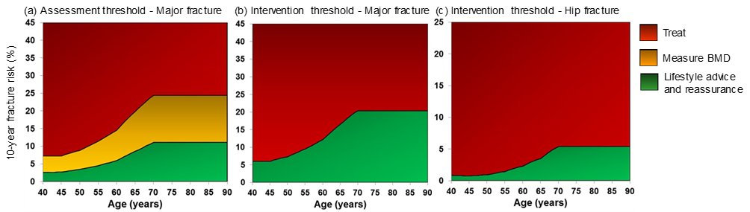

**Figure 2.** Age-specific prevalence of red/amber FRAX risk category in CORTEX study data.



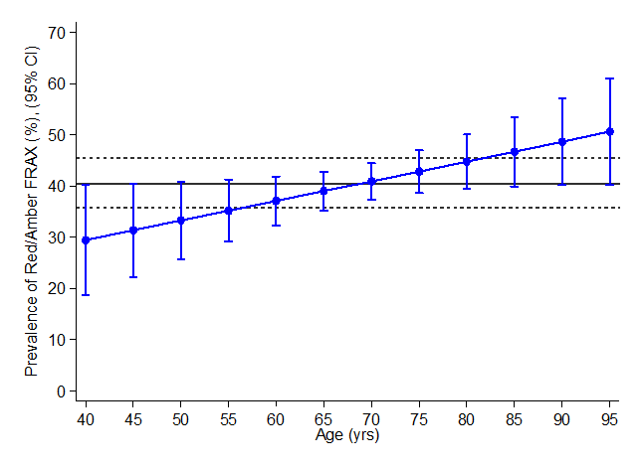

**Figure 3.** Power vs sample size to detect differences in 12-month treatment rates in a 3-arm trial.*



* Assuming treatment percentages of 4.5% vs. 15.5% vs. 20.3% with 1:1:1 randomisation to USUAL-CARE vs. FRAX-GP vs. PHOENIX-F and respectively, and Type 1 error = 0.05.

**Figure 4.** Estimated total invites needed to recruit 375 red/amber participants, assuming different response rates and different prevalence estimates.

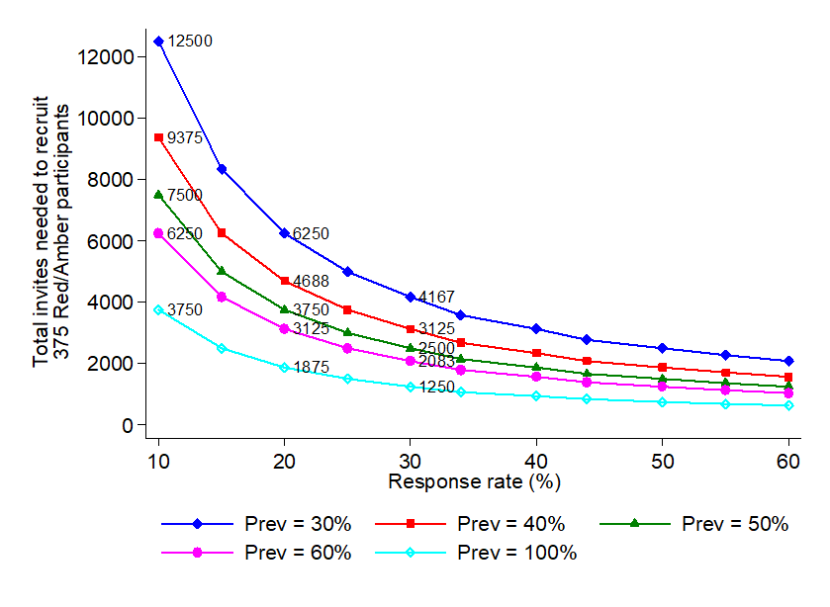

**Figure 5.**

Eventual number of participants available for analyses (green, red, amber FRAX) when aiming to recruit and randomise 375 red/amber FRAX participants, with green FRAX only included afterwards for secondary comparison.

**Figure 6.** Sample size for 80% power to reject null hypothesis of 30% response rate.



**Figure 7.** Sample size for 80% power to reject null hypothesis of 75% retention rate.





**8.8 Economic evaluation**

**Health Economic Analysis**

In line with this being a feasibility trial, the health economic component seeks to determine the feasibility of conducting an economic evaluation of PHOENIX in any future definitive trial. To determine this feasibility, we will review completion rates of the baseline and follow-up questionnaires: in particular, the health economic components of these questionnaires (costs implications measured by the resource questions and benefits measured by the EQ-5D-5L). These rates will inform whether sufficient data could be collected to conduct an economic evaluation. If shown to be broadly feasible, we will review response patterns and any qualitative feedback from researchers’ members delivering the telephone interviews for ways to improve the questionnaires for use in the definitive trial.

# 9 DATA MANAGEMENT

## **9.1 Data collection tools and source document identification**

Source baseline data will be obtained from the validated FRAX questionnaire and ICF completed by the participant. The original source documentation will be retained on site, and a scanned copy sent to a .net account at CUH.

Original CT scans are held on the PACS system at each hospital and will be auditable. Images retrieved through the IEP will be temporarily stored for analysis only on an encrypted hard drive.

Completed original copies of the postal questionnaires will be retained by the sponsor in a secure locked area. Access will be given to allow source data verification. The health economic questionnaire will be based on the validated EQ-5D-5L questionnaire. We will attempt to improve data completeness rates by telephoning participants who have not returned postal questionnaires

## **9.2 Data handling and record keeping**

Data from the study questionnaires will be entered onto a secure database at the sponsor’s site. Copies of the forms will be held with the sponsor where it will be possible to compare original data with the processed data allowing auditing for transcription accuracy. A study participant number will be used to enable identification of all the data reported for each participant.

## **9.3 Access to Data**

Direct access will be granted to authorised representatives from the Sponsor, host institution and the regulatory authorities to permit trial-related monitoring, audits and inspections in line with participant consent.

9.4 Archiving

Archiving will be authorised by the Sponsor following submission of the end of trial report.

The Sponsor will be responsible for archiving all documentation relating to the Trial Master File and the trial databases according to the CUH standard operating policies and procedures

### 10 MONITORING, AUDIT & INSPECTION

Local site monitoring with direct access to data will be arranged by the Trial Manager. Local investigators will permit trial-related monitoring, ethics committee review and regulatory inspections by providing direct access to source data/documents.

Data will be held and processed in accordance with the Data Protection Act 2018. All study data will be held securely. It will not be disclosed to third parties. All staff working on the study owe a duty of confidentiality to the participants. Manual records will be held securely (for example in locked filing cabinets). Electronic records will be held on a secure network requiring user ID and password access. Individuals will not be identifiable from the results of the trial.

# 11 ETHICAL AND REGULATORY CONSIDERATIONS

**11.1 Research Ethics Committee (REC) review& reports**

Before the start of the trial, approval will be sought from a REC for the trial protocol, informed consent forms and other relevant documents such as the patient information leaflet, questionnaires and GP information letters

All correspondence with the REC will be retained in the Trial Master File/Investigator Site File

An annual progress report (APR) will be submitted to the REC within 30 days of the anniversary date on which the favourable opinion was given, and annually until the trial is declared ended. It is the Chief Investigator’s responsibility to produce the annual reports as required.

The Chief Investigator will notify the REC of the end of the trial, and if the trial is ended prematurely, including the reasons for the premature termination

Within one year after the end of the trial, the Chief Investigator will submit a final report with the results, including any publications/abstracts, to the REC

**11.2** **Peer Review**

The protocol will be reviewed by the sponsor and project team prior to submission to the REC

**11.3 Public and Patient Involvement (PPI)**

The PPI has been involved in the design of the study, including input in to the ICF and PIL content. They have also tested the phone questionnaires and their responses have been taken account of when finalising the scripts. We would like to seek PPI views further down the line in the study, with their perspective on analysis of results and suggestions for dissemination of findings

**11.4 Regulatory Compliance**

The trial will not commence until Favourable REC opinion has been granted

Before any site can enrol patients into the study, the Chief Investigator and local Principal Investigator will ensure that appropriate approvals from participating organisations are in place.

For any amendment to the study, the Chief Investigator or Trial Manager, in agreement with the sponsor will submit information to the appropriate body in order for them to issue approval for the amendment. The Chief Investigator or Trial Manager will work with sites (R&D departments at NHS sites as well as the study delivery team) so they can put the necessary arrangements in place to implement the amendment to confirm their support for the study as [amended](http://www.hra.nhs.uk/resources/after-you-apply/amendments/).

**11.5 Protocol compliance**

There will be monitoring of protocol compliance during the study.

Accidental protocol deviations will be adequately documented on the relevant forms and reported to the Chief Investigator and Sponsor immediately.

**11.6 Notification of Serious Breaches to GCP and/or the protocol**

It is unlikely any one protocol deviation will constitute a serious breach. However, in the case of frequent deviations where the scientific value of the trial may be affected, the sponsor will be notified and the licensing authority will be notified in writing

**11.7 Data protection and patient confidentiality**

All investigators and trial site staff must comply with the requirements of the Data Protection Act 2018 with regards to the collection, storage, processing and disclosure of personal information and will uphold the Act’s core principles.

Name, NHS number, and contact details of the participants will be collected. Consenting to join the study means that permission will be given for these personal details and relevant identifiable medical information to be sent to the study team at CUH and the University of Cambridge. Identifiable scans will be sent to Addenbrooke’s Hospital via the Image Exchange Portal (IEP) where they will be kept securely on an encrypted hard drive and will only be available to the research team.

Contact details and other personally identifiable data will be scanned from the recruiting site to a NHS.net account at CUH. This personally identifiable data (PID) will be stored at CUH on a password protected NHS computer and held separately from any clinical data. The PID is required to enable checking of health status by the research team from the Office for National Statistics database (ONS) before contact at 1 year.

Addresses and telephone numbers are necessary to allow the research team to post out questionnaires and to invite a small sample of participants for a phone interview. GP addresses will be required to contact GPs regarding patient trial participation in the study and to inform them of any results.

 Access to data will be limited to the minimum number of individuals necessary for quality control, audit, and analysis

**Safeguarding**

If, during the course of the study the researcher hears or sees something that gives them cause for concern, it may be necessary to share their concern as directed by the CUH Safeguarding Adults Policy (Version 9; Approved July 2015). Reporting procedures are outlined in the policy document.

**11.8 Financial and other competing interests**

There are no competing interests in this study

11.9 Indemnity

The NHS Indemnity scheme will apply. The University of Cambridge Insurance scheme applies to the design of the study. Adequate provision is made for insurance or indemnity to cover liabilities which may arise in relation to the design, management and conduct of the research project.

11.10 Amendments

**None**

**11.11 Access to the final trial dataset**

Researchers involved in the trial who will have access to the full dataset. Applications for access to the final trial dataset will be through the Trial Management Group. All members of the TMG will have full access to the dataset, and a controlled access model (openly available to all applicants) will be followed as set out in the MRC and NIHR guidance <https://www.methodologyhubs.mrc.ac.uk/files/7114/3682/3831/Datasharingguidance2015.pdf>

### 12 DISSEMINIATION POLICY

### 12.1 Dissemination policy

On study completion the data will be analysed and a report submitted which will indicate the feasibility of progressing to a full clinical trial

The education and dissemination network infrastructure already established by the NOS (National Osteoporosis Society) will be used to share best practice. If successful, the potential of PHOENIX-f opportunistic vertebral fracture and osteoporosis detection will be highlighted across the NOS educational platforms.

For patients and the public we would like to hold an interactive workshop in Cambridge. Results will also be available through social media

The publication strategy involves including a Full, Executive Summary and Plain English summary of the research to peer review journals. Core components of PHOENIX sit within

radiology, primary care and hospital bone densitometry services, and these specialities are represented within the existing team. It will therefore be the responsibility of team members to disseminate the results in relevant areas of interest

**12.2 Authorship eligibility guidelines and any intended use of professional writers**

It is essential that the following be included in any publications arising, “*NIHR Cambridge BRC funded project*

“This research was funded by the National Institute for Health Research for Patient Benefit programme, and Cambridge Biomedical Research Centre at the Cambridge University Hospitals NHS Foundation Trust. The views expressed are those of the authors and not necessarily those of the NHS, the NIHR or the Department of Health and Social Care.”

The authorship of any manuscripts arising from the PHOENIX-f study will be decided using the four ICMJE criteria: <http://www.icmje.org/recommendations/browse/roles-and-responsibilities/defining-the-role-of-authors-and-contributors.html>

Others not meeting authorship criteria will be acknowledged as set out in the ICMJE guidelines.

### REFERENCES

1 OECD (2014). Computed tomography (CT) exams, total. Health: Key Tables from OECD, OECD - ISSN 2075-8480

2 Ziemlewicz TJ, Binkley N, Pickhardt PJ. Opportunistic Osteoporosis Screening: Addition of Quantitative CT Bone Mineral Density Evaluation to CT Colonography. *J Am Coll Radiol*. 2015;12(10):1036-41.

3 Lee SJ, Binkley N, Lubner MG, et al. Opportunistic screening for osteoporosis using the sagittal reconstruction from routine abdominal CT for combined assessment of vertebral

fractures and density. Osteoporosis International 2016;27(3):113, 1-36. doi: 10.1007/s00198-0153318-

4.Carberry GA, Pooler BD, Binkley N, et al. Unreported Vertebral Body Compression Fractures at Abdominal Multidetector CT. Radiology 2013;268(1):120-26. doi:10.1148/radiol.13121632

5.Al-Sari UA, Tobias J, Clark E. Health-related quality of life in older people with osteoporotic vertebral fractures: a systematic review and meta-analysis. Osteoporosis International 2016;27(10):2891-900. doi: 10.1007/s00198-016-3648-x

6 Department of Health. Hospital episode statistics (England) 2006

7 Jewell PD, Mitchell R, Javaid MK, et al. Reporting and Follow-up of Vertebral Fractures Seen on Imaging; Can Radiologists Help Reduce the Number of Hip Fractures? Osteoporosis

International 2014;25:S674-S74.

8 Harvey N, Cushnaghan J, Lawrence W, et al. Anxiety, Fracture Risk and Adherence to Treatment: The MRC SCOOP Trial. Osteoporosis International 2012;2 3:S531-S31.

9 Steiger P, Staal J, Engelke K, et al. Validation of an Automatic Vertebral Prevalent Fracture

Classifier Based Upon Full Vertebral Shape. Osteoporosis International 2013;24:S307-S08.

10 Shepstone L, Lenaghan E, Cooper C, et al. Screening in the community to reduce fractures in older women (SCOOP) - a randomised controlled trial Lancet 2017(pii)S0140-6736(17)32640-5

11 National Institute for Health and Care Excellence. Osteoporosis: assessing the risk of fragility fracture 2012. NICE guidelines CG146, 2015

12 Nelson HD, Haney EM, Dana T, et al. Screening for Osteoporosis: An Update for the US Preventive Services Task Force. Annals of internal medicine 2010;153(2):99-W43. doi:10.7326/0003-4819-153-2-201007200-00262

13 Lindsay R et. Al. Risk of new vertebral fracture in the year following a fracture. JAMA. 2001 Jan 17;285(3):320-3

14 https://www.england.nhs.uk/statistics/wp-content/uploads/sites/2/2016/08/Provisional-Monthly-Diagnostic-Imaging-Dataset-Statistics-2017-05-18.pdf

15 Moore G, Audrey S, Barker M, Bond L, Bonell C, Hardeman W, Moore L, O’Cathain A, Tinati T, Wight D, Baird J. Process evaluation of complex interventions: Medical Research Council guidance. MRC Population Health Science Research Network, London, 2014

<https://www.mrc.ac.uk/documents/pdf/mrc-phsrn-process-evaluation-guidance-final/>

<https://www.mrc.ac.uk/documents/pdf/mrc-phsrn-process-evaluation-summary-guidance/>

16Moore G, Audrey S, Barker M, Bond L, Bonell C, Hardeman W, Moore L, O’Cathain A, Tinati T, Wight D, Baird J. Process evaluation of complex interventions: Medical Research Council guidance BMJ 2015;350:h1258 doi:10.1136/bmj.h1258 <http://www.bmj.com/content/bmj/350/bmj.h1258.full.pdf>

17 Shepstone L, Lenaghan E, Cooper C, et al. Screening in the community to reduce fractures in older women (SCOOP) - a randomised controlled trial Lancet 2017(pii)S0140-6736(17)32640-5

18.Pickhardt PJ, Pooler BD, Lauder T, et al. Opportunistic screening for osteoporosis using abdominal computed tomography scans obtained for other indications. Annals of internal medicine 2013;158(8):588-95. doi: 10.7326/0003-4819-158-8-201304160-00003

### 14. APPENDICIES: Appendix 1 - Risk

|  |  |  |  |  |
| --- | --- | --- | --- | --- |
| Risks associated with trial interventions  A ≡ Comparable to the risk of standard medical care | | | | |
| Justification: Category A risk as the feasibility trial involves no intervention, only an additional screening process | | | | |
| **What are the key risks related to therapeutic interventions you plan to monitor in this trial?** | | **How will these risks be minimised?** | | |
| **IMP/Intervention** | **Body system/**  **Hazard** | **Activity** | **Frequency** | **Comments** |
| FRAX questionnaire | Raised anxiety | We will conduct patient experience questionnaires and quality of life questionnaires to assess any impact | Approx 5% of sample will be interviewed. All participants will receive 2 QOL questionnaires during the study period | We will take note of any PPI / participant comments to reduce anxiety if designing for full trial |
| Group 2 & 3 – no CT scan review results sent to GP initially | Danger that these patients may have undiagnosed osteoporosis or vertebral fractures | 1 year post randomisation, a full diagnostic report on any patients’ CT scan that is found to feature osteoporosis, vertebral fracture or a high calculated fracture-risk will be sent to the GP so participants in these groups will not be disadvantaged | Once |  |
| Outline any other processes that have been put in place to mitigate risks to participant safety (e.g. DMC, independent data review, etc.)  N/A | | | | |
| Outline any processes (e.g. IMP labelling +/- accountability +/- trial specific temperature monitoring) that have been simplified based on the risk adapted approach.  N/A | | | | |

**Appendix 2 - Trial management / responsibilities**

**14.2.1 Patient registration/randomisation procedure**

Registration/ consent takes place at the local sites in the individual CT scanning departments. Randomisation will be a web based service, Sealed Envelope (www.sealed.envelope.co.uk)

**14.2.2 Data management**

No part of the data management service will be outsourced.

Database design and data entry will be managed from within the research team.

**14.2.5 Data protection/confidentiality**

CUH is responsible for looking after patient information and using it properly. All study related documentation and data will be archived in accordance with the Sponsor’s Standard operating Policies and Procedures

Your rights to access, change or move your information are limited, as we need to manage your information in specific ways in order for the research to be reliable and accurate. If a participant withdraws from the study, we will keep the information already obtained. We will use the minimum personally-identifiable information possible.

**Appendix 3 – Authorisation of participating sites**

**14.3.1 Required documentation**

* CVs of research team

**14.3.2 Procedure for initiating/opening a new site**

Sites will receive a site initiation visit (SIV) before opening

**14.3.3 Principal Investigator responsibilities**

* Attendance at SIV
* Training of new staff in protocol and procedures and maintaining delegation log
* Ensuring ISF is maintained
* Storage of original documentation (ICF & FRAX questionnaires) in secure environment

**Appendix 4 – Schedule of Procedures**

|  |  |  |  |  |  |
| --- | --- | --- | --- | --- | --- |
|  | **Enrolment** | | **Post-allocation** | | |
| * TIMEPOINT | From May 2019 | Randomisation | Before 1 month | 2 months | 1 Year |
| **Eligibility screen** | **X** |  |  |  |  |
| **Informed consent** | **X** |  |  |  |  |
| **Complete FRAX questionnaire** | **X** |  |  |  |  |
| **Allocation** |  | **X** |  |  |  |
| **Group 1** |  | **X** |  |  |  |
| **Group 2** |  | **X** |  |  |  |
| **Group 3** |  | **X** |  |  |  |
| **Review CT scan** |  | **X** |  |  |  |
| **FRAX calculation** |  | **X** |  |  |  |
| **Baseline Health Economics Questions** |  |  | **X** |  |  |
| **Patient Experience Interview** |  |  |  | **X** |  |
| **Follow up questionnaire** |  |  |  |  | **X** |

**Appendix 5 – Safety Reporting Flow Chart**

N/A

**Appendix 6 – Amendment History**

|  |  |  |  |  |
| --- | --- | --- | --- | --- |
| **Amendment No.** | **Protocol version no.** | **Date issued** | **Author(s) of changes** | **Details of changes made** |
|  |  |  |  |  |

Protocol amendments must be submitted to the Sponsor for approval prior to submission to the REC committee or MHRA.

**Appendix 7 – FRAX Questionnaire**

|  |  |  |  |
| --- | --- | --- | --- |
| **BONE HEALTH QUESTIONNAIRE** | **Yes** | **No** | **Not sure** |
| Have you broken any bones since you turned 40? |  |  |  |
| • If Yes, which bones? | | |  |
| Did your mother or father ever break a hip? |  |  |  |
| Do you currently smoke? |  |  |  |
| Do you take steroid tablets now (eg: ‘prednisolone’), or have you taken steroid tablets in the past, for longer than three months at any time? |  |  |  |
| Have you been diagnosed with rheumatoid arthritis? |  |  |  |
| Have you been diagnosed with any of the following? *(Tick if relevant diagnosis)*  • Premature menopause (before 45yrs of age)  • Insulin dependent diabetes  • Brittle bone disease, Ankylosing spondylitis  • Overactive thyroid  • Low testosterone level (men only)  • Chronic malnutrition or malabsorption eg: anorexia or coeliac disease   * Chronic liver disease |  |  |  |
| Do you drink three or more units of alcohol **a day**, **on average**?  (That’s 1 1/2 pints of beer or 3 glasses of wine or 3 short measures of spirits) |  |  |  |

**Appendix 8 - Baseline Questionnaire**

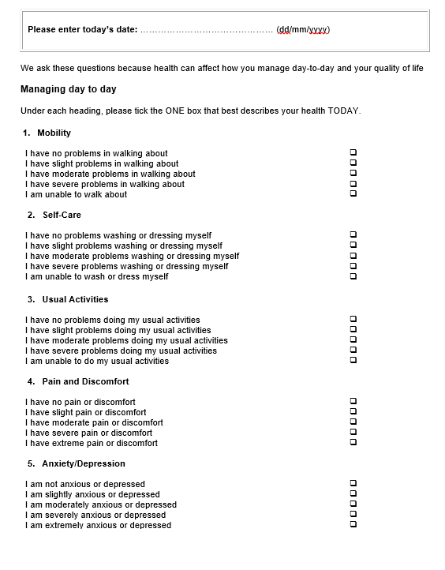

|  |
| --- |
| 1. **How do you feel today?**   We would like to know how good or bad your health is TODAY. |
| This scale is numbered from 0 to 100. |
| 100 means the best health you can imagine. 0 means the worst health you can imagine. |
| Mark an X on the scale to indicate how your health is TODAY. |
| Now, please write the number you marked on the scale in the box below. |

The worst health you can imagine

YOUR HEALTH TODAY =

10

0

20

30

40

50

60

80

70

90

100

5

15

25

35

45

55

75

65

85

95

**Your use of Hospital Services**

1. Please list any overnight stays in hospital during the last year before your CT scan that were to do with your bone health (e.g. broken bones).

|  |  |  |
| --- | --- | --- |
| **Admission number** | **Department or ward  (don’t worry if you can’t remember)** | **Length of admission (days)** |
| *Example* | *Ward D8, Addenbrooke’s Hospital* | *5 days* |
| 1 |  |  |
| 2 |  |  |
| 3 |  |  |
| 4 |  |  |

1. If you had an outpatient appointment for your bone health in the last year before your CT scan (examples include attending fracture clinic, attending bone clinic, attending for a bone scan or x-ray, an infusion or a physiotherapy appointment), please tell us whom you saw.

|  |  |  |
| --- | --- | --- |
| **Outpatient visit** | **Main medical professional** | **Visit duration  (in hours and minutes)** |
| *Example* | *Physiotherapist* | *30 mins* |
| 1 |  |  |
| 2 |  |  |
| 3 |  |  |
| 4 |  |  |
| 5 |  |  |

**Your use of Community Services**

1. Please record below any visits to or by the following professionals relating to your bone health during the last year before your CT scan. (Please enter 0 for any you have not seen.)

|  |  |
| --- | --- |
|  | **Number of visits (Enter ‘0’ if none)** |
| General Practitioner (GP) |  |
| Practice nurse |  |
| Social worker |  |
| Physiotherapist |  |
| Other - please name: …………………………. |  |

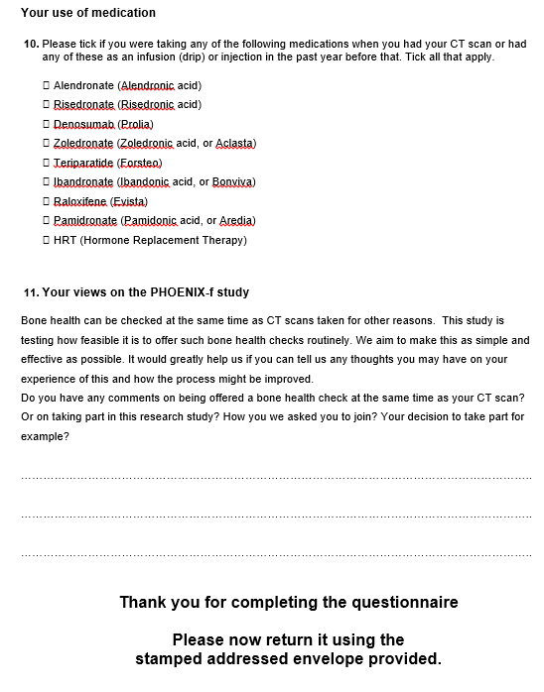

**Appendix 9 - Topic guide for interviews with participants 2-3 months after CT scanning**

For participants who completed a FRAX and had CT bone-density calculated

**Introduction**

Thank you again for agreeing to take part in the PHOENIX-f study when you had a CT scan a couple of months ago, and thank you for agreeing to talk with me today. PHOENIX-f is the study that will be looking at your CT scan to assess your bone health and letting your GP know the results. We want to make the process as straightforward and effective as possible, so my questions today are to try to understand how this worked for you.

***1) Did agreeing to take part in this study raise any expectations of what would happen next?***

Exploring whether participants recalled information about results reporting – whether aware they would hear nothing directly and their GP might not have heard (only GPs of ‘group C’ participants should have received results by now, but results for participants in ‘group A’ and ‘group B’ won’t go to their GPs until a year later)

***2) If so, were you satisfied or dissatisfied?***

Exploring reactions to this process – whether acceptable to wait a year maybe, whether even mentioning the possibility of checking bone health raised anxiety, any views on whether appropriate to offer at same time as CT for other reason, etc

***3) Has anything happened in relation to your bone health as a result of taking part in this study?***

Exploring whether GP contacted participant / vice versa, whichever study arm – if so how bone health results were communicated, participant recall and perception of what GP explained results to mean and advice given on bone health, any further tests such as blood tests or new bone protective treatments prescribed, whether taking any new prescription, reason(s) decided not to take if not, etc

***4) Are you doing anything different as a result of taking part in this study?***

Exploring whether FRAX questions or knowing bone health could be measured at CT prompted any sort of change – e.g. consulting GP re fracture risk, discussing with family/friends, encouraging relatives perhaps also at risk to get bone health checked, trying to make lifestyle changes, etc

We really appreciate your making time to answer all these questions. Your answers can help us improve the CT bone health check process to help others in the future. Thank you very much indeed.

**Appendix 10 - One year Follow-up Questionnaire**

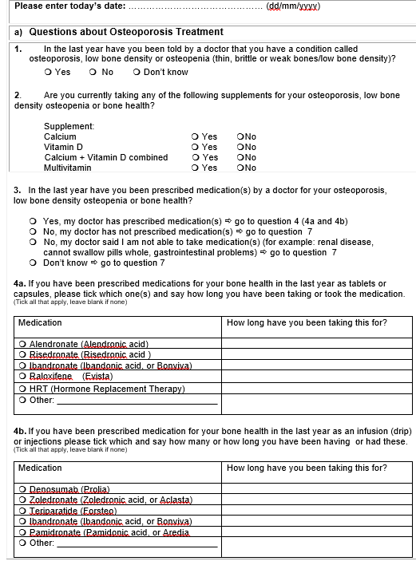

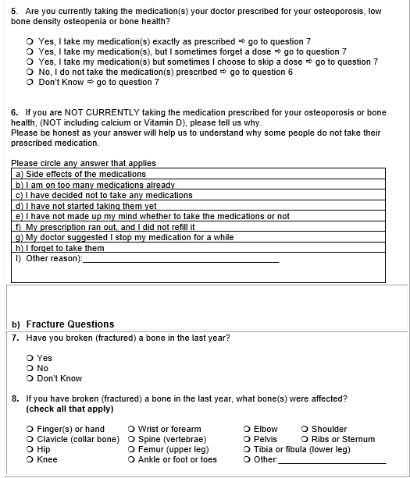

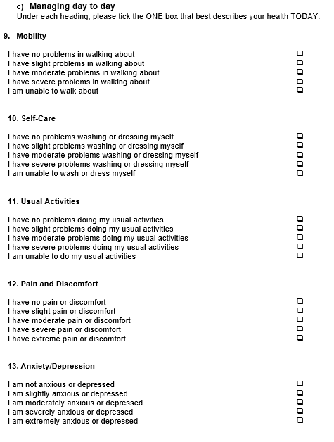

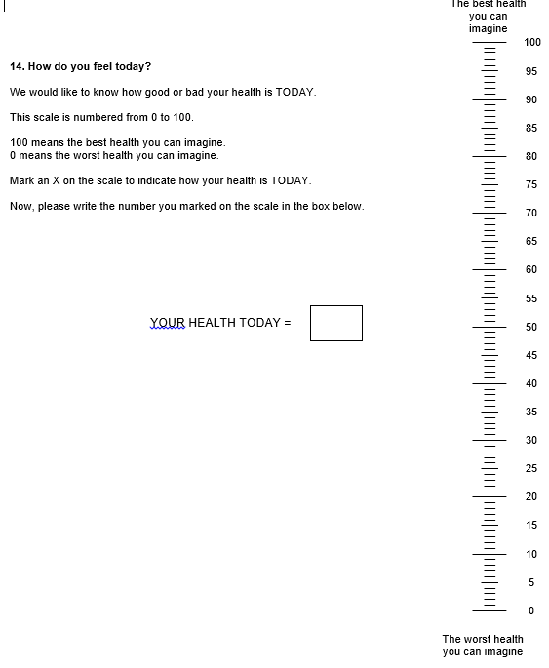

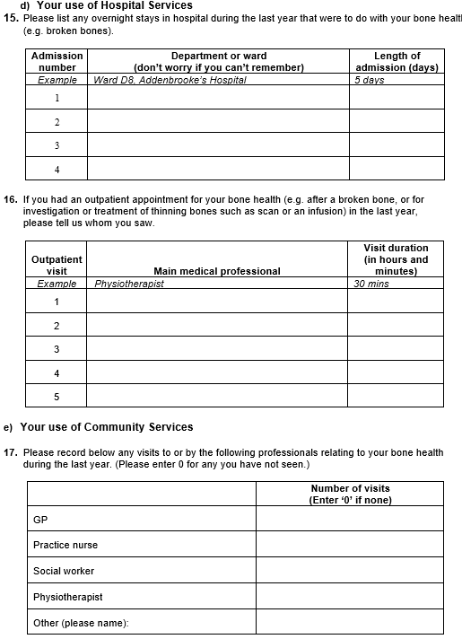

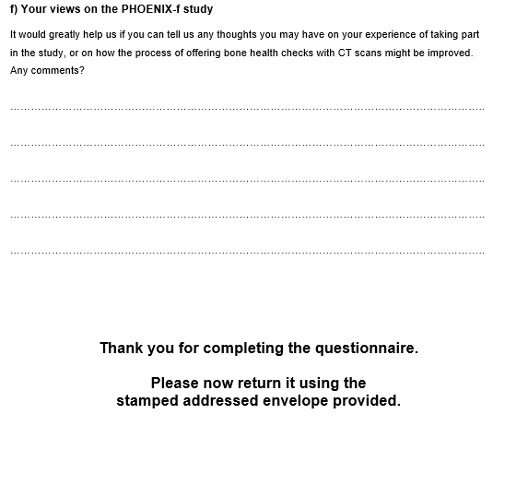

**Appendix 11 - GP Report Example**

