Participant Flow

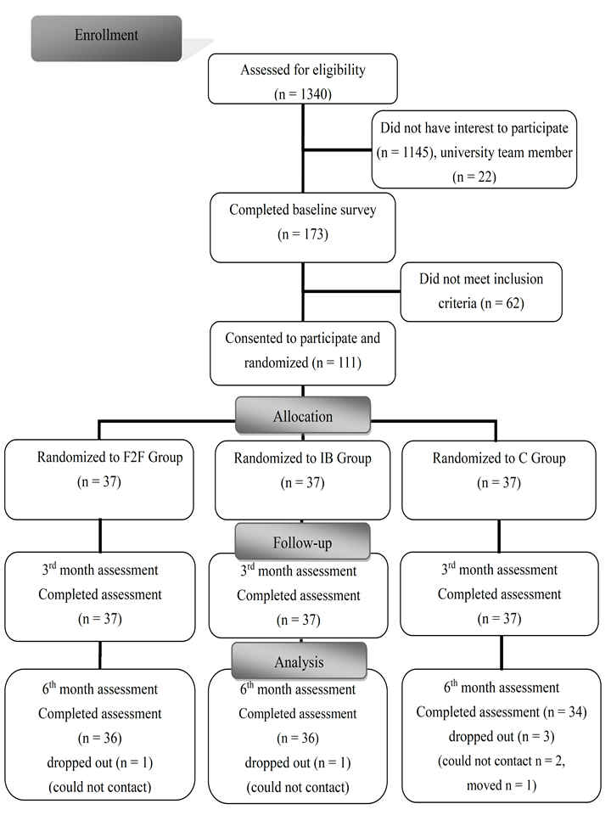

Baseline Characteristics

Baseline characteristics of total sample and three groups (mean ± SD or %)

 | Total sample (n = 111) | F2F Group  (n = 37) | IB Group  (n = 37) | C Group  (n = 37)
Demographics  Gender (% female)  Age (year)  BMI (kg/m²) | 55.9  19.2 ± 1.2  20.3 ± 2.6 | 56.8  19.1 ± 1.2  20.2 ± 2.8 | 56.8  19.2 ± 1.2  20.2 ± 2.9 | 54.1  19.2 ±1.3  20.4 ± 2.1
Physical activity  Total PA Score  (MET·min/week) | 1,314.2  ± 672.3 | 1,325.2  ± 632.0 | 1,228.0  ± 656.4 | 1,389.3  ± 733.1
Meeting the PA recommendation (%) | 85.6 | 91.9 | 78.4 | 86.5
Stages of change  Pre-contemplation (%)  Contemplation (%)  Preparation (%)  Action (%)  Maintenance (%) | 2.7  16.2  73.9  7.2  0 | 2.7  16.2  73.0  8.1  0 | 2.7  16.2  73.0  8.1  0 | 2.7  16.2  75.7  5.4  0

BMI=body mass index; PA=physical activity.

Outcome Measures

Mean PA scores (MET·min per week) at baseline, 3rd month and 6th month assessments

 | F2F Group  (n = 36) | IB Group  (n = 36) | C Group  (n = 34) | F
Baseline | 1,330.8 ± 640.0 | 1,213.2 ± 659.4 | 1,414.9 ± 758.9
3rd month | 1,849.2 ± 1,234.3* | 1,689.8 ± 1,085.2* | 1,393.5 ± 870.2 | F2F: 8.364  IB: 7.958
Mean Difference (3rd month-baseline) | 518.4# | 476.6 | -21.4
6th month | 1,880.0 ± 1,238.7* | 1,738.2 ± 1287.9* | 1,252.1 ± 728.5 | F2F: 7.625  IB: 6.259
Mean Difference  (6th month-baseline) | 549.2# | 525.0# | -162.8

*p < 0.05, compared with baseline data within group
#p < 0.05, compared with C group
Stages of change at baseline, 3rd and 6th month assessments

 | Baseline |  |  |  | 3rd Month |  |  |  | 6th Month
 | F2F  (n = 36) | IB  (n = 36) | C  (n = 34) |  | F2F †  (n = 36) | IB*  (n = 36) | C †  (n = 34) |  | F2F*  (n = 36) | IB*  (n = 36) | C  (n = 34)
Pre-contemplation | 1 | 1 | 1 |  | 1 | 0 | 1 |  | 0 | 1 | 2
Contemplation | 5 | 6 | 5 |  | 3 | 3 | 4 |  | 6 | 3 | 5
Preparation | 27 | 26 | 26 |  | 28 | 17 | 25 |  | 14 | 19 | 19
Action | 3 | 3 | 2 |  | 4 | 15 | 4 |  | 12 | 10 | 6
Maintenance | 0 | 0 | 0 |  | 0 | 1 | 0 |  | 4 | 3 | 2

Wilcoxin Signed Ranks Tests: * p < 0.05 compared with baseline within groups.
Mann-Whitney Tests: † p < 0.05, compared with IB group.

Adverse Events

No adverse events associated with this trial.

