Participant flow diagram:

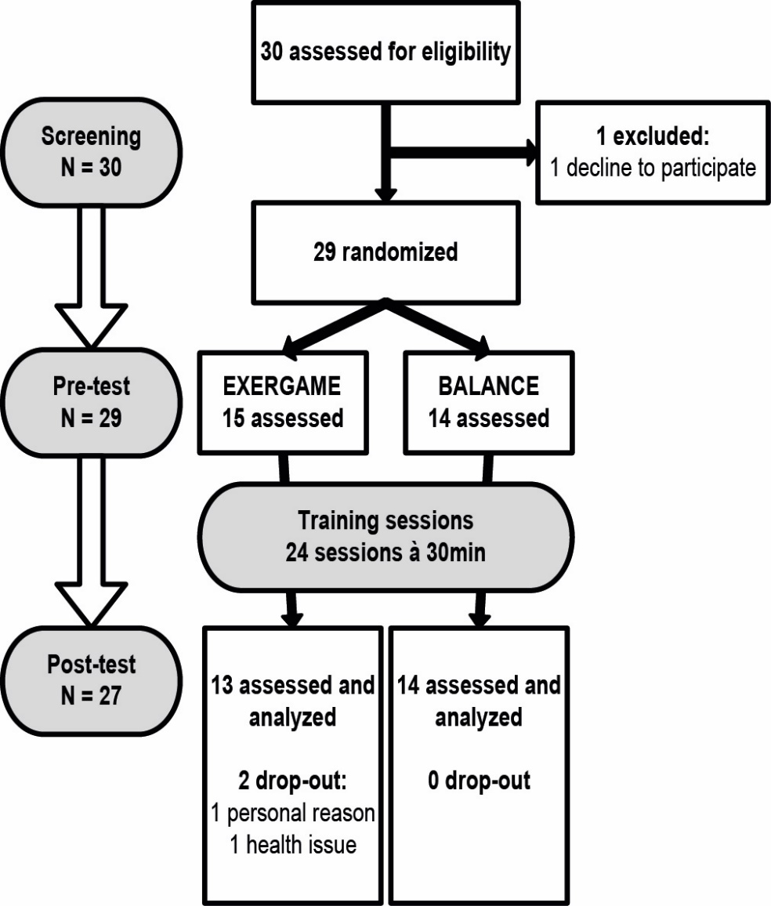

Baseline characteristics
 | Exergame group | Balance group
Sex (female/male) | 5/8 | 7/7
 |  |  | p (two-tailed)
Age (years) | 80 (73; 83) | 80 (72.25; 81.75) | .685
Mini mental status examination | 29 (29; 30) | 28.5 (27; 29) | .259
Geriatric depression scale | 1 (0; 2) | 2.5 (1; 4.75) | .085
Short-fear of efficacy scale international | 7 (7; 8) | 8.5 (7; 10) | .076

Outcome measures:
EEG during walking
The analysis of this neuronal activity during gait performance was not possible due to non-standardized triggering modalities and the unconventional EEG device.
EEG during cognitive testing
Table 1 Interaction effects (time × intervention) of repeated measures Puri & Sen-analyses of ranked data for relative power values
 | Pillai’s trace  r² | L  L = (N-1)*r² | p
Auditory stimuli
Delta | 0.218 | 3.052 | .079
Theta | 0.445 | 6.230 | .007**
Alpha low | 0.216 | 3.024 | .081
Alpha high | 0.223 | 3.122 | .076
Beta | 0.125 | 1.750 | .195
Visual stimuli
Delta | 0.020 | 0.280 | .618
Theta | 0.215 | 3.010 | .082
Alpha low | 0.260 | 3.640 | .052
Alpha high | 0.174 | 2.436 | .122
Beta | 0.240 | 3.360 | .064
N=15; exergame group N=7 and balance group N=8. *p ≤ 0.05, * p ≤ 0.01, p-values are one-tailed and based on normalized data.

Table 2 Pre- vs. post-test of relative power for exergame and balance group
 |  |  | z | p | r
Exergame group | Pre (N=8) | Post (N=9)
Auditory stimuli
Delta | 1.79 (1.61; 2.07) | 1.59 (1.33; 1.95) | -1.52 | .156 | -0.37ª
Theta | 1.86 (1.55; 2.42) | 1.70 (1.24; 1.86) | -2.37 | .016* | -0.57^{b}
Alpha low | 1.24 (1.16; 1.38) | 1.00 (0.80; 1.35) | -1.18 | .297 | -0.29
Alpha high | 1.14 (0.67; 1.38) | 0.83 (0.55; 1.16) | -1.18 | .297 | -0.29
Beta | -0.21(-0.6; 10.06) | -0.19 (-0.44; 0.14) | -1.18 | .297 | -0.29
Visual stimuli
Delta | -0.08 (-0.63; 0.07) | -0.22 (-0.46; 0.14) | -1.01 | .375 | -0.25
Theta | -0.82 (-1.29; -0.38) | -0.60 (-0.96; -0.28) | -1.18 | .297 | -0.29
Alpha low | -0.57 (-1.23; -0.21) | -0.32 (-0.78; 0.02) | -1.70 | .109 | -0.41ª
Alpha high | -0.77 (-1.14; -0.09) | -0.44 (-1.14; -0.09) | -0.85 | .469 | -0.21
Beta | -0.70 (-0.90; -0.74) | -0.31 (-0.74; -0.04) | -1.52 | .078 | -0.37ª
Balance group | Pre (N=10) | Post (N=9)
Auditory stimuli
Delta | 1.70 (1.28; 2.10) | 1.99 (1.55; 2.29) | -0.56 | .641 | -0.13
Theta | 1.81 (1.63; 2.02) | 1.92 (1.65; 2.10) | -0.70 | .547 | -0.16
Alpha low | 0.79 (0.44; 1.17) | 1.30 (0.69; 1.47) | -1.54 | .148 | -0.35ª
Alpha high | 0.79 (0.29; 1.28) | 1.26 (0.77; 1.46) | -1.82 | .078 | -0.42ª
Beta | -0.16 (-0.33; 0.20) | -0.26 (-0.90; 0.21) | -1.54 | .148 | -0.35ª
Visual stimuli
Delta | -0.12 (-0.48; 0.18) | -0.14 (-0.68; 0.15) | 0.00 | 1.000 | 0.00
Theta | -0.24 (-1.49; 0.03) | -0.77 (-1.55; -0.43) | -1.40 | .195 | -0.32ª
Alpha low | -0.27 (-1.12; -0.13) | -0.60 (-0.90; -0.37) | -0.70 | .547 | -0.16
Alpha high | -0.21 (-1.81; -0.07) | -0.97(-1.74; -0.32) | -1.12 | .313 | -0.26
Beta | -0.35 (-1.38; 0.07) | -0.84 (-1.16; -0.28) | -0.70 | .547 | -0.16
Normalized data from pre-post are median values (interquartile range) as indicated.*Significant within-group differences pre-post (p ≤ 0.05) calculated with Wilcoxon signed-rank test (p-values are two-tailed). For effect size r, r=0.1 indicates a small effect, ª r=0.3 indicates a medium effect, and ^{b} r=0.5 indicates a large effect
Executive functions
Table 3 Interaction effects (time × intervention) of repeated measures Puri & Sen-analyses of ranked data for test for attention performance
 | Pillai’s trace  r² | L  L = (N-1)*r² | p
Working memory⁺ | 0.144 | 3.456 | .061
Divided attention auditory⁺⁺ | 0.040 | 1.000 | .326
Divided attention visual | 0.043 | 1.118 | .297
Go/No-go | 0.063 | 1.701 | .206
Set shift | 0.023 | 0.598 | .446
Test for attentional performance measured reaction time [ms]. N=27; exergame group N=13 and balance group N=14. ⁺N=25; exergame group N=12 and balance group N=13; ⁺⁺N=26; exergame group N=12 and balance group N=14. p ≤ 0.05, p-values are one-tailed.

Table 4 Pre- vs. post-test of test for attention performance for exergame and balance group
 |  |  | z | p | r
Exergame group | Pre (N=13) | Post (N=13)
Working memory | 876.5 (701.8; 1104.5)⁺ | 750 (649.5; 907.5) | -2.28 | .021* | -0.46ª
Divided attention auditory | 631.5 (580; 756.25)⁺⁺ | 598 (533.5; 629) | -2.51 | .009** | -0.50^{b}
Divided attention visual | 1109 (835; 1291) | 945 (879.5; 1082) | -2.06 | .040* | -0.40ª
Go/No-go | 450 (426; 496) | 421 (410.5; 451.5) | -2.55 | .008** | -0.50^{b}
Set shift | 1723 (1143.5; 2273.5) | 1405 (855; 1727.5) | -2.90 | .002** | -0.57^{b}
Balance group | Pre (N=14) | Post (N=14)
Working memory | 802 (682.3; 871.5) | 767 (726; 926.5)⁺⁺⁺ | -0.31 | .787 | -0.06
Divided attention auditory | 720 (606.25; 787.75) | 665.5 (604.25; 733.5) | -1.10 | .296 | -0.21
Divided attention visual | 961 (841.75; 1082.25) | 907.5 (8855.5; 1054.25) | -0.60 | .583 | -0.11
Go/No-go | 472 (448.5; 503.75) | 466 (417.3; 509) | -0.25 | .802 | -0.05
Set shift | 1196 (1045.5; 1752.25) | 1110 (984; 1409.5) | -2.04 | .042* | -0.39ª
The table presents the reaction time [ms] for each test for attentional performance. Data from pre-post are median values (interquartile range) as indicated. *Significant within-group differences pre-post (*p ≤ 0.05 and ** p ≤ 0.01) calculated with Wilcoxon signed-rank test (p-values are two-tailed). For effect size r, r=0.1 indicates a small effect, ª r=0.3 indicates a medium effect, and ^{b} r=0.5 indicates a large effect. ⁺ N=12; ⁺⁺ N=13; ⁺⁺⁺N=12.
Spatio-temporal gait parameters

Table 5 Interaction effects (time × intervention) of repeated measures Puri & Sen-analyses of ranked data for gait parameters
Time × intervention interaction | Pillai’s trace  r² | L  L = (N-1)*r² | p
Speed [m/s]
Single task normal | 0.001 | 0.026 | .880
Single task fast | 0.068 | 1.768 | .189
Dual task normal | 0.001 | 0.026 | .882
Dual task fast | 0.004 | 0.104 | .753
Cadence [steps/min]
Single task normal | 0.003 | 0.078 | .774
Single task fast | 0.108 | 2.808 | .094
Dual task normal | 0.032 | 0.832 | .371
Dual task fast | 0.031 | 0.806 | .376
Stride [m]
Single task normal | 0.000 | 0.000 | .915
Single task fast | 0.007 | 0.182 | .682
Dual task normal | 0.014 | 0.364 | .554
Dual task fast | 0.070 | 1.820 | .183
N=27; exergame group N=13 and balance group N=14. p ≤ 0.05, p-values are one-tailed

Table 8 Pre- vs. post-test of gait parameters for exergame and balance group
 |  |  | z | p | r
Exergame group | Pre (N=13) | Post (N=13)
Speed [m/s]
Single task normal | 1.13 (0.92; 1.22) | 1.19 (1.06; 1.29) | -1.64 | .110 | -0.32ª
Single task fast | 1.54 (1.31; 1.63) | 1.49 (1.38; 1.64) | -1.29 | .216 | -0.25
Dual task normal | 1.02 (0.88; 1.18) | 1.08 (0.95; 1.29) | -2.90 | .002** | -0.57^{b}
Dual task fast | 1.40 (1.13; 1.47) | 1.45 (1.10; 1.62) | -2.97 | .001** | -0.58^{b}
Cadence [steps/min]
Single task normal | 103.7 (95.9; 109.3) | 106.3 (100.9; 113.3) | -1.78 | .080 | -0.35ª
Single task fast | 129.7 (114.9; 142.6) | 125.6 (118.48; 134.0) | -0.45 | .685 | -0.09
Dual task normal | 104.4 (94.37; 107.3) | 104.1 (96.8; 116.7) | -2.97 | .001** | -0.58^{b}
Dual task fast | 116.7 (106.6; 129.8) | 124.2 (110.3; 131.1) | -1.43 | .168 | -0.28
Stride [m]
Single task normal | 1.26 (1.14; 1.34) | 1.30 (1.26; 1.37) | -1.92 | .057 | -0.38ª
Single task fast | 1.39 (1.35; 1.48) | 1.43 (1.37; 1.48) | -1.15 | .273 | -0.23
Dual task normal | 1.18 (1.10; 1.30) | 1.21 (1.15; 1.32) | -1.57 | .127 | -0.31ª
Dual task fast | 1.33 (1.21; 1.39) | 1.36 (1.29; 1.53) | -2.69 | .005** | -0.53^{b}
Balance group | Pre (N=14) | Post (N=14)
Speed [m/s]
Single task normal | 1.06 (0.92; 1.25) | 1.12 (1.04; 1.41) | -2.54 | .009** | -0.48^{b}
Single task fast | 1.44 (1.29; 1.62) | 1.56 (1.40; 1.78) | -1.98 | .049* | -0.37ª
Dual task normal | 1.00 (0.87; 1.05) | 1.04 (0.90; 1.24) | -1.54 | .135 | -0.29
Dual task fast | 1.22 (1.16; 1.47) | 1.40 (1.17; 1.54) | -1.98 | .049* | -0.37ª
Cadence [steps/min]
Single task normal | 108.2 (100.1; 112.8) | 115.1 (101.1; 116.9) | -2.79 | .003** | -0.53^{b}
Single task fast | 133.1 (117.78; 147.4) | 137.4 (129.6; 150.2) | -1.92 | .058 | -0.36ª
Dual task normal | 101.9 (92.0; 111.8) | 111.1 (99.8; 115.4) | -1.85 | .068 | -0.35ª
Dual task fast | 115.9 (110.4; 131.7) | 127.0 (117.5; 135.0) | -1.35 | .194 | -0.26
Stride [m]
Single task normal | 1.18 (1.06; 1.34) | 1.29 (1.04; 1.39) | -1.92 | .058 | -0.36ª
Single task fast | 1.32 (1.11; 1.53) | 1.40 (1.15; 1.56) | -0.91 | .391 | -0.17
Dual task normal | 1.17 (1.02; 1.28) | 1.20 (0.97; 1.34) | -0.79 | .463 | -0.15
Dual task fast | 1.30 (0.93; 1.53) | 1.37 (1.07; 1.42) | -1.10 | .296 | -0.21
Data from pre-post are median values (interquartile range) as indicated. *Significant within-group differences pre-post (*p ≤ 0.05 and ** p ≤ 0.01) calculated with Wilcoxon signed-rank test (p-values are two-tailed). For effect size r, r=0.1 indicates a small effect, ª r=0.3 indicates a medium effect, and ^{b} r=0.5 indicates a large effect.

Adverse events
There were no adverse events associated with this trial.

