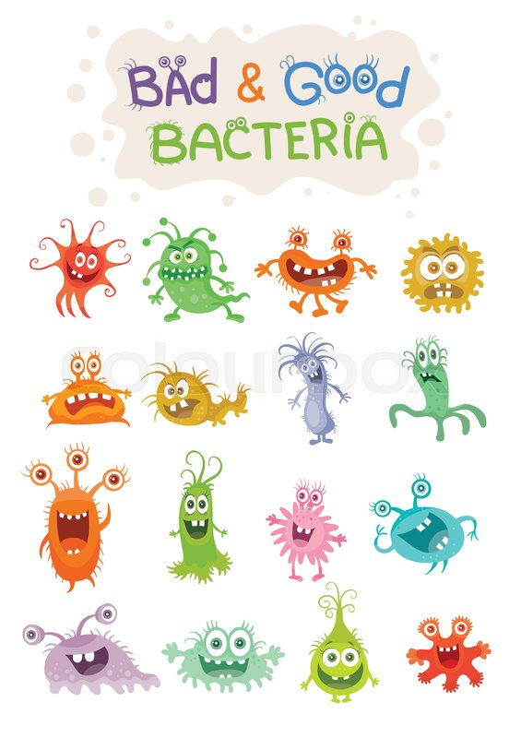
To be read and discussed with children aged 6-10 years
We would like to invite you and your family to take part in a research study called FAMILY MICRO.
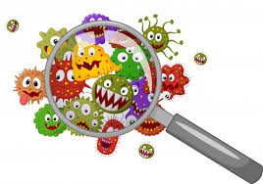

We want to examine the bugs in the nose and mouth of you and your family to better understand why you may get coughs and colds during winter.
Why Me?
You are in a family of four members and you are all generally well. We want to understand how bugs are shared between you and your family members over time. This information could help us to learn more about how healthy people get coughs and colds and use this information to prevent and treat coughs and colds in the future.

What will happen if I take part?
We will ask you and your family to spit in a pot, to place a strip of paper in your nose for 2 minutes and swab your hands for less than a minute. This will be every 2 weeks for 6 months.
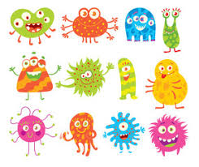
We will ask you and your parent(s) or the person who looks after you to answer questions and keep a diary of what life is like for you. If you have been unwell or had any treatment, we will also ask your doctors to let us know. We will keep this information to help us learn more.

What happens to what the researchers find out?
Any information about you which leaves the hospital will not have your name in it. We will send a weblink after the end of the study to tell you what we have found.

How do I join?
You should talk to your parents or the person who looks after you about the project. It is your choice if you want to join and you can change your mind whenever you like. If you changed your mind, please let your parent or the person who looks after you and they can email2volresearch@lstmed.ac.uk You must have permission from your parents or the person who looks after you if you want to take part.
Happy to take part?

If you have any questions you can contact us at any time
Research Team: ****, EMAIL: ****, PHONE: ****

