Participant Flow
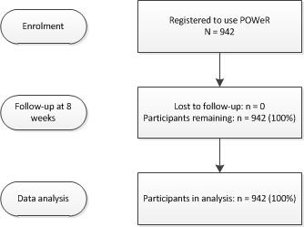

Baseline Characteristics
Characteristic | N = 942
Age (years): M (SD) | 44.68 (10.34)
Gender: Female | 721 (76.50)
Body mass index: M (SD) | 31.35 (12.25) ª
Ethnicity
White | 896 (95.10)
Bangladeshi | 1 (.10)
Chinese / South East Asian | 2 (.20)
Indian | 6 (.60)
Pakistani | 6 (.60)
Other | 15 (1.60)
Education
No formal educational qualifications | 14 (1.50)
GCSE / O Levels | 155 (16.50)
A Levels | 148 (15.70)
Diploma | 172 (18.30)
Degree | 257 (27.30)
Postgraduate degree | 146 (15.50)
Other | 34 (3.60)
Smartphone ownership
Yes | 761 (80.80)
No | 155 (16.50)
Unsure | 10 (1.10)
Smartphone platform
Android | 305 (32.40)
Windows | 39 (4.10)
iOS | 329 (34.90)
Blackberry | 25 (2.70)
Unsure | 51 (5.40)
Data are presented as N (%) unless otherwise stated. ªData missing for n=12.

Outcome measures
Primary outcome measures

Usage of POWeR website
Usage metric | N = 942
Sessions completed: M (SD) | .96 (2.01)
Duration of use (minutes): M (SD) | 44 (43)
Completion of first core session: n (%) | 554 (58.1)
Completion of first three core sessions: n (%) | 106 (11.25)
Completion of three or more sessions: n (%) | 68 (7.22)

Usage of POWeR Tracker application
Usage metric | N = 60
Log-ins: M (SD) | 10.33 (19.92)
Days used: M (SD) | 6.7 (11.10)
Duration of use (minutes): M (SD) | 22 (38)

Secondary outcome measures

Not currently available
Adverse events
There were no adverse events associated with this trial

