Participant Flow Diagram

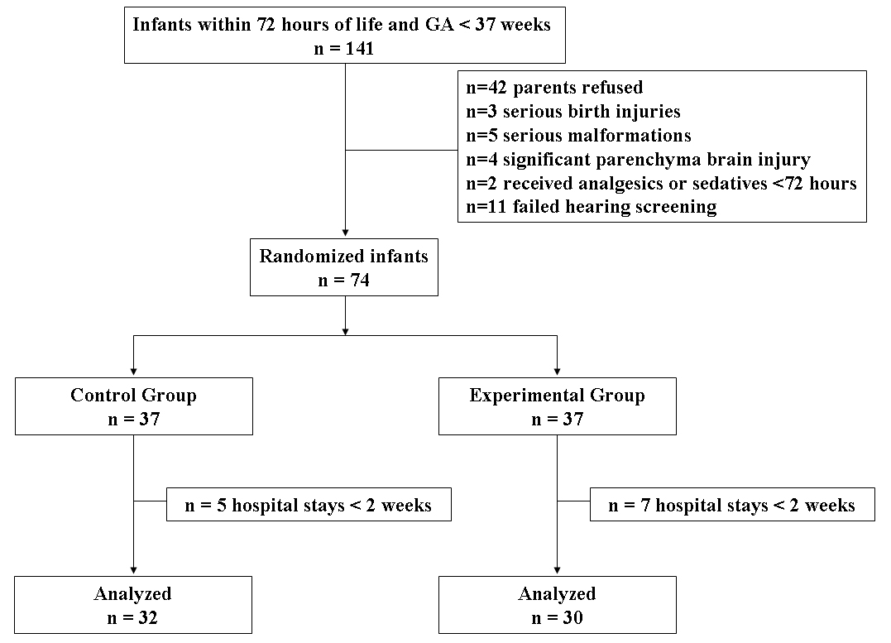

Baseline Characteristics

 | Control Group  n =32 | Experimental Group  n =30 | P
Gestational age (weeks) | 33.33±0.54 | 34.30±0.67 | 0.10
Birth weight (kg) | 2.00±0.07 | 1.93±0.13 | 0.64
Sex (male/female) | 15/17 | 13/17 | 0.80
1-min APGAR | 8.67±0.24 | 9.37±0.32 | 0.96
5-min APGAR | 9.40±0.22 | 9.64±0.15 | 0.47
Severity (SNAP-Ⅱ) | 8 (0-57) | 8 (0-33) | 0.69

Data are presented as mean±SD or median (range).
APGAR indicates appearance, pulse, grimace, activity, respiration.

Outcome measures

 |  | Control Group  n =32 | Experimental Group  n =30
PIPP | Hospital beginning | 11.17 ± 0.91 | 12.14 ± 0.46
 | Two weeks later | 13.00 ± 0.46 | 10.50 ± 0.85
Cortisol | Hospital beginning | 237.20 ± 43.86 | 184.60 ± 21.17
 | Two weeks later | 131.00 ± 18.19 | 162.40 ± 23.58
beta-endorphin | Hospital beginning | 1.18 ± 0.09 | 1.64 ± 0.39
 | Two weeks later | 1.39 ± 0.41 | 2.29 ± 0.74

Data are presented as mean±SD.

Adverse events

There were no adverse events associated with the study.

