Participant flow

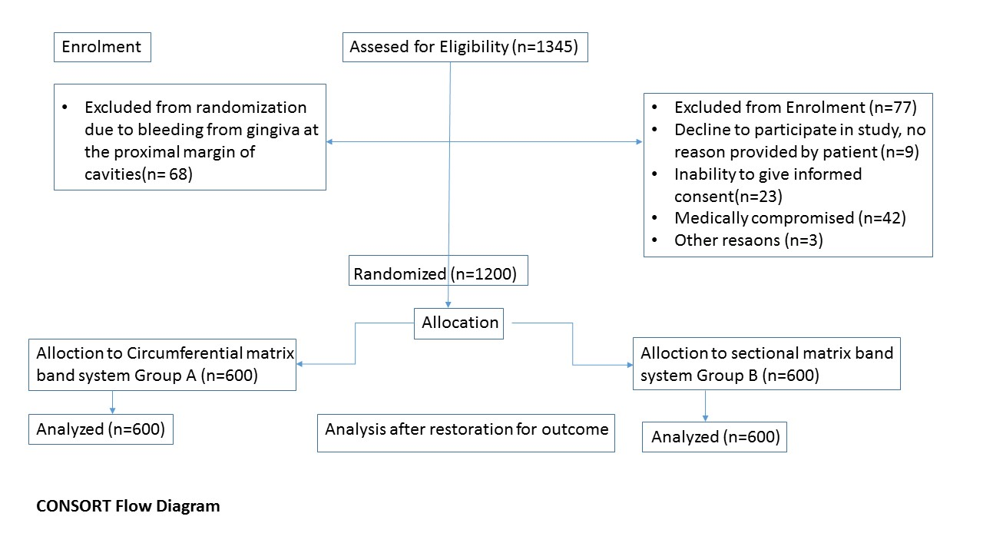

Baseline characteristics

Chi square test was used. P value < 0.05 is considered as significant.
Variables | Cirumferential matrix band | Sectional matrix band | Total | P value
Dental Cavities in Male patients | 304 | 304 | 608 | 0.523
Dental Cavities in Female patients | 296 | 296 | 592
Treated by 4th year dental students | 295 | 305 | 600 | 0.302
Treated by 5th year dental students | 305 | 295 | 600
Tight contact points | 31 | 41
Open contact points | 569 | 170 | 739 | 0.000
Optimum contact points | 0 | 389 | 389
Positive overhanged margins | 62 | 80 | 142
Negative overhanged margins | 95 | 37 | 132 | 0.000
Absent over-hanged margins | 443 | 483 | 926
Amalgam restoration done | 79 | 60 | 139 | 0.052
Composite restoration done | 521 | 540 | 1061
Supragingival margins of cavity | 303 | 340 | 643 | 0.001
Subgingival margins of cavity | 188 | 132 | 320
Cavity margins at the level of gingiva | 109 | 128 | 237

Outcome measures

Table 1: Association of Matrix band system with proximal contacts (Chi Square test was used at 95% confidence interval, α = 5%)
Matrix band system used |  | Proximal | Contacts |  | P values
 | open contacts | tight contacts | optimum contacts | Total
circumferential | 569 | 31 | 0 | 600 | 0.000
sectional | 170 | 41 | 389 | 600
Total | 739 | 72 | 389 | 1200

Table 2: Association of Matrix band system with proximal margins (Chi Square test was used at 95% confidence interval, α = 5%)
Matrix band system used |  | Proximal | margins |  | P values
 | positive overhangs | negative overhangs | Absent overhangs | Total
circumferential | 62 | 95 | 443 | 600 | 0.000
sectional | 80 | 37 | 483 | 600
Total | 142 | 132 | 926 | 1200

Adverse Events

There were no adverse events associated with this trial.

