Parent / Guardian Information Sheet

You and your child are invited to take part in a research trial being run by the University of Bristol, the University of Exeter and the COCO clinic in the Bristol Royal Hospital for Children. Next time you are in clinic you can meet with the researcher who can give you some more details.

What is the research about?
The research is looking at introducing a new app for your child to use between appointments. The app is a healthy eating app, for use on smartphones, iPads and tablets, called “FoodT”.
We have done some research that shows that the FoodT app may help people to eat less of foods that are high in fat, salt and sugar. So far, we've tried it with adults and found that it helped them lose weight.

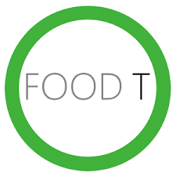
We would like to understand if:
- Food T is a useful addition to the support you and your child get from the weight-management clinic
- If FoodT is something your child has the time to do in their daily life
- If FoodT is something they don’t mind doing

We are asking your child to play the game at home, then inviting you both to tell us what you think by taking part in questionnaires or interviews with us.
All research will take part at the same time as your appointments, you will not need to come to the clinic any additional times.

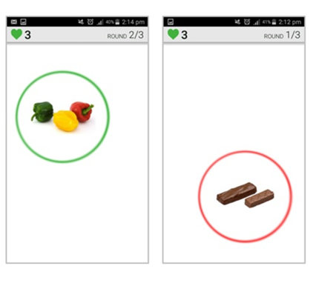
How do you play the app?
The app contains a simple brain training game. It will show pictures, one by one. When there is a green circle around the picture, the aim is to tap it as quickly as possible. When there is a red circle around the picture, try not to tap it.
Information of how to download and play the FoodT app will be provided at your next clinic appointment, should you want to take part. You can download the app onto your smartphone/iPad/tablet and use the app at home or when you are out-and-about.

What are the benefits?
Based on evidence from previous work with this app, there is a chance that the app will support your child with making healthy food choices, that may lead to weight loss.

What are the potential disadvantages?
Based on research so far, there is no evidence that playing this app is a risk of any kind. However, the training will take up more time that the standard clinic appointments alone and may not be effective for your child.
In less than 1 in 1000 people, the training increased food cravings. If you or your child notice an increase in cravings, we will advise you to stop the training immediately.

Expenses / Payment
To compensate for you and your families time, we will offer a £5 Amazon voucher for each questionnaire filled in or a £10 Amazon voucher for each interview that is participated in.
These vouchers can be allocated to parent and child if both take part.

What will it involve?
OR

OR

Do we have to take part? What if I start but decide I do not want to carry on?
No, you do not need to take part, it is your choice to take part and you can stop taking part at any time without explaining why. The decision to not be involved in the trial does not affect your child’s usual treatment. Choosing to stop taking part will prevent further data being submitted. The data that has been collected by the app, up to this point may have already been analysed, but your data from questionnaires and interviews may be removed from the trial.
If your child no longer wants to take part, you may continue to answer our questionnaires/interviews. You may also decline to take part, whilst your child chooses to carry on with the study.

Who can give consent to participating?
If your child is 16 or over, they can give their own consent to take part in the research. The forms to fill out will be given to them in the clinic at the next appointment.

If your child is aged 15 or younger, you as parents/guardians will need to give consent to them taking part in this research. The forms to fill out will be given out in the clinic at your child’s next appointment. These will need to be completed by a legal parent or guardian.
We will also ask your child to sign an assent form to let us know that they are also happy to take part. Without both of these forms, we will not begin the research with your child, but you may take part in the interviews/questionnaires.

What happens to my data?
- Everything you say in interviews, on questionnaires, and the data received from the app will be stored and analysed anonymously.
- The information will be stored using a user number given to you to protect your identity.
- All the information will be kept securely within University of Bristol and the University of Exeter.
- Whenever your child completes a round of the FoodT app, your scores, and answers to the questions will automatically be sent to the University of Exeter.
- Any interviews you take part in with us will be recorded and stored until the information is transcribed by a member of the research team. The recordings will then be destroyed, and a written copy of the interview stored.
- The findings of the study will be published in an academic journal and used as part of a PhD thesis.
- The anonymous data will be made available to other research teams, which may be used for purposes not related to this study, however, it will not be possible to identify you from this data.

NB/ If during the research, information is shared that would be considered a safeguarding or medical concern, this information will be shared with the clinical team to ensure your families safety.

How does this fit in with GDPR?
The University of Bristol is the sponsor for this study based in the United Kingdom. We will be using information from you in order to undertake this study and will act as the data controller for this study. This means that we are responsible for looking after your information and using it properly. The University of Bristol will keep non-identifiable research data you provide for 5 years after the study has finished.
Your rights to access, change or move your information are limited, as we need to manage your information in specific ways in order for the research to be reliable and accurate. If you withdraw from the study, we will keep the information about you that we have already obtained. To safeguard your rights, we will use the minimum personally-identifiable information possible.
You can find out more about how we use your information by contacting the Information Governance Manager at data-protection@bristol.ac.uk.
The research team will collect information from you for this research study in accordance with our instructions.
The NHS clinical team only, not the researchers, will use your name, NHS number and contact details to contact you about the research study, and make sure that relevant information about the study is recorded for your care, and to oversee the quality of the study.
Individuals from The University of Bristol and regulatory organisations may look at your research records to check the accuracy of the research study. The only people in The University of Bristol who will have access to information that identifies you will be people who need to contact you or audit the data collection process. The people who analyse the information will not be able to identify you and will not be able to find out your name, NHS number or contact details. The University of Bristol will keep identifiable information about you from this study for 1 year after the study has finished.
When you agree to take part in a research study, information collected related to the research be provided to researchers running other research studies in this organisation and in other organisations. These organisations may be universities, NHS organisations or companies involved in health and care research in this country or abroad. Your information will only be used by organisations and researchers to conduct research in accordance with the UK Policy Framework for Health and Social Care Research.
This information will not identify you and will not be combined with other information in a way that could identify you. The information will only be used for the purpose of health and care research, and cannot be used to contact you or to affect your care. It will not be used to make decisions about future services available to you, such as insurance.
Funding
This study is being funded by the GW4 biomedical doctoral training programme and has been reviewed by senior academics within the University of Bristol and the University of Exeter and the NIHR’s young person’s advisory group for research.

Ethics
Ethical Approval has been granted by South Central – Berkshire B Research Ethic Committee.

If you have any questions or concerns about the study, please contact the principal investigator Jennifer Cox at Jennifer.cox@bristol.ac.uk
or speak to a member of the team at your next clinic appointment.

