Participant Flow

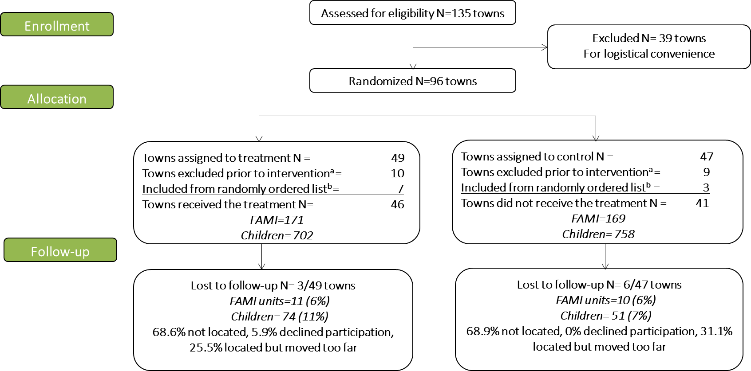

Source: Consort Flow Chart. Own Elaboration
ª Once in the field for data collection, it was realized that some towns did not have any FAMI units as they had made the transition to other models (MF)
^{b} Towns not originally assigned to the sample were randomly ranked and used as replacements. However, there were not enough in all randomization strata.

Baseline Characteristics
Table 1. Baseline characteristics of children and their households by randomization status
 | ITT=1 |  | ITT=0
 | Mean | SD | Mean | SD
Sociodemographic characteristics
Child's age in months | 5.76 | (3.44) | 5.54 | (3.29)
Boys (%) | 0.52 | (0.50) | 0.51 | (0.50)
First Born (%) | 0.47 | (0.50) | 0.45 | (0.50)
Child's birth weight (gr) | 3,190 | (572) | 3,156 | (500)
Low birth weight (%) | 0.07 | (0.26) | 0.07 | (0.26)
Mother's age (number of years) | 26.16 | (6.95) | 26.48 | (6.81)
Mother's education (years) | 8.85 | (3.42) | 8.40 | (3.31)
Father present (%) | 0.70 | (0.46) | 0.75 | (0.43) | **
Mother present (%) | 1.00 | (0.06) | 1.00 | (0.07)
Mother single (%) | 0.24 | (0.43) | 0.21 | (0.41)
Mother divorced (%) | 0.01 | (0.11) | 0.03 | (0.16) | *
Teenage mothers (%) | 0.25 | (0.44) | 0.21 | (0.41) | *
Household wealth index ª | 0.06 | (0.96) | -0.06 | (1.04) | **
Home ownership | 0.37 | (0.48) | 0.39 | (0.49)
SISBEN survey ^{b} | 0.71 | (0.45) | 0.70 | (0.46)
Household size | 4.08 | (1.47) | 4.10 | (1.43)
No. of observations | 702 |  | 758
Caregiver Characteristics
Peabody Picture Vocabulary Test (raw score) | 22.33 | (8.53) | 19.76 | (8.8) | **
Personality Traits by Big Five
Extroversion (raw score) | 3.33 | (0.54) | 3.35 | (0.54)
Agreeableness (raw score) | 3.88 | (0.57) | 3.86 | (0.61)
Conscientiousness (raw score) | 3.92 | (0.60) | 3.73 | (0.60) | ***
Emotional Stability (raw score) | 2.73 | (0.61) | 2.77 | (0.56)
Openness (raw score) | 3.80 | (0.60) | 3.78 | (0.57)
No. of observations | 702 |  | 758
Intermediate Outcomes
FCI No. of adult books, magazines and newspapers^{c} | 2.57 | (3.08) | 2.76 | (3.17)
FCI No. of toy sources | 1.35 | (0.94) | 1.38 | (0.97)
FCI No. of varieties of play materials | 1.42 | (1.41) | 1.42 | (1.45)
FCI No. of varieties of play activities over past 3 days | 2.53 | (1.56) | 2.53 | (1.57)
FCI No. of parental care activities over past 3 days | 4.75 | (1.04) | 4.72 | (1.06)
Exclusive breastfeeding at least 6 months (%) | 0.72 | (0.45) | 0.73 | (0.44)
Social support DUKE UNC-11 scale total (raw score) | 41.22 | (8.26) | 42.21 | (8.89)
Self-efficacy in the Caregiver Role Test – Modified^{d} | 26.47 | (5.60) | 26.45 | (4.76)
Mothers with depression symptoms CESD-10 (%) | 0.15 | (0.36) | 0.13 | (0.33)
Use of verbal or physical abuse in the household (%) | 0.02 | (0.15) | 0.01 | (0.11)
No. of observations | 702 |  | 758
Note: ***p<0.01; **p<0.05; *p<0.1
Standard errors clustered by town in parenthesis
a The wealth index was computed as the principal component of a set of dichotomous variables that describe characteristics of the household, ownership of durable goods, and access to public utilities.
b Colombia’s proxy means test
c FCI: UNICEF’s family care indicator (Frongillo, Sywulka and Kariger, 2003).
d Pedersen et al. (1989) and Porter and Hsu (2003)
Outcome measures

Table 2. Outcomes of children at baseline and end of intervention by randomization status
 | ITT=1 |  | ITT=0
 | Mean | SD | Mean | SD
Baseline
Nutrition
Height (cm) | 64.98 | (6.85) | 63.99 | (7.05) | *
Weight (kg) | 7.38 | (1.97) | 7.34 | (2.02)
Weight for age Z-score | 0.25 | (1.40) | 0.27 | (1.42)
Length for age Z-score | -0.02 | (1.70) | -0.21 | (1.74)
Weight for length Z-score | 0.37 | (1.59) | 0.55 | (1.65)
Global Malnutrition (Underweight) | 0.07 | (0.25) | 0.05 | (0.22)
Acute Malnutrition (Wasting) | 0.06 | (0.24) | 0.07 | (0.25)
Chronic Malnutrition (Stunting) | 0.10 | (0.30) | 0.14 | (0.35)
Overweight by BMI | 0.10 | (0.29) | 0.09 | (0.28)
ELCSA food insecurity | 0,50 | (0,50) | 0,42 | (0,50)
ELCSA food insecurity (Moderate or Severe) | 0,04 | (0,21) | 0,03 | (0,175)
No. of observations | 702 |  | 758
Motor Development
No. of WHO motor milestones achieved | 2,70 | (1,661) | 2,78 | (1,870)
No. of observations | 344 |  | 361
End of the Intervention
Nutrition
Height (cm) | 84.34 | (4.50) | 84.30 | (4.59)
Weight (kg) | 12.05 | (1.69) | 11.94 | (1.66)
Weight for age Z-score | 0.02 | (1.09) | -0.06 | (1.03)
Length for age Z-score | -0.82 | (1.15) | -0.89 | (1.18)
Weight for length Z-score | 0.59 | (1.22) | 0.52 | (1.23)
Global Malnutrition (Underweight) | 0.02 | (0.14) | 0.04 | (0.19)
Acute Malnutrition (Wasting) | 0.01 | (0.09) | 0.02 | (0.15)
Chronic Malnutrition (Stunting) | 0.16 | (0.37) | 0.16 | (0.37)
Overweight by BMI | 0.26 | (0.44) | 0.22 | (0.42)
ELCSA food insecurity | 0,49 | (0,50) | 0,65 | (0,48) | **
ELCSA food insecurity (Moderate or Severe) | 0,05 | (0,22) | 0,07 | (0,25)
No. of observations | 628 |  | 707
Socio-emotional Development
ASQ:SE Raw Scores Total | 44,30 | (26,02) | 48,44 | (28,69)
No. of observations | 628 |  | 707
Bayley-III Raw Scores
Cognition | 59,37 | (7,95) | 59,47 | (7,53)
Receptive language | 24,34 | (5,25) | 24,67 | (5,06)
Expressive language | 25,78 | (5,76) | 25,47 | (5,49)
Gross motor | 54,58 | (4,74) | 54,37 | (4,44)
Fine motor | 38,18 | (4,18) | 38,06 | (3,80)
No. of observations | 628 |  | 707
Note: ***p<0.01; **p<0.05; *p<0.1
Standard errors clustered by town in parenthesis

Table 3. Secondary outcomes of participant children at the end line by randomization status
 | ITT=1 |  | ITT=0
 | Mean | SD | Mean | SD
End of the Intervention
FCI No. of adult books, magazines and newspapers | 6,01 | (3,97) | 4,77 | (3,80) | ***
FCI No. of toy sources | 2,73 | (0,50) | 5,56 | (0,37) | ***
FCI No. of varieties of play materials | 3,98 | (1,67) | 4,00 | (1,76)
FCI No. of varieties of play activities over past 3 days | 5,87 | (0,49) | 5,84 | (0,42)
FCI No. of parental care activities over past 3 days | 7,89 | (2,36) | 7,96 | (2,51)
Use of verbal or physical abuse in the household (%) | 0,10 | (0,30) | 0,13 | (0,33)
Social support DUKE UNC-11 total (raw score) | 39,77 | (9,02) | 37,45 | (8,61) | *
Self-Efficacy Score Above Median | 0,30 | (0,46) | 0,24 | (0,43)
Mothers with depressive symptoms (%) | 0,18 | (0,39) | 0,19 | (0,39)
Parental Knowledge (Raw Score) | 29,27 | (3,61) | 29,49 | (3,44)
No. of observations | 628 |  | 707
Note: ***p<0.01; **p<0.05; *p<0.1
Standard errors clustered by town

Adverse events
There were no adverse events associated with this trial.

