Participant Flow
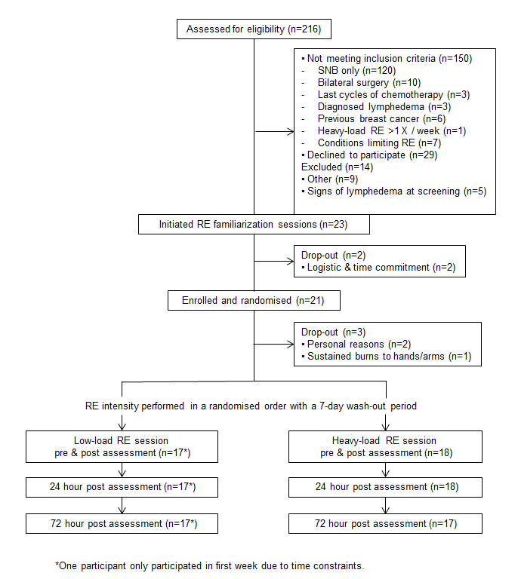

Baseline Characteristics
Baseline characteristics of participants (n=21)
Variables | Mean ± SD / Median (range)
Age (years) | 45.3 ± 9.2 / 46 (23-60)
BMI (kg/m²⁾ | 25.3 ± 4.7
Cancer stage n (%)
ll | 15 (71)
lll | 6 (29)
Tumor size (mm) | 21.5 ± 12.9 / 18 (7-62)
Breast surgery n (%)
Lumpectomy | 8 (38)
Mastectomy | 13 (62)
Surgery on dominant side n (%) | 11 (52)
Axillary lymph nodes removed | 21.7 ± 7.8
Metastatic lymph nodesª | 5.7 ± 7 / 2 (1-25)
Seroma drainage n (%) | 5.5 ± 3.4
Chemotherapy n (%)
3-wkly CE x 3 -> 3 wkly docetaxel x 3 | 10 (48)
3-wkly CE x 3 -> 1 wkly paclitaxel x 9 | 11 (52)
Axillary webbing at screening n (%) | 8 (38)
L-Dex at screening | -0.08 ± 2.23

Abbreviations: CE (cyclophosphamide and epirubicin)
ª) micro- and macrometastases

Outcome Measures
Equivalence between resistance exercise loads for all outcomes (n=17)
 | Estimated mean difference^{b} |  | Equivalence 90% CI
L-Dex (±3.0)ª
Post- exercise | -0.97 | -2.09 to 0.16
24-hrs Post-exercise | -0,14 | -1.63 to 1.35
72-hrs Post-exercise | -1.00 | -3.17 to 1.17^{c}
Inter-arm volume % difference (±3.0)ª
Post- exercise | 0,21 | -0.89 to 1.31
24-hrs Post-exercise | 1,09 | 0.41 to 1.78
72-hrs Post-exercise | 0,96 | -0.09 to 2.02
Inter-arm difference Pain (±1.0)ª
Post- exercise | 0 | -0.43 to 0.43
24-hrs Post-exercise | -0.06 | -0.58 to 0.46
72-hrs Post-exercise | -0,06 | -0.61 to 0.49
Inter-arm difference Heaviness (±1.0)ª
Post- exercise | 0,24 | -0.23 to 0.70
24-hrs Post-exercise | 0,18 | -0.32 to 0.67
72-hrs Post-exercise | 0,24 | -0.38 to 0.85
Inter-arm difference Tightness (±1.0)ª
Post- exercise | -0,06 | -0.45 to 0.34
24-hrs Post-exercise | -0.11 | -0.50 to 0.27
72-hrs Post-exercise | 0.20 | -0.37 to 0.77
Inter-arm difference Swelling (±1.0)ª
Post- exercise | 0 | -0.33 to 0.33
24-hrs Post-exercise | 0 | -0.33 to 0.33
72-hrs Post-exercise | 0.06 | -0.42 to 0.54
L-Dex primary outcome. ªEquivalence margin. ^{b} Estimated mean difference calculated using a generalized estimating equations model with heavy-load as comparator (heavy minus low). ^{c} equivalence not demonstrated

Adverse Events
There were no adverse events with this trial.

