Participant flow

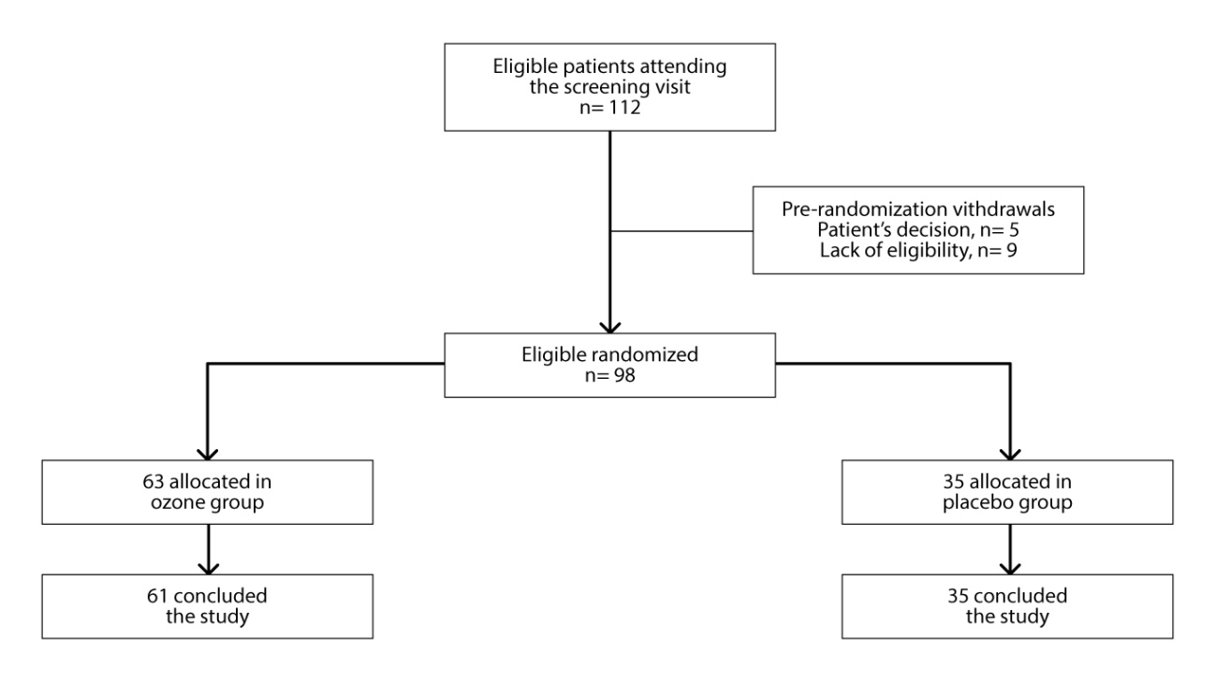

Baseline characteristics
Variable | Ozone | Placebo | Total | p
Age (years) |  |  |  | 0.533*
Medium (SD) | 70.50 (7.20) | 69.50 (7.60) | 70.10 (7.30)
Schooling |  |  |  | 0.218**
None | 5 (8.20) | 5 (14.30) | 10 (10.40)
1st degree | 38 (49.20) | 21 (60.00) | 59 (61.40)
2nd degree | 14 (23.00) | 9 (25.70) | 23 (24.00)
Superior | 4 (6.60) | 0 (0.00) | 4 (4.20)
Marital status |  |  |  | 0.044***
Single | 8 (13.10) | 0 (0.00) | 8 (8.30)
Married | 31 (50.80) | 22 (62.90) | 53 (55.20)
Divorced/separated | 5 (8.20) | 2 (5.70) | 7 (7.30)
Widow | 17 (27.90) | 11 (31.40) | 28 (29.20)
Sex |  |  |  | 0.489****
Female | 56 (91.80) | 30 (85.70) | 86 (89.60)
Male | 5 (8.20) | 5 (14.30) | 10 (10.40)
Race |  |  |  | 0.062***
Caucasian | 49 (80.30) | 22 (62.90) | 71 (74.00)
Negro | 10 (16.40) | 13 (37.20) | 23 (23.90)
Mongolian | 2 (3.30) | 0 (0.00) | 2 (2.10)
Knee |  |  |  | 0.148
Right | 29 (47.50) | 22 (62.90) | 51 (53.10)
Left | 32 (52.50) | 13 (37.10) | 45 (46.90)
Qui-squared test, *t-Student test, **Mann-Whitney’s test
***Likelihood ratio test, ****Fisher’s exact test

Outcome measures
Results from Visual Analogic Scale and Geriatric Pain Measure
Scale/  Groups PBO - OZ | Comparison | MD | SE | p | Inferior (CI 95%) | Superior (CI 95%)
VAS | Basal | 0.06 | 0.56 | <0.999 | - 1.68 | 1.79
VAS | 4 weeks | 1.72 | 0.56 | 0.055 | - 0.02 | 3.46
VAS | 8 weeks | 2.16 | 0.56 | 0.003 | 0.42 | 3.89
VAS | 16 weeks | 3.16 | 0.56 | <0.001 | 1.42 | 4.89
GPM | Basal | 4.63 | 4.96 | >0.999 | -10.87 | 20.14
GPM | 4 weeks | 18.75 | 4.96 | 0.004 | 3.25 | 34.26
GPM | 8 weeks | 18.94 | 4.96 | 0.004 | 3.43 | 34.44
GPM | 16 weeks | 23.10 | 4.96 | <0.001 | 7.60 | 38.61
MD = medium difference, SE = standard error, CI = confidence interval
VAS = Visual Analogic Scale, GPM = Geriatric Pain Measure

Results from Lequesne’s Index
Lequesne’s Index /  Groups PBO - OZ | Comparison | MD | SE | p | Inferior (CI 95%) | Superior (CI 95%)
 | Basal | 1.55 | 0.95 | <0.999 | - 1.40 | 4.51
 | 4 weeks | 3.85 | 0.95 | 0.001 | 0.90 | 6.81
 | 8 weeks | 4.05 | 0.95 | 0.001 | 1.10 | 7.00
 | 16 weeks | 4.39 | 0.95 | <0.001 | 1.44 | 7.35
MD = medium difference, SE = standard error, CI = confidence interval, LEQ =Lequesne’s Index

Results from Womac
 |  | Group |  |  | CI95% median of diff
 |  | Ozônio | Placebo | Median of diff | Lower | Upper | P-value
Dor | Semana 1 | 50,0 (40; 70) | 60,0 (42; 70) | 0.000 | -9.999 | 10,000 | 0,752
 | Semana 4 | 20,0 (7; 37) | 45,0 (25; 60) | 15.000 | 5.000 | 25.000 | <0.001
 | Semana 8 | 10,0 (0; 30) | 20,0 (10; 40) | 9.999 | 0.000 | 15.000 | 0.019
 | Semana 16 | 10,0 (0; 20) | 25,0 (2; 52) | 14.999 | 0.000 | 25.000 | 0.005
Rigidez | Semana 1 | 37,5 (25; 62) | 37,5 (25; 62) | 0.000 | -12.499 | 12.499 | 0.5695
 | Semana 4 | 0,0 (0,0; 12) | 12,5 (0; 25) | 0.000 | 0.000 | 12.500 | 0.0336
 | Semana 8 | 0,0 (0,0; 12,5) | 12,5 (0; 25) | 12.499 | 0.000 | 12.500 | <0.001
 | Semana 16 | 0,0 (0; 0) | 0,0 (0; 12) | 0.000 | 0.000 | 0.000 | 0.1135
Déficit Funcional | Semana 1 | 44,1 (26; 68) | 50,0 (40; 61) | 5.879 | -44.100 | 147.100 | 0.2973
 | Semana 4 | 17,6 (9; 31) | 33,8 (26; 51) | 16.170 | 7.350 | 23.529 | <0.001
 | Semana 8 | 11,7 (3; 26) | 27,9 (14; 35) | 11.760 | 4.409 | 19.119 | 0.003
 | Semana 16 | 11,8 (2; 24) | 25,0 (7; 35) | 7.350 | 1.469 | 16.180 | 0.016
Mann-Whitney U Test, Median of diff: median of difference, CI 95%: confidence interval, Hodges-Lehmann methods

Results from SF-36 Health Survey Instrument
SF-36  Groups PBO/OZ | Time | MD | SE | p | Inferior (CI 95%) | Superior (CI 95%)
FC |  | -12.99 | 4.64 | 0.005 | -22.08 | -3.90
 | Basal – 4 weeks | -20.51 | 2.31 | <0.001 | -26.59 | -14.43
 | Basal – 8 weeks | -25.82 | 2.97 | <0.001 | -33.65 | -17.99
 | Basal – 16 weeks | -27.70 | 3.42 | <0.001 | -36.73 | -18.67
PH |  | -23.30 | 5.62 | <0.001 | -34.32 | -12.27
 | Basal – 4 weeks | -29.93 | 4.40 | <0.001 | -41.53 | -18.33
 | Basal – 8 weeks | -40.82 | 5.18 | <0.001 | -54.48 | -27.17
 | Basal – 16 weeks | -37.72 | 5.65 | <0.001 | -52.61 | -22.82
GSH |  | -1.92 | 0.61 | 0.002 | -3.13 | -0.72
 | Basal – 4 weeks | -1.96 | 0.45 | <0.001 | -3.16 | -0.77
 | Basal – 8 weeks | -3.38 | 0.55 | <0.001 | -4.83 | -1.93
 | Basal – 16 weeks | -2.40 | 0.59 | <0.001 | -3.95 | -0.85
SA |  | -4.46 | 2.18 | 0.041 | -8.74 | -0.18
 | Basal – 4 weeks | -8.99 | 1.85 | <0.001 | -13.87 | -4.11
 | Basal – 8 weeks | -13.96 | 2.17 | <0.001 | -19.67 | -8.24
 | Basal – 16 weeks | -13.29 | 2.28 | <0.001 | -19.32 | -7.27
EA |  | -21.43 | 5.02 | <0.001 | - 31.27 | -11.60
 | Basal – 4 weeks | -26.23 | 4.45 | <0.001 | -37.98 | -14.48
 | Basal – 8 weeks | -35.37 | 5.11 | <0.001 | -48.86 | -21.89
 | Basal – 16 weeks | -31.17 | 5.45 | <0.001 | -46.09 | -17.32
FC = Functional Capacity, PH = Physical Health, GSH = General Status of Health,
SA = Social Aspects, EA = Emotional Aspects

Adverse events
Adverse events | Ozone group | Placebo group
Puncture accidents | 01 patient | 02 patients

