Effects of shoes in individuals with intermittent claudication

Information about this document
You are being invited to take part in a research study to help us understand how different shoes affect walking in people with leg and foot circulation problems. This study will form part of a student PhD thesis. Before you decide, it is important for you to understand why the research is being done and what it will involve. This document gives you important information about the purpose, risks, and benefits and compensations of participating in the study. Please take time to read the following information carefully. If you have any questions then feel free to contact the researcher whose details are given at the end of the document. Take time to decide whether or not you wish to take part.
What is the purpose of this study?
This study will examine the differences in walking between people who have calf pain when they walk due to poor blood supply to their legs and feet (a condition called Intermittent claudication) and those who do not. The data collected from you will therefore be compared to people without calf pain. The study will also investigate how special shoes modify walking and might help people who experience calf pain when they walk. The results of this study will be used to improve footwear design to enable you to walk further without pain and potentially improve blood supply to the legs.

Why have I been chosen?
You are being invited to take part because your Doctor has indicated that you have poor circulation (called intermittent claudication) in one or both lower legs. This makes walking difficult and sometimes painful. We want to better understand how you walk and whether by using special footwear we might improve your walking pattern. You are therefore being invited to be one of 40 participants aged 50 or more.
Do I have to take part?
No. Your participation in this study is entirely voluntary. If you do not wish to take part this will in no way affect your treatment. If after reading this information sheet, having asked any questions you might have, you decide to take part, you will be asked to sign a consent form. You are however free to withdraw your consent at any time during the study. If you withdraw this will not affect your treatment in any way.

What will happen to me if I take part?
You will be asked to come to the Podiatry Clinic at the University of Salford. You will be met at reception by the researcher organising the study (Ms Effy Evangelopoulou) and guided to the walking laboratory. You are asked to bring a t-shirt and pair of shorts and will be given time and privacy to change. You will then be asked to lie on a physiotherapy bed, and gel electrodes (like ECG electrodes that are used to measure heart beats) will be placed on your calf muscles. These do not hurt. They will pick up information about when your muscles are on and off whilst you walk. Reflective markers that allow us to measure how your joints move will then be placed on the shoes, legs and back (see picture below). You will be asked to walk in 5 pairs of shoes (shoes and new socks provided by us) and in two combinations of shoe and orthotic. You will perform the same walking task in each case and will be given time to rest between each test.

The distances you will be asked to walk are relatively short and are not meant to physically exert you. If you at any point you feel aching in your calves, the trials will be paused and you will be given adequate time to rest before continuing.

The shoes:
Examples of the sorts of shoes and orthotic (plastic brace) we are testing are given below (please ignore the colours, these are just examples). They are designed to alter the way your calf muscles act and have been used by clinicians for many years to help patients with lower limb problems. 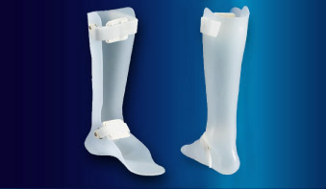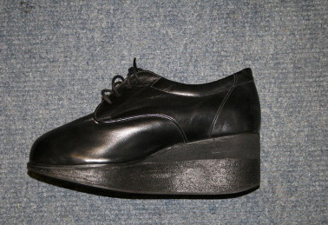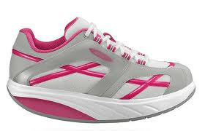

RISKS & POTENTIAL BENEFITS OF THE STUDY
What risks are involved in participating in the study?
During the tests there is a chance that you may feel the ache in your calves that you sometimes experience when you walk, but we do not expect this to occur because we will not be asking you to walk very far. You will be able to take frequent rests as and when required.
Because the shoes we are testing are different to the ones you usually wear you may need some time to get used to them. You will be given as much time as you need to get comfortable and used to wearing the shoes. Sometimes, people can feel unsteady in new footwear, but there are no reported risks of falls or trips in these shoes. Whilst we do not expect it to be necessary, if you prefer, a person will be able to walk close to you during the walking tests.
What benefits are involved in participating in the study?
You will not benefit directly from taking part in the study. However, the results will be used in the design of shoes that will specifically target calf muscles in order to allow people like yourself to walk further without developing a calf ache. The same concepts will be used to design shoes that exercise the calf muscles, to improve circulation in your legs. These may also help in the management of your condition and you may therefore benefit in the future.
What if something goes wrong?
If you wish to complain, or have any concerns about any aspect of the way you have been approached or treated during the course of this study, you can approach the University of Salford Research and Innovation Manager (Anish Kurien) to file a complaint. If you are still not happy you may then go through the standard NHS complaints procedure. The University has insurance to cover you against any harm. However, if you decide to take legal action, you may have to pay for this.

ENDING THE STUDY
What if I want to leave the study early?
You can withdraw from this study at any time without loss of any non-study related benefits to which you would have been entitled before participating in the study. If you want to withdraw you may do so by notifying the people mentioned in the “Contact Information” section below. However, we will use the data unless you request us not to do so.
Who has approved this study
This study has been approved by the University of Salford Research and Governance Ethical Committee (Number HSCR13/91) and NHS Research Ethical Committee (Brighton and Sussex NRES committee, study number: 14/LO/0382 )
FINANCIAL INFORMATION
Who is organising and funding the research?
This study will form part of a PhD thesis and is jointly funded by the University of Salford and the Wrightington, Wigan and Leigh NHS Foundation Trust.
Will I be paid for participating?
No, you are invited to take part in this study as a volunteer. However, we acknowledge that by consenting to take part in this study you will be giving up 3 hours of your time and may incur some travel costs. To recognise this you will receive gift vouchers equalling to a worth of £30. If you live in a radius of 15 miles from the University you will also be picked up from and dropped back at your home by taxi, paid for by the University.

CONFIDENTIALITY OF PARTICIPANT RECORDS
Will my taking part in this study be kept confidential?
All information which is collected about you during the course of the research will be kept strictly confidential. Any information about you which leaves the University of Salford will have your name and address and any other identifying features removed so that you cannot be recognised from it.
What will happen to the results of the research study?
Findings of this study will be published in clinical journals and presented to clinical audiences but your details will not be identified in any way.

RECORD OF INFORMATION PROVIDED
Your will receive a copy of the information sheet and a signed consent form to keep for your personal records.

Thank you very much for taking time to read this document!
We appreciate your interest in this study and hope to welcome you at the School of Health, Sport and Rehabilitation Sciences, University of Salford.

CONTACT INFORMATION
If you require more information about the study, want to participate, or if you are already participating and want to withdraw, please contact

Ms Effy Evangelopoulou

Email: e.evangelopoulou@edu.salford.ac.uk
Phone : 0161 295 2670
Address : School of Health, Sport and Rehabilitation Sciences
Blatchford Building,
University of Salford,
Frederick Rd Campus,
Salford, M6 6PU.

Alternatively you may contact Ms Emma Sutton (research coordinator)
Email: e.sutton@salford.ac.uk
Phone: 01612957016

