Participant Information Sheet.
Faculty of Health and Human Sciences
School of Health Professions
Plymouth University
Peninsula Allied Health Centre
Derriford Road
PL6 8BH

Professor Jon Marsden
BSc (Hons) MSc PhD MCS

Version 6
Date 26/04/19

Study Title: Elastic therapeutic taping of the thigh for children with Cerebral Palsy and spastic hemiplegia or diplegia.
Your child is being invited to take part in a research study. Before you decide whether to participate, it is important for you to understand why the research is being done and what it will involve. Please take time to read the following information carefully and discuss it with others if you wish. Please ask if there is anything that is not clear or if you would like more information. Take time to decide whether or not you wish to take part.
We are carrying out research into Elastic therapeutic taping of the thigh in children with Cerebral Palsy and spastic hemiplegia or diplegia. We want to compare the immediate impact of applying tape in different ways. All children in the study will be assessed both with and without tape on their leg, however the order of assessment and taping will change between participants.

What is the purpose of the study?
Elastic therapeutic taping (the most recognised brand name is Kinesio taping) has become increasingly popular within the world of athletics as well as with treatment of conditions such as Cerebral Palsy. You may have seen the bright coloured tapes worn by sports people. The tape is felt to improve muscle tone and the control of muscles in people with Cerebral Palsy. Yet there is limited research to support the use of taping. We are interested in assessing the effect of applying elastic therapeutic tape to the hamstring and quadriceps (muscles at the back and front of the thigh) on the response to hamstring muscles when they are stretched (stretch reflex/ stiffness of the hamstrings; Phase1) and the impact on muscle length and walking with taping the hamstring muscle using different techniques (Phase 2).
Why has my child been chosen?
We want to assess 16 children for Phase 1 and 20 children for Phase 2. All participants are children with altered muscle tone through Cerebral Palsy (diplegia or hemiplegia), between 6-16 years old and are able to stand up and walk with no adult assistance (but can use orthotics and walking aids if required).
Do we have to take part?
It is up to you and your child to decide whether or not you will take part. This study takes place over two phases and if you do decide to take part you can choose whether to do Phase 1 or Phase 2 or both phases.
If you do decide to take part, you will be asked to sign a consent form on their behalf of your child. We would also like your child to sign an assent form, if possible. If you decide to take part then you are still free to withdraw your child at any time and without giving a reason. A decision to withdraw at any time, or a decision not to take part, will not affect your current and future treatment, therapy intervention, involvement with the club or inclusion on any future research projects.

What will happen if we choose to take part?

Phase 1
This study will take place at the Peninsula Allied Health Centre in Plymouth. We will provide directions. We are going to take one leg through a set of stretches to test the response of the muscle. Before signing consent (and assent) you and your child will be shown a short video of a young person having these stretches done. The choice of leg will be that assessed as the tighter leg, if both legs have the same hamstring length we will tape the dominant leg (the leg your child would chose to kick a ball with). Your child will lay on their back with a strap across their pelvis to stabilise him/her. A CCTV camera will be set up to show the image of your child’s leg on a monitor to improve accuracy of measure and ensure starting position is maintained. This will not include their face and will not be recorded or kept in any form.

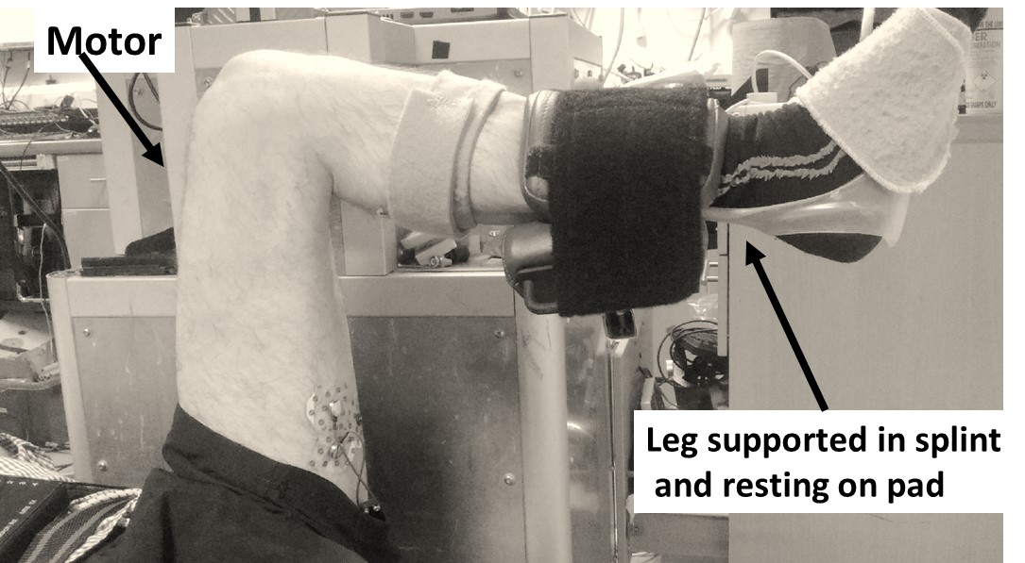

Picture of motor set up used to stretch leg

The test leg will rest on a padded part of a machine and this padded part will be moved by a customised motor to stretch the hamstring muscles through a comfortable range. Initially this range will be 105° to 90° and then through a range specific to your child and nearer the end of their range. Although no part of the assessment should cause pain, participants are supplied with a safety cut off switch and there are mechanical stops and software induced breaks to prevent over stretching.
Small sticky pads that measure muscle activity will be placed on the hamstring and quadricep muscles. We will test the response of the muscles to stretching when there is no tape applied over the muscles, when there is tape applied to the quadriceps muscle at the front of the thigh and when there is tape applied to the hamstring muscle at the back of the thigh. The order of these tests will vary and there will be a 5 minute rest between each taping application. It will take approximately 60 minutes to the complete the whole process.
At the end of the study we will remove any tape and pads that have been applied.

Phase 2
We are going to take a set of 5 measures as explained below with after either an application of tape or two control applications (mimicking tape application), all taping will be applied to the same leg. The choice of leg will be that assessed as the tighter leg, if both legs have the same hamstring length we will tape the dominant leg (the leg your child would chose to kick a ball with). The order will vary and throughout the testing, the leg will be covered a tubigrip bandage so the assessor does not know if whether any tape has been attached.
The set of tests will take 10 minutes to perform and they will be repeated with 3 different conditions, with or without tape attached, depending on which group your child has been allocated to. The order of conditions will vary and between each set your child will have a minimum of a 5 minute rest. Therefore it will take ~50-60 minutes for the whole process.

The measures we will take are:
1) Myotonometer. Your child will be lying on their front. The device applies a small tap to the back of the leg and measures how much the muscle subsequently moves. This gives us a direct measure of the stiffness of the muscle and surrounding connective tissue. We will measure 3 taps. The test is not at all painful and takes 1 minute to perform. We can test the tap on your child’s hand beforehand to make sure he/she is familiar and comfortable with the test.
2) In another test of stiffness, your child will be lying on their
front with the lower leg over the edge of the bed. The leg will
be raised and allowed to drop with gravity. We will record
how quickly the leg drops using sensors that are placed
above and below the knee and attached using Velcro straps.
We will record 3 drops and the test should take 3 minutes.

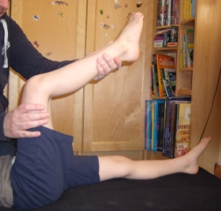
3) To measuring the length of the hamstring muscles, your child will
lie on their back with the leg lifted so the thigh is vertical. We will
then lift up one leg and move it until we feel the onset of resistance
that indicates the end of range and hold the leg there for ~ 3
seconds. We will record the length of the muscle using the sensors
placed on the side of the leg. With the child remaining in the same position, the movement will be repeated three times.
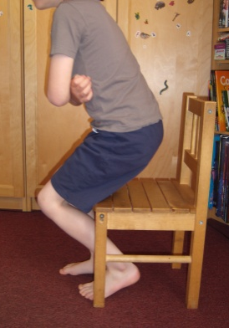
4) We will measure how quickly the child can stand up from sitting 5
times. The use of arms and any aids to help push up are allowed if
needed.

5) The last measure of the sequence will be taken while your child
walks 5 meters, twice. This will be video recorded and this video footage will be kept for analysis. We will measure the speed of knee movement as they move, the speed they walk over the distance and the quality of the walk. Your child can use any walking aids typically used.
At the end of the study we will remove any tape that has been applied and ask you to complete a short questionnaire about your experience in the study.

At the end of the study we will remove any tape that has been applied and ask you to complete a short questionnaire about your experience in the study.

What do we have to do?
Shorts will need to be worn for the tests and we ask for these can be brought to the test. All usual medication should be continued.
Your child should not participate on the day if they are feeling unwell or show any signs of infection such as a raised temperature.

Are there any side effects?
The tests may be tiring and may result in some temporary fatigue and slight muscle soreness as the muscles are stretched. This should wear off within one to two days. If symptoms persist give your child pain relief and take them to their GP or out of hours doctor. The research team can be contacted using the contact details at the end of this letter from Monday-Friday between 8-00 to 18-00. Outside of these hours please telephone 01752 587 590 and leave a message on the password protected answerphone.

What are the possible risks and benefits of taking part?
There are no direct benefits or risks of taking part in this study, however the research hopes to improve the lives of those with Cerebral Palsy.

Will taking part in this study be kept confidential?

The University of Plymouth is the sponsor for this study based in the United Kingdom. We will be using information from you child in order to undertake this study and will act as the data controller for this study. This means that we are responsible for looking after your information and using it properly. The University of Plymouth will keep identifiable information about you up to 1 year after the study has finished.

Your rights to access, change or move your information are limited, as we need to manage your information in specific ways in order for the research to be reliable and accurate. If you withdraw from the study, we will keep the information about you that we have already obtained. To safeguard your rights, we will use the minimum personally-identifiable information possible.
You can find out more about how we use your information at https://www.plymouth.ac.uk/your-university/governance/general-data-protection-regulation-gdpr and /or by contacting the sponsor on plymouth.sponsor@plymouth.ac.uk.

The University of Plymouth research team will use your name and contact details to contact you about the research study, and make sure that relevant information about the study is recorded for your care, and to oversee the quality of the study. Individuals from University of Plymouth sponsor team and regulatory organisations may look at your research records to check the accuracy of the research study. The University of Plymouth research team will pass these details to University of Plymouth sponsor team along with the information collected from. The only people in University of Plymouth who will have access to information that identifies you will be people who need to contact you to arrange appointments and provide summaries of the research or audit the data collection process. The people who analyse the information will not be able to identify you and will not be able to find out your name or contact details. The University of Plymouth research team will keep identifiable information about you from this study for up to 1 year.

When you agree to take part in a research study, the information about your health and care may be provided to researchers running other research studies in this organisation and in other organisations. These organisations may be universities, NHS organisations or companies involved in health and care research in this country or abroad. Your information will only be used by organisations and researchers to conduct research in accordance with the UK Policy Framework for Health and Social Care Research. This information will not identify you and will not be combined with other information in a way that could identify you. The information will only be used for the purpose of health and care research, and cannot be used to contact you or to affect your care. It will not be used to make decisions about future services available to you, such as insurance.

In summary, information which is collected about you and your child during the course of the research will be kept strictly confidential, this includes the video recording. Data will be stored on a secure password-protected electronic file on the University server within the University of Plymouth. Professor J Marsden, a member of the research team, will be responsible for the security of the data. Your details and those of your child will not be shared with anyone outside of the research team. We will keep any video recordings until the results are finalised and then delete the files. Your personal contact details will be kept securely until a summary report is complete so that we can provide you with information about the outcomes of study, if you choose. Any other data we gather will be made anonymous; personal information such as age and GMFCS level will be retained but we believe that it is unlikely that your child can be recognised from this information. Individual children will not be identifiable in any way from any publication arising from the study.

On completion of the data collection, the anonymised information will be stored for 10 years. This information will be available to and used by the research team to prepare publications, reports and other research outputs from this study. If you choose, it will also be made available to other researchers for research purposes.

Withdrawal from the project
Your participation in the trial is entirely voluntary. You are free to decline to enter or to withdraw from the study any time without having to give a reason. You can choose for your child not to enter the trial, or to withdraw once entered. This means you can withdraw at any time including during the measurement session if your child becomes upset or distressed or for any other reason. This will in no way affect your involvement with future studies, or the team who advised you of the study. You can withdraw your information and data up to two weeks after taking part. All your information will be treated as strictly confidential.

What if something goes wrong?
If you have any concerns or questions about this study, contact any of the research team through the details on this sheet. It is extremely unlikely, however, if a participant is harmed by taking part in this research project, there are no special compensation arrangements. If they are harmed due to someone’s negligence, then there may be grounds for a legal action but you may have to pay for it. Regardless of this, if you wish to complain, or have any concerns of this study, please approach the research supervisor Professor J Marsden, School of Health Professions, Faculty of Health and Human Sciences Derriford Road PL68BH. Tel 01752 587590, jonathan.marsden@plymouth.ac.uk)

What will happen to the results of the research study?
With the completion of the study, the results will be shared with the participants through an emailed newsletter, however if you would like a copy of the report, this can be indicated on the consent form, which will be completed with you and your child at the session. The research will be presented to the Association of Paediatric Chartered Physiotherapists and Chartered Society of Physiotherapy at their conferences and published in research and professional journals.

Who is funded and reviewed the research?
This research has been funded by a Grant from the Physiotherapy Research Foundation, part of the CSP Charitable Trust Registered Charity 279882. The study is being completed as part of Samantha Payne’s PhD qualification.
It has been reviewed by the trust and by independent researchers in Plymouth University.
Ethical has been reviewed and approved by the Plymouth & Cornwall Research Ethics Committee (REC) for NHS Ethics, and by the Faculty of Health and Human Sciences ethics sub-committee.

Contact for further information please contact:
Samantha Payne (C/O J Marsden), School of Health Professions, Faculty of Health and Human Sciences Derriford Road PL68BH
Email address: samantha.payne@ plymouth.ac.uk
Mobile number: TBC

You should be given a copy of this information sheet and a signed consent form to take home.
Thank you for reading this and considering whether to let your child take part in the project.
Thank you
Samantha Payne
Samantha.payne@plymouth.ac.uk

