Healthy Future: A Community Health Worker Program to Improve Maternal, Newborn and Child Health

**IMPACT EVALUATION PROTOCOL**

A Study of the:

West China School of Public Health, Sichuan University

Stanford Center on China’s Economy and Institutions and Department of Pediatrics, Stanford University

Gillings School of Global Public Health, University of North Carolina at Chapel Hill

School of Public Health, University of Nevada, Reno

Protocol Version: 4.0, July 6, 2021

Protocol Team

Yunwei Chen

Department of Health Policy and Management

University of North Carolina at Chapel Hill

[ywchen@live.unc.edu](mailto:ywchen@live.unc.edu)

Gary L. Darmstadt

Department of Pediatrics

Stanford University School of Medicine

[gdarmsta@stanford.edu](mailto:gdarmsta@stanford.edu)

Stephanie Martin

Department of Nutrition

University of North Carolina at Chapel Hill

[slmartin@live.unc.edu](mailto:slmartin@live.unc.edu)

Alexis Medina

Stanford Center on China’s Economy and Institutions

Stanford University

[amedina5@stanford.edu](mailto:amedina5@stanford.edu)

Scott Rozelle

Stanford Center on China’s Economy and Institutions

Stanford University

[rozelle@stanford.edu](mailto:rozelle@stanford.edu)

Sean Sylvia

Department of Health Policy and Management

University of North Carolina at Chapel Hill

[sean_sylvia@unc.edu](mailto:sean_sylvia@unc.edu)

Ann Weber

School of Public Health,

University of Nevada, Reno

[annweber@unr.edu](mailto:annweber@unr.edu)

Huan Zhou

West China School of Public Health

Sichuan University

[zhouhuan@scu.edu.cn](mailto:zhouhuan@scu.edu.cn)

Sarah-Eve Dill

Stanford Center on China’s Economy and Institutions

Stanford University

[sedill@stanford.edu](mailto:sedill@stanford.edu)

Yian Guo

Stanford Center on China’s Economy and Institutions

Stanford University

[yg1047@stanford.edu](mailto:yg1047@stanford.edu)

**Abstract**

**Introduction.** Integrated home visiting programs delivered by community health workers have the potential to improve child nutrition, health, and maternal mental health and well-being in low-resource settings, but evidence on effective integrated approaches that engage multiple caregivers is lacking, especially in rural China where grandmothers play an important role in child care and family decision-making.

**Methods and Analysis.** We are conducting a cluster randomized controlled trial in Nanchong, Sichuan Province in southwestern China. 80 towns are randomized into two study arms: a treatment arm with regular home visits by CHWs, and a control arm with no intervention. Within the treatment arm, half of the communities are randomly assigned to encourage the grandmother residing in the household to participate in the home visits. Families with pregnant women or children under 6 months of age are invited to participate in the 12-month study. Primary outcomes include children’s hemoglobin level, exclusive breastfeeding rates, and dietary diversity in complementary feeding. Secondary outcomes are a combination of caregiver-reported and objective measures, including child health; infant and young child feeding practices, attitudes, efficacy, and knowledge; use of healthcare services, and maternal mental health and well-being.

**Ethics and Dissemination.** Ethical approval has been provided by Stanford University, Sichuan University, and University of North Carolina at Chapel Hill. This research will generate rigorous evidence on the impact of a community health worker program on child feeding practices, health outcomes, and maternal mental health and well-being. Trial findings will be disseminated through national and international peer-reviewed publications and conferences.

INTRODUCTION 6

STUDY OBJECTIVES 8

STUDY INTERVENTION 8

Description of the Healthy Future Program 8

Theory of Change 9

EVALUATION DESIGN 10

Administration 11

Power Calculations 12

Sampling and Randomization 13

Data Collection Methods 13

STUDY POPULATION 14

Community Level Inclusion Criteria 14

Individual Level Inclusion Criteria 14

Informed Consent 14

Enrollment 14

STUDY OUTCOMES 14

Primary Outcomes 15

Secondary Outcomes – Child Health 15

Secondary Outcomes – Feeding Practices 15

Secondary Outcomes – Attitude, Efficacy, and Knowledge 15

Secondary Outcomes – Health Care Utilization 16

Secondary Outcomes – Maternal Well-being 16

EMPIRICAL STRATEGY 16

General Econometric Framework 16

Subgroup Analyses 17

ETHICAL APPROVAL 17

PUBLICATION PLAN 17

Appendix A. Curriculum Outline 18

Appendix B. List of modules in household survey 19

Appendix C. List of Hypotheses and Indicators 20

# INTRODUCTION

Despite China’s rapid progress in maternal and child survival in recent decades, child malnutrition persists, infant and young child feeding (IYCF) practices remain poor, and preventable diseases and injuries are still dominant causes of child mortality in poorer rural areas.(1–6) In particular, anemia, a common public health problem in many low- and middle-income countries (LMICs), affects half of the young children in northwestern China.(7) Child anemia has irreversible consequences on health, development, educational attainment, and labor force participation.(8–13) More generally, poor health and nutrition in early childhood also create large and long-term private and social costs and perpetuate poverty and inequality.(14–17) These conditions are largely preventable through quality perinatal care, micronutrient supplementation, improved knowledge of nutrition and child feeding, increased awareness of danger signs and care seeking for illness, good sanitation and hygiene practices, and timely and complete vaccinations.(18) However, coverage of many of these lifesaving interventions remains low for poor communities in rural China.(19,20)

Maternal mental health is another urgent public health issue in LMICs, and China is no exception.(21–27) Perinatal maternal mental disorders, primarily depression and anxiety, not only affect women’s well-being, but are associated with adverse child outcomes, such as compromised physical and cognitive development, behavioral difficulties, and increased risk for later common mental disorders.(28–31) Maternal mental health presents a particular challenge in China due to the absence of a surveillance system and the lack of mental health services, especially in rural areas.(32–34)

Home visiting programs delivered by community health workers (CHWs), especially integrated intervention packages, are a promising approach to improve maternal, neonatal, and child health in LMICs. Past studies have shown paraprofessional CHWs to be effective in promoting immunization uptake, increasing breastfeeding rates, and reducing child morbidity and mortality, even when the CHWs themselves lack formal professional training or tertiary education.(35–38) However, existing studies have mainly been concentrated in in South Asia or sub-Saharan Africa and have focused on a narrow range of outcomes, such as breastfeeding promotion and immunization uptake. Additionally, previous interventions have rarely tapped the potential of CHWs to improve maternal mental health.(35,37,39–44) In rural China, there is virtually no evidence on CHW-delivered programs, as there has been only one CHW study to date. This study aimed to improve prenatal care by training local midwives, however the CHW program could not be fully carried out due to political, socio-economic, and logistical challenges.(45) Thus, research on the feasibility and effectiveness of integrated CHW interventions is urgently needed, especially in rural China.

The context of rural China is unique in its family structure, which has important implications for CHW programs. Due to massive rural-to-urban migration, dual household registration systems, and patrilocal norms, women from rural areas typically go to their husbands’ villages during pregnancy, live with their in-laws even after the husband has gone back to work, and often return to cities after the first six to 12 months of the child’s life.(46–48) As a result, grandparents, especially paternal grandmothers, play an important role in household decision-making and often assume partial or full caregiving responsibilities for their grandchildren.(46,49,50) In a recent study in western China, 40% of children were primarily cared for by grandmothers by two years of age.(51) These findings illustrate the importance of engaging multiple caregivers and tailoring health communication strategies based on the local context. Literature from other LMICs has also begun to recognize the role of grandmothers in IYCF practices and perinatal care and have recommended that maternal and child health programs consider extended family relations and decision-making dynamics within the household.(52–56) However, existing studies on grandmothers as caregivers of young children have often been exploratory and have rarely used experimental study designs. Furthermore, past studies were conducted primarily in South Asia and sub-Saharan Africa and may not be applicable to the context of rural China.

The patrilocal living arrangements and migration patterns in rural China also place mothers in an especially vulnerable situation during the perinatal period. Because pregnant women and new mothers often live in their husbands’ villages with their in-laws, they are without their usual community and social supports.(48) Evidence has also suggested that the daughter-in-law and mother-in-law relationship is associated with maternal stress and depression in China, meaning that there is a need for greater support between mothers and grandmothers.(22,23,57) CHW programs have the opportunity to enhance the health and well-being of mothers through health education and recruitment of other household members, such as grandmothers, as allies to reduce maternal stress and foster social support.(58–60) To our knowledge, however, no study has examined the impact of interventions that engage grandmothers on maternal well-being and child caring.

**In short, integrated home visiting programs delivered by community health workers have the potential to improve child nutrition, health, and maternal mental health in low-resource settings, but evidence on effective approaches is lacking, especially in rural China**. To fill the evidence gap, the Healthy Future program aims to develop, deliver, and evaluate a stage-based home-visiting curriculum that targets infant nutrition, health, and maternal mental health in rural China. The curriculum focuses on six content domains: maternal nutrition, breastfeeding, complementary feeding, preventative health and daily care, maternal mental health, and uptake of government health services. Designed to be scalable, the intervention will be delivered by trained CHWs through home visits to pregnant mothers and caregivers of young children in rural China. The home visits will typically be conducted monthly, but will be more frequent during the first month after birth. In addition to the standard treatment that focuses on the primary caregiver alone, the study will also include an enhanced delivery mode that encourages engagement of both the primary and secondary caregivers in the household, who are usually mothers and grandmothers of young children.

The impact evaluation of the Healthy Future program is a collaboration among investigators from the School of Public Health at Sichuan University, the Stanford Center on China’s Economy and Institutions and Department of Pediatrics at Stanford University, and the Gillings School of Global Public Health at the University of North Carolina at Chapel Hill, and the University of Nevada at Reno. This multi-disciplinary team consists of experts from diverse backgrounds, including economics, nutrition, pediatrics, and public health.

# STUDY OBJECTIVES

The main objective of the study is to assess the impact of the Healthy Future program on child health and IYCF behavioral outcomes through a randomized controlled trial (RCT) implemented in southwestern China. Further, we will overlay the Healthy Future program with an encouragement condition in which the CHWs in a randomly selected half of treatment communities will encourage the mother and grandmother to participate in the home visit activities together.

# STUDY INTERVENTION

## Description of the Healthy Future Program

The Healthy Future program is a curriculum-based caregiver education intervention that aims to improve early childhood nutrition, health, and maternal well-being through home visits by CHWs. Figure 1 presents the Healthy Future curriculum outline, which covers the two-year period from the second trimester of pregnancy to 18 months after birth. With funding from private donors, the curriculum was developed in conjunction with China’s Ministry of Health for use in rural areas based on local formative research and previous child health and nutrition research and programming. Delivered via a tablet-based application, the curriculum is designed to target multiple key areas in maternal and child health, including breastfeeding, maternal and child nutrition, sanitation and hygiene, maternal mental health, and use of government health services. As of December 2019, the curriculum modules have completed pilot testing to ensure that the content and activities area acceptable to community health workers and caregivers in rural areas of China.

The Healthy Future curriculum has several features that make it distinct from existing CHW home visiting programs. First, it is stage-based, timed to the stage of pregnancy/age of the child. Second, it is highly-scripted to facilitate delivery by minimally-trained paraprofessional CHWs. Third, it is organized in a modular format: the CHWs are asked to cover three to five “essential” modules according to the child’s age while “elective” modules are provided in case caregivers have additional questions. This modular format enables the CHWs to repeat key messages at multiple stages of a child’s development and to adjust the schedule based on the individual needs of each family and child. For example, although the curriculum will cover most breastfeeding content during pregnancy, we will re-emphasize key points in the first six months of a child’s life to promote exclusive breastfeeding. In addition, if a family starts the program at a later stage, the CHW can easily pull from relevant modules designated to an earlier month. Many modules will be accompanied by short, entertaining, infographic-style videos to enhance engagement and learning. Finally, each home visit includes at least one hands-on activity to better engage caregivers, encourage recommended behaviors and build necessary skills. For example, pregnant women will watch a short video on different breastfeeding positions and have the opportunity to practice on a baby doll under the guidance of the CHW.

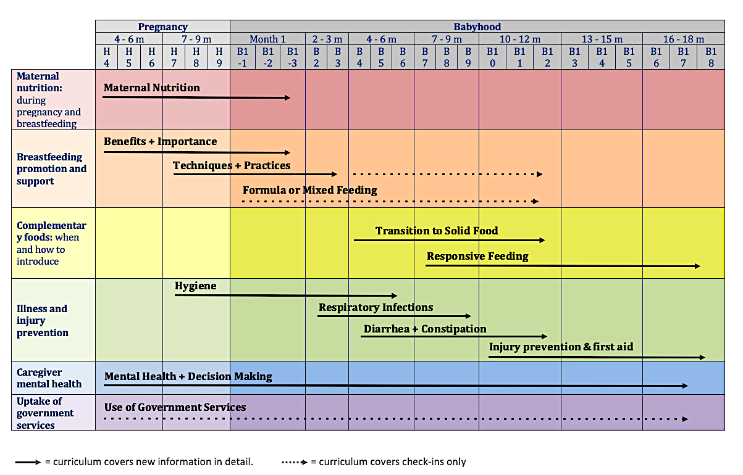



Figure 1. Healthy Future Home-Visiting Curriculum Design

## Theory of Change

The theory of change for the Healthy Future program is shown in Figure 2. The theory of change diagram lists the main process and outcome indicators we will use to measure intervention impact and the key assumptions along the steps in the theory of change pathway. The primary outcomes of interest are children’s hemoglobin levels, exclusive breastfeeding rates, and dietary diversity in complementary feeding. The secondary outcomes are a combination of caregiver-reported and objective measures of health and nutrition behaviors and maternal and child health, including IYCF practices, attitudes, efficacy, and knowledge; use of healthcare services; and maternal mental health and well-being. The diagram highlights that participation in home visits provided by trained CHWs can enhance the attitudes, efficacy, and knowledge of caregivers regarding maternal and child health and nutrition. This, in turn, can lead to behavioral changes that result in better child health and maternal well-being outcomes.

Although the standard condition and encouragement condition follow the same theory of change, the two treatment arms are expected to differ in impact. Compared to the standard treatment, the encouragement condition engages both primary and secondary caregivers (i.e., mothers and grandmothers) in the home visits and has the potential benefit of narrowing the gap in attitudes and knowledge between family members. Given the importance of grandmothers in household decision-making, the encouragement condition aims to amplify the intervention effects on behavioral change, foster family support to individual caregivers, and encourage shared household decision-making by aligning caregivers’ preferences. As the result, the encouragement condition is expected to further improve child health, raise maternal well-being, and reduce household conflicts compared to targeting the primary caregivers alone.

In addition to the main indicators illustrated in Figure 2, other CHW-, caregiver-, child-, and community-level characteristics are expected to moderate the steps along the theory of change pathway. First, CHW-related factors, such as CHWs’ age, education, health status, social capital, communication skills, and prior beliefs, may directly affect caregivers’ participation in and learning from the home visits. Second, given the intervention’s focus on individual behavioral change, caregiver-related factors may influence each step along the pathway. These factors include caregivers’ age, education, parity, employment status, health, wealth, presence, family structure, and relationship with other household members. Third, child-related factors, such as sex, age, number of siblings, and health status, may determine to a large extent their response to changes in caregivers’ feeding practices. Finally, community-level factors such as market access, healthcare resources, peer influence, and other information sources are likely important determinants in caregivers’ likelihood of following recommended practices and sustaining behavioral changes.

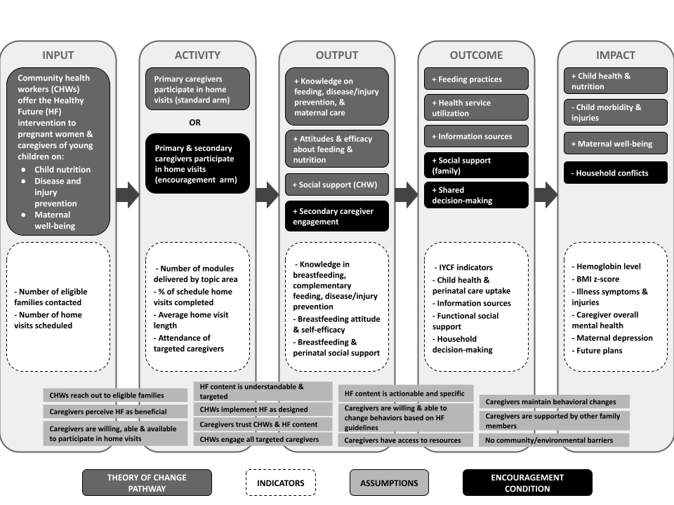

Figure 2. Theory of change of the Healthy Future Program

# EVALUATION DESIGN

The impact evaluation is designed as a nested cluster RCT with townships randomly allocated to one of two main study arms:

* Treatment arm: Healthy Future program (40 townships)   
  CHWs in these townships will deliver the Healthy Future curriculum to pregnant women or caregivers of young children through monthly home visits. The frequency of home visits will increase during the first month after birth.
* Control arm: No intervention (40 townships)  
  The Healthy Future program will not be delivered to families in these villages. This arm serves as the no-intervention “control” arm in the study.

Within the intervention arm, an encouragement overlay design is used to further randomize families into different conditions:

* Standard condition (20 townships)  
  CHWs in these townships will deliver the Healthy Future program to the primary caregiver of each child, typically the child’s mother.
* Encouragement condition (20 townships)   
  CHWs in these townships will invite both the primary and secondary caregiver of each child to participate in the Healthy Future program. The secondary caregiver is typically the child’s grandmother. CHWs in these townships will also be trained to encourage participation of both primary and secondary caregivers during the home visits, and will receive scripted guides within the Healthy Future curriculum to assist them in engaging both mothers and grandmothers during the home visit.

The impact evaluation will conduct repeated cross-sectional surveys at baseline, 6-month midline, and 12-month endline. After the initial recruitment at baseline, we will continue enrolling pregnant women until the 6-month midline. The evaluation design is presented in Figure 3.

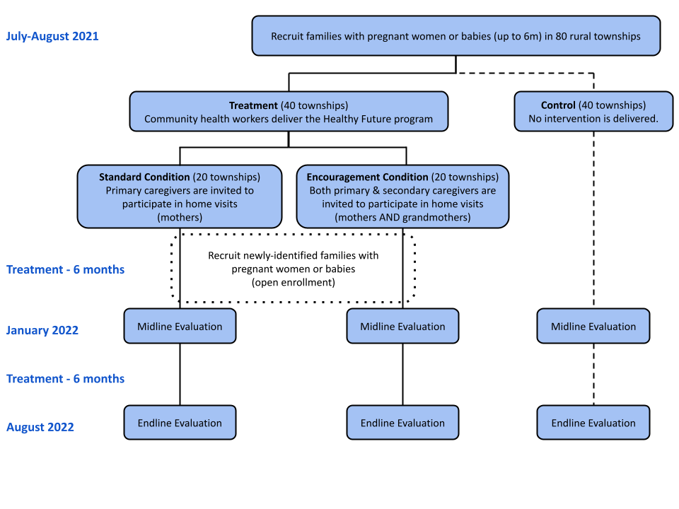Figure 3. Impact Evaluation Design

## Administration

The Healthy Future intervention will be delivered by CHWs who will be recruited by the local township health center (THC) of each treatment township and selected through an interview process by the study team. All CHWs will complete a seven-day training provided by members of the research team prior to the start of the intervention, as well as a seven-day refresher training at the midline of the intervention (six months after the initial training). CHWs will also receive three-day condensed refresher trainings as needed. The trainings will cover basic background on early childhood health and nutrition, the Healthy Future curriculum, and standard operation procedures for intervention implementation. The training will also include multiple role-play sessions to let the CHWs practice conducting home visits; familiarize themselves with the curriculum content, delivery format, and tablet-based application; and receive feedback on their communication styles.

At the start of the intervention, members of the research team will accompany CHWs to treatment households to introduce the Healthy Future program. After the intervention starts, we will conduct monthly check-ins with the CHWs to provide support and identify challenges in intervention implementation. In addition, we will collect monitoring data on home visits and household information through the tablet-based application that CHWs use to deliver the Healthy Future curriculum. We will also periodically contact treatment households to assess their satisfaction with the CHW and home visits. In the case of poor-performing CHWs, members of the research team will conduct in-person observations of home visits to identify areas for improvement, and will provide structured feedback to the CHW.

## Power Calculations

Sample sizes were estimated based on minimal detectable differences between two main study arms for the three primary outcome indicators: hemoglobin level, exclusive breastfeeding rates, and dietary diversity in complementary feeding. Our sample size estimates accounted for randomization at the cluster level with .05 significance level and 80% power.

Using the parameters from our previous research and conservative estimates based on similar programs, the sample sizes for the three primary outcome indicators are as follows:

**Hemoglobin level.** The sample size to detect a 0.2 standardized effect is 37 townships per arm, assuming an intra-cluster correlation of .01 and a cluster size of 12 babies per township.

**Exclusive breastfeeding.** The sample size to detect a 15-percentage-point difference is 16 townships per arm, assuming a baseline exclusive breastfeeding rate of 37%, an intra-cluster correlation of .01, and a cluster size of 12 babies per township.

**Dietary diversity (no baseline).** The sample size to detect a .2 standardized effect is 37 townships per arm, assuming an intra-cluster correlation of .01 and a cluster size of 12 babies per township.

Thus, a sample size of 80 townships, with 40 townships assigned to each of the two main study arms, is sufficient to detect the minimal detectable differences for all three primary outcomes described. We also consider a 15% loss to follow-up for the two primary outcomes we measure at baseline.

## Sampling and Randomization

Townships located in four nationally-designated poverty counties in Nanchong prefecture in Sichuan Province are included in the sampling frame. A canvas survey was conducted between November 2018 and March 2019 to yield a list of towns. From the list, urban townships and townships with less than 10,000 people were excluded. From the remaining list of townships, 80 townships were randomly selected, stratified by county.

Following a survey in November 2019, the 80 towns were randomly allocated to one of the two main study arms. We randomize treatment allocation within each county: 10 towns in each county will be allocated to the treatment group, and 10 towns will be allocated to the control group. Within the 40 treatment towns, we conduct an individual RCT to randomize towns into the two treatment arms main caregivers and the whole family engagement.

## Data Collection Methods

The data for the impact evaluation will come from four main sources: CHW survey, household surveys, and program administrative records.

**CHW survey**. The CHW survey will capture information on CHW-related factors that might moderate the intervention effect, such as their age, education, general health, social capital, and knowledge related to child nutrition and feeding practices. The CHW survey will be conducted on the first day of the CHW training.

**Household surveys**. The household survey component includes a baseline survey and two follow-ups conducted at six months (midline) and 12 months after the intervention initiation (endline). The survey team will use computer tablets for data collection. Prior to conducting the survey, the questionnaire will be programmed into survey enumerator tablets and include range checks, structure checks, and internal consistency checks.

The survey will collect information from caregivers of the index child on various topics (see Appendix B for the list of modules in the household survey). In addition to the questionnaire-based data collection, anthropometric measurements (height and weight) will be taken for the index child in each household. Moreover, a nurse will administer the HemoCue 201+ test, a finger-prick blood test, to assess hemoglobin levels. The household survey will last approximately two hours.

In addition to the baseline and follow-up surveys, CHWs will collect intermediate information on caregivers’ health and IYCF behaviors using a structured questionnaire. The questionnaire is adapted to the age of the child and includes questions regarding prenatal nutrition, breastfeeding and complementary feeding, child illness symptoms and recent doctor visits.

**Program administrative records.** Program administrative data will be also be collected by CHWs during home visits via the tablet-based application. Administrative data includes the date and time of home visits, modules delivered, length of the home visits, attendance of family members, and reasons for why visits were not completed or modules not delivered.

# STUDY POPULATION

## Community Level Inclusion Criteria

* Located within four selected nationally-designated poverty counties
* Support from the township health centers and county maternal and child hospitals
* At least one CHW candidate who is willing to participate in the training for the Healthy Future program
* At least 12 households with pregnant women or children under 12 months of age

## Individual Level Inclusion Criteria

* Pregnant women or caregivers of children 0-6 months of age
* Wiling to participate in the Healthy Future program
* Willing to participate in the impact evaluation, including the household surveys, anthropometric measures, and hemoglobin tests
* Able and willing to give informed consent.

## Informed Consent

All caregivers must give informed oral consent for their own and their infants’ participation in the study. Enumerators trained in the informed consent process will explain the study risks and benefits, answer any questions, and gather informed oral consent. We do not collect written consent as a large number of rural caregivers in China, particularly grandmothers, are not literate.

## Enrollment

Families that meet the inclusion criteria will be enrolled at the beginning of the study through a door-to-door approach. These participants will complete the baseline survey and invited later on to participate in the two follow-up surveys. For the first six months after the intervention initiation, the CHWs will continue to enroll pregnant women who become newly eligible to participate in the study. During enrollment, CHWs will collect basic information from newly-enrolled households, such as child age/gestational age of the mother. Participants will complete the midline and the endline surveys alongside participants enrolled at baseline.

# STUDY OUTCOMES

## Primary Outcomes

* Hemoglobin concentration among children aged 6 weeks – 18 months
* Exclusive breastfeeding under 6 months: proportion of children aged < 6 months who received only breastmilk in the previous day
* Dietary diversity: number of food groups consumed by children aged 6 – 18 months in the previous day

## Secondary Outcomes – Child Health

* BMI z-scores among children aged < 18 months
* Anemia status (hemoglobin concentration < 70 g/L) among children aged 6 weeks – 18 months
* Proportion of children aged < 18 months that had any illness in the past 14 days
* Proportion of children aged < 18 months that had any unintended injuries in the past 14 days

## Secondary Outcomes – Feeding Practices

* Early initiation of breastfeeding: proportion of children born in the last 24 months who were put to the breast within one hour of birth
* Proportion of newborns who were given colostrum
* Proportion of children aged 6 – 12 months who were fed breastmilk in the previous day
* Children ever breastfed: proportion of children born in the last 24 months who were ever breastfed
* Predominant breastfeeding under 6 months: proportion of children < 6 months who received breastmilk as the predominant source of nourishment in the previous day
* Continued breastfeeding at 1 year: proportion of children aged 12 – 15 months who received breast milk in the previous day
* Duration of breastfeeding: the age in months when children aged 0 – 18 months stopped receiving breastmilk
* Initiation of formula feeding: the age in months when children aged 0 – 18 months started to receive formula
* Proportion of children aged 6-8 months who received solid, semi-solid or soft foods in the previous day
* Initiation of complementary feeding: the age in months when children aged 0 – 18 months started to receive solid, semi-solid or soft foods
* Minimum dietary diversity: proportion of children aged 6 – 18 months who received foods from at least 4 food groups in the previous day
* Minimum meal frequency: proportion of children aged 6 – 18 months who received solid, semi-solid, or soft foods the minimum number of times or more in the previous day, where minimum is defined as:
  + 2 times for breastfed infants 6 – 8 months
  + 3 times for breastfed children 9 – 18 months
  + 4 times for non-breastfed children 6 – 18 months
  + “Meals” include both meals and snacks
* Minimum acceptable diet: proportion of children aged 6 – 18 months who had at least the minimum dietary diversity and the minimum meal frequency in the previous day
* Consumption of iron-rich or iron-fortified foods: proportion of children aged 6 – 18 months who received an iron-rich or iron-fortified food or supplement that contains iron in the previous day

## Secondary Outcomes – Attitude, Efficacy, and Knowledge

* Breastfeeding attitude among caregivers
* Efficacy in breastfeeding among breastfeeding mothers
* Efficacy in preparation to breastfeed among pregnant women
* Knowledge about breastfeeding and complementary feeding among caregivers
* Knowledge about disease prevention and hygiene among caregivers

## Secondary Outcomes – Health Care Utilization

* Proportion of children aged 0 – 18 months that have completed vaccines according to government schedule
* Number of prenatal visits among mothers during most recent pregnancy
* Proportion of pregnant women and mothers of children aged <18 months who used folic acid and iron supplements during current/most recent pregnancy

## Secondary Outcomes – Maternal Well-being

* Social support among caregivers
* Mental health among caregivers
* Perinatal depression among pregnant women and mothers
* Household decision-making among caregivers

# EMPIRICAL STRATEGY

## General Econometric Framework

Primary analyses will be performed on an intent-to-treat (ITT) basis. The overall approach for estimating the impact of the Healthy Future program will be to regress outcomes measured at the follow-up surveys on dummy variables indicating treatment assignment, baseline controls, stratum fixed effects (county) using the following specification:

$$Y_{ivzt}=α+βT_{v}+γY_{ivz0}+X_{ivz0}θ+τ_{z}+ε_{ivt}, t=\left\{1,2\right\}$$

where *Yivt*is the outcome of interest for the index child or caregiver *i* in village *v* ofcounty *z* measured at time *t* (which is 1 for the midline and 2 for the endline), *Tv* is a dummy equal to one if the village is assigned to the treatment arm, *Yizv0* is the baseline value of the dependent variable for families recruited in the beginning of the study and village-level averages at baseline for families recruited after the baseline survey, *Xivz0* is a vector of demographic variables at baseline including child’s age, sex, caregiver’s relationship to the child, age, parity, family structure, education, employment, and wealth index, and *τz*is a set of strata (county) fixed effects. Standard errors will be clustered at the township level using the cluster-corrected Huber-White estimator.

We will also estimate treatment effects under a parsimonious specification which only includes treatment assignment, baseline values of the dependent variable, and the township fixed effects.

The main parameters of interest are *β*, representing the average treatment effects and will be interpreted as the causal effects of offering the Healthy Future program.

For the comparison between the two modes of treatment implementation, we expect compliance with the random assignment into standard vs. encouragement arms will not be perfect. Thus, we will use an Instrumental Variable (IV) approach and the Wald estimator for the local average treatment effect:

$${\hat{β}}_{Wald}=\frac{({\overline{Y}}_{2}-{\overline{Y}}_{1})}{({\overline{P}}_{2}-{\overline{P}}_{1})}$$

where ${\overline{Y}}_{1}$ and ${\overline{Y}}_{2}$ denote the average outcome of interest for the standard and encouragement arm respectively (i.e., the ITT effect), ${\overline{P}}_{1}$ and ${\overline{P}}_{2}$ denote probability of secondary caregivers’ participation in home visits for the individual and pair arm respectively. Thus, the denominator ${\overline{P}}_{2}-{\overline{P}}_{1}$ is the propensity of secondary caregiver participating in home visits between the individual and pair arms.

Appendix C lists the main indicators for the study outcomes, process, and moderators. For outcomes that cannot be measured directly, we will use summary measures from validated scales whenever possible. In the absence of scales, we will construct summary indices using multiple interrelated indicators or survey items for a given outcome using the GLS weighting procedures published previously and report the adjusted p-value for each indicator.(61) In addition, we will report p-values adjusted for multiple hypothesis testing using the Romano-Wolf step-down procedures.(62)

# ETHICAL APPROVAL

The study has been approved by the Institutional Review Boards at Sichuan University (Protocol K2019046) and the Stanford University (Protocol 44312.

# PUBLICATION PLAN

The findings from this impact evaluation may be published in economics, medical, and public health journals and as policy briefs in Chinese or English languages. No individual participant’s identity will be used in any reports or publications resulting from the evaluation.

## Appendix A. List of modules in household survey

|  |  |  |  |  |
| --- | --- | --- | --- | --- |
| **Module** | **Respondents** | **Baseline** | **Midline** | **Endline** |
| Household roster | Primary caregiver | X | X | X |
| Baby Information |  | X |  |  |
| Family background | Primary caregiver | X | X | X |
| Feeding practices | Primary caregiver (index child > 0 month) | X | X | X |
| Micronutrient supplements | Primary caregiver (index child > 0 month) | X | X | X |
| Breastfeeding attitude | Primary & secondary caregivers separately | X | X | X |
| Breastfeeding efficacy | Breastfeeding mothers | X | X | X |
| Feeding knowledge | Primary & secondary caregivers separately | X | X | X |
| Feeding information source | Primary & secondary caregivers separately | X | X | X |
| Vaccination | Primary caregiver (index child > 0 month) | X | X | X |
| Newborn and child health services | Primary caregiver (index child > 0 month) | X | X | X |
| Perinatal healthycare | Mothers of index child | X | X | X |
| Child Illness/injuries & care seeking | Primary caregiver (index child > 0 month) | X | X | X |
| Household Decision-making | Primary & secondary caregivers separately | X | X | x |
| Future plans | Mothers of index child | X | X | X |
| Household Bargaining | Primary & secondary caregivers jointly |  | X |  |
| Breastfeeding family support | Mother of index child (0 – 6 months) | X | X | X |
| Perinatal social support | Mother of index child | X | X | X |
| Multidimensional scale of perceived social support | Primary & secondary caregivers separately | X | X | X |
| Mental health | Primary & secondary caregivers separately | X | X | X |
| Maternal depression | Mother of index child | X | X | X |
| Pregnancy history | Mother of index child | X |  |  |
| Birth history | Mother of index child | X |  |  |
| Anthropometric & hemoglobin | Index child | X | X | X |

## Appendix B. List of Hypotheses and Indicators

| **Main Hypothesis\*** | **Comparison between caregivers** | **Domain** | **Outcome/indicator** | **Measure** |
| --- | --- | --- | --- | --- |
| Primary Outcomes | | | | |
| 1. Healthy Future will improve child iron status. | No | Child health | - Hemoglobin concentration among children aged 0 – 18 months | HemoCue 201+ test |
| 1. Healthy Future will increase exclusive breastfeeding rate. | No | Feeding practice | - Exclusive breastfeeding under 6 months: proportion of children aged < 6 months who received only breastmilk in the previous day | Infant and young child feeding indicators (63) |
| 1. Healthy Future will increase dietary diversity. | No | Feeding practice | - Dietary diversity: number of food groups received by children aged 6 – 18 months in the previous day | Infant and young child feeding indicators (63) |
| * Secondary Outcomes | | | | |
| 1. Healthy Future will improve child health. | No | Child Health | - BMI z-scores among children aged < 18 months  - Anemia status (hemoglobin concentration < 70 g/L) among children aged < 18 months | * Physical exam * HemoCue 201+ test |
| 1. Healthy Future will reduce child illness and injuries. | No | Child health | - Proportion of children aged < 18 months that had any illness in the past 14 days  - Proportion of children aged < 18 months that had any unintended injuries in the past 14 days | Child illness & medical care module |
| 1. Healthy Future will improve breastfeeding practices. | No | Feeding practice | - Early initiation of breastfeeding: proportion of children born in the last 24 months who were put to the breast within one hour of birth  - Proportion of newborns who were given colostrum  - Proportion of children aged 6 – 12 months who were fed breastmilk in the previous day  - Children ever breastfed: proportion of children born in the last 24 months who were ever breastfed  - Predominant breastfeeding under 6 months: proportion of children < 6 months who received breastmilk as the predominant source of nourishment in the previous day  - Continued breastfeeding at 1 year: proportion of children aged 12 – 15 months who received breast milk in the previous day  - Duration of breastfeeding: the age in months when children aged 0 – 18 months stopped receiving breastmilk  - Initiation of formula feeding: the age in months when children aged 0 – 18 months started to receive formula | Infant and young child feeding indicators (63) |
| 1. Healthy Future will improve complementary feeding practices. | No | Feeding practice | - Introduction of solid, semi-solid or soft foods: proportion of children aged 6-8 months who received solid, semi-solid or soft foods in the previous day  - Initiation of complementary feeding: the age in months when children aged 0 – 18 months started to receive solid, semi-solid or soft foods  - Minimum dietary diversity: proportion of children aged 6 – 18 months who received foods from at least 4 food groups in the previous day  - Minimum meal frequency: proportion of children aged 6 – 18 months who received solid, semi-solid, or soft foods the minimum number of times or more in the previous day  - Minimum acceptable diet: proportion of children aged 6 – 18 months who had at least the minimum dietary diversity and the minimum meal frequency in the previous day  - Consumption of iron-rich or iron-fortified foods: proportion of children aged 6 – 18 months who received an iron-rich or iron-fortified food or supplement that contains iron in the previous day | Infant and young child feeding indicators (63) |
| 1. Healthy Future will improve caregivers’ attitudes about breastfeeding. | Yes | Attitudes, efficacy, & knowledge | - Breastfeeding attitude among caregivers | Iowa Infant Feeding Attitude Scale (64,65) |
| 1. Healthy Future will improve mothers’ self-efficacy about breastfeeding. | No | Attitudes, efficacy, & knowledge | - Efficacy in breastfeeding among breastfeeding mothers  - Efficacy in preparation to breastfeed among pregnant women | * Breastfeeding Self-Efficacy Scale (Short Form) (66,67) * Efficacy in Preparation to Breastfeed(68) |
| 1. Healthy Future will improve caregivers’ knowledge about feeding. | Yes | Attitudes, efficacy, & knowledge | - Knowledge about breastfeeding and complementary feeding among caregivers | Breastfeeding feeding knowledge module [index] |
| 1. Healthy Future will improve caregivers’ knowledge about disease prevention & hygiene. | Yes | Attitudes, efficacy, & knowledge | - Knowledge about disease prevention and hygiene among caregivers | Disease prevention knowledge module [index] |
| 1. Healthy Future will increase use of preventative health services. | No | Health services utilization | - Proportion of children aged 0 – 18 months that have completed vaccines according to government schedule  - Number of prenatal visits among mothers during most recent pregnancy  - Proportion of pregnant women and mothers of children aged <18 months who used folic acid and iron supplements during current/most recent pregnancy | * Vaccination module * Perinatal care module |
| 1. Healthy Future will improve iron status of pregnant women. | No | Maternal wellbeing | - Hemoglobin concentration among pregnant women | HemoCue 201+ test |
| 1. Healthy Future will increase perceived support to caregivers. | Yes | Maternal wellbeing | - Perceived support for breastfeeding among mothers  - Perceived social support among caregivers | Breastfeeding Family Support Scale (69)  Multidimensional scale of perceived social support (70,71) |
| 1. Healthy Future will improve mental health status of caregivers. | Yes | Maternal wellbeing | - Perinatal depression among pregnant women and mothers  - Depression, anxiety, and stress levels among caregivers | * Edinburgh Postnatal Depression Scale (72,73) * Depression, Anxiety, and Stress Scales (74,75) |
| 1. Healthy Future will lead to more shared decision-making among caregivers. | Yes | Maternal wellbeing | - Joint decision-making among caregivers | Household decision-making module [index] (76–78) |
| Process Indicators | | | | |
| 1. *Pair* implementation will lead to greater participation of secondary caregivers compared to *individual* implementation. | Not applicable | Caregiver Participation | - Proportion of home visits attended by both primary and secondary caregivers.  - Proportion of age-specific modules completed. | Program administrative records |
| Moderators | | | | |
|  | Not applicable | Community Health Worker | - Age, education, self-reported overall health  - Birth place and length of residency  - Breastfeeding attitudes  - Knowledge about breastfeeding and complementary feeding  - Knowledge about disease prevention and hygiene | Community health worker survey |
|  | Not applicable | Caregiver | - Age, sex, education, parity, employment status, overall health, household wealth index  - Family structure, relationship with in-laws, presence of index child’s parents | Household survey |
|  | Not applicable | Child | - Sex, age, siblings, health | Household survey |
|  | Not applicable | Community | - Availability of public health services | Household survey |
| * For the primary and secondary outcomes, we also hypothesize the encouragement condition (in which CHWs engage both primary and secondary caregivers in the home visits) will lead to better outcome compared to the standard treatment condition. | | | | |

**References**

1. Chen C, He W, Wang Y, Deng L, Jia F. Nutritional Status of Children during and post-Global Economic Crisis in China. Biomed Environ Sci. 2011 Aug;24(4):321–8.

2. Duan Y, Yang Z, Lai J, Yu D, Chang S, Pang X, et al. Exclusive Breastfeeding Rate and Complementary Feeding Indicators in China: A National Representative Survey in 2013. Nutrients. 2018 Feb;10(2):249.

3. Liu L, Oza S, Hogan D, Perin J, Rudan I, Lawn JE, et al. Global, regional, and national causes of child mortality in 2000-13, with projections to inform post-2015 priorities: an updated systematic analysis. Lancet Lond Engl. 2015 Jan 31;385(9966):430–40.

4. Lili X, Jian H, Liping L, Zhiyu L, Hua W. Epidemiology of Injury-Related Death in Children under 5 Years of Age in Hunan Province, China, 2009-2014. Simeoni U, editor. PloS One. 2017 Jan 11;12(1):e0168524.

5. Song P, Theodoratou E, Li X, Liu L, Chu Y, Black RE, et al. Causes of death in children younger than five years in China in 2015: an updated analysis. J Glob Health. 2016 Dec;6(2):020802.

6. Gao Y, Zhou H, Singh NS, Powell-Jackson T, Nash S, Yang M, et al. Progress and challenges in maternal health in western China: a Countdown to 2015 national case study. Lancet Glob Health. 2017 May 1;5(5):e523–36.

7. Luo R, Shi Y, Zhou H, Yue A, Zhang L, Sylvia S, et al. Anemia and Feeding Practices among Infants in Rural Shaanxi Province in China. Nutrients. 2014 Dec;6(12):5975–91.

8. Haas JD, Brownlie T. Iron Deficiency and Reduced Work Capacity: A Critical Review of the Research to Determine a Causal Relationship. J Nutr. 2001 Feb 1;131(2):676S-690S.

9. Horton S, Ross J. The economics of iron deficiency. Food Policy. 2003 Feb 1;28(1):51–75.

10. Heckman JJ. Skill Formation and the Economics of Investing in Disadvantaged Children. Science. 2006 Jun;312(5782):1900–2.

11. Grantham-McGregor S, Ani C. A Review of Studies on the Effect of Iron Deficiency on Cognitive Development in Children. J Nutr. 2001;

12. Balarajan Y, Ramakrishnan U, Özaltin E, Shankar AH, Subramanian S V. Anaemia in low-income and middle-income countries. Vol. 378, The Lancet. Elsevier; 2011. p. 2123–35.

13. Hipgrave DB, Fu X, Zhou H, Jin Y, Wang X, Chang S, et al. Poor complementary feeding practices and high anaemia prevalence among infants and young children in rural central and western China. Eur J Clin Nutr. 2014 Aug 4;68(8):916–24.

14. Grantham-McGregor S, Cheung YB, Cueto S, Glewwe P, Richter L, Strupp B. Developmental potential in the first 5 years for children in developing countries. The Lancet. 2007 Jan 6;369(9555):60–70.

15. Hoddinott J, Maluccio JA, Behrman JR, Flores R, Martorell R. Effect of a nutrition intervention during early childhood on economic productivity in Guatemalan adults. The Lancet. 2008 Feb 2;371(9610):411–6.

16. Victora CG, Adair L, Fall C, Hallal PC, Martorell R, Richter L, et al. Maternal and child undernutrition: consequences for adult health and human capital. The Lancet. 2008 Jan 26;371(9609):340–57.

17. Stein AD, Wang M, Martorell R, Norris SA, Adair LS, Bas I, et al. Growth patterns in early childhood and final attained stature: Data from five birth cohorts from low- and middle-income countries. Am J Hum Biol. 2010;22(3):353–9.

18. World Health Organization. Essential nutrition actions: Improving maternal, newborn, infant and young child health and nutrition. Geneva: World Health Organization; 2013.

19. World Health Organization. Children: Reducing mortality [Internet]. 2017 [cited 2018 Sep 15]. Available from: http://www.who.int/news-room/fact-sheets/detail/children-reducing-mortality

20. He Q, Kang W, Tian D, Huang Y, Gao L, Deng X, et al. Analysis of the quantity and quality of published randomised controlled trials related to injury prevention from 2001 to 2010 in China. Inj Prev J Int Soc Child Adolesc Inj Prev. 2014 Jun 1;20(3):148–54.

21. Lau Y, Wong DFK, Chan KS. The utility of screening for perinatal depression in the second trimester among Chinese: A three-wave prospective longitudinal study. Arch Womens Ment Health. 2010 Apr 8;13(2):153–64.

22. Wan EY, Moyer CA, Harlow SD, Fan Z, Jie Y, Yang H. Postpartum depression and traditional postpartum care in China: Role of Zuoyuezi. Int J Gynecol Obstet. 2009 Mar 1;104(3):209–13.

23. Zhou C, Zheng W, Yuan Q, Zhang B, Chen H, Wang W, et al. Associations between social capital and maternal depression: Results from a follow-up study in China. BMC Pregnancy Childbirth. 2018 Dec 2;18(1):45.

24. Li J, Mao J, Du Y, Morris JL, Gong G, Xiong X. Health-related quality of life among pregnant women with and without depression in Hubei, China. Matern Child Health J. 2012 Oct 2;16(7):1355–63.

25. Fisher J, Cabral de Mello M, Patel V, Rahman A, Tran T, Holton S, et al. Prevalence and determinants of common perinatal mental disorders in women in low- and lower-middle-income countries: a systematic review. Bull World Health Organ. 2012 Feb 1;90(2):139G-149G.

26. Herba CM, Glover V, Ramchandani PG, Rondon MB. Maternal depression and mental health in early childhood: an examination of underlying mechanisms in low-income and middle-income countries. Lancet Psychiatry. 2016 Oct;3(10):983–92.

27. Surkan PJ, Patel SA, Rahman A. Preventing infant and child morbidity and mortality due to maternal depression. Vol. 36, Best Practice and Research: Clinical Obstetrics and Gynaecology. 2016. p. 156–68.

28. Weissman MM, Wickramaratne P, Nomura Y, Warner V, Pilowsky D, Verdeli H. Offspring of Depressed Parents: 20 Years Later. Am J Psychiatry. 2006 Jun;163(6):1001–8.

29. Goodman SH, Rouse MH, Connell AM, Broth MR, Hall CM, Heyward D. Maternal depression and child psychopathology: a meta-analytic review. Clin Child Fam Psychol Rev. 2011 Mar 4;14(1):1–27.

30. Wachs TD, Black MM, Engle PL. Maternal depression: A global threat to children’s health, development, and behavior and to human rights. Vol. 3, Child Development Perspectives. Wiley/Blackwell (10.1111); 2009. p. 51–9.

31. Bennett IM, Schott W, Krutikova S, Behrman JR. Maternal mental health, and child growth and development, in four low-income and middle-income countries. J Epidemiol Community Health. 2015 Feb 1;70(2):168–73.

32. Zhou W, Xiao S. Existing public health surveillance systems for mental health in China. Vol. 9, International Journal of Mental Health Systems. BioMed Central; 2015. p. 3.

33. Phillips MR, Zhang J, Shi Q, Song Z, Ding Z, Pang S, et al. Prevalence, treatment, and associated disability of mental disorders in four provinces in China during 2001-05: an epidemiological survey. The Lancet. 2009 Jun 13;373(9680):2041–53.

34. Liu J, Ma H, He YL, Xie B, Xu YF, Tang HY, et al. Mental health system in China: History, recent service reform and future challenges. World Psychiatry. 2011 Oct 1;10(3):210–6.

35. Lewin S, Munabi-Babigumira S, Glenton C, Daniels K, Bosch-Capblanch X, van Wyk BE, et al. Lay health workers in primary and community health care for maternal and child health and the management of infectious diseases. Cochrane Database Syst Rev. 2010 Mar 17;(3):211.

36. Lassi ZS, Bhutta ZA. Community-based intervention packages for reducing maternal and neonatal morbidity and mortality and improving neonatal outcomes. Cochrane Database Syst Rev. 2015 Mar 23;(3):CD007754.

37. Gilmore B, McAuliffe E. Effectiveness of community health workers delivering preventive interventions for maternal and child health in low- and middle-income countries: a systematic review. BMC Public Health. 2013 Sep 13;13(1):847.

38. Peacock S, Konrad S, Watson E, Nickel D, Muhajarine N. Effectiveness of home visiting programs on child outcomes: a systematic review. BMC Public Health. 2013 Dec 9;13(1):17.

39. Gogia S, Sachdev HPS. Home-based neonatal care by community health workers for preventing mortality in neonates in low- and middle-income countries: A systematic review. Vol. 36, Journal of Perinatology. Nature Publishing Group; 2016. p. S54–72.

40. Mbuagbaw L, Habiba Garga K, Ongolo-Zogo P. Health system and community level interventions for improving antenatal care coverage and health outcomes. Cochrane Database Syst Rev. 2014 Dec 1;2014(2):CD010994.

41. Lassi ZS, Kumar R, Bhutta ZA. Community-Based Care to Improve Maternal, Newborn, and Child Health. In: Disease Control Priorities, Third Edition (Volume 2): Reproductive, Maternal, Newborn, and Child Health. The International Bank for Reconstruction and Development / The World Bank; 2016. p. 263–84.

42. Atif N, Lovell K, Rahman A. Maternal mental health: The missing “m” in the global maternal and child health agenda. Vol. 39, Seminars in Perinatology. 2015. p. 345–52.

43. Rahman A, Surkan PJ, Cayetano CE, Rwagatare P, Dickson KE. Grand Challenges: Integrating Maternal Mental Health into Maternal and Child Health Programmes. PLoS Med. 2013 May 7;10(5):e1001442.

44. Bhutta ZA, Das JK, Rizvi A, Gaffey MF, Walker N, Horton S, et al. Evidence-based interventions for improvement of maternal and child nutrition: what can be done and at what cost? The Lancet. 2013 Aug;382(9890):452–77.

45. Wu Z, Viisainen K, Wang Y, Hemminki E. Evaluation of a community-based randomized controlled prenatal care trial in rural China. BMC Health Serv Res. 2011 Dec 4;11(1):92.

46. Ye J, Wang C, Wu H, He C, Liu J. Internal migration and left-behind populations in China. J Peasant Stud. 2013 Nov;40(6):1119–46.

47. Chan KW, Zhang L. The Hukou System and Rural-Urban Migration in China: Processes and Changes. China Q. 1999 Dec 12;160:818.

48. Wu H, Ye J. Hollow Lives: Women Left Behind in Rural China. J Agrar Change. 2016 Jan 1;16(1):50–69.

49. Yue A, Sylvia S, Bai Y, Shi Y, Luo R, Rozelle S. The Effect of Maternal Migration on Early Childhood Development in Rural China. SSRN. 2016 Dec.

50. Zhang N, Chandola T, Bécares L, Callery P. Parental Migration, Intergenerational Obligations and the Paradox for Left-Behind Boys in Rural China. Asian Popul Stud. 2016 Jan 2;12(1):68–87.

51. Yue A, Shi Y, Luo R, Chen J, Garth J, Zhang J, et al. China’s invisible crisis: Cognitive delays among rural toddlers and the absence of modern parenting. China J. 2017;

52. White D, Dynes M, Rubardt M, Sissoko K, Stephenson R. The influence of intrafamilial power on maternal health care in Mali: perspectives of women, men and mothers-in-law. Int Perspect Sex Reprod Health. 2013 Jun;39(2):58–68.

53. Negin J, Coffman J, Vizintin P, Raynes-Greenow C. The influence of grandmothers on breastfeeding rates: a systematic review. BMC Pregnancy Childbirth. 2016/04/29 ed. 2016 Dec 27;16(1):91.

54. Deo KK, Paudel YR, Khatri RB, Bhaskar RK, Paudel R, Mehata S, et al. Barriers to Utilization of Antenatal Care Services in Eastern Nepal. Front Public Health. 2015 Aug 14;3:197.

55. Chrisman NJ. Strengthening Grandmother Networks to Improve Community Nutrition: Experience from Senegal. Cult Med Psychiatry. 1977 Dec 13;1(4):351–77.

56. Scott M, Malde B, King C, Phiri T, Chapota H, Kainja E, et al. Family networks and infant health promotion: A mixed-methods evaluation from a cluster randomised controlled trial in rural Malawi. BMJ Open. 2018 Jun 7;8(6):e019380.

57. Gao LL, Chan SWC, You L, Li X. Experiences of postpartum depression among first-time mothers in mainland China. J Adv Nurs. 2010 Feb;66(2):303–12.

58. Schwab-Reese LM, Schafer EJ, Ashida S. Associations of social support and stress with postpartum maternal mental health symptoms: Main effects, moderation, and mediation. Women Health. 2017 Jul 3;57(6):723–40.

59. Hetherington E, McDonald S, Williamson T, Patten SB, Tough SC. Social support and maternal mental health at 4 months and 1 year postpartum: analysis from the All Our Families cohort. J Epidemiol Community Health. 2018 Oct;72(10):933–9.

60. Balaji AB, Claussen AH, Smith DC, Visser SN, Morales MJ, Perou R. Social support networks and maternal mental health and well-being. J Womens Health 2002. 2007 Dec;16(10):1386–96.

61. Anderson ML. Multiple Inference and Gender Differences in the Effects of Early Intervention: A Reevaluation of the Abecedarian, Perry Preschool, and Early Training Projects. J Am Stat Assoc. 2008 Dec;103(484):1481–95.

62. Romano JP, Wolf M. Stepwise multiple testing as formalized data snooping. Econometrica. 2005 Jul 1;73(4):1237–82.

63. World Health Organization (WHO). Indicators for assessing infant and young child feeding practices part 2: measurement. World Health Organ. 2008;http://www:19.

64. Dai HX, Guan XD, Li XM, You LM, Lau Y. Psychometric properties of a mainland Chinese version of the Iowa infant feeding attitude scale among postpartum women in China. Contemp Nurse. 2013 Apr 17;44(1):11–20.

65. Mora A de la, Russell DW, Dungy CI, Losch M, Dusdieker L. The Iowa Infant Feeding Attitude Scale: Analysis of Reliability and Validity1. J Appl Soc Psychol. 1999;29(11):2362–80.

66. Ip WY, Gao LL, Choi KC, Chau JPC, Xiao Y. The Short Form of the Breastfeeding Self-Efficacy Scale as a Prognostic Factor of Exclusive Breastfeeding among Mandarin-Speaking Chinese Mothers. J Hum Lact. 2016 Nov 30;32(4):711–20.

67. Dennis C-L. The Breastfeeding Self‐Efficacy Scale: Psychometric Assessment of the Short Form. J Obstet Gynecol Neonatal Nurs. 2003;32(6):734–44.

68. McKinley erinm. M, Knol LL, Turner LW, Burnham JJ, Graettinger KR, Hernandez-Reif M, et al. The Prenatal Rating of Efficacy in Preparation to Breastfeed Scale: A New Measurement Instrument for Prenatal Breastfeeding Self-efficacy. J Hum Lact. 2018;089033441879904.

69. Zhu X, Liu L, Wang Y. Utilizing a Newly Designed Scale for Evaluating Family Support and Its Association with Exclusive Breastfeeding. Breastfeed Med. 2016;11(10):526–31.

70. Zimet GD, Dahlem NW, Zimet SG, Farley GK. The Multidimensional Scale of Perceived Social Support. J Pers Assess. 1988;52(1):30–41.

71. Wang Y, Wan Q, Huang Z, Huang L, Kong F. Psychometric properties of multi-dimensional scale of perceived social support in Chinese parents of children with cerebral palsy. Front Psychol. 2017;8(NOV):2020.

72. Cox JL, Holden JM, Sagovsky R. Detection of Postnatal Depression: Development of the 10-item Edinburgh Postnatal Depression scale. Br J Psychiatry. 1987;

73. Wang Y, Guo X, Lau Y, Chan KS, Yin L, Chen J. Psychometric evaluation of the Mainland Chinese version of the Edinburgh Postnatal Depression Scale. Int J Nurs Stud. 2009 Jun;46(6):813–23.

74. Wang K, Shi HS, Geng FL, Zou LQ, Tan SP, Wang Y, et al. Research on translations of tests: Cross-cultural validation of the depression anxiety stress scale-21 in China. Psychol Assess. 2016;28(5):e88–100.

75. Lovibond SH, Lovibond PF. Manual for the Depression Anxiety Stress Scales. 2nd ed. Sydney: Psychology Foundation of Australia; 1996.

76. Shroff MR, Griffiths PL, Suchindran C, Nagalla B, Vazir S, Bentley ME. Does maternal autonomy influence feeding practices and infant growth in rural India? Soc Sci Med. 2011 Aug;73(3):447–55.

77. Peterman A, Schwab B, Roy S, Hidrobo M, Gilligan D. Measuring women’s decisionmaking: Indicator choice and survey design experiments from cash and food transfer evaluations in Ecuador, Uganda, and Yemen. 2015.

78. Schaner S. The cost of convenience? Transaction costs, bargaining power, and savings account use in Kenya. J Hum Resour. 2017;52(4):919–45.