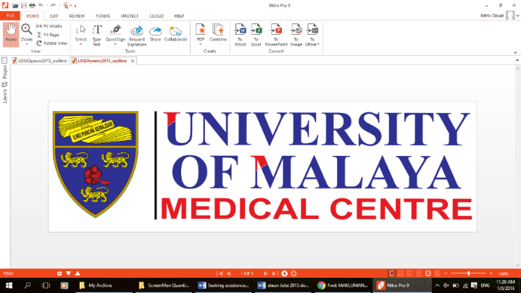

PARTICIPANT INFORMATION SHEET

**Study Title: A prospective randomized trial comparing Midazolam Alone Compared With Midazolam Combined With Fentanyl During Transvaginal Ultrasound Guided Oocyte Retrieval**

**Version No: 1**

**Version Date: 16/8/2021**

We would like to invite you to take part in a research study. Before you decide whether to participate, you need to understand why the research is being done and what it would involve. Please take time to read the following information carefully; talk to others about the study if you wish.

Ask us if there is anything that is not clear or if you would like more information. Take time to decide whether or not you wish to take part.

1. **Introduction**

You are invited to participate in this research study because you have been planned for oocyte retrieval. The details of the research trial are described in this document. It is important that you understand why the research is being done and what it will involve. Please take your time to read through and consider this information carefully before you decide if you are willing to participate. Ask the study staff if anything is unclear or if you want more information. Once you are satisfied and understood the study, and wished to participate the study, you must sign the informed consent form. You are required to provide your doctor with information on your health history; you may harm yourself if you are not truthful with the information provided.

Your participation in this study is voluntary. You do not have to be in this study if you do not want to. You may also refuse to answer any questions you do not want to answer. If you volunteer to be in this study, you may withdraw from it any time. If you withdraw, any data collected from you up to your withdrawal will still be used for the study. Your refusal to participate or withdrawal will not affect any medical or health benefits to which you are otherwise entitled.

1. **What is the purpose of this study?**

This study is to compare the effectiveness of midazolam alone compared to combination of midazolam and fentanyl in patients undergoing transvaginal oocyte retrieval in IVF treatment and the rational of avoiding opioids which further reduce side effects from opioids.

1. **Why is this study important?**

This study is important to show thatthe use midazolam alone which is as efficacious and more safe as compared to combination of midazolam with opioids.

1. **What type of study is this?**

This is a double blinded randomized trial which means both you and the doctor performing the will not know what medication is being given as analgesia prior to oocyte retrieval which could be either midazolam alone or combination of midazolam and fentanyl. Additional to this , you will be given local pain relief around the vaginal mucosa as standard protocol priot to the procedure.

1. **Can I refuse to take part in the study?**

Yes, you are allowed to do so, and you will be given the usual care with standard protocol which is IV Pethidine & IV Midazolam.

1. **What will happen to me if I take part?**

On the day of oocyte retrieval you will be randomised into either midazolam alone arm or combination midazolam and fentanyl arm. Drugs will be administered according to the randomisation.

During the procedure if you were found to be perceived in distress during the sedation , or if you complaint of pain after awakening a rescue analgesia will be given.

After the procedure completed , pain score will be assesed according to time the frame. Additional rescue dose will be given if needed as per protocol.

1. **How long will I be involved in this study?**

You will be involved in the study until the day of embryo transfer.

1. **What are the possible disadvantages and risks?**
2. Discomfort or pain
3. Side effects ; nausea , vomiting , dizziness
4. **What are the possible benefits to me?**
5. Better pain relief
6. Avoidance of side effects
7. **Who will have access to my medical records and research data?**

Only the investigators and trained personnel will have access to your medical records and research data.

1. **Will my records/data be kept confidential?**

Yes, all records/data will be kept confidential in a locked cupboard in the fertility unit.

1. **What will happen if I don’t want to carry on with the study?**

You are allowed to withdraw at any point of the study and it would not affect your care**.**

1. **What will happen to the results of the research study?**

All the information obtained in this study will be kept and handled in a confidential manner, in accordance with the applicable laws and/or regulations. When publishing or presenting the study results, your identity will not be disclosed without your consent. Individuals that are involved in your medical care, qualified monitors and auditors, the sponsors or its affiliates and governmental or regulatory authorities may inspect and copy your medical records, where appropriate and necessary.

Data from the study will be archived and may be transmitted outside the country for the purpose of analysis, but your identity will not be reveled at any time.

1. **Will I receive compensation for participating in this study?**

No

1. **Who funds this study?**

This study is funded by Department of Obstetrics and Gynecology, University Malaya Medical Center.

1. **Who should I contact if I have additional questions/problems during the course of the study?**

If you have any questions about the study or if you think you have a study related injury and you need information about treatment, please contact Dr Suntharram at 0164991170.

1. **Who should I contact if I am unhappy with how the study is being conducted?**

Medical Research Ethics Committee

University of Malaya Medical Centre

Telephone number: 03-7949 3209/2251

**BK-MIS-1116-E03**