

**Meniscal Tear Outcome Study (METRO): Understanding the disease process of young patients with a meniscal tear of the knee and response to treatment.**

**Patient Information Sheet**

**Chief Investigator: Dr Andrew Metcalfe**

You are invited to take part in our research study. Before you decide whether to take part we would like you to understand why the research is being done and what it would involve for you.

Once you have read this information sheet a member of our team will go through the information with you and answer any questions you may have.

If you have any questions please contact the research team. Imran Ahmed. Tel 02476968630. Email: metro@warwick.ac.uk

**Background Information**

Within your knee, there is a cartilage called the meniscus (see picture). The meniscus has an important role in distributing weight across the knee joint. It also acts as a cushion between the femur (thigh bone) and the tibia (shin bone).

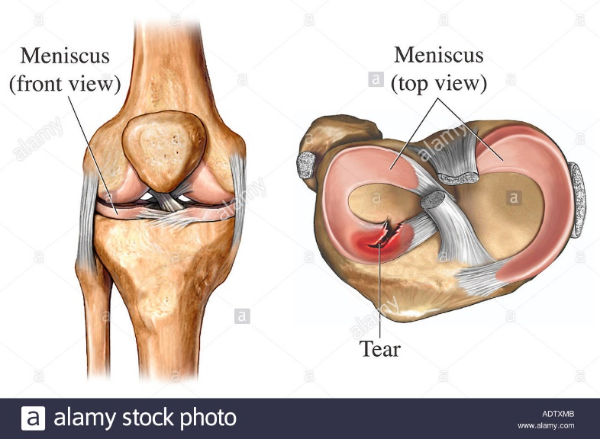

Meniscal tears are common and can occur following an injury or can happen without a specific cause. Sometimes they happen because there is some arthritis in the knee, but sometimes they happen in an otherwise normal knee. They may be painful, cause swelling or clicking in the knee, or sometimes cause the knee to catch or stick. A meniscal tear is most commonly diagnosed with a magnetic resonance imaging (MRI) scan.

Some meniscal tears get better with time and others do not, and we do not know how to predict that. Your doctor or physiotherapist may recommend painkillers or a course of physiotherapy, or they may recommend surgery, which is typically done using keyhole surgery. We do not yet know why some people get better without surgery whereas other people require an operation to get better, which is why we are doing this research. We also do not know how many people have very early signs of arthritis in their knee on scans, or if these findings make any difference to their recovery. We need to know how people recover from different treatments in order to improve the way we make decisions for people in the future.

**What is the purpose of this study? (METRO Cohort study)**

We want to find out about the pain, stiffness or other problems you may have with your knee over the next year. We will work out how many people have signs of arthritis in their knee on their scans, and whether there are particular symptoms, or findings on the scan, that affect the success of treatment. We also wish to study the current NHS treatment of people under the age of 55 with a meniscal tear. We will use this information to improve the way we care for people with tears of the meniscus in the future.

**Why have I been invited?**

Your MRI result shows that you have a tear of the meniscus. Because of this, you would be helpful in helping us understand how meniscal tears affect young patients and how they respond to treatment, so will can improve research and treatment for the future.

**Do I have to take part?**

It is up to you whether or not to take part. If you decide to take part you are still free to withdraw at any time and without giving a reason. A decision to withdraw at any time or a decision not to take part will not affect the standard of care you receive. If you withdraw from the study you will have the option to include all your existing data which you have already procedure in our final analysis. If you would prefer, we can remove all existing data we hold on yourself, excluding it from the final analysis. Once all the information from each participant has been collected, the data will be anonymised before we analyse and publish out findings. At this point, it will not be possible for your data to be excluded from the final analysis.

**What will happen if I take part?**

**METRO Cohort study**

If you decide to take part you will be asked to sign a consent form. There will be no change to the treatment or the standard of care you receive. The purpose of this study is understand how patients are currently being treated and the features which influence the success of treatment.

You will be asked to fill in a questionnaire about your general health, when the symptoms started in your knee and some questionnaires about your knee. The study team will review the MRI of the knee that you have had, to look at the type of meniscal tear you have, to see whether you have any signs of wear within the knee, and to assess the different structures in the knee. The MRI can will be sent from your hospital to the lead NHS hospital (University Hospital Coventry and Warwickshire) using the secure electronic image transfer service. Only NHS staff and the study team will have access to this information. At this point these images will still contain your name, DOB, and NHS number. Once at the lead NHS site, the scan will be anonymised (all personal information will be removed) and it will be downloaded onto a password encrypted hard drive.

Your scan will also be reviewed using advanced techniques where we produce 3D computer models of your knee so we can see if there are subtle signs of arthritis within the knee. This will be performed by a company called IMorphics Ltd (Manchester, UK). They are an internationally recognised company which has taken part in substantial amounts of research related to the knee and arthritis. They will not have any access to your personal details and none of your personal details will be on the scan.

After you complete the initial questionnaire we will also request contact details from yourself (email address, postal address and phone number). We will then send out a questionnaire either electronically or through the post at 3 months, 6 months and 12 months. This is so we can see how your symptoms change over time and also see if you have had any additional treatment. If you agree we can send you a text message or email to remind you that the questionnaire is due. If you need help completing a questionnaire, a researcher can contact you by phone to help you complete it, or we can help you complete it in person.

If you agree and prefer, we can also collect your responses to the questionnaire using a mobile application designed for this study. If you agree on the consent for to be contacted about the ‘myrecovery’ application, you will receive an email with instructions on how to download the mobile application. The application (provided by Future Health Works Ltd) will allow you to complete all questionnaires electronically and will provide notifications when they are due. All information will be used as part of the METRO study. You will need to provide specific additional consent if the data were to be used for additional reasons. The application has been through a rigorous security process at the University of Warwick and is compliant with all quality assurance and data compliance standards.

**METRO Interview study**

As well as this study we are also running a small interview study of 20 patients. You do not have to take part in both studies, you can take part in just the main study if you wish. If you are happy to also take part in this we ask that you initial the relevant box on the consent form.

We are doing this to find out, in your own words, what it is like living with a meniscal tear, which symptoms you find important, your thoughts on the treatment options and your thoughts on future research.

If you would like to take part in the interview study a researcher will contact you between 3-9 months after you sign your consent form. You will have a choice of whether we do the interview face to face or over the phone. The interview will last 45-60 minutes and we will ask about your experiences of living with a meniscal tear. The interviews will be recorded with a digital voice recorder, this is so that we can type up the results and listen to the interview again afterwards. After the interview we will type up the interview, we may use a service who will type up the interview who is recognised and approved by the University of Warwick. This company will have no access to your personal details. The recordings will be deleted once the interview is typed out. This typing process will take place within 3 months of completion of the final interview. If you agree, we may use direct (anonymous) quotes that you use in reports we produce for medical journals, but we would not identify you or use any of your personal details in this text.

**What are the possible disadvantages and risks of taking part?**

As we are not changing your current treatment pathway or the standard care in your hospital for patients with a meniscal tear, there are no additional risks to yourself by taking part in this research.

**What are the possible benefits of taking part?**

There are no specific benefits to taking part. You are helping improve our knowledge and understanding on the treatment of meniscal tears and will directly inform the care that people receive in the NHS and future large-scale research in this area.

**What if new information becomes available?**

Sometimes during the course of a study, new information becomes available about the treatments that are being studied. If this happens, someone will tell you about it and discuss with you whether you want to continue in the study. This is unlikely to affect this study as we are not influencing your treatment. If you decide to withdraw, you can discuss your continued care with your doctor. If you decide to continue in the study you might be asked to sign an updated consent form.

**What happens when the research study ends?**

You will be in the study for 12 months unless you choose to withdraw. If you are having any problems relating to the knee after this time, your general practitioner can arrange for you to see your specialist to continue your care.

**Will my taking part in this study be kept confidential?**

All information which is collected about you during the course of the research, including copies of your previous knee imaging, will be kept strictly confidential. Research data including your name, initials, date of birth/ age, address and contact details (telephone number, email and next of kin contact details) will be sent to the University of Warwick so that research staff can stay in touch with you by post, email or phone. These details will be sent from the hospital by secure means, and kept in locked filing cabinets or in password-protected computer databases accessible only to essential research personnel at the University of Warwick.

The University of Warwick is the sponsor for this study based in the UK. We will be using information from yourself and your medical records in order to undertake this study and will act as the data controller for the study. This means that we are responsible for looking after your information and using it properly. The University of Warwick will keep identifiable information about you for up to 10 years beyond duration of the study (See below for more information).

The NHS will use your name, NHS number, initials and date of birth and contact details to contact you about the research study, and make sure that relevant information about the study is recorded for your care, and to oversee the quality of the study. The NHS site will pass these details to the University of Warwick along with information collected as part of this study.

The only people in the University of Warwick who will have access to information that identifies you will be people who need to contact you to arrange completion of follow up questionnaires, to arrange an interview or to audit the data collection process.

The people who analyse the information will not be able to identify you and will not be able to find out your name, NHS number, date of birth or contact details.

Your rights to access, change or move your information are limited, as we need to manage your information in specific ways in order for the research to be reliable and accurate. If you withdraw from the study, we will keep the information about you that we have anonymised already. To safeguard your rights, we will use the minimum personally-identifiable information possible.

For full details on how we manage your data at the University of Warwick please visit the following webpage: <https://warwick.ac.uk/services/sim/privacynotices/research>.

The scans of your knee will be sent to the University Hospitals Coventry and Warwickshire where they will be anonymised and processed by the University of Warwick. We will not access images of any other part of your body. They will also be sent (with no details identifying you) to IMorphics Ltd who will process them anonymously and not share them with anyone else.

The Myrecovery mobile application is designed by a third party (Future Health Works Ltd). The application has been through a rigorous security process at the University of Warwick. The application will store details about yourself such as contact details and health details including whether you have had an operation or experienced any complications during the study period. The data will be stored at Future Health Works Ltd electronic servers. These electronic servers are protected with appropriate firewalls and have been checked at approved by the University of Warwick. All data will be encrypted and is compliant with current data protection guidelines. The study team will have access to the data on request. All stored data at Future Health works will be destroyed in a secure manner once the study period is over.

We may, in the future, wish to find out what has happened to you or your knee using NHS secure national databases. In order to do this, some of your details, including your name, initials, date of birth, address and contact details may be kept for up to 10 years beyond the duration of the study (or as long as it is indicated if sooner). Access to this data will be restricted to authorised personnel only. All of your data will be handled with full data security measures and will not be shared outside of the study team. The chief investigator or the study team will be ones who use this information to contact either your GP or the national database in the future. You can opt out of this at any point and all identifiable information we possess will be securely destroyed.

All other information about you which leaves the hospital will have your name and address removed so that you cannot be recognised from it.

Individuals from the University of Warwick and regulatory organisations may look at your medical and research records to check the accuracy of the research study.

If you agree to take part, your GP and other doctors who may treat you, but are not part of this study, may be notified that you are taking part in this study. If we are not able to keep in touch with you, we may contact your GP in the future to collect your health records so we know if you have had any problems related to your knee. The Chief investigator or the study team will be the only ones to contact you in the future.

**What happens if something goes wrong?**

In the event that something goes wrong and you are harmed during the research due to someone’s negligence, then you may have grounds for legal action for compensation against the University of Warwick (contact the Head of Research Governance, Impact Services, University House, University of Warwick, Coventry, CV4 8UW or by email [researchgovernance@warwick.ac.uk](mailto:researchgovernance@warwick.ac.uk) or telephone 02476 522746)

**Who should I contact if I wish to make a complaint?**

Any complaint about the way you have been dealt with during the study or any possible harm you might have suffered will be addressed.  Please address your complaint to the person below, who is a Senior University of Warwick Official, entirely independent of this study:

**Deputy Director/Head of Research Governance**

Research and Impact Services

University House

University of Warwick

Coventry, CV4 8UW

Tel: 02476 522746 Email: researchgovernance@warwick.ac.uk

For independent advice contact the PALS service (Patient Advice Liaison Service) on 0800 028 4203 or follow the NHS complaints procedure.

**What will happen to the results of the research study?**

At the end of the study we will publish the findings in medical journals and at medical conferences. You will not be identified in any reports or publications resulting from the study. If you would like to obtain a copy of the published results, please contact the study manager on 02476968630 or Metro@warwick.ac.uk

**Who has reviewed this study?**

This study has been reviewed and approved by the West Midlands – Black Country Research Ethics Committee and the Health Research Authority (ref: 19/WM/0079). It has been reviewed by numerous experts throughout the United Kingdom and by the National Institute of Health Research (NIHR).

**Who is organising and funding the research?**

This research has been organised by the University of Warwick. It has been funded by the UK NHS research body, the National Institute for Health Research, though its Doctoral Research Fellowship programme.

**Contacts for further information**

If, at any time, you would like further information about this research project you may contact the research team on 02476968630 or metro@warwick.ac.uk

**Thank you for considering participation in this study and for taking the time to read this information sheet**