Evaluation of the POPGUNS Protocol
Prioritisation of Patients: a Guide to Urgency for Non-clinical Staff

PARTICIPANT INFORMATION SHEET

Background and aims of this research
Prioritising the allocation of appointments, a form of basic triage, is something that General Practice reception staff undertake every day. Some have extensive experience and skills in this regard while many others do not. In most cases this process is not formalised, and is difficult to document or define. A receptionist needs to prioritise to the extent of deciding which problems justify interrupting the doctor or nurse, or what to do about a call when no doctor is present. This is particularly so in rural practices, where waiting times may be extensive or doctors may be absent from the practice.

In 2003, the South East NSW Division of General Practice (SENSW DGP), using a grant from the Australian Council for Safety & Quality in Health Care, developed an assessment template to guide this process. The POPGUNS (Prioritisation Of Patients: a Guide to Urgency for Nonclinical Staff) protocol was the first of its kind in Australia and generated considerable national attention. It has been taken up by a wide range of general practice organisations, however it has not been rigorously evaluated and its impact on patient outcomes is unknown.

This evaluation study will examine the use of the POPGUNS triage system as a prioritisation tool in rural general practices. The study will determine the effectiveness of POPGUNS in improving the quality and safety of receptionist triage in this context. Secondary objectives will examine whether the protocol is acceptable and useful to patients and reception staff.

24 practices will be selected to participate in the study, with 12 implementing POPGUNS and 12 implementing an alternative approach representative of ‘usual’ practice. 3 receptionists in each practice will be asked to respond to a number of scenarios depicting possible general practice presentations. The safety and appropriateness of these responses will be compared across the two groups. Patients and receptionists will also be asked to complete some brief surveys describing their view of the quality of decision making around these issues.

Benefits of the research project
Managing requests for urgent appointments is a source of stress for GPs and their staff, who are often conscious of the clinical risks involved. POPGUNS was designed to support an approach which enabled safe, high quality decision-making in general practice, and to protect nurses and doctors from constantly being distracted by decisions that may be safely made by non-clinical support staff with an appropriate safety net. It is respectful of individual practices, and the differing contexts in which they operate.
This evaluation will determine the safety and effectiveness of POPGUNS as a prioritisation tool, guide future implementation efforts, and suggest further improvements which may be required. The project has the potential to deliver for practices a set of tools and an approach which they can use in continuing to develop flexible and innovative solutions to the challenges they face.

What is involved?
24 practices will be selected to participate in the study. Of these 12 will be randomly assigned to implement POPGUNS and 12 to implementing an alternative approach representative of their normal practice.
Each practice will be asked to provide at least 3 receptionists who are willing to participate individually in the study. These reception staff will be asked to respond to a number of written scenarios depicting possible general practice presentations both before and after the implementation phase.
Responses to the scenarios will be assessed by a multi-disciplinary panel who will consider the individual practice context in determining an ‘appropriate’ response. The safety and appropriateness of responses will be compared between the two groups.
Following this, a series of five telephone encounters will be conducted with each practice to provide a comparison between self-reported behaviour and actual responses. These encounters will use a ‘mystery shopper’ approach and practices will be informed that will occur within a two week period.
At the end of the study period, practices will be asked to recruit a group of 10 patients via their waiting room to complete a brief survey about access to urgent appointments. Receptionists will also be asked to respond to a final survey describing their view of the quality of decision making around this issue.
Confidentiality and rights of participants
All participation in this study is entirely voluntary and participants are free to withdraw at any time. Participants are also free to withdraw any unprocessed data previously supplied. Withdrawal from this study will not cause consequences for participants in the workplace.

Participating receptionists and practices prinicipals are required to give informed consent prior to involvement in the project. In practices with multiple practitioners, practitioner consensus is sought for participation. An information sheet and poster will also be available to participating practices for display to patients.

Data gathered during the research will be de-identified and kept securely in locked cabinets in secure rooms. All electronic data will also be de-identifed and password protected. Researchers who conduct practice visits are required to sign confidentiality agreements regarding information gathered. It will not be possible to identify any specific practice or individual in any material subsequently published as a result of the study, unless practices seek to be idenitified.

Ethics
This study has received ethics approval from the Royal Australian College of General Practitioners (RACGP) College House and from Australian National University (ANU). These groups can be contacted as follows:

Ms Gabrielle Douglas, Executive Officer  National Research and Evaluation Ethics Committee  RACGP  Ph: 03 8699 0481  Fax: 03 8699 0400  Email ethics@racgp.org.au | The Secretary  Human Research Ethics Committee  Research Services Office  Chancelry 10B  The Australian National University  ACT 0200  Tel: 6125-2900  Fax: 6125-4807  Email: Human.Ethics.Officer@anu.edu.au

Further information
Further information about this study can be obtained by contacting:
Ms Sally Hall | Research Manager  Academic Unit of General Practice & Community Health | Ph: (02) 6244 4952  Mob: 0437 226161  email: sally.hall@anu.edu.au

Research team
The research team is listed below:
Dr Christine Phillips | Chief Investigator | Australian National University
Dr Phillip Gray | Co-Investigator | Australian National University
Ms Sally Hall | Co-Investigator | Australian National University
A/Prof Amanda Barnard | Co-Investigator | Australian National University
Ms Kym Batt | Co-Investigator | South East NSW Division of General Practice

Evaluation of the POPGUNS Protocol
Prioritisation of Patients: a Guide to Urgency for Non-clinical Staff

INFORMATION SHEET FOR PATIENTS

General background and aims of the study:
This information sheet is to inform you that this practice has agreed to take part in a research study looking at the way urgent appointments are allocated by reception staff.
Prioritising the allocation of appointments, a form of basic triage, is something that General Practice reception staff undertake every day. Some have extensive experience and skills in this regard while many others do not. In most cases this process is not formalised, and is difficult to document or define. A receptionist needs to prioritise to the extent of deciding which problems justify interrupting the doctor or nurse, or what to do about a call when no doctor is present. This is particularly so in rural practices, where waiting times may be extensive or doctors may be absent from the practice. Managing requests for urgent appointments is also a source of stress for GPs and their staff, who are often conscious of the clinical risks involved.
The POPGUNS Protocol (Prioritisation of Patients: a Guide to Urgency for Non-clinical Staff) was designed to assist reception staff to make decisions about urgent appointments in a safe way, under the direction of their doctor or nurse. It is respectful of individual practices, and the differing contexts in which they operate. This evaluation will determine the safety and effectiveness of POPGUNS as a prioritisation tool, guide future implementation efforts, and suggest further improvements which may be required.

What the study involves:
The research involves two groups of practices. One group will implement the POPGUNS protocol and one will undertake their normal process for dealing with urgent appointments. Receptionists in the practices will be asked to respond to a set of hypothetical scenarios describing possible patient requests for urgent appointments. Their responses to these scenarios before and after implementation and between groups will be compared.
The research does NOT involve collecting personal information about patients or their interactions with the practice.
A small group of patients will be asked by the practice to compete a questionnaire at the end of the study period. Participation in this survey is entirely voluntary and will not affect the care or treatment you might receive from the practice. Patients will not be asked for any information which might identify them.

Confidentiality and rights of participants:
The staff of this practice have been asked to give informed consent to this study. They understand that participation in this study is entirely voluntary and that they can withdraw from the study at any time. Similarly, although this research is designed not to interfere with the activities of daily general practice, you may raise any concerns or questions you have with your practitioner.

As mentioned above, this research does not involve seeing patient information. Any data that is gathered about the practice from the research is de-identified and kept securely in locked cabinets in secure rooms. It will not be possible to identify either the general practice or individuals in any material subsequently published as a result of the study.

Ethics:
This study has received ethics approval from the Royal Australian College of General Practitioners (RACGP) College House and from Australian National University (ANU). These groups can be contacted as follows:

Ms Gabrielle Douglas, Executive Officer  National Research and Evaluation Ethics Committee  RACGP  Ph: 03 8699 0481  Fax: 03 8699 0400  Email ethics@racgp.org.au | The Secretary  Human Research Ethics Committee  Research Services Office  Chancelry 10B  The Australian National University  ACT 0200  Tel: 6125-2900  Fax: 6125-4807  Email: Human.Ethics.Officer@anu.edu.au

Further information: For further information about this study please contact the research team via
Ms Sally Hall, on (02) 6244 4952 email: sally.hall@anu.edu.au

Evaluation of the POPGUNS Protocol
Prioritisation of Patients: a Guide to Urgency for Non-clinical Staff
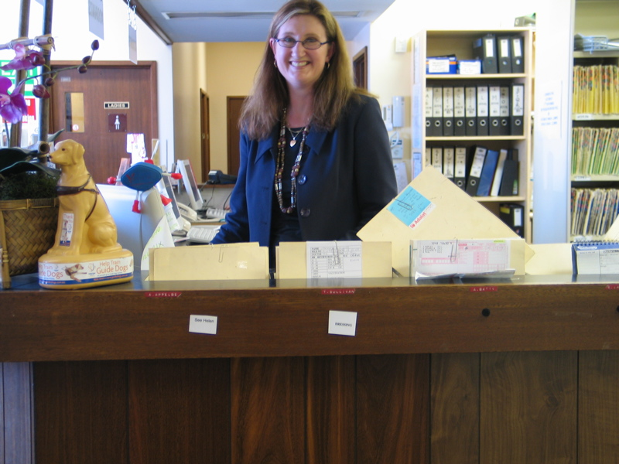
INFORMATION POSTER
This general practice has agreed to take part in a research study looking at the way urgent appointments are allocated by reception staff. Prioritising the allocation of appointments, a form of basic triage, is something that General Practice reception staff undertake every day.
It is hoped that this research may assist practices to make sure this is done in a way that is safe for patients and relieves the stress sometimes felt by reception staff.
During the study trained researchers will be collecting information about the way practice staff respond to certain hypothetical situations.The research does NOT involve talking about patients, looking at patients during consultations or seeing patients’ personal or other information.
Ethics approval for this study has been granted from:

The Royal Australian College of General Practitioners (RACGP),
and
The Australian National University (ANU) Ethics Committee, Canberra ACT 0200 (phone 02 6125 5111).

For more detailed information about this research, free information sheets are available at the front desk of this practice. If you have any other concerns or questions about the study you can also contact the research team through Ms Sally Hall on (02) 6244 4952.

Thank you for taking the time to read this information

