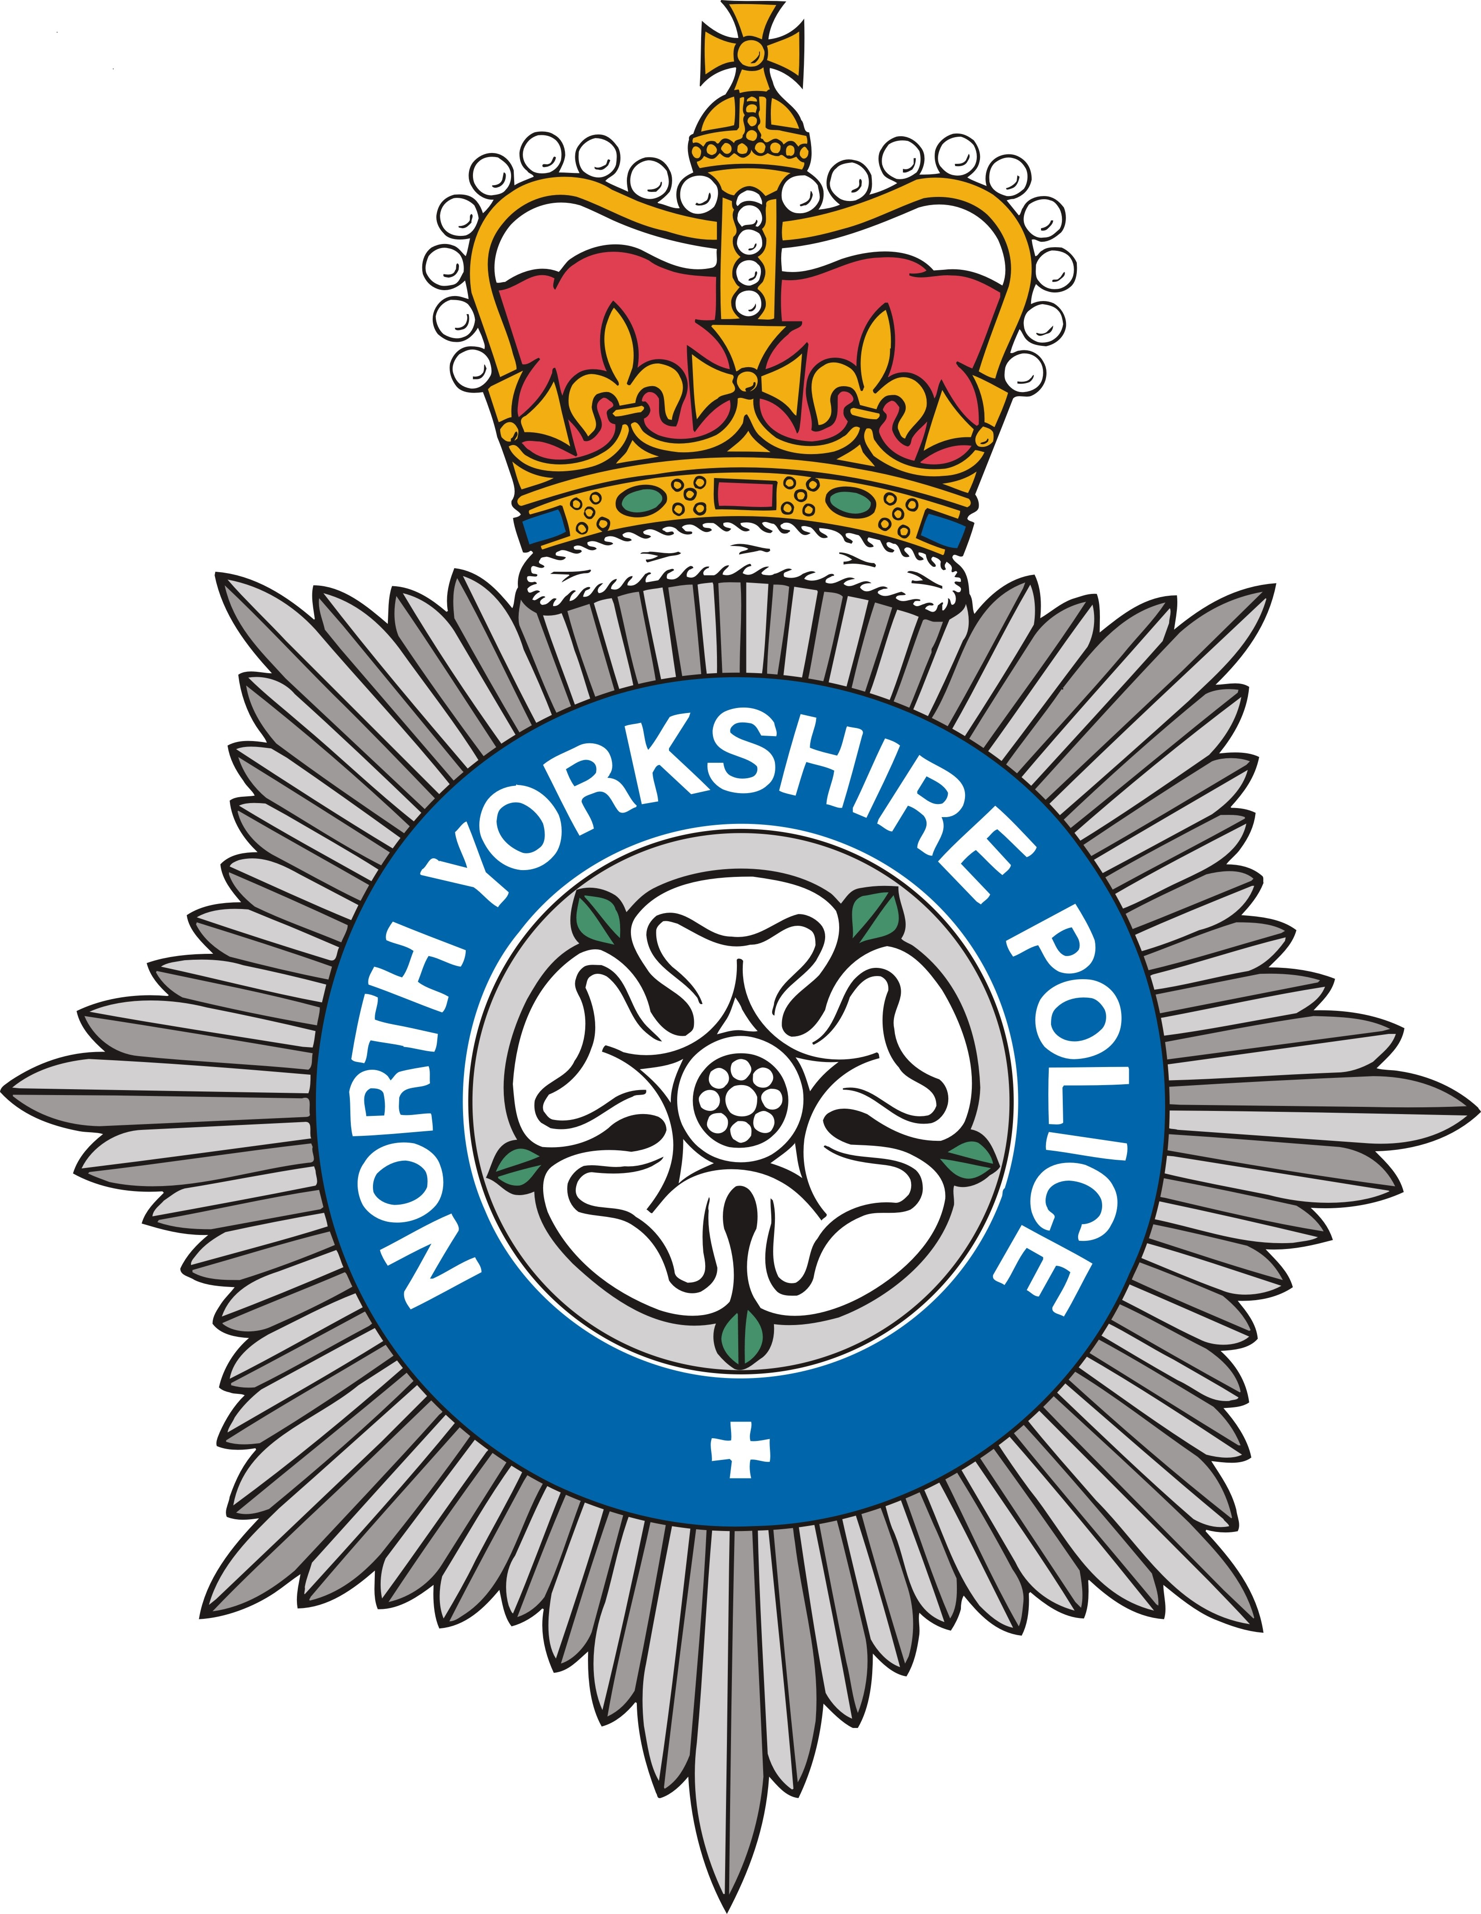


Mental Health Training for Front Line Police Officers: a Randomised Controlled Trial (RCT)

Information Sheet

Background
A significant amount of police time is spent dealing with incidents involving people who are mentally vulnerable. Whilst we are acutely aware that police officers are not, and indeed should not be, experts in mental health, they are often the first responders and yet have minimal training in this area. Last year, North Yorkshire Police (NYP) in conjunction with the University of York and the Office of the Police and Crime Commissioner North Yorkshire obtained over £1.1M to work together to develop evidence, research and training with a focus on mental health. The ‘Connect’ project includes a randomised controlled trial of new mental health training for front-line officers; this will build upon the Rethinking Mental Health training being delivered by NYP during early 2016. The training aims to increase awareness and identification of mental health vulnerabilities, improve the recording of incidences involving people with mental ill-health, enhance skills in communicating with people in mental health distress, provide a clearer understanding of referral pathways into mental health services, and aid multiagency working.

What is a randomised controlled trial?
In order to measure the effectiveness of the training we are conducting a randomised controlled trial (RCT). Out of 12 identified police stations in North Yorkshire we are selecting six at random to receive the new training. Officers attached to the other six stations will receive any training currently available in NYP. Officers in the ranks of PCSO, Police Constable, Sergeant and Inspector from Response and Safer Neighbourhood Teams in the stations randomised to the intervention group will undertake a one-day training course on working with people with mental health problems in late Spring/ Summer 2016. By analysing outcomes from the two groups before and after the intervention we are able to measure the impact of the training. The trial will explore whether the new training better equips front-line officers to deal with individuals with mental ill-health and reduce demand on police resources.

Why am I being asked to take part?
You are attached to one of the police stations taking part in the trial. The training has been approved by NYP and so, as per usual, will be mandatory for identified ranks. If your station has been randomised to the intervention group and you are a Response or SNT PCSO, PC, Sergeant or Inspector, then you will receive the training. The one-day training course will be repeated as many times as is necessary to train all the identified officers. Officers in the control group will receive the training at a later date after the trial has been completed.

What will the training entail?
The training will include classroom style delivery of information; skills based learning around communicating with people in mental health crisis; videos of mental health service users talking about their experiences; role play activities; and small group discussions. There will be opportunities throughout the day for officers to discuss real-world incidents (anonymised), and seek advice and information. The content of the training has been developed by Professor Martin Webber and Dr Nicola Moran from the Dept. of Social Policy and Social Work at the University of York, in conjunction with mental health professionals, and in consultation with NYP’s Mental Health Partnership Development Inspector Bill Scott. The training will be a localised NYP version of the mental health training currently being developed by the College of Policing. The findings from the RCT will help to inform the development of College of Policing training on working with people with mental ill health.

Who will deliver the training?
Depending upon scheduling, the training will likely be delivered by mental health professionals from across Tees, Esk and Wear Valley NHS Trust, Leeds Community Healthcare NHS Trust, and the Department of Health Sciences at the University of York.

Who is undertaking the study and how is it funded?
The project is funded by the College of Policing, the Home Office, and the Higher Education Funding Council for England (HEFCE), through the Police Knowledge Fund. The trial of the mental health training is being undertaken by an interdisciplinary team of researchers from the Department of Social Policy and Social Work and the York Trials Unit at the University of York, in conjunction with NYP.

Evaluating the training
In order to identify and measure the impact of the training, it is essential that officers in both the control and intervention groups complete two online surveys – the first will be circulated by NYP in Spring 2016 and aims to collect baseline data; the second will be circulated towards the end of the year and will gather follow-up data. In addition, a number of measures of routinely collected data will be collected at the start and finish of the trial. Comparison of responses at the end of the research period will help us to measure the effectiveness of the training and make recommendations to NYP and the College of Policing to shape future mental health training for front-line officers. The results of the trial (anonymised) will also be presented to the funding body and published in academic and policing journals.

Confidentiality
All data will be anonymised, thus nobody taking part will be identifiable in the project report or any other publication. Only members of the research team will have access to the data, which will be kept in locked storage or on password protected computers at the University of York. All information collected during the course of the research will be kept strictly confidential in line with the Data Protection Act. Data will be securely stored for five years from the end of the study and then destroyed.

Ethical approval
This randomised controlled trial of mental health training for front-line police officers has been approved by the Health Sciences Research Governance Committee at the University of York.

Further information
If you would like any further information on the training please contact Dr Nicola Moran (nicola.moran@york.ac.uk), Dept. of Social Policy and Social Work, University of York, York, YO10 5DD, Tel.: 01904 321246.

