Randomised Evaluation of incentive Spirometry in OLder adults with rib fractures to preVEnt pulmonary complications: RESOLVE

SUMMARY PARTICIPANT INFORMATION SHEET
You are invited to take part in a research study. It is important for you to understand why the research is being done and what it involves. You are welcome to ask us any questions. Thank you for taking the time to read this information.

Why have we approached you?
We are looking for patients like you, who have been admitted to a UK hospital with broken ribs, to take part in our research.
The doctors looking after you may feel that it would be best for you to stay in hospital after your injury. You will be assessed, have injuries treated and be given pain relief according to usual care.

Patients with broken ribs may sometimes have problems in their recovery because it is difficult to take deep breaths. Patients may be given a device called an incentive spirometer and/or shown how to do breathing exercises. Some UK hospitals use spirometers and some do not; there is currently no research showing whether they help recovery in patients with broken ribs. The RESOLVE study will help us compare using incentive spirometers against not using them.

An incentive spirometer (shown on the left) is a light, easy-to-use device. You breath in through the mouthpiece, which raises a small ball or disc inside and gives visual feedback on how strong the breath was, which can be used to track progress. We aim to find out if using one will help reduce problems, like chest infections, in the first 5 days after patients come into hospital.

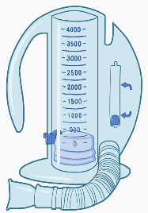

QR code to be entered here
Optional: If you have a smartphone, hover the camera over this black and white picture (a ‘QR code’). Click on the link and it will take you directly and securely to a video explaining this research.

What happens if I join the study?
- If you join the study, you will be asked to complete a consent form, confirming you agree to take part.
- You will randomly be put into one of two groups.
- This choice will not affect the routine care you receive for your broken ribs.
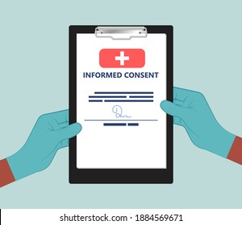
GROUP 1 - TREATMENT WITH CURRENT USUAL CARE:
You will be treated in the normal way whilst in hospital, including being taught breathing exercises.

OR
GROUP 2 - TREATMENT WITH CURRENT USUAL CARE PLUS USE OF INCENTIVE SPIROMETER:
You will be treated in the normal way whilst in hospital, but you will also be given an incentive spirometer. You will be shown how to use the device by a trained member of staff, given an educational leaflet and shown where to find an instruction video online. You should use the spirometer 3 times a day; you will be given a diary and asked to record this for 5 days.

What happens after I take part?
Day 1
A member of the research team at your hospital will gather some information on your health and you will be given two questionnaires to complete (if you can), about your pain and breathlessness.

Day 5
Around 5 days after you have joined the study, you will be asked to complete the same two questionnaires. If you are still in hospital, then these will be done with research team on the ward. However, if you have already been discharged home, the research team will give you a ring and ask to complete these over the telephone with you.

If you were in Group 2, you will be asked to return your diary.

Day 30
Around 30 days after you joined the study, the research team at your hospital will check your medical records to see if you required further treatment or had any complications. You do not need to do anything at this time.

In recognition of your time, we will offer you £20 vouchers at day 5, after the completion of all patient questionnaires.

What happens with my data?
- We will keep all information about you safe and secure.
- We will NOT share information about how you got your injuries with anyone outside of this research study.
- Personal information such as your name and phone number will be stored on a secure database. This allows us to contact you about questionnaires and other study related activities. We will follow all privacy rules.
- If you would like further information, see our leaflet “How we use information from patients” available from: https://resolve.blogs.bristol.ac.uk/

Taking part is voluntary.
If you take part, you can leave the study at any time without giving a reason. We will keep data collected for the study up to the point you choose to leave. Your treatment will continue as normal.

