**FULL/LONG TITLE OF THE STUDY**

The Incremental Utility of Cardiac Magnetic Resonance Imaging in Clinical Decision Making in Myocardial Infarction with Non-Obstructed Coronary Arteries (MINOCA)

**SHORT STUDY TITLE / ACRONYM**MINOCA CMR

**PROTOCOL VERSION NUMBER AND DATE**Version 1.0, 27/07/2020

|  |  |
| --- | --- |
| **IRAS Number** 255358 |  |

**This protocol has regard for the HRA guidance and order of content**

# SIGNATURE PAGE

The undersigned confirm that the following protocol has been agreed and accepted and that the Chief Investigator agrees to conduct the study in compliance with the approved protocol and will adhere to the principles outlined in the Declaration of Helsinki, the Sponsor’s SOPs, and other regulatory requirement.

I agree to ensure that the confidential information contained in this document will not be used for any other purpose other than the evaluation or conduct of the investigation without the prior written consent of the Sponsor

I also confirm that I will make the findings of the study publically available through publication or other dissemination tools without any unnecessary delay and that an honest accurate and transparent account of the study will be given; and that any discrepancies from the study as planned in this protocol will be explained.

|  |  |  |
| --- | --- | --- |
| **For and on behalf of the Study Sponsor:** | | |
| **Principle Investigator:** | | |
| Signature:  *Signed digitally* |  | Date: 27/07/2020 |
| Name: (please print):  *Dr David Austin MBChB MD PGCert FRCP* |  |  |
| **Chief Investigator:** | | |
|  |  |  |
| Signature:  *Signed digitally* |  | Date: 27/07/2020 |
| Name: (please print):  *Dr David Austin MBChB MD PGCert FRCP* |  |  |

# LIST of CONTENTS

|  |  |
| --- | --- |
| **GENERAL INFORMATION** | **Page No.** |
| HRA PROTOCOL COMPLIANCE DECLARATION | i |
| TITLE PAGE | ii |
| RESEARCH REFERENCE NUMBERS | ii |
| SIGNATURE PAGE | iii |
| LIST OF CONTENTS | iv |
| KEY STUDY CONTACTS | v |
| STUDY SUMMARY | v |
| FUNDING | vi |
| ROLE OF SPONSOR AND FUNDER | vi |
| PROTOCOL CONTRIBUTERS | vi |
| STUDY FLOW CHART | vii |
| SECTION | |
| 1. BACKGROUND | 1 |
| 2. RATIONALE |  |
| 3. THEORETICAL FRAMEWORK |  |
| 4. RESEARCH QUESTION/AIM(S) |  |
| 5. STUDY DESIGN/METHODS |  |
| 6. STUDY SETTING |  |
| 7. SAMPLE AND RECRUITMENT |  |
| 8. ETHICAL AND REGULATORY COMPLIANCE |  |
| 9. REFERENCES |  |
| 10. APPENDICES |  |

# KEY STUDY CONTACTS

|  |  |
| --- | --- |
| Chief Investigator | Dr David Austin, Consultant Cardiologist The James Cook University Hospital Marton Road, Middlesbrough, TS4 3BW Dr Adil Rajwani, Consultant Cardiologist |
| Co-investigator 1 | Royal Perth Hospital, Dept of Cardiology 197 Wellington Street, Perth, WA 6000 Tel: +61 412 442 784 Email: adil.rajwani@health.wa.gov.au |
| Co-investigator 2 | Dr Neil Maredia, Consultant Cardiologist The James Cook University Hospital Marton Road, Middlesbrough, TS4 3BW |

**STUDY SUMMARY**

|  |  |
| --- | --- |
| Study Title | The incremental utility of cardiac MRI in clinical decision making in Myocardial Infarction with Non-Obstructed Coronary Arteries (MINOCA) |
| Internal ref. no. (or short title) | CMR in MINOCA |
| Study Design | Prospective international multi-centre pre- vs post- longitudinal assessment |
| Study Participants | Patients with MINOCA undergoing further evaluation by cardiac MRI |
| Planned Size of Sample (if applicable) | 384 participants across all sites |
| Follow up duration (if applicable) | 1 year |
| Planned Study Period | 2 years |
| Research Question/Aim(s) | To evaluate the real clinical role of CMR in MINOCA with regards to frequency of change (if any) in diagnosis, diagnostic certainty and management. To evaluate pre-test predictors of a useful CMR study, and the cost-efficacy of CMR in MINOCA. |

**FUNDING AND SUPPORT IN KIND**

|  |  |
| --- | --- |
| **FUNDER(S)** | **FINANCIAL AND NON FINANCIALSUPPORT GIVEN** |
| The Medical Research Foundation | $20,000 seeding grant for CMR studies conducted via Royal Perth Hospital |

**ROLE OF STUDY SPONSOR AND FUNDER**

1. This is a non-interventional study, with no change to standard clinical care for patients treated at the James Cook University Hospital (CMR is typically performed routinely in MINOCA in NHS tertiary centres). As such, no specific funding is required for the CMR study. In-kind funding is agreed for the treating clinician to complete the required questionnaires.

2. A seeding grant of $20,000 was awarded in Nov 2018 to the lead site (Royal Perth Hospital) on a competitive basis with peer-review of the study. This funding is required for the conduct of CMR in MINOCA patients – unlike the NHS, the Australian federal Medicare does not routinely fund CMR investigations. Completion of the required questionnaires is funded in-kind by the Royal Perth Hospital.

**PROTOCOL CONTRIBUTORS**

The protocol is written by chief investigator Rajwani

|  |  |
| --- | --- |
| **KEY WORDS:** | MINOCA CMR Incremental utility Diagnostic certainty |

# STUDY FLOW CHART

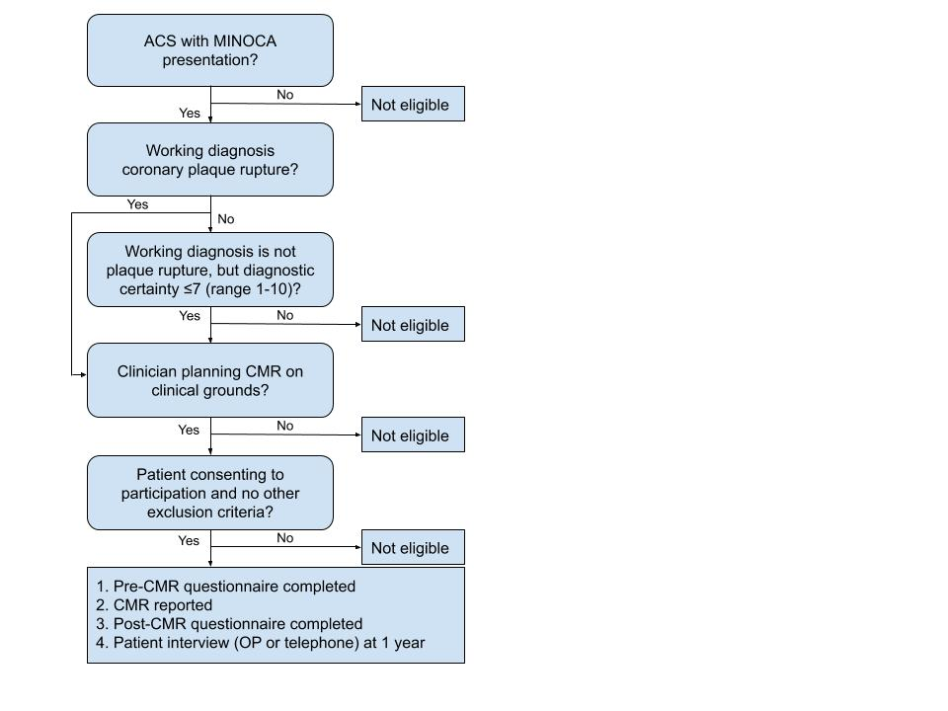

ACS – Acute coronary syndrome

MINOCA – Myocardial infarction with non-obstructed coronary arteries

CMR – Cardiac magnetic resonance imaging

OP - Outpatient

**STUDY PROTOCOL**

# 1 BACKGROUND AND RATIONALE

Myocardial infarction with non-obstructed coronary arteries (MINOCA) is the term used to denote a presentation that appears to be a heart attack but without clear culprit on diagnostic coronary angiography. This is a common presentation, representing 5-10% of all heart attacks.1 The mechanism is thought to be spontaneous recanalization of the infarcted artery by the time of the angiogram, where the culprit atheroma plaque was not itself obstructive. However, because a wide and heterogenous range of disease processes can masquerade as a myocardial infarction (e.g. myocarditis, coronary artery vasospasm, stress-induced cardiomyopathy, index presentation of chronic cardiomyopathies etc), in the absence of clear evidence from the angiogram the actual cause often remains unclear to the treating clinician even after comprehensive assessment. *Thus, this common presentation is associated with major diagnostic uncertainty*.

Given that 20-40% of MINOCA-type presentations are caused by genuine coronary plaque rupture - and with real risk of recurrence in such cases if untreated - the current ESC Consensus statement on MINOCA recommends continuing to treat with standard heart-attack therapy, namely dual antiplatelet therapy and statins.1 It follows however that 60-80% of individuals will be unnecessarily exposed to the risks of this treatment. In particular, dual antiplatelet therapy is associated with annual major bleeding rates of ~3.5%; statin therapy is associated with a small but significant increased risk of diabetes and other complications. In addition, there are a number of other aspects of management that also differ according to diagnosis, including the need for specialist follow-up, repeated testing, implantation of devices for monitoring or treatment, further risk stratification in cardiomyopathy, and cascade screening of family members. *Thus, in MINOCA, diagnostic uncertainty in turn leads uncertainties in clinical care, with accompanying real risk of morbidity and even mortality*.

Cardiac magnetic resonance (CMR) imaging has emerged as a valuable imaging tool in such patients, due to its unique ability to non-invasively detect and characterise scar tissue in the heart - a 'virtual histology'. A number of studies have demonstrated the utility of CMR in determining the aetiology of MINOCA, and consensus statements such as that from the ESC advocate in favour of CMR in MINOCA.1 A major knowledge gap exists however in that there are no high-quality data evaluating the real contribution of this expensive and complex investigation to clinical care. Firstly, there are no prospective data testing how often CMR actually ***changes*** the diagnosis or management over and above that of a competent clinician. Secondly, CMR studies will fail to show any abnormalities in as many as 50% of cases, however on the other hand the absence of infarction on a 'normal' study may still be of clinical value; the net effect of these considerations on clinical care is very difficult to gauge without formal prospective study. Thirdly, the cost-efficacy of CMR in MINOCA is entirely unexplored; CMR is an expensive test, but on the other hand the cost of medication after a heart attack is also costly (over $2000 for dual-antiplatelets annually in Australia, over GBP1000 in the UK), and de-prescription of such medication after reliable exclusion of a 'true' heart attack by CMR may in fact be cheaper than the current strategy of treating empirically. De-prescription of medication may also have additional cost-benefits if bleeding complications of such medications and their (significant) attendant health-care costs are averted.

While a number of studies have documented the diagnostic utility of CMR in MINOCA, only 3 studies have attempted to evaluate the ***change*** in diagnosis and management due to CMR in MINOCA; all 3 have major limitations, and there are no studies at all of cost-efficacy. Assomull *et al* retrospectively reviewed the single-centre case notes of 60 individuals with MINOCA versus the CMR findings, to determine how often CMR changed the diagnosis.2 This small, single centre retrospective dataset was based on case-note review which greatly limited the quality of information regarding pre-test diagnosis. Post-CMR diagnosis and clinical impact of the CMR on management was ascertained by the CMR-avid authors themselves, with clear potential for bias. Similarly, Dastidar *et al* retrospectively compared pre-CMR working diagnosis garnered from the radiology request form at a single-centre versus the CMR-guided diagnosis in 204 consecutive MINOCA patients.3 Again, retrospective data of this nature without planned prospective documentation and the potential biases of the adjudicating authors are major criticisms. Both studies are also weakened by the lack of clear account as to whether other tests such as echocardiogram had already secured the diagnosis sufficiently to render the CMR redundant. Rajwani *et al* attempted to address some of these challenges in a cohort of 110 patients, adjudicating incremental utility of CMR only if other investigations were inconclusive, and analyses were performed not only by 2 cardiologists separately but also one of whom had no special interest in CMR.4 Nonetheless, this was still also a retrospective single-centre dataset that relied upon case-note perusal, with inevitable negative impact on the quality and reliability of data.

**3 THEORETICAL FRAMEWORK**

In this prospective international multi-centre pre- versus post-CMR longitudinal analysis, we will now comprehensively evaluate the real impact in MINOCA of CMR on diagnosis, diagnostic certainty, management and costs. With reference to the widely accepted Fryback hierarchical model for the evaluation of diagnostic imaging efficacy,5 this will provide comprehensive assessment on level 3 (influence on diagnostic thinking), level 4 (influence on management), and will contribute to information at level 6 with regards to costs (influence on societal outcomes). We will also evaluate pre-test predictors of a diagnostic CMR, to identify those sub-groups where CMR is most likely to be useful. These data will clearly determine the real clinical role of CMR in this common condition. Importantly, in this common and globally-encountered condition, these data will inform international guidelines. Information regarding cost-efficacy will be particular novel, and we also envisage that any identification of sub-groups with the most / least favourable "number-needed-to-test" will be of major fiscal interest to health-care systems.

**Table 1:** Hierarchical model of diagnostic imaging efficacy

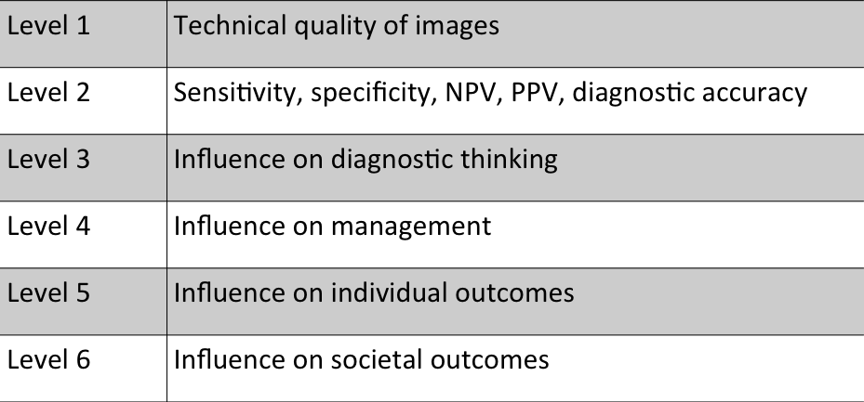

# 4 RESEARCH QUESTION/AIM(S)

This study will evaluate the real clinical impact of CMR in MINOCA on diagnosis, diagnostic certainty, and clinical management. The primary outcome will be the frequency of change in diagnosis or management in MINOCA when CMR is undertaken.

Secondary outcomes will be frequency of (i) change in diagnosis; (ii) change in diagnostic certainty; (iii) change in management; and also the (iv) number-needed-to-test by CMR to change either diagnosis or management.

Exploratory data regarding the 1-year incidence of major adverse cardiovascular events or bleeding will also be documented, however the observational study design does not allow a formal outcomes-based assessment of the impact of CMR-guided management.

Univariate predictors of a useful CMR will be explored from a wide range of clinical and laboratory parameters. Finally, cost-efficacy of CMR in the care of MINOCA patients in the study population will be evaluated.

# 5 STUDY DESIGN and METHODS of DATA COLLECTION AND DATA ANALYIS

This non-interventional study will be a prospective international multi-centre pre- versus post-CMR longitudinal analysis of the real impact of CMR on clinical care in patients with MINOCA in whom there is diagnostic uncertainty as to the underlying aetiology.

The local research team at James Cook University Hospital (JCUH) will comprise:

* Dr David Austin PhD, Consultant and Interventional Cardiologist, and Cardiovascular Researcher at JCUH. Principle investigator for JCUH.
* Dr Neil Maredia MD, Consultant cardiologist and Head of CMR at JCUH. Co-investigator.
* Ms Nicola Cunningham, Lead research nurse for cardiology

Of note, JCUH is a tertiary referral centre for angiography not only for patients admitted at JCUH but also Durham and Darlington NHS Trust and North Tees and Hartlepool NHS Trust, and these patients will also be eligible to be recruited following angiography at JCUH.

The following study design will be followed:

* Identification of a patient with MINOCA will be by any of the clinical team caring for the patient on the cardiology ward / coronary care unit, following diagnostic angiography.
* Upon identification, a member of the research team will approach the patient to discuss participation, and to confirm absence of any exclusion criteria.
* For individuals expressing interest in participation after initial comprehensive outline of the study, the Patient Information Letter and Consent form will be provided for their perusal. Recruitment requires written consent, and can be at any time up to the conduct of the CMR study. Please note that the CMR study is being performed as standard clinical care and is NOT in any way an additional research activity.
* Consenting participants will be allocated a Research ID by the research team member who is obtaining consent, which will be recorded on a Master Log using an Excel spreadsheet. This will be password-protected, stored on an encrypted South Tees NHS Foundation Trust hospital computer, with the research server accessible only to authorised research staff. A separate Results spreadsheet will hold coded (re-identifable) data only, using only the Research ID for participant identification and not their name, date of birth, hospital number or other non-coded identifiers. Data can only be transcribed by a research team member.
* Consenting patients at JCUH will not be required to have any intervention outside of their normal clinical care. This is therefore a non-interventional low / negligible risk research study, and the only potential for harm to patients is any failure of data protection.
* The following information will be gathered:  
  (a) The treating cardiologist will be asked to complete a pre-CMR questionnaire detailing working diagnosis, diagnostic certainty (scale 1-10, see section 7.1), and detailed capture of the management, encompassing in particular all medications, further tests planned / deferred, plans for future follow-up, and planned family screening. A copy of the questionnaire is included as an Appendix. All data will be transcribed immediately by the research team member to the electronic results spreadsheet.  
  (b) A list of clinical and laboratory parameters which may predict the utility of the CMR will be documented by a research team member, from the clinical notes. These will include age, gender, symptoms and observations at presentation, troponin elevation magnitude, diabetes, renal function, heart failure, peripheral vascular disease, serum C-reactive protein, observations at presentation (pulse, blood pressure, temperature), angiographic findings, whether intra-vascular coronary imaging was performed, quantitative echocardiographic findings (namely left atrial volume, left ventricular volumes, and left ventricular ejection fraction), ECG findings at presentation, and GRACE score of future cardiovascular risk in acute coronary syndromes.  
  (c) After the CMR, the treating cardiologist will now complete a post-CMR questionnaire again detailing the working diagnosis, diagnostic certainty and management. See appendix.  
  (d) At 12 months post presentation, the patient will be contacted either in person or by telephone by a member of the research team. This will document the occurrence of all hospitalisations, recurrent cardiac events and bleeding over the 12-month period. This will be entered directly into the password-protected research spreadsheet.
* The conduct of the CMR will be in accordance with the institution's own standard protocol rather than a fixed research protocol, but will be expected to broadly align with international standards such as those detailed in the "SCMR board of trustees task force on standardized protocols (2016)". This has been confirmed for the proposed UK sites. Sites will be encouraged to perform CMR within approx. 2 weeks of presentation in line with standard practice.

Final data analysis will be conducted at the conclusion of the study by the lead investigator Rajwani in Perth, Western Australia. This will require transfer of the spreadsheet from each recruiting site **which only contains de-identified (coded) data**. Access to the Master Log for each site remains only with the local research teams, thus re-identification of patient identity by the Perth investigator is not possible. The spreadsheets will be sent as an encrypted and password-protected email attachment from PI Austin’s nhs.net account, to lead investigator Rajwani to the encrypted email account at the East Metro Health Service in Perth which is [adil.rajwani@health.wa.gov.au](mailto:adil.rajwani@health.wa.gov.au).

Data analysis will be performed with respect to the primary and secondary outcomes. For diagnosis, the paired pre- versus post-CMR diagnostic labels (from an exhaustive list of 10 aetiologies + “other (please specify)”) will be tabulated, compared and quantified for frequency of change (McNemars test). A further analysis will also determine which pre-CMR diagnoses were most / least susceptible to change. Diagnostic certainty is selected from 1 (very uncertain) to 10 (highly certain). Change in diagnostic certainty pre- versus post-CMR will be tested for significance by Student’s paired t-test. Interaction of change in certainty with pre-CMR (un)certainty will also be explored. Management changes will be multi-parametric covering (i) pharmacotherapy, (ii) further tests indicated / abandoned, and (iii) future outpatient follow-up, with similar analyses to diagnostic label change. Change in any one parameter is clinically significant however, thus multiple changes are not hierarchical over single change. The composite of change in diagnosis or management forms the primary endpoint, and individual components will form the first 3 secondary outcomes. The 4th secondary outcome (number-needed-to-test) will be the ratio of scans performed divided by the number of participants where diagnosis or management were changed consequent to the CMR. Univariate predictors of a diagnostic CMR study will be determined by logistic regression, and with receiver-operating curve used to determine the sensitivity and specificity for continuous variables such as serum troponin. Statistical analyses will be performed using GraphPad V7 software. Health economic analyses detailed in the proposal will be conducted by Health Economics Professor Elizabeth Geelhoed PhD (UWA Perth).

# 6 STUDY SETTING

This is a multi-centre international study, with recruiting sites located in Western Australia, South Australia, and now the UK. Recruiting sites must satisfy the following 3 attributes:

1. Providing a 24/7 acute cardiology service and thus which will be responsible for the inpatient diagnosis and care of MINOCA cases
2. Already providing access to CMR as part of standard clinical care for MINOCA
3. Local CMR reporting must by a cardiologist or radiologist with at least Level II accreditation by either the SCMR or EuroCMR societies.

**7 SAMPLE AND RECRUITMENT**

**7.1 Eligibility Criteria**

Key inclusion criteria:

1. Presentation with MINOCA (as per the 2016 ESC consensus statement definition)
2. Working diagnosis coronary plaque rupture, or significant diagnostic uncertainty* if an alternative diagnosis is considered most likely
3. Treating clinician intends to further assess by CMR
4. Age >18 years

*Diagnostic uncertainty is defined as significant doubt on the part of the treating clinician as to the underlying mechanism for the MINOCA, and quantified as a certainty level ≤7 (range 1-10, with 1 being fully uncertain and 10 being fully certain)

Exclusion criteria are:

1. CMR is contra-indicated or not planned
2. Type II myocardial infarction rather than MINOCA
3. Pregnancy

**7.2 Sampling**

All consecutive eligible individuals at JCUH with a MINOCA presentation following angiography will be approached over a period of up to 2 years, and then with conclusion of data accrual at the 1-year anniversary of the last-recruited participant. The total sample size required across all recruiting sites is 384 participants. This will allow the frequency of the composite of change in diagnosis and / or management to be estimated such that their confidence intervals will be no wider than +/-5%, assuming a conservative 50% prevalence for there being a change consequent to the CMR. It is anticipated that approximately 100 individuals will be recruited via the UK site(s).

**7.3 Consent**

Informed consent will be obtained in every case prior to undergoing any activity related to the study. The following steps will be followed:

* Consent will be in accordance with the principles of GCP.
* Consent can only be obtained by a research team member, who will be knowledgeable about the research, its objectives and conduct, and all possible risks.
* Following verbal explanation of the study and opportunity to ask questions, patients will be provided with a printed copy of the PIL and Consent form (which must be approved by the REC and all other relevant local bodies). Patients will be provided as much time as required to consider participation, but will cease to be eligible if this is not provided before the CMR study is performed; this time period is anticipated to span between 24hrs – 2 weeks. This signed form is retained securely in the research office as per standard protocols, a copy is retained in the clinical notes, with, and a second copy is retained by the patient.
* Where there is concern about a patient’s capacity to consent, these will not be recruited.
* Participants are able to withdraw consent at any time during the study.

# 8 ETHICAL AND REGULATORY CONSIDERATIONS

## This non-interventional study carries low / negligible risk of serious harm to participants. The only appreciable risk is that of failure to ensure data security; the likelihood of this with rigorous adherence to standard research governance and data protection is very low, the data gathered are not of an overly sensitive or embarrassing nature, and the research team are themselves NHS clinicians who would in any case have access to the clinical data captured for this study. The risks of data breach in this study are not anticipated to be any higher than other research studies conducted at this site.

## **8.1 Assessment and management of risk**

## This is a non-interventional study which carries low / negligible risk of serious harm to participants. By nature of the study design, with all study parameters being provided by the treating clinician rather than patient, the probability of receipt of information portending safeguarding implications is negligible.

**8.2 Research Ethics Committee (REC) and other Regulatory review & reports**

* Before the start of the study, a favourable opinion will be sought from a REC for the study protocol, informed consent forms and other relevant documents e.g. study questionnaires.
* For any amendment to the study, the Chief Investigator or designee, in agreement with the sponsor will submit information to the appropriate body in order for them to issue approval for the amendment. The Chief Investigator or designee will work with sites (R&D departments at NHS sites as well as the study delivery team) so they can put the necessary arrangements in place to implement the amendment to confirm their support for the study as [amended](http://www.hra.nhs.uk/resources/after-you-apply/amendments/).
* Substantial amendments that require review by NHS REC will not be implemented until that review is in place and other mechanisms are in place to implement at site. Investigators Rajwani, Austin and Maredia will determine whether an amendment is substantial or non-substantial. Version numbers of amended documents will be updated.
* All correspondence with the REC will be retained.
* It is the Chief Investigator’s responsibility to produce the annual reports as required.
* The Chief Investigator will notify the REC of the end of the study.
* An annual progress report (APR) will be submitted to the REC within 30 days of the anniversary date on which the favourable opinion was given, and annually until the study is declared ended.
* If the study is ended prematurely, the Chief Investigator will notify the REC, including the reasons for the premature termination.
* Within one year after the end of the study, the Chief Investigator will submit a final report with the results, including any publications/abstracts, to the REC.
* Before any site can enrol patients into the study, the Chief Investigator/Principal Investigator or designee will ensure that appropriate approvals from participating organisations are in place.
* Independent scientific peer-review of this study was provided by the Medial Research Foundation, Perth, Australia in November 2017.
  1. **Protocol compliance**

Protocol deviations, non-compliances, or breaches are departures from the approved protocol. Accidental protocol deviations can happen at any time. They must be adequately documented on the relevant forms and reported to the Chief Investigator and Sponsor immediately. Deviations from the protocol which are found to frequently recur are not acceptable, will require immediate action and could potentially be classified as a serious breach.

### 

**8.4 Data protection and patient confidentiality**

All investigators and study site staff must comply with the requirements of the Data Protection Act 1998 with regards to the collection, storage, processing and disclosure of personal information and will uphold the Act’s core principles. Participants will be assigned unique research identifier codes, with a suffix of xxx representing sequential numbers from 001 to 999 according to order of recruitment. A master log with participant details stored against study ID will be kept on a password-protected electronic spreadsheet. Data regarding the diagnosis and management will be captured by questionnaires completed by the treating consultant, before and after the CMR study as described (section 5). The research data will be entered into a separate password-protected spreadsheet under these re-identifiable (coded) identifiers and without identifiable data such as name, date of birth or hospital number. Both spreadsheets will be hosted on a password-protected secure computer on the South Tees NHS Foundation encrypted server, which will only be accessible to members of the research team. As detailed in section 5, final data analysis will be conducted at the conclusion of the study by the lead investigator Rajwani in Perth, Western Australia. This will require transfer of the spreadsheet from each recruiting site **which only contains de-identified (coded) data**; access to the Master Log for each site remains only with the local research teams. Thus re-identification of patient identity by the analysing individual in Perth is not possible. The spreadsheets will be sent as an encrypted and password-protected email attachment from PI Austin’s nhs.net account, to lead investigator Rajwani at WA Health which is an encrypted email account at the East Metro Health Service in Perth, address [adil.rajwani@health.wa.gov.au](mailto:adil.rajwani@health.wa.gov.au). Original hard-copy data will be retained securely for 5 years, with PI Austin being the nominated data custodian.

8.7 Indemnity

This low / negligible risk non-interventional study will be covered by NHS indemnity.

**8.8 Access to the final study dataset**

Data will be stored in an anonymised de-identified format as described earlier, separately from the master log listing patient names. Principal Investigators will only have access to the datasets for their individual site, and will not routinely have access to the full dataset. At the conclusion of the study, the datasets will be amalgamated by Chief Investigator Rajwani to permit data analysis, but this will only be of the de-identified datasets and not individual site master logs, and as such no single researcher will be able to perform re-identification of the full dataset. Check analysis of the full (de-identified) dataset by overall study investigator Rajwani will be performed with statistician Dr Sally Burrows at the University of Western Australia, and analysis on a sub-set of the full data for cost-efficacy analyses will be by affiliate investigator Prof Elizabeth Geelhoed, University of Western Australia. We also seek to retain the ability to perform secondary analyses of the dataset, however these will be confined to (i) epidemiological associations of MINOCA, and (ii) any additional interactions of CMR with MINOCA, and we have explicitly listed this request within the patient documentation.

### 9 REFERENCES

1. Agewall S, Beltrame JF, Reynolds HR, et al. ESC working group position paper on myocardial infarction with non-obstructive coronary arteries. Eur Heart J. 2017;38(3):143-53.
2. Assomull RG, Lyne JC, Keenan N, et al. The role of cardiovascular magnetic resonance in patients presenting with chest pain, raised troponin and unobstructed coronary arteries. Eur Heart J. 2007;28:1242-49
3. Dastidar AG, Rodrigues JC, Johnson TW, et al. Myocardial Infarction with non-obstructed coronary arteries. Impact of CMR early after presentation. J Am Coll Cardiol. 2017;10(10):1204-06
4. Rajwani A, Stewart MJ, Richardson JD, Child NM, Maredia N. The incremental impact of cardiac MRI on clinical decision-making. Br J Radiol. 2016;89(1057):20150662
5. Fryback DG, Thornbury JR. The efficacy of diagnostic imaging. Med Decis Making. 1991;11(2):88-94

### 10. APPENDICIES

**10.1 Appendix 1- Required documentation**

CV – Investigator Rajwani

CV – Investigator Austin

Patient information letter and consent form

Pre-CMR questionnaire

Post-CMR questionnaire

One-Year interview questionnaire

**10.2** **Appendix 2 – Schedule of Procedures (Example)**

|  |  |  |  |  |
| --- | --- | --- | --- | --- |
| **Procedures** | **Visits (insert visit numbers as appropriate)** | | | |
| **Screening** | **Baseline** | **Post CMR** | **1 year** |
| Informed consent | X1 |  |  |  |
| Demographics |  | X1 |  |  |
| Baseline questionnaire  (by treating clinician) |  | X1 |  |  |
| Post-CMR questionnaire (by treating clinician) |  |  | X1 |  |
| 1 year interview |  |  |  | X1 |

**13.3** **Appendix 3 – Amendment History**

|  |  |  |  |  |
| --- | --- | --- | --- | --- |
| **Amendment No.** | **Protocol version no.** | **Date issued** | **Author(s) of changes** | **Details of changes made** |
|  |  |  |  |  |