# Support 4 All Clinical Feasibility Trial Results

## Consort flow diagram

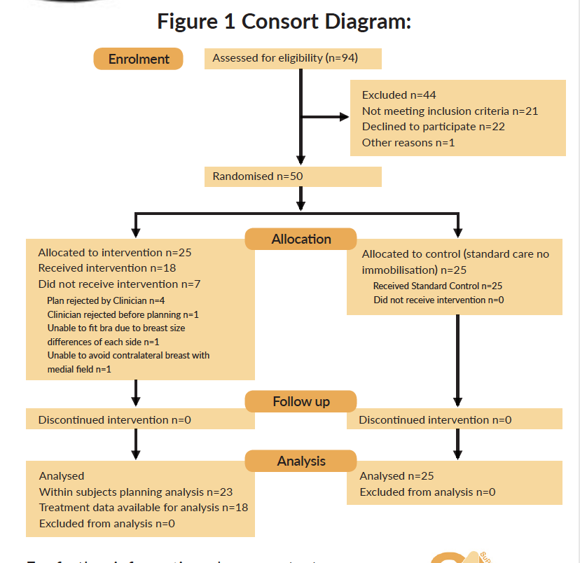

## Basic Characteristics

Table 1 below shows patient breast volume (in cm3) for the two intervention arms and also for group A (the S4A group) the breast volume measured with and without the bra. It can be seen for the within subjects assessment (rows 1 and 2) that when planned wearing the S4A bra on average a greater volume of breast tissue was included in the plan than when planned without the bra (1,468.0 vs 1,416.3 respectively).

### Table 1 Breast volume measured at planning

|  |  |  |  |  |  |
| --- | --- | --- | --- | --- | --- |
|  | Allocation | Status Bra | Mean | SD | Median |
| 1 | A (n=23) | NOBRA | 1,416.3 | 417.6 | 1,335.7 |
| 2 | A (n=23) | WITHBRA | 1,468.0 | 456.1 | 1,454.2 |
| 3 | B (n=25) | NOBRA | 1,480.6 | 458.1 | 1,432.4 |

A= bra/intervention arm, these patients were planned with and without the S4A bra.

B= control arm, no bra.

Table 2 below is a summary of the measures taken at the radiotherapy planning stage by allocated group.

### Table 2 Baseline measures of positioning from planning images (mm).

|  |  |  |  |  |  |
| --- | --- | --- | --- | --- | --- |
|  | Measurement | Allocation | Mean | SD | Median |
| 1 | Central Lung Depth (CLD) | A | 11.4 | 3.2 | 11.0 |
|  |  | B | 14.2 | 3.8 | 14.0 |
| 2 | Cranial Lung Distance (CrLD) | A | 8.7 | 4.1 | 8.5 |
|  |  | B | 10.2 | 4.2 | 9.0 |
| 3 | Central Beam Edge Skin Distance (CBESD) | A | 35.7 | 7.5 | 33.5 |
|  |  | B | 34.4 | 4.6 | 34.0 |
| 4 | Central Irradiated Width (CIW) | A | 88.6 | 12.9 | 85.0 |
|  |  | B | 81.0 | 10.2 | 79.5 |
| 5 | Caudo-Cephalic Distance (CCD) | A | 177.2 | 16.8 | 178.0 |
|  |  | B | 187.0 | 14.2 | 185.5 |

A= intervention arm S4A bra (n=23), B= control arm no bra (n=25)

Measures 1 and 2 in Table 2 represent measures of ipsilateral lung included in the radiation fields for each of the allocated groups. It can be seen that for both measures (CLD and CrLD) the average lung depth measures are lower in the S4A groups than in the control arm (Group B no immobilization).

## Outcome Measures

As this was a feasibility trial what is presented below are the outcome measures that were being assessed for inclusion in a future larger trial. Hence, they are not reported as primary or secondary outcome measures.

#### Set-Up Reproducibility

To assess daily reproducibility in the S4A bra compared with standard no bra set-ups (Group A vs Group B) both random and systematic components of the set up error were calculated.

##### Systematic Error

Systematic error refers to a consistent error in the same direction that occurs for each treatment fraction. Table 3 below shows the population mean systematic error for the measures shown in Table 2 above.

### Table 3 Summary of Population Mean Systematic Error (mm).

|  |  |  |  |  |  |  |
| --- | --- | --- | --- | --- | --- | --- |
| Measurement | Difference in means  (bra - no bra) | Mean group A  S4A bra | Mean group B  No Bra | P-value | Lower CI | Upper CI |
| CLD | 2.4 | 0.9 | -1.5 | 0.002 | 0.9 | 3.9 |
| CrLD | 1.7 | 0.2 | -1.5 | 0.014 | 0.4 | 3.1 |
| CBESD | -0.6 | -2.6 | -2.0 | 0.529 | -2.3 | 1.2 |
| CIW | 1.0 | 2.3 | 1.3 | 0.236 | -0.7 | 2.6 |
| CCD | 1.2 | 2.7 | 1.5 | 0.194 | -0.6 | 3.1 |

##### Random Error

The random component of the overall set-up error refers to a deviation that can vary in direction and magnitude for each delivered treatment fraction.

### Table 4 Summary of Mean Random Population Set-Up errors (mm).

|  |  |  |  |  |  |  |
| --- | --- | --- | --- | --- | --- | --- |
| Measurement | Difference in means  (bra - no bra) | Mean random group A  S4A Bra | Mean random group B  No Bra | P-value | Lower CI | Upper CI |
| CLD | 0.7 | 2.8 | 2.1 | 0.055 | -0.0 | 1.4 |
| CrLD | 0.7 | 2.6 | 1.9 | 0.050 | -0.0 | 1.3 |
| CBESD | 0.5 | 3.2 | 2.7 | 0.206 | -0.3 | 1.3 |
| CIW | 0.7 | 3.2 | 2.5 | 0.049 | 0.0 | 1.5 |
| CCD | 2.4 | 4.6 | 2.2 | 0.000 | 1.2 | 3.7 |

### Dose to Organs at Risk (OAR)

#### Heart Doses

Table 5 below shows the heart doses broken down by laterality (left (2) vs right side (1)).

### Table 5 Summary of Heart Doses for the Within Subjects Analysis.

|  |  |  |  |  |  |  |
| --- | --- | --- | --- | --- | --- | --- |
| Allocation | Status Bra | Breast Trt | Heart V10Gy | Heart V2Gy | Heart mean dose (Gy) | N |
| A | NOBRA | 1 | 0.000 | 0.021 | 0.529 | 10 |
| A | NOBRA | 2 | 0.001 | 0.105 | 1.040 | 13 |
| A | WITHBRA | 1 | 0.000 | 0.023 | 0.549 | 10 |
| A | WITHBRA | 2 | 0.000 | 0.094 | 0.980 | 13 |

**Lung Doses**

Table 6 demonstrates the within subjects analysis for lung doses.

### Table 6 Summary of Lung Doses in the Within Subjects Analysis (1=right breast, 2=left breast)

|  |  |  |  |  |  |  |
| --- | --- | --- | --- | --- | --- | --- |
| Allocation | Status Bra | Breast Trt | Ipsilateral V12Gy | Ipsilateral lung mean dose | Combined lungs mean dose | N |
| A | NOBRA | 1 | 0.101 | 4.851 | 2.636 | 10 |
| A | NOBRA | 2 | 0.063 | 3.622 | 1.704 | 13 |
| A | WITHBRA | 1 | 0.065 | 3.720 | 2.017 | 10 |
| A | WITHBRA | 2 | 0.051 | 3.231 | 1.539 | 13 |

Table 7 shows the RTOG (skin toxicity) scores for the two groups (A= S4A bra group, B = control group).

### Table 7 Summary RTOG scores

RTOG 0 1 2a 2b

A 39 36 14 2

B 35 46 14 0

Table 8 RTOG (skin toxicity) scores from baseline and at weeks 1, 2 and 3 of treatment.

|  |  |  |  |  |  |
| --- | --- | --- | --- | --- | --- |
| Planning | 0 | 1 | 2a | 2b | (missing data) |
| A | 23 | 1 | 0 | 0 | 1 |
| B | 23 | 1 | 0 | 0 | 1 |
| **Week 1** |  |  |  |  |  |
| A | 13 | 8 | 1 | 0 | 3 |
| B | 9 | 14 | 1 | 0 | 1 |
| **Week 2** |  |  |  |  |  |
| A | 2 | 18 | 2 | 0 | 3 |
| B | 2 | 18 | 2 | 0 | 3 |
| **Week 3** |  |  |  |  |  |
| A | 1 | 8 | 11 | 2 | 3 |
| B | 1 | 13 | 11 | 0 | 0 |
| **Week 7** |  |  |  |  |  |
| A |  | 1 |  |  | 22 |
| B |  |  |  |  | 25 |

No patient experienced a grade 3 toxicity in either group. There were no serious adverse events reported in the trial.