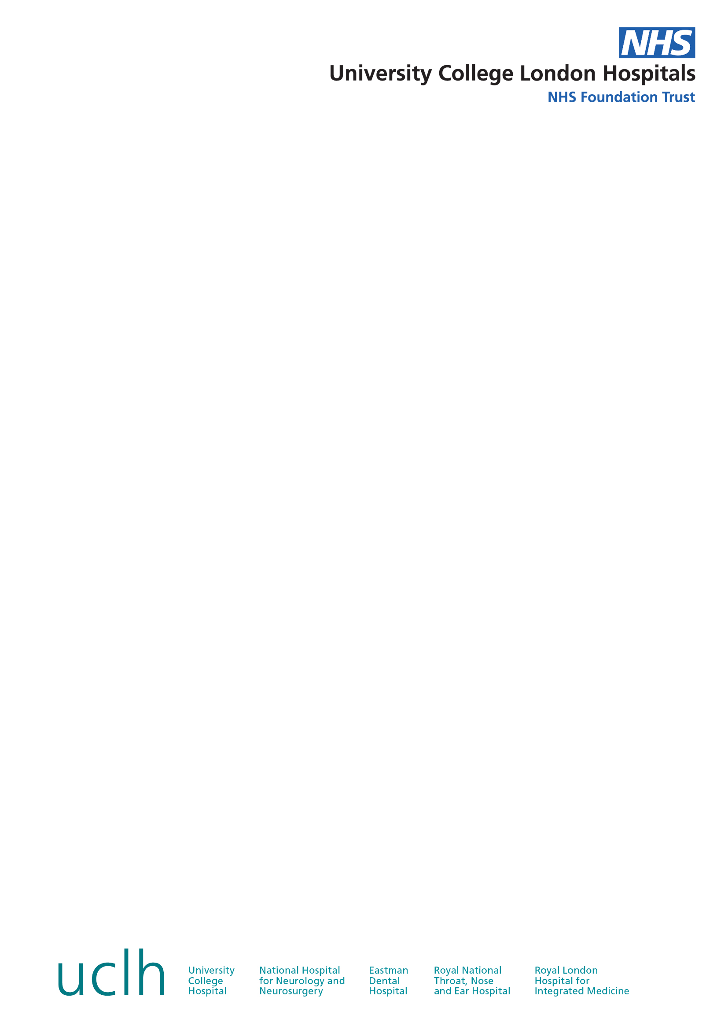

Informed Consent: V1.1 (25Feb2021) Royal National ENT and Eastman Dental Hospitals

Principal Investigator: Prof. Francesco D’Aiuto 47-49 Huntley Street

Study Number: Perio-19-68 Bloomsbury, London

IRAS ID: 286856 WC1E 6DG

REC No: 21/YH/0015

**PARTICIPANT INFORMATION SHEET**

Diabetes, Hypertension and COVID Exposure Screening in Tertiary Care Dental Setting (DIHSCO)

## *Please read this document carefully.*

## *Please ask if you do not understand or would like more information.*

**1. Invitation to participate**

### You are being invited to participate in a research study. The following information is provided so that you can make an informed decision regarding your willingness to participate in this study. Feel free to discuss with family and friends and ask us if there is anything that is not clear or if you would like more information.

**2. Background and purpose**

On a global level, there is an astonishingly rapid rise in the prevalence of non-communicable diseases (NCDs). NCDs are defined as diseases which are non-transmissible amongst individuals. Two of the most common diseases being diabetes and high blood pressure, in which the rate of unidentified cases is continually rising. Recent figures have estimated that between one to five million individuals remain undiagnosed for diabetes and high blood pressure in the UK, as both rarely cause symptoms in their early stages. Both of these conditions are major risk factors for coronavirus disease 2019 (COVID-19) severity and a majority of global COVID-19 deaths were related to these two conditions, therefore prevention and early detection of these is key. Furthermore, emerging evidence has shown that exposure to COVID-19 may increase the risk of future developments of co-morbidities and health complications.

The blood test for diabetes detection (HbA1c) can be used to reveal the level of blood sugar control over the previous two to three months in diabetic and non-diabetic individuals. “Finger prick” HbA1c testing is commonly used to provide immediate results and facilitate prompt management. In a non-diabetic patient, the HbA1c level should be below <42mmol/mol (6.0%) and above this level indicates possible pre-diabetes or diabetes. Clinic blood pressure can be measured on the upper arm with optimal systolic/diastolic levels below 120/80mmHg and normal in the range of 120-129/80-84mmHg. Anything above is indicative of possible pre-high blood pressure or high blood pressure. Screening and early diagnosis of both diabetes and high blood pressure is crucial as late diagnosis of these life-threatening conditions poses a significant health as well as economic risk.

Dental professionals have access to different groups of the population and members of the public may be more likely to visit their dentist than their general medical practitioner. Therefore, dentists may be in a fortunate position to access patients that are not seeking medical services elsewhere and ideally risk assess, offer preventative advice and screen for conditions such as diabetes and high blood pressure.

Therefore, the dental clinic may be a particularly unique and unrecognised opportunity for screening of such conditions, as they share common risk factors with oral diseases like gum disease (periodontitis). There is well established evidence linking diabetes with periodontitis and growing evidence supporting the link with high blood pressure. Consequently, there is merit for opportunistic screening of diabetes and high blood pressure in patients in a dental clinic, which could prove to be extremely valuable in early detection and intervention.

**4. Is my participation voluntary?**

It is up to you to decide whether you would like to take part in this study or not. If you decide to take part, you will be given this information sheet to keep and be asked to sign a consent form after which a copy will be given to you. The alternative is to not participate in this research study. Please note, if you opt not to participate then your dental care will not be affected. Even if you sign the consent form, you are still free to withdraw from the study at any time and you do not have to give a reason. The Investigator may discontinue your participation in the study at any time without your consent if it is decided that the study is not appropriate for you.

**5. What are the requirements for taking part?**

To take part in this study, you must be at least 18 years of age, in good general health, with a minimum of 20 teeth. You must read and sign the Informed Consent Form.

**6. What will happen to me if I decide to take part?**

Assessment of your eligibility to participate will take place at visit 1. Following this, visit 2 (if required) will entail the data collection including HbA1c point-of-care ‘finger prick’, blood pressure measurements, height and weight demographics in order to measure body mass index (BMI) and COVID-19 screening. If time permits, visit 1 and visit 2 can be performed together in the same visit. If deemed appropriate, a letter shall be sent to your GP for further investigation dependent upon the clinic readings of HbA1c, blood pressure and COVID-19 antigen tests. If we advise sending a letter to your GP with the findings, we would recommend that you contact your GP yourself to arrange an appointment to discuss further management (if any).

**Visit 1:**

This visit will be your appointment to the new patient clinic and during this appointment we shall assess your eligibility to participate. You will have the opportunity to ask questions to the study staff.

**Visit 2:**

If you wish to take part, you will be asked to sign two copies of the consent form. Data to be collected will include HbA1c point-of-care ‘finger prick’ (which will includes a droplet of blood which is then immediately disposed of), blood pressure measurements, height and weight demographics in order to measure body mass index (BMI) and COVID-19 screening. COVID-19 screening involves antigen and antibody testing. Antigen testing involves a nose and throat swab whereas antibody testing involves a ‘finger prick’ droplet of blood which is then promptly disposed.

As noted above, if time permits visit 1 and visit 2 can be combined and performed together as one visit.

**7. What will happen to the samples I give?**

The finger prick sample will be discarded after the result is read (performed immediately after collected).

**8. Are there any restrictions I will have to comply with if I take part?**

No restrictions are required of you during this study.

**9. Are there any possible risks from the study measurements?**

The study measurements are all minimally invasive and carry the low risk of pain, bruising, bleeding and infection.

**10. What are the possible benefits in taking part?**

The benefits include screening measurements for the level of glycaemic, blood pressure control and COVID-19. This may potentially highlight levels of pre-diabetes/diabetes and/or pre-hypertension/hypertension in which further investigation may be required with your GP to facilitate the opportunity of addressing this as appropriate. In the event you receive a COVID-19 positive antigen test, we will refer to the UCLH standard procedure for COVID-19 patients to prevent the spread of infection.

**11. Will I be paid for taking part in this study?**

There will be no financial remuneration for taking part in the study.

**12. Will my taking part in this study be confidential?**

Yes, only UCL Eastman Dental Institute staff will know that the information is related to you and this information is kept separate and confidential.

Only data needed to meet the study objectives will be collected. Throughout the study, all data will be identified only by a unique identification number. Your name is never entered into the electronic database.

**13. General Data Protection Regulation (GDPR) and Data Protection Act 2018 for health and care research**

UCL is the sponsor for this study based in London, UK. We will be using information from you and/or your medical records in order to undertake this study and will act as the data controller for this study. This means that we are responsible for looking after your information and using it properly.

Your rights to access, change or move your information are limited, as we need to manage your information in specific ways in order for the research to be reliable and accurate. If you withdraw from the study, we will keep the information about you that we have already obtained. To safeguard your rights, we will use the minimum personally-identifiable information possible.

You can find out more about how we use your information at https:/ /www.ucl.ac.uk/legal-services/ucl-general-data-protection-regulation-gdpr or by contacting: [gdpr@ucl.ac.uk](mailto:gdpr@ucl.ac.uk). If you are concerned about how your personal data is being processed, or if you would like to contact us about your rights, please contact UCL in the first instance at data-protection@ucl.ac.uk.

UCLH will collect information from you and/or your medical records for this research study in accordance with our instructions. Only your initials, date of birth and trial identification number, will be used for identification.

UCLH will keep your name, contact details, and biological samples confidential and will not pass this information to UCL. UCLH will use this information as needed, to contact you about the research study, and make sure that relevant information about the study is recorded for your care, and to oversee the quality of the study. Certain individuals from UCL and regulatory organisations may look at your medical and research records to check the accuracy of the research study. UCL will only receive information without any identifying information. The people who analyse the information will not be able to identify you and will not be able to find out your name, NHS number, or contact details. UCLH will keep identifiable information about you from this study for 20 years after the study has finished.

UCL will collect information about you for this research study from UCLH. UCLH will not provide any identifying information about you to UCL. We will use this information to for additional data analysis.

When you agree to take part in a research study, the information about your health and care may be provided to researchers running other research studies in this organisation and in other organisations. These organisations may be universities, NHS organisations or companies involved in health and care research in this country or abroad. Your information will only be used by organisations and researchers to conduct research in accordance with the UK Policy Framework for Health and Social Care Research.

Your information could be used for research in any aspect of health or care and could be combined with information about you from other sources held by researchers, the NHS or government. Where this information could identify you, the information will be held securely with strict arrangements about who can access the information. The information will only be used for the purpose of health and care research, or to contact you about future opportunities to participate in research. It will not be used to make decisions about future services available to you, such as insurance. Where there is a risk that you can be identified your data will only be used in research that has been independently reviewed by an ethics committee.

**14. Complaints**

If you wish to complain or have any concerns about any aspect of the way you have been approached or treated by members of staff during your participation in the research, then National Health Service or UCL complaints mechanisms are available to you. Please ask your research doctor if you would like more information on this. In the unlikely event that you are harmed by taking part in this study, compensation may be available.

If you suspect that the harm is the result of the Sponsor’s (University College London) or the hospital's negligence, then you may be able to claim compensation. After discussing with your research doctor, please make the claim in writing to Professor D’Aiuto, who is the Chief Investigator for the research, and is based at UCL Eastman Dental Institute. The Chief Investigator will then pass the claim to the Sponsor’s Insurers, via the Sponsor’s office. You may have to bear the costs of the legal action initially, and you should consult a lawyer about this.

If you have a concern about any aspect of this study, you should ask to speak to the researchers who will do their best to answer your questions, contact details are at the end of the document. If you remain unhappy and wish to complain formally, you can do this via the hospital’s Patient Advisory Liaison Service (PALS).

Royal National ENT and Eastman Dental Hospitals, 47-49 Huntley St, Bloomsbury, London WC1E 6DG

Tel: 020 3446 7890

**15. Study results**

The results of this study will be presented at scientific meetings or published in scientific journals. Results will be presented as summary measures only and no individual data will be identifiable. A summary sheet of findings will be provided to participants if interested and upon request to the chief investigator.

**17. How have patients and public been involved in the study?**

An appreciation of the ever-increasing healthcare and financial burden of NCDs such as diabetes and hypertension led us to design this study in an attempt to utilise other healthcare professionals and environments such as the dental clinic.

**Who is organising and funding the research?**

This research study is being organised by UCL. The study is sponsored by UCL and funded by BHR Pharmaceuticals Limited. BHR Pharamceuticals Limited will be providing the point of care Quo-Test analyser for HbA1c testing, the Cardiocheck PA blood analyser for cholesterol testing, the BioCredit Covid-19 AG antigen test and the Covid-19 antibody test with all relevant reagents.

**18. Ethical approval of the study**

All research in the NHS is reviewed by an independent group of people, called a Research Ethics Committee which is there to protect your safety, rights, wellbeing and dignity. This study has been reviewed and given a favourable ethical opinion by the {INSERT REC NAME}.

**19. Is there a contact to ask questions regarding this study?**

You have the right to ask questions about this study at any time. You will be informed about any change to the study that might concern you. Should you have questions, please contact the research site on 0203 456 1276 or Professor Francesco D’Aiuto/Dr Jeanie Suvan during normal office hours.

**Thank you for taking the time to read this information sheet.**

**A copy of this information sheet and a signed consent form will be given to you.**