**INTRODUCTION:**

Nigeria, a country in West Africa with a population of about 185 million is administratively divided into 36 states and the federal capital territory. Each state is divided into a number of Local Government Areas (LGAs).

The proposed project is to be carried out in Ogbaru LGA which is one of the 21 LGAs in Anambra state, south east of Nigeria. Ogbaru LGA is politically divided into 16 wards, with a total population of 294,342 projected from the 2006 national population census figure. The sex distribution is 152, 469 males and 141, 873 females. It covers an area of 458km2 with a population density of 643/km2. It is located in the tropical rain forest belt, along the south-eastern bank of the River Niger and is bordered by Imo and Rivers States to the south, and Onitsha North, Ihiala, Idemili North and Ekwusigo LGAs to the East, and Onitsha south to the North. Along its western border, it is separated from Delta state by the River Niger. The pre-dominant occupations are farming and fishing.

The project will be carried out in two communities – Okpoko and Ogbakuba in Ogbaru LGA. Okpoko community is an urban suburb of the renowned trading town Onitsha where the largest market in West Africa is located. Ogbakuba on the other hand is a rural community located by the bank of the River Niger. Okpoko community is served by 2 primary health centres and 10 Health Posts while Ogbakuba has only one Primary health centre. The project will make use of one Primary health centre each in the two communities as the focal health facilities.

Neglected Tropical Diseases (NTDs) are a group of communicable diseases associated with poverty and mainly found in areas with poor access to good sanitation, water and housing.[1] In Nigeria, it is estimated that 122 million people are at risk of these diseases. NTDs with established endemicity in Nigeria include Leprosy, Buruli ulcer (BU), Lymphatic Filariasis (LF), Trachoma, Dengue Fever, Onchocerciasis, Schistosomiasis (SCH), Soil transmitted helminths (STH), Human African Trypanosomiasis (HAT), Leishmaniosis, Guinea Worm and Rabies.[2]

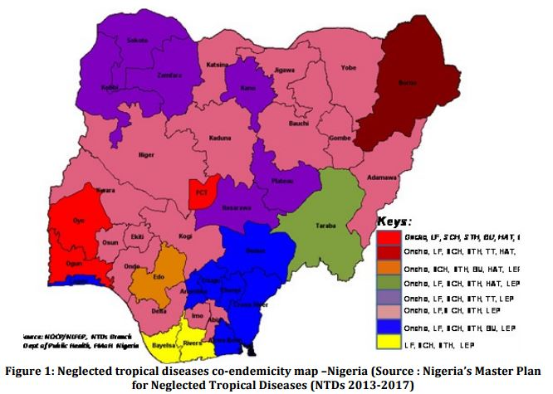

According to Okorie P. N. et al (2013), the mean prevalence of LF in Nigeria is 14% by circulating filarial antigen (CFA) and 8% by microfilaria (Mf) smear. The prevalence of LF in Anambra state is estimated to be 18.8% by CFA[3]. The result of a prevalence survey done in the second quarter of 2016 has not yet been released. Surveillance data on the number of patients with lymphoedema and hydrocele is also not available. However, Ogbaru LGA has been established to be endemic for LF, SCH and STH.

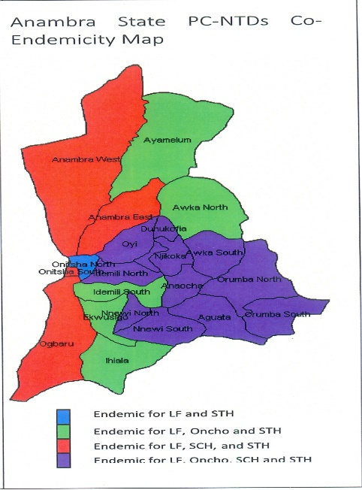

Prevalence data for BU and Leprosy in Nigeria are not available[4]. In 2015, a total of 2,892 cases of leprosy were notified ,15% (447) of which had grade 2 disability (G2D). Anambra state in 2015 reported 11 cases of leprosy with a registered prevalence of 1.8/100000 population. Prevalence data for NTDs in Ogbaru LGA is not available. However, in 2015, 1 case of leprosy and 10 cases of BU were notified from the LGA. Community level data for Okpoko and Ogbakuba is also not available.

NTDs incapacitate the sufferers especially when treated late leading to impaired growth development, reduced cognitive ability, prolonged absence from school for school-age children and inability to engage in economic activities which all impact negatively on national productivity.[5]

There has been considerable investment in the control of these diseases in Nigeria especially in mass administration of medicines (MAMs). However, there is still a huge gap in the morbidity management and disability prevention (MMDP) component. Factors contributing to the gap include poor capacity of healthcare workers, non- involvement of patients and families in care, knowledge gap in the causes and management of NTDs as well as myths and beliefs surrounding the diseases in various settings in the country.

In November 2016, a team from ALM and GLRA visited the two communities (Okpoko and Ogbakuba) in Ogbaru LGA of Anambra State and interacted with healthcare workers and community members including those with wounds and limb swelling. The communities were chosen due to the presence of health workers and community volunteers that had been trained and were involved in morbidity management of some NTDs like Buruli Ulcer. Notwithstanding the cause of their morbidity (wound, edema etc.), many patients ascribed their ailments to witchcraft and other spiritual causes. This was also reflected in the type of care they sought and employed. Most patients interviewed preferred traditional treatment first for their illness. Many talked about using other means like anti poison oil, hot water, spirits, procaine, Shea butter and herbs in taking care of the wounds. Finally, while the patients appreciated being taken care of in the health centre most of them expressed a preference to be to taught how to take care for their ailment at home.

To overcome these barriers, it is important to support affected individuals and communities with information and resources they need to free themselves from the yoke of these diseases and regain meaningful dignity and hope in their lives. German Leprosy and TB Relief Association (GLRA), an ILEP partner, has been supporting control of Leprosy and BU in 15 states in Southern Nigeria with a well-established MMDP component. This experience in supporting morbidity management services and social economic rehabilitation to persons suffering from Leprosy and BU will be invaluable in extending such services to persons affected by other NTDs.

This pilot project aims to improve access to and availability of **integrated** NTD morbidity management services in two communities in Ogbaru Local Government Area in Anambra state, Nigeria. It will also seek to actively enhance self-care practices by patients and as well as promote collaboration at all levels in the control of NTDs.

**PROBLEM STATEMENT**: In the quest to eradicate NTDs, provision of morbidity management services for patients in addition to preventive services is essential. However, despite many similarities, there is wide disparity in availability of and access to morbidity management services of NTDs in Ogbaru LGA of Anambra State. Morbidity management services are available only in health centres supported by the National Tuberculosis, Leprosy and Buruli Ulcer Control Programme (NTBLCP) for patients with CM-NTDs like BU and Leprosy but are not available for patients with morbidities due to PC-NTDs or in other health centres. The dearth of MMDP services is a socioeconomic burden to the patients, community and nation at large. During a visit to two communities in the LGA in December 2016, the burden of morbidities to patients and lack of services were very apparent. An integrated approach in providing MMDP services to patients with NTDs is required. This should leverage and improve existing structures and services, improve access to MMDP services, promote self-care and access to specialized services and contribute to the overall goal of eliminating NTDs in Nigeria.

**PROJECT GOAL AND STRATEGIC OBJECTIVES**:

**Project Goal**Improve availability and accessibility of MMDP services for people affected by NTDs and involve people affected, their families and communities in self-care and MMDP issues

**Strategic Objectives for Ogbaru LGA**

1. Improve knowledge & skills of health care system and communities in Ogbaru L.G.A. to identify, provide care and manage NTD complications locally or refer.
   * Conduct a 5-day non-residential training of GHWs on integrated management of NTDs including morbidity management using the ‘Ten steps’ monograph
   * Conduct regular (monthly) supervision of GHWs using the ‘Ten steps’ checklist
2. Promote knowledge and skill transfer about self-care from HCW to people affected by NTDs
   * Provide standard operating procedures for morbidity management and self-care training.
3. Increase and Improve practices of Self-care of people affected by NTDs
   * Provide health education on self-care by GHWs using the ‘Ten steps’ monograph
   * Refer for specialized care (surgery, physiotherapy) for patients that require it

**METHODOLOGY**:

**Strategy/Approach:**

A survey will be conducted at the beginning to establish a baseline of the NTDs situation and care practices in the two focus communities. The survey will employ both qualitative (Focus group Discussions [FGD] and Key informant interview [KII]) and quantitative - interviewer administered questionnaire- methods. Subsequently, there will be capacity building of 6 health care workers and program staff on integrated morbidity management of NTDs. This will be in form of a workshop and preceptorship during supervisory visits. The trained health care workers are expected to transfer self-care skills to patients with various forms of morbidity from endemic NTDs in the community. Finally, a survey will be conducted at the end to evaluate the project.

**Timeline**: The project is to last a total of nine months and consists of two phases;

* + - * A 3-month pre-implementation phase for advocacy, trainings and the design and production of novel tools to be used.
      * A 6-month implementation phase

**Budget**: $36,485.16. (see attached budget breakdown).

**Monitoring and Evaluation**:

1. Establish baseline information through rapid needs assessment.
2. Design and produce recording and reporting tools
3. Monthly report from TBLS/GHW to GLRA
4. Monthly monitoring and supervisory visits by 2 LGA staff (NTDs/TBLCP) to the communities
5. Quarterly monitoring and supervisory visits by the STBLCP/NTDs staff
6. Monthly monitoring and supervisory visits by GLRA staff (MA and M&E).
7. Post project survey

**Expected results**:

1. Improved knowledge and capacity of 10 Health Care Workers in Ogbaru L.G.A to identify, treat and refer patients requiring NTD management
2. Increased transfer of knowledge about self-care from HCW to patients
3. Improved Self-care practices among NTD patients/community members

**REFERENCES**:

1. Hotez, P. J., Molyneux, D. H., Fenwick, A., Kumaresan, J., Sachs, S. E., Sachs, J. D., & Savioli, L. (2007). Control of Neglected Tropical Diseases. New England Journal of Medicine, 357(23), 2407–2408. JOUR. <https://doi.org/10.1056/NEJMc072881>
2. Nigeria, Federal Ministry of Health, (2016). Nigeria Multi - Year Master Plan for Neglected Tropical Diseases (NTDs) 2015-2020.
3. Okorie, P. N., Ademowo, G. O., Saka, Y., Davies, E., Okoronkwo, C., Bockarie, M. J., … Kelly-hope, L. A. (2016). Lymphatic Filariasis in Nigeria; Micro-stratification Overlap Mapping ( MOM ) as a Prerequisite for Cost- Effective Resource Utilization in Control and Surveillance, 7(9). <https://doi.org/10.1371/journal.pntd.0002416>
4. Ukwaja, K. N., Meka, A. O., Chukwuka, A., Asiedu, K. B., Huber, K. L., Eddyani, M., … Ntana, K. (2016). Buruli ulcer in Nigeria: results of a pilot case study in three rural districts. Infectious Diseases of Poverty, 5, 39. <http://doi.org/10.1186/s40249-016-0119-8>
5. Paulo, S. (2009). Neglected tropical diseases in brazil, 51(5), 247–253. <https://doi.org/10.1590/S0036-46652009000500003>