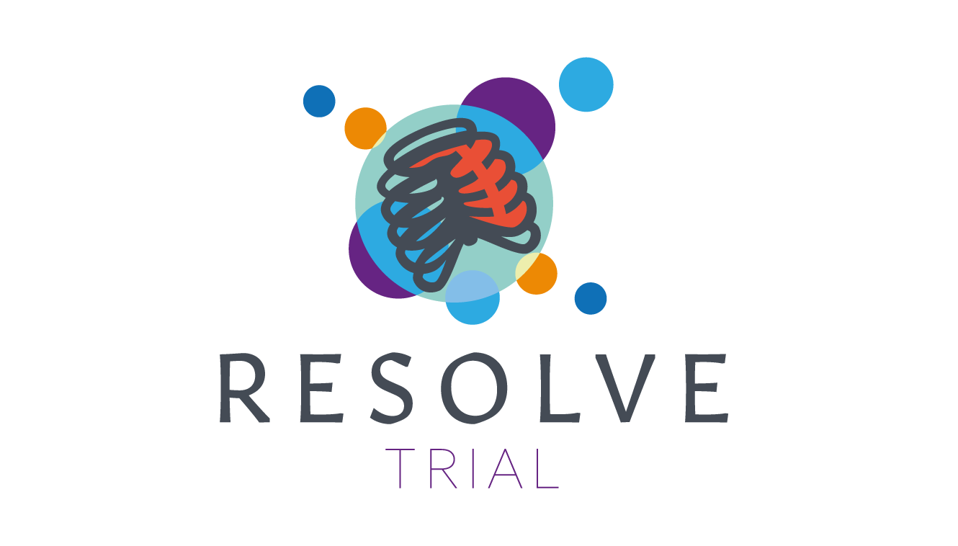
Randomised Evaluation of incentive Spirometry in OLder adults with rib fractures to preVEnt pulmonary complications: RESOLVE

DETAILED PARTICIPANT INFORMATION SHEET
Please note: for the purpose of this information sheet,
any reference to ‘we’ means the study Sponsor (North Bristol NHS Hospital Trust).
The RESOLVE Study Office
Bristol Trials Centre
Chief Investigator: Kate Coates
Trial Coordinator: Stephen Palmer
Tel: 0117 455 8184
Email: resolve-trial@bristol.ac.uk
Study website: resolve.blogs.bristol.ac.uk
IRAS ID: 349783 & 365245

Within this information sheet:
PART A: Why is the study being done? 3
1. What is the purpose of the RESOLVE study? 3
2. Is it suitable for me to take part? 3
PART B: What does taking part in the study involve? 4
1. What will happen to me if I agree to take part? 4
2. What else is involved in the study? 4
3. What are the possible benefits and disadvantages or risks of taking part in this study? 5
4. Will my GP be informed? 5
5. What if I don’t want to take part in the study anymore? 5
6. What happens if I lose mental capacity during the study? 5
7. What if something goes wrong? 6
8. Will my taking part in this study be kept confidential? 6
PART C: Further information about the study and what will happen to your data if you take part 7
1. How will we use information about you? 7
2. How will we use information about you after the study ends? 7
3. What are your choices about how your information is used? 7
4. Where can you find out more about how your information is used? 8
5. What will happen to the results of the research study? 8
6. Can the study information be used to help with other research? 8
7. Have patients and the public been involved in the study? 8
8. Who is organising the research? Who has reviewed the study? 8
RESOLVE STUDY TEAM CONTACT DETAILS 9

PART A: Why is the study being done?

You are being invited to take part in a research study. It is important for you to understand why the research is being done and what it will involve. You are welcome to ask us any questions. Thank you for taking the time to read this information.

If you have already read the Summary Participant Information Sheet and provided written informed consent, but on reading this more detailed information pack you would like to amend (or withdraw) your consent, please speak with a member of the study team. More information about changing your mind is available in section 5 (page 5).

What is the purpose of the RESOLVE study?
Thousands of older people are taken to hospital each year with broken ribs. They are painful and can make it harder to take a deep breath or cough. Over half of older people with broken ribs develop problems during their recovery, like chest infections, because they can’t take deep breaths. We think that a breathing exercise device called an ‘incentive spirometer’ may help to prevent these problems. The incentive spirometer encourages people to take a deeper breath. Incentive spirometers are already given to some patients who have had an operation. They aren’t used everywhere for patients with broken ribs because we don’t know yet whether they help with recovery.
This research will help us find out if using an incentive spirometer reduces problems, like chest infections, in the first 5 days after patients come into hospital.

Is it suitable for me to take part?
We are looking for 276 participants (aged 65 years or older), who have been admitted to a UK hospital with broken ribs, to take part in our research.
You have been given this Participant Information Sheet because you have broken at least one rib. If the doctors looking after you feel it would be best for you to stay in hospital, it may be suitable for you to take part in the study. It is up to you whether you would like to take part or not. If you decide not to take part, your usual care will not be affected in any way. Your doctors and nurses will double check if you are suitable to take part before you are included.

PART B of this information sheet explains what taking part in this study involves. Please continue over the page for more information.

PART B: What does taking part in the study involve?

What will happen to me if I agree to take part?

- A healthcare professional will ask you to complete a form (known as a consent form) confirming you understand the study and agree to take part. You will be given a summary information sheet, this more detailed information sheet and a copy of your completed consent form to keep.
- You will then be put into one of two groups. Being entered into either of these groups will not affect the care you receive for your broken ribs.
- One group will receive standard care for your injury (current usual care; Group 1) and the other group will be given an incentive spirometer in addition to standard care (Group 2).
GROUP 1 - TREATMENT WITH CURRENT USUAL CARE: you will be treated in the normal way whilst in hospital, including being taught breathing exercises.
GROUP 2 - TREATMENT WITH CURRENT USUAL CARE PLUS USE OF INCENTIVE SPIROMETER: you will be treated in the normal way whilst in hospital, but you will also be given an incentive spirometer. You will be shown how to use the device by a trained member of staff, given an educational leaflet and shown where to find an instruction video online. You should use the spirometer 3 times a day; you will be given a diary and asked to record this for 5 days.

- To make sure the two groups are the same, you will be put into a group randomly, so that you have an equal chance of receiving either treatment. No one will be able to predict which group you will be in.
- All participants will have their rib injury assessed, have any other injuries treated, be given pain relief, and be monitored according to usual care of this hospital. You should not need to undergo any extra tests or spend any extra time in hospital as a result of taking part in this study.
- After you have been allocated to a group, a member of the research team will collect some information about you, your general health, your injuries and medical treatments from you and your medical records.
- If you can, we will also ask you to complete some questionnaires about your pain and breathing; this could happen the day or the day after you join the study. We may ask a patient representative (such as your partner or a family member) to support you to provide some of this information, if you are too unwell to do this.

What else is involved in the study?

- If you are allocated to Group 2 and are given an incentive spirometer, you will receive training on using the device. You will be asked to try to use the spirometer regularly throughout the day for the first 5 days you are in hospital. To help the research, we will ask that you complete a diary about your use of the spirometer.
- All patients in the study will be asked to complete questionnaires on their pain and breathing around 5 days after joining the study. You may still be in hospital then but, if not, the research team will call you and complete these with you over the telephone.
- Around 30 days after you join the study, a researcher will also look at relevant parts of your medical notes to see if you have any further treatments or complications, and to record details of your care (e.g., how long you stayed in hospital).
- Patient perspectives and experience are extremely important to this research and there are additional opportunities to get involved. For more information, please get in touch using the contact details on the final page.

What are the possible benefits and disadvantages or risks of taking part in this study?
Benefits. We cannot promise that the study will benefit you directly, however it will help us decide on the best ways to care for people with broken ribs in the future. The benefit to patients, the NHS and society is that at the end of the study, it will be known if incentive spirometers reduce health complications in patients with broken ribs. We are unable to offer any payment or expenses for taking part in the study.
Disadvantages or risks. Given that some NHS hospitals already safely use incentive spirometers and some do not, there are unlikely to be any risks. However, because we are using them in injured patients, the safety of all participants will be closely monitored by an independent group of experts.
In recognition of your time, we will offer you £20 vouchers at day 5, after the completion of all patient questionnaires.

Will my GP be informed?
Yes. Your GP Practice will be informed in writing that you are taking part in this study. We do this so they know you’re in the study, and so we can access medical records relevant to this study. With your permission, we may tell your doctor/GP if we have concerns about your health or well-being during your time in the study. If, however, there is a risk of harm to you or others, we may share such information without your consent.

What if I don’t want to take part in the study anymore?
You can stop participating in the study at any time without giving a reason. Your medical care and legal rights will not be affected.
If you no longer want to complete questionnaires (or other optional elements of the study) that is OK. In this situation, we will continue to collect relevant information from your medical notes, without bothering you, unless you tell us you don’t want us to.
If you wish to stop participation completely, we will confidentially keep any information (data) collected about you up to the point of withdrawal to include in our analysis of the study results.

What happens if I lose mental capacity during the study?
In some cases, it is possible that due to an acute medical problem you may experience (temporary) mild to moderate confusion or loss of capacity during the study. If this happens:
For patients in England, Wales & Northern Ireland:
We will seek advice from a Personal Consultee about whether you should remain in the study. A Personal Consultee is an individual who knows you well (i.e. your partner, relative, or a particular friend or unpaid carer).
For patients in Scotland:
We will seek advice from a Personal Legal Representative (i.e. a Welfare Guardian or Welfare Attorney, or if not in place, then your nearest relative) about whether you should remain in the study.
Those providing advice on behalf of a patient must ensure that they put aside their own feelings and wishes and consider what the past and present feelings and wishes of the person they are providing advice on behalf of would have been, had they been able to consent for themselves.
If your Consultee/Personal Legal Representative does not think it is suitable for you to remain in the study, then your participation in the study will stop. In this case, we will confidentially keep any information (data) collected about you up to that point to include in our analysis of the study results.
If you were to regain capacity after a Consultee/Personal Legal Representative has agreed to you remaining in the study (e.g. once your acute medical problem has resolved), your original consent will remain valid and we will not repeat the consent paperwork with you again. However, staff will remind you of ongoing study procedures and you will have the right to withdraw at any time.
Similarly, if a Consultee/Personal Legal Representative provided initial advice to support your involvement in this study, you later regain capacity and provide your own consent but subsequently lose capacity again, the consultee/Personal Legal Representative will not be re-approached: their original advice will continue to apply. They will have the right to withdraw you at any time.

What if something goes wrong?
If you are unhappy about any aspect of this study, the doctor or nurse looking after you in the hospital will do their best to address your concerns and/or answer your questions.
In the unlikely event that something does go wrong and you are harmed during the study, there are no special compensation arrangements. If you are harmed and this is due to someone's negligence, then you may have grounds for a legal action for compensation against the Sponsor (North Bristol NHS Trust), but you may have to pay your legal costs. The normal National Health Service (NHS) complaints mechanisms will still be available to you.

Will my taking part in this study be kept confidential?
Yes, all information collected about you during the study will be kept strictly confidential. Your data will be stored and used in compliance with the current data protection laws; Data Protection Act 2018 and General Data Protection Regulation 2025 (GDPR).
Relevant sections of your medical notes and relevant (electronic) records and information collected during the study may be looked at by authorised individuals from the Sponsor or its representatives, University of Bristol, your local NHS Trust and the regulatory authorities, where it is relevant to you taking part in this research. The Sponsor (North Bristol NHS Trust) and the University of Bristol will act as joint data controllers for this study. This means that they are both responsible for looking after your information and using it properly. The University of Bristol, on behalf of the Sponsor, will keep identifiable information about you for 5 years after the study has finished.
QR code to be entered here
Optional: If you have a smartphone, hover the camera over this black and white picture (a ‘QR code’). Click on the link and it will take you directly and securely to a video explaining the study

PART C of this information sheet explains in more detail about what will happen to your data if you take part in this study. Please continue over the page for more information.

PART C: Further information about the study and what will happen to your data if you take part

How will we use information about you?
We will need to use information from you, your medical records and/or from your GP for this research project. This information will include your:
- NHS/CHI number
- Name
- Sex and/or Gender
- Ethnicity
- Date of birth
- Contact details (for example: postcode, telephone number, email address)

People will use this information to do the research or to check your records to make sure that the research is being done properly. People who do not need to know who you are will not be able to see your name or contact details. Your data will have a code number instead.
North Bristol NHS Trust is the sponsor of this research and are responsible for looking after your information.
We will share some of your information with “Sealed EnvelopeTM”. This is the company that provides the computer software that randomly decides which treatment group you are allocated to. Your local researcher will provide this company with the minimum relevant information about you to enable the randomisation process. They must follow our rules about keeping your information safe.
We will keep all information about you safe and secure. Personal information such as your name, email address and phone number will be stored on a secure database with the central research team (University of Bristol) to allow us to contact you about questionnaires and other study related activities.
Your data will not be shared outside the UK.

How will we use information about you after the study ends?
Once we have finished the study, we will keep some of the data so we can check the results. We will write our reports in a way that makes sure no-one will know that you took part in the study.
We will keep your study data for 5 years. The study data will then be fully anonymised and securely archived or destroyed.

What are your choices about how your information is used?
- You can stop being part of the study at any time, without giving a reason, but we will keep the information about you that we have already collected to that point.
- If you choose to stop taking part in the study, we would like to continue collecting information about your health from central NHS records, your hospital and/or your GP without bothering you again. If you do not want this to happen, tell us and we will stop.
- You have the right to ask us to access, remove, change or delete data we hold about you for the purposes of the study. You can also object to our processing of your data. We might not always be able to do this if it means we cannot use your data to do the research. If so, we will tell you why we cannot do this.
- If you agree to take part in this study, you will have the option to take part in future research using your data saved from this study.

Where can you find out more about how your information is used?
- You can find out more about how we use your information at: https://www.hra.nhs.uk/patientdataandresearch
- Our leaflet “How we use information from patients” available from: https://resolve.blogs.bristol.ac.uk/
- At the University of Bristol website: www.bristol.ac.uk/secretary/data-protection/policy/research-participant-fair-processing-notice/
- At the North Bristol NHS Trust website: https://www.nbt.nhs.uk/research-innovation/take-part-research/patient-research-studies
- By asking one of the research team: see last page
- By sending an email to: resolve-trial@bristol.ac.uk, or by ringing us on: 0117 455 8184

What will happen to the results of the research study?
We aim to complete this research in mid-2027 (may be subject to change). Once available, results will be published in medical journals and presented at conferences attended by healthcare professionals. Updates and results will also be made accessible to participants and the wider public via our website, and potentially in a short film, for example. You will not be personally identified in any report/publication.

Can the study information be used to help with other research?
It is important that good quality research data can be shared with others to advance clinical research and benefit patients in the future. After the end of the study, anonymised information collected during the study may be made available to other researchers under an appropriate data sharing agreement, but it will not be possible to identify you personally from any information shared.

Have patients and the public been involved in the study?
Yes. Patient volunteers have helped us design this research and continue to be involved in all aspects. If you would like to become a patient volunteer to help shape this research or future injury research then you can let us know by email (resolve-trial@bristol.ac.uk) or by ringing us on 0117 455 5321.

Who is organising the research? Who has reviewed the study?
Doctors and researchers from North Bristol NHS Trust and the University of Bristol are leading this research. The study is funded by a grant awarded by the National Institute for Health Research (NIHR208172). Your doctors will not be paid for including you in this study. All research in the NHS is looked at by an independent group of people, called a Research Ethics Committee, to protect your interests. This study has been reviewed and given favourable opinion by (name of REC) and the Health Research Authority. An independent oversight committee will monitor the study to ensure it is conducted according to good research practice.

THANK YOU FOR READING THIS INFORMATION SHEET.
PLEASE KEEP A COPY FOR YOUR RECORDS.

RESOLVE STUDY TEAM CONTACT DETAILS
LOCAL (HOSPITAL) RESEARCH TEAM
Local Principal Investigator(s): [insert name]
Local Research Nurse(s): [insert name]
Local Contact Details: [insert as appropriate e.g. telephone number, address]
Local PALS Contact Details: [insert details]
STUDY OFFICE (University of Bristol): see front page.

Acknowledgements and Disclaimers: This study is funded by the National Institute for Health Research (NIHR) Health Technology Assessment (HTA) Programme (NIHR208172). The views expressed are those of the author(s) and not necessarily those of the NIHR or the Department of Health and Social Care. This study was designed and delivered by the Bristol Trials Centre, a UKCRC registered clinical trials unit, which is in receipt of National Institute for Health Research CTU support funding. This study is sponsored by North Bristol NHS Trust.

