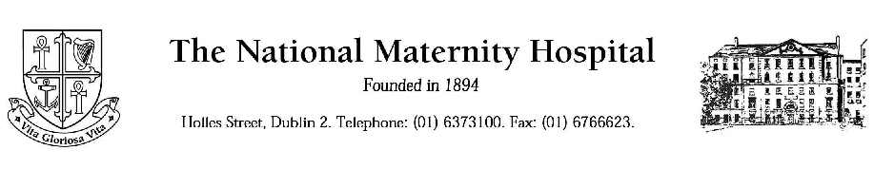

Title: : Is six hours fasting time enough in term pregnancy? An ultrasound study of the stomach of fasted pregnant patients who are ≥ 36 weeks pregnant to determine if the 6hours fasting time before an operation is enough in pregnancy.

INFORMATION FOR PATIENTS

You are invited to participate in a Research Project that is explained below.

Thank you for taking the time to read this Information Statement. It is 3 pages long. Please make sure you have all the pages.

Title of the Research Project
Is 6 hours fasting time enough in term pregnancy? A prospective observational study to determine the residual gastric volume in fasted pregnant patients of ≥36 wks gestation.

What is the Research Project about?

1.Fasting before surgery is very important in order to save the patient from any complication related to aspiration [which means any food going into the lungs] when the patient is put to sleep called general anaesthesia.
2.We have guidelines from our anesthesiology societies, which suggest a minimum of 6 hours fasting time after a light meal e.g., tea and toast, 2 hours for clear fluids and 8 hours for a full meal.
3.These guidelines are similar in pregnant and non-pregnant patients.
4. Pregnant women are at increased risk of aspiration because of the various changes that occur during pregnancy.
5.The aim of our study is to see whether 6 hours fasting time is enough in term pregnancy, which will be done by a simple ultrasound scan of patient’s stomach.

What is expected from you?

1.If you agree to take part, you will be asked to sign a consent form.
2. The ultrasound of your stomach will be performed at your first antenatal visit after 36 weeks.
3. You will receive a phone call by the anesthetist doing the scan a day or two before your antenatal appointment and advised about the fasting times & what time to attend the hospital.
4. You will be expected to be fasting for six hours after a light meal i.e., tea and toast for this study.
5. The anesthetist will perform an ultrasound scan of your stomach. It will take approximately 5 min to perform the scan.
6.You can eat and drink anytime after the scan.
7. Your antenatal appointment with the midwife or obstetrician will occur after the stomach ultrasound.

Who are the Researchers?

The Department of Anesthesia, National Maternity Hospital, and Holles Street organize this study. Dr Larry Crowley, a consultant anesthetist, is the supervisor of the study; and Dr Sheeba Hakak is the principal investigator

Why I being asked to participate in this research project?
All suitable women who are ≥36weeks pregnant are being invited to join the study

Is there likely to be a benefit to me or will there be potential benefits to improve future medical care?

You will not benefit directly from taking part in this study but the information we will obtain may provide further knowledge about the duration of minimum fasting times required in term pregnant patients.

What will my role be in this Research Project?
You will be a passive participant.

What are the possible risks, discomforts, side effects or inconveniences?
Ultrasonography is a non-hazardous test, and does not cause any harm to the patient or the baby. However you will have to come fasting for 6 hours for the ultrasound to be carried out.

What measures will be taken to ensure confidentiality?
Your identity will remain confidential. A study number will identify you. Your name will not be published or disclosed to anyone.

At the completion of the project, will I be informed of the research outcome?
Yes, if you wish. We anticipate that the results will be known by the end of this year

If you require non-English versions of the Information Statement and Consent Form, please ask for it to be provided in your language.

More Information?

You may wish to discuss participation in this research project with your family and with your doctor. Please feel free to ask for further information before
deciding if you will take part. If more information is required please contact: Drs. Sheeba hakak: Dr Larry Crowley. ________________________

My rights as a Participant

- I am informed that no information regarding my medical history will be divulged and the results of any tests involving myself will not be published so as to reveal my identity.

- The detail of the procedure proposed has also been explained to me, including the anticipated length of time it will take, the frequency with which the procedure will be performed and an indication of any discomfort which may be expected.

- Although I understand that the purpose of this research project is to improve the quality of medical care, it has also been explained that my involvement may not be of any benefit to myself.

- I have been given the opportunity to have a member of my family or a friend present while the project was explained to me.

- I understand that this research project has been approved by the Research Ethics Committee of the National Maternity Hospital

- I have received a copy of this document for my records

Name and phone number of emergency contact (also the person(s) to contact first if you require more information or have any concerns related to the study):
Dr Sheeba Hakak, Dr Larry Crowley.
Phone (01) 6373100

