**Participant Flow**



**Baseline Characteristics**



**Outcome Measures**

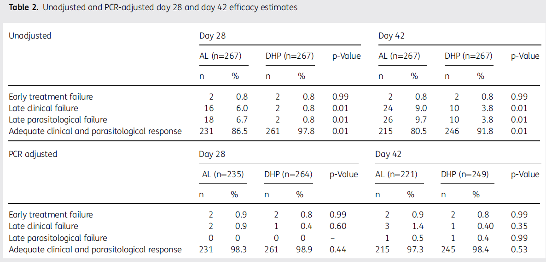

**Adverse Events**

There were no adverse events associated with this trial.