

**LONDON’S GLOBAL UNIVERSITY**

**Neurotherapeutics Group**

Institute of Cognitive Neuroscience

17 Queen Square

London

WC1N 3AZ

Telephone: **020 7679 1134**

**Participant Information Sheet: ATTEND clinical trial**

**You will be given a copy of this information sheet to keep.**

|  |  |  |  |  |  |  |  |  |  |
| --- | --- | --- | --- | --- | --- | --- | --- | --- | --- |
| **Title:** | **A**ttentional **T**herapy for the **T**r**E**atment of **N**eglect **D**isorder (**ATTEND**) | | | | | | | | |
| **Name of Chief investigator** | | | | Professor Alex Leff | | | | | |
| **REC Number** | | 20/LO/1061 | **IRAS** | | 276250 | **Version** | 4.0 | **Date** | 23.11.2020 |

# Invitation to take part

We would like to invite you to take part in our research study. Before you decide, we would like you to understand why the research is being done and what it would involve for you. One of our team will go through this information sheet with you and answer any questions you have. This should take about 5-10 minutes. You should talk to others about the study if you wish.

Ask us if there is anything that is not clear. Please, take time to decide whether or not you wish to take part. Your treatment will not be affected in any way if you decide not to take part.

# At a glance, this is the contents of this participant information sheet

* Purpose of the study
* Why you have been chosen
* Do you have to take part
* What will happen in the study if you choose to take part
* What will you have to do and when.
* Possible benefits of taking part
* Possible risks or side effects involved
* Expenses and Payments
* Restrictions during the study
* Reasons you may not take part
* What if something goes wrong

**What is the purpose of the study?**

We are doing RESEARCH into inattention after a STROKE.

Inattention after a stroke means that a person has difficulty paying attention to things on their right OR their left side. Having problems paying attention to the LEFT side after stroke is the most common.

Eye scanning exercises after stroke can help the brain to recover its ATTENTION to the left side. Virtual reality games played on a computer can be an enjoyable way to exercise these eye movements.

In this study we want to find out whether practising moving your eyes left and right (scanning) in a virtual reality game, will IMPROVE how your eyes scan afterwards. We are studying the effects of a new computer-based scanning therapy called ‘ATTEND’ to see if we can improve this type of attention, which can be damaged after a stroke.

As with a lot of research we need to prove that it is this new therapy that causes the change in people’s symptoms. This means that we will randomly allocate 50% of participants to the new therapy (we call this the **therapy stimulation**) and that the remaining 50% of participants will receive something that looks like the therapy but it is not (we call this the **control stimulation)**. We intend to make both activities fun and engaging. If you agree to be part of the research we will assign you to either the therapy group or the control group. We will not tell you which group you are in until after the end of study.

We will also TEST some of your VISUAL and THINKING skills. You will have the choice to complete all, some or none of these tasks.

# Why have I been chosen?

You have been chosen because you have had a STROKE.

Your BRAIN has been INJURED by the stroke.

We are looking for people who have a problem looking and responding to the left (or right) side of space or of the body, caused by a stroke to take part in the study.

Inattention can occur from damage usually to the RIGHT side of the brain. It can cause difficulty with processing vision, movement and sensations on the left side of space or left side of the body.

# Do I have to take part?

No you do not have to take part. YOU decide whether or not you want to take part. Taking part will NOT affect your standard care.

If you decide to take part, you will be asked to sign a **CONSENT FORM**.

You can change your mind and STOP taking part at any time. You don’t need to give a reason for changing your mind.

If you don’t want to take part, this will NOT affect the standard of your medical care.

# What will happen if I take part?

We will ask you to take part in up to **15 sessions, face to face,** spread out over **12 weeks.** Some sessions will be spent testing your responses on thinking tasks and questionnaires and some will be spent in virtual reality stimulation. Throughout we will check for any side effects from the virtual stimulation therapy. If these persist you can withdraw at any time.

This study will START while you are in hospital and will END when we follow you up 12 weeks after the last stimulation session.

The study will require intensive practice with ATTEND, completing **4 sessions** of **10 minutes** virtual reality stimulation per day. It will continue for **5 days** a week for **up to three weeks**, whilst you are in hospital.

In summary, during the intensity practice time you will be asked to spend just over **1½ hours** with our research team per day for a continuous 5 days (Monday – Friday only).

We would like to interview you about your experience of the virtual reality stimulation in a face-to -face interview with one of the researchers. These interviews will ***be either filmed or audio recorded.*** *You will have choice over whether we record or film the session and the recordings will be used as part of the evaluation of the therapy. The recordings will be stored on a UCL secure server with your other data, transcribed and accessed only by the research team, and kept by the lead researcher for up to 10 years.*

Please consider these requirements CAREFULLY when deciding whether or not to participate.

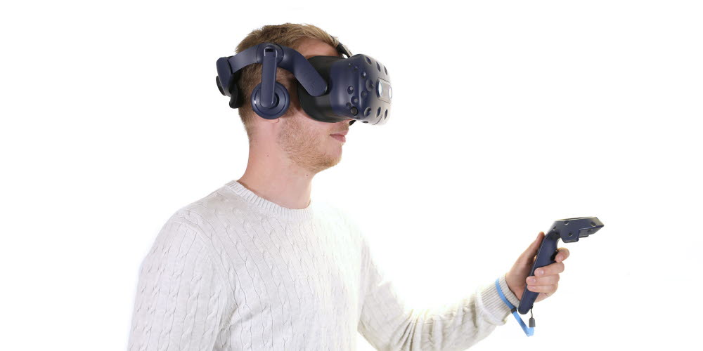

# If I take part, what will I have to do and when will I do it?

This is a diagram of the time point we will use in the study.

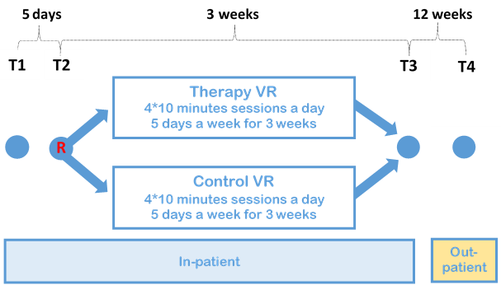

Below is a more detailed table about what will happen at each time point and the tasks you will be asked to participate in.

|  |  |  |
| --- | --- | --- |
| **Schedule of Events by Timepoint** | | |
| Timepoint | Event | Timings |
| T1  Day 1 | We will make a note of your basic demographic information (e.g. age, gender)  You will have some standard tests of your eye movements, inattention symptoms and thinking skills (Baseline neuropsychological screen).  We will check your probability for possible side effects from the virtual reality therapy (Baseline symptom questionnaire). | ~2 hours |
| T2  Day 5 | You will have daily (5 days a week) tests of your eye movements (Free Visual Exploration Paradigm) and inattention symptoms.  You will be placed in either Group 1 or Group 2 (Therapy or Control group)  **Virtual reality stimulation starts**  The Research team will administer stimulation in 10 minute sessions a day, 5 days a week for up to 3 weeks.  We will check daily (5 days a week) for possible side effects from the virtual reality therapy. | ~ 1 hour |
| T3  End of week 4 | You will have tests of your eye movements Free Visual Exploration Paradigm) and inattention symptoms.  We will interview you about your experience of the stimulation.  We will check for possible side effects from the virtual reality therapy. | ~ 1.5 hours |
| T4  Follow up at 12 weeks | You will have tests of your eye movements Free Visual Exploration Paradigm) and inattention symptoms. | ~ 1.5 hours |

# What are the possible benefits of taking part?

The study will provide information useful to the study of stroke recovery.

The study MAY improve your ability to look and respond to the left (or right) and improve some of your inattention symptoms, but this CANNOT BE GUARANTEED. If you are in the control group your symptoms may not get better.

# Are there any risks or side-effects involved?

Since we are asking you to complete an intensive therapy programme you will spend a lot of time using a virtual reality headset. The effects of prolonged use of virtual reality can include **eye strain, nausea** or **virtual reality sickness** and sometimes a feeling of **anxiety**.

If you experience any of these side effects we will strongly encourage you to STOP using the virtual reality headset and take a break. The research team will be with you throughout the stimulation.

The virtual reality headsets we will be using are CE marked. This is a certification mark that shows the headset conforms with health, safety and environmental protection standards for products within Europe.

# What restrictions do I need to follow during the study?

We ask that you do not drink alcohol for 12 hours before testing or your scheduled virtual reality stimulations as this may affect your experience. Otherwise you can eat and drink as normal.

You should take ALL your medications as USUAL during the study.

# **Expenses and Payments**

We cannot offer direct compensation for time spent taking part in the study. However we can REIMBURSE any travel expenses incurred on your journey to and from the study (up to £50). We can also provide lunch or compensation for lunch. This will be at the 12 week appointment as an outpatient.

Please keep all public transport receipts for your journey. If you are driving, UCL reimbursement policy can offer £0.45 per mile for your journey.

# Are there any reasons why I can’t take part in the study?

You may not be able to take part in the study if you have:

* Any serious health problems apart from your stroke.
* If you suffer from motion sickness or vertigo and experience symptoms whilst using the virtual reality headsets.
* If your care team are planning to discharge you home within a few days of the trial starting.

# What if something goes wrong?

If you wish to complain, or have any concerns about any aspect of the way you have been approached or treated by members of staff due to your participation in the research, National Health Service or UCL complaints mechanisms are available to you. Please ask your research doctor if you would like more information on this. In the unlikely event that you are harmed by taking part in this study, compensation may be available.

If you suspect that the harm is the result of the Sponsor’s (University College London) or the hospital's negligence then you may be able to claim compensation. After discussing with a member of the research team, please make the claim in writing to Professor Alex Leff who is the Chief Investigator for the research and is based at the Institute of Neurology, UCL. Professor Leff will then pass the claim to the Sponsor’s Insurers, via the Sponsor’s office.

You may have to bear the costs of the legal action initially, and you should consult a lawyer about this.

If you have a concern about any aspect of this study, you should ask to speak to the researchers who will do their best to answer your questions, contact details are at the end of the document. If you remain unhappy and wish to complain formally, you can do this via the hospital’s Patient Advisory Liaison Service (PALS). Their contact details appear here:

Site: University College London Hospitals NHS Foundation Trust

Address: Ground Floor Atrium, University College Hospital, 235 Euston Road, London NW1 2BU

Tel: 020 3447 3042

Email: uclh.pals@nhs.net

# What happens if I withdraw from the study?

You can STOP being part of the study at any time, without giving a reason, but we will keep information about you that we already have, unless you request us to delete it.

In the unlikely event that you lose capacity to consent during your participation in the study, you would be withdrawn from the study but we would retain your existing data.

**How will my information be used and kept secure?**

**(General Data Protection information)**

We will need to use information from your medical records for this research project.

This information will include your

* Name
* NHS number
* Contact details
* Age
* Gender
* Stroke Diagnosis
* Other health information

People will use this information to do the research or to check your records to make sure that the research is being done properly.

People who do not need to know who you are will not be able to see your name or contact details. Your data will have a code number instead.

We will keep all information about you safe and secure.

We MAY need to inform your GP and therapist (if you have one) to let them know you are involved in the study.

Once we have finished the study, we will keep some of the data so we can check the results. We will write our reports in a way that no-one can work out that you took part in the study.

Your personal data will be stored SECURELY at University College London, on a University computer with all names removed so that you cannot be identified.

When the research study is over your research data will be disposed of securely after 20 years.

**What are my choices about how my information is used?**

You can stop being part of the study at any time, without giving a reason, but we will keep information about you that we already have.

We need to manage your records in specific ways for the research to be reliable. This means that we won’t be able to let you see or change the data we hold about you.

**Where can I find out more about how my information is used?**

You can find out more about how we use your information

• at www.hra.nhs.uk/information-about-patients/

• by asking one of the research team

• by sending an email to [alexander.leff@nhs.net](mailto:alexander.leff@nhs.net), who is the principal investigator for this research or

• by ringing the principal investigator on 020 7679 1129

• by emailing the Sponsor’s Data Protection Officer on: [data-protection@ucl.ac.uk](mailto:data-protection@ucl.ac.uk) or <https://www.ucl.ac.uk/legal-services/privacy>

# Will my ward-based therapists be involved?

We will INFORM your ward based therapists (if you have them) for example, your physiotherapist or occupational therapist, to let them know you are involved in the study.

# What happens when the research study stops?

The results of the study will be reported in medical and scientific JOURNALS or at conferences. None of the study participants will be identified in any report or publication. We will inform you about these publications and how to access them after the study is over by email.

When the study is over we will also send you a SUMMARY of the results via post or email.

# Who is organising and funding the research?

This study is organised by the Institute of Neurology (part of University College London).

It is sponsored by UCL.

It is funded by the National Institute for Health Research (NIHR).

Professor Alex Leff is the Chief investigator. Please contact Alex or any member of the research team if you have any questions, using the contact details below.

# Who has reviewed this study?

This study has been reviewed and given favourable opinion by the Bromley Research Ethics Committee and the Health Research Authority.

**How have patients and the public been involved in the study?**

In planning research, we recognise that everyone has expertise, lived experiences and novel insights relating to our research, which can add value to a study. In preparation for this study, we involved patients and the public (PPI) and invited people to advise on the design of this form, the research, and to help us manage the research, undertake the research, and peer review on how to analyse of results and dissemination of findings.

**Contacts for further information:**

Chief Investigator: Professor Alex Leff

Institute of Cognitive Neuroscience

University College London

17 Queen Square

London

WC1N 3AR

T: 020 7679 1129

E: [alexander.leff@nhs.net](mailto:alexander.leff@nhs.net)

**Research Team**

Dr Catherine Doogan

E: [c.doogan@ucl.ac.uk](mailto:c.doogan@ucl.ac.uk)

T: 020 7679 1134

Henry Coley-Fisher:

E: henry.coley-fisher.15@ucl.ac.uk

T: 020 7679 1134

Thank you very much for taking the time to consider your involvement in our study. Please keep this copy of the information sheet and do not hesitate to contact us if you have further questions.