**Study Title:**  Effect of obstructive sleep apnoea on retinal vasculature reactivity following CPAP withdrawal.

**Internal Reference Number / Short title:** Obstructive sleep apnoea and retinal vasculature reactivity

**Ethics Ref: 14/SC/1235**

**Date and Version No: 03/02/2016 5.0**

|  |  |
| --- | --- |
| **Chief Investigator:** | **Prof John Stradling**, Churchill Hospital Campus, University of Oxford |
| **Investigators:** | **Dr Christopher Turnbull,** Churchill Hospital Campus, University of Oxford  **Dr Rebekka Heitmar**, Aston University, Birmingham  **Dr Shyam Madathil**, Queen Elizabeth University Hospitals Birmingham NHS Foundation Trust  **Dr Syed Huq**, Queen Elizabeth University Hospitals Birmingham NHS Foundation Trust  **Dr Brendan Cooper**, Queen Elizabeth University Hospitals Birmingham NHS Foundation Trust  **Professor Malcolm Kohler**, University of Zurich |
| **Statistician:** | **Mr Daniel Bratton,** MRC CTU at UCL |
| **Sponsor:** | University of Oxford |
| **Funder:** | ResMed Foundation  Research Fellow funded for one year from Oxford Radcliffe Hospitals Charitable Fund no. 0189 |
| **Chief Investigator Signature:** | signature.jpg |

**Conflicts of Interest:** No conflicts of interest relevant to this protocol

**Confidentiality Statement**

This document contains confidential information that must not be disclosed to anyone other than the Sponsor, the Investigator Team, host organisation, and members of the Research Ethics Committee, unless authorised to do so.

**TABLE OF CONTENTS**

1. SYNOPSIS 4

2. ABBREVIATIONS 5

3. BACKGROUND AND RATIONALE 5

4. OBJECTIVES AND OUTCOME MEASURES/ENDPOINTS 10

5. STUDY DESIGN 10

6. PARTICIPANT IDENTIFICATION 11

6.1. Study Participants 11

6.2. Inclusion Criteria 12

6.3. Exclusion Criteria 12

7. STUDY PROCEDURES 13

7.1. Recruitment 16

7.2. Informed Consent 16

7.3. Screening and Eligibility Assessment 17

7.4. Randomisation, blinding and un-blinding 18

7.5. Baseline Assessments 19

7.6. Visits and phone calls 19

7.7. Discontinuation/Withdrawal of Participants from Study 19

7.8. Definition of End of Study 20

8. INTERVENTION 20

9. SAFETY REPORTING 20

9.1. Definition of Serious Adverse Events 21

10. STATISTICS AND ANALYSIS 21

10.1. Description of Statistical Methods 21

10.2. The Number of Participants 22

10.3. Analysis of Outcome Measures/Endpoints 22

11. DATA MANAGEMENT 23

11.1. Access to Data 23

11.2. Database 23

11.3. Data Entry and Query Management 23

11.4. Data Quality and Security 24

12. QUALITYASSURANCE PROCEDURES 24

13. ETHICAL AND REGULATORY CONSIDERATIONS 24

13.1. Declaration of Helsinki 25

13.2. ICH Guidelines for Good Clinical Practice 25

13.3. Approvals 25

13.4. Reporting 25

13.5. Participant Confidentiality 25

13.6. Expenses and Benefits 26

13.7. Other Ethical Considerations 26

14. FINANCE AND INSURANCE 26

14.1. Funding 26

14.2. Insurance 26

15. PUBLICATION POLICY 27

16. REFERENCES 27

17. APPENDIX C: AMENDMENT HISTORY 27

# SYNOPSIS

|  |  |  |
| --- | --- | --- |
| **Study Title** | Effect of obstructive sleep apnoea on retinal vasculature reactivity following CPAP withdrawal. | |
| **Internal ref. no. / short title** | Obstructive sleep apnoea and retinal vasculature reactivity | |
| **Study Design** | Randomised, controlled, double blind intervention | |
| **Study Participants** | Patients on CPAP for OSA | |
| **Planned Sample Size** | Up to 50 participants | |
| **Planned Study Period** | 18 months | |
|  | **Objectives** | **Endpoints** |
| **Primary** | a) To establish if OSA reduces retinal vascular reactivity | Retinal vascular response to flicker light protocol. Outcome measure will be the ‘intervention effect’ of OSA versus no OSA on retinal vascular reactivity following 14 days CPAP withdrawal, with appropriate controlling for baseline reactivity, OSA severity, BMI and cardio-vascular co-morbidities (via Pocock risk score). |
| **Secondary** | b) Does any change in retinal vascular reactivity correlate with OSA severity and/or change in markers of sympathetic activity. | Correlation between change in retinal vascular reactivity (from baseline to two weeks in the CPAP withdrawal arm), with the severity of OSA (>4%ODI) returning, and/or change in both heart rate and blood pressure in the same group (from home measurements over penultimate 3 days), |
| Tertiary Objectives (exploratory) | c) Does any change in retinal vascular reactivity and retinal vessel oxygen saturation variables correlate with changes in mRNA expression. | Collection of blood samples for later analysis of mRNA expression. |

# ABBREVIATIONS

|  |  |
| --- | --- |
| CI | Chief Investigator |
| CRF | Case Report Form |
| CTRG | Clinical Trials & Research Governance, University of Oxford |
| GCP | Good Clinical Practice |
| GP | General Practitioner |
| ICF | Informed Consent Form |
| ICH | International Conference of Harmonisation |
| NHS | National Health Service |
| NRES | National Research Ethics Service |
| OXTREC | Oxford Tropical Research Ethics Committee |
| PI | Principal Investigator |
| PIL | Participant/ Patient Information Leaflet |
| R&D | NHS Trust R&D Department |
| REC | Research Ethics Committee |
| SOP | Standard Operating Procedure |
| OSA | Obstructive sleep apnoea |
| CPAP | Continuous positive airway pressure |
| PVT | Psychomotor vigilance test |
| KSS | Karolinska sleepiness scale |
| OSLER test | Oxford Sleep Resistance Test |
| DVA | Dynamic vessel analyser |
|  |  |

# BACKGROUND AND RATIONALE

Obstructive sleep apnoea

Obstructive sleep apnoea (OSA) is a highly prevalent sleep-related breathing disorder characterized by a repetitive collapse of the pharynx during sleep, which results in apnoea or hypopnoea associated with repetitive oxygen desaturations, and arousals from sleep with consequent repetitive surges in blood pressure. In severe cases these repetitive drops in oxygen and surges in blood pressure occur more than every minute throughout the night (figure 1).

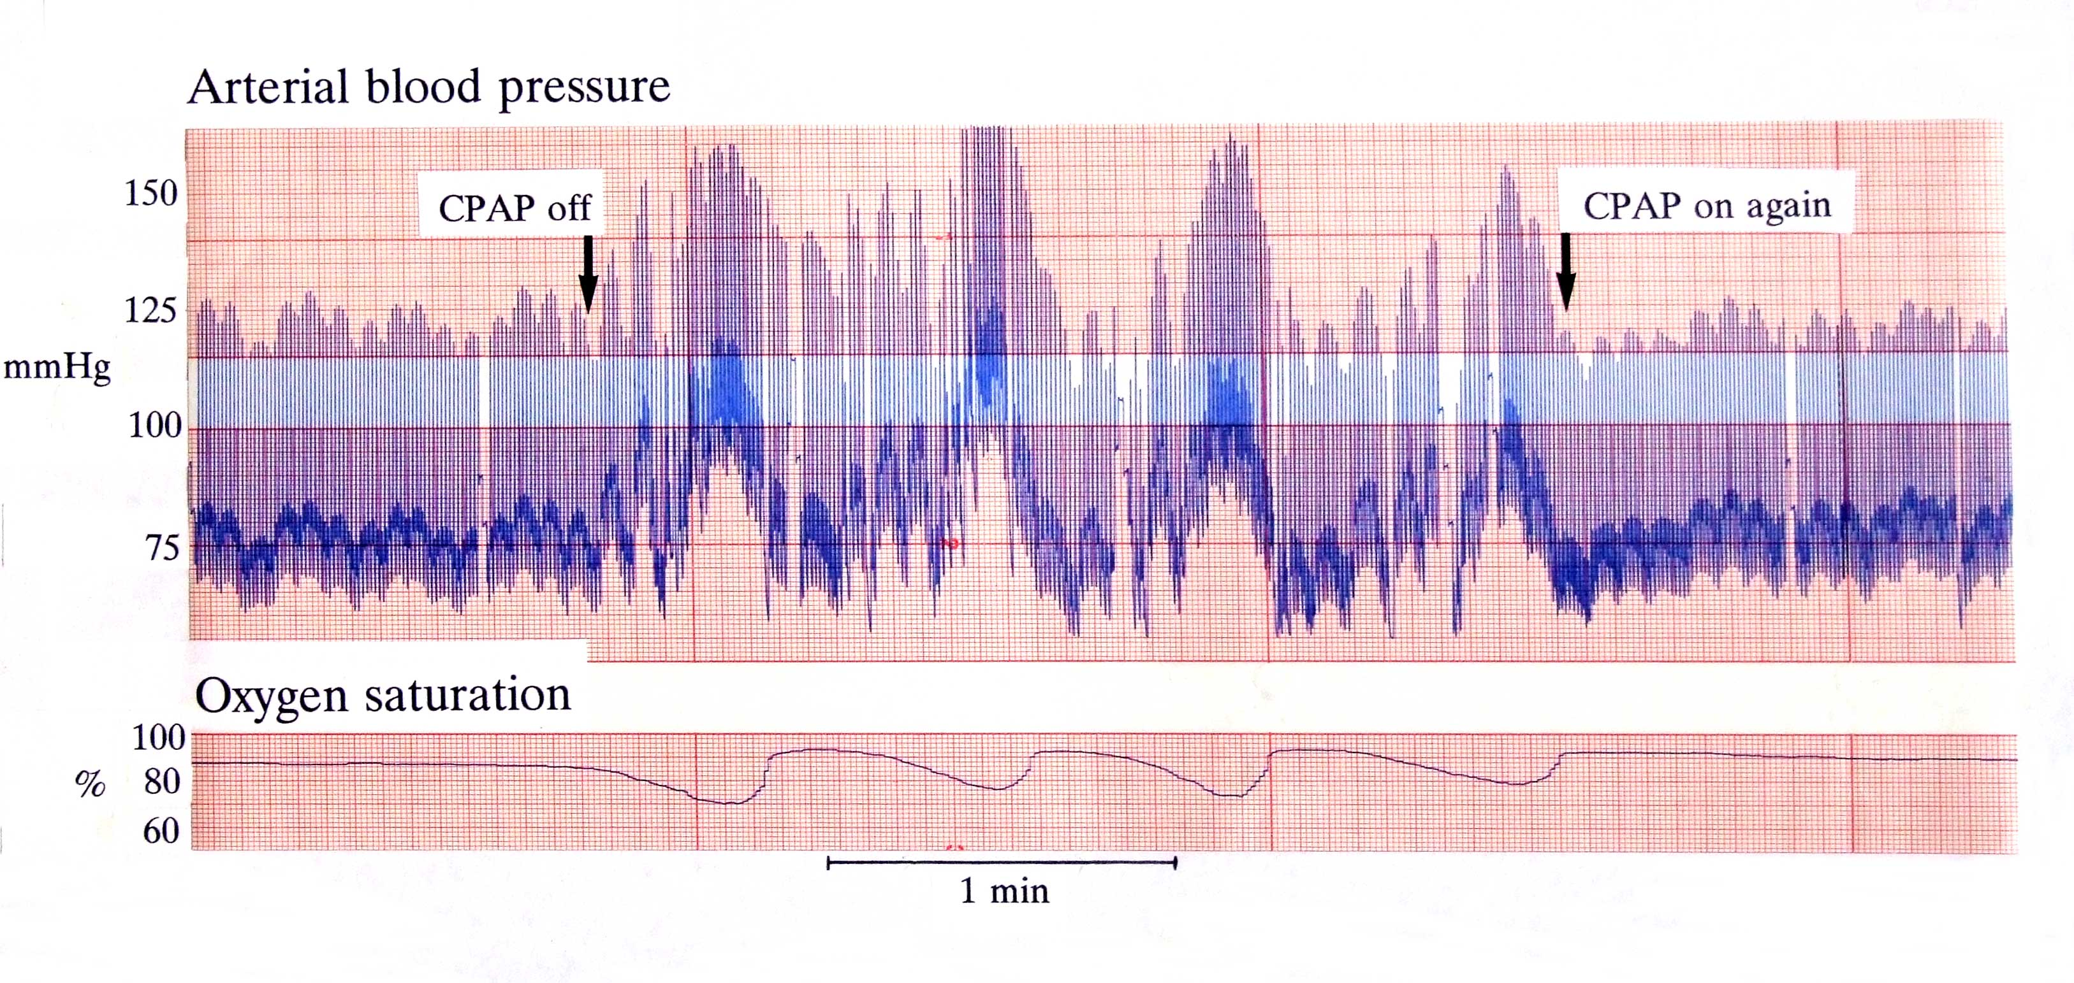

***Figure 1*** *Effect of turning CPAP on and off in a patient being treated with CPAP. Note the instant return of hypoxic dips (down to SaO2 70%, and a blood pressure surge (>75mmHg) with each arousal from sleep that terminates the apnoea.*

OSA affects up to 24% of the adult male population(1) and is associated with daytime sleepiness (2), risk of traffic accidents (3), arterial hypertension (4), vascular dysfunction (5) and cardiovascular events (6). In certain medical conditions, the prevalence is even higher, sometimes more than 50% (7).Intermittent hypoxia and reoxygenation (leading to increased oxidative stress and increased sympathetic activity), acute intra-thoracic pressure changes (leading to mechanical stress on the heart and large artery walls), and arousal-induced reflex sympathetic activation (with resultant repetitive blood pressure rises), are thought to be the most important mechanisms linking OSA to the above mentioned consequences of OSA (8).

**OSA and diabetic retinopathy**

An association between OSA and diabetic retinopathy has been suggested by our previous study which showed that retinopathy and maculopathy were both significantly worse in patients with OSA compared to those without OSA (7;9). The cause of this is not clear, but it may relate to the effect on the retina of the repetitive episodes of intermittent hypoxia, catecholamine surges and hypertension, all of which are found in OSA (figure 1).

In diabetic retinopathy the commonest cause of visual impairment is macula oedema caused by leakage of plasma from retinal capillaries (10). This seems to be related to the duration of diabetes, the blood pressure, lipid levels, and tightness of blood sugar control (11-15), although much variation remains unexplained (16). In addition there is loss of retinal vasculature autoregulation and vascular reactivity such that retinal capillaries are more susceptible to rises in blood pressure (17) and possibly ischaemia (18;19). This therefore leads to the question, would controlling the nocturnal apnoeas, desaturations and arousals with CPAP slow progression of, or even reverse, diabetic retinopathy. Proof of principle work has been undertaken by us with a small uncontrolled intervention study using CPAP for those people with type 2 diabetes, diabetic macular oedema and OSA (20). This study has shown some visual improvement following treatment with CPAP for the OSA. On average, there was central visual improvement of approximately one line when assessing visual acuity with the LogMAR test (similar to conventional Snellen chart) after six months CPAP treatment. The improvement was only seen in those who used their CPAP regularly. CPAP was only accepted by about half the patients during the 6 month study, and these patients elected to continue CPAP beyond the 6 month study period. These patients also experienced a reduction in sleepiness, the usual reason for treating OSA, and this improvement in their symptoms is the likely explanation for their wish to continue using CPAP. The response in vision was variable even within those who used their CPAP, with no structural clues from optical coherence tomography or static retinal photos as to the cause of any improvement in this small study. There is now a randomised controlled trial, run by Newcastle and Oxford (ISRCTN95411896), to establish whether these improvements in vision can be replicated and shown to be due to CPAP. A simple study showed that the improvement in sleepiness, a possible more prosaic explanation for improved ability to read the logMAR chart, was not the likely explanation(21). This Newcastle study is again finding a very high prevalence of OSA within a population of patients with diabetes and consequent retinopathy. The work proposed here, however, is designed to explore the potential mechanisms by which OSA might further damage the retina in patients with type II diabetes. Impairment of retinal vascular endothelial function and oxygen delivery/consumption may well be an early consequence of OSA that may not be of great significance in the normal retina, but be an important part of the pathophysiology in diabetic retinopathy and maculopathy where the vessels are already abnormal.

**Measuring retinal vascular reactivity**

The ability to directly visualize the retinal vasculature allows detailed measurement of vascular responses to changes in retinal metabolic demand. Computerised dynamic measurements of arterial and venous dimensions during a flickering light protocol (which greatly increases retinal oxygen demand) have been shown to correlate with changes in vascular reactivity in other organs (22;23), but the correlation is not strong, suggesting adverse factors may influence vascular beds differently. Poor retinal vascular reactivity has been shown to correlate with hypertension and markers of vascular risk (23;24), and is reduced in patients with diabetes and diabetic retinopathy (25;26). The current gold standard for measuring retinal vascular reactivity is with the Dynamic Retinal Vessel Analyser (DVA, IMEDOS Systems, Jena, Germany); in brief it consists of a Zeiss F450+ fundus camera with a coupled CCD camera and associated software capable of continuously measuring retinal vessel diameters (27). This is an entirely painless and harmless procedure. Aston University (Birmingham) is the only unit in the UK with one of these very expensive devices, and Dr Rebekka Heitmar is an acknowledged expert in its use and the interpretation of the results (28). In addition Dr Heitmar can measure oxygen saturation in the retina with the same device using a dual wavelength filter(29). The intention is therefore to recruit patients on CPAP from the Queen Elizabeth University Hospitals Birmingham NHS Foundation Trust sleep clinic (where they have over 1000 patients on CPAP), and potentially other sleep clinics in the region, to ensure minimum travel times for patients.

CPAP-withdrawal model

The most effective treatment for OSA is continuous positive airway pressure (CPAP). CPAP therapy withdrawal can efficiently investigate the effects of OSA on physiology, symptoms and cardiovascular risk in OSA (figure 1). This approach offers the possibility of including patients who have been compliant with CPAP for a long time, and in whom a maximal treatment effect can be assumed. Sleep units have large numbers of patients on CPAP (for example Oxford has >9,000), allowing the selection of specific sub-categories (e.g. by OSA severity) to approach for study consent. In a joint study between Professor Kohler (Zurich) and Professor Stradling(oxford) it was previously shown that short-term withdrawal of CPAP for two weeks leads to rapid recurrence of OSA, associated with sympathetic activation, deterioration of both blood pressure and endothelial dysfunction (5;30-32). This CPAP-withdrawal model developed by Zurich and Oxford will be used to investigate any changes in retinal vascular reactivity that can be attributed to OSA by studying patients before and after two weeks CPAP withdrawal, versus control subjects continuing on CPAP. In addition, we have shown this CPAP withdrawal model to be entirely safe, with no adverse consequences in the more than 130 patients who have undergone it so far.

**Rationale**

This study therefore builds on two aspects of our previous and current work in the area of OSA, vascular function and diabetic retinopathy. By measuring retinal endothelial function via retinal vascular reactivity, in patients after two weeks of OSA, versus two weeks of no OSA, we hope to establish whether reduced retinal vascular reactivity is a likely mechanism by which OSA contributes to diabetic retinopathy and macular oedema. Any significant correlation between the degree of OSA, and the degree of impaired retinal vascular reactivity, would further strengthen the evidence linking the two.

A potential limitation is that CPAP is only being withdrawn for two weeks, and it may take longer for OSA to influence vascular reactivity. However, in our previous similar two-week CPAP withdrawal studies, two weeks was long enough to significantly raise awake heart rate and diastolic BP, catecholamine excretion, and produce a significant deterioration in brachial artery endothelial function (5), the latter having been shown to correlate with retinal vessel reactivity (22).

If a link between OSA and impaired retinal vascular function is established (both reactivity and oxygen delivery/consumption), then this might indicate alternative therapeutic strategies to avoid the retinal damage from OSA in patients with diabetes. Although those with the usual symptom of OSA, excessive daytime sleepiness, may tolerate CPAP therapy, we and others have found that CPAP tolerance is reduced in those with few symptoms from their OSA. Since over half of patients with OSA and diabetic retinopathy do not have excessive daytime sleepiness, therapies other than CPAP would be required. For example there may be appropriate pharmacological approaches that target the pathophysiology. Given the high prevalence of OSA in diabetes, particularly those with maculopathy (50%), considerable numbers of patients stand to benefit (7).

# OBJECTIVES AND OUTCOME MEASURES/ENDPOINTS

|  |  |
| --- | --- |
| **Objectives** | **Outcome Measures/Endpoints** |
| Primary  a) To establish if OSA reduces retinal vascular reactivity | Retinal vascular response to flicker light protocol. Outcome measure will be the ‘intervention effect’ of OSA versus no OSA on retinal vascular reactivity following 14 days CPAP withdrawal, with appropriate controlling for baseline reactivity, OSA severity, BMI and cardio-vascular co-morbidities (via Pocock risk score). |
| Secondary  b) Does any change in retinal vascular reactivity correlate with OSA severity and/or change in markers of sympathetic activity. | Correlation between change in retinal vascular reactivity (from baseline to two weeks in the CPAP withdrawal arm), with the severity of OSA (>4%ODI) returning, and/or change in both heart rate and blood pressure in the same group (from home measurements over penultimate 3 days), |
| Tertiary Objectives (exploratory) c) Does any change in retinal vascular reactivity and retinal vessel oxygen saturation variables correlate with changes in mRNA expression. | Collection of blood samples for later analysis of mRNA expression. |

# STUDY DESIGN

We will conduct a randomised double-blind placebo-controlled trial in patients with moderate to severe OSA in whom their vascular reactivity will be compared between the subjects continuing CPAP (control group with no OSA), versus subjects receiving subtherapeutic CPAP (in whom OSA will return to a varying degree).

Patients with known obstructive sleep apnoea who are effectively treated with CPAP for at least 6 months, registered in the database of their sleep centre or attending clinic follow-up at their sleep centre , will be pre-screened for eligibility. Following identification and consent, patients will then undergo screening ambulatory nocturnal pulse-oximetry performed every night at home for a week (**visit 1** to collect oximeter and autoCPAP machine, record demographic data). For the first three nights, CPAP will be used as normal (to confirm adequate treatment of OSA with the autoCPAP machine). For the last 4 nights of this week of oximetry monitoring, CPAP will not be used; the oximetry on this 4-night period without CPAP will confirm return of OSA to the level specified in the entry criteria (oximeter returned **by post**). Following this they will continue therapy with CPAP for at least 2 weeks before entering the main study and performing baseline measurements (**visit 2**). These will include blood samples for later analysis of mRNA, standard office blood pressures and heart rate (after 15 minutes rest), and retinal vascular function measurements by Dr Rebekka Heitmar at Aston University. Thereafter participants will be randomised to the sub-therapeutic CPAP or therapeutic CPAP group(control group) for two weeks.

During the two weeks of study, patients will again use an overnight oximeter every night to ensure the continuing usage and efficacy of CPAP (in the control group), and to measure the degree to which OSA returns (in the CPAP withdrawal/sub-therapeutic group). In addition patients will monitor their BP twice a day during the two weeks trial period and record in a diary (these data are also recorded on the BP machine itself for download at study end). At the end of two weeks the baseline measurements will be repeated (**visit 3**): blood samples for later analysis of mRNA, standard office blood pressures and heart rate (after 15 minutes rest), and retinal vascular function measurements. Following this visit, patients will have completed the study and will return to their normal CPAP therapy.

The following information will be downloaded from the internal memory of the autoCPAP devices: hours on CPAP therapy, percent days with >4h of CPAP use, applied mask pressure, mask leaks and apnoea/hypopnoea index. This will be a further check that patients maintained the intended intervention in the two groups.

# PARTICIPANT IDENTIFICATION

## Study Participants

Participants will have previously diagnosed obstructive sleep apnoea, have already been on CPAP treatment for more than 6 months, and have a severity defined as >20/hr, >4%SaO2 dips, on an oximetry sleep study, during any of the four nights of CPAP withdrawal.

## Inclusion Criteria

1. Objectively confirmed obstructive sleep apnoea (at the time of original diagnosis) with an oxygen desaturation index (ODI, >4% dips) or AHI of >20 (this threshold will exclude participants with borderline OSA, in whom there may be little experimental effect)

2. Currently >20/h oxygen desaturations (>4% dips) returning on any night during home nocturnal pulse oximetry performed for a 4-night period without CPAP, prior to entry into the study.

3. Treated with CPAP for more than 6 months, minimum compliance 4h per night.

4. ODI <10 during treatment (obtained during the preliminary week of oximetry monitoring, from the first 3 nights of oximetry monitoring on CPAP, before the 4 nights CPAP withdrawal).

5. Age between 20 and 75 years at trial entry.

6. Written informed consent.

## Exclusion Criteria

1. Previous ventilatory failure (awake resting arterial oxygen saturation <93% or arterial PCO2> 6kPa) or severe respiratory disorders other than OSA.

2. Unstable, untreated coronary or peripheral artery disease, severe arterial hypertension (>180/110mmHg), severe arterial hypotension (<90/60mmHg).

3. Previously diagnosed with Cheyne-Stokes breathing.

4. Current professional driver

5. History of any sleep-related driving accident or other accident.

6. Acute inflammatory disease

7. Acute or chronic hepatic or renal disease.

8. Known type 1 or 2 diabetes (likely to have low retinal reactivity even on CPAP)

9. Known severe vascular disease (likely to have low retinal reactivity even on CPAP)

10. Mental or physical disability precluding informed consent or compliance with the protocol.

11. Non-feasible trial follow-up (for example, distance from follow-up centre, physical inability).

12. Epilepsy: flickering light used for retinal provocation could lead to a seizure

13. Lens opacities: this could lead to insufficient contrast and make it impossible to image the retinal vasculature.

# STUDY PROCEDURES

*Retinal vascular function and reactivity*

Retinal vascular function is measured using a high quality digital fundus camera (Zeiss FF450, Germany) capable of taking video images at 25 frames per second (IMEDOS, Jena, Germany). A computer program measures arterial and venous vessel diameters continuously at pre-specified locations. The digitised video signals are stored for later analysis, which enables the user to analyse additional vessels and/or additional segments of the same vessel. Following pupil dilation, baseline measurements are taken and then the eye is exposed to flickering light at 12.5HZ (video sample rate drops to 12.5 frames per second to accommodate the flicker). The standard protocol consists of 50s baseline measurements, followed by three cycles of 12.5 Hz flicker light for 20s and 80s recovery (figure 2). This protocol maximally increases retinal oxygen demand via an NO dependant pathway, and should lead to increased vessel diameter as blood flow increases in response. The % increase in arterial and venous diameter is the numerical expression of this phenomenon. Healthy values for maximal dilation are in the region of 3-7% and figures as low as 0.1-2.9% have been found in patients with diabetes but unknown OSA status. This test takes less than 10 minutes and is entirely harmless. Other more sophisticated analysis tools are in development by Dr Heitmar’s team and will also be used.

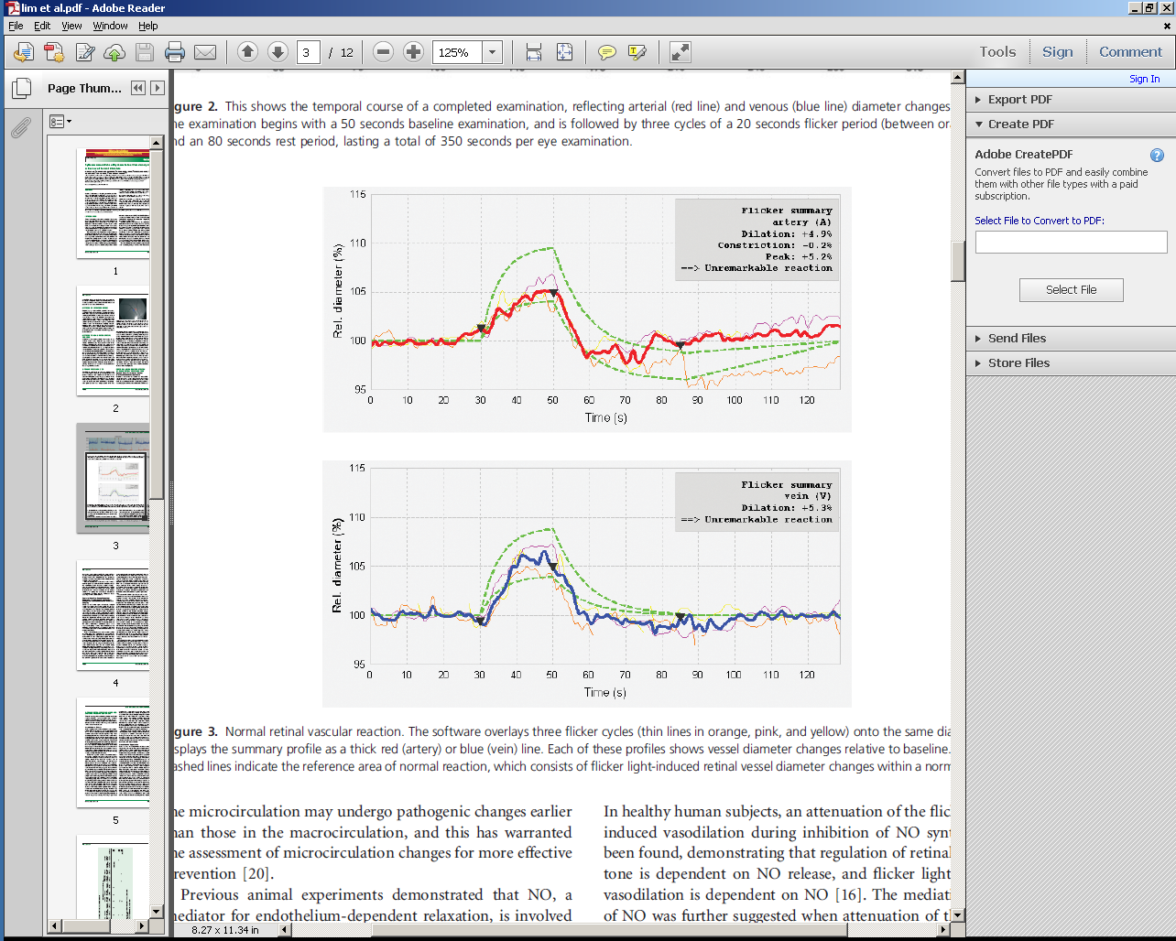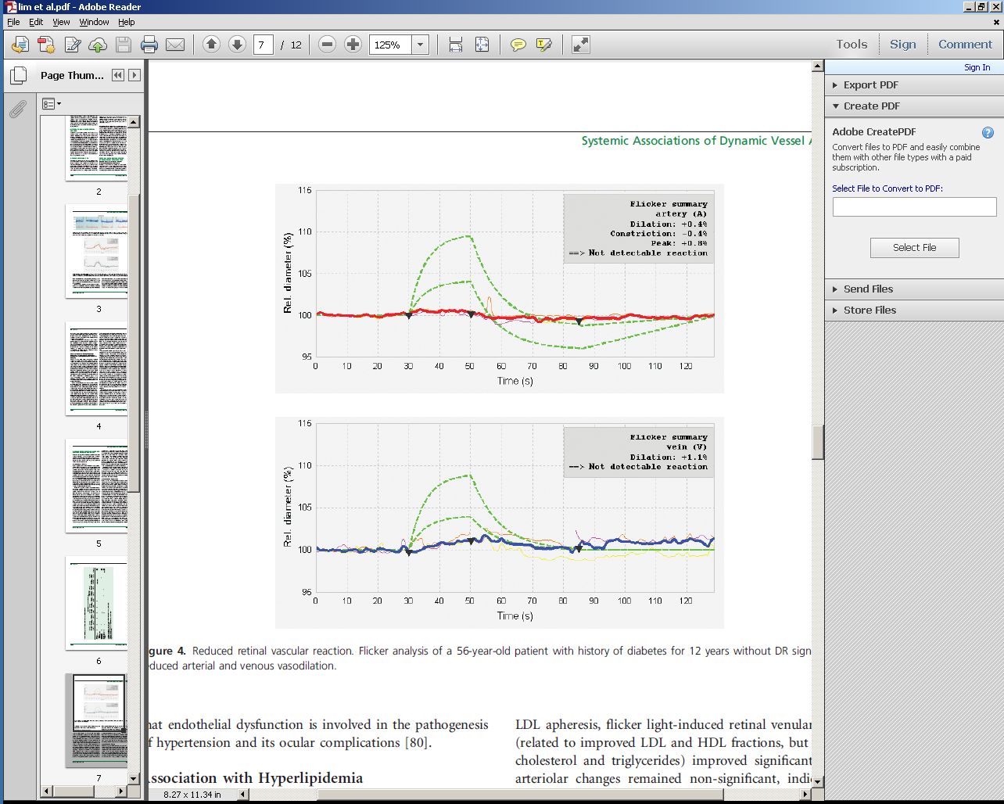

*Figure 2. Arterial (red) and venous (blue) diameters before, during and after 20s of flickering light, left panel, normal individual; right panel, a patient with diabetes for 12 years. The dotted green lines* are the expected normal range (Lim et al 27). The normal individual has about 5% arterial dilation, the patient with diabetes has about 0.5% (from reference 27).

*Retinal Oximetry*

Retinal Oximetry will be performed using the Zeiss F450+ fundus camera used for continuous retinal diameter imaging but for this application a dual wavelength filter is inserted into the illumination pathway. This filter will enable simultaneous imaging of the retina at 548 and 610nm; customized dual-wavelength filter (transmission bands at 548 and 610 nm; bandwidth 10 nm each). Optical densities (ODR) of the vessels are measured as the logarithmic ratio of the fundus reflection at the vessel centre and its surrounding. The ODR at 610 and 548 nm is proportional to the vessel haemoglobin oxygen saturation when compensating for the vessel diameter and fundus pigmentation (33)

Full field (macula centred) and optic nerve head (ONH) centred images with the camera angle set at 30 and 50 degree will be taken (minimum of 5 images per setting). Following image acquisition, we will analyse retinal arterioles and venules in a concentric annulus around the ONH in order to calculate incoming and outgoing oxygen saturation levels as well as oxygen consumption. Further analyses using macula centred images will be used to gain further insight into the oxygen supply and drainage of the macula area.

*Oximetry*

Overnight oximetry involves wearing a painless clip-type probe on the finger and is a standard clinical investigation in any sleep unit. This will be performed i) for the seven night study used in defining entry to the main study and ii) for the 14 nights of the actual randomised study. The Minolta 300i is capable of storing at least 14 nights of data so that a new machine is not required each night.

*Blood pressure and heart rate*

Blood pressure and heart rate will be measured in triplicate with a standard digital automatic monitor (Omron Healthcare Company, Kyoto, Japan) in the sitting position after a period of rest of 15 minutes in the mornings before the retinal vascular function measurements. In addition patients will monitor their BP twice a day during the two weeks trial period and record in a diary (these data are also recorded on the BP machine itself). For analysis, the average of the penultimate three days will be used, as this was shown in our previous studies to be the most robust.

*Blood sampling*

Standard venous phlebotomy will provide samples for PAXgene tubes for later mRNA analysis. These will be stored in Oxford.

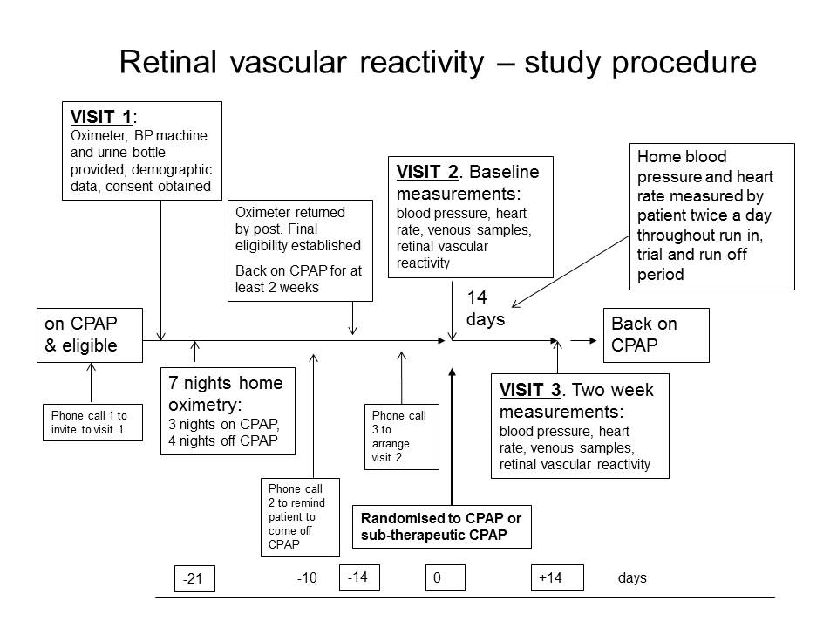

## Recruitment

Recruitment will take place in two ways: Either; Potential participants will be pre-screened and identified for trial enrolment by members of their clinical team according to the relevant eligibility and ineligibility criteria outlined above through review of the notes and information stored on the CPAP patient management database. These subjects will be contacted by a member of their clinical team and, if interested, they will be sent the patient invitation letter/patient information leaflet and are invited to speak on the phone to a member of the trial team. Or; Potential participants will be identified when they attend routine clinical CPAP follow-up appointments by the clinical team at their sleep centre. Once identified by the clinical team as eligible they will be invited to consider taking part and offered a patient information sheet/ patient invitation letter.

Once they have read the information and considered it, if they would like to take part, then they are invited to the first meeting, at which the study will be further explained by a member of trial staff and written consent obtained. They are then recruited to the first part of the study and this becomes **visit 1**. At the same appointment they will be provided with an oximeter for the 7 night assessment which confirms or otherwise the remaining entry criteria (adequate control of OSA on CPAP, and sufficient return of OSA off CPAP).

## Informed Consent

The consent process referred to above will embody the following.

The patient will personally sign and date the latest approved version of the Informed Consent form before any study specific procedures are performed.

Written and verbal versions of the Participant Information and Informed Consent will be presented to the participants detailing no less than: the exact nature of the study; what it will involve for the participant; the implications and constraints of the protocol; the known side effects and any risks involved in taking part. It will be clearly stated that the participant is free to withdraw from the study at any time for any reason without prejudice to future care, and with no obligation to give the reason for withdrawal. Participants will be informed that their GPs will be informed about their participation in this study.

The participant will be allowed as much time as wished to consider the information, and the opportunity to question the Investigator, their GP or other parties to decide whether they will participate in the study. Written Informed Consent will then be obtained by means of participant dated signature, and dated signature of the person who presented and obtained the Informed Consent. The person who obtained the consent must be suitably qualified and experienced, and have been authorised to do so by the Chief/Principal Investigator. A copy of the signed Informed Consent will be given to the participant. The original signed form will be retained at the study sites.

## Screening and Eligibility Assessment

The maximum duration allowed between the one week of overnight oximetry screening, and starting the experimental phase, will be three months, and the minimum two weeks.

Potential participants will be pre-screened and identified for trial enrolment according to the relevant eligibility and ineligibility criteria outlined above, through review of the notes and information stored on the CPAP patient management database. The assessment of returning OSA severity and adequacy of CPAP treatment is established by experimentation in the first phase of the study (inclusion criteria 2 & 4).

***Inclusion Criteria – source of data***

1. Objectively confirmed obstructive sleep apnoea (at the time of original diagnosis) with an oxygen desaturation index (ODI, >4% dips) or AHI of >20.

**From medical records/CPAP database.**

2. Currently >20/h oxygen desaturations (>4% dips) returning on any night during home nocturnal pulse oximetry performed for a 4-night period without CPAP, prior to entry into the study.

**By experimentation.**

3. Treated with CPAP for more than 6 months, minimum compliance 4h/night.

**From medical records/CPAP database and experimentation.**

4. ODI <10 during treatment (obtained during the preliminary week of oximetry monitoring, from the first 3 nights of oximetry monitoring on CPAP, before the 4 nights CPAP withdrawal).

**By experimentation.**

5. Age between 20 and 75 years at trial entry.

**From medical records/CPAP database.**

6. Written informed consent

**First visit.**

***Exclusion criteria – source of data***

1. Previous ventilatory failure (awake resting arterial oxygen saturation <93% or arterial PCO2 > 6kPa) or severe respiratory disorders other than OSA.

**From medical records.**

2. Unstable, untreated coronary or peripheral artery disease, severe arterial hypertension (>180/110mmHg), severe arterial hypotension (<90/60mmHg).

**From medical records/CPAP database.**

3. Previously diagnosed with Cheyne-Stokes breathing.

**From medical records/CPAP database.**

4. Current professional driver.

**From current enquiry.**

5. History of any sleep-related driving or other accident.

**From current enquiry and medical records.**

6. Acute inflammatory disease.

**From current enquiry and medical records.**

7. Acute or chronic hepatic or renal disease.

**From current enquiry and medical records.**

8. Known type 1 or 2 diabetes (Likely to have low retinal reactivity even on CPAP).

**From current enquiry and medical records.**

9. Known severe vascular disease (Likely to have low retinal reactivity even on CPAP).

**From current enquiry and medical records.**

10. Mental or physical disability precluding informed consent or compliance with the protocol.

**From current enquiry.**

11. Non-feasible trial follow-up (for example, distance from follow-up centre, physical inability).

**From current enquiry.**

12. Epilepsy: flickering light used for retinal provocation could lead to a seizure.

**From current enquiry and medical records.**

13. Lens opacities: this could lead to insufficient contrast and make it impossible to image the retinal vasculature.

**By visual inspection and contrast sensitivity measurement.**

## Randomisation, blinding and un-blinding

Randomisation will be performed using a company called “Sealed Envelope” (<http://www.sealedenvelope.com/> ), incorporating minimisation by OSA severity (established from the oximetry study using thevalue from the night with the highest ODI during home nocturnal pulse oximetry performed for a 4-night period without CPAP) and BMI. Dr Heitmar will be blind to the allocation, and all subsequent analyses will be done blind of group allocation. Patients are often aware that the sub-therapeutic CPAP is not as effective as their usual, so are not truly blind. However, the measurements in this study are all objective rather than subjective. This has been the case in previous CPAP withdrawal studies. Unblinding if required will be possible by simple inspection of the CPAP machine and mask.

## Baseline Assessments

Baseline assessments for the primary and secondary endpoints are heart rate, blood pressure and retinal vascular reactivity, as detailed above, performed at the second visit.

## Visits and phone calls

**First phone call** **or invitation at routine clinical follow up appointment** – introduction to trial, explanation and if interested the patient information is sent out

**Second phone call** – if still interested first visit date arranged

**First visit (patient’s sleep unit hospital)** – Signed consent obtained, demographics collected (age, weight, height, address, contact details, current drugs etc.). Oximeter provided for subsequent use over 7 nights.

**Third phone call** – to remind patient not to use CPAP for last 4 nights of the 7 night assessment.

Oximeter returned by post after 7 nights. Eligibility criteria, based on oximetry results, checked.

**Fourth phone call** - patient rung to explain whether they meet the entry criteria for ODI, both on and off CPAP. If so, second visit date arranged (Aston University) for at least 2 weeks later. Patient randomisation with minimisation performed during these 2 weeks, ready for second visit to Aston.

**Second visit (Aston University)** – Heart rate, BP, blood sample, retinal function. Patient given autoCPAP or sub-therapeutic CPAP according to previous randomisation by a member of Dr Heitmar’s unit not involved in collecting the retinal vascular data. Oximeter provided for subsequent use over 14 nights. BP machine provided for subsequent use twice a day over following 14 days.

**Third visit (Aston University)** – Heart rate, BP, blood sample, retinal function (outcome measures). Patient returns oximeter and BP machine, and is re-established on their usual CPAP system. Patient leaves trial.

## Discontinuation/Withdrawal of Participants from Study

Each participant has the right to withdraw from the study at any time. In addition, the Investigator may discontinue a participant from the study at any time if the Investigator considers it necessary for any reason including:

* Ineligibility (either arising during the study or retrospectively having been overlooked at screening)
* Significant protocol deviation
* Significant non-compliance with treatment regimen or study requirements
* Withdrawal of Consent
* Loss to follow up

Withdrawal from the study, prior to the last visit and the repeat measurement of vascular reactivity, will result in exclusion of the data for that participant as an analysis will not be possible.

If a patient is withdrawn for any reason, a replacement will be recruited to ensure 20 fully analysable subjects in each arm of the study (see section 10.2, power calculation).

If a patient withdraws, a withdrawal form should be completed.

## Definition of End of Study

The end of the main study will be the date of the last visit of the last participant’s follow up. Analysis of samples and data will continue beyond this.

# INTERVENTION

*CPAP therapy/CPAP withdrawal*

All subjects will have been using CPAP for more than one year and thus are entirely familiar with it. They will continue to use their usual CPAP mask for the duration of the study, but will swap to a ResMed S9 autoCPAP machine which is essentially no different, but is able to record nightly compliance, mask leak and residual apnoeas accurately. Sub-therapeutic CPAP will be delivered as in all our previous studies (2;34;35). The CPAP is rendered sub-therapeutic by first setting it to the lowest pressure possible (4cms H2O), and the pressure lowered still further (to 1cm H2O) using extra blow-off holes in the mask tubing at the patient end (which also ensures full blow off of exhaled CO2). The machine is restrained from trying to compensate for this extra leak with a 5mm restriction introduced at the machine end of the tubing.

# SAFETY REPORTING

No serious adverse events are expected, and none have occurred in our previous CPAP-withdrawal studies. Patients often stop their CPAP for short periods anyway, such as when going away for a holiday or on business. However, if patients experience the return of unacceptable sleepiness within the two weeks, then they are of course free to withdraw from the study. Patients are advised not to drive if they feel that any return of sleepiness is sufficient to impair driving (DVLA regulations).

Adverse events unrelated to the study interventions will not be recorded, but those possibly related to the study intervention will be.

## Definition of Serious Adverse Events

A serious adverse event is any untoward medical occurrence that:

* results in death
* is life-threatening
* requires inpatient hospitalisation or prolongation of existing hospitalisation
* results in persistent or significant disability/incapacity
* congenital anomaly or birth defect.

Other ‘important medical events’ may also be considered serious if they jeopardise the participant or require an intervention to prevent one of the above consequences.

The term "life-threatening" in the definition of "serious" refers to an event in which the participant was at risk of death at the time of the event; it does not refer to an event which hypothetically might have caused death if it were more severe.

A serious adverse event (SAE) occurring to a participant will be reported to the REC that gave a favourable opinion of the study where in the opinion of the Chief Investigator the event was ‘related’ (resulted from administration of any of the research procedures) and ‘unexpected’ in relation to those procedures. Reports of related and unexpected SAEs should be submitted within 15 days of the Chief Investigator becoming aware of the event, using the NRES [report of serious adverse event](http://www.nres.npsa.nhs.uk/docs/forms/Safety_Report_Form_(non-CTIMPs).doc) form (see IRAS/NRES website).

# STATISTICS AND ANALYSIS

## Description of Statistical Methods

Primary outcome measure. The % retinal vascular response to the flicker light protocol at two weeks is the primary outcome. The ‘intervention effect’ (i.e. CPAP withdrawal versus continuing CPAP) will be modelled using linear regression with allowance for the baseline %response, the minimisation variables (OSA severity and BMI), and age. This will be done in SPSS.

## The Number of Participants

An accurate sample size calculation is not possible due to relevant data not being available for this outcome in this situation. Previous CPAP withdrawal studies have been powered to ensure a significant difference in ODI between the two groups (5). This approach has assumed that if the ODI is clearly different at two weeks, then any consequence should be different too. This has worked well for our previous CPAP withdrawal studies where clear differences in heart rate, diastolic BP, endothelial function, and cardiac repolarisation were found (5). These studies had a sample size of20 completed in each arm.

An alternative approach is to look at other studies where retinal vascular reactivity has been assessed in two different situations and assume that our intervention is of a similar magnitude. A paper by Chittari et al (36), looking at retinal vascular reactivity between control subjects and those with type 2 diabetes, found values of 3.2(SD1.6)% and 1.4(SD1.8)% respectively. If we powered the study so as to not miss a similar difference between our two groups then, for 80% power we would need 15 patients in each arm, and for 90% power we would need 20 patients in each arm. Assuming a 10% drop out and/or failure rate, we would need 22 in each arm, but will adjust recruitment to ensure 20 patients complete with all primary endpoint data.

## Analysis of Outcome Measures/Endpoints

Because this is a physiological study, and not a therapeutic trial, we will analyse per protocol. Only subjects with: 1) valid retinal vascular reactivity measurements at baseline and at two weeks, 2) adherence to the protocol, and 3) adherence to the treatment arm allocation, will be analysed for the primary endpoint. The secondary outcome of correlation between change in the vascular reactivity measure and change in the other measures (ODI, BP, heart rate (from home monitor)),will be analysed in the CPAP withdrawal arm.

# DATA MANAGEMENT

## Access to Data

Direct access will be granted to authorised representatives from the Sponsor or host institution for monitoring and/or audit of the study to ensure compliance with regulations.

## Database

This study will utilise a validated system based around a fully licensed enterprise version of OpenClinica, with support services provided by OpenClinica, LLC. The study database is bespoke and hosted on the University of Oxford server with services provided through the University’s Information Management Services Unit (IMSU). The server and database are protected by a number of measures including anti-virus and anti-spyware applications, firewalls, encryption technology and permissions. The database will be backed up on a daily basis. ORTU will be responsible for all data stored on the database in relation to this study.

The database and access to computers are password protected. Paper-based identifiable data at each site will be kept in a locked cabinet, in a locked or ID-access controlled area. The Data Manager will maintain a list of personnel to grant and revoke access.

## Data Entry and Query Management

Patients recruited into the study are identified by their Trial Number, which cannot be traced back to personal identifiable information of the patient. Sites enrolling patients will complete the paper CRFs with aide of CRF Completion Guidelines which will be distributed to sites along with professionally printed CRFs. Upon completing the CRFs at sites, they will be sent to ORTU for data entry. ORTU will track these CRFs on a daily basis in a spread-sheet and query sites for missing CRFs. The data entry into the clinical database is performed by the designated trained ORTU staff using single data entry system. CRFs will be date-stamped and stored in a suitable locked filing cabinet.

The data stored in the clinical database will be checked for missing or unusual values and for consistency within participants over time. If any problems are identified, appropriate CRFs will be queried with relevant local site personnel for confirmation or correction as required until resolution. Should any data require changing, the ORTU staff will update the data point as per amended CRF and close the query this will be electronically tracked as an audit trail (name of reviewer, changes made and date) for the purposes of any future audit or external review. Data queries will be sent to sites on a monthly basis initially and as needed at the time of study completion or specific milestones. Details will be included in a study specific Data Management Plan).

## Data Quality and Security

At the time of data entry, quality checks will be performed for missing data, illegible data, appropriate data types, incomplete data, etc. The study’s Data Manager will perform quality checks of data entered and also assist with site training. Validation checks are also programmed into the database to query any discrepant data.

As part of an internal database quality check, validation of primary data will include at least confirmation of participant identity, informed consent, eligibility criteria and primary outcome data; this validation process will be carried out by the Data Manager in a subset of participants (approximately 10%).

The data will be securely stored in line with GCP standards and the data protection principles. Standard Operating Procedures (SOPs) will be followed to ensure quality control. Only staff authorised to work on this study will have access to participants’ data from across all sites. The Chief Investigator and/or Principal Investigators at each individual site will facilitate access to study records for the purpose of monitoring, audits, and regulatory inspections. Participant’s consent to this will be sought at the time of enrolment into the study. ORTU will monitor recruiting sites if required in accordance with the trial Monitoring Plan which will be written based on the trial Risk Assessment.

# QUALITYASSURANCE PROCEDURES

The study will be monitored in accordance with the current approved protocol and relevant regulations (including GCP) and standard operating procedures.

# ETHICAL AND REGULATORY CONSIDERATIONS

## Declaration of Helsinki

The Investigator will ensure that this study is conducted in accordance with the Declaration of Helsinki.

## ICH Guidelines for Good Clinical Practice

The Investigator will ensure that this study is conducted in full conformity with relevant regulations and with the Guidelines for Good Clinical Practice.

## Approvals

The protocol, informed consent form, participant information sheet and any proposed advertising material will be submitted to an appropriate Research Ethics Committee (REC), and host institution(s) for written approval.

The Investigator will submit and, where necessary, obtain approval from the above parties for all substantial amendments to the original approved documents.

## Reporting

The CI shall submit once a year throughout the study, or on request, an Annual Progress Report to the REC Committee, host organisation and Sponsor. In addition, an End of Study notification and Final Report will be submitted to the same parties.

## Participant Confidentiality

The study staff will ensure that the participants’ anonymity is maintained. The participants will be identified only by initials and a participant’s ID number on the CRF and any electronic database. All documents will be stored securely and only accessible by study staff and authorised personnel. The study will comply with the Data Protection Act, which requires data to be coded as soon as it is practical to do so. This research will form part of a doctoral project and anonymised data from this study will be used in writing up thesis and in peer reviewed publication.

## Expenses and Benefits

Reasonable travel expenses for patients for any visits additional to normal care will be reimbursed on production of receipts, or a mileage allowance provided as appropriate.

## Other Ethical Considerations

Withdrawing CPAP therapy as part of patients’ routine care is an ethical consideration. Patients will be informed of the possibility that excessive daytime sleepiness may return during the trial and those who rely on driving for their livelihood will be excluded as outlined above. In the event that excessive daytime sleepiness does return patients are informed not to drive. In previous studies using this withdrawal model that have not been any serious adverse events whilst patients have been receiving sub- therapeutic CPAP.

We will be using limited genetic testing in participants who agree to undergo tests to look at microRNA and mRNA profiles. At present this not likely to turn up any clinically relevant incidental findings but should research advance face to face discussion with patients will be conducted and patients will be informed of this during the consent process.

# FINANCE AND INSURANCE

## Funding

The ResMed Charitable Foundation has supplied an unrestricted donation to cover the cost of the retinal investigations and some further analyses (through the Oxford Radcliffe Charitable funds (0189)).

The Research Fellow is funded from the Oxford Radcliffe Charitable funds (0189).

Any additional costs will be covered from the Oxford Radcliffe Charitable funds (0189.

## Insurance

The University has a specialist insurance policy in place which would operate in the event of any participant suffering harm as a result of their involvement in the research (Newline Underwriting Management Ltd, at Lloyd’s of London). NHS indemnity operates in respect of the clinical treatment which is provided.

# PUBLICATION POLICY

The Investigators will be involved in reviewing drafts of the manuscripts, abstracts, press releases and any other publications arising from the study. Authors will acknowledge that the study was partially supported by an unrestricted donation from the ResMed Foundation. Authorship will be determined in accordance with the ICMJE guidelines and other contributors will be acknowledged.

# REFERENCES

See below

# APPENDIX C: AMENDMENT HISTORY

|  |  |  |  |  |
| --- | --- | --- | --- | --- |
| **Amendment No.** | **Protocol Version No.** | **Date issued** | **Author(s) of changes** | **Details of Changes made** |
| 1 (sub amendment 2) | 3.0 | 26/02/2015 | Dr Chris Turnbull | Removal of urine catecholamine testing |
| 2 (sub amendment 3) | 4.0 | 14/07/2015 | Dr Chris Turnbull | Pg15 Section 7.1 and Pg19 Section 7.6 inclusion of a patient invitation letter |
| 3 (sub amendment 4) | 5.0 | 03/02/2016 | Dr Chris Turnbull | Pg10 Section 5, Pg11 Section 6.1 and Pg12 Section 6.2, Pg17 Section 7.3 Q3 change from 12 months to 6 months on CPAP and Pg15 Section 7.1 sentence made generic for all sleep centres as more centres are recruiting |

**REFERENCES**

(1) Young T, Palta M, Dempsey J, Skatrud J, Weber S, Badr S. The occurrence of sleep-disordered breathing among middle-aged adults. N Engl J Med 1993; 328:1230-1235.

(2) Jenkinson C, Davies RJ, Mullins R, Stradling JR. Comparison of therapeutic and subtherapeutic nasal continuous positive airway pressure for obstructive sleep apnoea: a randomised prospective parallel trial. Lancet 1999; 353:2100-2105.

(3) George CF. Sleep apnea, alertness, and motor vehicle crashes. Am J Respir Crit Care Med 2007; 176:954-956.

(4) Peppard PE, Young T, Palta M, Skatrud J. Prospective study of the association between sleep-disordered breathing and hypertension. N Engl J Med 2000; 342:1378-1384.

(5) Kohler M, Stoewhas AC, Ayers L, Senn O, Bloch KE, Russi EW et al. Effects of continuous positive airway pressure therapy withdrawal in patients with obstructive sleep apnea: a randomized controlled trial. Am J Respir Crit Care Med 2011; 184(10):1192-1199.

(6) Redline S, Yenokyan G, Gottlieb DJ, Shahar E, O'Connor GT, Resnick HE et al. Obstructive sleep apnea-hypopnea and incident stroke: the sleep heart health study. Am J Respir Crit Care Med 2010; 182:269-277.

(7) Mason RH, West SD, Kiire CA, Groves DC, Lipinski HJ, Jaycock A et al. High prevalence of sleep disordered breathing in patients with diabetic macular edema. Retina 2012; 32:1791-1798.

(8) Kohler M, Stradling JR. Mechanisms of vascular damage in obstructive sleep apnea. Nat Rev Cardiol 2010; 7:677-685.

(9) West SD, Groves DC, Lipinski HJ, Nicoll DJ, Mason RH, Scanlon PH et al. The prevalence of retinopathy in men with Type 2 diabetes and obstructive sleep apnoea. Diabet Med 2010; 27(4):423-430.

(10) Lang GE. Diabetic macular edema. Ophthalmologica 2012; 227 Suppl 1:21-9. doi: 10.1159/000337156. Epub@2012 Apr 24.:21-29.

(11) Bertelsen G, Peto T, Lindekleiv H, Schirmer H, Solbu MD, Toft I et al. Tromso eye study: prevalence and risk factors of diabetic retinopathy. Acta Ophthalmol 2012;10-3768.

(12) Wright AD, Dodson PM. Diabetic retinopathy and blockade of the renin-angiotensin system: new data from the DIRECT study programme. Eye (Lond) 2010; 24:1-6.

(13) Salinero-Fort MA, San Andres-Rebollo FJ, de Burgos-Lunar C, rrieta-Blanco FJ, Gomez-Campelo P. Four-Year Incidence of Diabetic Retinopathy in a Spanish Cohort: The MADIABETES Study. PLoS One 2013; 8:e76417.

(14) Jee D, Lee WK, Kang S. Prevalence and risk factors for diabetic retinopathy: the Korea national health and nutrition examination survey 2008-2011. Invest Ophthalmol Vis Sci 2013; 54:6827-6833.

(15) Kohner EM. Microvascular disease: what does the UKPDS tell us about diabetic retinopathy? Diabet Med 2008; 25 Suppl 2:20-4. doi: 10.1111/j.1464-5491.2008.02505.x.:20-24.

(16) Tan GS, Ikram MK, Wong TY. Traditional and novel risk factors of diabetic retinopathy and research challenges. Curr Med Chem 2013; 20:3189-3199.

(17) Frederiksen CA, Jeppesen P, Knudsen ST, Poulsen PL, Mogensen CE, Bek T. The blood pressure-induced diameter response of retinal arterioles decreases with increasing diabetic maculopathy. Graefes Arch Clin Exp Ophthalmol 2006; 244:1255-1261.

(18) Arden GB, Sivaprasad S. Hypoxia and oxidative stress in the causation of diabetic retinopathy. Curr Diabetes Rev 2011; 7:291-304.

(19) Arden GB, Jyothi S, Hogg CH, Lee YF, Sivaprasad S. Regression of early diabetic macular oedema is associated with prevention of dark adaptation. Eye (Lond) 2011; 25:1546-1554.

(20) Mason RH, Kiire CA, Groves DC, Lipinski HJ, Jaycock A, Winter BC et al. Visual improvement following continuous positive airway pressure therapy in diabetic subjects with clinically significant macular oedema and obstructive sleep apnoea: proof of principle study. Respiration 2012; 84:275-282.

(21) Proudlove K, Manuel A, Hall R, Rieu R, Villarroel M, Stradling J. Effect of CPAP treatment for OSA on visual processing of degraded words. Respiration 2013;in press.

(22) Pemp B, Weigert G, Karl K, Petzl U, Wolzt M, Schmetterer L et al. Correlation of flicker-induced and flow-mediated vasodilatation in patients with endothelial dysfunction and healthy volunteers. Diabetes Care 2009; 32:1536-1541.

(23) Heitmar R, Cubbidge RP, Lip GY, Gherghel D, Blann AD. Altered blood vessel responses in the eye and finger in coronary artery disease. Invest Ophthalmol Vis Sci 2011; 52:6199-6205.

(24) Patel SR, Bellary S, Qin L, Gill PS, Taheri S, Heitmar R et al. Abnormal retinal vascular function and lipid levels in a sample of healthy UK South Asians. Br J Ophthalmol 2011; 95:1573-1576.

(25) Mandecka A, Dawczynski J, Blum M, Muller N, Kloos C, Wolf G et al. Influence of flickering light on the retinal vessels in diabetic patients. Diabetes Care 2007; 30:3048-3052.

(26) Nguyen TT, Kawasaki R, Wang JJ, Kreis AJ, Shaw J, Vilser W et al. Flicker light-induced retinal vasodilation in diabetes and diabetic retinopathy. Diabetes Care 2009; 32:2075-2080.

(27) Lim M, Sasongko MB, Ikram MK, Lamoureux E, Wang JJ, Wong TY et al. Systemic associations of dynamic retinal vessel analysis: a review of current literature. Microcirculation 2013; 20:257-268.

(28) Heitmar R, Summers RJ. Assessing vascular function using dynamic retinal diameter measurements: a new insight on the endothelium. Thromb Haemost 2012; 107:1019-1026.

(29) Heitmar R, Safeen S. Regional differences in oxygen saturation in retinal arterioles and venules. Graefes Arch Clin Exp Ophthalmol 2012; 250:1429-1434.

(30) Rossi VA, Stoewhas AC, Camen G, Steffel J, Bloch KE, Stradling JR et al. The effects of continuous positive airway pressure therapy withdrawal on cardiac repolarization: data from a randomized controlled trial. Eur Heart J 2012.

(31) Ayers L, Stoewhas AC, Ferry B, Stradling J, Kohler M. Elevated levels of endothelial cell-derived microparticles following short-term withdrawal of continuous positive airway pressure in patients with obstructive sleep apnea: data from a randomized controlled trial. Respiration 2013; 85:478-485.

(32) Rossi VA, Winter B, Rahman NM, Yu LM, Fallon J, Clarenbach CF et al. The effects of Provent on moderate to severe obstructive sleep apnoea during continuous positive airway pressure therapy withdrawal: a randomised controlled trial. Thorax 2013; 68:854-859.

(33) Hammer M, Vilser W, Riemer T, Schweitzer D. Retinal vessel oximetry-calibration, compensation for vessel diameter and fundus pigmentation, and reproducibility. J Biomed Opt 2008; 13:054015.

(34) Pepperell JC, Ramdassingh-Dow S, Crosthwaite N, Mullins R, Jenkinson C, Stradling JR et al. Ambulatory blood pressure after therapeutic and subtherapeutic nasal continuous positive airway pressure for obstructive sleep apnoea: a randomised parallel trial. Lancet 2002; 359:204-210.

(35) Hack M, Davies RJ, Mullins R, Choi SJ, Ramdassingh-Dow S, Jenkinson C et al. Randomised prospective parallel trial of therapeutic versus subtherapeutic nasal continuous positive airway pressure on simulated steering performance in patients with obstructive sleep apnoea. Thorax 2000; 55:224-231.

(36) Chittari MV, McTernan P, Bawazeer N, Constantinides K, Ciotola M, O'Hare JP et al. Impact of acute hyperglycaemia on endothelial function and retinal vascular reactivity in patients with Type 2 diabetes. Diabet Med 2011; 28:450-454.