

PARTICIPANT INFORMATION SHEET

**Study Title: Induction Of Labour In One Previous Caeserean Delivery And History Of Vaginal Birth(s) With Foley Catheter Versus Dinoprostone Controlled-Released Vaginal Insert: A Randomised Trial**

**Version No: 2**

**Version Date: 1/6/2021**

We would like to invite you to take part in a research study. Before you decide whether to participate, you need to understand why the research is being done and what it would involve. Please take time to read the following information carefully; talk to others about the study if you wish.

Ask us if there is anything that is not clear or if you would like more information. Take time to decide whether or not you wish to take part.

1. **Introduction**

As Caesarean delivery is rising globally, more and more women embark on pregnancy with previous Caesarean scar. Trial of labour after Caesarean delivery allows women who desire a vaginal delivery in achieving a vaginal birth. Previous vaginal delivery or previous successful vaginal birth after Caesarean birth is associated with higher success rate and lower risk of uterine rupture, delivery complication and Caesarean rate. Induction of labour is an option for women with one previous scar to try vaginal birth. Methods of induction of labour such as controlled release dinoprostone vaginal insert and foley’s catheter are used for ripening of cervix.

1. **What is the purpose of this study?**

To show that use of controlled release dinoprostone vaginal insert for induction of labour in women with one previous Caesarean delivery and history of vaginal birth will result in lower Caesarean rate and higher patient’s satisfaction with birth process.

1. **Why is this study important?**

This study is important as to our best knowledge there is no information available on the relative performance of these two common labour induction methods in women with a previous Caesarean and history of vaginal birth(s).

1. **What type of study is this?**

This a randomised controlled clinical trial.

1. **Can I refuse to take part in the study?**

Yes. If you choose not to take part, your care will not be affected in any way.

1. **What will happen to me if I take part?**

If you have been planned for induction of labour and you fulfil the inclusion criteria as listed, you will be randomly allocated to undergo induction of labour by Foley’s catheter or controlled release dinoprostone vaginal insert. Your baby’s heart rate trace will be checked before and after the procedure.

1. **If you are allocated to Foley’s catheter group:**

A size 16F foley catheter will be inserted into the cervix. The catheter will be in place and be removed at 24 hours if not already expelled spontaneously, when your water bag is broken or when you are in labour.

1. **If you are allocated to dinoprotone controlled release vaginal insert group:**

The vaginal insert will be placed in the vagina and will be removed at 24 hours if not already expelled spontaneously, when your water bag is broken or if you develop hyperstimulation (excessive frequent strong contraction pain).

After 24 hours, if your cervix is favourable, rupture of your water bag will be done in labour room as per standard protocol. If the cervix is not favourable after 24 hours, you will be counselled and given option to continue with induction of labour or to proceed with a repeat Caesarean delivery.

1. **How long will I be involved in this study?**

You will be involved in the study from the insertion of induction device until you are discharge from the hospital.

1. **What are the possible disadvantages and risks?**

Risk of failed induction and uterine scar rupture (up to 2-3%) which

necessitates an urgent Caesarean delivery. However, previous vaginal delivery, particularly previous successful vaginal birth after caesarean section is associated with higher success rate of 85-90% and it independently associated with a reduction of uterine rupture risk.

1. **What are the possible benefits to me?**

Possible benefit is a lower caesarean section rate, thus reduction of repeated caesarean section complication to mother and baby. But participants should not expect any benefit as it is not known which of the study’s labour induction method will be more efficient. The two methods may also be of equivalent performance.

1. **Who will have access to my medical records and research data?**

Only the investigators and trained personnel will have access to your medical records and research data.

1. **Will my records/data be kept confidential?**

Yes, all records/data will be kept confidential. When you participate in this study, a new identification will be given to you. All the datas collected using the case report form will be kept in a sealed envelope and locked in a cabinet. The keys will be kept by me (principle investigator). The data will then be transcribed into statistical analysis program with encrypted password.

1. **What will happen if I don’t want to carry on with the study?**

You are allowed to withdraw at any point of the study and it would not affect your care**.**

1. **What will happen to the results of the research study?**

All the information obtained in this study will be kept and handled in a confidential manner, in accordance with the applicable laws and/or regulations. When publishing or presenting the study results, your identity will not be disclosed without your consent. Individuals that are involved in your medical care, qualified monitors and auditors, the sponsors or its affiliates and governmental or regulatory authorities may inspect and copy your medical records, where appropriate and necessary.

Data from the study will be archived and may be transmitted outside the country for the purpose of analysis, but your identity will not be reveled at any time.

1. **Will I receive compensation for participating in this study?**

The induction of labour device will be provided without charge.

1. **Who funds this study?**

This study is internally funded by Department of Obstetrics and Gynecology, University of Malaya.

1. **Who should I contact if I have additional questions/problems during the course of the study?**

If you have any questions about the study please contact Dr Nor Dalila Shamsuddin ( 013-3267990 )

1. **Who should I contact if I am unhappy with how the study is being conducted?**

Medical Research Ethics Committee

University of Malaya Medical Centre

Telephone number: 03-7949 3209/2251

**Figure 1 – Foley catheter**

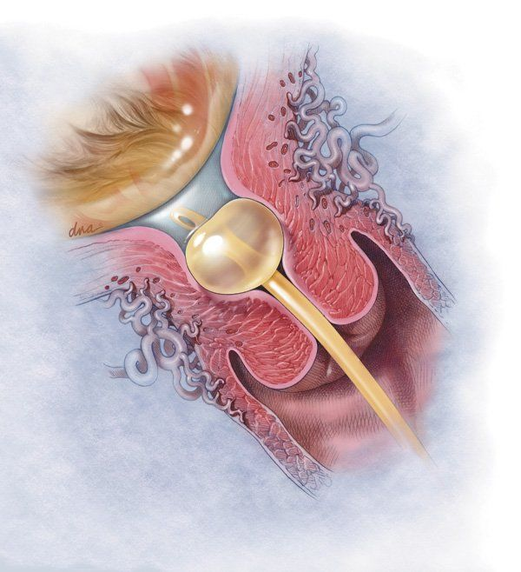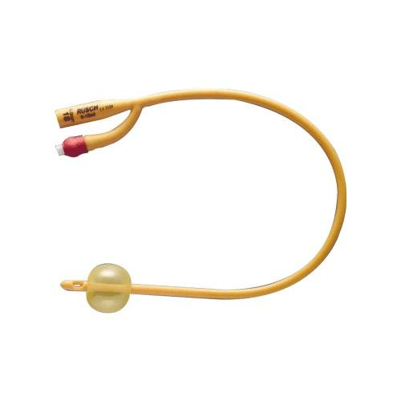

**Figure 2 – Dinoprostone controlled release vaginal insert**

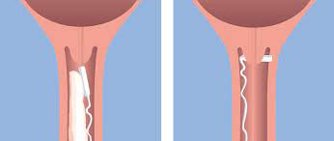 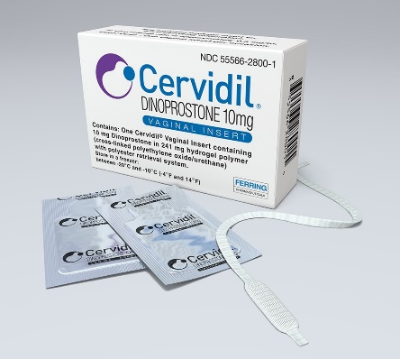

**Figure 3 – cardiotocography (CTG)**

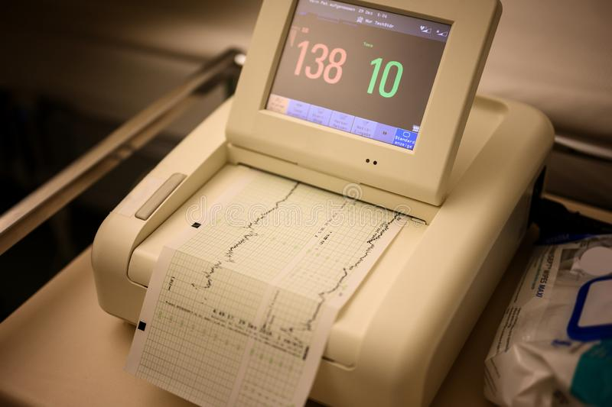

**BK-MIS-1116-E03**