**PROTOCOL**

**Version 5 : 25th January 2021**

**Title of study: Trial of personalised advice to aid weight loss**

**Study identifiers**

**IRAS number: 283149**

**REC number: 20/EM/0297**

**CPMS ID: 47773**

**University of Southampton RGO number: 56280**

**Funder of the study: European Commission**

**Sponsor of the study: University of Southampton**

**Principal investigator: Professor Philip C. Calder, School of Human Development & Health, Faculty of Medicine, University of Southampton, IDS Building. MP887 Southampton General Hospital, Tremona Road, Southampton SO16 6YD**

**Email: pcc@soton.ac.uk**

**Phone: 02381 205250**

**Researchers: Dr Ella Baker, Research Fellow, a Research Fellow in Dietetics yet to be appointed and Research Nurses in the NIHR Clinical Research Facility at University Hospital Southampton**

1. **Introduction & rationale**

Obesity is defined as a body mass index > 30 kg/m2. Obesity has become a common condition in Western society. Proportions and numbers of both adults and children with obesity are increasing (1,2). Obesity itself has physical, psychological and social penalties. Furthermore, obesity significantly increases the risk of developing several health problems, including heart disease, type 2 diabetes, non-alcoholic fatty liver disease, and several common cancers (3). Obesity results from an intake of energy in excess of energy expenditure. However, in reality obesity is more complex than this and involves the interactions of many different factors, including polymorphisms in many genes, metabolism, eating behavior, physical activity and some non-biological factors. These interactions are involved in both weight gain and weight loss. Therefore to fully understand weight gain and weight loss we need to know about more than just what people eat; we also need to know about their genetics, their eating behavior, their food environment and their physical activity amongst other things. Individuals with overweight and with “modest” obesity are typically advised to change their diet, lowering energy intake, and do more exercise (4). This can work to some extent especially in more motivated individuals. It is known that weight loss (and fat loss) reduce risk of the co-morbidities, but that bigger gains come from greater weight (and fat) loss. Some individuals become more motivated through more personal and/or technology-based interventions and studies show these can induce bigger improvements in obesity outcomes than the more traditional approach (5). Personalised nutrition (PN) is a relatively new approach which aims to provide individual’s with unique nutrition advice based on genetic, environmental and lifestyle (including diet related) factors. Personalisation of interventions may be effective in changing behaviour that will affect health outcomes, including weight loss. Individuals may also need prompting to modify their dietary and lifestyle habits for such approaches to be successful. In this study we plan to compare generic advice from a dietitian with more personalised advice in individuals with overweight and obesity to see if the effect on various outcomes is different. The generic advice will be based upon dietary assessment with suggestions for altered behavior (e.g. around snacking), food substitution and alternative ways of preparing meals. The personalised advice will be of two types. Firstly, personalised advice will be generated based upon diet, metabolic profile and relevant genetic polymorphisms. The project will use CE-marked software (MetaDieta, developed by Meteda in Italy) accessed via an app (on a mobile phone, a tablet or a PC) to provide individualised information to a dietitian. This information will be generated by the integration of data, through the software, on each individual’s diet, metabolic profile and other biomarkers, and a number of genetic polymorphisms. The dietitian will then impart the personalised advice to the participant. The third group will additionally receive general behaviour change prompts through the app; these prompts are listed later in this protocol. Participants in all groups will use the app to record their daily food and beverage intake and, if they are in the personalized advice groups, to track their diets in order to see whether they are meeting the advice they are given. It is hypothesised that the individuals in the personalised dietary advice groups will show greater effects on waist circumference, body weight, body fat, body mass index, metabolic profile, inflammatory markers and other outcomes compared to the group receiving standard dietetic advice. It is further hypothesised that those receiving the additional behaviour change prompts will show the greatest improvements in these outcomes. This project is funded by the European Commission as part of a consortium called “Empower consumers to PREVENT diet-related diseases through OMICS sciences” (acronym PREVENTOMICS).

1. **Objective**

The objectives of this study are a) to identify whether personalised (“tailored”) dietary advice is superior to usual dietetic advice in promoting a reduction in waist circumference, weight loss, body fat and favourable changes in blood metabolic and inflammatory biomarkers in individuals with overweight and obesity over four months and b) to identify whether the combination of lifestyle behaviour change prompts and personalised dietary advice is superior to usual dietetic advice and to personalised dietary advice alone in promoting a reduction in waist circumference, weight loss, body fat and favourable changes in blood metabolic and inflammatory biomarkers in individuals with overweight and obesity over four months.

1. **Inclusion and exclusion criteria**

Inclusion criteria

1. Aged > 18 years
2. Body mass index 25-40 kg/m2
3. Waist circumference > 94 cm (for men) or > 80 cm (for women), which, according with the International Diabetes Federation, indicates abdominal obesity In Western populations (6)
4. Possess a mobile phone or other device capable of hosting the app
5. Able to provide written informed consent.

Exclusion criteria

1. Diagnosed with diabetes or having a serum glucose ≥ 125 mg/dL (6.9 mmol/l) (at V1 blood sampling), other metabolic and endocrine disorders
2. Presence of chronic disease (cardiovascular disease, kidney disease (or a serum creatinine ≥ 1.7 mg/dl (150 µmol/l) for men and ≥ 1.5 mg/dl (132 µmol/l) for women at V1 blood sampling), cancer, pulmonary diseases, coeliac disease, Crohn’s disease, etc.)
3. Body mass index > 40 kg/m2
4. Being pregnant or planning to become pregnant within the study period
5. Use of prescribed medicine to control blood glucose, inflammation or dyslipidemia (or LDL-cholesterol ≥ 4.9 mmol/L (> 190 mg/dL) and/or triglycerides ≥ 4.5 mmol/L (≥ 400 mg/dL) at V1 blood sampling)
6. Consumption of more than 14 drinks of alcoholic beverages per week
7. Current smoking
8. Use of dietary supplements
9. Blood donation in the previous 3 months
10. No access to the internet
11. Note: Subjects with hypertension and taking antihypertensive drugs (metabolically neutral) will be not excluded and allowed to continue their prescribed dosage.
12. **Study design and participant schedule**

All procedures involving human subjects will be approved by a relevant NHS Research Ethics Committee. This study will be conducted according to the guidelines established in the Declaration of Helsinki. The study will be registered at a relevant site.

The study will be a single-blind randomised, placebo-controlled trial carried out with clinically healthy class I and II obese adult participants with abdominal obesity. Due to the nature of the study, the participants and the study dietitian cannot be blinded to the intervention, although the investigators who will perform the sample and data analysis will be blinded.

Participants will be sought through poster advertisements; articles in the media (newsletters, newspapers, radio); email shots within the University of Southampton and University Hospital Southampton NHS Foundation Trust; contacting those on a GDPR compliant database held by the University Hospital Southampton; and through local GP surgeries who will act as Participant Identification Centres (these will be identified with the help of the Wessex clinical research network (CRN)). Individuals who are interested will contact the research team by telephone. They will answer a small number of questions to ascertain whether they are likely to meet the inclusion/exclusion criteria. If so, they will be sent a Participant Information Sheet. After 7 days they will be contacted to see if they remain interested in the study. If they are still interested, an appointment will be made for a screening visit (visit 1 (V1)) at the NIHR Clinical Research Facility at Southampton General Hospital. If at the screening visit the individual is found not to be eligible for entry into the study (according to the inclusion/exclusion criteria), the reason for their exclusion will be noted and the screening questionnaire will be destroyed.

Visit 1

Participants will attend the NIHR Clinical Research Facility at Southampton General Hospital in the morning (between 8 and 10 am) in the fasted state (no food or drink apart from water from 9 pm the night before). Participants will be given the opportunity to discuss the study and have any questions answered. If they are happy to be enroled they will be asked to sign an Informed Consent Form. If a participant is female and still having periods or it is less than two years since their menopause they will have a standard urine test to confirm that they are not pregnant. At this visit participant’s height, weight, waist and hip circumference will be measured as will their body composition (Tania bioelectric impedance) and blood pressure. Then a saliva swab will be taken from inside the mouth and 20 mL blood will be collected to provide whole blood, serum and plasma. Then participants will be given breakfast (orange juice, toast and jam, tea or coffee). After they finish their breakfast, participants will complete a food frequency questionnaire, a 3-day diet recall and a behaviour assessment questionnaire. During this visit they will be asked to provide a urine sample (20 ml). The duration of visit 1 is likely to be 1.5 to 2 hours. Before leaving, participants will be given a pot and instructions for collecting a faecal sample immediately prior to visit 2 and visit 3; this is not compulsory.

The samples collected at V1 will be used as follows:

|  |  |  |  |
| --- | --- | --- | --- |
| Sample | Measurement | Analysed by | Reason |
| Blood - Plasma | IL-6  TNFα  MCP-1  IL-10  Soluble ICAM-1  Soluble CD14  Oxidised LDL  Acylcarnitine profile | University of Southampton  Eurecat, Barcelona, Spain | Inflammatory marker analysis  Fatty acid and branched-chain amino acid catabolism analysis |
| Blood - Serum | Leptin  Adiponectin  CRP  Insulin  Total cholesterol  HDL- cholesterol  LDL- cholesterol  Triglycerides  Glucose  Creatinine  ALT  GGT  Uric acid  Food intake biomarkers | University of Southampton  Eurecat, Barcelona, Spain | Blood lipid profile  Liver and Kidney function analysis  Creation of personalised plan |
| Urine | Food intake biomarkers  Food intake biomarkers  8-iso-PGF2α  8-OHdG | University of Parma, Parma, Italy  Eurecat, Barcelona, Spain  Eurecat, Barcelona, Spain | Validation of diet  Creation of personalised plan  Analysis of oxidative stress |
| Saliva | 36 different single nucleotide polymorphisms (SNPs) | Alimentomica, a spin-off of University of Balearic Islands, Palma de Mallorca, Spain | Genetic health status, gene-diet interactions and creation of personalised plan |
| Faeces | 16S rRNA sequencing | LEITAT, Barcelona, Spain | Gut microbiome profile |

Volumes of blood to be collected will be as follows:

|  |  |  |  |
| --- | --- | --- | --- |
| Matrix | Collection tube | Volume | Analytes |
| Serum | SST | 2 ml | Insulin |
| Serum | SST | 5 ml | CRP, cholesterol, HDL, LDL, triglycerides, creatinine, ALT, GGT, uric acid |
| Serum | SST | 2 ml | Leptin, adiponectin |
| Plasma | Fluoride oxalate | 5 ml | Glucose |
| Plasma | EDTA | 5 ml | IL-6, TNFα, MCP-1, IL-10, Soluble ICAM-1, Soluble CD14, Oxidised LDL, Acylcarnitine profile |

Data on nutrient intake, genotype (36 different single nucleotide polymorphisms (SNPs)), metabolic profile, and other blood biomarkers will be integrated through computational modelling to provide personalised dietetic advice for the participants in the personalized advice groups. This advice will be provided to the dietitian (via an app linked to the MetaDieta software).

The gene polymorphisms to be analysed will include the following:



Visit 2

About a month after V1, participants will return to the NIHR Clinical Research Facility at Southampton General Hospital for visit 2 (V2). Participants may bring a recent faecal sample with them. Prior to V2, participants will have been randomly allocated to receive standard dietetic advice or personalised advice or personalised advice and behaviour change prompts via an app on their mobile phone. Allocation will be stratified by age (decades) and sex. Participants will not be required to be in the fasted state for this visit. Their weight and waist and hip circumference will be measured. They will complete quality of life, physical activity, and food environment and habits questionnaires. If the quality of life questionnaire indicates that the participant is at risk they will be advised to discuss this with their GP.

The dietitian will help the participant to download the app to their phone or tablet and will demonstrate how to use it. The participant will also have their first consultation with the study dietitian. All groups will receive guidance on how to reduce their daily calorie intake by 500 cal relative to their calculated calorie need. The dietitian will provide the control group with healthy eating advice based upon the dietary information collected at V1. The dietitian will provide the other two groups with personalised advice; this advice will be based upon the dietary information provided at V1 as well as the genetic and metabolic profile determined in the saliva and blood samples collected at V1. The duration of V2 is likely to be 1 hour.

Between Visit 2 and Visit 3

Participants in the control group will have a telephone consultation each month with the study dietitian.

Participants in the personalized advice groups will receive regular information about their diet without or with behavior change prompts via the app in addition to the dietitian telephone consultations.

All participants will complete an on-line daily food diary via the app.

The software contains the UK food database information so that when a participant inputs what they are eating the app gives them a nutritional readout for those foods (e.g. calories, grams of proteins, grams of fat etc.) and provides a running total across the day and how the participant is doing compared with their target. The software also includes the behaviour change program that will issue prompts via the app if the individual is that group. The software stores the history of the messages received and sent.

The app was created by Meteda, Italy (see <https://www.meteda.it/en/>) and belongs to Meteda. The software is called MetaDieta; it is CE marked. The user face of the food diary on the app will appear as follows:

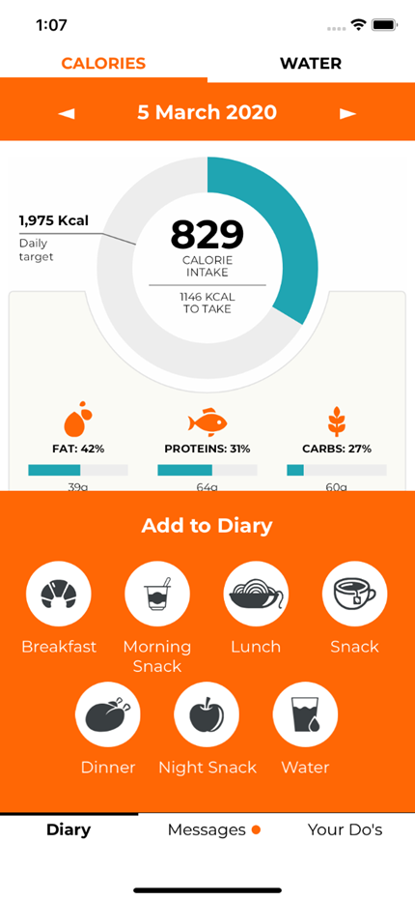

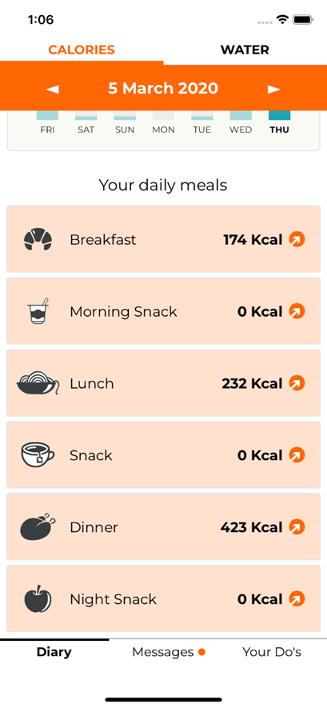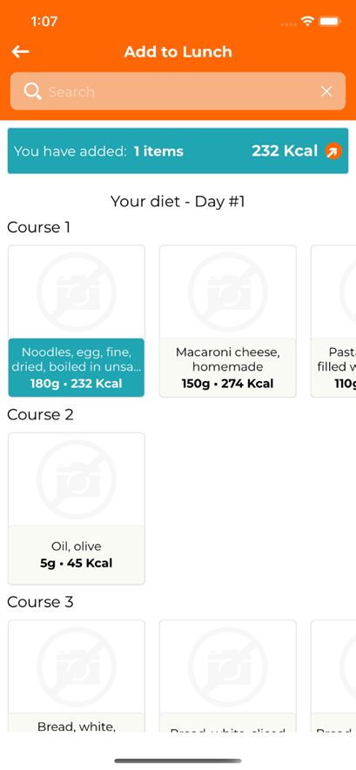

The behaviour change prompts to be used are as follows:

|  |
| --- |
| NURTURE THE NEAR AND DEAR. Tell people how special they are. Even if they know, it's heart-warming to hear it spoken or see it written down. Do it often.  WELL DONE FOR BREAKFASTING! It's an important meal. Can you make one change to refresh tomorrow's breakfast? Find ideas <<here>>.  PLAN! You tend to only eat when you're hungry. Good. A weekly menu <<planner>> will ensure you make healthy choices, and save you time and money.  LOVE YOUR LOW ALCOHOL LIFE! Watch for the sugar in soft drinks. Try a new healthy drink, vegetable juice or herbal tea today, and feel extra good.  REFRESH YOUR FRESH! Keep going for your daily quota of fruit and vegetable. Pack more of a nutritional <<punch>> today by adding beets, chard or peas  TIME TO TRY IT. Look up your family tree, try Sudoku, invent a cocktail. <<Here's>> a list of 30 new things to try, choose one and Go Do!  GET ON IT. Sort out any overdue health checks today. Arrange your dental check-up, medical appointment, eye test or health screen. Make that call.  FOOD SWAP DAY. Well done for staying clear of sugar. Is there another switch you could make to stay healthy? Click <<here>> for ideas.  STRESS MANAGEMENT SORTED. Well done. Today reach out to someone who you know is stressed. Offer to help, cook a meal or take time to listen to them.  SLUMBER NUMBER. There are many ways to improve sleep. <<These>> 10 tips can help, make sure you try at least one tonight.  PLASTIC NOT FANTASTIC. Try to cut down your plastic usage today. Get yourself a reusable shopping bag or get a reusable water bottle. Put them in sight so you use them everyday. Easy and effective!  ZERO WASTE KITCHEN. You’re a conscious chef, great! Want to challenge yourself? Check out <<this>> website to see if you can run a zero waste kitchen.  SHARED STRATEGY. Think of 3 ways in which you could be more sustainable and discuss them with a colleague. Next week try to change one of them. <<Here>> are some ideas if you need inspiration.  SUNSHINE DAY. Write down 3 things you're looking forward to today, this week, this month. New experiences, someone to see, even small pleasures count. A key to happiness is having something to look forward to!  PEOPLE FIRST. Today make more time for those who matter. Treat a friend, surprise a loved one, take the kids out or just really listen to someone.  MORNING MATTERS. Research shows eating breakfast helps control weight. Rediscover the pleasure, add a healthy twist. Find ideas <<here>>.  PLAN YOUR MEALS. Take 10 minutes to fill out a weekly menu <<planner>>. You’ll find it easier to make healthier choices, save time and money.  TIPPLE SWITCH. Find a lower alcohol version of your usual drink today. Low-alcohol beers and wines are tasty and mocktails are cool. Check <<this>> website for ideas.  YOU'RE BODY IS A TEMPLE. Cherish it today. Book a health check, try self-massage, a face mask, meditate, do yoga or get a nice early night.  SHUN SUGAR. Today make a significant health improvement, commit to having less sugar. Opt for a sweeter life instead. Click <<here>> for tips.  BREATHING SPACE DAY. When you feel pressured today, take a 3 minute breathing space. Stop everything and focus just on your breath, let the calm in.  SWEET DREAMS. Come when you avoid screens 2 hours before bed. <<Here>> are some tips: have a bath, wind down, put on calm music, take nice thoughts to bed.  MARKET MANIA. This weekend try to buy most of your food items at the farmers market. Bring your own bag and ask for paper packaging, no plastic allowed!  CONSCIOUS KITCHEN. Check out <<this>> website for tips about smart shopping. What can you do to reduce food waste even more?  OFFICE OPTIONS. Discuss ways to make your office more sustainable with your colleagues. Go paperless, reusable cups, improve recycling, reduce energy? Every little bit helps.  GRATITUDE JOURNAL. Notice good things as they happen today. Write down things that make you feel good and that you're grateful for. Try to add to the list a few times per week. Paying attention to the positive creates a new way of looking at life!  ME TIME. You make time for other people. That's good. Today set aside 20 minutes just for you. Don't apologise or feel guilty. Do what makes you happy.  WHAT ARE YOU EATING FOR? Back off from boredom, address your stress. Get busy, unwind, release your emotions so you only eat when you're hungry today.  BAR CODE. Today plan some alcohol-free fun. Go on a walk with buddies instead of the pub, picnics rather than restaurants, or a movie night.  VEGETABLE POWER UP! Well done for getting your fruit and vegetable quota. Add beets, kale, chard or peas and pack more of a nutritional <<punch>> today.  YOU'RE GREAT AT TRYING NEW THINGS. Can you go further outside your comfort zone today? Pick one new thing from <<this>> list and Go Do!  CELEBRATE! It's great that you take good care of yourself. Today pay attention to a part of your body you love. Hands, legs, feet or back. Stretch it, appreciate it, treat it.  PRIORITISE DAY. Accept you can't do everything today. Separate what's really important from what's not. Focus on the important and let the rest wait.  GREEN CHALLENGE. You’re conscious of the environment, great! Challenge yourself and try to find even more ways to be sustainable <<here>>.  CONSCIOUS KITCHEN. Check out <<this>> website for tips to prevent food waste. Start by implementing one and notice the difference. How many of these can you use?  MAKE SOMEONE’S DAY. Find your oldest living relative or friend. Pay them a visit, give them a call or drop them a friendly hello letter with a photo. They’ll be happy and you’ll be glad you did it. |

Visit 3

V3 will take place about 4 months after V2. Participants will attend the NIHR Clinical Research Facility at Southampton General Hospital in the morning (between 8 and 10 am) in the fasted state (no food or drink apart from water from 9 pm the night before). Participants may bring a recent faecal sample with them. Participant’s weight, and waist and hip circumference will be measured as will their body composition (Tania bioelectric impedance) and blood pressure. Then a 20 mL blood sample will be collected to provide whole blood, serum and plasma. Then subjects will be given breakfast (orange juice, toast and jam, tea or coffee). After they finish their breakfast, participants will complete a food frequency questionnaire, a 3-day diet recall and quality of life, physical activity, food environment and habits, and behavior assessment questionnaires. During this visit subjects will be asked to provide a urine sample (20 ml). The duration of visit 3 is likely to be 2 hours.

The samples collected at V3 will be used as follows:

|  |  |  |  |
| --- | --- | --- | --- |
| Sample | Measurement | Analysed by | Reason |
| Blood - Plasma | IL-6  TNFα  MCP-1  IL-10  Soluble ICAM-1  Soluble CD14  Oxidised LDL  Acylcarnitine profile | University of Southampton  Eurecat, Barcelona, Spain | Inflammatory marker analysis  Fatty acid and branched-chain amino acid catabolism analysis |
| Blood - Serum | Leptin  Adiponectin  CRP  Insulin  Total cholesterol  HDL- cholesterol  LDL- cholesterol  Triglycerides  Glucose  Creatinine  ALT  GGT  Uric acid  Food intake biomarkers | University of Southampton  Eurecat, Barcelona, Spain | Blood lipid profile  Liver and Kidney function analysis  Validation of diet |
| Urine | Food intake biomarkers  Food intake biomarkers  8-iso-PGF2α  8-OHdG | University of Parma, Parma, Italy  Eurecat, Barcelona, Spain  Eurecat, Barcelona, Spain | Validation of diet  Validation of diet  Analysis of oxidative stress |
| Faeces | 16S rRNA sequencing | LEITAT, Barcelona, Spain | Gut microbiome profile |

Volumes of blood to be collected at V3 will be the same as at V1.

The flow of participants through the study is depicted in the figure below:

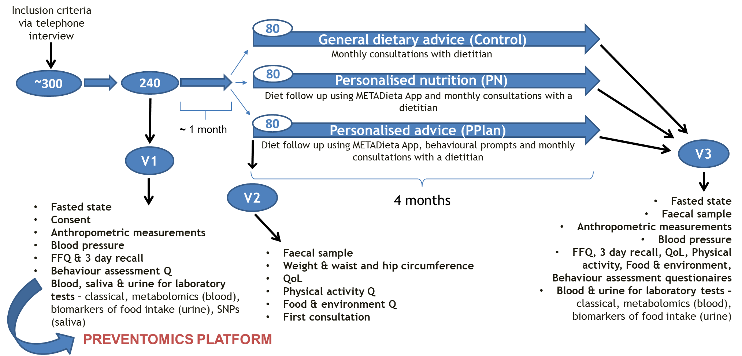

A summary of the questionnaires to be used at each time point is as follows:

|  |  |  |  |
| --- | --- | --- | --- |
| **Questionnaire** | **V1** | **V2** | **V3** |
| Food frequency | YES |  | YES |
| 3-day diet recall | YES |  | YES |
| Behaviour assessment | YES |  | YES |
| Quality of life |  | YES | YES |
| Physical activity |  | YES | YES |
| Food environment & habits |  | YES | YES |

1. **Variables and analyses**

The primary outcome measure will be the reduction of waist circumference compared between the three groups.

In addition, the following will be measured as secondary outcomes:

1. Weight, body mass index, body fat mass, body lean mass, hip circumference, waist:hip ratio
2. Dietary and nutrient intake (from food frequency questionnaire)
3. Quality of life (questionnaire)
4. Physical activity (questionnaire)
5. Attitude to food (questionnaire)
6. Blood glucose, insulin, HOMA-IR
7. Blood lipids (total, LDL and HDL cholesterol, triglycerides, non-esterified fatty acids)
8. Adipokines (leptin, adiponectin, leptin/adiponectin ratio)
9. Inflammatory biomarkers (CRP, IL-6, MCP-1, IL-10, sICAM-1, sCD14, oxidized LDL)
10. Liver health markers (ALT, GGT)
11. Renal health markers (uric acid, creatinine)
12. Blood pressure
13. Faecal microbiota
14. **Sample size and statistical analysis**

The primary outcome of the study is a reduction in waist circumference. A meta-analysis that reviewed 31 randomised controlled trials (8442 participants) identified that traditional interventions such as dietary advice have a very modest effect on waist circumference (a loss of ~0.6 cm) over a period of months (5). In comparison, reduction in waist circumference was greater (a loss of ~3.0 cm) in trials that used internet-based interventions (5). Thus, we hypothesise that the difference in reduction in waist circumference between the control group and the personalised nutrition group will be 2.4 cm with a further difference of 2.4 cm between the personalised nutrition group and the personalised nutrition plus behaviour change prompts group. To detect this difference in waist circumference between groups with 80% power with a two-tailed α of 0.05 and assuming a standard deviation (SD) of 5.5 cm, a sample size of 65 per group was calculated (total n for three groups = 195). Thus, to allow for a drop-out rate of about 20%, 240 subjects will be enrolled. Changes between V1 and V3 in all outcomes will be compared between groups by one-way ANOVA; where the ANOVA is significant pairwise comparisons between groups will be performed. Statistical analysis will be conducted using the current version of SPSS.

1. **Adverse events**

***7.1 What is an adverse event?***

An adverse event (AE) is defined as any untoward medical occurrence in a patient or clinical study subject administered an investigational product and which does not necessarily have a causal relationship with this treatment. An AE can therefore be any unfavourable and unintended sign (including an abnormal laboratory finding), symptom, or disease temporally associated with the use of an investigational product, whether or not related to the investigational product.

An adverse reaction is defined as all untoward and unintended responses to an investigational product related to any dose administered, i.e. where a causal relationship between the investigational product and an adverse event is at least a reasonable possibility.

An unexpected adverse reaction is an adverse reaction, the nature or severity of which is not consistent with the information about the investigational product or intervention in question set out in the Summary of Product Characteristics or Investigator's Brochure.

An adverse event, adverse reaction, or unexpected adverse reaction, is defined as serious if it:

a) results in death;

b) is life-threatening;

Life threatening in the definition of a serious adverse event (SAE)/serious adverse reaction (SAR) refers to an event in which the subject was at risk of death at the time of the event; it does not refer to an event that hypothetically might have caused death if it were more severe.

c) requires hospitalisation or prolongation of existing hospitalisation;

In general, hospitalisation signifies that the subject has been detained (usually involving an overnight stay) at the hospital or emergency ward for observation and/or treatment which would not have been appropriate at the investigator site. When in doubt as to whether hospitalisation occurred or was necessary, the adverse event should be considered as serious. Hospitalisation for elective surgery or routine clinical procedures, which are not the result of an AE, need not be considered AE and should be recorded on a Clinical Assessment form and added to the study file. If something untoward is reported during the procedure, this must be reported as an AE and either ‘serious’ or ‘non-serious’ attributed according to the usual criteria.

d) results in persistent or significant disability or incapacity;

e) consists of a congenital anomaly or birth defect.

Medical judgement should be exercised in deciding whether an SAE/SAR is serious in other situations. Important SAE/SARs that are not immediately life-threatening or do not result in death or prolonged hospitalisation but may jeopardise the subject or may require intervention to prevent one or the other outcomes listed in the definition above, should also be considered serious.

A suspected serious adverse reaction (SSAR), is any serious adverse reaction that is suspected (possibly or probably) to be related to the investigational product.

A suspected unexpected serious adverse reaction (SUSAR) is an SSAR which is also “unexpected”, meaning that its nature and severity are not consistent with the information about the investigational product in question set out in the IB.

***7.2 Intensity***

The assessment of intensity will be based on the investigator’s clinical judgement using the following definitions:

• Mild: An event that is easily tolerated by the participant, causing minimal discomfort and not interfering with everyday activities.

• Moderate: An event that is sufficiently discomforting to interfere with normal everyday activities.

• Severe: An event that prevents normal everyday activities.

The term severity is often used to describe the intensity (severity) of a specific event. This is not the same as ‘seriousness’, which is based on participant/event outcome or action criteria.

***7.3 Causality***

The relationship between the investigational product/procedure and the occurrence of each AE will be assessed and categorised as below by the investigator. The investigator will use clinical judgement to determine the relationship. Alternative causes, such as natural history of the underlying diseases, concomitant therapy, other risk factors etc. will be considered. The Investigator will also consult the IB or other product information.

• Not related: Temporal relationship of the onset of the event, relative to administration of the product, is not reasonable or another cause can by itself explain the occurrence of the event.

• Unlikely: Temporal relationship of the onset of the event, relative to administration of the product, is likely to have another cause which can by itself explain the occurrence of the event.

• Possibly related: Temporal relationship of the onset of the event, relative to administration of the product, is reasonable but the event could have been due to another, equally likely cause.

• Probably related: Temporal relationship of the onset of the event, relative to administration of the product, is reasonable and the event is more likely explained by the product than any other cause.

• Definitely related: Temporal relationship of the onset of the event, relative to administration of the product, is reasonable and there is no other cause to explain the event, or a re-challenge (if feasible) is positive.

• Where an event is assessed as possibly related, probably related, definitely related the event is an adverse reaction.

***7.4 Expectedness***

Adverse reactions must be considered as unexpected if they add significant information on the specificity or severity of an expected adverse reaction. The expectedness of an adverse reaction shall be determined according to the reference documents.

• Expected: Reaction previously identified and described in protocol and/or reference documents.

• Unexpected: Reaction not previously described in the protocol or reference documents.

All AEs occurring during the period from screening visit to the trial completion will be registered and reported if applicable.

For all adverse event/reactions the investigator will make an assessment of intensity, causality, expectedness and seriousness.

The PI will keep the Sponsor and the REC informed of any significant findings.

At the end of the study all adverse events recorded during the study will be subject to statistical analysis and analysis and subsequent conclusions will be included in the final study report. All AEs experienced by study subjects will be registered. After trial completion these study subjects will be unblinded and the list of treatment allocation should be transferred to BASF AS.

***7.5 Expedited reporting of serious adverse events***

All patient safety related incidents will be reported according to University Hospital Southampton NHS Foundation Trust (UHS) Incident Reporting and Management Policy. In addition to the Trust Incident reporting, SAEs are expedited to the people and departments identified below. The PI (or delegated person) will make an initial report, orally or in writing. The initial report will include as much information as is available at the time.

The PI (or delegated person) will report the following:

SUSAR

Immediately report to:

- the PI

- the sponsor

- UHS R&D department

- UHS patient safety team (using Trust incident Reporting form)

- the University of Southampton

UHS will be responsible to further expedite the Reporting of SUSAR to the REC that gave approval as soon as possible but within 7 days. The investigator (or delegated person) will make an initial report, orally or in writing. The initial report will include as much information as is available at the time. Oral reports will be followed up in writing within a further 24 hours of the initial report.

After the initial report the investigator will actively follow up the subject. The

Investigator (or delegated person) will provide information missing from the initial report within five working days of the initial report.

Written reports will be made by completing an SAE/SUSAR reporting form provided by University Hospital Southampton R&D.

UHS incident report template available from UHS Staffnet or departmental log books

SAE

Within 24 hours report to:

- the PI

- the Sponsor

- UHS R&D Department

- the University of Southampton

As above; but no expedited reporting to the REC.

Urgent Safety Measures/ Temporary Halt of the Trial

Implement and report immediately as a substantial amendment to:

- the PI

- the Sponsor

The PI

must inform as soon as possible but within 3 days:

- the REC that granted approval

- the University of Southampton

The Sponsor and the PI must be notified of any urgent safety measures/temporary halt of a trial that have had to be taken that are not part of the protocol.

The report must include the reasons for the urgent safety measure and the plan for further action.

1. **Ethical and governance considerations**

The study will be approved by an NHS Ethics Committee; such approval will be sought as soon as the protocol is finalised.

The study will be approved by the University of Southampton Research Governance Office.

The study sponsor will be University of Southampton.

The study will be registered at a relevant clinical trial registration site.

The study will be conducted in accordance with the recommendations for physicians involved in research on human participants adopted by the 18th World Medical Assembly, Helsinki 1964 as revised and recognized by governing laws and EU Directives; and the principles of GCP and in accordance with all applicable regulatory requirements including but not limited to the Research Governance Framework and the Medicines for Human Use (Clinical Trial) Regulations 2004, as amended in 2006 and any subsequent amendments.

The PI will submit a final report at conclusion of the trial to the REC within the timelines defined in the Regulations.

1. **Special measures because of the coronavirus pandemic**

The health and safety of study participants and researchers is paramount. The procedures described in this protocol will be carried out according to whatever measures are introduced by University of Southampton, University Hospital Southampton NHS Foundation Trust or the NIHR Wellcome Trust Clinical Research Facility in response to the coronavirus pandemic. These might include measures such as temperature testing at the start of clinic visits; staggered clinic visits so that not too many participants are present at the same time; use of PPE (e.g. face masks) by both participants and research staff; hand washing; and keeping a safe distance where possible during clinic visits. Prior to each visit, participants will be informed of the measures that are in place.

1. **References**

1. [NCD Risk Factor Collaboration (NCD-RisC)](https://www.ncbi.nlm.nih.gov/pubmed/?term=NCD%20Risk%20Factor%20Collaboration%20(NCD-RisC)%5BCorporate%20Author%5D). Worldwide trends in body-mass index, underweight, overweight, and obesity from 1975 to 2016: a pooled analysis of 2416 population-based measurement studies in 128·9 million children, adolescents, and adults. [Lancet](https://www.ncbi.nlm.nih.gov/pubmed/29029897) 2017, 390, 2627-2642.

2. National Child Measurement Programme. See: https://khub.net/web/phe-national/public-library/-/document_library/v2WsRK3ZlEig/view_file/283231935?_com_liferay_document_library_web_portlet_DLPortlet_INSTANCE_v2WsRK3ZlEig_redirect=https%3A%2F%2Fkhub.net%3A443%2Fweb%2Fphe-national%2Fpublic-library%2F-%2Fdocument_library%2Fv2WsRK3ZlEig%2Fview%2F283231753%3F_com_liferay_document_library_web_portlet_DLPortlet_INSTANCE_v2WsRK3ZlEig_redirect%3Dhttps%253A%252F%252Fkhub.net%253A443%252Fweb%252Fphe-national%252Fpublic-library%252F-%252Fdocument_library%252Fv2WsRK3ZlEig%252Fview%252F283169557x.

3. Haslam DW, James WP. Obesity. [Lancet](https://www.ncbi.nlm.nih.gov/pubmed/16198769) 2005, 366, 1197-209.

4. Yumuk V, Tsigos C, Fried M, Schindler K, Busetto L, Micic D, Toplak H, for the Obesity Management Task Force of the European Association for the Study of Obesity European Guidelines for Obesity Management in Adults. Obest Facts 2015, 8:402-424.

5. Seo DC, Niu J. Evaluation of internet-based interventions on waist circumference reduction: A meta-analysis. J Med Internet Res 2015, 17, e181.

6. International Diabetes Federation. IDF Consensus Worldwide Definition of the Metabolic Syndrome. Brussels, Belgium IDF Commun 2006:1–24. http://www.idf.org/webdata/docs/IDF_Meta_def_final.pdf.1-24.