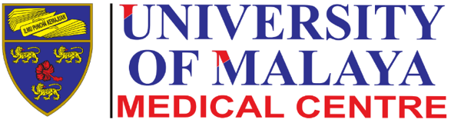
STUDY PROTOCOL

Study Title: Pipelle sampling with full bladder versus no intervention: a randomised clinical trial Version No: 1
Version Date: 17/03/2021

